Real-Time Type 2 Diabetes Mellitus Detection and
Classification Using ECG Signals
Sruthi Balasubramaniam | Tanusha Srinivasan
Guides: Dr. V. Durgadevi, Dr. R. Srinivasan • Healthcare Vertical • AY 2025–2026

Abstract
Diabetes Mellitus is a chronic metabolic disorder for which conventional glucose-based diagnostic and monitoring methods commonly require repeated blood sampling. This work proposes a non-invasive, automated approach for detecting Type 2 Diabetes Mellitus (T2DM) from electrocardiogram (ECG) signals. The system applies discrete wavelet transform (DWT) based preprocessing using Symlet-4 (Sym4) or Daubechies-4 (DB4) wavelets to attenuate noise and baseline variation, followed by normalization, R-peak detection and heartbeat segmentation. Two feature-engineering strategies are evaluated. Independent Component Analysis (ICA) reduces each segmented heartbeat representation to up to 48 statistically independent components, to which the segment standard deviation is added to form 49 features. Empirical Mode Decomposition (EMD) provides an alternative representation using statistical descriptors derived from intrinsic mode functions together with the segment standard deviation. Four wavelet-feature combinations are compared using K-Nearest Neighbors (KNN), radial-basis-function Support Vector Machine (SVM), Decision Tree and Random Forest classifiers. Evaluation is performed using a grouped stratified split at the recording level to reduce leakage between training and testing segments. In the current preliminary experiments, Sym4 + ICA with a Decision Tree provides the strongest overall result, with 62.83% accuracy, 67.89% balanced accuracy and 52.96% diabetes F1-score. The high specificity but moderate sensitivity observed across models indicates that the approach is promising as a research prototype but requires a larger subject cohort and further validation before clinical use. The proposed framework provides a practical basis for future pain-free ECG-based diabetes pre-screening and continuous health-monitoring systems.

Introduction
Type 2 Diabetes Mellitus is a long-term metabolic condition that requires timely identification and continued monitoring. Conventional diagnostic procedures such as fasting plasma glucose and glycated haemoglobin are clinically established but depend on blood collection; repeated self-monitoring may also involve finger-prick measurements. These requirements motivate research into complementary, non-invasive screening approaches that can be incorporated into wearable or remote-monitoring systems.
ECG is inexpensive, non-invasive and widely available, and diabetes is known to be associated with cardiovascular and autonomic changes that may be reflected in cardiac electrical activity and heart-rate dynamics. A systematic review by Zanelli et al. found ECG- and PPG-based analysis to be a promising direction for diabetes detection and management, while emphasizing the need for standardized preprocessing, subject-independent validation and clinical evaluation [6]. These observations support investigation of signal-processing and machine-learning techniques that can extract subtle diabetes-related patterns from ECG recordings without relying on a large deep-learning architecture.
The objective of the present project is therefore to develop and compare a lightweight ECG-based T2DM classification framework. The central workflow combines wavelet denoising, heartbeat segmentation, compact feature extraction and conventional machine-learning classifiers. Although the wider project concept also considers ECG-based screening of arrhythmia and sleep-apnea-related markers, the scope of this paper is intentionally centered on diabetes detection and classification so that the methodology, dataset and validation remain directly aligned with the stated research objective.

Literature Survey
Prior work supports ECG-based diabetes assessment from both physiological and computational perspectives. Early studies showed that nonlinear heart-rate variability (HRV), discrete wavelet transform (DWT) features and empirical mode decomposition (EMD) features can distinguish diabetic from non-diabetic patterns using conventional classifiers [1]–[3]. A systematic review and meta-analysis subsequently confirmed that T2DM is associated with significant reductions in multiple HRV measures, providing a physiological basis for ECG-derived biomarkers [4]. Deep-learning approaches further demonstrated that ECG-derived heart-rate signals can support automated diabetes classification [5]. Broader and more recent studies have extended the field toward ECG/PPG reviews, raw beat-morphology classification, long-term risk prediction and multimodal ECG-based prediction [6]–[9]. The latest ECG-focused systematic review emphasizes that, despite promising internal performance, standardization, external validation and reproducibility remain important barriers to clinical translation [10].
Study | ECG / Inputs | Method | Reported outcome | Relevance to this work
Acharya et al. (2013) [1] | ECG-derived HRV | Nonlinear HRV features + AdaBoost | 86% accuracy | Established that nonlinear HRV descriptors can support automated diabetes discrimination.
Acharya et al. (2015) [2] | ECG-derived HRV | DWT features + DT/KNN/NB/SVM | 92.02% accuracy; 92.59% sensitivity; 91.46% specificity | Directly supports wavelet-based feature extraction with conventional classifiers.
Pachori et al. (2016) [3] | RR-interval signals from ECG | EMD + IMF features + LS-SVM | 95.63% accuracy | Supports EMD as an adaptive decomposition method for diabetes-related cardiac signals.
Benichou et al. (2018) [4] | 24-h Holter ECG / HRV | Systematic review and meta-analysis | 25 studies; 2,932 participants; overall HRV reduction in T2DM | Provides physiological evidence linking T2DM with altered autonomic cardiac regulation.
Swapna et al. (2018) [5] | ECG-derived HRV | CNN/LSTM features + SVM | 95.7% accuracy | Shows the potential of deep learning for diabetes classification from cardiac timing information.
Zanelli et al. (2022) [6] | ECG and PPG literature | Systematic review | 78 studies reviewed; 31 focused on diabetes detection | Highlights the promise of ECG/PPG methods and the need for standardized clinical validation.
Kulkarni et al. (2023) [7] | 12-lead ECG; 1,262 individuals | Time-aligned beats + XGBoost (DiaBeats) | 96.8% accuracy; 96.6% F1 on independent test set | Demonstrates that beat morphology itself contains information for diabetes/prediabetes screening.
Kim et al. (2024) [8] | 12-lead ECG | 1-D deep-learning model | AUROC 0.816 internal; 0.762 external | Extends ECG analysis from current-state detection toward long-term incident T2DM risk.
Mohsen et al. (2025) [9] | ECG features + clinical risk factors | Multimodal neural network (ECG-DiaNet) | AUROC 0.845 for longitudinal T2DM risk prediction | Shows that ECG contributes complementary information when combined with clinical risk factors.
Balakrishnan et al. (2026) [10] | ECG-based AI literature | Systematic review | 25 studies reviewed; strong internal results but limited external validation | Directly identifies standardization, reproducibility and generalizability gaps in ECG-based diabetes AI.
Table 1. Ten representative studies relevant to non-invasive diabetes assessment using ECG/HRV signals.
Compared with studies based on large 12-lead datasets or deep networks, the present work investigates whether a simpler single-channel signal-processing pipeline can produce useful discrimination using a small subject-level dataset. Wavelet decomposition provides a compact method for multiresolution signal processing [11], ICA provides statistically independent representations of multivariate observations [12], and EMD offers an adaptive decomposition for nonlinear and non-stationary signals [13]. These techniques are therefore suitable candidates for a computationally lightweight proof-of-concept pipeline.

Proposed Methodology
The proposed system is organized as one unified ECG-processing workflow. The different wavelet and feature-extraction combinations are experimental variants within this workflow rather than separate end-to-end systems. This keeps the project focused on the core objective: identifying diabetes-related ECG patterns using a practical, non-invasive machine-learning framework.

1. ECG ingestion and signal-quality preparation
Each CSV recording is treated as one physiological record. The ECG channel is selected from the available numeric channels, after which missing numeric values are interpolated where required. Because the dataset contains repeated consecutive samples, subject-specific baseline/amplitude differences and clipping in two recordings, the final signal-quality stage should explicitly detect repeated sequences, flag or reject clipped intervals, and standardize the usable ECG before feature extraction. The current implementation performs robust CSV parsing and z-score normalization; clipping and effective-rate correction remain explicit quality-control requirements for the final real-time pipeline.

2. Wavelet preprocessing
The ECG is denoised using a DWT with either Sym4 or DB4. Wavelet coefficients are soft-thresholded to suppress high-frequency noise while retaining the morphology of the cardiac cycle. Sym4 is the primary wavelet used in the original project design, while DB4 is evaluated as a closely related alternative so that the effect of the wavelet basis can be compared without changing the remainder of the processing chain.

3. R-peak detection and heartbeat segmentation
After normalization, R-peaks are identified using a peak detector. Complete heartbeat windows are then extracted around each accepted R-peak. In the current implementation, each segment contains 90 samples before and 120 samples after the detected peak, giving a fixed 210-sample beat representation. This converts long recordings into consistent local cardiac cycles that can be used for feature extraction.

4. Feature engineering
Two complementary feature representations are evaluated. For ICA, FastICA is fitted only on the training records and the segmented beats are transformed into up to 48 independent components. The standard deviation of each beat is appended as an additional scalar feature, producing a 49-feature representation. For EMD, each beat is adaptively decomposed into up to five intrinsic mode functions (IMFs). Compact statistics—including energy, relative energy, RMS, standard deviation, mean absolute value, entropy, skewness, kurtosis and zero-crossing rate—are extracted from each IMF, together with residue energy, residue standard deviation and the original beat standard deviation. This produces a compact alternative representation without making the project dependent on one feature-extraction method.

5. Classification and validation
The extracted features are evaluated using KNN, RBF-SVM, Decision Tree and Random Forest classifiers. Standardization is applied before KNN and SVM, while balanced class weighting is used where supported by the classifier. Most importantly, the train/test split is performed with recording-level grouping using a stratified grouped split. Thus, beat windows originating from the same ECG recording are kept together, reducing the risk of artificially high performance caused by near-duplicate beats appearing in both training and testing data.

6. Experimental combinations
Combination | Wavelet stage | Feature stage | Feature count | Role in comparison
Sym4 + ICA | Sym4 DWT | 48 ICA components + beat SD | 49 | Primary configuration
Sym4 + EMD | Sym4 DWT | EMD IMF statistics + beat SD | 48 | Primary configuration
DB4 + EMD | DB4 DWT | EMD IMF statistics + beat SD | 48 | Primary configuration
DB4 + ICA | DB4 DWT | 48 ICA components + beat SD | 49 | Additional comparative configuration
Table 2. Wavelet and feature-extraction combinations evaluated in the project.
The detailed framework figures in the next section show the three primary pipelines specifically requested for the project report. DB4 + ICA is retained in the performance comparison because it was also executed in the experimental code and provides a useful control for separating wavelet effects from feature-extraction effects.

Block Diagram/Framework Showing the Workflow and Description
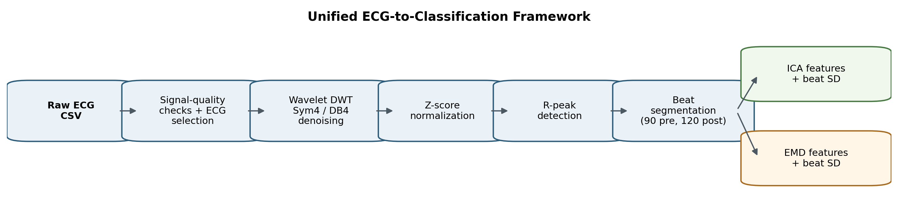
Figure 1. Unified workflow used for ECG-based T2DM classification.
Figure 1 summarizes the complete workflow. Raw ECG is first passed through signal-quality preparation and wavelet denoising, followed by normalization, R-peak detection and fixed-length heartbeat segmentation. At the feature stage, the pipeline branches to either ICA or EMD. The resulting feature vector is then supplied to the same set of machine-learning classifiers, allowing the signal-processing choices to be compared under a consistent evaluation setup.
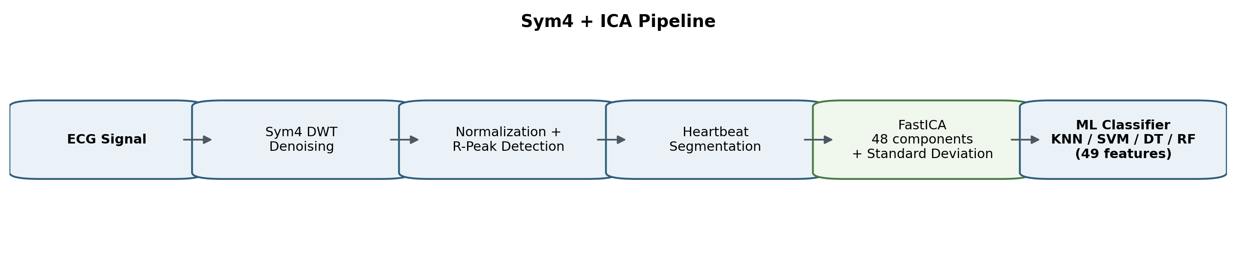
Figure 2. Sym4 + ICA primary pipeline.
In the Sym4 + ICA configuration, Sym4 wavelet preprocessing is followed by ICA-based dimensionality reduction. Forty-eight independent components summarize the beat morphology and the beat standard deviation is appended as the forty-ninth feature. This configuration produced the strongest current balanced performance when paired with a Decision Tree.
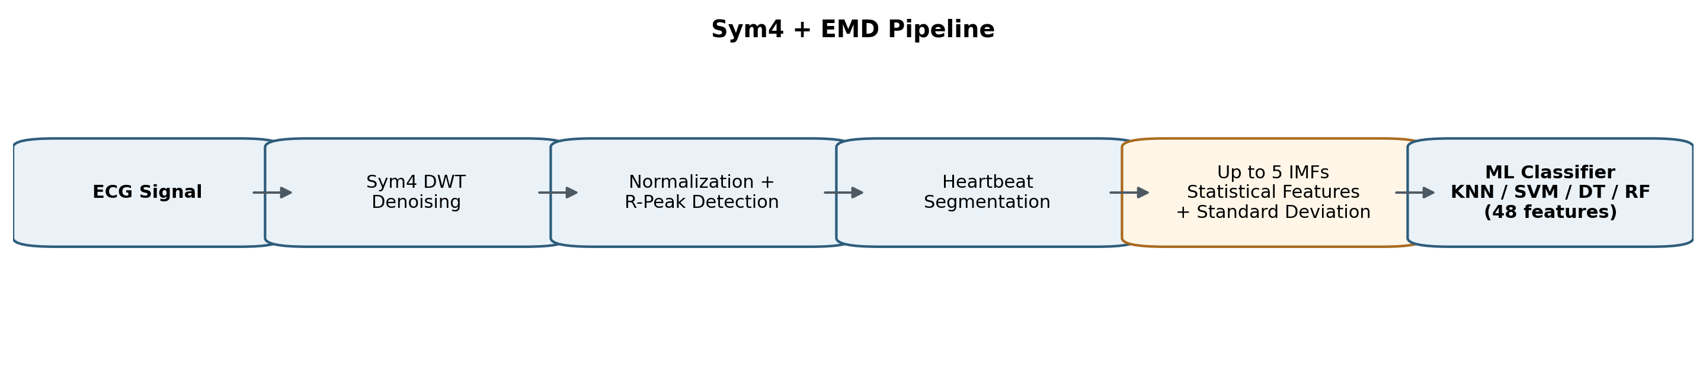
Figure 3. Sym4 + EMD primary pipeline.
In the Sym4 + EMD configuration, the same Sym4 preprocessing and heartbeat segmentation are retained, but the beat is decomposed into adaptive IMFs. Statistical IMF descriptors characterize the local energy, variability and waveform distribution before classification. This configuration allows the study to test whether nonlinear, data-adaptive decomposition provides more useful information than ICA.
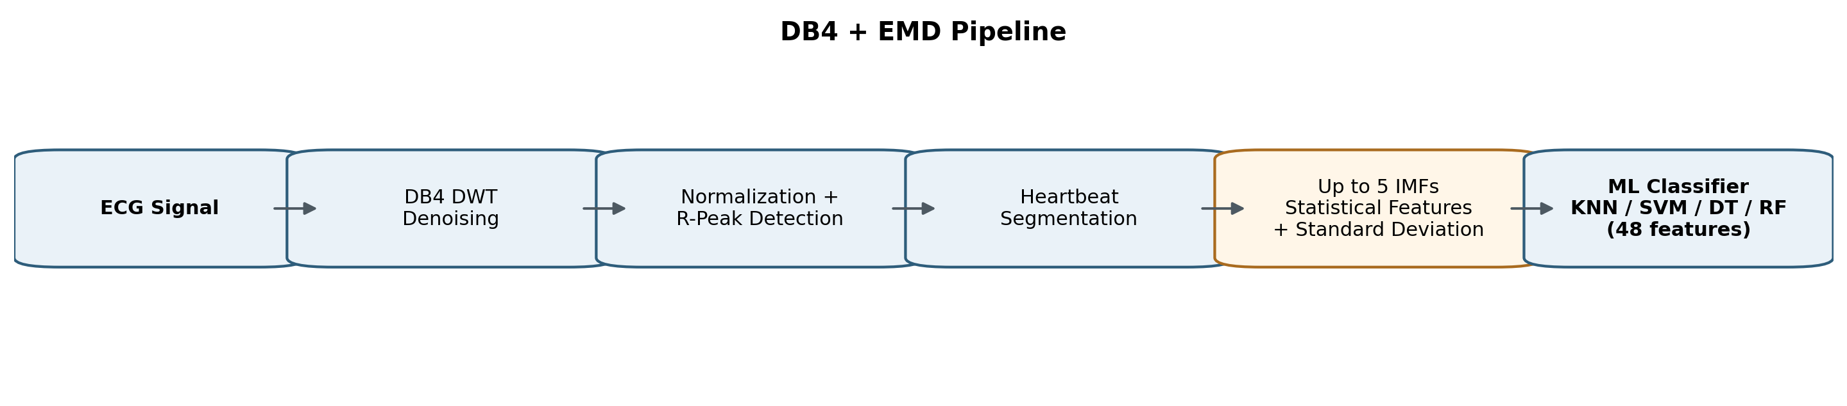
Figure 4. DB4 + EMD primary pipeline.
The DB4 + EMD configuration keeps the EMD feature representation unchanged while replacing the Sym4 denoising basis with DB4. Its purpose is to assess whether classifier behavior is sensitive to the chosen wavelet family while preserving the same segmentation, feature-engineering and validation stages.

Data Set Description
The dataset comprises 12 subject-level physiological recordings, including 5 diabetic and 7 non-diabetic subjects. Each recording contains a timestamp and three physiological signal channels: one ECG channel and two optical/PPG-related channels. The recordings range approximately from 10 to 20 minutes per subject, resulting in approximately 1.72 million raw samples across all recordings.
Inspection of the recordings revealed that consecutive signal measurements are frequently repeated, with a typical repetition factor of approximately four samples. Consequently, the effective information rate is estimated to be approximately 50 Hz, despite the raw CSV representation containing approximately 200 rows per second. The recordings also exhibit substantial subject-specific baseline and amplitude variations, requiring appropriate signal normalization during preprocessing. Additionally, ECG signal clipping at the 16-bit limits (-32768 and 32767) was identified in two recordings and must be addressed during signal-quality preprocessing.
Property | Description
Subjects | 12 total: 5 diabetic and 7 non-diabetic
Recording duration | Approximately 10–20 minutes per subject
Raw samples | Approximately 1.72 million rows across all recordings
Channels | Timestamp + 1 ECG + 2 optical/PPG-related channels
Raw row rate | Approximately 200 rows/s
Estimated effective information rate | Approximately 50 Hz due to repeated values (~4× repetition)
Observed quality issues | Baseline/amplitude variation; 16-bit ECG clipping in two recordings
Table 3. Summary of the current subject-level physiological dataset.
Because the cohort is small, the dataset should be treated as a proof-of-concept research dataset rather than evidence of clinical diagnostic performance. Future validation should increase the number and diversity of subjects, document acquisition conditions, and evaluate the final model on a fully independent subject set.

Performance Metrics
Medical classification cannot be judged by accuracy alone, particularly when the number of samples or usable beat windows differs between classes. The proposed solution is therefore validated with class-sensitive metrics derived from the confusion matrix, where diabetes is treated as the positive class.
Accuracy: Overall proportion of correctly classified samples.
Accuracy = (TP + TN) / (TP + TN + FP + FN)
Balanced accuracy: Average of sensitivity and specificity; useful when classes are imbalanced.
Balanced Accuracy = (Sensitivity + Specificity) / 2
Diabetes precision: Among samples predicted as diabetes, the fraction that are truly diabetic.
Precision = TP / (TP + FP)
Diabetes recall / sensitivity: Fraction of diabetic samples correctly detected; important for screening.
Sensitivity = TP / (TP + FN)
Specificity: Fraction of normal samples correctly rejected as non-diabetic.
Specificity = TN / (TN + FP)
Diabetes F1-score: Harmonic mean of diabetes precision and recall.
F1 = 2 × (Precision × Recall) / (Precision + Recall)
For the current experiments, balanced accuracy, diabetes recall and diabetes F1-score are especially informative. The models frequently achieve very high diabetes precision and specificity while retaining low diabetes recall, meaning that positive predictions are usually correct but many diabetic samples are still missed. A suitable screening model must improve this sensitivity without creating an unacceptable false-positive rate.

Current Comparative Performance
Pipeline | ML model | Accuracy | Balanced  accuracy | Diabetes  precision | Diabetes  recall | Specificity | Diabetes F1
Sym4 + ICA | Decision Tree | 62.83% | 67.89% | 99.39% | 36.09% | 99.70% | 52.96%
Sym4 + ICA | SVM (RBF) | 57.58% | 63.41% | 100.00% | 26.82% | 100.00% | 42.30%
Sym4 + ICA | Random Forest | 48.50% | 55.57% | 100.00% | 11.15% | 100.00% | 20.06%
Sym4 + ICA | KNN | 46.51% | 53.86% | 100.00% | 7.73% | 100.00% | 14.34%
DB4 + ICA | SVM (RBF) | 55.75% | 61.89% | 100.00% | 23.78% | 100.00% | 38.43%
DB4 + ICA | Decision Tree | 49.84% | 56.80% | 100.00% | 13.61% | 100.00% | 23.95%
DB4 + ICA | Random Forest | 49.65% | 56.64% | 100.00% | 13.27% | 100.00% | 23.44%
DB4 + ICA | KNN | 46.05% | 53.54% | 100.00% | 7.08% | 100.00% | 13.22%
Sym4 + EMD | KNN | 53.29% | 59.63% | 97.83% | 19.87% | 99.39% | 33.03%
Sym4 + EMD | SVM (RBF) | 49.33% | 56.29% | 100.00% | 12.58% | 100.00% | 22.35%
Sym4 + EMD | Decision Tree | 45.68% | 53.12% | 98.31% | 6.40% | 99.85% | 12.02%
Sym4 + EMD | Random Forest | 43.76% | 51.49% | 100.00% | 2.98% | 100.00% | 5.79%
DB4 + EMD | KNN | 49.13% | 56.15% | 98.28% | 12.61% | 99.69% | 22.35%
DB4 + EMD | SVM (RBF) | 47.59% | 54.87% | 100.00% | 9.73% | 100.00% | 17.74%
DB4 + EMD | Decision Tree | 44.44% | 52.16% | 100.00% | 4.31% | 100.00% | 8.27%
DB4 + EMD | Random Forest | 42.39% | 50.39% | 100.00% | 0.77% | 100.00% | 1.54%
Table 4. Current results for all wavelet–feature combinations and classifiers. Light blue marks the best overall configuration; grey marks the best model within the other pipeline families.
The current comparison identifies Sym4 + ICA with Decision Tree as the strongest overall configuration: 62.83% accuracy, 67.89% balanced accuracy, 36.09% diabetes recall and 52.96% diabetes F1. Within the EMD pipelines, KNN performs best for both Sym4 and DB4. The consistently high specificity and precision indicate that false-positive diabetes predictions are uncommon, but the low recall across many configurations shows that sensitivity is the main limitation at this stage. Consequently, future optimization should prioritize subject-level generalization and diabetes recall rather than maximizing raw accuracy alone.

Conclusion
This study presents a compact, non-invasive framework for T2DM classification from ECG signals. The proposed approach combines wavelet-based signal preprocessing, R-peak-centered heartbeat segmentation, ICA or EMD feature engineering, and conventional machine-learning classifiers. The design intentionally compares multiple signal representations while preserving a common end-to-end objective: identifying diabetes-related patterns from ECG in a form that can eventually support portable and continuous pre-screening.
The current results show that Sym4 + ICA with a Decision Tree provides the most balanced performance among the evaluated configurations, but the modest diabetes recall demonstrates that the prototype is not yet suitable for clinical diagnosis. The most important next steps are to expand the number of subjects, explicitly correct repeated-sample and clipping artifacts, use repeated subject-grouped cross-validation or an independent test cohort, tune the models for sensitivity, and then evaluate the final pipeline on real-time sensor data. With these improvements, the work can serve as a foundation for a practical ECG-based, pain-free diabetes screening system.

References
[1] U. R. Acharya et al., “An integrated diabetic index using heart rate variability signal features for diagnosis of diabetes,” Computer Methods in Biomechanics and Biomedical Engineering, vol. 16, no. 2, pp. 222–234, 2013. doi: 10.1080/10255842.2011.616945.
[2] U. R. Acharya, V. K. Sudarshan, D. N. Ghista, W. J. E. Lim, F. Molinari, and M. Sankaranarayanan, “Computer-aided diagnosis of diabetic subjects by heart rate variability signals using discrete wavelet transform method,” Knowledge-Based Systems, vol. 81, pp. 56–64, 2015. doi: 10.1016/j.knosys.2015.02.005.
[3] R. B. Pachori, M. Kumar, P. Avinash, K. Shashank, and U. R. Acharya, “An improved online paradigm for screening of diabetic patients using RR-interval signals,” Journal of Mechanics in Medicine and Biology, vol. 16, art. 1640003, 2016. doi: 10.1142/S0219519416400030.
[4] T. Benichou, B. Pereira, M. Mermillod, I. Tauveron, D. Pfabigan, S. Maqdasy, and F. Dutheil, “Heart rate variability in type 2 diabetes mellitus: A systematic review and meta-analysis,” PLOS ONE, vol. 13, no. 4, art. e0195166, 2018. doi: 10.1371/journal.pone.0195166.
[5] G. Swapna, R. Vinayakumar, and K. P. Soman, “Diabetes detection using deep learning algorithms,” ICT Express, vol. 4, no. 4, pp. 243–246, 2018. doi: 10.1016/j.icte.2018.10.005.
[6] S. Zanelli, M. Ammi, M. Hallab, and M. A. El Yacoubi, “Diabetes Detection and Management through Photoplethysmographic and Electrocardiographic Signals Analysis: A Systematic Review,” Sensors, vol. 22, no. 13, art. 4890, 2022. doi: 10.3390/s22134890.
[7] A. R. Kulkarni et al., “Machine-learning algorithm to non-invasively detect diabetes and pre-diabetes from electrocardiogram,” BMJ Innovations, vol. 9, no. 1, pp. 32–42, 2023. doi: 10.1136/bmjinnov-2021-000759.
[8] J. Kim et al., “Deep learning-based long-term risk evaluation of incident type 2 diabetes using electrocardiogram in a non-diabetic population: a retrospective, multicentre study,” eClinicalMedicine, vol. 68, art. 102445, 2024. doi: 10.1016/j.eclinm.2024.102445.
[9] F. Mohsen, A. Safa, and Z. Shah, “ECG features improve multimodal deep learning prediction of incident T2DM in a Middle Eastern cohort,” Scientific Reports, vol. 15, art. 27164, 2025. doi: 10.1038/s41598-025-12633-z.
[10] K. Balakrishnan, D. Velusamy, K. Ramasamy, H. E. Hinkle, H. J. Hudson, R. B. Pachori, and H. Khan, “Artificial intelligence approaches for non-invasive diabetes prediction using ECG signals: A systematic review,” Computer Methods and Programs in Biomedicine, vol. 278, art. 109264, 2026. doi: 10.1016/j.cmpb.2026.109264.
[11] S. G. Mallat, “A Theory for Multiresolution Signal Decomposition: The Wavelet Representation,” IEEE Transactions on Pattern Analysis and Machine Intelligence, vol. 11, no. 7, pp. 674–693, 1989. doi: 10.1109/34.192463.
[12] A. Hyvärinen and E. Oja, “Independent component analysis: algorithms and applications,” Neural Networks, vol. 13, nos. 4–5, pp. 411–430, 2000. doi: 10.1016/S0893-6080(00)00026-5.
[13] N. E. Huang et al., “The empirical mode decomposition and the Hilbert spectrum for nonlinear and non-stationary time series analysis,” Proceedings of the Royal Society A, vol. 454, no. 1971, pp. 903–995, 1998. doi: 10.1098/rspa.1998.0193.

