MINI PROJECT REPORT

**BANK ASSISTANCE APLLICATION**

**Aim:**

To design a people assisting bank application program incorporating various Data structures.

**Description:**

The program/application is designed to aid those people need assistance to accessing bank services. Hence this application is modelled to be used by staffs, who provide assistance to these people. Through this application, the staff can assist a customer in need to perform banking operations such as deposit money, withdraw cash, transfer amount from the current customer’s account to an account existing in the bank data base or avail a loan. The application has been designed to give the elderly more preference than the youth. The application begins with a login page , through which the already existing staff in the bank’s database can login to perform their responsibilities. The staff details are kept in an AVL tree, to make matching process more efficient. When a satff logs in, a queue of customers that needs to be tended to are assigned to the staff,the customers are arranged in a priority queue based upon their age, modelling a real life queue, and are served one by one. Customers are first authenticated by the staffs, either with their passwords or with their ID’s. They are provided the option to update their passwords if required. After the authentication process, the customers are provided with different services to choose from including withdrawing money, money transaction, account to account transfer etc. The customers are eligible to avail for a laon , the loan amount that can be sanctioned to them is determined by their credit points. A customer has increase his/her credit point by performing various transactions with the bank. All transactions are allowed based on some upper bound and lower bound for the amount in action. There is also an option for the bank staffs to view the customer and bank database, to review transactions.

**Data structures used**

1.AVL tree

AVL tree in our application is made to hold the details of the bank's customers. The tree is based upon the customer ID. By using AVL tree, the searching efficiency is highly increased, which reduces the time complexity of the application.

2.Priority Queue

Priority queue holds the customers who are served one by one in accordance to their position in the queue. The customers in the queue are placed in such a way that the older people are served first

3.Binary heap

Binary heap is used to enqueue the customers on to the priority queue based on their age. We have used a max heap , which fetches customer data from the AVL tree and creates the heap accordingly. After the heap is created , it is emptied one by one onto the priority queue.

**Design of Application**

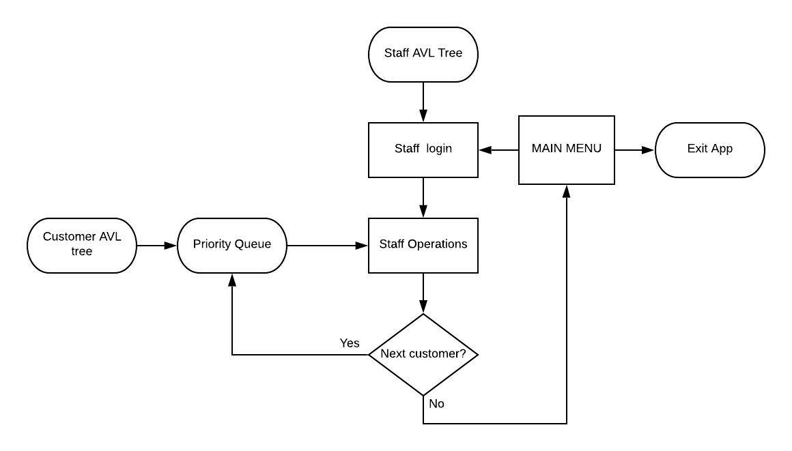

Learning Outcome:

* We have developed a CustomerADT which contains a customer’s name, account number, age, address, account balance, password etc.
* We have developed a PriorityQueueADT which contains a queue of customers, arranged according to their age (the higher the age, the higher their priority) .
* We have developed a StaffADT which contains the staff ID, staff password and a queue of customers.
* The Customer data and Staff data have been arranged randomly in an AVL tree.
* The queue of customers have been arranged sequentially in the queue
* Operations such an en-queuing customers the customers to the priority queue, DE-queuing served customers can be performed on the organised pirorityQueueADT data.
* Operations such as insertion, searching, displaying etc can be performed on the organised CustomerADT data and StaffADT data in their respective AVL trees.
* We have implemented modular and incremental programming throughout the course of development of our project.
* We learnt to systematically debug the program.
* By virtue of designing the application, we thoroughly understood the concepts behind various data structures and were able to implement them at various stages of the application thereby learning about their use cases.
* The usage of data structures helped us in increasing the efficiency of the program. Throughout the course of completion of this application, we learnt how to select the correct data structure to achieve maximum efficiency.
* We have learnt to develop BankADT , which contains a data base of its staffs and customers.
* We have learnt to develop an application using BankADT.

Output Screenshots

