**PART 1: Connecting & Shaping the Data**

***Open a new Power BI Desktop file, and complete the following steps:***

**1) Update your Power BI options and settings as follows:**

* **Deselect the "*Autodetect new relationships after data is loaded*" option in the Data Load tab**
* **Make sure that Locale for import is set to "*English (United States)*" in the Regional Settings tab**

**2) Connect to the SuperMarket_Customers csv file**

* **Name the table "Customers", and make sure that headers have been promoted**
* **Confirm that data types are accurate (Note: "*customer_id*" should be whole numbers, and both "*customer_acct_num*" and "*customer_postal_code*" should be text)**
* **Add a new column named "*full_name"*to merge the the "*first_name"* and "*last_name"* columns, separated by a space**
* **Create a new column named "*birth_year"*to extract the year from the "*birthdate"*column, and format as text**
* **Create a conditional column named "*has_children"*which equals "N" if "*total_children"* = 0, otherwise "Y"**

**3) Connect to the SuperMarket_Products csv file**

* **Name the table "Products" and make sure that headers have been promoted**
* **Confirm that data types are accurate (Note: "*product_id*" should be whole numbers, "*product_sku*" should be text), "*product_retail_price*" and "*product_cost*" should be decimal numbers)**
* **Use the statistics tools to return the number of distinct product brands, followed by distinct product names**
* **Add a calculated column named "*discount_price*", equal to 90% of the original retail price**
  + **Format as a fixed decimal number, and then use the rounding tool to round to 2 digits**
* **Select "*product_brand*" and use the Group By option to calculate the average retail price by brand, and name the new column "*Avg Retail Price*"**
* **Delete the last applied step to return the table to its pre-grouped state**
* **Replace "*null*" values with zeros in both the "*recyclable*" and "*low-fat*" columns**

**4) Connect to the SuperMarket_Stores csv file**

* **Name the table "Stores" and make sure that headers have been promoted**
* **Confirm that data types are accurate (Note: "*store_id*" and "*region_id*" should be whole numbers)**
* **Add a calculated column named "*full_address*", by merging "*store_city*", "*store_state*", and "*store_country*", separated by a comma and space (*hint: use a custom separator*)**
* **Add a calculated column named "*area_code*", by extracting the characters before the dash ("-") in the "*store_phone*" field**

**5) Connect to the SuperMarket_Regions csv file**

* **Name the table "Regions" and make sure that headers have been promoted**
* **Confirm that data types are accurate (Note: "*region_id*" should be whole numbers)**

**6) Connect to the SuperMarket_Calendar csv file**

* **Name the table "Calendar" and make sure that headers have been promoted**
* **Use the date tools in the query editor to add the following columns:**
  + ***Start of Week (starting Sunday***
  + ***Name of Day***
  + ***Start of Month***
  + ***Name of Month***
  + ***Quarter of Year***
  + ***Year***

**7) Connect to the SuperMarket_Returns csv file**

* **Name the table "Return_Data" and make sure that headers have been promoted**
* **Confirm that data types are accurate (all ID columns and *quantity* should be whole numbers)**

**8) Add a new folder on your desktop (or in your documents) named "SuperMarket Transactions", containing both the SuperMarket_Transactions_1997 and SuperMarket_Transactions_1998 csv files**

* **Connect to the folder path, and choose "Edit" (*vs. Combine and Edit*)**
* **Click the "*Content*" column header (double arrow icon) to combine the files, then remove the "*Source.Name*" column**
* **Name the table "Transaction_Data", and confirm that headers have been promoted**
* **Confirm that data types are accurate (all ID columns and *quantity* should be whole numbers)**

**9) With the exception of the two data tables, disable "*Include in Report Refresh*", then Close & Apply**

* **Confirm that all 7 tables are now accessible within both the RELATIONSHIPS view and the DATA view**

**10) Save your .pbix file (*i.e. "SuperMarket_Report"*)**

**PART 2: Creating the Data Model**

***Using the report you created in Part 1, complete the following steps:***

**1) In the MODEL view, arrange your tables with the lookup tables above the data tables**

* **Connect Transaction_Data to Customers, Products, and Stores using valid primary/foreign keys**
* **Connect Transaction_Data to Calendar using both date fields, with an inactive "*stock_date*" relationship**
* **Connect Return_Data to Products, Calendar, and Stores using valid primary/foreign keys**
* **Connect Stores to Regions as a "snowflake" schema**

**2) Confirm the following:**

* **All relationships follow one-to-many cardinality, with primary keys (1) on the lookup side and foreign keys (*) on the data side**
* **Filters are all one-way (no two-way filters)**
* **Filter context flows "downstream" from lookup tables to data tables**

**4) In the DATA view, complete the following:**

* **Update *all* date fields (across all tables) to the "M/d/yyyy" format using the formatting tools in the Modeling tab**
* **Update "*product_retail_price*", "*product_cost*", and "*discount_price*" to Currency ($ English) format**
* **In the Customers table, categorize "*customer_city*" as City, "*customer_postal_code*" as Postal Code, and "*customer_country*" as Country/Region**
* **In the Stores table, categorize "*store_city*" as City, "*store_state*" as State or Province, "*store_country*" as Country/Region, and "*full_address*" as Address**

**5) Save your .pbix file**

***Solution screenshot (for reference):***

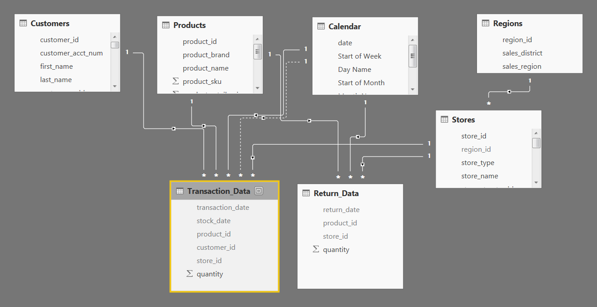

**PART 3: Adding DAX Measures**

*Using your report from Part 2, complete the following steps:*

**1)** In the **DATA** view, add the following **calculated columns**:

* In the **Calendar** table, add a column named "***Weekend***"
  + Equals "***Y***" for Saturdays or Sundays (otherwise "***N***")

**Weekend = IF('Calendar'[Day Name] ="Saturday" || 'Calendar'[Day Name] = "Sunday","Y","N")**

* In the **Calendar** table, add a column named "***End of Month***"
  + Returns the last date of the current month for each row

**End of Month = EOMONTH(‘Calendar’[date],0)**

* In the **Customers** table, add a column named "***Current Age***"
  + Calculates current customer ages using the "*birthdate*" column and the TODAY() function

**Current_Age = DATEDIFF(‘Customers’[birthdate],TODAY(),YEAR)**

* In the **Customers** table, add a column named "***Priority***"
  + Equals "***High***" for customers who own homes and have Golden membership cards (otherwise "***Standard***")

**Priority = IF(‘Customers’[member_card] = “Golden” && ‘Customers’[homeowner] = “Y”, “High”, “Standard”)**

* In the **Customers** table, add a column named "***Short_Country***"
  + Returns the first three characters of the customer country, and converts to all uppercase

**Short_country = UPPER(LEFT(‘Customers’[Customer_country],3))**

* In the **Products** table, add a column named "***Price_Tier***"
  + Equals "***High***" if the retail price is >**$3**, "***Mid***" if the retail price is >**$1**, and "***Low***" otherwise

**Price_Tier = IF(‘Products’[product_retail_price]>3, “High”,IF(‘Products’[product_retail_price]>1,”Mid”, “Low”))**

* In the **Stores** table, add a column named "***Years_Since_Remodel***"
  + Calculates the number of years between the current date (TODAY()) and the last remodel date

**Years_Since_Remodel = DATEDIFF(‘Store’[last_remodel_date],TODAY(),YEAR)**

**2)** In the **REPORT** view, add the following **measures**

Create new measures named "**Quantity Sold**" and "**Quantity Returned**" to calculate the sum of quantity from each data table

**Quantity_Sold = SUM(‘Transaction_Data’[quantity])**

**Quantity_Returtned = SUM(‘Return_Data’[quantity])**

* Create new measures named "**Total Transactions**" and "**Total Returns**" to calculate the count of rows from each data table

**Total_Tranctions = COUNTROWS(‘Transaction_data’)**

**Total_Returns = COUNTROWS(‘Return_Data’)**

* Create a new measure named "**Return Rate**" to calculate the ratio of quantity returned to quantity sold (format as %)

**Return_Rate = [Quantity Returned] / [Quantity Sold]**

* Create a new measure named "**Weekend Transactions**" to calculate transactions on weekends

**Weekend_Transactions = CALCULATE([Total Transactions],’Calendar’[Weekend]=”Y”)**

* Create a new measure named "**% Weekend Transactions**" to calculate weekend transactions as a percentage of total transactions (format as %)

**% Weekend Transactions = [Weekend_Transactions] / [Total Transactions]**

* Create new measures named "**All Transactions**" and "**All Returns**" to calculate grand total transactions and returns (regardless of filter context)

**All Transactions = CALCULATE([Total Transactions],ALL(Transaction_Data))**

**All Returns = CALCULATE([Total Returns],ALL(Return_Data))**

* Create a new measure to calculate "**Total Revenue**" based on transaction quantity and product retail price, and format as $ (***hint:****you'll need an iterator*)

**Total Revenue = SUMX(Transaction_Data, Transaction_Data[quantity] \***

**RELATED(Products[product_retail_price])**

* Create a new measure to calculate "**Total Cost**" based on transaction quantity and product cost, and format as $ (***hint:****you'll need an iterator*)
* **Total Cost = SUMX(Transaction_Data, Transaction_Data[quantity] \***
* **RELATED(Products[product_cost])**
* Create a new measure named "**Total Profit**" to calculate total revenue minus total cost, and format as $

**Total Profit = [Total Revenue] – [Total Cost]**

* Create a new measure to calculate "**Profit Margin**" by dividing total profit by total revenue calculate total revenue (format as %)

**Profit Margin = [Total Profit] / [Total Revenue]**

* Create a new measure named "**Unique Products**" to calculate the number of unique product names in the **Products** table

**Unique Products = DISTINCTCOUNT(Products[Product_Name])**

* Create a new measure named "**YTD Revenue**" to calculate year-to-date total revenue, and format as $

**YTD_Revenue = CALCULATE([Total Revenue],DATESYTD(‘Calendar’[Date]))**

* Create a new measure named "**60-Day Revenue**" to calculate a running revenue total over a 60-day period, and format as $

**60-Day Revenue = CALCULATE([Total Revenue], DATESINPERIOD(‘Calendar’[Date],MAX(‘Calendar’[Date]),-60,DAY))**

* Create new measures named  "**Last Month Transactions**", "**Last Month Revenue**", "**Last Month Profit**", and "**Last Month Returns**"

**Last Month Transactions = CALCULATE([Total Transactions],DATEADD(‘Calendar’[Date], -1, MONTH))**

**Last Month Revenue = CALCULATE([Total Revenue],DATEADD(‘Calendar’[Date], -1, MONTH))**

**Last Month Profit = CALCULATE([Total Profit],DATEADD(‘Calendar’[Date], -1, MONTH))**

**Last Month Returns = CALCULATE([Total Returns],DATEADD(‘Calendar’[Date], -1, MONTH))**

* Create a new measure named "**Revenue Target**" based on a 5% lift over the previous month revenue, and format as $

**Revenu Target = [Last Month Revenue] * 1.05**

**PART 4: Building the Report**

*For the final phase of the project, you can either follow the instructions to recreate the report shown below, or design your own version*

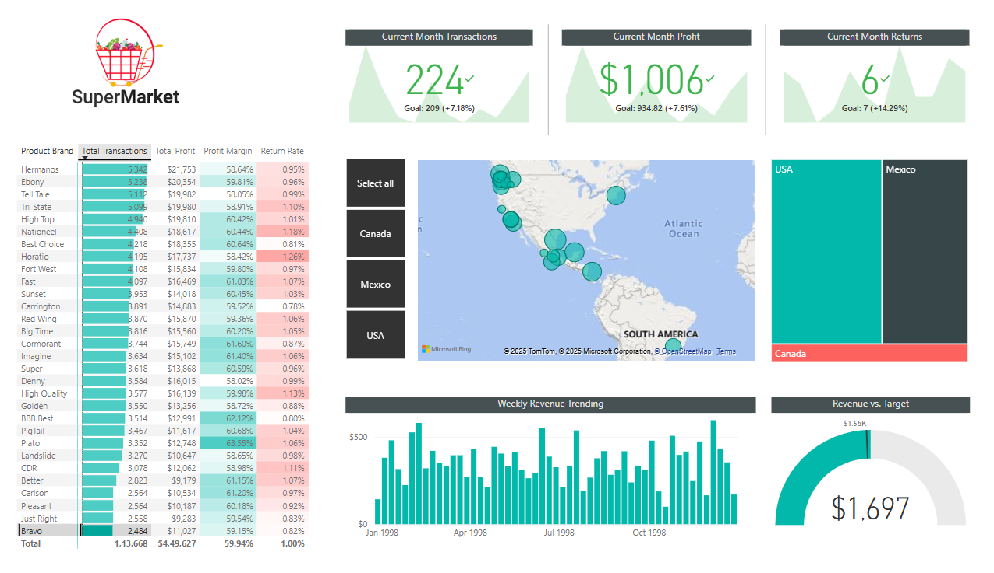

**1)** Rename the tab "**Topline Performance**" and insert the Super Market logo

**2)** Insert a **Matrix** visual to show **Total Transactions**, **Total Profit**, **Profit Margin**, and **Return Rate** by **Product_Brand**(*on rows*)

* Add conditional formatting to show **data bars** on the Total Transactions column, and **color scales** on Profit Margin (*White to Green*) and Return Rate (*White to Red*)
* Add a visual level**Top N** filter to only show the top 30 product brands, then sort descending by Total Transactions

**3)**Add a **KPI Card** to show **Total Transactions**, with **Start**

**of Month** as the trend axis and **Last Month Transactions** as the target goal

* Update the title to "***Current Month Transactions***", and format as you see fit
* Create two more copies: one for **Total Profit**(*vs. Last month Profit*) and one for **Total Returns** (*vs. Last Month Returns*)
  + Make sure to update titles, and change the Returns chart to color coding to "*Low is Good*"

**4)**Add a **Map** visual to show **Total Transactions** by store city

* Add a slicer for store country
  + Under the "selection controls" menu in the formatting pane, activate the "***Show Select All***" option
  + **Pro Tip:** Change the orientation in the "General" formatting menu to**horizontal** and resize to create a *vertical*stack (rather than a list)

**5)** Next to the map, add a **Treemap** visual to break down **Total Transactions** by store country

* Pull in **store_state** and **store_city**beneath **store_country** in the "Group" field to enable drill-up and drill-down functionality

**6)** Beneath the map, add a **Column Chart** to show **Total Revenue** by week, and format as you see fit

* Add a **report level filter** to only show data for 1998
* Update the title to "***Weekly Revenue Trending***"

**7)** In the lower right, add a **Gauge Chart** to show **Total Revenue** against**Revenue Target**(*as either "target value" or "maximum value"*)

* Add a visual level **Top N** filter to show the latest **Start of Month**
* Remove data labels, and update the title to "***Revenue vs. Target***"

**8)**Select the Matrix and activate the  **Edit interactions** option to prevent the Treemap from filtering