CITIZEN AI - Intelligent Citizen Engagement Platform

Project Documentation

1.Introduction
- Project title: CITIZEN AI-Intelligent Citizen Engagement Platform.
- Team member :Suba sri S
- Team member: Sudarvizhi S
- Team member: Susana S
- Team member: Swathi G

2. Project Overview
Purpose:
The Citizen AI platform enables smart city assistants that empower citizens and city officials to work together toward a more sustainable and efficient city. The AI assistant uses real-time data to help citizens access essential city services and information.
Features:
- Conversational Interface: Interact with the assistant via natural language queries.
- Policy Summarization: Quickly understand city policies and regulations.

3. Architecture:
- Frontend (Gradio): For creating a clean, easy-to-use interface.
- Backend (FastAPI): Handles the logic, processes queries, and communicates with the AI.
- AI Integration (IBM Watsonx or GPT): Used to process natural language queries and generate responses.
- Data Storage (Pinecone): Store documents and data for semantic search.

4. Setup Instructions:
Prerequisites:
- Python 3.9 or later
- pip, gradio, transformers, torch for AI model integration

Installation:
- Clone the repository.
- Install dependencies with: pip install transformers torch gradio
- Set up your .env file for any necessary API keys (e.g., IBM, Pinecone).
- Run the backend server using FastAPI.
- Launch the Gradio frontend.

5. Folder Structure:
- APP/:Contains FastAPI backend logic.
  - app/api/: API endpoints for handling city queries, file uploads, etc.
  - app/models/: Machine learning models (Granite or GPT models).
- UI/: Contains Gradio UI components.
  - gradio_app.py: Main script to run the Gradio UI.
  - gradio_templates/: Templates for the UI (HTML/Markdown)
- DATA/: Dataset for testing or analysis.
  - city_data.csv: City-specific statistics (e.g., crime rates, accidents).
  - policies.json: JSON file with government policies.

6. Running the Application:
- Start the FastAPI Server: Launch the backend API server.
- Run the gradio Interface: Run gradio_app.py to interact with the platform via the browser.

7. API Documentation:
- POST /query: Submit a query (e.g., "What are the crime rates in City X?").
- POST /upload: Upload documents for analysis (e.g., policy papers).

8. Authentication:
This version uses open access for demo purposes. Future enhancements will include:
- Token-based authentication (JWT).
- OAuth2 integration.

9. User Interface:
The Gradio interface provides:
- City Analysis Tab: For analyzing a city's crime index, traffic stats, etc.
- Citizen Services Tab: For answering queries about public services and policies.

10. Testing:
Testing involves:
- Unit Testing: For core functions (e.g., AI responses, file handling).
- API Testing: Using tools like Postman or Swagger UI.
- Manual Testing: For UI interactions (query submission, responses).
11.Screenshot:
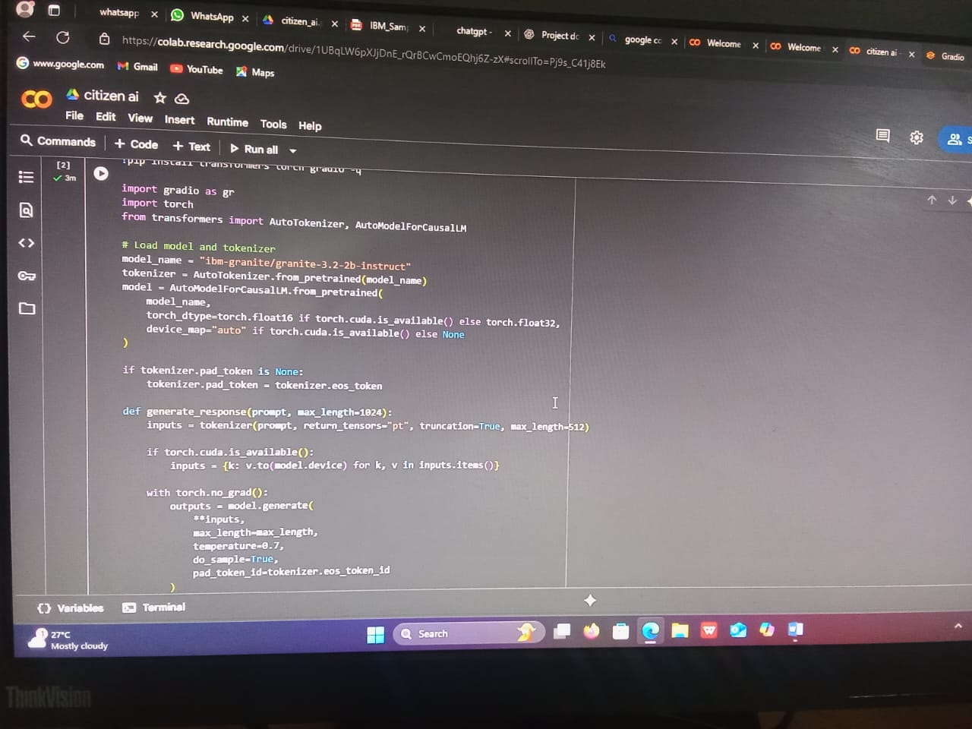

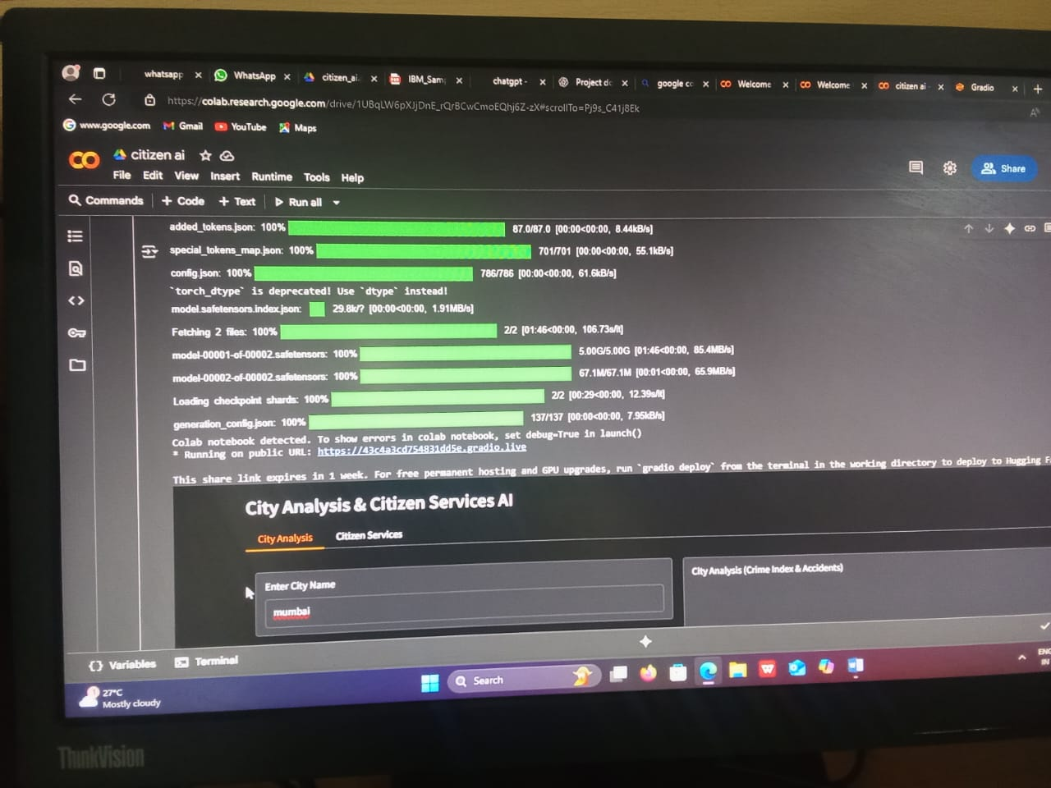

12.Known Issues
- AI sometimes takes longer to respond with large data inputs.
- Occasional errors during document upload.

13.Future Enhancements
- Implement token-based authentication (JWT) for security.
- Add multilingual support for wider reach.

