**CHAITANYA BHARATHI INSTITUTE OF TECHNOLOGY (AUTONOMOUS)**

Accredited by NBA & NAAC, Approved by A.I.C.T.E, Affiliated to Osmania University GANDIPET, HYDERABAD-500075



**SMARTBRIDGE IN COLLABORATION WITH IBM**

**A PROJECT ON**

**SMART PARKING SYSTEM USING IBM WATSON**

**SUBMITTED IN FULFILMENT FOR THE COMPLETION OF**

**SUMMER INTERNSHIP PROGRAM**

**AT**

**SMARTBRIDGE**

**Submitted by**

SUNKARA CHANDANA

KALAKUNTLA SRUTHI

SAI PRIYA V D S BHERI



**CERTIFICATE**

This is to certify that the project “SMART PARKING SYSTEM USING IBM WATSON” is submitted by **Sunkara Chandana** (CBIT, Roll Number: **160117735064**), Kalakuntla Sruthi(BVRIT Hyderabad), Sai Priya V D S Bheri(BVRIT Hyderabad)is a record of original word done, carried out under my supervision and guidance, in the stream of**Internet of Things (IoT)** in SmartBridge Summer Internship Program.

**SUBMITTED TO**

**ANJUSHA RAMANA ANCY JENNIFER**

**ABSTRACT**

The increase in world population, civilization, and development has promoted the need for vehicles for transportation and as a status symbol as well. An increased vehicle production and easy-to-buy scheme has increased the number of vehicles on road. In the metropolitan cities which have a highly active urban life, locating parking spaces in populated areas like shopping malls, exhibitions, etc. has become a cumbersome task leading to wastage of time, increased frustration, congestion and adds to the pollution levels.

Smart Parking Using IBM Watson is a parking system that detects the available parking slots and assists the drivers in finding the nearest parking slot. It is a Real-Time application of Internet of Things which has sensors(ultrasonic sensors) equipped in the parking slots that detect the availability of vacant parking slots. This sensor values are sent to IBM Watson service and are stored in a database. A user interface is created using Node Red through which we can inform the users about the availability of vacant. So forth, reducing the time and energy consumed, in finding a parking slot, hence reduce pollution and optimize the utilization of available space.

**PROBLEM STATEMENT**

Globalization, and increase in population caused a growing need for transportation. With an increased production, and emerging schemes like EMI, purchasing power of people has increased. With limited space and increased number of vehicles, finding a parking slot has become a cumbersome process. Many a times, people travel a lot of unnecessary distance thorough filled parking slots in search for a vacant one, but in vain. This futile process causes frustration, wastage of spaces and time, and add to the already existing pollution level.

**OBJECTIVE OF THE PROJECT**

This project is meant to assist people in finding nearby parking slots in busy and congested places, with ease. It mainly focus on reducing the time in a finding the parking slots, optimise utilization of available space and avoids the unnecessary travelling through filled parking slots in a parking area. It also helps reduce pollution caused due to the unnecessary travel in finding a parking slot.

**DESCRIPTION ABOUT THE PROJECT**

**HARDWARE REQUIREMENS**

1) NodeMCU

2) Ultrasonic Sensor

**NodeMCU**

NodeMCU is an open source IoT platform. It includes firmware which runs on the ESP8266Wi-Fi SoC. It has integrated TCP/IP protocol stack that can give any microcontroller accessto your Wi-Fi network

**ULTRASONIC SENSOR**

As the name indicates, ultrasonic sensors measure distance by using ultrasonic waves. The sensor transmitter emits an ultrasonic wave and receives the wave reflected back from the target using a receiver. Ultrasonic Sensors measure the distance to the target by measuring the time between the emission and reception.

**SOFTWARE REQUIREMENTS**

1)Arduino IDE

2)IBM Watson Cloud Platform

3)Node-RED

4)MIT App Inventor

**ARDUINO**

The Arduino integrated development environment (IDE) is a cross-platform application (for Windows, macOS, Linux) that is written in the programming language Java. It is used to write and upload programs to the physical board.

**IBM WATSON CLOUD PLATFORM**

Powered by the latest innovations in machine learning, Watson is the open, multi-cloud platform that lets you automate the AI lifecycle. Watson on the IBM Cloud allows you to integrate the world&#39;s most powerful AI into your application and store, train and manage your data in the most secure cloud.

**Node-RED**

Node-RED is a programming tool for wiring together hardware devices, APIs and online services in new and interesting ways. It provides a browser-based editor that makes it easy to wire together flows using the wide range of nodes in the palette that can be deployed to its runtime in a single-click.

**MIT APP INVENTOR**

App Inventor for Android is an open-source web application originally provided by Google, and now maintained by the Massachusetts Institute of Technology (MIT), which allows newcomers to computer programming to create software applications for the Android operating system (OS).It uses a graphical interface very similar to Scratch and the StarLogo TNG user interface,which allows users to drag-and-drop visual objects to create an application that can run on Android devices. Data is visualized on the web app (MIT APP INVENTOR) from where people access the information (like distance) using MIT mobile app.

**METHODOLOGY**

In this project, an ultrasonic sensor is used to check the status of the parking slot. . These sensor values are sent to IBM Watson services and these values are stored in the database. A User interface is created by using Node Red through which the users are notified about the availability of parking slots. If an empty slot is found, a message is sent to the driver’s phone number telling the availability of a parking slot.

**OUTPUT SCREENSHOTS**

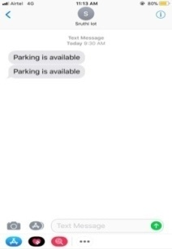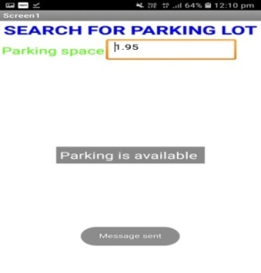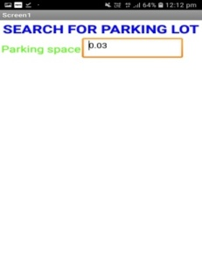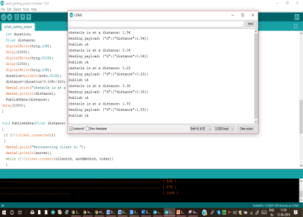

**BLOCK DIAGRAM**

