**EXERCISE1:**

**Question1:**

//var ShuttleName="Determination";

//var ShuttleSpeed=17500;

//var MarsDistance=225000000;

//var MoonDistance=384400;

//var milesperKm=0.621;

let ShuttleName:string="Determination";

let ShuttleSpeed:number=17500;

let MarsDistance:number=225000000;

let MoonDistance:number=384400;

let milesperKm:number=0.621;

console.log("The Shuttle Name is:"+ShuttleName);

console.log("The Shuttle Speed is: "+ShuttleSpeed);

console.log("The distance of the planet Mars: "+MarsDistance);

console.log("Miles per Km: "+milesperKm);

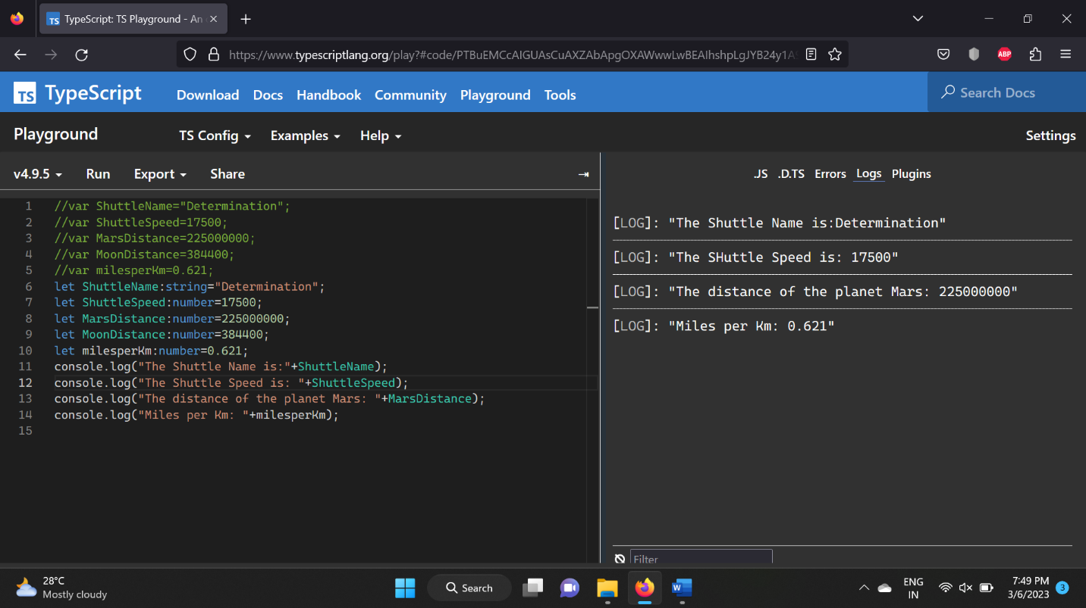

**Question2:**

let VehicleName:string="Yamaha";

console.log("The name of the Vehicle is: "+VehicleName);

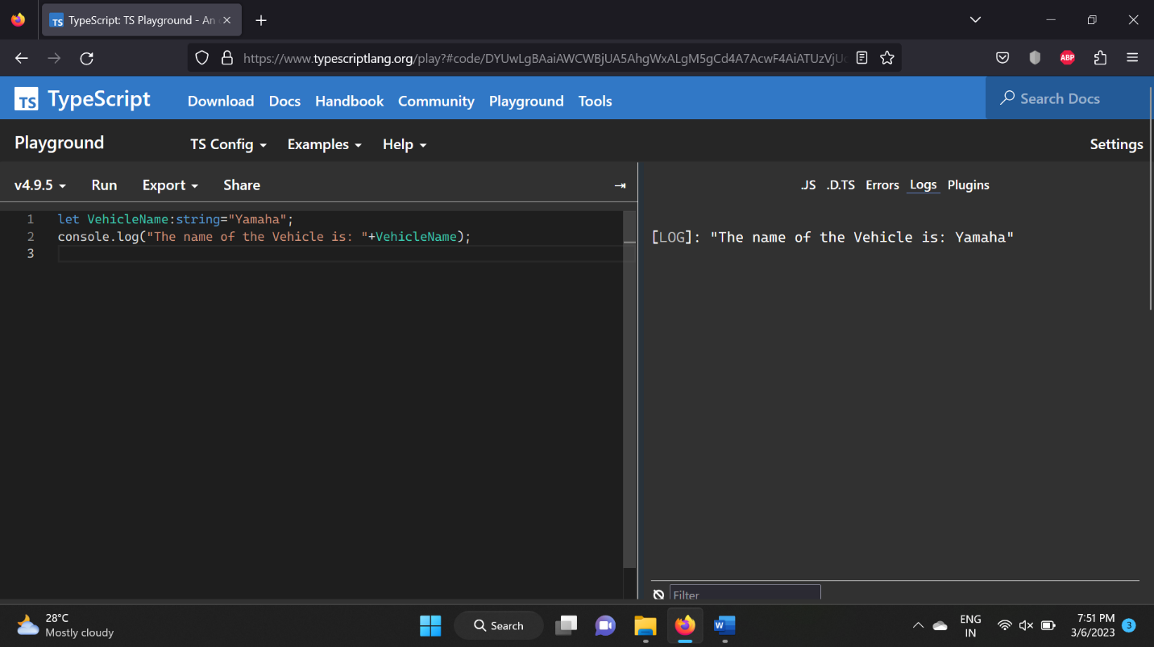

**Question3:**

let cargoHold:string[]=['oxygen tanks','space suits','parrot','instruction manual','meal packs','slinky','security blanket'];

for(var value of cargoHold){

console.log(value);

}

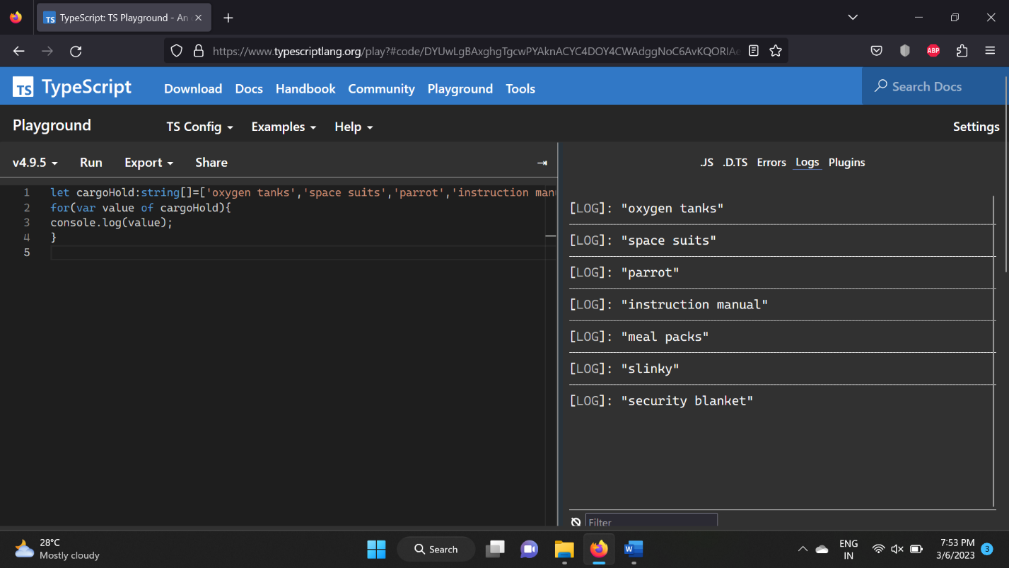

**Question4:**

let element1:any=['hydrogen','H',1.008];

let element2:any=['helium','He',4.003];

let element26:any=['iron','Fe',55.85];

console.log("The element1 is: "+element1);

console.log("The element2 is: "+element2);

console.log("The element26 is: "+element26);

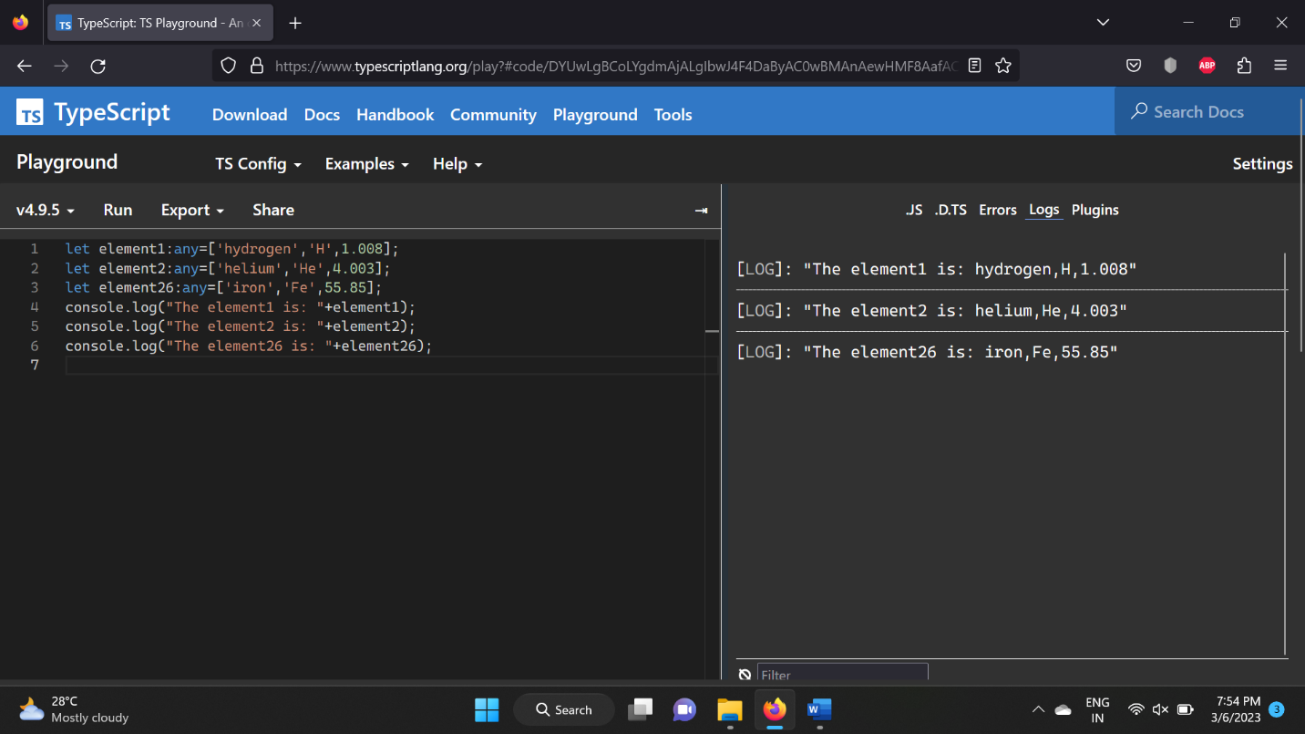

**Question5:**

function myFunction(x:number):number{

return x*2;

}

let value:number=myFunction(5);

console.log("The value of the function is: "+value);

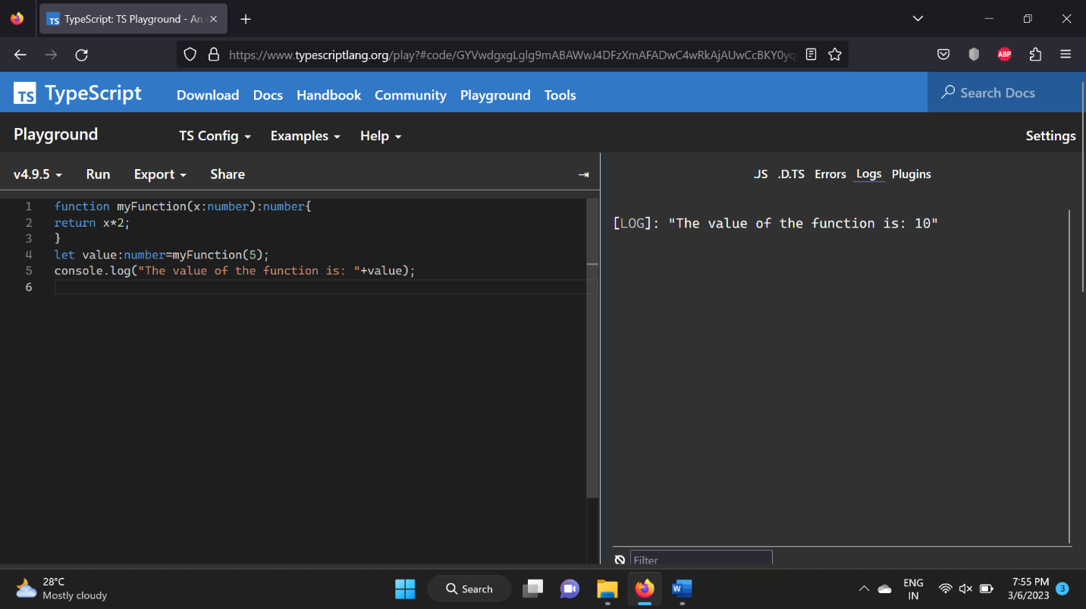

**Question6:**

var myFunction=function(x:number):number{

return x*2;

}

console.log("Implementing anonymous functions, and the outcome is: "+myFunction(2));

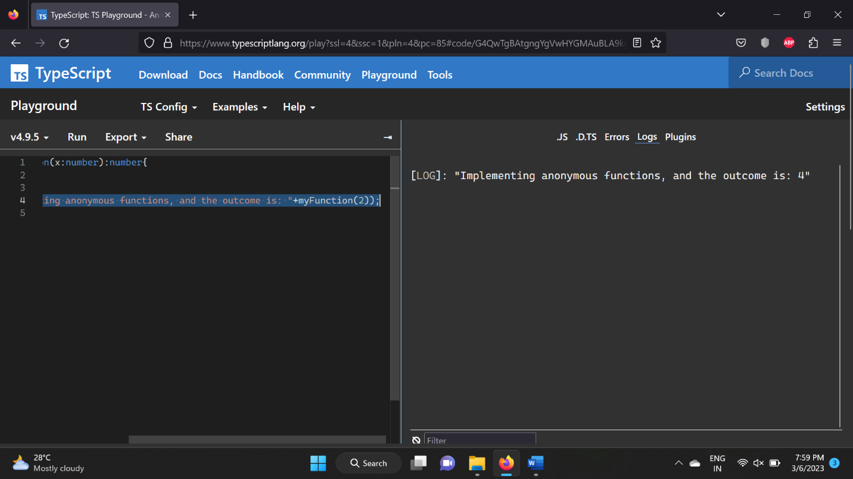

**Question7:**

function myFunction(x:number,y?:number):number{

    if(typeof y=="undefined"){

        return x+5;

    }

    return x+y+5;

}

let val:number=myFunction(1);

let val1:number=myFunction(1,2);

console.log("Passing a single argument: "+val);

console.log("Passing 2 arguments: "+val1);

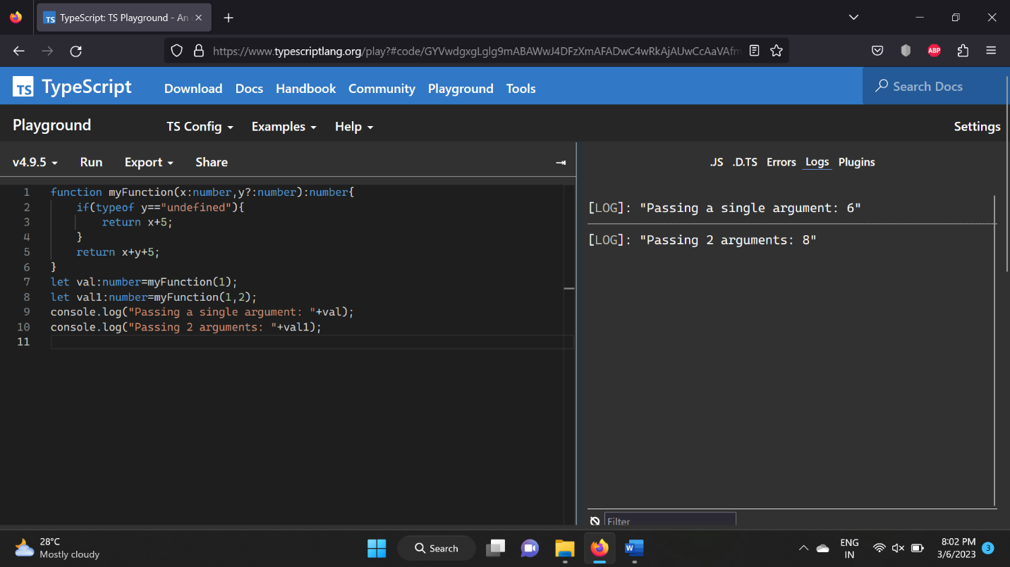

**Question8:**

function isLeap(year:number):boolean{

    if(year%400==0)

    return true;

    if(year%100==0)

    return false;

    if(year%4==0)

    return true;

    return false;

}

console.log("Is 2000 a leap year: "+isLeap(2000));

console.log("Is 1998 a leap year: "+isLeap(1998));

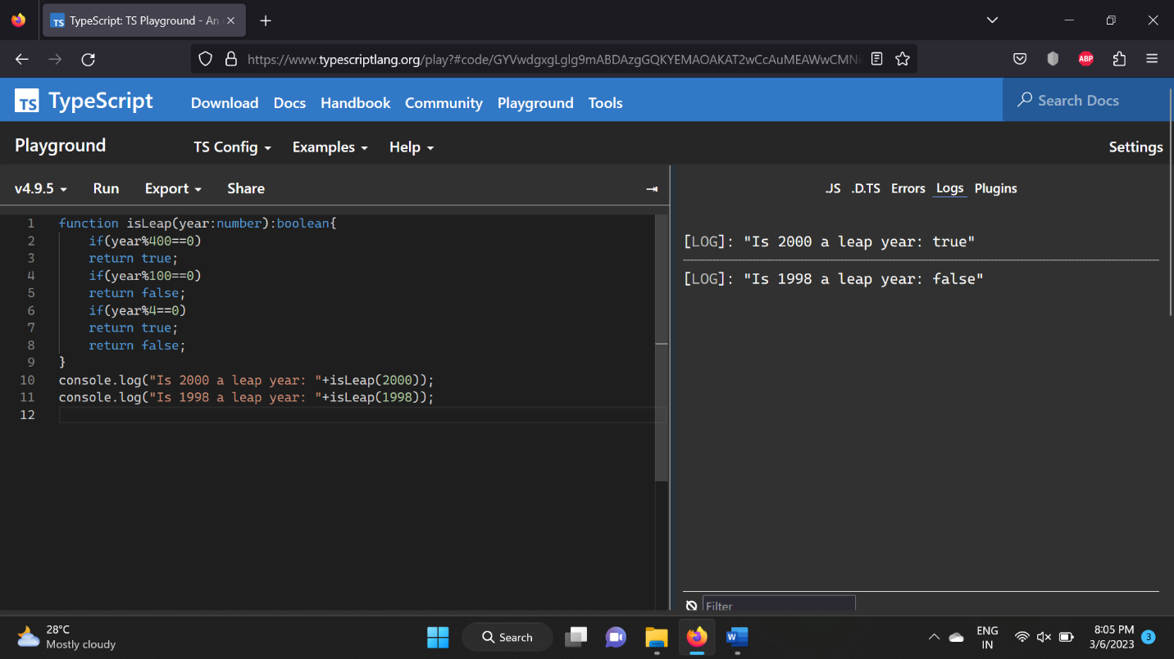

**Question9:**

function myFunction(name:string):string{

    var p="";

    for(var i=name.length-1;i>=0;i--){

        p+=name[i];

    }

    return p;

}

let val:string=myFunction("Madhan");

console.log("The reversed string is: "+val);

