**EXERCISE3:**

**Question1:**

export function returnGreeting(greeting:string){

    console.log("Greetings! "+greeting);

}

**Question2:**

export function returnGreeting():string{

    return "Hey! Greeting for you!!";

}

export function getLength(n:number):string{

    return "Length = "+n;

}

**Question3:**

import * as g1 from "./greetingmodule";

import * as g2 from "./secondgreetingmodule";

g1.returnGreeting("sruthi");

console.log(g2.returnGreeting());

console.log(g2.getLength(23));



**Question4:**

export namespace first{

    export class Train{

        trainID:number;

        trainName:string;

        speed:number;

        constructor(trainID:number,trainName:string,speed:number){

            this.trainID=trainID;

            this.trainName=trainName;

            this.speed=speed;

        }

        coverDistance(hour:number){

            console.log("The train "+this.trainName+" of id "+this.trainID+" has covered a distance of "+hour*this.speed);

        }

    }

    export class Driver{

        driver(){

            console.log("Driver with Train");

        }

    }

}

**Question5:**

import {first} from "./firstNs";

let t=new first.Train(12078,"Jana Shatabdi",30);

let d=new first.Driver();

t.coverDistance(6);

d.driver();

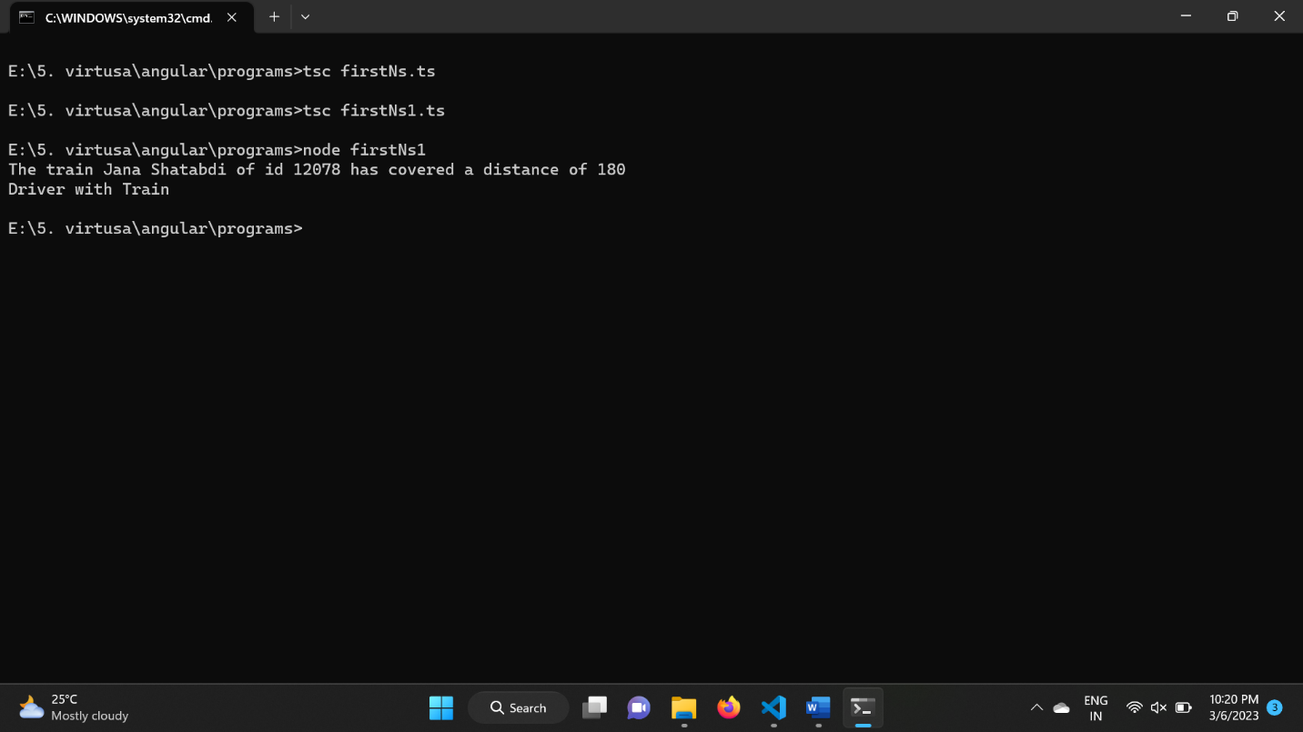

**Question6:**

namespace second{

    export class stadium{

        stadiumName:string;

        city:string;

        capacity:number;

        constructor(stadiumName:string,city:string,capacity:number){

            this.stadiumName=stadiumName;

            this.city=city;

            this.capacity=capacity;

        }

        matchResult(team1Score:number,team2Score:number){

            console.log("The match is in "+this.stadiumName+" stadium situated in a city "+this.city+" with a capacity of "+this.capacity);

            if(team1Score>team2Score){

                console.log("Team A won the match!");

            }

            else if(team2Score>team1Score){

                console.log("Team B won the match!");

            }

            else{

                console.log("Both Teams with simillar score");

            }

        }

    }

}

**Question7:**

///<reference path="./secondNs.ts"/>

let s=new second.stadium("ntr","guntur",200);

s.matchResult(30,50);

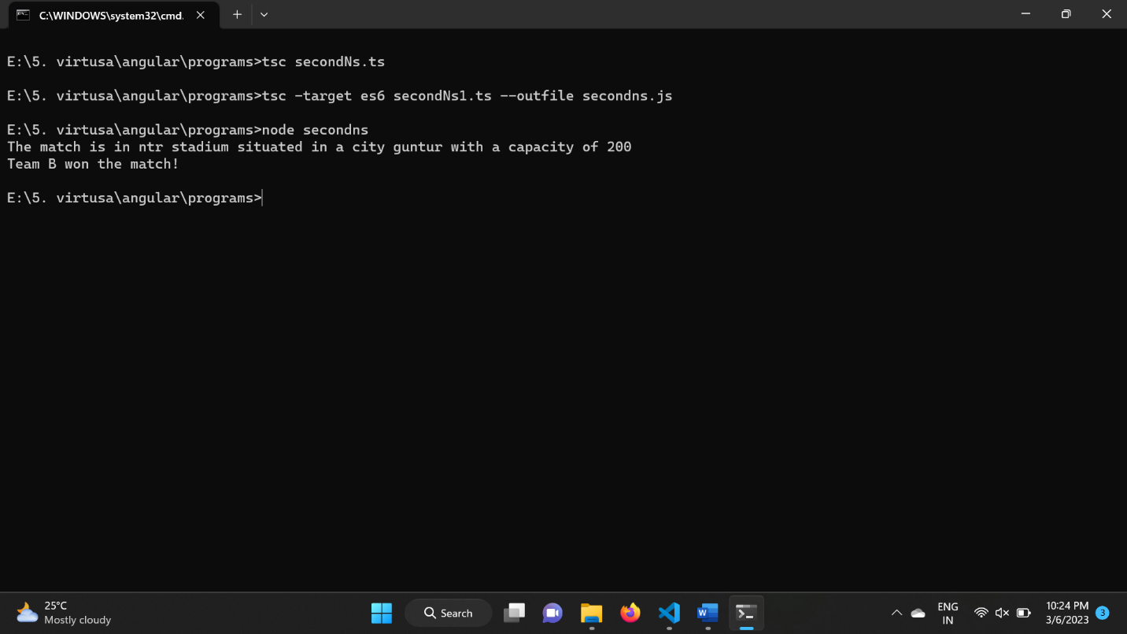

**Question8:**

interface ProcessIdentity<T,U>{

    value:T;

    message:U;

    property():T;

}

**Question9:**

interface ProcessIdentity<T,U>{

    value:T;

    message:U;

    property():T;

}

class callIdentity<X,Y> implements ProcessIdentity<X,Y>{

    value:X;

    message:Y;

    constructor(value:X,message:Y){

        this.value=value;

        this.message=message;

    }

    property():X{

        return this.value;

    }

    message_return():Y{

        return this.message;

    }

}

let g=new callIdentity<number,string>(6,"sruthi");

console.log("The message is: "+g.message_return());

console.log("The value is: "+g.property());

