Exersice 1

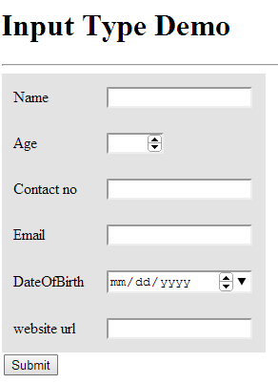

Using Html5 form tags do the following

Name, contact and email fields are manadatory

Name should have only upper case letters

Contact No should be a valid no(start with 6789)

Age must be 20 and 45

Contact must be 10 digits

After Successful form submission it is redirect to facebook page.

Exersice 2

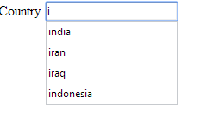

Submit

Design the suggestion box/auto completer