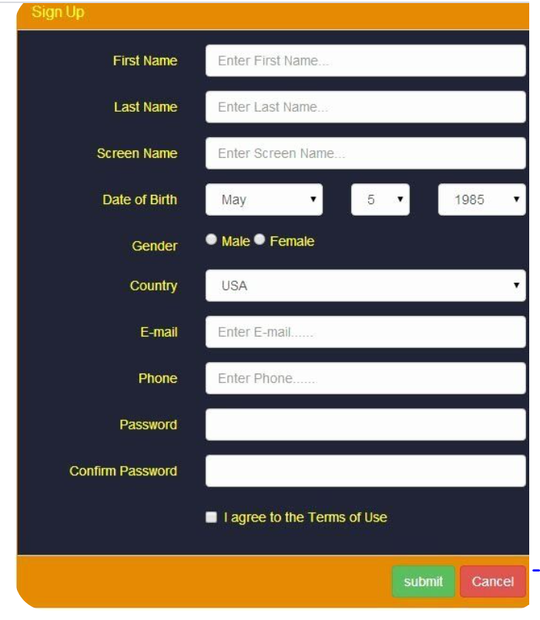

Apply required validations using pattern attribute.