AWS Mini Project
Sruthi Muraleedharan Nair
For this project I built a pipeline where a CSV file gets uploaded to S3, which triggers a Lambda function, and the Lambda reads the file, calculates the total salary spend for India and US, and writes the result to another bucket.
I started by creating two S3 buckets, one for the file upload and one for the final output to be saved.
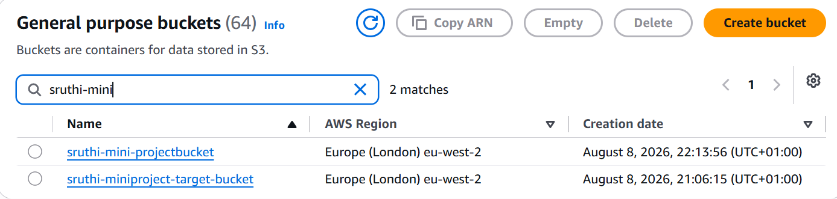
Inside the source bucket I created another folder for the upload.
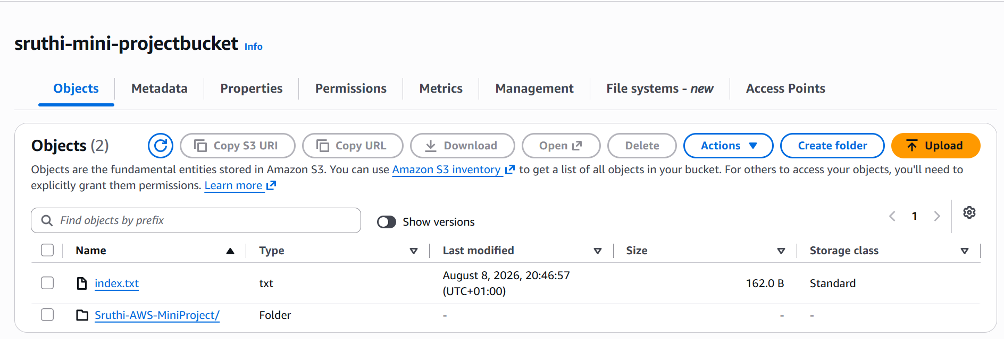
I added a pandas layer since pandas is not available in the default Lambda runtime.
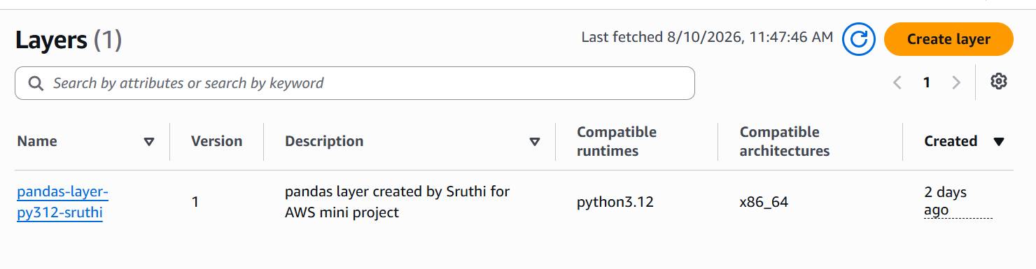
Because of the layer, I was getting a timeout error, so I increased the timeout to 10 seconds so the function had enough time to finish running.
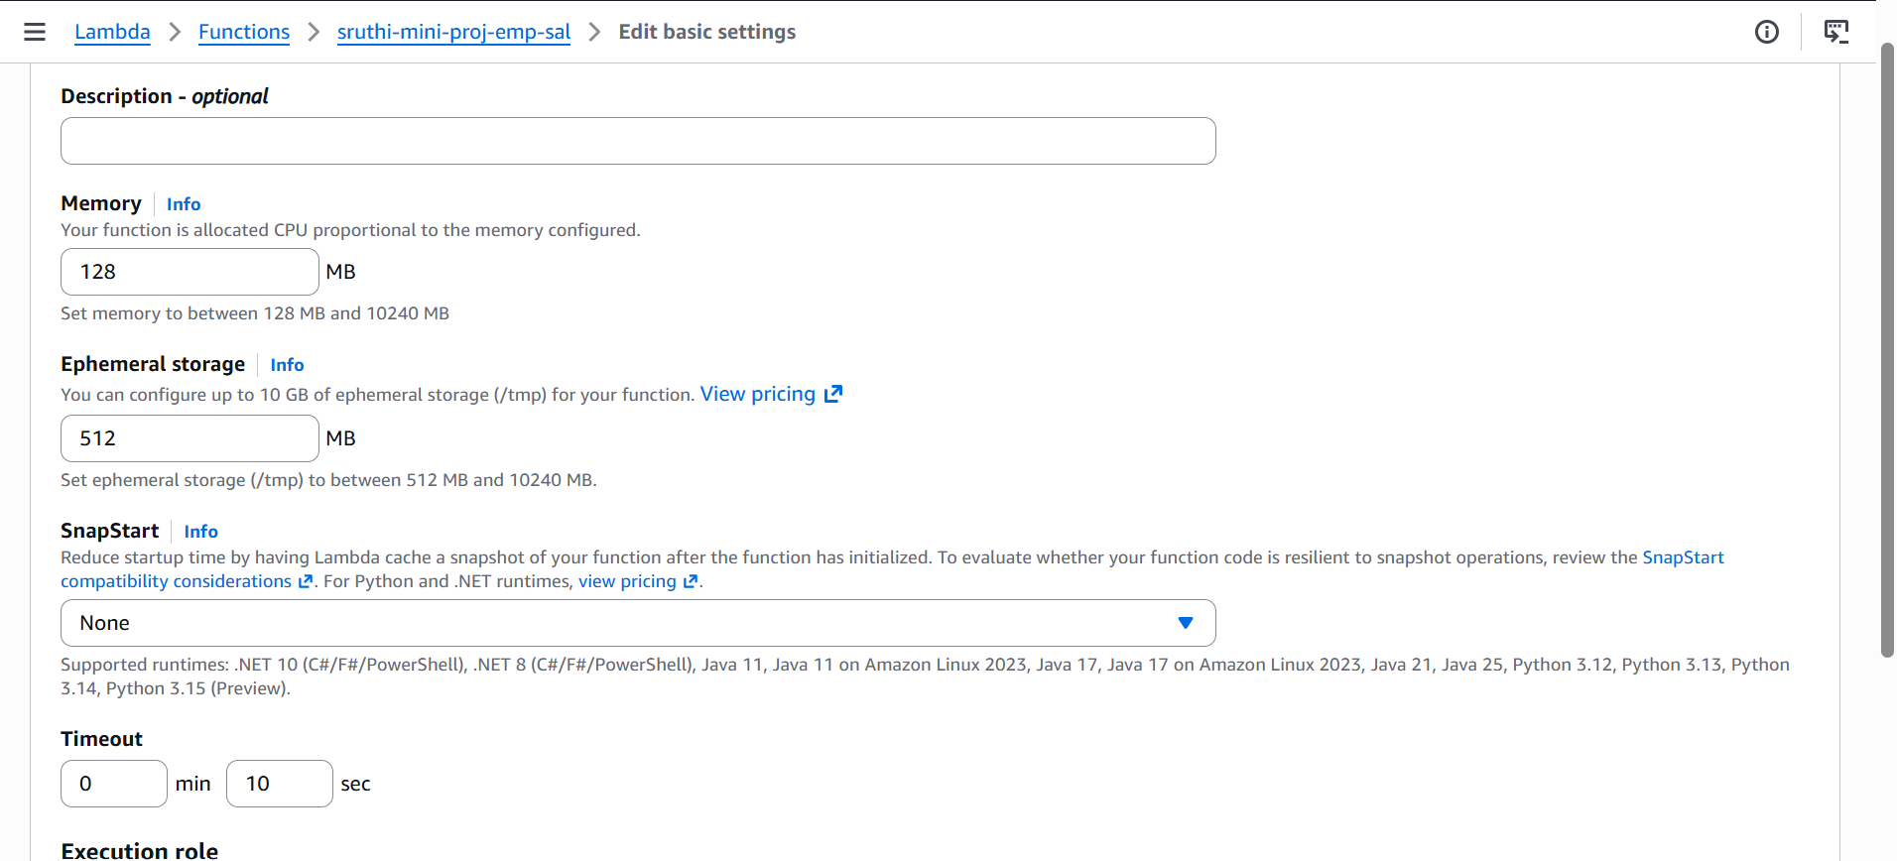
I created the Lambda function using Author from scratch, since the code was already given by Om. On the additional settings, I chose to create a custom execution role, where I gave the Lambda permission for s3:GetObject for the source bucket, scoped to only .csv files, and s3:PutObject for the target bucket. I also made sure AWSLambdaBasicExecutionRole was attached so I could see the CloudWatch logs.
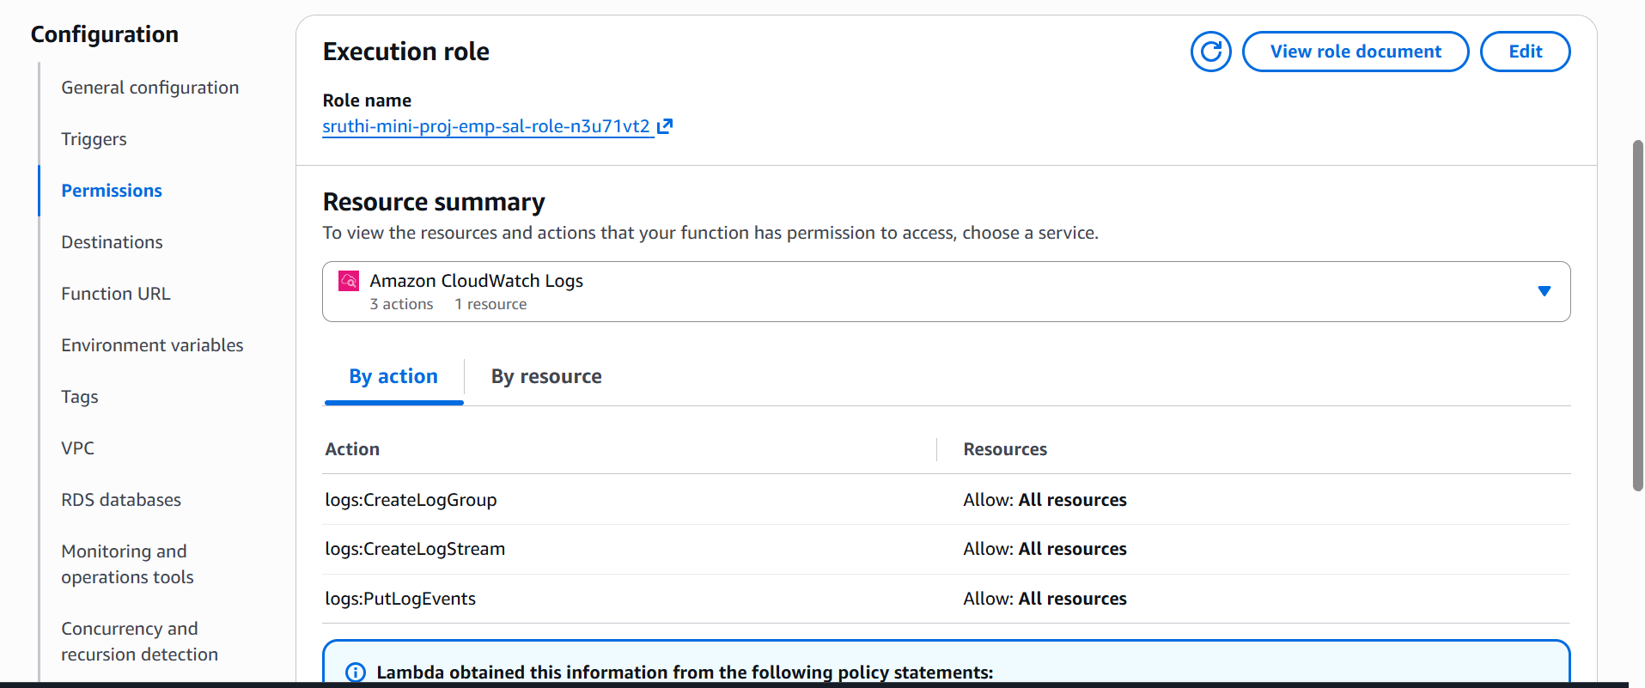
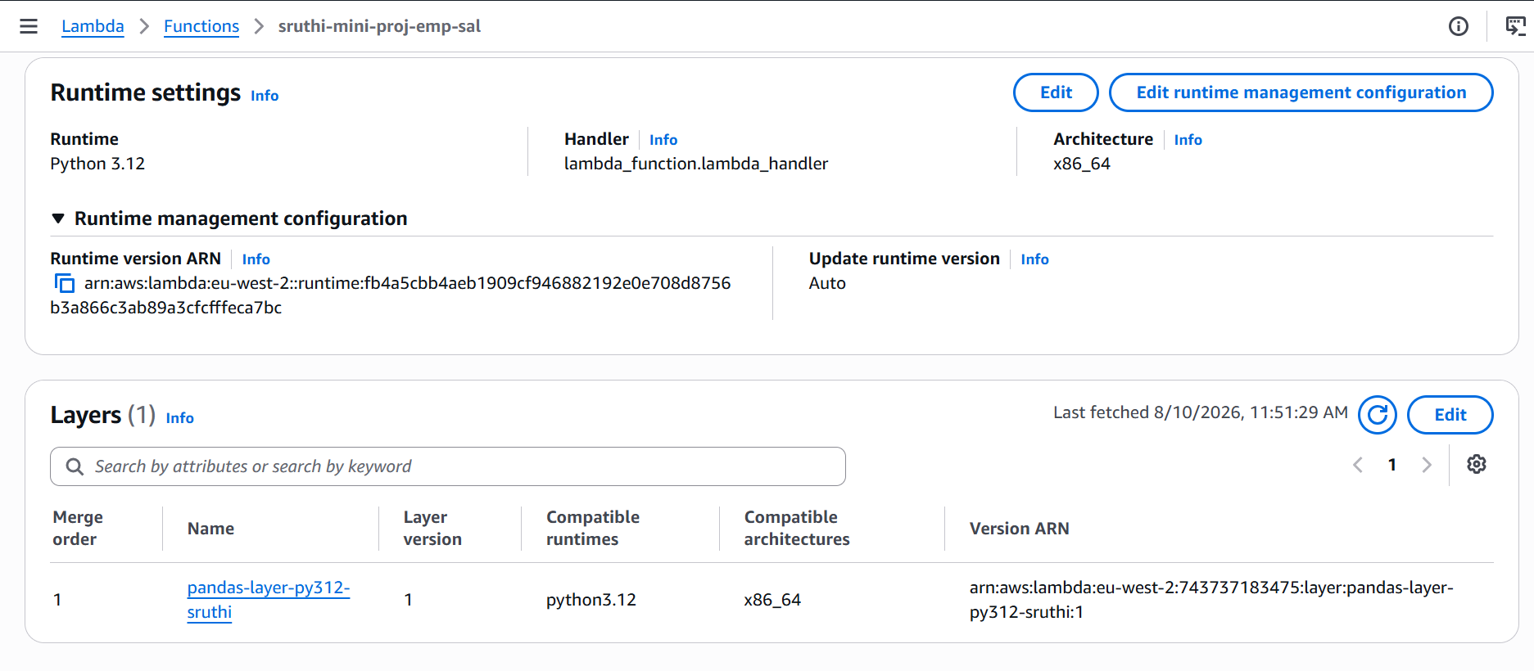
After the Lambda was created, I added the code with the necessary changes, deployed it, and tested it. It ran successfully and picked up the layer and the runtime correctly.
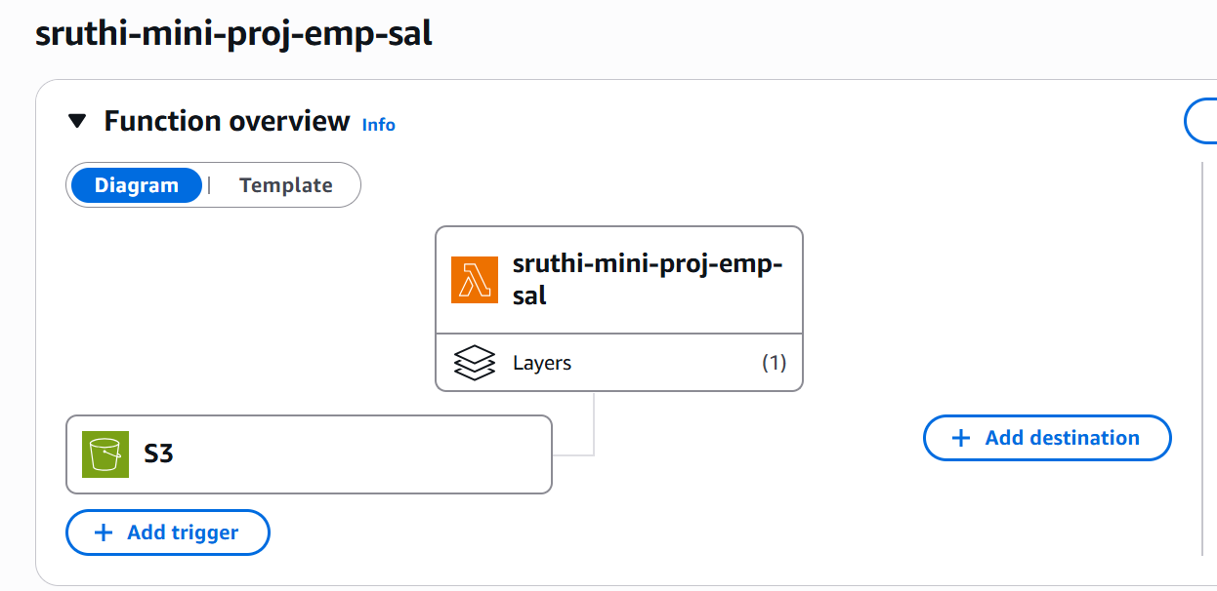
Then I added the trigger on the Lambda page for S3 and gave the source bucket details, so the function runs automatically whenever a file is uploaded.
Finally I checked CloudWatch to confirm the function was running and logging properly.
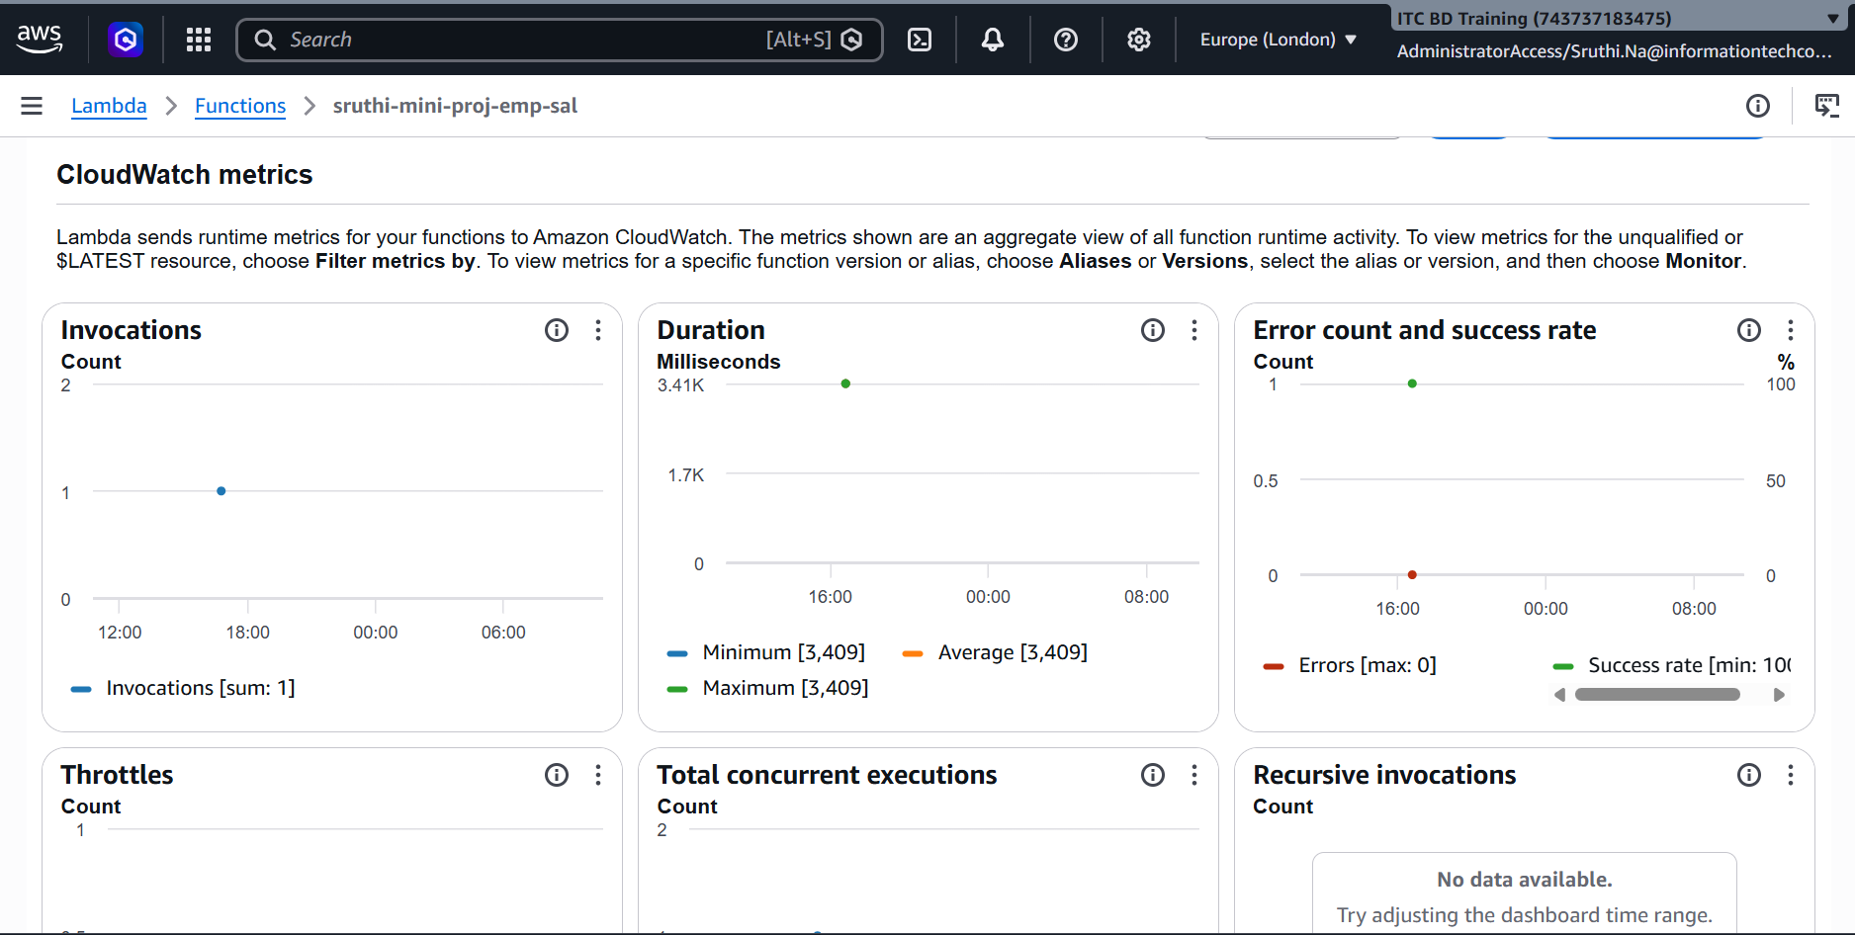
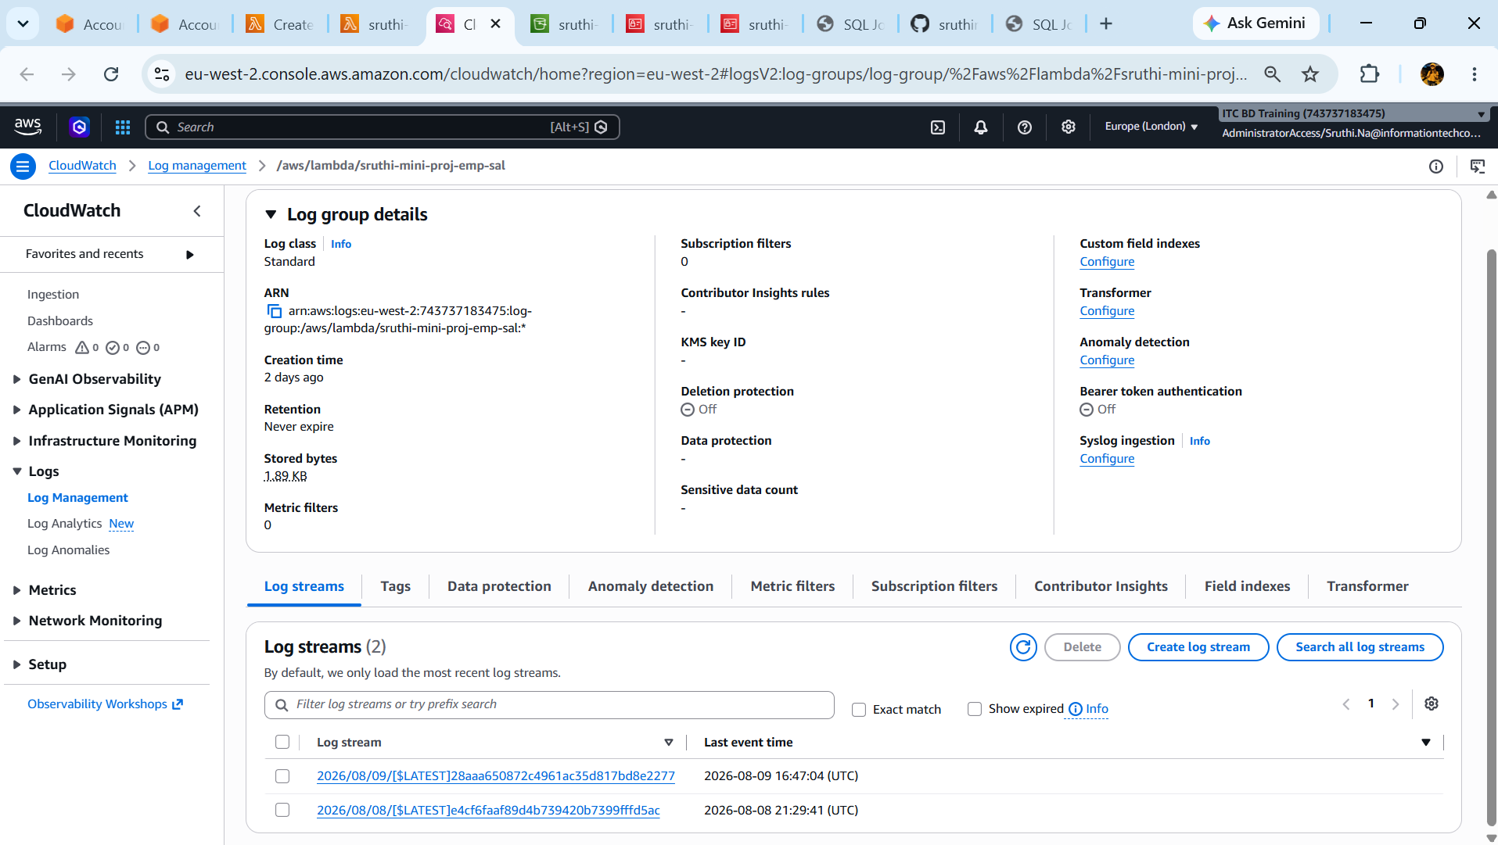
The final Lambda code:
import csv
import json
import boto3
import time
from datetime import datetime

def lambda_handler(event, context):

event_params = event["Records"][0]

bucket = event_params["s3"]["bucket"]["name"]
key = event_params["s3"]["object"]["key"]

print("here")

s3_resource = boto3.resource('s3')
s3_object = s3_resource.Object(bucket, key)

data = s3_object.get()['Body'].read().decode('utf-8').splitlines()

lines = csv.reader(data)
print(lines)
headers = next(lines)
print('headers: %s' % (headers))

list_data = list(lines)

print(list_data)
india = []
us = []
for i in list_data:
if i[3] == 'India':
india.append(int(i[2]))
else:
us.append(int(i[2]))

print('The total India salary spend is ', sum(india))
print('The total US salary spend is ', sum(us))
print(f"""The total India,US salary spend is ,{(sum(india), sum(us))}""")
file_content = f"""total india,us salary spend is ,{(sum(india), sum(us))}"""

target_bucket = 'sruthi-miniproject-target-bucket'
s3 = boto3.client('s3')
s3.put_object(Body=file_content, Bucket=target_bucket, Key='aggregated salary')

return {
'statusCode': 200,
'body': json.dumps('Hello from Lambda!')
}

