Pharma Manufacturing Data Platform
Project Documentation
Azure Data Factory | ADLS Gen2 | Databricks | Snowflake | dbt Cloud | Power BI
Prepared by: Sruthi and Aimun
Data used: synthetic pharmaceutical manufacturing data (2024 to 2025)

1. Problem Statement
A pharmaceutical manufacturer keeps its production, laboratory, equipment and inventory data in four different systems. Each system does its own job well, but they are not connected to each other. Because of this, simple business questions take a long time to answer, for example:
- Which batches had a deviation or failed a quality test?
- Did the equipment show abnormal readings while a failed batch was being made?
- Which products and sites have the most problem batches?
- Which materials are running below the reorder level, and which deliveries are late?
Today someone would have to pull data out of each system and match it by hand in a spreadsheet. That is slow, and the numbers are hard to trust.
Objective. Build one data platform that brings the four sources together, cleans and checks the data, models it into a star schema and shows it in a single Power BI dashboard. The pipeline has to run every night without manual work.

2. Data Sources
The project uses four source systems. Two of them are tables in an Azure SQL database and two arrive as CSV files. The common key across production, lab and sensor data is the batch ID. Inventory is linked through site and product code.
Source | System | What it contains | Arrives as | Rows
MES | Manufacturing Execution System | One record per production batch: site, production line, product, planned and actual quantity, yield, status, deviation flag, start and end time | Azure SQL table (pharma_mes.mes_batches) | 500
LIMS | Laboratory Information Management System | Lab tests done on each batch: test name, result, lower and upper specification limit, lab status, release status | CSV file (lims_results.csv) | 1,015
Historian | Process historian | Sensor readings taken during manufacturing: temperature, pressure, pH and flow rate, with a timestamp | CSV file (historian_readings.csv) | 20,173
ERP | Enterprise Resource Planning | Inventory of materials per site: available quantity, reorder level, supplier, expected delivery date | Azure SQL table (pharma_mes.erp_inventory) | 500

Some facts about the data:
- 4 manufacturing sites: Dublin, Houston, Singapore and Wuxi.
- 12 products in 6 therapy areas (Cardiology, Immunology, Infectious Disease, Neurology, Oncology and Others).
- 7 kinds of lab test: Assay, pH, Impurities, Hardness, Content uniformity, Dissolution and Moisture.
- 3 material types in inventory: API, excipient and packaging.

2.1 Data quality issues found in the sources
The data was not clean. These are the main issues we found and had to handle:
Issue | Details
Orphan records | 15 lab tests and 40 sensor readings refer to a batch that does not exist in MES
Lab status does not match the result | In 18 tests the status recorded by the lab disagrees with the result when compared with the specification limits
Missing product code | 3 batches have no product code
Invalid flag values | 4 batches have a deviation flag that is neither Yes nor No
Mixed date formats | ERP dates came in more than one format
Duplicates | Exact duplicate rows in the raw files

3. Solution Overview
We followed the medallion architecture. Data moves through three layers and each layer has one job:
- Bronze: a raw copy of the source, kept unchanged.
- Silver: cleaned and validated data, one table per source.
- Gold: business tables (facts and dimensions) used for reporting.
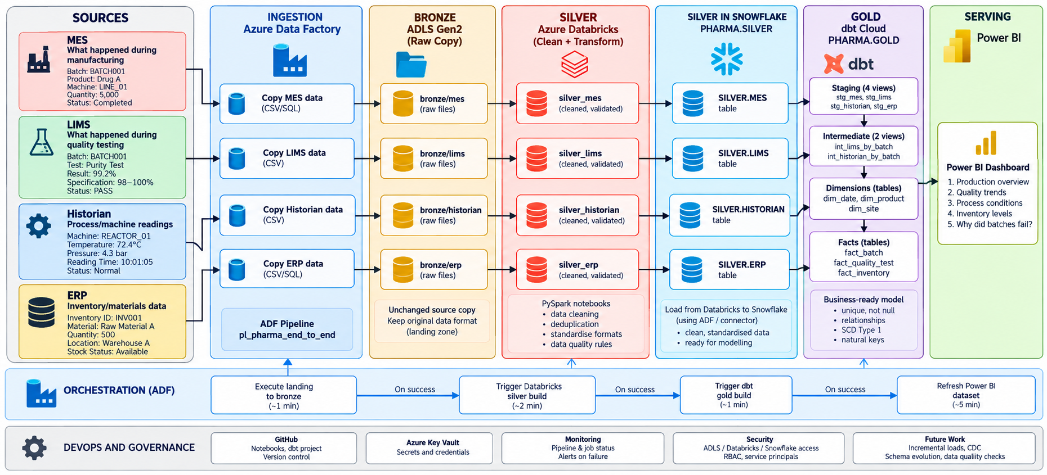
Figure 1: End to end architecture
Tool | Used for
Azure Data Factory (ADF) | Copying data from the sources and running the whole pipeline on a schedule
ADLS Gen2 | Data lake storage for the bronze and silver layers
Azure Databricks | Cleaning and validating the data with PySpark (bronze to silver)
Snowflake | Data warehouse that holds the silver and gold tables
dbt Cloud | Building and testing the gold models with SQL
Power BI | Dashboard
Azure Key Vault | Storing tokens and secrets
GitHub | Version control for ADF, Databricks and dbt code

4. Pipeline Steps

Step 1: Ingestion (source to bronze)
An ADF pipeline called pl_landing_to_bronze has four Copy activities, one per source (cp_mes, cp_lims, cp_historian, cp_erp). MES and ERP are read from the Azure SQL database and LIMS and Historian are read from the CSV files in the landing area.
The data is written to the bronze container in ADLS (bronze/mes, bronze/lims, bronze/historian, bronze/erp) exactly as it is in the source. No cleaning is done at this stage. This way bronze is always a true copy of the source and we can reprocess from it at any time.

Step 2: Cleaning and validation (bronze to silver)
A Databricks job called silver_build runs four PySpark notebooks on serverless compute: silver_mes, silver_lims, silver_historian and silver_erp. silver_mes runs first because the other three check their records against the list of MES batches. After that the remaining three run in parallel.
What the notebooks do:
- Standardise timestamps and date formats.
- Cast columns to the correct data types.
- Remove exact duplicate rows.
- Where a record appears more than once, keep the latest one using a window function.
- Flag orphan records (tests or readings with no matching batch in MES).
- Flag invalid or suspicious values, for example sensor readings outside the accepted range, yield above 100 percent or an end time before the start time.
- Add inventory flags for stock below the reorder level and overdue deliveries.
Problem rows are flagged, not deleted. In a pharma setting the original values have to stay traceable.
Each notebook writes two outputs to the silver container: a Delta table, and a Parquet export in silver/export/ that Snowflake can load.
Databricks reaches ADLS through Unity Catalog (an Access Connector with a managed identity and external locations). No storage keys are kept in the notebooks.

Step 3: Loading silver into Snowflake
Databricks and Snowflake are not connected directly. Snowflake reads the Parquet export from ADLS through an external stage (ADLS_SILVER_STAGE) that has read and list permission only.
A dbt macro called load_silver truncates each table and runs COPY INTO, which loads the four tables PHARMA.SILVER.MES, LIMS, HISTORIAN and ERP.

Step 4: Modelling (silver to gold)
The gold layer is built in dbt Cloud in three stages:
Stage | Models | Purpose
Staging (views) | stg_mes, stg_lims, stg_historian, stg_erp | Select the needed columns, rename them and fix data types
Intermediate (views) | int_lims_by_batch, int_historian_by_batch | Roll lab tests and sensor readings up to one row per batch
Marts (tables) | dim_date, dim_product, dim_site, fact_batch, fact_quality_test, fact_inventory | Final dimension and fact tables in PHARMA.GOLD

Main rules applied in gold:
- fact_batch starts from MES and uses left joins, so a batch is never dropped even if it has no tests or readings.
- Tests and readings are rolled up to batch level before joining. Joining 20,133 readings directly to 500 batches would multiply the rows.
- Orphan tests and readings are left out of gold by joining to MES batches.
- Final quality result: where the lab status and the specification limits disagree, we use the measured value against the limits, keep the original lab status and set a mismatch flag. OOS stays as OOS.
- A batch is marked as a problem batch if it has a deviation or at least one failed test.
Testing. dbt runs 25 tests on every build (8 on the sources and 17 on gold):
Test | What it checks
not_null | Every key column has a value
unique | One row per batch, per test and per dimension key
relationships | Every fact row links to an existing dimension row
accepted_values | quality_result can only be Pass, Fail or OOS
If a test fails the build stops, so wrong data does not reach the dashboard.

Step 5: Orchestration and scheduling
One master pipeline in ADF, pl_pharma_end_to_end, runs all the steps in order:
Activity | Type | What it does
exec_landing_to_bronze | Execute Pipeline | Runs the four copies to bronze
dbx_silver_build | Databricks Job | Runs the silver_build job
web_get_dbt_token | Web (GET) | Reads the dbt token from Key Vault
web_dbt_gold_build | Web (POST) | Calls the dbt Cloud API to start the Gold build job

The activities are connected with on success dependencies, so a step only starts when the one before it has finished successfully. A schedule trigger (tr_daily_pharma) runs the pipeline every day at 4:30 AM UK time. A full run takes about 5 to 7 minutes.

Step 6: Security
- The Databricks and dbt tokens are stored in Azure Key Vault. ADF reads them at run time with its managed identity, which has read only access.
- dbt connects to Snowflake in production with a service user (DBT_SERVICE) and key pair authentication, not a password.
- The Snowflake stage uses a SAS token limited to read and list.
- No password or token is stored in the pipeline code or in GitHub.

Step 7: Version control and deployment
All code is kept in one GitHub repository with three folders: /adf, /databricks/silver and /dbt. Changes are made on a branch and merged into main through a pull request. For dbt, a CI job runs on each pull request, builds the changed models in a temporary schema and runs their tests. Production jobs always run the code in main.

Step 8: Reporting
Power BI connects to Snowflake and imports only the dimension and fact tables from PHARMA.GOLD. The dashboard is described in section 6.

5. Star Schema Design
The gold layer is a star schema with three fact tables that share three dimensions. Because the dimensions are shared, the dashboard can filter batches, tests and inventory by the same product, site and date.
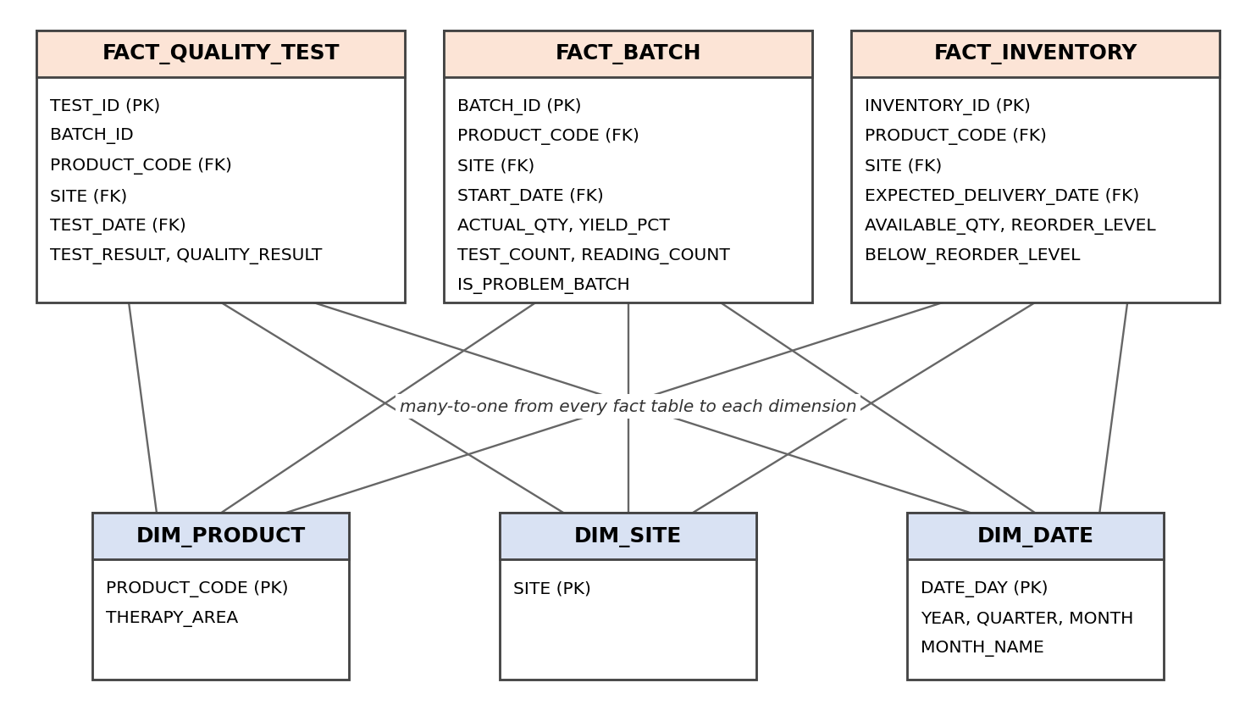
Figure 2: Star schema in PHARMA.GOLD

5.1 Dimension tables
Table | Key | Main columns | Notes
dim_product | PRODUCT_CODE | THERAPY_AREA | 12 products
dim_site | SITE | - | 4 sites
dim_date | DATE_DAY | YEAR, QUARTER, MONTH, MONTH_NAME, WEEK_OF_YEAR, DAY_OF_WEEK | 731 days, 1 Jan 2024 to 31 Dec 2025, generated in Snowflake

The dimensions use natural keys (product code and site name). The source gives only the current values with no history, so this was enough and kept the model simple.

5.2 Fact tables
Table | Grain | Main columns | Rows
fact_batch | One row per production batch | BATCH_ID, PRODUCT_CODE, SITE, PRODUCTION_LINE, START_DATE, END_DATE, PLANNED_QTY, ACTUAL_QTY, YIELD_PCT, BATCH_STATUS, DEVIATION_FLAG, TEST_COUNT, FAILED_TEST_COUNT, HAS_QUALITY_FAILURE, READING_COUNT, ABNORMAL_READING_COUNT, AVG_TEMPERATURE, AVG_PRESSURE, AVG_PH, AVG_FLOW_RATE, IS_PROBLEM_BATCH | 500
fact_quality_test | One row per lab test | TEST_ID, BATCH_ID, PRODUCT_CODE, SITE, TEST_DATE, TEST_NAME, TEST_RESULT, LOWER_SPEC_LIMIT, UPPER_SPEC_LIMIT, RESULT_STATUS, CALCULATED_STATUS, STATUS_MISMATCH, QUALITY_RESULT | 1,000
fact_inventory | One row per inventory item | INVENTORY_ID, MATERIAL_ID, MATERIAL_NAME, MATERIAL_TYPE, PRODUCT_CODE, SITE, AVAILABLE_QTY, REORDER_LEVEL, EXPECTED_DELIVERY_DATE, SUPPLIER, BELOW_REORDER_LEVEL, DELIVERY_OVERDUE | 500

5.3 Relationships
From (fact) | Column | To (dimension) | Type
fact_batch | PRODUCT_CODE | dim_product | Many to one
fact_batch | SITE | dim_site | Many to one
fact_batch | START_DATE | dim_date | Many to one
fact_quality_test | PRODUCT_CODE | dim_product | Many to one
fact_quality_test | SITE | dim_site | Many to one
fact_quality_test | TEST_DATE | dim_date | Many to one
fact_inventory | PRODUCT_CODE | dim_product | Many to one
fact_inventory | SITE | dim_site | Many to one
fact_inventory | EXPECTED_DELIVERY_DATE | dim_date | Many to one

fact_batch also has END_DATE, which links to dim_date as an inactive relationship in Power BI. It is only used inside measures when needed. fact_quality_test keeps BATCH_ID so a test can be traced back to its batch.

5.4 Design decisions
- Lab tests and sensor readings are summarised into fact_batch (test count, failed test count, reading count, abnormal reading count and averages). This gives one complete row per batch without duplicating batches.
- Where a batch has no tests or readings, the counts are set to 0 but the averages are left empty. An average of 0 would be wrong information.
- Sensor readings are not kept as a separate fact in gold, because the dashboard only needs them at batch level.

6. Dashboard and Results
The Power BI report (Pharma Manufacturing Control Tower) has one page covering production, quality, process and supply risk. It can be filtered by year, quarter, month, product and site.
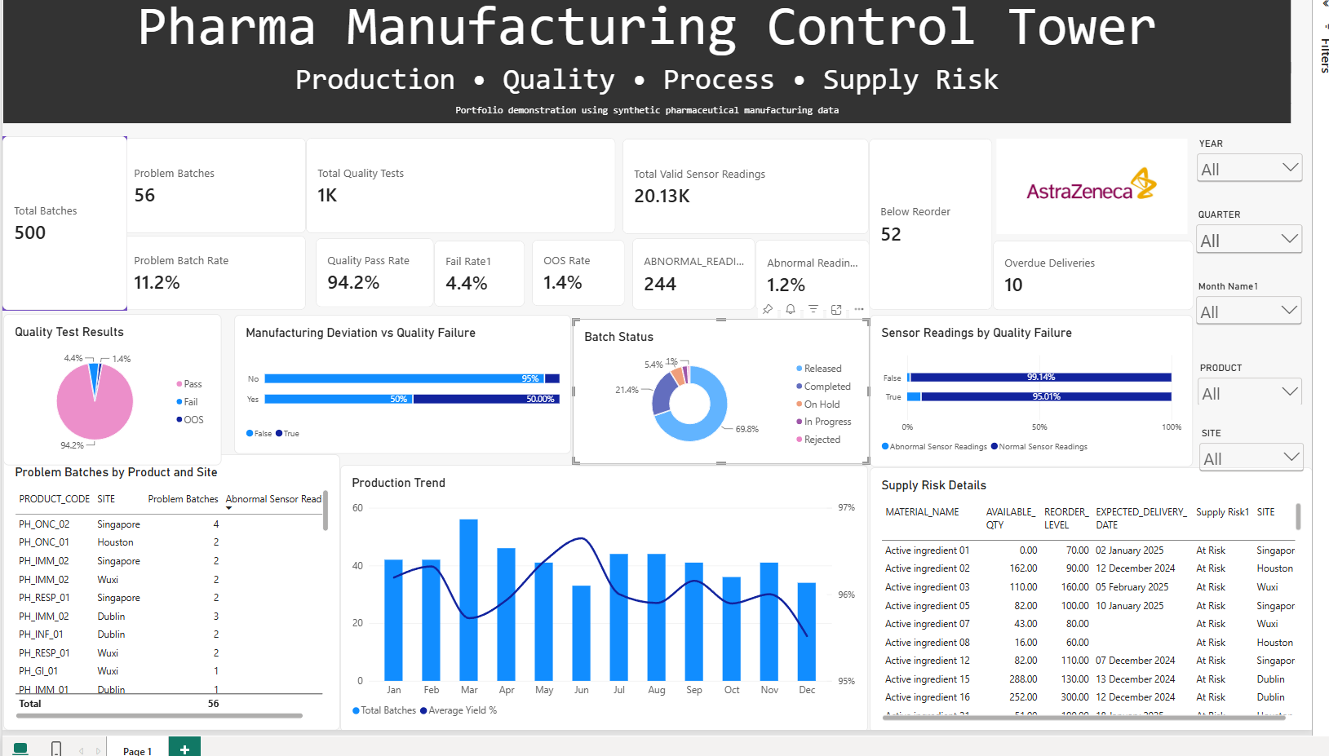
Figure 3: Power BI dashboard
Measure | Value
Total batches | 500
Problem batches | 56 (11.2%)
Total quality tests | 1,000
Quality pass rate | 94.2% (Fail 4.4%, OOS 1.4%)
Valid sensor readings | 20,133
Abnormal readings | 244 (1.2%)
Materials below reorder level | 52
Overdue deliveries | 10

What the dashboard shows:
- Batches with a deviation fail quality far more often than normal batches (about 50% against about 5%).
- Batches that failed quality have a higher share of abnormal sensor readings (about 5% against 0.9%).
- The table of problem batches by product and site shows where to look first.

6.1 Validation
We checked the gold tables against the sources to make sure nothing was lost or counted twice:
- fact_batch has 500 rows and 500 distinct batch IDs.
- The test counts in fact_batch add up to 1,000, which is 1,015 source tests minus the 15 orphans.
- The reading counts add up to 20,133, which is 20,173 source readings minus the 40 orphans.
- Problem batches: 28 with a deviation + 42 with a quality failure - 14 with both = 56.

7. Limitations and Future Improvements
Current limitation | Planned improvement
Every run reloads all the data (full refresh) | Load only new and changed records at each layer
ADF starts the dbt job but does not wait for the result | Poll the dbt API and fail the pipeline if the dbt run fails
No alert is sent when the pipeline fails | Email or Teams notification on failure
Rejected and flagged records are not reviewed in a set process | Quarantine tables and a review step for the quality team
Tests cover keys and relationships only | Add business rule tests such as sensor ranges and date order
A change in source columns is not handled automatically | Schema evolution checks and dbt model contracts
Snowflake stage uses a SAS token that expires | Snowflake storage integration
Databricks is called with a personal access token | Service principal

