Deadlock Prevention Strategy Simulator

1. Cover Page
Field | Details
Project title | Deadlock Prevention Strategy Simulator
Unit / topic | Unit 4 – Deadlock
Course | Operating Systems (Mini Project)
Course code | 702CO1C002
Group number | 4
Member 1 (name – roll no.) | Sruthi Patro , C067
Member 2 (name – roll no.) | Vijay Sarath , C072
Member 3 (name – roll no.) | Ravi Sagar – C031
Faculty name | Wasiha Tasneem

3. Abstract
Deadlock occurs when a set of processes each hold a resource while waiting for another held by a member of the set, so none can proceed. This project builds a Deadlock Prevention Strategy Simulator that demonstrates how deadlock is avoided by making at least one of the necessary conditions impossible. It implements three prevention techniques: eliminating Hold-and-Wait through all-at-once resource allocation, eliminating No Preemption through a preemption policy, and eliminating Circular Wait through ordered resource acquisition. A common process and resource model runs the same workload with no prevention and with each strategy, and a wait-for graph detector confirms whether a deadlock forms. The simulator records deadlocks detected, average waiting time, resource utilisation, throughput and starvation counts. Results show that the unprotected run deadlocks on the test workload, while each strategy prevents deadlock at a different cost: lower utilisation for Hold-and-Wait prevention, rollback overhead for preemption, and restricted request order for resource ordering.

4. Introduction

4.1 Background
In a multiprogrammed system, processes compete for a limited set of resources such as printers, files, memory blocks and locks. If each process in a group holds one resource and waits for another held by a different member of the group, no process can proceed. This state is called deadlock. It wastes resources, stalls work and usually needs outside intervention to resolve.
An operating system has four broad ways to deal with deadlock: prevention, avoidance, detection with recovery, and ignoring it (the ostrich approach). Prevention is the most conservative: it designs the system so that deadlock cannot occur.

4.3 Problem Statement
Design and implement a simulator that applies deadlock prevention techniques targeting the Hold-and-Wait, No Preemption and Circular Wait conditions, runs identical workloads with and without each technique, detects whether deadlock occurs, and reports comparative performance metrics.

4.4 Objectives
- Model processes, resources and their allocation state.
- Implement one prevention strategy per Coffman condition (Hold-and-Wait, No Preemption, Circular Wait).
- Detect deadlock through a wait-for graph so every run is verifiable.
- Compare strategies on deadlock occurrence, waiting time, utilisation, throughput and starvation.
- Provide a simple interface for entering workloads and viewing step-by-step execution.

5. Related Concepts / Theory
Deadlock can arise only if all four Coffman conditions hold at the same time. Prevention breaks at least one of them permanently.

5.1 The four necessary conditions
Condition | Meaning | Prevention idea
Mutual exclusion | A resource can be used by only one process at a time | Make resources sharable where possible (not always feasible, so not targeted here)
Hold and wait | A process holds resources while waiting for more | Request all resources at once, or release everything before requesting more
No preemption | Resources cannot be forcibly taken from a process | Allow the OS to preempt resources from a waiting process
Circular wait | A closed chain of processes each waits for the next one's resource | Number resource types and require requests in increasing order

5.2 Prevention strategies implemented
Strategy A – Hold-and-Wait prevention. A process must request every resource it will need before it starts, and it runs only when all are granted (all-or-nothing). A variant lets a process request more only after releasing everything it holds. Cost: low resource utilisation, since resources sit idle, and possible starvation of processes needing many resources.
Strategy B – No-Preemption prevention. If a process requests a resource that is unavailable, all resources it currently holds are implicitly released (preempted) and it restarts the request later with the full set. Alternatively, the OS preempts the needed resource from a waiting holder. Cost: lost work and rollback, and it suits only resources whose state can be saved and restored, such as CPU registers or memory.
Strategy C – Circular-Wait prevention. Every resource type gets a unique number, and a process may request resources only in increasing order of that number. A cycle would need at least one process to request a lower-numbered resource, which the rule forbids. Cost: the ordering must be chosen carefully and may not match how programs naturally need resources.

5.3 Detection with a wait-for graph
To verify each run, the simulator builds a wait-for graph: each node is a process, and an edge P → Q means P waits for a resource held by Q. A cycle in this graph is a deadlock when every resource has a single instance. The simulator finds cycles with depth-first search.

5.4 Related approaches (for context)
Deadlock avoidance (for example the Banker's algorithm) grants a request only if the system stays in a safe state. It needs advance knowledge of maximum demand and is outside the scope of this project, but it is the natural point of comparison with prevention.

6. System Design

6.1 Architecture
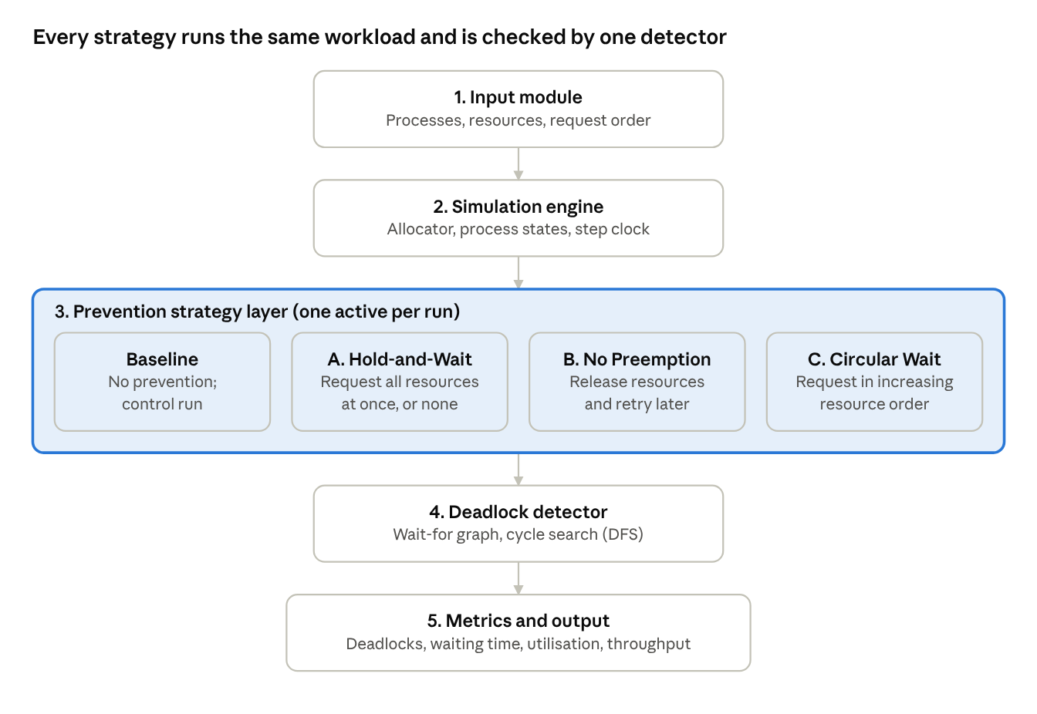
simulator architecture · 5 modules, 4 strategy options
Each run takes one workload through one strategy. The detector checks the outcome after every step, and the metrics module records it.

6.2 Modules
Module | Responsibility
Input module | Reads processes, resource types and each process's ordered request and release sequence, from a file or the interface
Simulation engine | Advances a step clock, grants or blocks requests, and tracks process states (ready, running, waiting, finished)
Strategy layer | Applies the selected rule (none, A, B or C) before an allocation is granted
Deadlock detector | Builds the wait-for graph after each step and runs depth-first search to find a cycle
Metrics and output | Logs events, computes metrics, and prints the step trace and a comparison table

6.3 Flow of control
- Load the workload and select a strategy (or the baseline).
- At each step, a process issues its next request or release.
- The strategy layer checks the request: A grants all resources together or none; B releases the process's held resources when it would block; C rejects a request that breaks the resource order.
- The engine grants, blocks or rolls back the request accordingly.
- The detector builds the wait-for graph and searches for a cycle. A cycle marks a deadlock.
- Steps repeat until every process finishes or a deadlock or timeout ends the run, and then metrics are computed.

6.4 Assumptions
- Resources are non-sharable, so mutual exclusion always holds.
- Each resource type has a single instance, so a wait-for cycle means deadlock.
- Time is discrete, and each process issues at most one request per step.
- For Strategies A and C, each process declares its full resource need and request order in advance.
- A preempted process restarts from the beginning of its request sequence.
- A process that waits longer than a fixed threshold is counted as starved.

7. Implementation

7.1 Tools and language
Item | Choice
Language | Python 3
Interface | Command-line menu (optional Tkinter view for the step trace)
Libraries | Standard library only for the simulator; matplotlib for result graphs
Version control | Git

7.2 Project structure
deadlock_simulator/
├── main.py # menu, runs workload under chosen strategy
├── models.py # Process and Resource classes
├── engine.py # step clock, allocation, process states
├── strategies/
│ ├── hold_wait.py # Strategy A
│ ├── no_preemption.py # Strategy B
│ └── circular_wait.py # Strategy C
├── detector.py # wait-for graph and cycle search
├── metrics.py # metrics and comparison table
├── workloads/ # sample input files
└── README.md

7.3 Key code
Data model. Each process keeps an ordered request list and the set of resources it holds. Each resource records its owner.
class Process:
def __init__(self, pid, requests):
self.pid = pid
self.requests = requests # ordered list of resource ids to acquire
self.held = set()
self.state = "READY" # READY, RUNNING, WAITING, FINISHED
self.waiting_for = None
class Resource:
def __init__(self, rid):
self.rid = rid # also the number used by Strategy C
self.owner = None
Strategy A – Hold-and-Wait prevention. The process gets every resource it needs in one atomic step, or none. While it waits, it holds nothing.
def request_all_or_nothing(proc, resources):
needed = set(proc.requests)
if all(resources[r].owner is None for r in needed):
for r in needed:
resources[r].owner = proc.pid
proc.held.add(r)
return True
return False # waits while holding nothing
Strategy B – No-Preemption prevention. If the next resource is busy, the process gives up everything it holds and restarts its request sequence.
def request_with_release(proc, r, resources):
if resources[r].owner is None:
resources[r].owner = proc.pid
proc.held.add(r)
return True
for h in list(proc.held): # preempt the process's own holdings
resources[h].owner = None
proc.held.clear()
proc.rollbacks += 1 # counted as lost work in the metrics
return False
Strategy C – Circular-Wait prevention. A request for a resource numbered lower than one already held is rejected, so a cycle cannot form.
def request_in_order(proc, r, resources):
if proc.held and r < max(proc.held):
return "REJECTED" # breaks the resource-numbering rule
if resources[r].owner is None:
resources[r].owner = proc.pid
proc.held.add(r)
return "GRANTED"
return "BLOCKED"
Deadlock detector. A wait-for graph is built from the waiting processes, and depth-first search looks for a back edge.
def build_wait_for(processes, resources):
g = {p.pid: set() for p in processes}
for p in processes:
if p.state == "WAITING":
owner = resources[p.waiting_for].owner
if owner is not None:
g[p.pid].add(owner)
return g
def has_cycle(g):
WHITE, GREY, BLACK = 0, 1, 2
colour = {p: WHITE for p in g}
def dfs(p):
colour[p] = GREY
for q in g[p]:
if colour[q] == GREY:
return True
if colour[q] == WHITE and dfs(q):
return True
colour[p] = BLACK
return False
return any(colour[p] == WHITE and dfs(p) for p in g)

7.4 Explanation
The engine calls the active strategy function for each request and updates process states from its return value. After each step it rebuilds the wait-for graph and calls has_cycle. In the baseline run no strategy filters requests, so the detector is what reveals the deadlock. In the three strategy runs it should never fire, which is the property the simulator tests.

8. Results & Discussion
The baseline run deadlocks on the test workload, and each strategy avoids the deadlock at a different cost. Cells marked [measure] are for your own values from the simulator runs; the deadlock outcomes follow directly from the workload.

8.1 Test workload
Three processes and three single-instance resources form the classic circular wait.
Process | Request order
P1 | R1, then R2
P2 | R2, then R3
P3 | R3, then R1
Without prevention, each process acquires its first resource and then blocks on the second: P1 waits for P2, P2 waits for P3 and P3 waits for P1. The detector reports the cycle P1 → P2 → P3 → P1.

8.2 Comparison of strategies
Metric | Baseline | A: Hold-and-Wait | B: No Preemption | C: Circular Wait
Deadlock occurs | Yes (P1 → P2 → P3 → P1) | No | No | No
Average waiting time (steps) | [measure] | [measure] | [measure] | [measure]
Resource utilisation (%) | [measure] | [measure] | [measure] | [measure]
Throughput (processes finished per 100 steps) | [measure] | [measure] | [measure] | [measure]
Rollbacks | 0 | 0 | [measure] | 0
Starved processes | [measure] | [measure] | [measure] | [measure]
Once the values are filled in, add a bar graph of waiting time and utilisation per strategy (matplotlib output) directly below this table.

8.4 Edge cases tested
- A single process with no competition.
- A process that requests a resource it already holds.
- More processes than resources.
- A process that needs every resource (starvation risk under Strategy A).
- A process with an empty request list.
- The workload scaled up to a large number of processes, to see how waiting time and rollbacks grow.

8.5 Discussion
Strategy | Main cost | Where it shows in the results
A: Hold-and-Wait | Resources sit idle while a process waits for its full set | Lower utilisation, longer waiting time, starvation of large requests
B: No Preemption | Work is lost when a process gives up its resources and restarts | Rollback count, and possible repeated restarts (livelock) without back-off
C: Circular Wait | Requests must follow the resource numbering | Some requests are rejected or reordered, so programs may need to acquire resources earlier than natural
Strategy C is the cheapest to run because it needs no rollback and no advance reservation, but it depends on a fixed numbering. Strategy A is the simplest to reason about but wastes the most resources. Strategy B suits resources whose state can be saved and restored, and is a poor fit for printers or files mid-write.

9. Conclusion & Future Scope

9.1 Conclusion
The simulator shows that deadlock can be prevented by breaking any one of the Hold-and-Wait, No Preemption or Circular Wait conditions, and that each choice trades safety for a different cost. A single workload, a common engine and a wait-for graph detector make the three strategies directly comparable, and the detector confirms that the baseline deadlocks while the prevention runs do not.

9.2 Limitations
- Resources are single-instance, so cycle detection is enough to identify deadlock.
- Mutual exclusion is not targeted, since most resources cannot be made sharable.
- Workloads are scripted rather than drawn from a real system.

10. References
- A. Silberschatz, P. B. Galvin and G. Gagne, Operating System Concepts, Wiley (chapter on deadlocks).
- A. S. Tanenbaum and H. Bos, Modern Operating Systems, Pearson (chapter on deadlocks).
- W. Stallings, Operating Systems: Internals and Design Principles, Pearson (chapter on concurrency: deadlock and starvation).
- E. G. Coffman, M. J. Elphick and A. Shoshani, "System Deadlocks", ACM Computing Surveys, vol. 3, no. 2, 1971.
- Python Software Foundation, Python 3 documentation, https://docs.python.org/3/

