PYTHON PROGRAMMING
CASE STUDIES
10 Programs with Algorithms, Pseudocode, Source Code,
Test Cases and Neat Flowcharts

Name | ____________________________
Class / Section | ____________________________
Roll Number | ____________________________

CONTENTS
- Program 1: Student Marks Calculation and Result System
- Program 2: Electricity Bill Calculation System
- Program 3: Simple Banking System
- Program 4: Employee Salary Calculation System
- Program 5: Mobile Data Plan Cost Calculation System
- Program 6: Mobile Data Plan Cost Calculation System (Alternative Case Study)
- Program 7: Retail Shopping Discount Calculation System
- Program 8: Student Attendance Eligibility System
- Program 9: Password Validation System
- Program 10: Water Tank Management System
Note: Programs 5 and 6 are similar mobile data plan examples, as provided in the original material.

PROGRAM 1

Student Marks Calculation and Result System

Problem Statement
Develop a Python program that accepts marks in three subjects, calculates the total and average, and displays whether the student has passed or failed.

Objectives
- Accept marks in three subjects.
- Calculate total and average marks.
- Check whether the student passed or failed.
- Display the total, average, and result.

Assumptions
- There are three subjects, each carrying 100 marks.
- Minimum passing mark is 35 in each subject.
- The student passes only if all three subject marks are 35 or more.

Algorithm
- Start.
- Input marks in three subjects.
- Calculate total = m1 + m2 + m3.
- Calculate average = total / 3.
- Check whether all three marks are at least 35.
- Display Pass if true; otherwise display Fail.
- Display total and average.
- Stop.

Flowchart
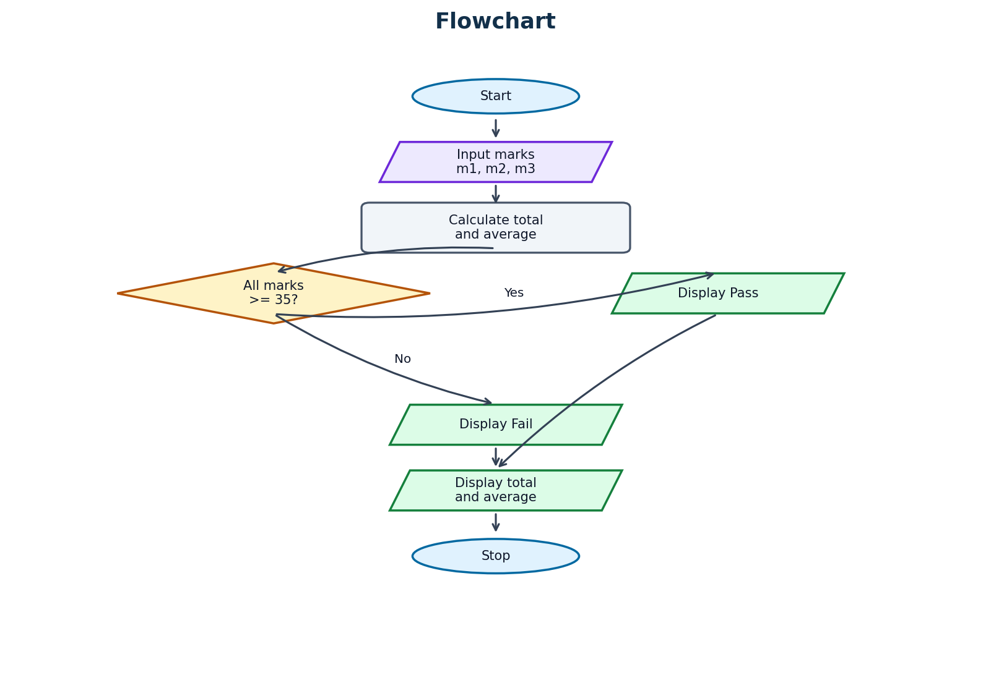

Pseudocode
START
Input m1, m2, m3
total = m1 + m2 + m3
average = total / 3
Display total and average
IF m1 >= 35 AND m2 >= 35 AND m3 >= 35
Display "Pass"
ELSE
Display "Fail"
STOP

Python Source Code
m1 = int(input("Enter marks in subject 1: "))
m2 = int(input("Enter marks in subject 2: "))
m3 = int(input("Enter marks in subject 3: "))
total = m1 + m2 + m3
average = total / 3
print("Total Marks:", total)
print("Average:", average)
if m1 >= 35 and m2 >= 35 and m3 >= 35:
print("Result: Pass")
else:
print("Result: Fail")

Test Cases
Test Case | Input | Expected Output
Pass | m1 = 80, m2 = 75, m3 = 90 | Total Marks: 245 | Average: 81.67 | Result: Pass
Fail | m1 = 80, m2 = 30, m3 = 90 | Total Marks: 200 | Average: 66.67 | Result: Fail

Output Screenshots
Run the program in Python IDLE, VS Code, or another Python compiler. Capture the output for each test case and paste the screenshots in this space.
Screenshot space: ______________________________________________

Conclusion
The system calculates total and average marks and displays the Pass or Fail result. It demonstrates arithmetic operations, input/output, and conditional statements.

PROGRAM 2

Electricity Bill Calculation System

Problem Statement
Develop a Python program that accepts electricity units consumed and calculates the bill using different rates for different unit ranges.

Objectives
- Accept electricity units.
- Apply the correct rate for each unit range.
- Calculate and display the electricity bill.

Assumptions
- First 100 units cost ₹2 per unit.
- Units 101–200 cost ₹3 per unit.
- Units above 200 cost ₹5 per unit.
- Units should be zero or positive.

Algorithm
- Start.
- Input electricity units.
- If units <= 100, bill = units * 2.
- Else if units <= 200, bill = 100 * 2 + (units - 100) * 3.
- Otherwise, bill = 100 * 2 + 100 * 3 + (units - 200) * 5.
- Display the bill.
- Stop.

Flowchart
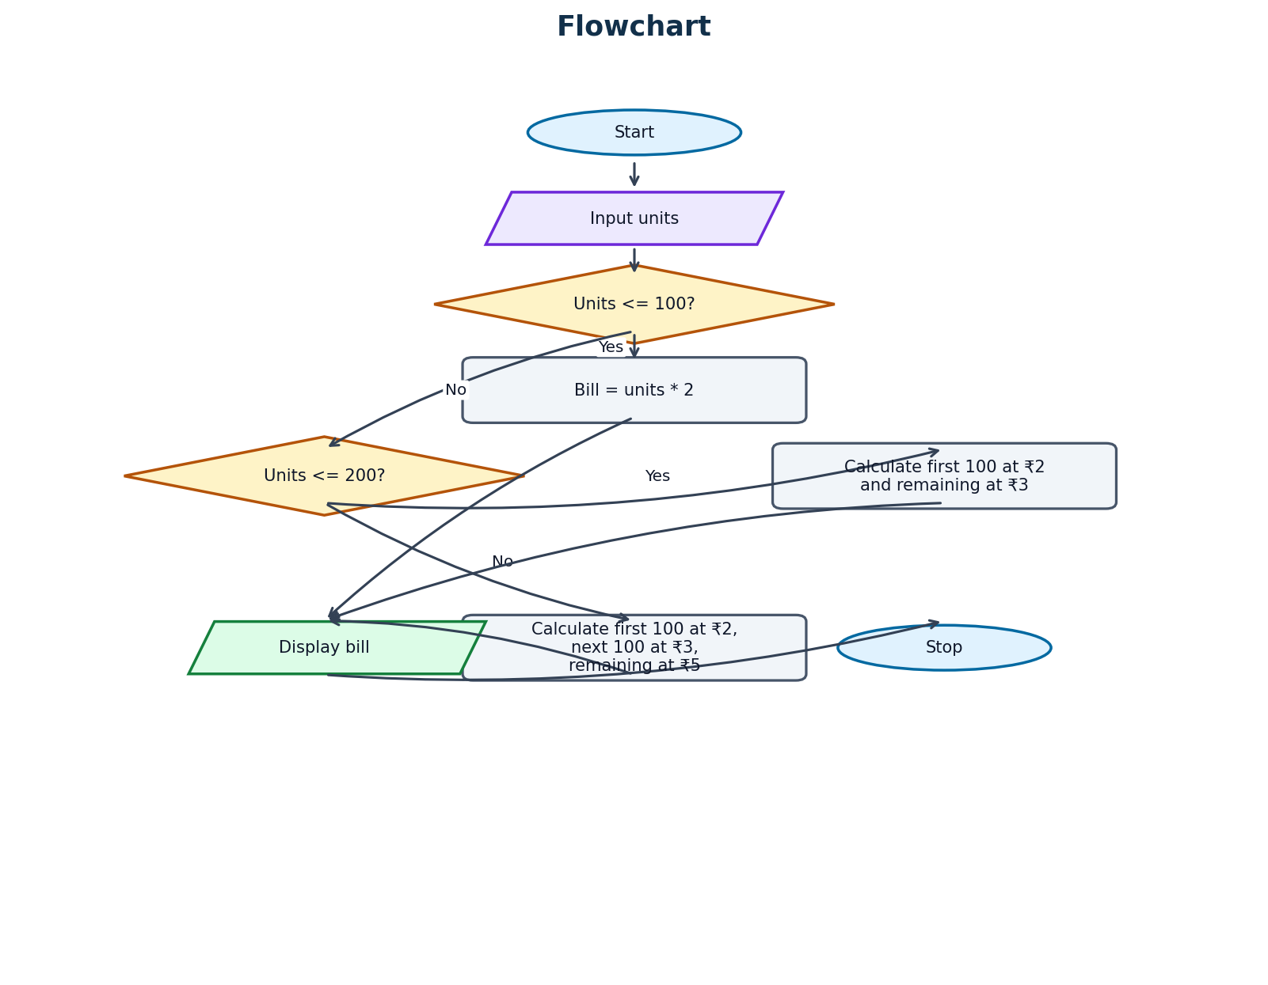

Pseudocode
START
Input units
IF units <= 100
bill = units * 2
ELSE IF units <= 200
bill = 100 * 2 + (units - 100) * 3
ELSE
bill = 100 * 2 + 100 * 3 + (units - 200) * 5
Display bill
STOP

Python Source Code
units = int(input("Enter electricity units: "))
if units <= 100:
bill = units * 2
elif units <= 200:
bill = 100 * 2 + (units - 100) * 3
else:
bill = 100 * 2 + 100 * 3 + (units - 200) * 5
print("Electricity Bill: Rs.", bill)

Test Cases
Test Case | Input | Expected Output
Test 1 | 80 units | Electricity Bill: Rs. 160
Test 2 | 150 units | Electricity Bill: Rs. 350
Test 3 | 250 units | Electricity Bill: Rs. 650

Output Screenshots
Run the program in Python IDLE, VS Code, or another Python compiler. Capture the output for each test case and paste the screenshots in this space.
Screenshot space: ______________________________________________

Conclusion
The system calculates electricity charges according to the units consumed. It demonstrates if, elif, and else statements and arithmetic operations.

PROGRAM 3

Simple Banking System

Problem Statement
Develop a Python program that allows a customer to deposit money, withdraw money, and view the account balance.

Objectives
- Start with an initial balance.
- Accept a deposit or withdrawal choice.
- Update the balance when the transaction is valid.
- Display the final balance.

Assumptions
- Initial balance is ₹5,000.
- Deposit and withdrawal amounts should be positive.
- Withdrawal is allowed only when sufficient balance is available.

Algorithm
- Start and set balance = 5000.
- Display Deposit and Withdraw options.
- Input choice and amount.
- If choice is 1, add amount to balance.
- If choice is 2, subtract amount only if amount <= balance; otherwise display Insufficient Balance.
- For any other choice, display Invalid Choice.
- Display balance.
- Stop.

Flowchart
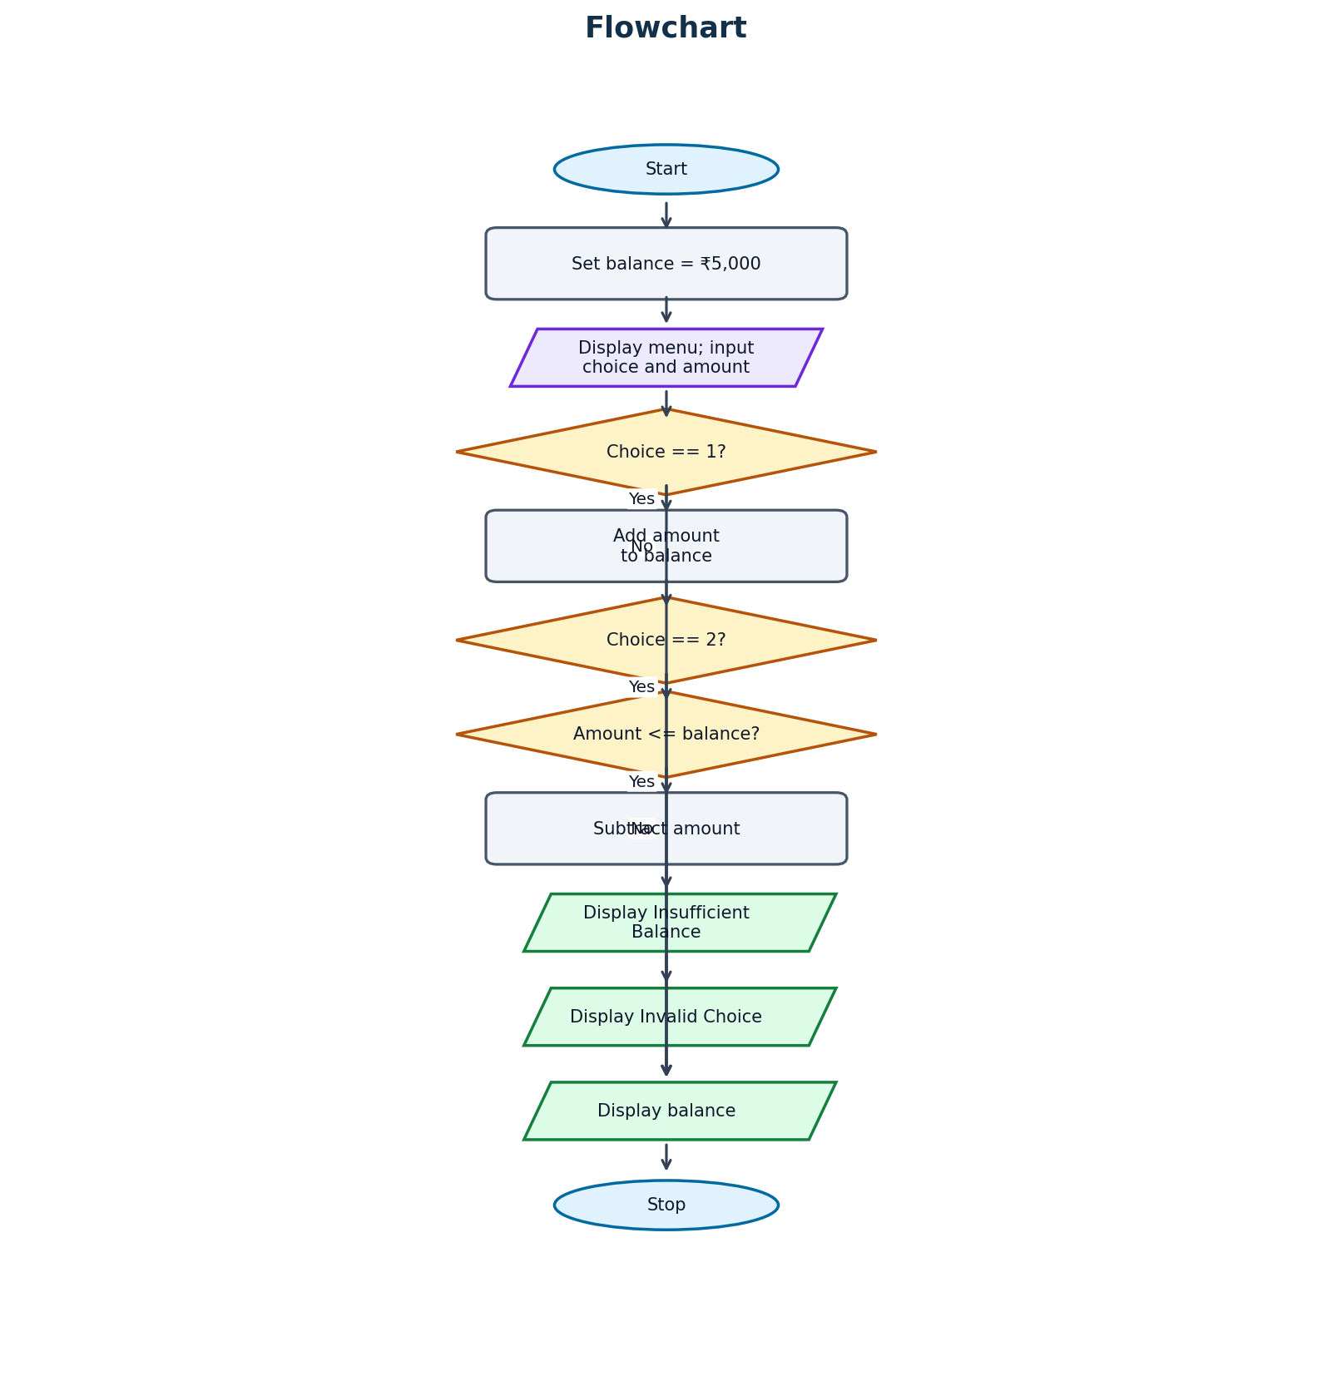

Pseudocode
START
balance = 5000
Display "1. Deposit" and "2. Withdraw"
Input choice and amount
IF choice == 1
balance = balance + amount
ELSE IF choice == 2
IF amount <= balance
balance = balance - amount
ELSE
Display "Insufficient Balance"
ELSE
Display "Invalid Choice"
Display balance
STOP

Python Source Code
balance = 5000
print("1. Deposit")
print("2. Withdraw")
choice = int(input("Enter your choice: "))
amount = int(input("Enter amount: "))
if choice == 1:
balance += amount
elif choice == 2:
if amount <= balance:
balance -= amount
else:
print("Insufficient Balance")
else:
print("Invalid Choice")
print("Balance: Rs.", balance)

Test Cases
Test Case | Input | Expected Output
Deposit | choice = 1, amount = 2000 | Balance: Rs. 7000
Withdraw | choice = 2, amount = 1000 | Balance: Rs. 4000
Insufficient balance | choice = 2, amount = 6000 | Insufficient Balance | Balance: Rs. 5000

Output Screenshots
Run the program in Python IDLE, VS Code, or another Python compiler. Capture the output for each test case and paste the screenshots in this space.
Screenshot space: ______________________________________________

Conclusion
The banking program performs basic deposit and withdrawal operations and checks the available balance. It demonstrates input, arithmetic, and nested conditional statements.
Note: This is a basic banking example. A more complete version should reject zero or negative transaction amounts.

PROGRAM 4

Employee Salary Calculation System

Problem Statement
Develop a Python program that accepts an employee's basic salary and calculates HRA, DA, and gross salary.

Objectives
- Accept the basic salary.
- Calculate HRA and DA.
- Calculate and display gross salary.

Assumptions
- HRA is 20% of basic salary.
- DA is 10% of basic salary.
- Gross salary = basic salary + HRA + DA.
- Basic salary should be positive.

Algorithm
- Start.
- Input basic salary.
- Calculate HRA = basic * 0.20.
- Calculate DA = basic * 0.10.
- Calculate gross = basic + HRA + DA.
- Display HRA, DA, and gross salary.
- Stop.

Flowchart
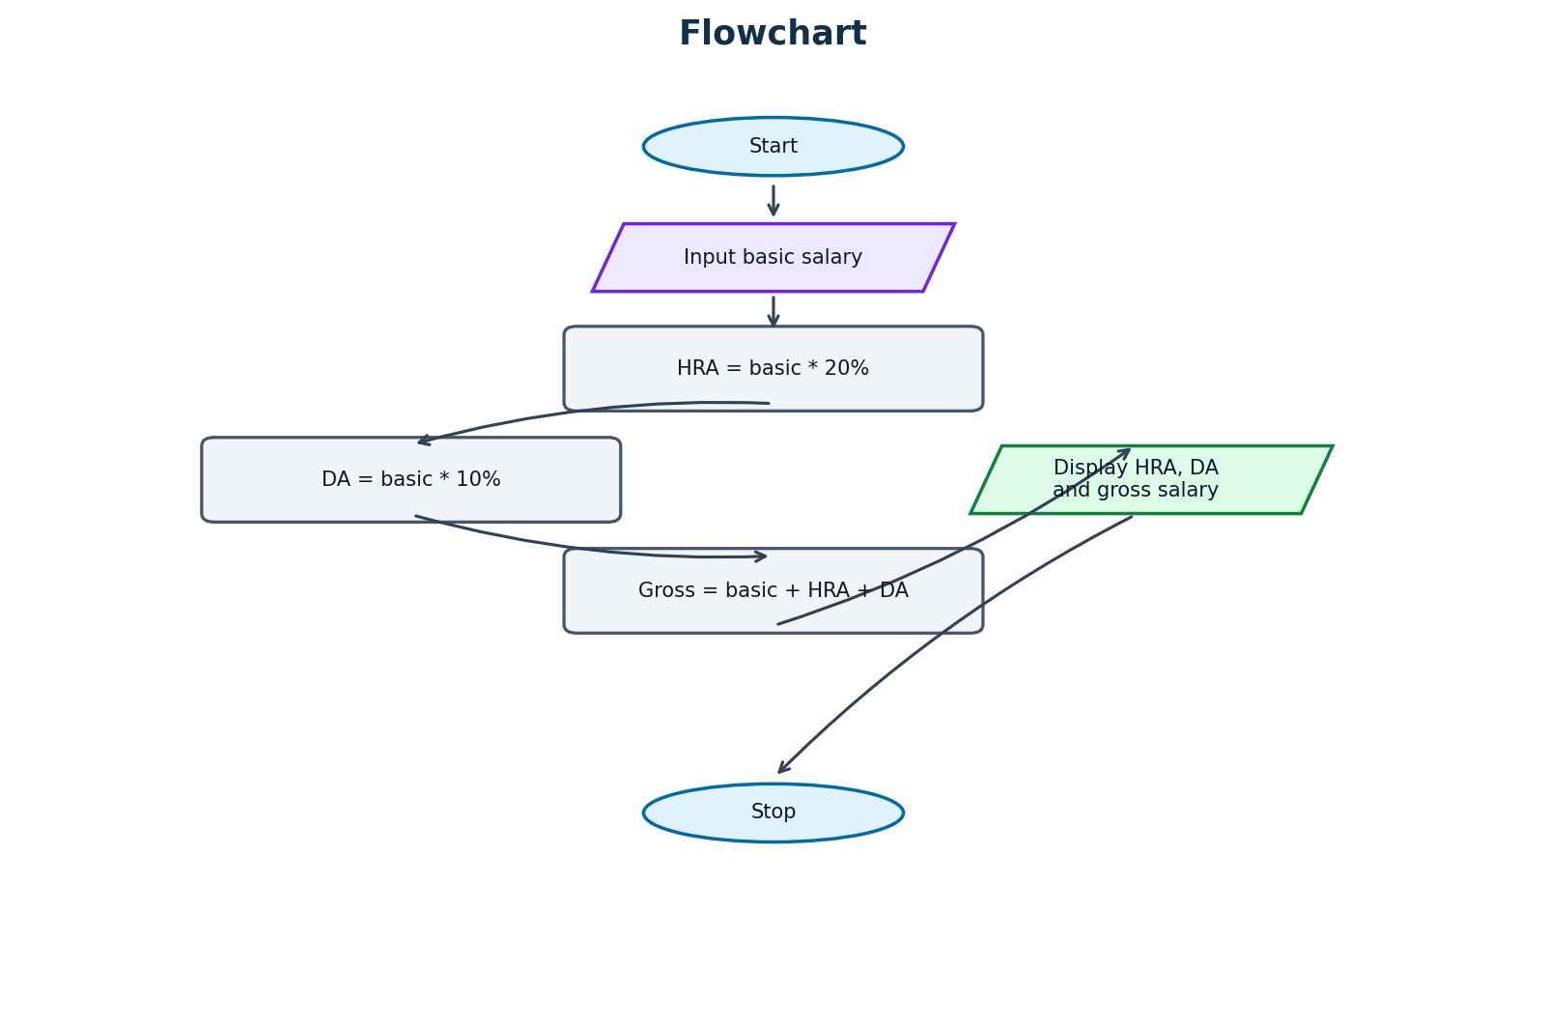

Pseudocode
START
Input basic
hra = basic * 0.20
da = basic * 0.10
gross = basic + hra + da
Display hra, da, gross
STOP

Python Source Code
basic = float(input("Enter basic salary: "))
hra = basic * 0.20
da = basic * 0.10
gross = basic + hra + da
print("HRA:", hra)
print("DA:", da)
print("Gross Salary:", gross)

Test Cases
Test Case | Input | Expected Output
Test 1 | Basic salary = ₹20,000 | HRA: 4000 | DA: 2000 | Gross Salary: 26000
Test 2 | Basic salary = ₹30,000 | HRA: 6000 | DA: 3000 | Gross Salary: 39000

Output Screenshots
Run the program in Python IDLE, VS Code, or another Python compiler. Capture the output for each test case and paste the screenshots in this space.
Screenshot space: ______________________________________________

Conclusion
The system calculates HRA, DA, and gross salary using percentages. It demonstrates arithmetic operations and percentage calculations.

PROGRAM 5

Mobile Data Plan Cost Calculation System

Problem Statement
Develop a Python program that accepts mobile data usage in GB and calculates the plan cost based on usage.

Objectives
- Accept data usage in GB.
- Select the correct price range.
- Display the mobile plan cost.

Assumptions
- Usage up to 2 GB costs ₹100.
- Usage above 2 GB and up to 5 GB costs ₹200.
- Usage above 5 GB costs ₹300.
- Usage should be positive.

Algorithm
- Start.
- Input data usage.
- If usage <= 2, cost = 100.
- Else if usage <= 5, cost = 200.
- Otherwise, cost = 300.
- Display cost.
- Stop.

Flowchart
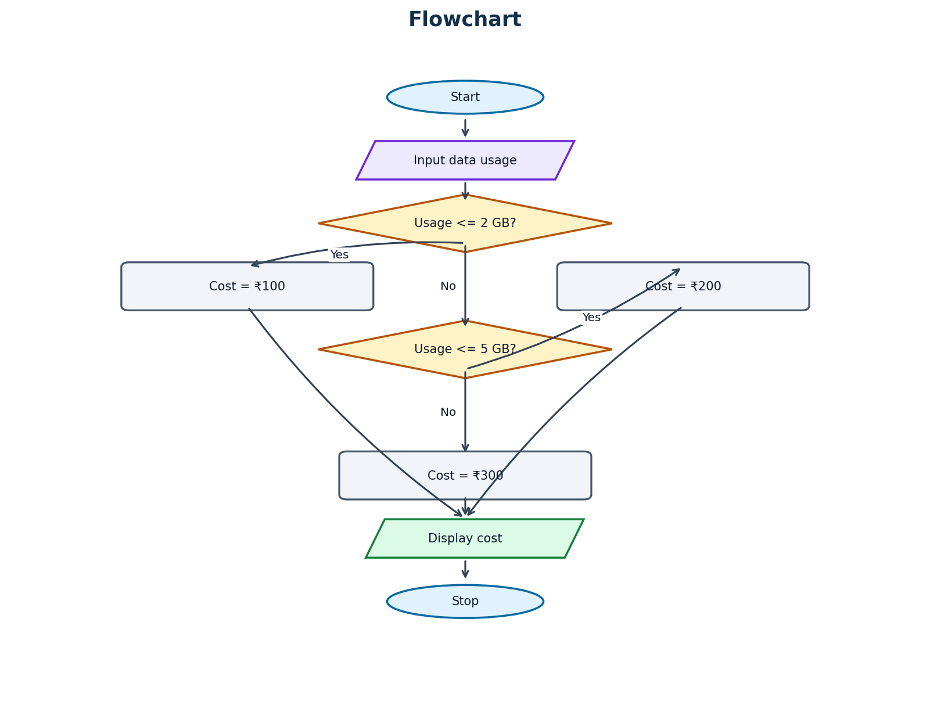

Pseudocode
START
Input usage
IF usage <= 2
cost = 100
ELSE IF usage <= 5
cost = 200
ELSE
cost = 300
Display cost
STOP

Python Source Code
usage = int(input("Enter data usage in GB: "))
if usage <= 2:
cost = 100
elif usage <= 5:
cost = 200
else:
cost = 300
print("Mobile Plan Cost: Rs.", cost)

Test Cases
Test Case | Input | Expected Output
Test 1 | Usage = 2 GB | Mobile Plan Cost: Rs. 100
Test 2 | Usage = 4 GB | Mobile Plan Cost: Rs. 200
Test 3 | Usage = 7 GB | Mobile Plan Cost: Rs. 300

Output Screenshots
Run the program in Python IDLE, VS Code, or another Python compiler. Capture the output for each test case and paste the screenshots in this space.
Screenshot space: ______________________________________________

Conclusion
The system selects a mobile plan price based on data usage. It demonstrates decision-making using if, elif, and else.

PROGRAM 6

Mobile Data Plan Cost Calculation System (Alternative Case Study)

Problem Statement
Develop a Python program that accepts mobile data usage in GB and calculates the plan cost based on the data consumed.

Objectives
- Accept data usage.
- Check the usage range.
- Calculate and display the final plan cost.

Assumptions
- Up to 2 GB costs ₹100.
- Above 2 GB and up to 5 GB costs ₹200.
- Above 5 GB costs ₹300.
- Usage should be positive.

Algorithm
- Start.
- Input data usage.
- If usage <= 2, set cost to 100.
- Else if usage <= 5, set cost to 200.
- Otherwise, set cost to 300.
- Display cost.
- Stop.

Flowchart
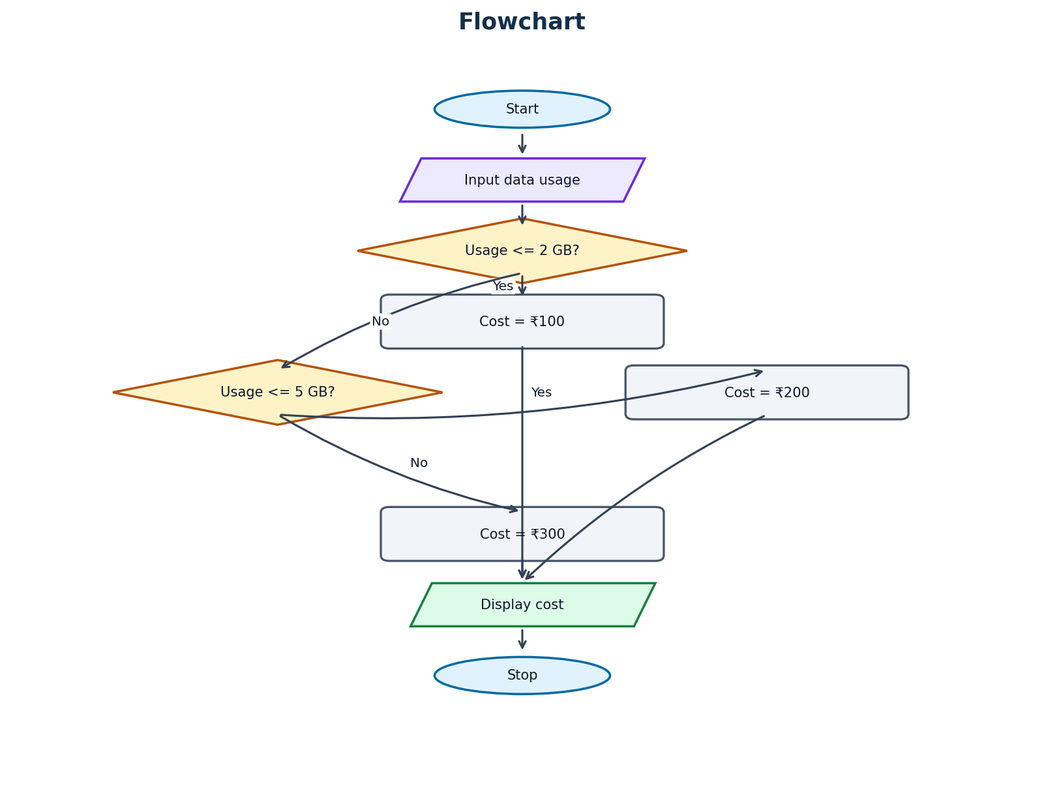

Pseudocode
START
Input usage
IF usage <= 2
cost = 100
ELSE IF usage <= 5
cost = 200
ELSE
cost = 300
Display cost
STOP

Python Source Code
usage = int(input("Enter data usage in GB: "))
if usage <= 2:
cost = 100
elif usage <= 5:
cost = 200
else:
cost = 300
print("Mobile Plan Cost: Rs.", cost)

Test Cases
Test Case | Input | Expected Output
Test 1 | Usage = 2 GB | Mobile Plan Cost: Rs. 100
Test 2 | Usage = 4 GB | Mobile Plan Cost: Rs. 200
Test 3 | Usage = 7 GB | Mobile Plan Cost: Rs. 300

Output Screenshots
Run the program in Python IDLE, VS Code, or another Python compiler. Capture the output for each test case and paste the screenshots in this space.
Screenshot space: ______________________________________________

Conclusion
This program calculates the mobile plan cost according to the data range. It reinforces the use of if, elif, and else statements.

PROGRAM 7

Retail Shopping Discount Calculation System

Problem Statement
Develop a Python program that accepts product price and quantity, calculates the total amount, applies a discount when eligible, and displays the final bill.

Objectives
- Accept product price and quantity.
- Calculate total cost.
- Apply a 10% discount when the total is above ₹1,000.
- Display total, discount, and final bill.

Assumptions
- Price and quantity should be positive.
- Total = price * quantity.
- A 10% discount is given only when total is greater than ₹1,000.

Algorithm
- Start.
- Input product price and quantity.
- Calculate total = price * quantity.
- If total > 1000, discount = total * 0.10; otherwise discount = 0.
- Calculate final_bill = total - discount.
- Display total, discount, and final bill.
- Stop.

Flowchart
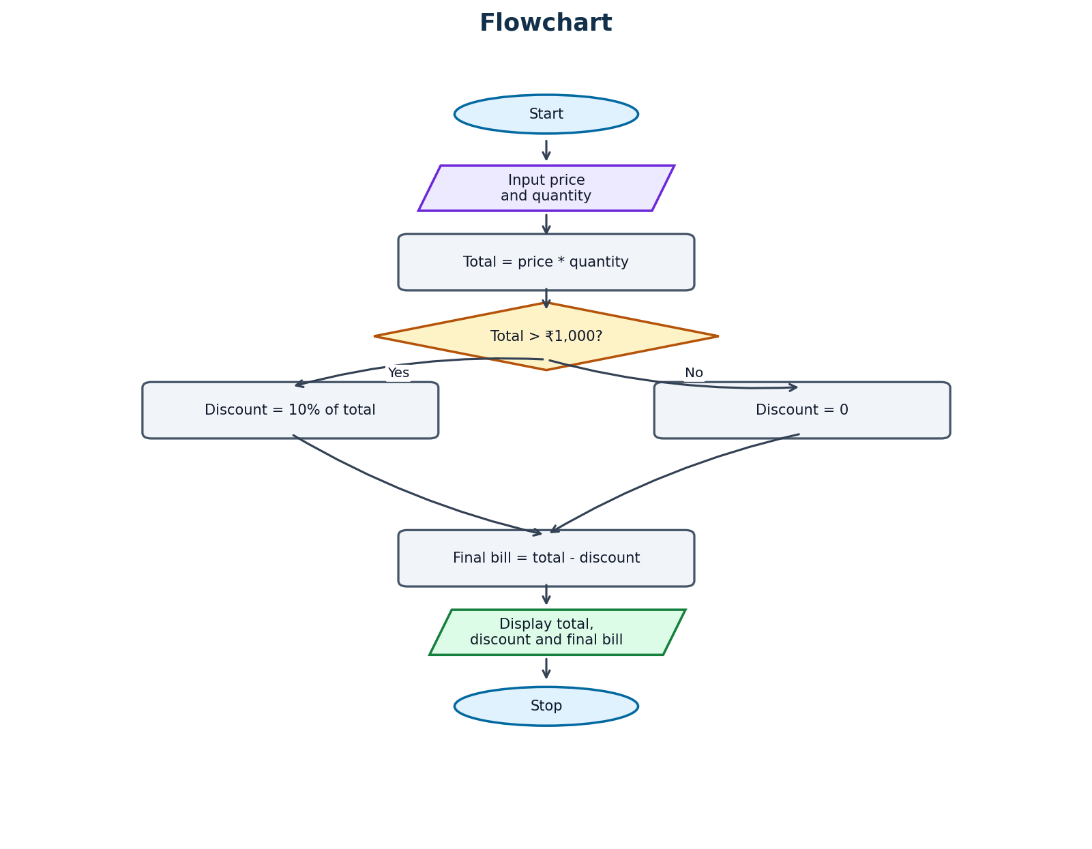

Pseudocode
START
Input price and quantity
total = price * quantity
IF total > 1000
discount = total * 0.10
ELSE
discount = 0
final_bill = total - discount
Display total, discount, final_bill
STOP

Python Source Code
price = float(input("Enter product price: "))
quantity = int(input("Enter quantity: "))
total = price * quantity
if total > 1000:
discount = total * 0.10
else:
discount = 0
final_bill = total - discount
print("Total:", total)
print("Discount:", discount)
print("Final Bill:", final_bill)

Test Cases
Test Case | Input | Expected Output
Discount applied | Price = ₹600, quantity = 2 | Total: 1200 | Discount: 120 | Final Bill: 1080
No discount | Price = ₹200, quantity = 3 | Total: 600 | Discount: 0 | Final Bill: 600
Exactly ₹1,000 | Price = ₹500, quantity = 2 | Total: 1000 | Discount: 0 | Final Bill: 1000

Output Screenshots
Run the program in Python IDLE, VS Code, or another Python compiler. Capture the output for each test case and paste the screenshots in this space.
Screenshot space: ______________________________________________

Conclusion
The system calculates the shopping total and applies a 10% discount when the total is above ₹1,000. It demonstrates arithmetic and conditional statements.

PROGRAM 8

Student Attendance Eligibility System

Problem Statement
Develop a Python program that calculates a student's attendance percentage and checks examination eligibility.

Objectives
- Accept total classes and attended classes.
- Calculate attendance percentage.
- Check whether attendance is at least 75%.
- Display exam eligibility.

Assumptions
- Total classes must be greater than zero.
- Attended classes cannot exceed total classes.
- Minimum attendance required is 75%.

Algorithm
- Start.
- Input total classes and attended classes.
- Calculate percentage = (attended / total) * 100.
- If percentage >= 75, display Eligible for Exam.
- Otherwise, display Not Eligible for Exam.
- Display attendance percentage.
- Stop.

Flowchart
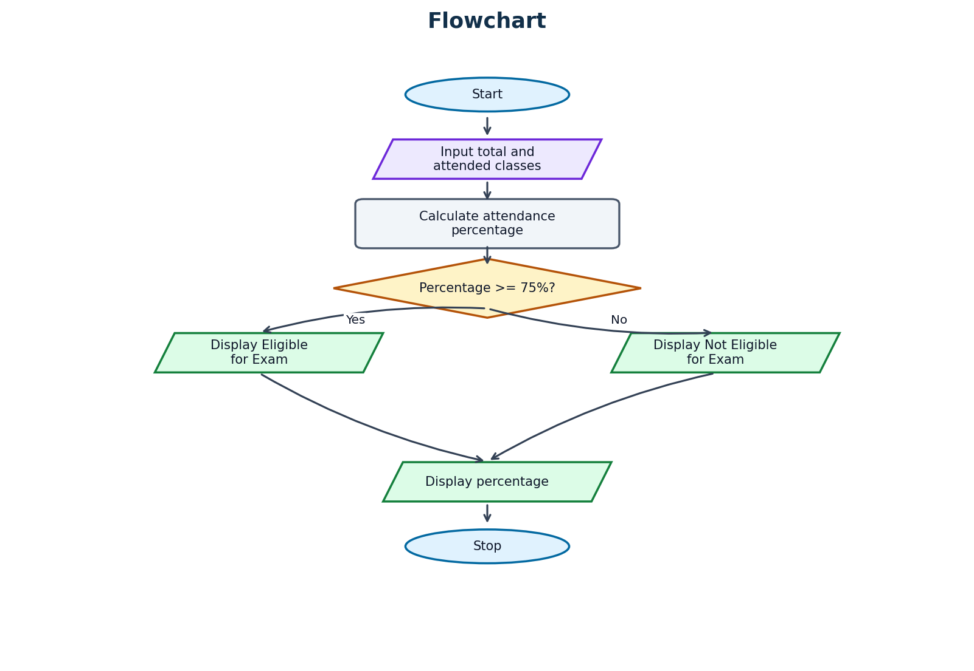

Pseudocode
START
Input total and attended
percentage = (attended / total) * 100
Display percentage
IF percentage >= 75
Display "Eligible for Exam"
ELSE
Display "Not Eligible for Exam"
STOP

Python Source Code
total = int(input("Enter total classes: "))
attended = int(input("Enter attended classes: "))
percentage = (attended / total) * 100
print("Attendance:", percentage, "%")
if percentage >= 75:
print("Eligible for Exam")
else:
print("Not Eligible for Exam")

Test Cases
Test Case | Input | Expected Output
Eligible | Total = 100, attended = 85 | Attendance: 85.0% | Eligible for Exam
Not eligible | Total = 100, attended = 60 | Attendance: 60.0% | Not Eligible for Exam
Exactly 75% | Total = 100, attended = 75 | Attendance: 75.0% | Eligible for Exam

Output Screenshots
Run the program in Python IDLE, VS Code, or another Python compiler. Capture the output for each test case and paste the screenshots in this space.
Screenshot space: ______________________________________________

Conclusion
The system calculates attendance percentage and checks exam eligibility using a 75% rule. It demonstrates division, multiplication, and conditional statements.
Note: The sample code assumes valid input. A safer version should check that total classes are greater than zero and attended classes do not exceed total classes.

PROGRAM 9

Password Validation System

Problem Statement
Develop a Python program that checks whether a password contains at least 8 characters.

Objectives
- Accept a password.
- Check the password length.
- Display whether the password is valid or too short.

Assumptions
- The password is a string.
- A minimum length of 8 characters is required.

Algorithm
- Start.
- Input password.
- Find the password length.
- If length >= 8, display Valid Password.
- Otherwise, display Password must contain 8 characters.
- Stop.

Flowchart
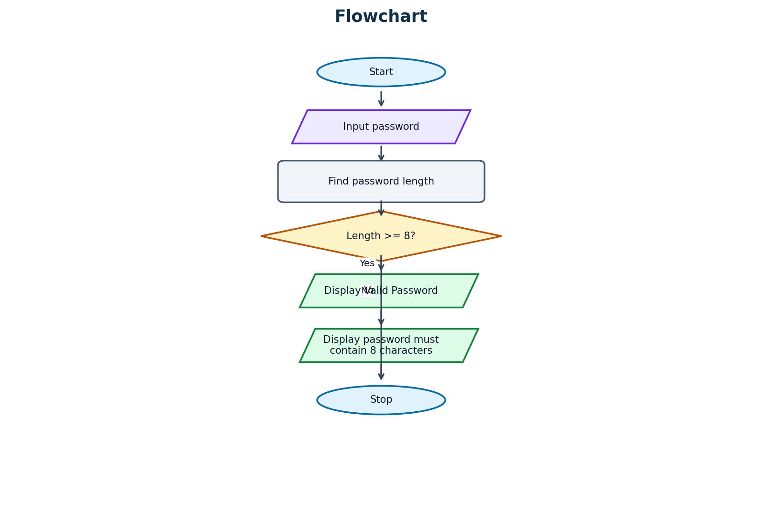

Pseudocode
START
Input password
IF length(password) >= 8
Display "Valid Password"
ELSE
Display "Password must contain 8 characters"
STOP

Python Source Code
password = input("Enter password: ")
if len(password) >= 8:
print("Valid Password")
else:
print("Password must contain 8 characters")

Test Cases
Test Case | Input | Expected Output
Valid password | python123 | Valid Password
Invalid password | hello | Password must contain 8 characters
Exactly 8 characters | abcdefgh | Valid Password

Output Screenshots
Run the program in Python IDLE, VS Code, or another Python compiler. Capture the output for each test case and paste the screenshots in this space.
Screenshot space: ______________________________________________

Conclusion
The system checks whether a password has at least 8 characters. It demonstrates string length using len() and conditional statements.

PROGRAM 10

Water Tank Management System

Problem Statement
Develop a Python program that accepts tank capacity, current water level, and water used, then calculates the remaining water.

Objectives
- Accept tank capacity, current water level, and water used.
- Calculate remaining water.
- Display the remaining amount or an insufficient-water message.

Assumptions
- Values are entered in litres.
- Current water level should not exceed tank capacity.
- Water used should be zero or positive.
- If water used exceeds current water, display Not enough water.

Algorithm
- Start.
- Input tank capacity, current water level, and water used.
- Calculate remaining = water - used.
- If remaining < 0, display Not enough water.
- Otherwise, display remaining water in litres.
- Stop.

Flowchart
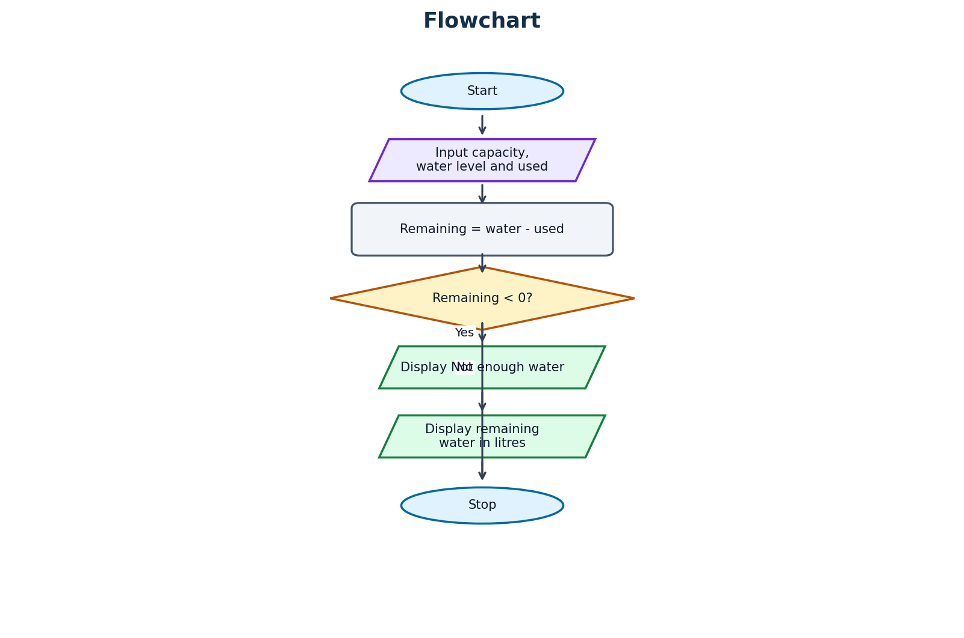

Pseudocode
START
Input capacity, water, used
remaining = water - used
IF remaining < 0
Display "Not enough water"
ELSE
Display remaining water
STOP

Python Source Code
capacity = int(input("Enter tank capacity in litres: "))
water = int(input("Enter current water level: "))
used = int(input("Enter water used: "))
remaining = water - used
if remaining < 0:
print("Not enough water")
else:
print("Remaining Water:", remaining, "litres")

Test Cases
Test Case | Input | Expected Output
Sufficient water | Capacity = 1000, water = 800, used = 300 | Remaining Water: 500 litres
Not enough water | Capacity = 1000, water = 200, used = 300 | Not enough water
No water used | Capacity = 1000, water = 500, used = 0 | Remaining Water: 500 litres

Output Screenshots
Run the program in Python IDLE, VS Code, or another Python compiler. Capture the output for each test case and paste the screenshots in this space.
Screenshot space: ______________________________________________

Conclusion
The system calculates the remaining water and checks whether enough water is available. It demonstrates subtraction and if-else decision-making.
Note: The capacity is accepted but is not used in the original calculation. It can be used to validate that the current water level does not exceed tank capacity.

