Comparative Analysis of Fake Job Posting Detection Using Natural Language Processing and Machine Learning
ABSTRACT: -
With the rapid advancement of modern technology and social media, advertising job postings has become widespread. However, this has also led to an increase in fake job postings, posing serious risks to job seekers. Detecting fraudulent job posts is a challenging classification task that requires robust machine learning techniques.This paper proposes the use of various data mining techniques and classification algorithms, including k-Nearest Neighbors (KNN), Decision Tree, Support Vector Machine (SVM), Naïve Bayes Classifier, Random Forest Classifier, Multilayer Perceptron (MLP), and Deep Neural Networks (DNN) to classify job postings as real or fraudulent.
We conducted experiments using the Employment Scam Aegean Dataset (EMSCAD), which consists of 18,000 job postings. Among the tested models, the Deep Neural Network (DNN) classifier, designed with three dense layers, outperformed others by achieving approximately 98% classification accuracy. The results demonstrate that deep learning techniques are highly effective in detecting fake job postings, providing a reliable approach to combating employment fraud.

EXSISTING SYSTEM | PROPOSED SYSTEM
- With the rise of social media and electronic advertisements, sharing job details has become easier than ever. However, this rapid growth has also increased the percentage of fraudulent job postings, causing distress and potential harm to job seekers.  - To address this issue, text processing techniques and dataset training were used to differentiate between real and fake job posts. By analyzing job descriptions, keywords, and patterns, the system aimed to identify fraudulent postings more effectively. | - This study examines the significant impact of job scams, which pose a growing challenge in detecting fraudulent job postings. The increasing number of fake job listings highlights the need for efficient detection methods.  - To address this issue, various data mining techniques and classification algorithms have been proposed, including K-Nearest Neighbors (KNN), Decision Tree, Support Vector Machine (SVM), Naïve Bayes, Random Forest Classifier, Multilayer Perceptron (MLP), and Deep Neural Networks (DNN) to classify job posts as real or fraudulent.
EXISTING ALGORITHM  - Text Processing & Dataset Training | PROPOSED ALGORITHM: -  - Deep Neural Network, Random Forest Classifier & Other
ALGORITHM DEFINITION: -  - Zhang Zhang proposed an automatic fake detector model that distinguishes between real and fake news (including articles, creators, and subjects) using text processing techniques. The model was trained on a custom dataset containing news and articles from the PolitiFact website Twitter account.  - To enhance performance, the dataset was used to train the GDU (Graph Diffusive Unit) model, which processes inputs from multiple sources simultaneously. The trained model performed well in fake news detection and showed potential for identifying fraudulent job postings. | ALGORITHM DEFINITION: -  - The system has been trained on the Employment Scam Aegean Dataset (EMSCAD), which contains 18,000 real and fraudulent job postings. The key objective is to classify fraudulent job advertisements without relying on text processing or natural language processing (NLP).  - Machine learning classifiers have been trained on this dataset, with Deep Neural Networks (DNN) playing a crucial role. The DNN model consists of virtual neurons initialized with random numerical weights. These weights are multiplied with the input to generate an output between 0 and 1, representing the likelihood of a job post being fraudulent. The training process adjusts the weights iteratively to enhance classification accuracy.
DRAWBACKS: -  - Lower Classification Accuracy  - Limited Precision Rate  - Performance Issues | ADVANTAGES: -  - Higher Classification Accuracy  - Enhanced Precision Rate  - Robust Performance

SYSTEM ARCHITECTURE
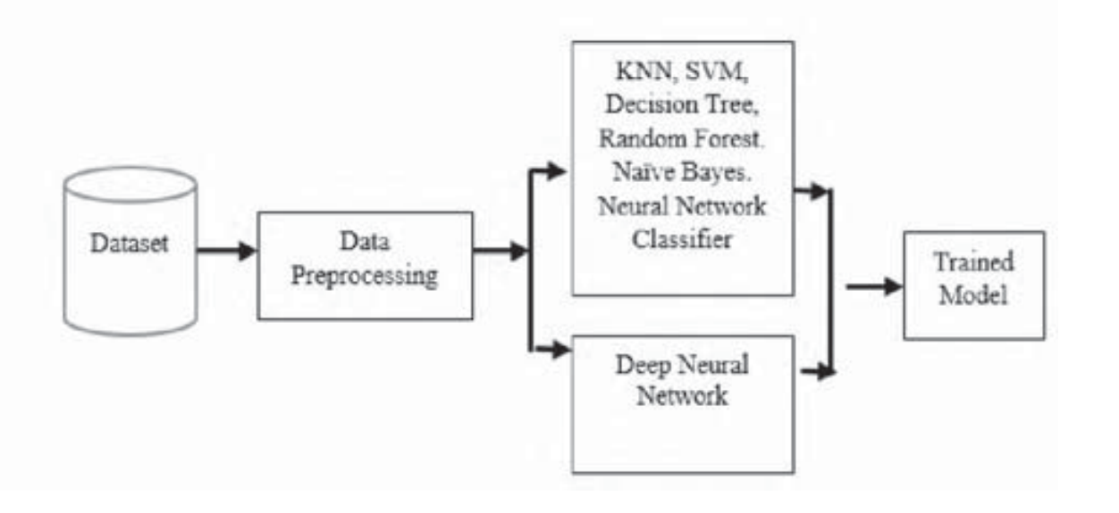
Fig. Proposed Methodology
MINIMUMSYSTEM REQUIREMENTS
HARDWARE REQUIREMENTS
- PROCESSOR : Pentium i3 Processor
- RAM : 2GB DD RAM
- HARD DISK : 250 GB

SOFTWARE REQUIREMENTS
- BACK END : PYTHON
- OPERATING SYSTEM : WINDOWS 7
- IDE : Spider3

