**Prototyping/Building Projects**

(A little compilation of some of my favorite engineering projects)

**Harry Styles Statue:**

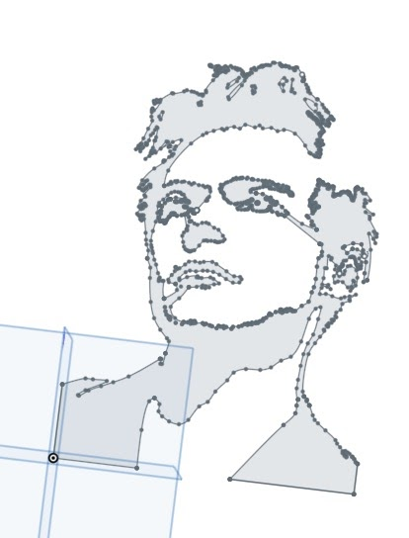 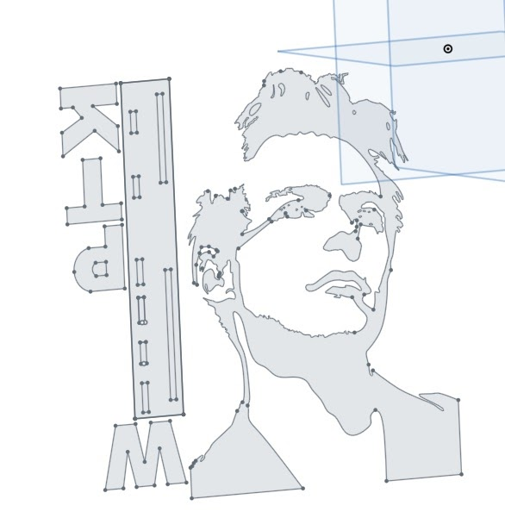

Preliminary drawing of statue on CAD Drawing of all pieces of statue (this was

the format used to program the waterjet)

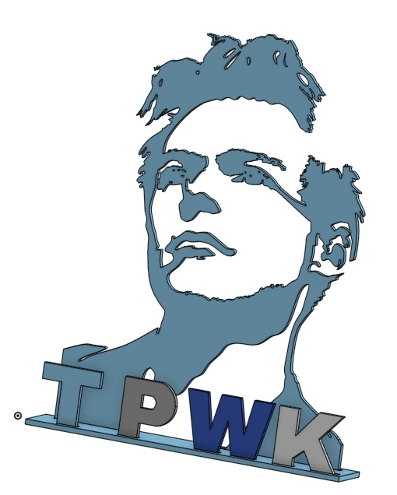

Extruded the drawing to 0.125 inches and assembled the drawing on CAD

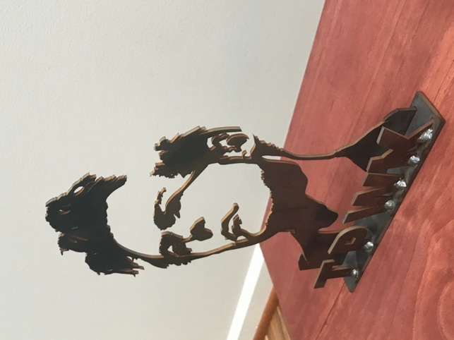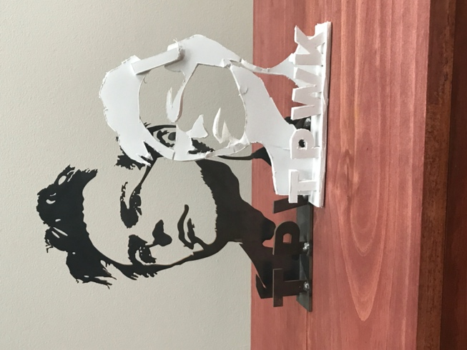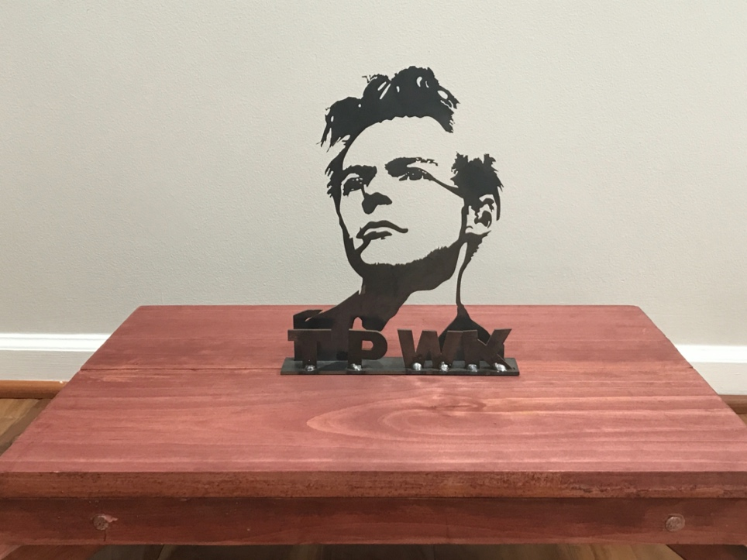Final metal product including Styrofoam prototype (also including the table I built!). You can also see the welding joints (where the letters were added to the base) on the statue.

**Robot Project:**

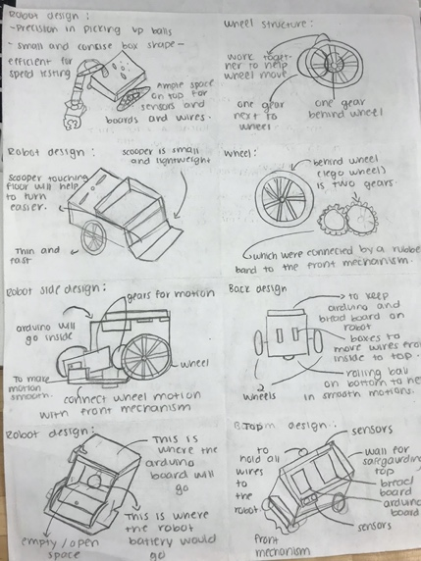 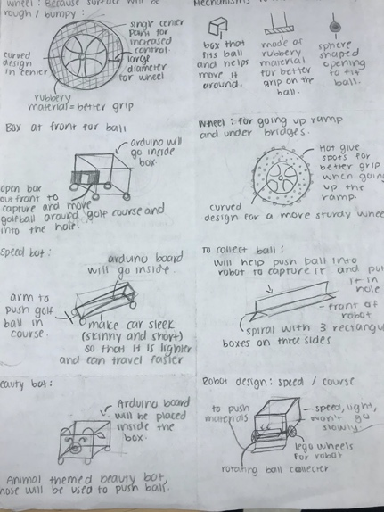 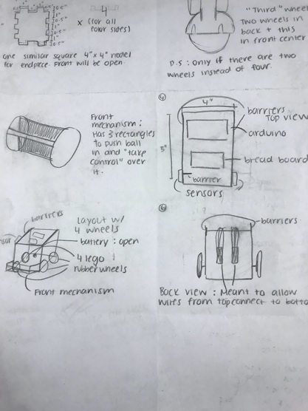

Brainstorming sketches of different ideas for the structure of robot given certain requirements.

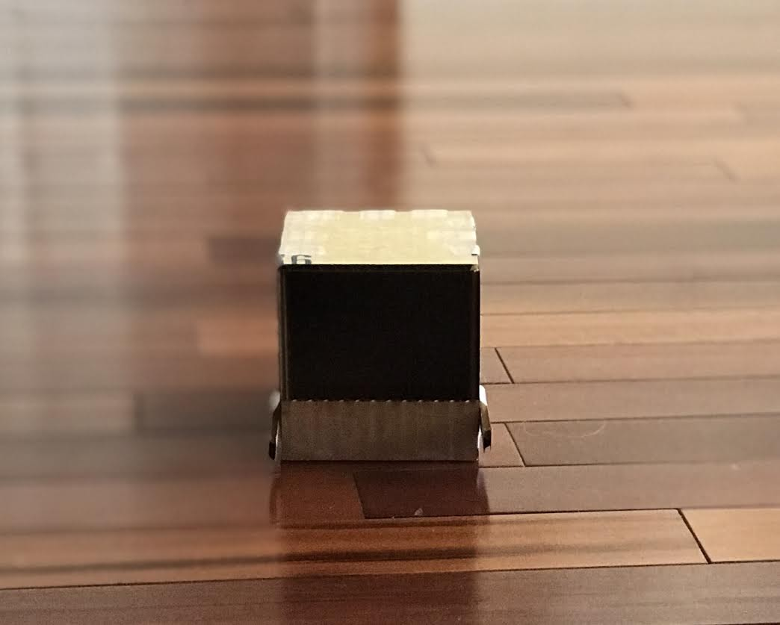 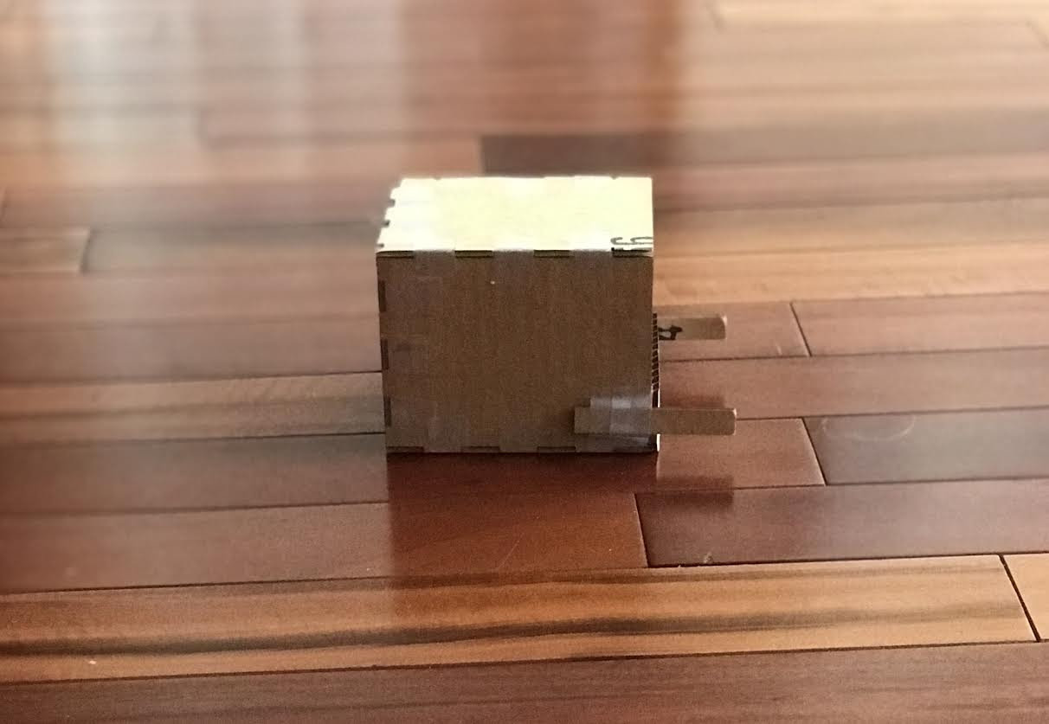

Preliminary carboard prototype of robot (including only the outer shell)

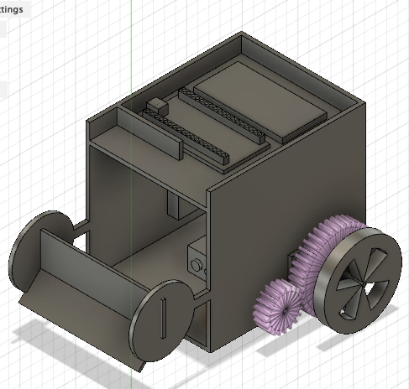

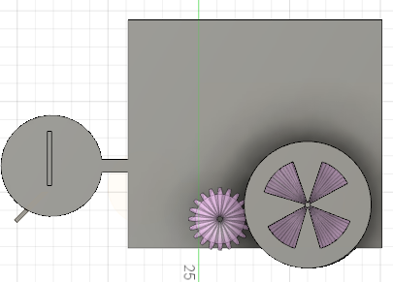

CAD model of chosen structure from side and top views

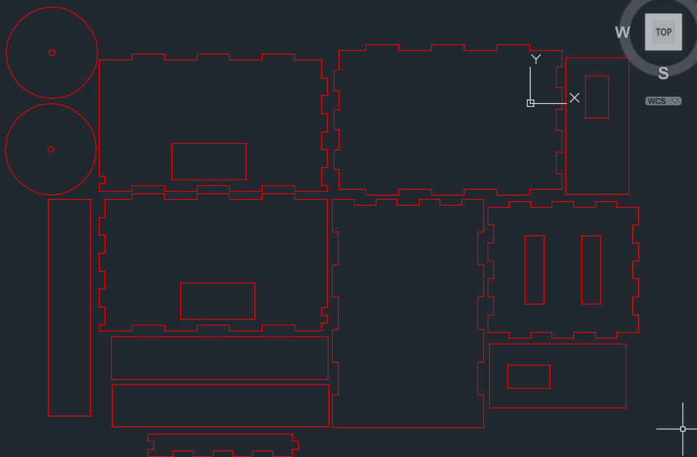

File used to program laser cutter to create wooden pieces of robot

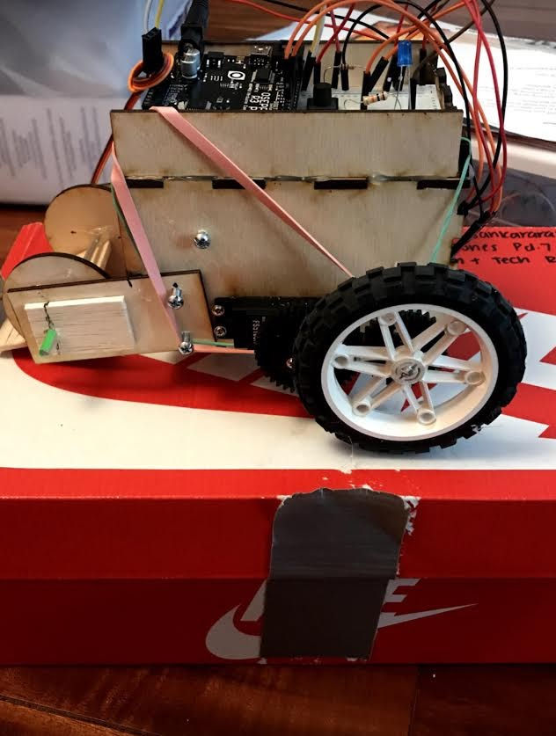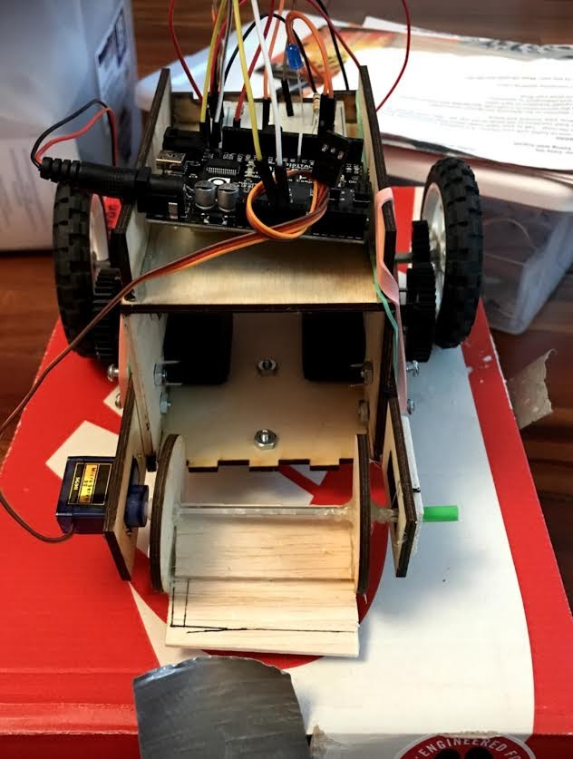

Final product (I soldered the Arduino board used for the final obstacle course robot challenge)

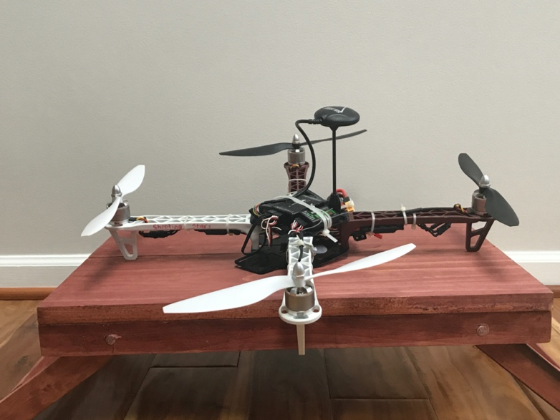**Drone:**

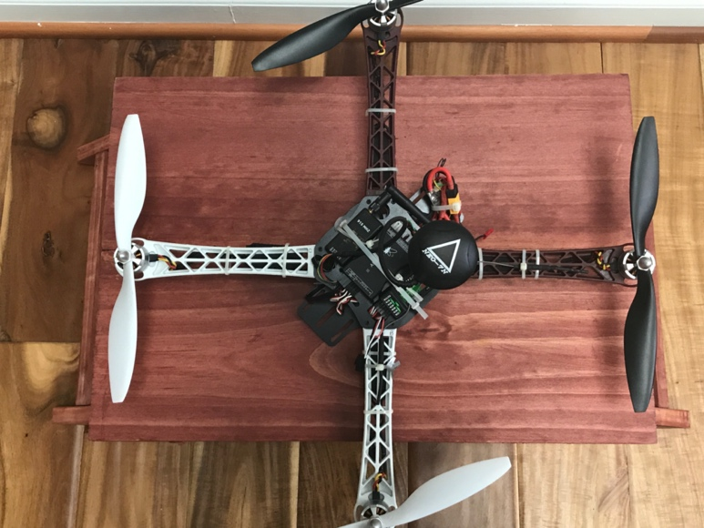

Image of the final drone I built over the summer

**Concord Plane Model:**

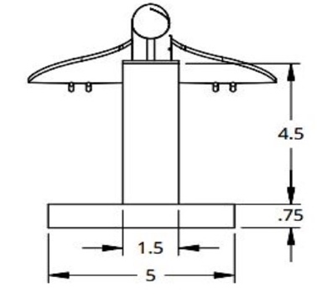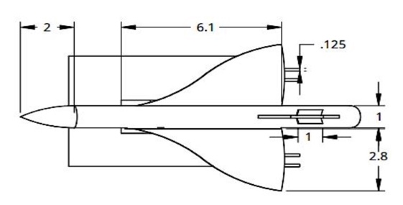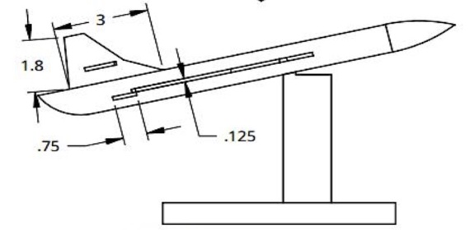

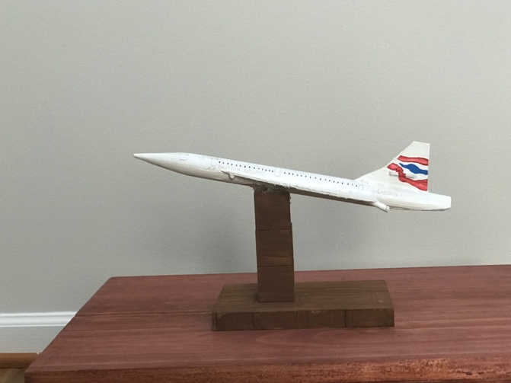Images of the orthographic drawings of the concord plane model.

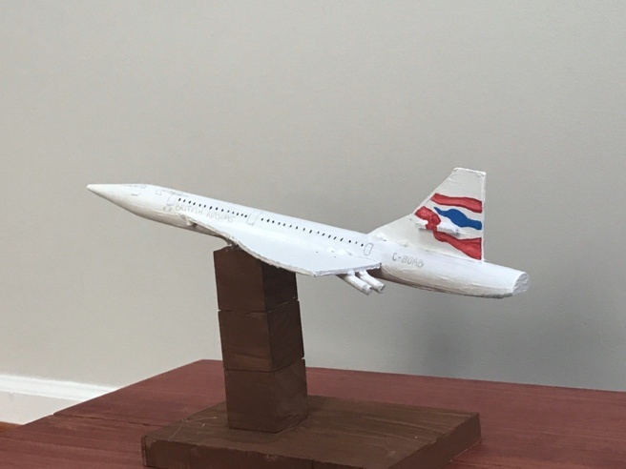

Final product of the plane model.