**DevOps Certification Training**

**Jenkins Assignment – 2**

**Adding a Slave node in Jenkins**

Done by

Sruthi Motepalli

You are working for an MNC - Software Solutions company as a DevOps Engineer and Company

would want you to establish the CICD pipeline in their organization by automating various

workflows.

As there is only one build server setup, many teams must wait for their changes to be built.

The organization would like to setup a slave node, so that workload can be shared from the

master to the slave node and parallel builds can be performed.

You are requested to do following action items :

1. Create an AWS EC2 Ubuntu instance. (name as Jenkins-master)

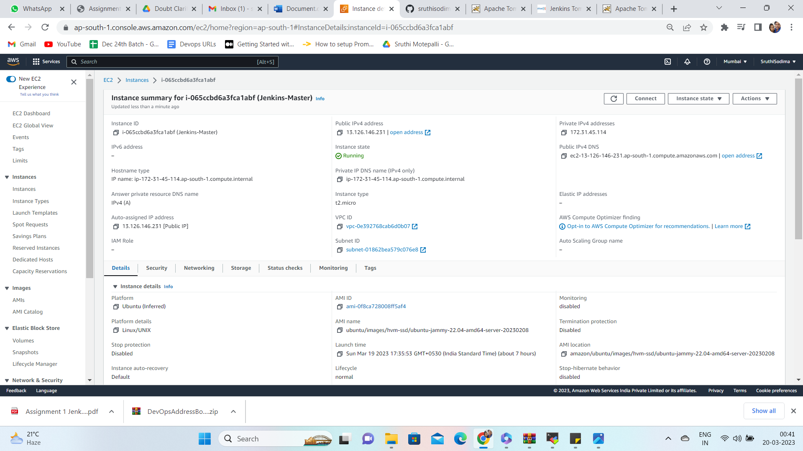

2. Setup Jenkins on this server.

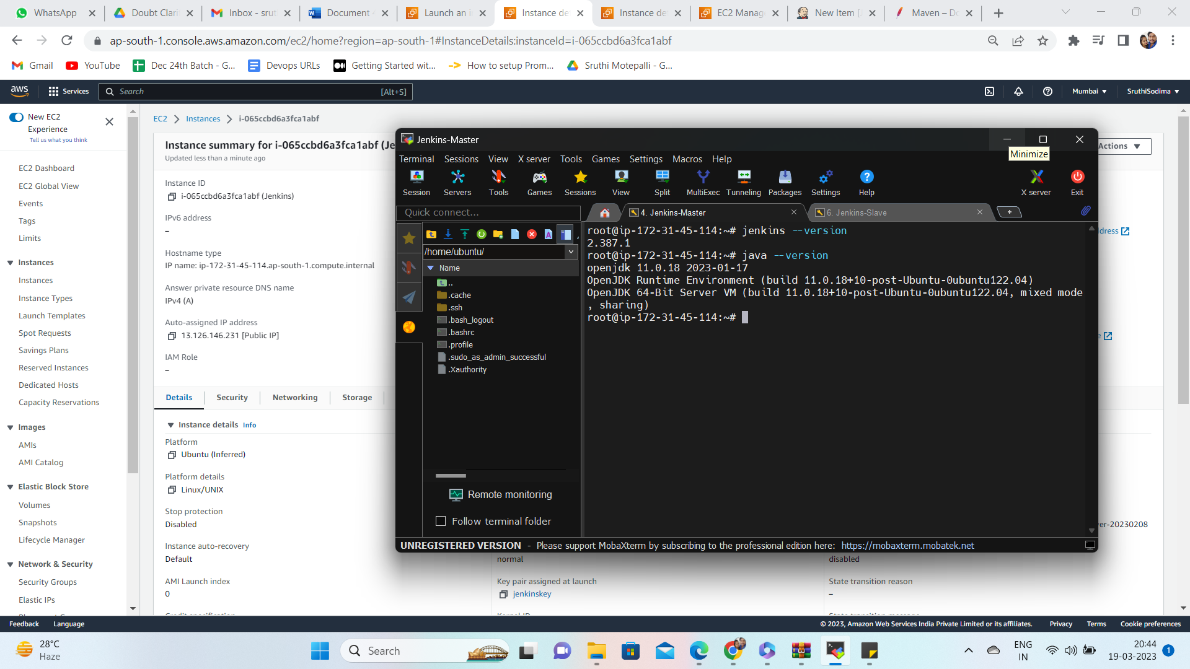

3. Add another AWS EC2 ubuntu instance(name as Jenkins-slave)

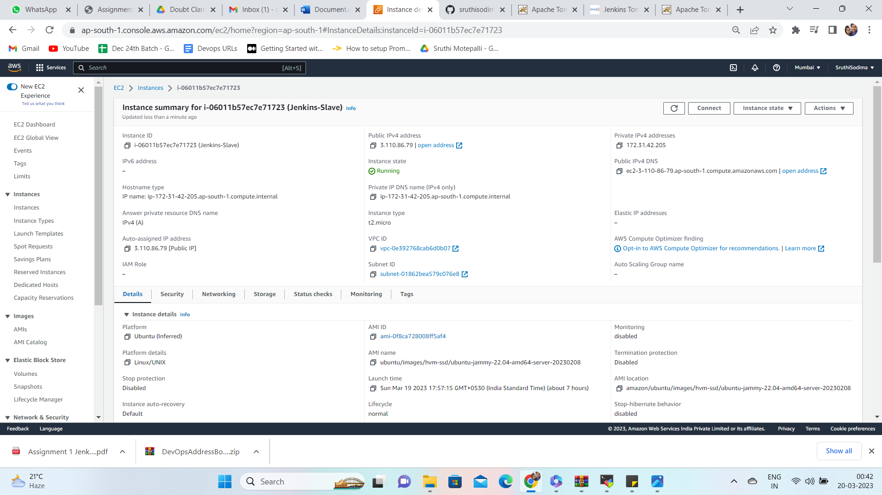

4. Add this node to the Jenkins Master as Slave.

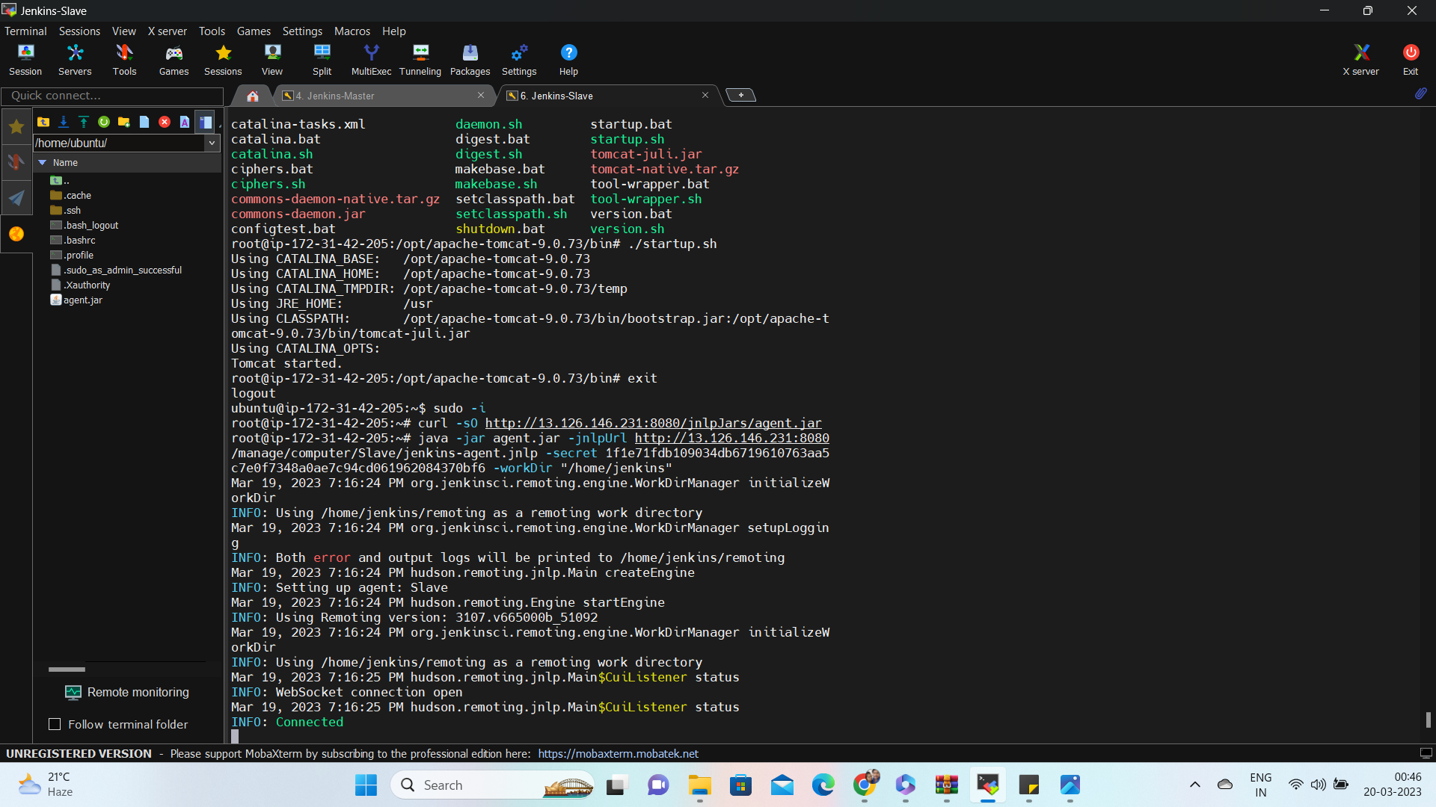

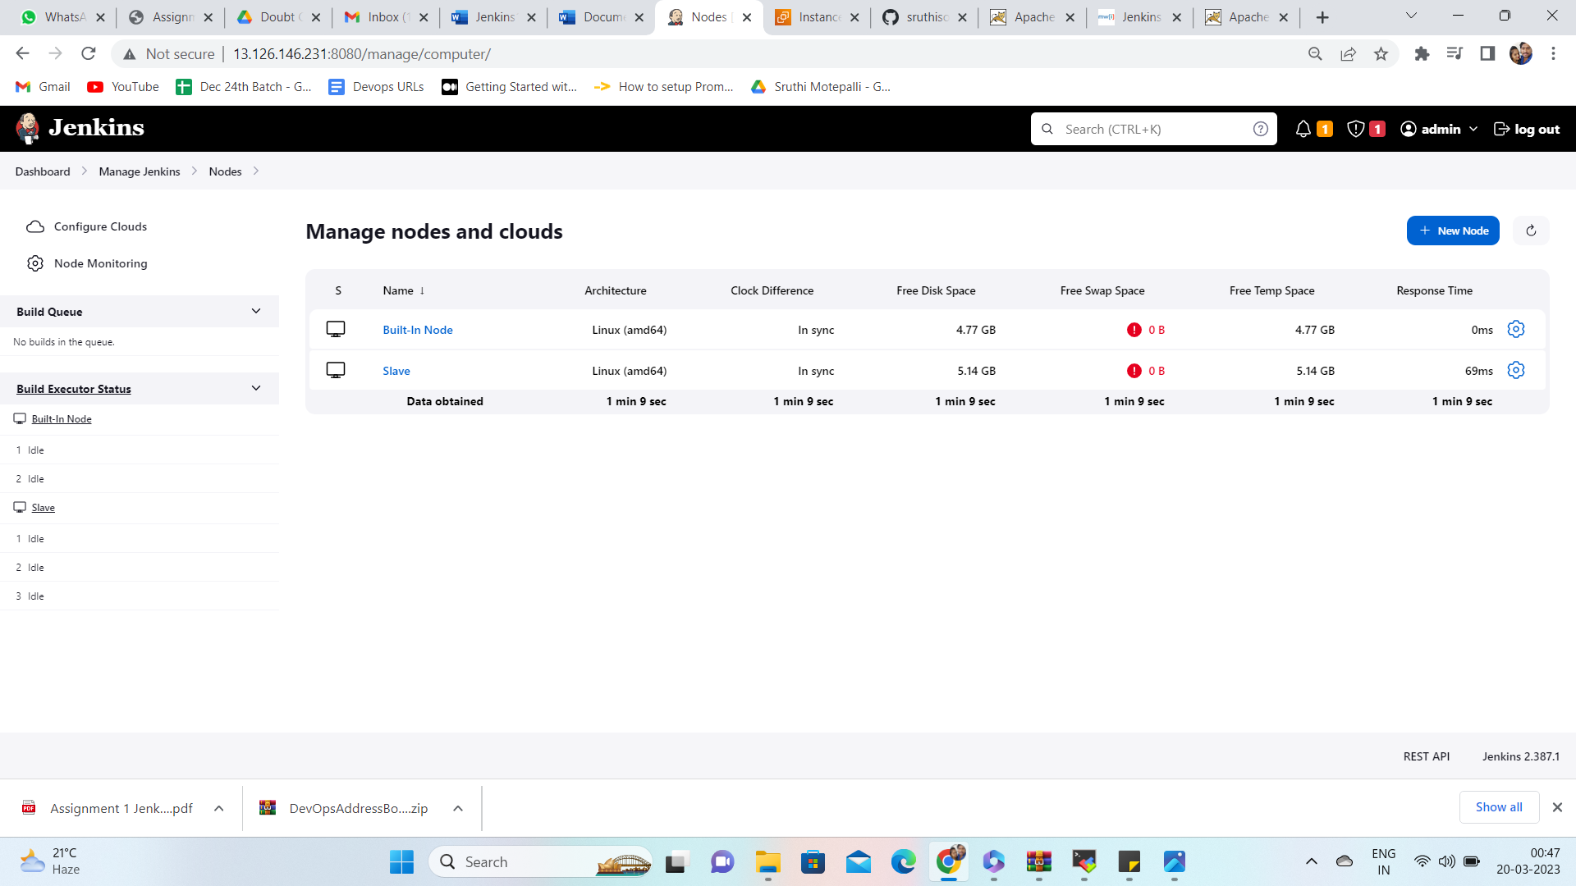

5. Configure the pipeline script from previous assignment to run the build on slave node.

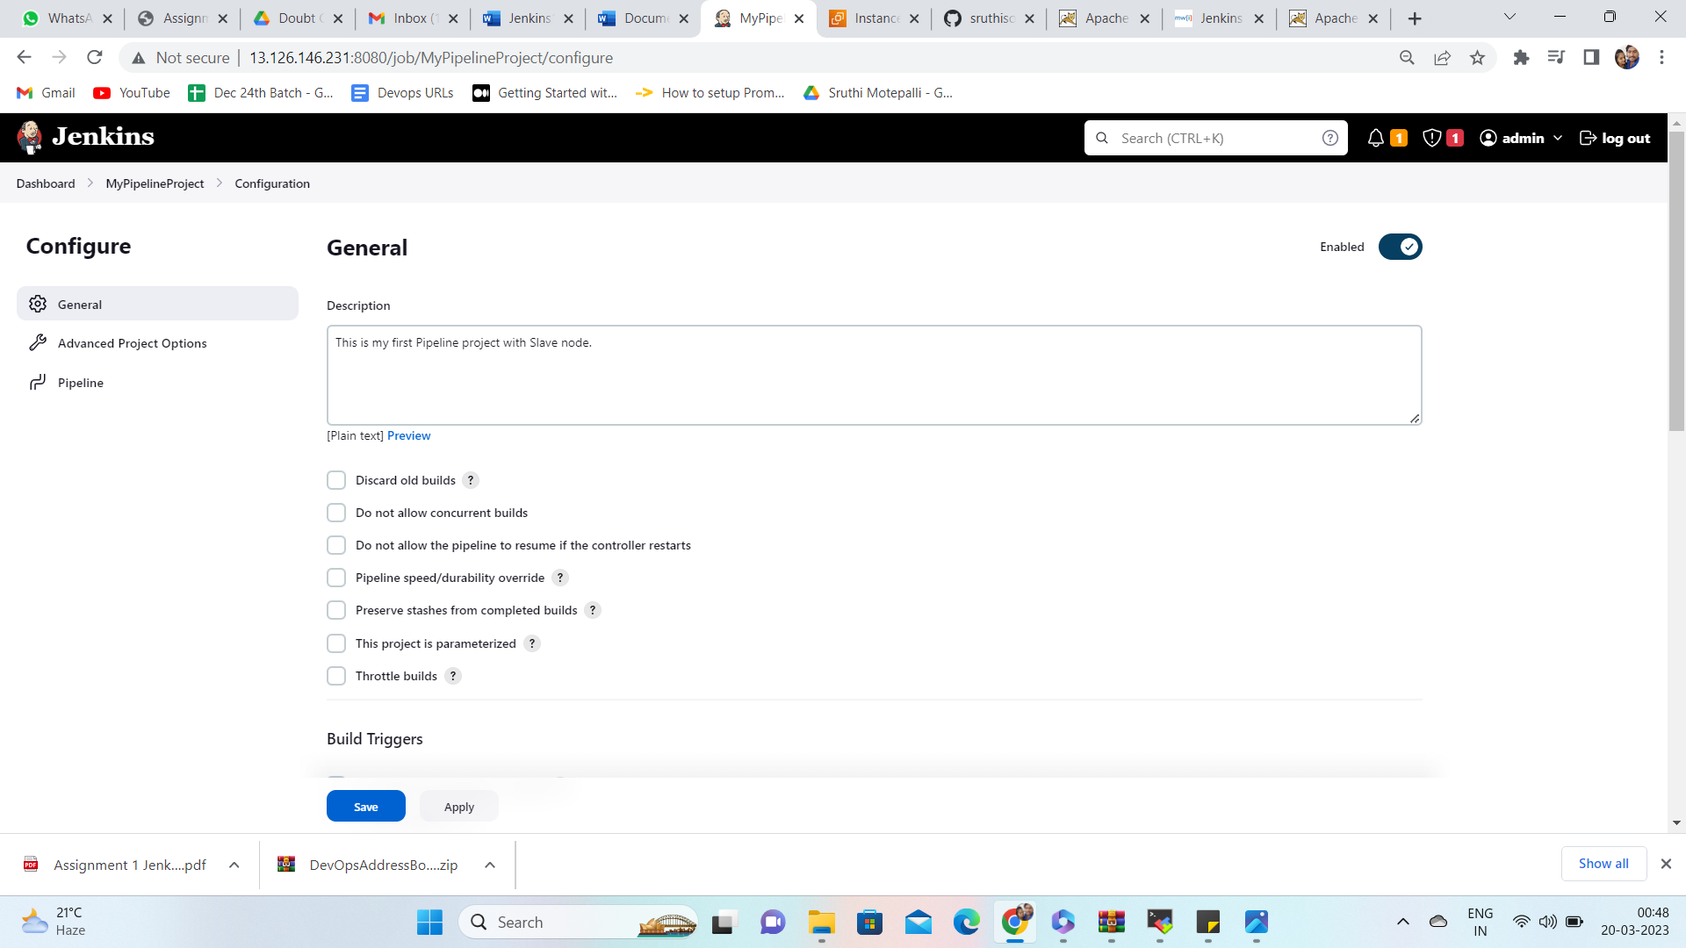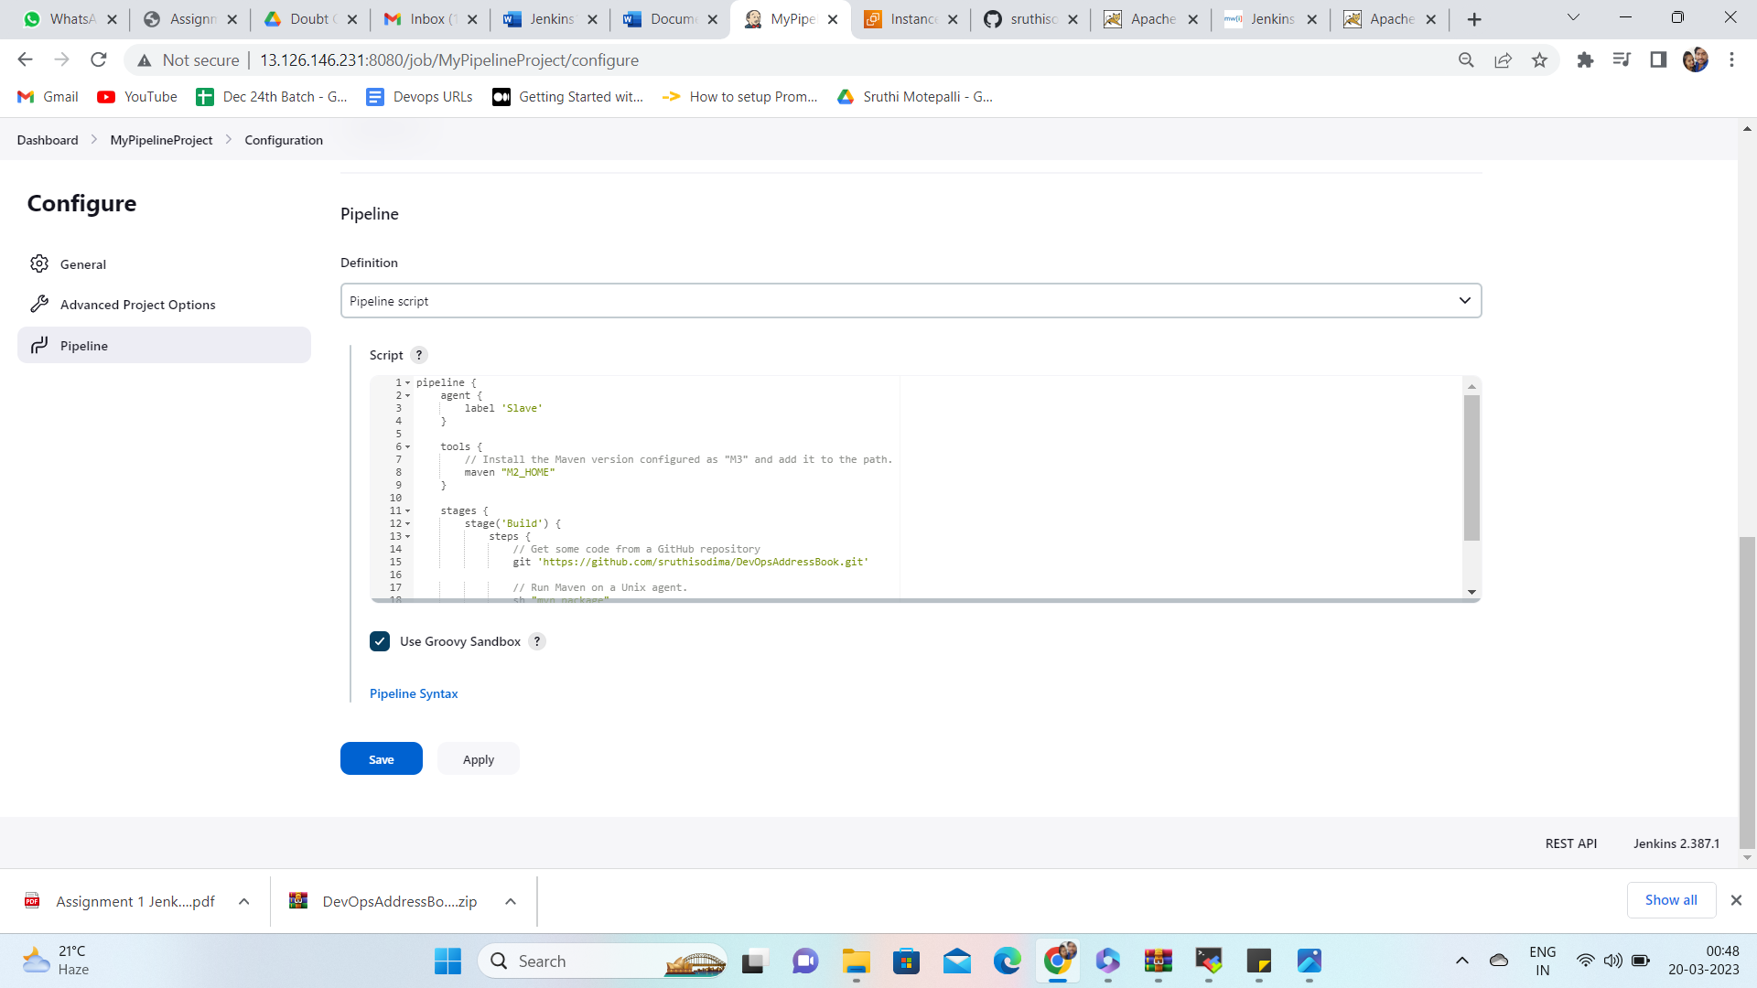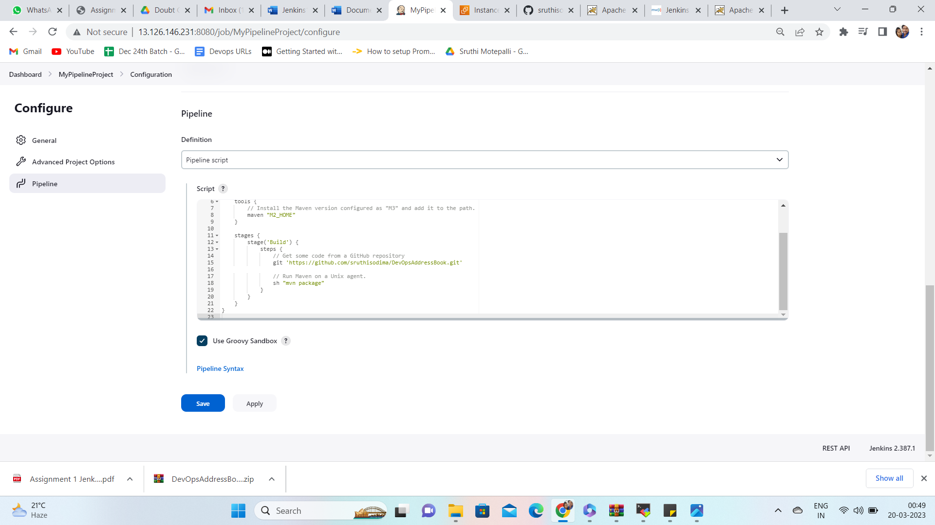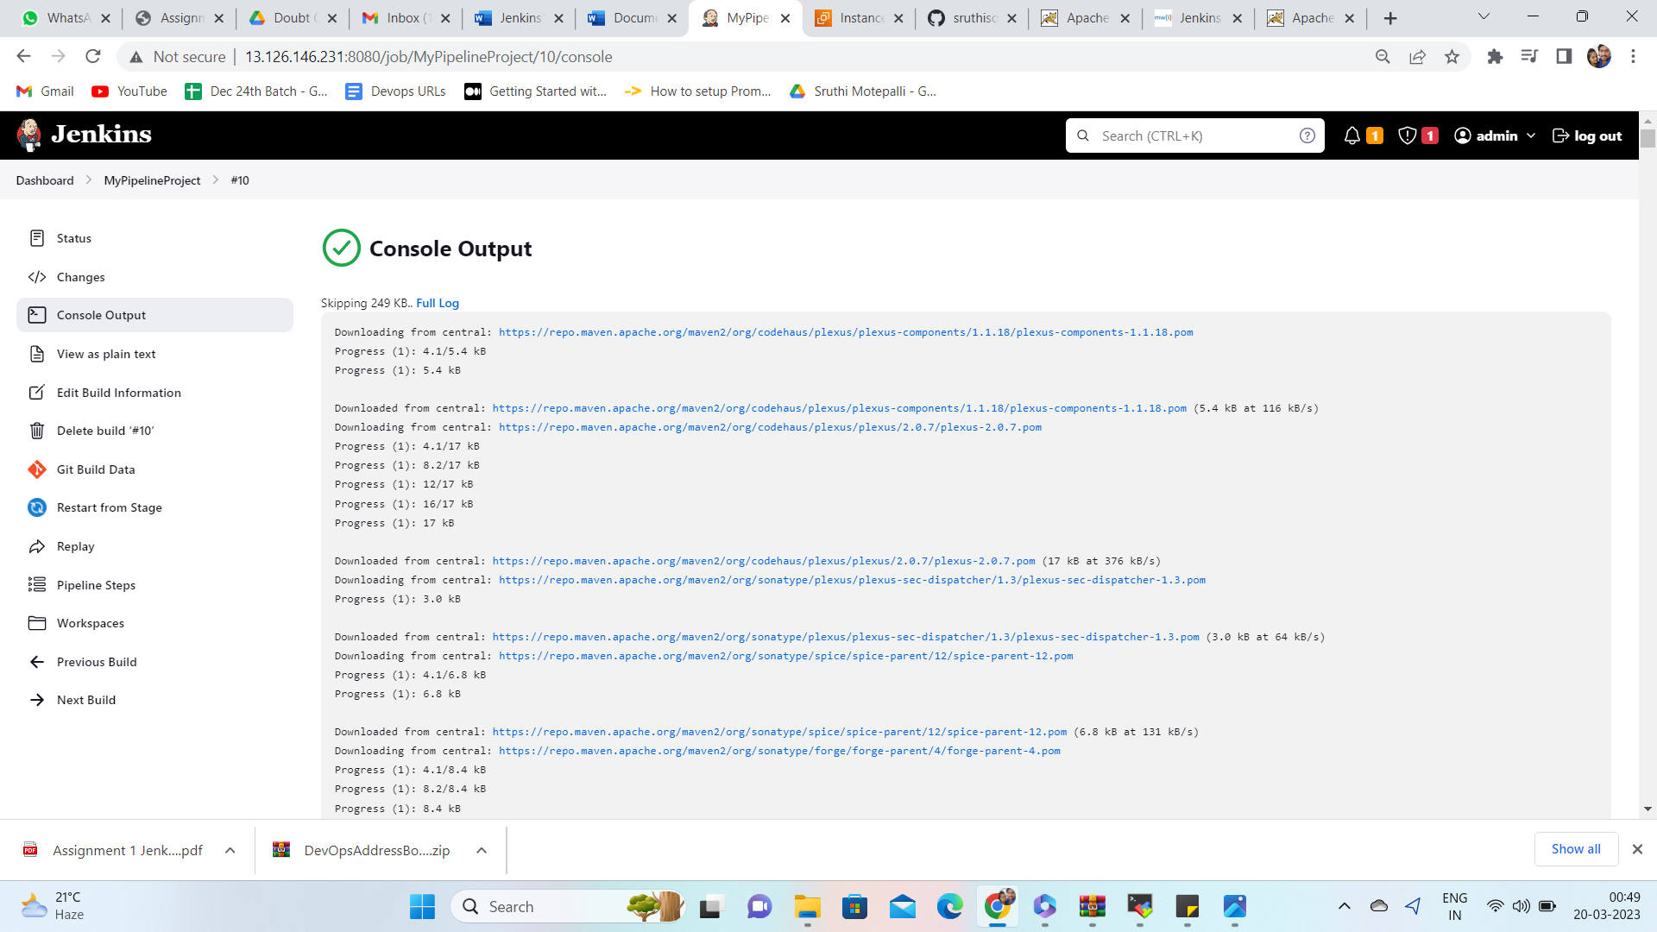

6. Trigger the build on master and verify if the build is running on slave node or not.

