LockedMe – Virtual Key for Repositories

**BY**

**SRUTHISREE GUMMADI**

# Table of contents

1. Project Objective
   * Background of the problem statement
   * The flow and features of the application
   * Requirements should be met
2. **S**print planning
3. Flow of the application
4. Concepts used in the application
5. Application details and user interactions

* Demonstrating the product capabilities,User interactions and appearance
* Output
* Steps to push the code in git Repositories
* Unique features of the application

1. Conclusion

# PROJECT OBJECTIVE

As a Full Stack Developer, complete the features of the application by planning the development in terms of sprints and then push the source code to the GitHub repository. As this is a prototyped application, the user interaction will be via a command line.

## Background of the problem statement

Company Lockers Pvt.Ltd hired you as a Full Stack Developer.They aim tio digitise their product and chose LockedMe.com as their first project to start with.You’re asked to develop a prototype of the application.The prototype of the application will be then presented to the relevant stakeholders for the budget approval.Your manager has set up a meeting where you’re asked to present the following in the next 15 working days.

* Specification document-Product’s Capabilities, appearance, and user interactions
* Number and duration of Sprints required
* Setting Git and GitHub account to store and track your enhancements of the prototype
* Java concepts being used in the project
* Data Structures where sorting and searching techniques are used
* Generic features and three operations:
  + Retrieve the file names in ascending order
  + Business-level Operations
    - Option to add a user specified file to the application
    - Option to delete a user specified file from the application
    - Option to search a user specified file from the application
    - Navigation option to close the current execution context and return to the main context
    - Option to close the application

The goal of the company is to deliver a high-end quality product as early as possible.

## The Flow and Features of the application

* Plan More than two sprints to complete the application
* Document the flow of the application and prepare a flow chart
* List the core Concepts and algorithms being used to complete this application
* Code to display the welcome screen.It should display:
  + Application Name and developer Details
  + The details of the user interface such as options displaying the user interaction informaiton
  + Features to accept the user to select one of the options listed
* The first option should return the current file names in ascending order.The root directory can be either empty or contain few files or folders in it
* The second option should return the details of the user interface such as options displaying the following
  + Add a file to the existing directory list
    - You can ignore the case sensitivity of the file names
  + Delete a user specified file from the existing directory list
    - You can add the case sensitivity on the file name in order to ensure that the right file is deleted from the directory list
    - Return a message if FNF(File Not Found)
  + Search a user specified file from the main directory
    - You can add the case sensitivity on the file name to retrieve the correct file
    - Display the result upon successful operation
    - Display the result upon unsuccessful operation
  + Option to navigate back to the main context
* There should be a third option to close the application
* Implement the appropriate concepts such as exceptions, collection, and sorting techniques for source code optimisation and increased performance

## The requirements should met

* The source code should be pushed to your Github repository.You need to document the steps and write the algorithms in it.
* The submission of your GitHub repository link is mandatory.In order to track your task.You need to share the link of the repository.You can add a section in your document.
* Document the set-by-step process starting from sprint planning to the product release.
* Application should not close, exit or throw an exception if the user specifies an invalid input.
* You need to submit the final specification document which includes
  + Project and developer details
  + Sprints planned and the tasks achieved in them
  + Alogorithms and flowcharts of the application
  + Core concepts used in the project
  + Links to the GitHub repository to verify the project completion
  + Your conclusion on enhancing the application. And defining the USPs (Unique Selling Points)

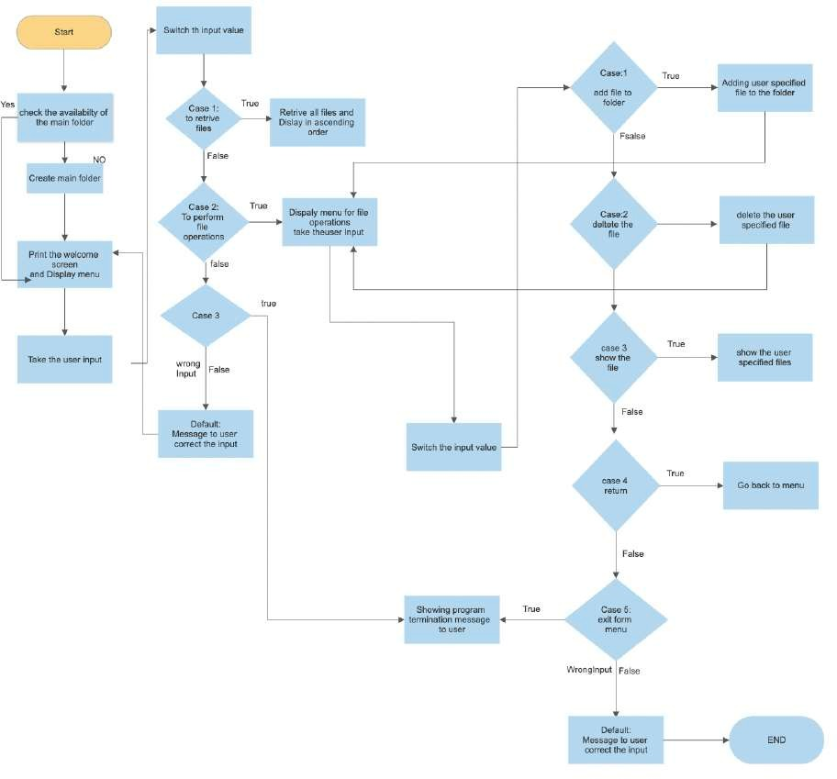

# SPRINT PLANNING

This application is planned to complete in 5 sprints.

The sprints are

a.) Developing the flow of application.

b.)configure the Git Repository to maintain and track the flow and development of the application.

c.) Developing the programs based on the user requirements. d.) Testing the project with different user aspects.

e.)Documenting about the complete project about its capability and working .

# FLOW OF APPLICATION

1. **CONCEPTS USED IN THE APPLICATION**

This project uses file Handling, sorting of files, Recursion, exception handling and flow control and streams IN JAVA programming

1. **APPLICATION DETAILS AND USER INTERACTIONS**

### Demonstrating the product capabilities, appearence and user interactions

The Steps Taken While developing the application

1. Creating a New Project called “Lockers”

—> Open Eclipse or Spring or any IDE

—> Go to File—> New—> Project —>JavaProject—> Next

—> Enter the Project title as “Lockers” then Click on Finish

—> Select the project and go to File—>New—>class.

—> write a Main java application program has welcome screen and primary menu options i.e. “**LockedmeMain.java**”

1. Writing a program to perform Primary menu options handling methods i.e

### “PrimaryOptions.java”

1. Writing a program of java class having methods to perform all the file operations such as crating file, deleting file, showallfiles, list them recursively and searching file etc.

### i.e “FileOPerations.java”

1. Writing a program to perform user specified operation on main folder having files

### i.e “SecondaryMenu.java”

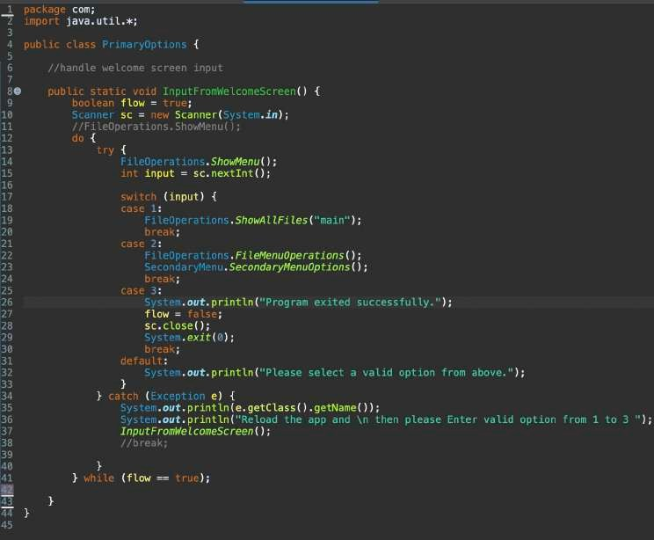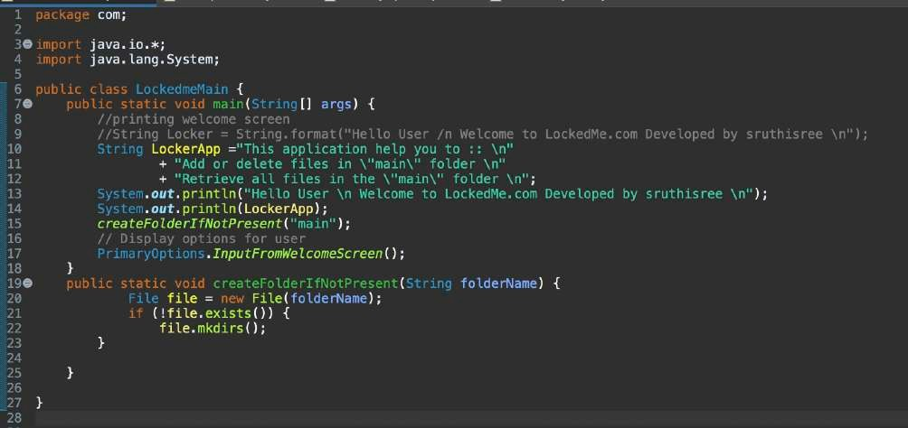

**Source code:**

**LockedmeMain.java**

**PrimaryOptions.java**

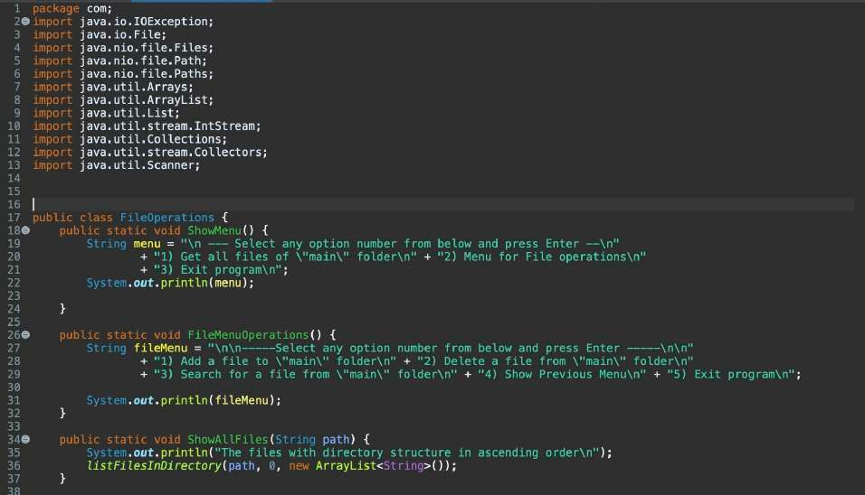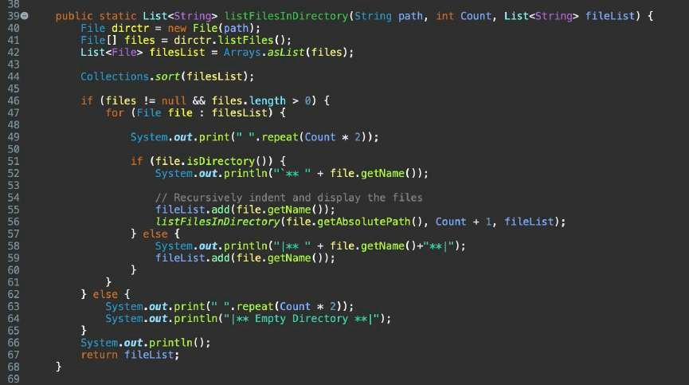

# FileOperation.java

ShowMenu() :: Primary Menu options FileMenuOerations() :: Menu for file Operations ShowAllFiles(String path) :: to Display all files in main

listFilesInDirectory():: to sort the files based on their size

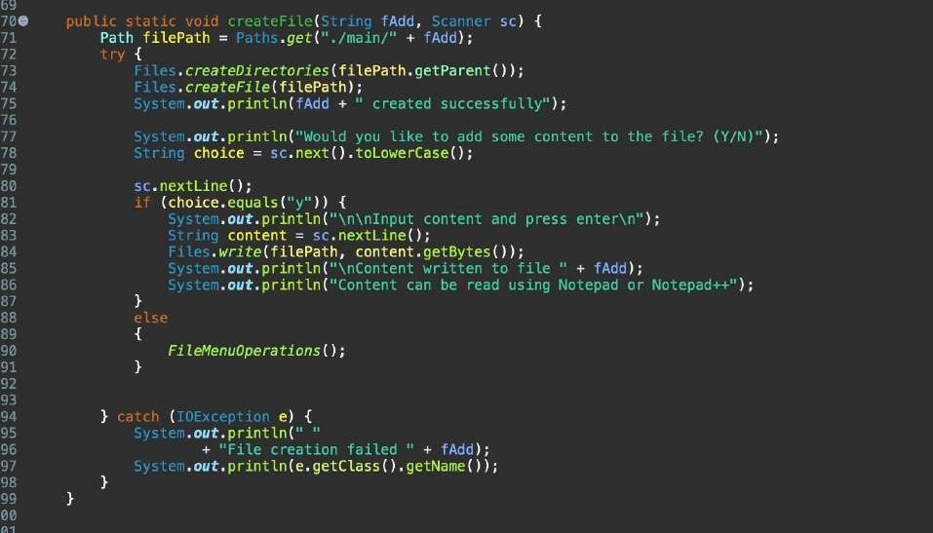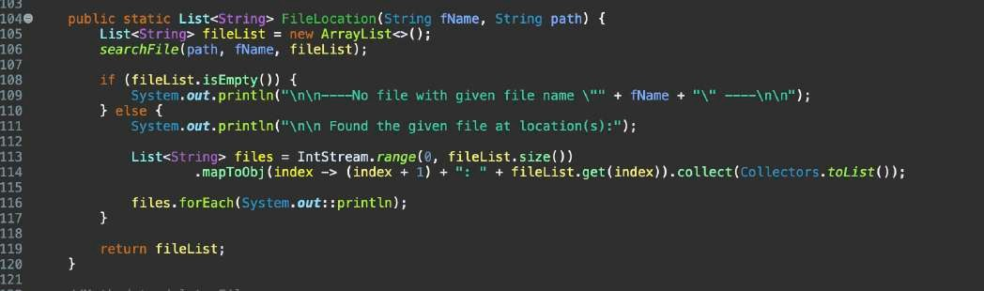

FileLocation() :: Method to display the Location of the user specified file

CreateFIle(String,scanner) :: To create user specified file

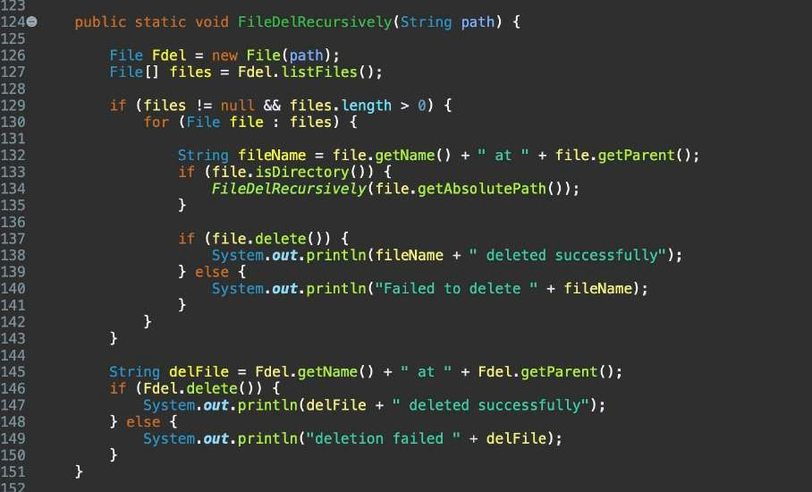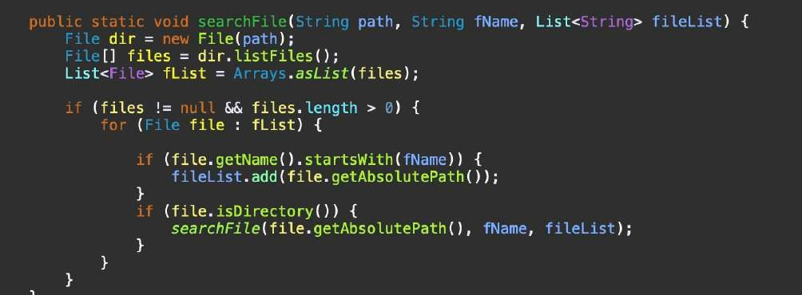

FileDelRecursivley(String) :: To delete user specified file

searchFile(String,String,List) :: Method to search file

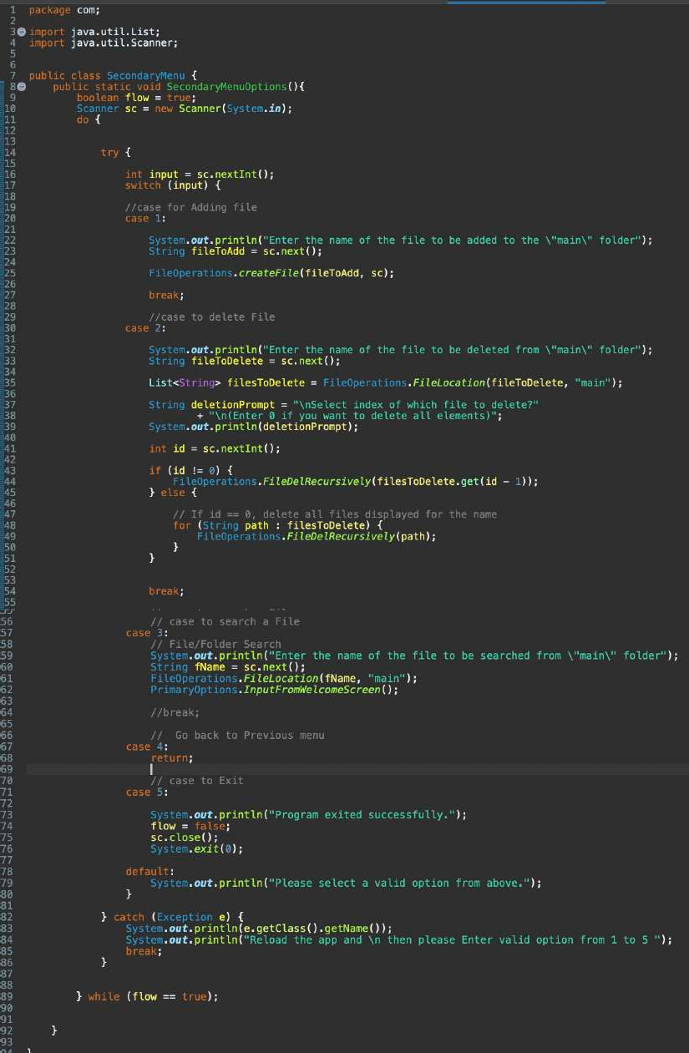

# SecondaryMenu.java

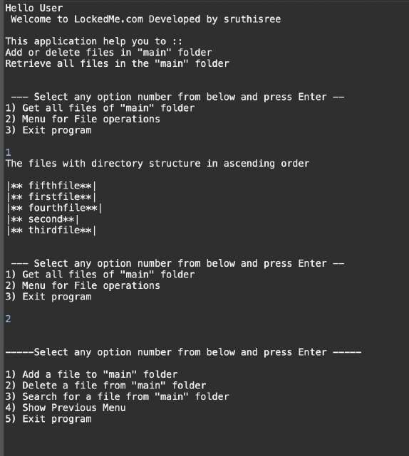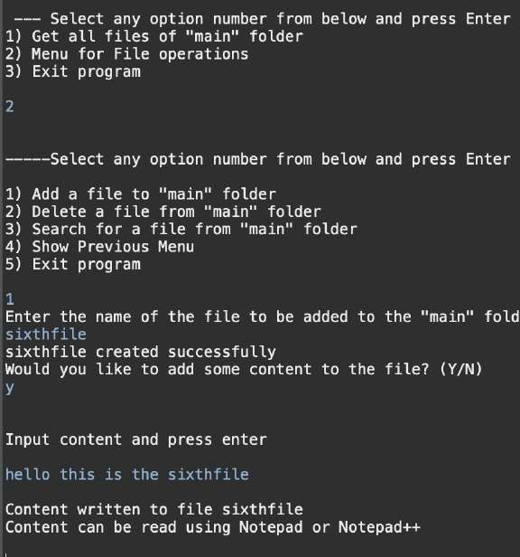

## OUTPUT

WelcomeScreen with Primary and secondary menu options

Adding file

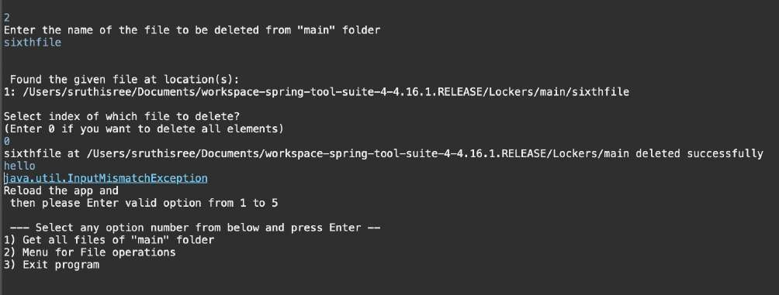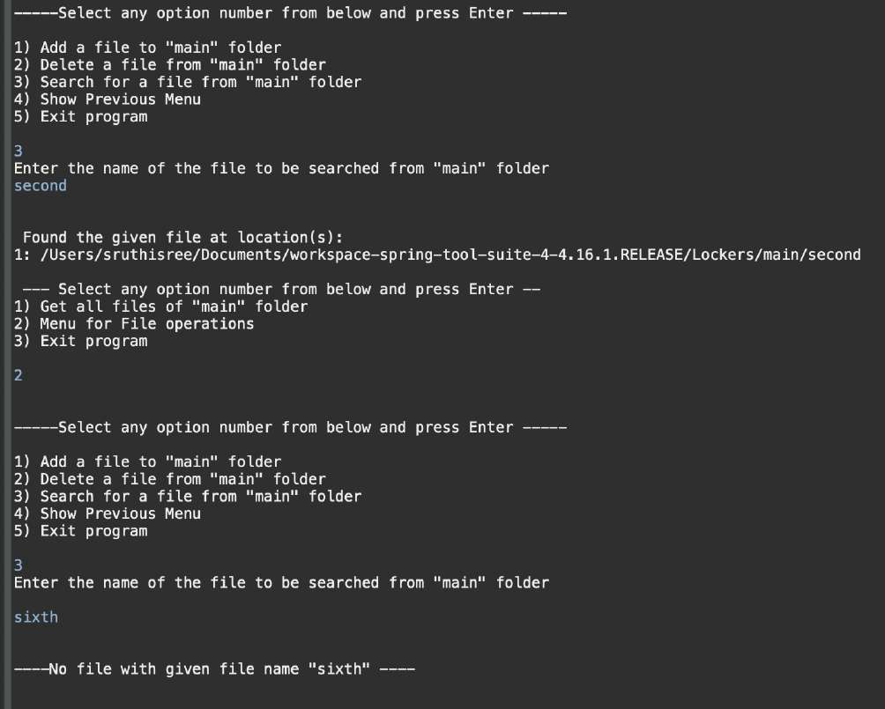

Deleting file and Handling the exception after entering the wrong output

Searching for file and output verification with handling exceptions

Steps to push the code in git Repositories

Step-1: Create a new GitHub Repository and Goto Directory which has project “Lockers”

$ cd documents/projects/simplilearn/Lockers; Step-2: Initialise Git in the project folder

$ git init —>enter

Step-3 : Add the files to Git Repository

$ git add -A

Step-4 : Push the files to the folder you initially created using the following command:

$ git push -u origin master

**Unique features of the Application**

1. This application performs all the Operations on user specified files.
2. This application completely work with user interactions.User can switch to the different inputs. 3.This application is designed to handle all the operations along with the exception handling.

4.The application developed with very less hard coding of data

**Conclusion**

The application provides all the file operations with completely user interactions.

Future enhancements will amend on concepts of file appendence and file selection based on last modified date and time and content in the file and type of the file.