**SRI CHANDRASEKHARENDRA SARASWATHI VISWA MAHAVIDYALAYA**

**(UNIVERSITY ESTABLISHED under section 3 of UGC Act 1956)**

**ENATHUR,** **KANCHIPURAM – 631 561**



**PROBLEM SOLVING TECHNIQUES IN C**

**LABORATORY RECORD**

**Name :** P. Sruthi

**Reg. No :** 112534050

**Class :** I Year BCA -‘A’

**Subject :** SEC101- PST IN C LAB

**SRI CHANDRASEKHARENDRA SARASWATHI**

**VISWA MAHAVIDYALAYA**

**(University Established under section 3 of UGC Act 1956)**



**BONAFIDE CERTIFICATE**

**This is to Certify that this is the bonafide record of work done by Ms. P.SRUTHI with** [**Reg.No**](http://reg.no) **112534050 of I Year Bachelor of Computer Applications in the Problem Solving Techniques in C Lab during the year 2025.**

**Staff-in-charge** **Head of the Department**

**Submitted for the Practical Examination held on ________________________**

**Internal Examiner** **External Examiner.**

**INDEX**

|  |  |  |  |  |
| --- | --- | --- | --- | --- |
| **S.NO** | **DATE** | **TITLE** | **PAGE NO.** | **SIGNATURE** |
| **1** | **24 Jul 2025** | Celsius to Fahrenheit |  |  |
| **2** | **31 Jul 2025** | Fibonacci Series |  |  |
| **3** | **7 Aug 2025** | Square and Cube of Numbers |  |  |
| **4** | **14 Aug 2025** | Generate Odd Numbers |  |  |
| **5** | **21 Aug 2025** | Generate Grade |  |  |
| **6** | **28 Aug 2025** | Genearate Tower |  |  |
| **7** | **4 Sep 2025** | Palindrome or Not |  |  |
| **8** | **25 Sep 2025** | String Handling |  |  |
| **9** | **25 Sep 2025** | Array Sorting |  |  |
| **10** | **9 Oct 2025** | Factorial |  |  |
| **11** | **9 Oct 2025** | Swapping of Numbers |  |  |
| **12** | **23 Oct 2025** | Using Structures |  |  |
| **13** | **23 Oct 2025** | File Programming |  |  |

|  |  |  |
| --- | --- | --- |
| **S.NO:** | **GRADE** | **DATE:** |

**AIM:**

To write a C program that reads marks (from 0 to 100) and prints the corresponding grade using a **switch-case** statement based on this grading:

**ALGORITHM:**

STEP 1: start

STEP 2: Declare a variable(n) to store marks

STEP 3: enter marks

STEP 4: Check if 0 <= marks <= 100 continue else go to step 8

STEP 5: calculate range=marks/10

STEP 6: Use switch case to decide the grade:

If range(80-100) grade= A

If range(60-79) grade =B

If range(50-59) grade =C

If range(40-49) grade =D

If range(0-39) grade=F

STEP 7: Print the grade.

STEP 8: End

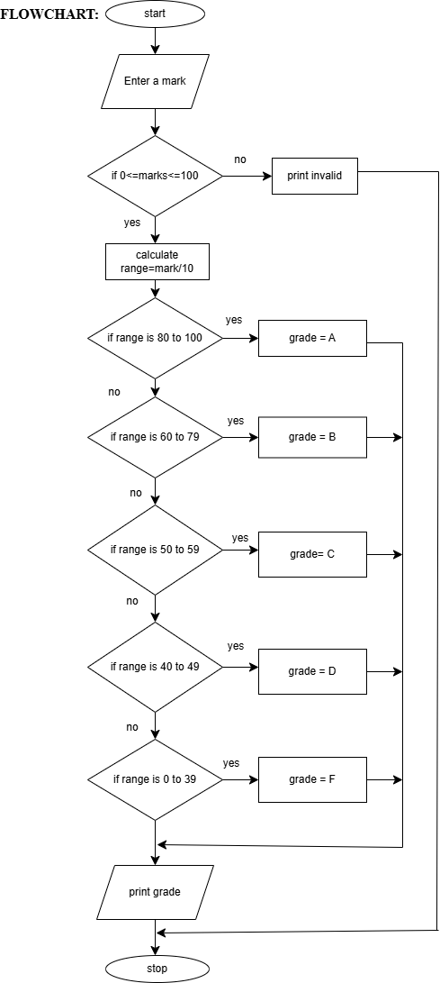

**SOURCE CODE:**

[**https://github.com/sruthisruthi18112007/c-lab/blob/main/grade.c**](https://github.com/sruthisruthi18112007/c-lab/blob/main/grade.c)

**OUTPUT:**

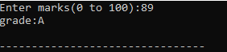





**RESULT:**

Thus the program is compiled and executed successfully with verified output.

|  |  |  |
| --- | --- | --- |
| **S.NO:** | **GENERATE TOWER** | **DATE:** |

**AIM:**

TO Write a C program that prints a right angled triangle pattern using a given character and number of lines.

**ALGORITHM:**

STEP 1:start.

STEP 2:declare variables: Limit (n), counters (i,j).

STEP 3**:** enter a character to print**, ch.**

STEP 4: enter a limit n.

STEP 5:i=1.

STEP 6: j=1.

STEP 7: Print character.

STEP 8**:** j++ .

STEP 9: If j<i, goto step 7, else continue

STEP 10: i++.

STEP11: print ‘\n’

STEP 12: if i<n, goto step 6, else continue

STEP 13 : stop.

**FLOWCHART:**

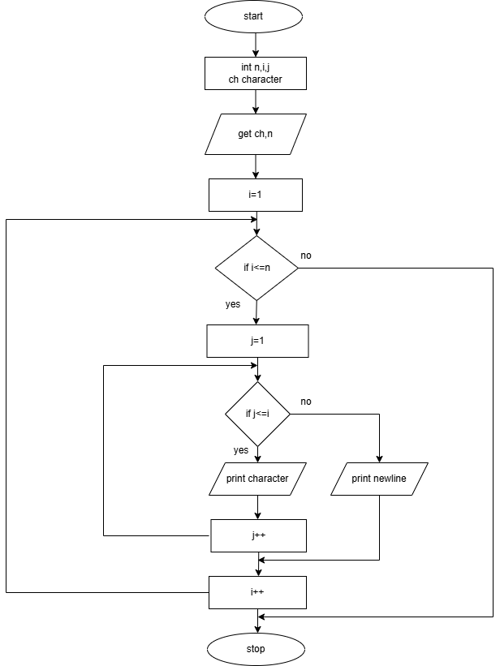

**SOURCE CODE:**

[**https://github.com/sruthisruthi18112007/c-lab/blob/main/tower.c**](https://github.com/sruthisruthi18112007/c-lab/blob/main/tower.c)

**OUTPUT:**

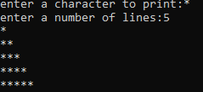

**RESULT:**

Thus the program is compiled and executed successfully with verified output.