SRI CHANDRASEKHARENDRA SARASWATHI VISWA MAHAVIDYALAYA

(UNIVERSITY ESTABLISHED under section 3 of UGC Act 1956)

ENATHUR, KANCHIPURAM – 631 561



OBJECT ORIENTED PROGRAMMING IN JAVA

LABORATORY RECORD

Name : P.SRUTHI

Reg. No : 112534050

Class : I YEAR BCA

Subject : UCAF252T50 – OOP in Java Lab

SRI CHANDRASEKHARENDRA SARASWATHI

VISWA MAHAVIDYALAYA
(University Established under section 3 of UGC Act 1956)



BONAFIDE CERTIFICATE

This is to Certify that this is the bonafide record of work done by Ms. P.SRUTHI with Reg. No 112534050 of I Year BCA in the Object Oriented Programming in Java Lab during the year 2026.

Staff-in-charge Head of the Department

Submitted for the Practical Examination held on ________________________

Internal Examiner External Examiner.

INDEX

S.No. | Date | Title | Page No. | Signature
1 | 05 Feb 2026 | PROGRAM USING CLASS, OBJECT, OVERLOADED METHODS, COMMAND LINE ARGUMENTS | 01
2 | 12 Feb 2026 | PROGRAM TO EXPLORE JAVA.LANG.MATH CLASS METHODS AND CUSTOM PACKAGE
3 | 12 Feb 2026 | PROGRAM TO EXPLORE STRING AND STRINGBUFFER METHODS
4 | 19 Feb 2026 | PROGRAM TO DEMONSTRATE INHERITANCE,  DYNAMIC DISPATCH CONCEPTS
5 | 26 Feb 2026 | PROGRAM TO EXPLORE BUILT IN EXCEPTIONS AND STATIC METHODS
6 | 05 Mar 2026 | PROGRAM TO EXPLORE USER-DEFINED (CUSTOM) EXCEPTIONS
7 | 26 Mar 2026 | PROGRAM TO EXPLORE MULTI THREADING
8 | 26 Mar 2026 | PROGRAM TO EXPLORE FILE OPERATIONS
9 | 02 Apr 2026 | PROGRAM TO EXPLOREL COLLECTIONS FRAMEWORK (DATASTRUCTURES) AND JAVADOC
10 | 09 Apr 2026 | SAMPLE GUI WITH EVENT HANDLING USING JAVA SWINGS
11 | 16 Apr 2026 | DATABASE PROGRAMMING WITH JAVA.SQL

1 | PROGRAM USING CLASS, OBJECT, OVERLOADED METHODS, COMMAND LINE ARGUMENTS | 05 Feb 2026

AIM:
To demonstrate the use of classes, packages, method overloading, and command-line arguments in Java.

UML DIAGRAMS:
Package Diagram:
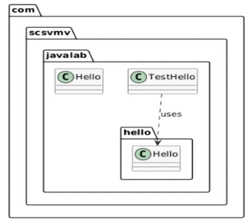

Class Diagram:
com.scsvmv.javalab.hello.Hello
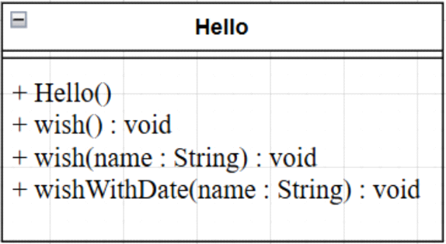

com.scsvmv.javalab.Hello
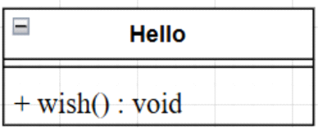

com.scsvmv.javalab.TestHello
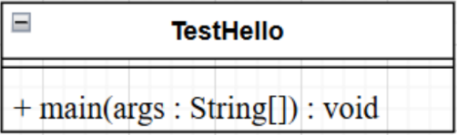
SOURCE CODE:
https://github.com/sruthisruthi18112007/javalab/tree/main/pgm1/src/com/scsvmv/javalab/hello

PROGRAM PATH:

- com/scsvmv/javalab/Hello.java

package com.scsvmv.javalab;
/*
*Simple Hello class
*Always wishes Hello World
*/

public class Hello{
public void wish(){
System.out.println("Hello World");
}
}

- com/scsvmv/javalab/TestHello.java
package com.scsvmv.javalab;
import com.scsvmv.javalab.hello.Hello;
/*
*TestHello class
*Demonstrates passing command-line arguments
*/
public class TestHello{
public static void main(String[] args){
Hello simpleHello = new Hello();
simpleHello.wish();

com.scsvmv.javalab.hello.Hello h =
new com.scsvmv.javalab.hello.Hello();

if(args.length>0){
h.wish(args[0]);
h.wishWithDate(args[0]);
}else{
System.out.println("Usage:");
System.out.println("java com.scsvmv.javalab.TestHello<name>");
System.out.println("Example:");
System.out.println("java com.scsvmv.javalab.TestHello Student");
}
}
}

- com/scsvmv/javalab/hello/Hello.java

package com.scsvmv.javalab.hello;
import java.util.Date;
/*
*Hello class
*Demonstartes method overloading and command-line arguments
*/
public class Hello{
public Hello(){
}
public void wish(){
System.out.println("Hello World");
}
public void wish(String name){
System.out.println("Hello" + name);
}
public void wishWithDate(String name){
Date today = new Date();
System.out.println("Hello"+name+"Date:"+today);
}
}

OUTPUT:
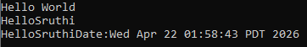

2 | PROGRAM TO EXPLORE JAVA.LANG.MATH CLASS METHODS AND CUSTOM PACKAGE | 12 Feb 2026

AIM:
To demonstrate the use of important methods in java.lang.Math class and to experiment custom packages in Java.

UML DIAGRAMS:
Class Diagram:
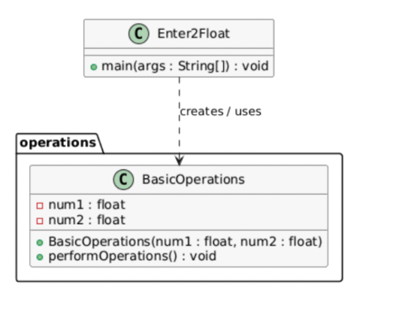
Sequence Diagram:
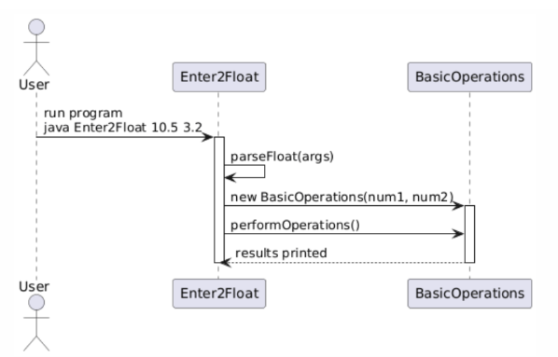

Package Diagram:

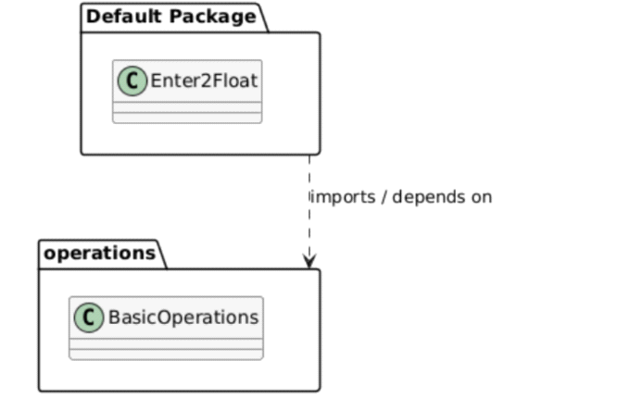
SOURCE CODE:

https://github.com/sruthisruthi18112007/java-lab/tree/main/pgm2/operations

PROGRAM PATH:

- pgm2/Enter2Float.java
import operations.BasicOperations;
public class Enter2Float {
public static void main(String[] args) {
if (args.length != 2) {
System.out.println("Usage: java Enter2Float <num1> <num2>");
return;
}
try {
float num1 = Float.parseFloat(args[0]);
float num2 = Float.parseFloat(args[1]);

BasicOperations obj1 = new BasicOperations(num1, num2);
obj1.performOperations();

BasicOperations obj2 = new BasicOperations(10, 3);
obj2.performOperations();
} catch (NumberFormatException e) {
System.out.println("Please enter valid float numbers.");
}
}
}

Pgm2/operations/BasicOperations.java

OUTPUT:
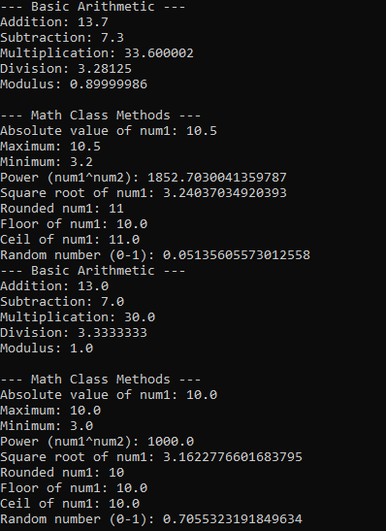

3 | PROGRAM TO EXPLORE STRING AND STRINGBUFFER METHODS | 12 Feb 2026

AIM:
To demonstrate the use of String and StringBuffer methods in Java using command-line arguments.

UML DIAGRAMS:
Class Diagram
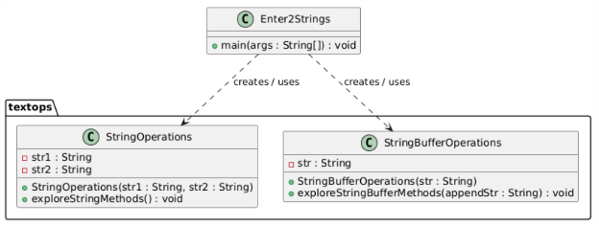

Package Diagram

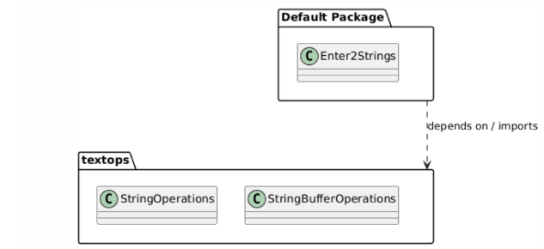

SEQUENCE DIAGRAM:
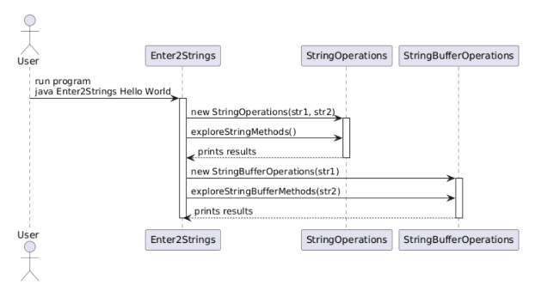

SOURCE CODE :

https://github.com/sruthisruthi18112007/java-lab/tree/main/pgm3/textops

OUTPUT:
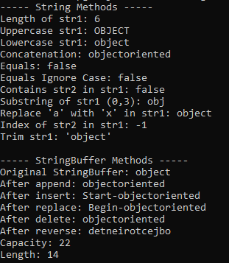

4 | PROGRAM TO DEMONSTRATE INHERITANCE, DYNAMIC DISPATCH CONCEPTS | 19 Feb 2026

AIM:
To demonstrate interfaces, inheritance, polymorphism (static & dynamic), and use of super keyword in Java.
UML DIAGRAMS:
Package and Class Diagram:
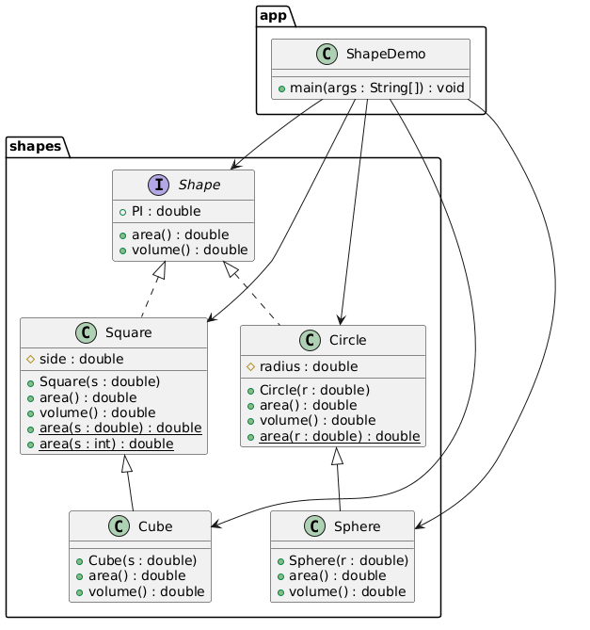
SEQUENCE DIAGRAM:

SOURCE CODE:
https://github.com/sruthisruthi18112007/java-lab/tree/main/pgm4

OUTPUT:

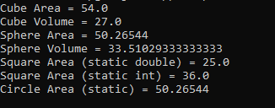

5 | PROGRAM TO EXPLORE BUILT IN EXCEPTIONS AND STATIC METHODS | 26 Feb 2026

AIM:
To demonstrate built-in exception handling and the use of static methods in Java.

UML DIAGRAM:

Class Diagram:
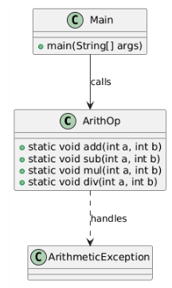
Sequence Diagram:

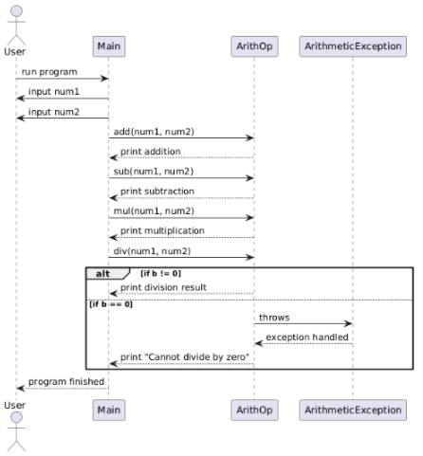
SOURCE CODE:
https://github.com/sruthisruthi18112007/java-lab/tree/main/pgm5

OUTPUT:
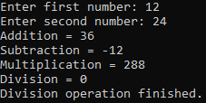

6 | PROGRAM TO EXPLORE USER-DEFINED (CUSTOM) EXCEPTIONS | 05 March 2026

AIM:
To demonstrate custom exception in Java.

UML DIAGRAM:

Class Diagram:

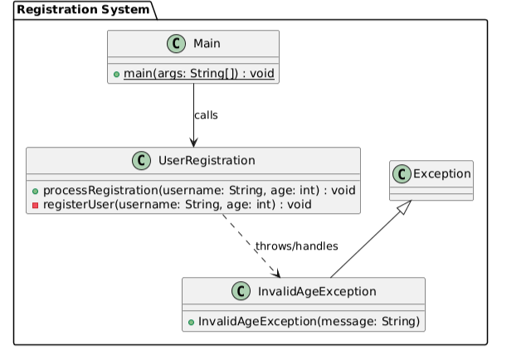

Sequence Diagram:
Failure scenario

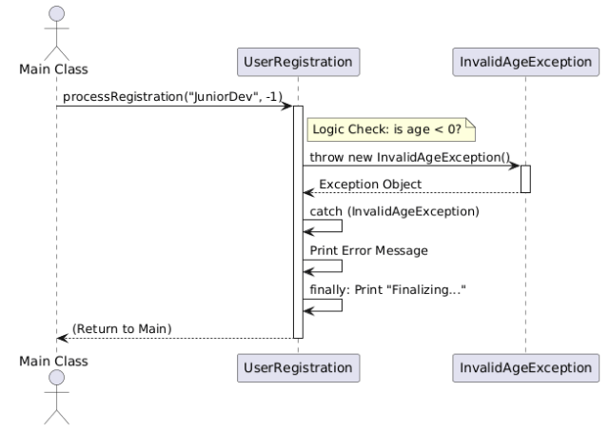

Sequence Diagram: Success Flow

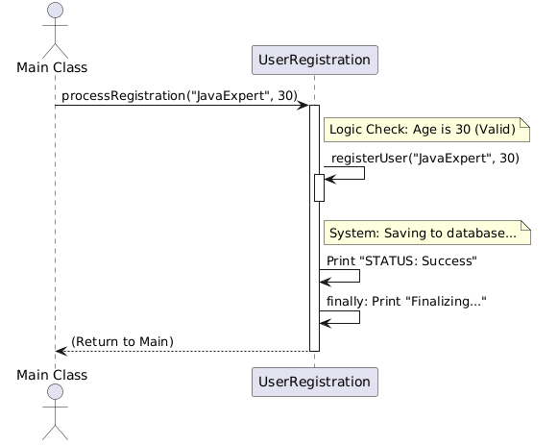

SOURCE CODE:

https://github.com/sruthisruthi18112007/java-lab/tree/main/pgm6

OUTPUT:

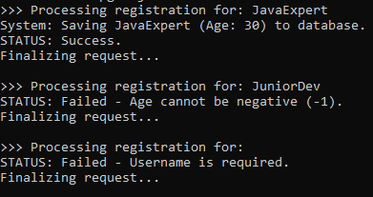

7 | PROGRAM TO EXPLORE MULTI THREADING | 26 March 2026

AIM:
To demonstrate Multithreading in Java.

UML DIAGRAM:

Class Diagram:

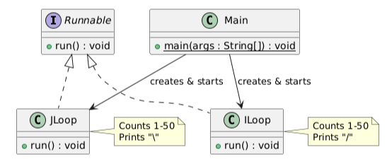
Sequence Diagram:
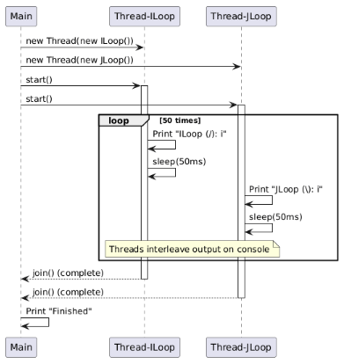
SOURCE CODE:

https://github.com/sruthisruthi18112007/java-lab/tree/main/pgm7

OUTPUT:

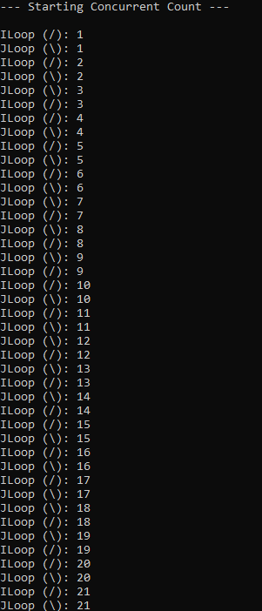

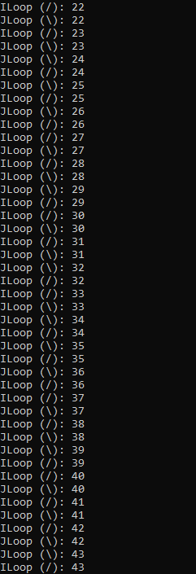
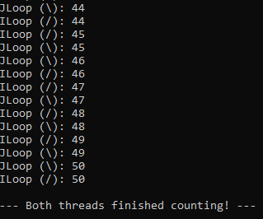
8 | PROGRAM TO EXPLORE FILE OPERATIONS | 26 March 2026

AIM:
To demonstrate File Operations using java.io package classes in Java.

UML DIAGRAM:

Class Diagram:
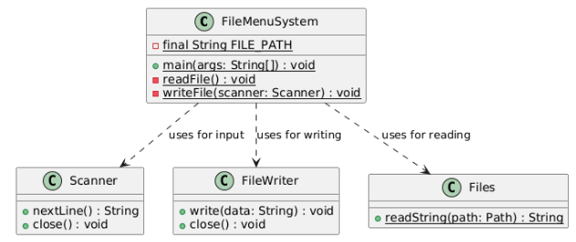
Activity Diagram:
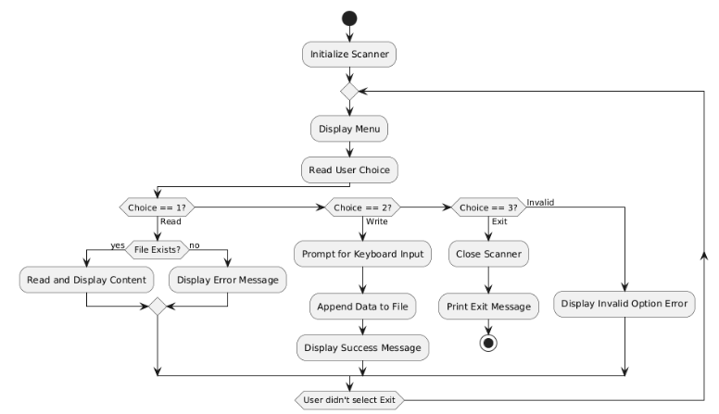SOURCE CODE:

https://github.com/sruthisruthi18112007/java-lab/tree/main/pgm8

OUTPUT:

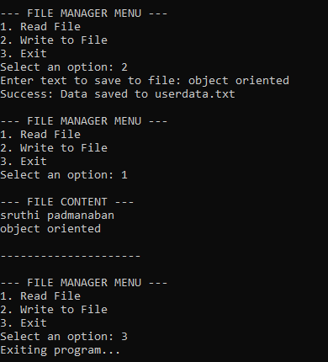

9 | PROGRAM TO EXPLOREL COLLECTIONS FRAMEWORK (DATA STRUCTURES) AND JAVADOC | 02 Apr 2026

AIM:
To demonstrate Data Structure Operations using java.util collections framework and to experiment Javadoc feature.

UML DIAGRAM:

CLASS DIAGRAM:
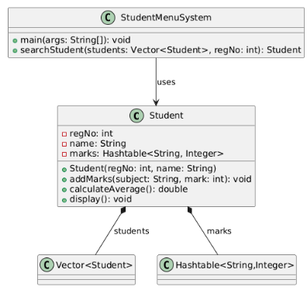
USE CASE DIAGRAM:
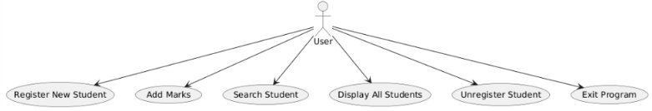
ACTIVITY DIAGRAM:
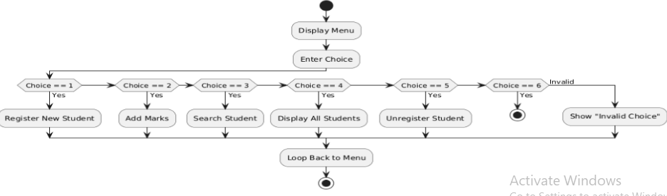

SEQUENCE DIAGRAM:
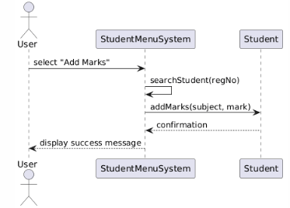
SOURCE CODE:
https://github.com/sruthisruthi18112007/java-lab/tree/main/pgm9

OUTPUT:

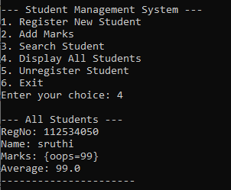
10 | SAMPLE GUI WITH EVENT HANDLING USING JAVA SWINGS | 09 Apr 2026

AIM:
To demonstrate java Graphical User Interface and Event handling features using javax.swing components.

UML DIAGRAM:

PACKAGE AND CLASS DIAGRAM:
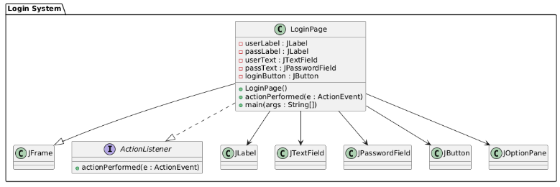
SEQUENCE DIAGRAM:

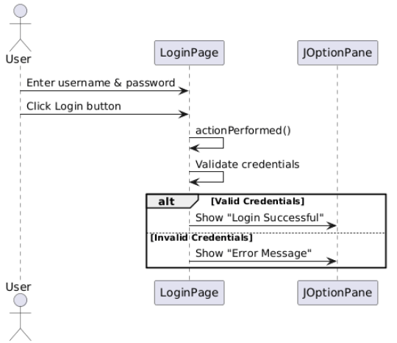

SOURCE CODE:

https://github.com/sruthisruthi18112007/java-lab/tree/main/pgm10

OUTPUT:

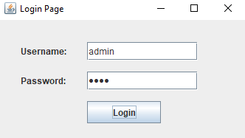

11 | DATABASE PROGRAMMING WITH JAVA.SQL | 16 Apr 2026

AIM:
To demonstrate data base connectivity capabilities with java.sql and mysql

UML DIAGRAM:

CLASS DIAGRAM:
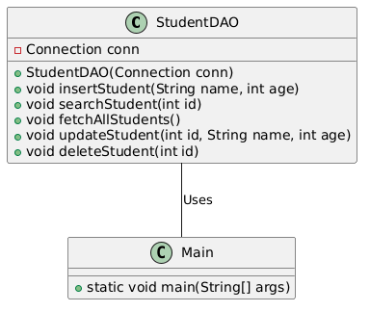
COMPONENT DIAGRAM:
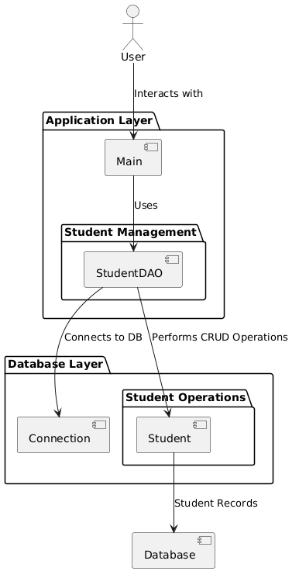

SEQUENCE DIAGRAM:
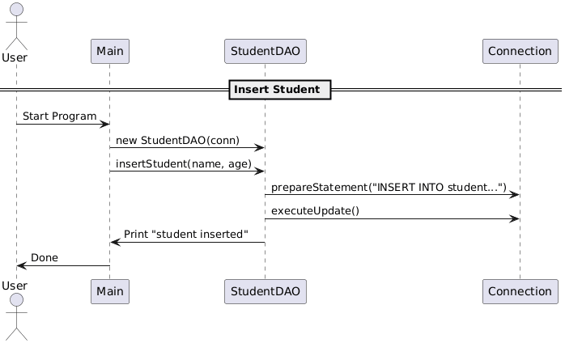

SOURCE CODE:

