Program 2:
List comprehensions:
(a)Generate positive list of numbers from a given list of integers
(b)square of N numbers

programcode(a):

numbers=[34.6,-203.4,44.9,68.3,-12.2,44.6,12.7]
newlist=[n for n in numbers if n>0]
print(newlist)numbers=[34.6,-203.4,44.9,68.3,-12.2,44.6,12.7]
newlist=[n for n in numbers if n>0]
print(newlist)
output:
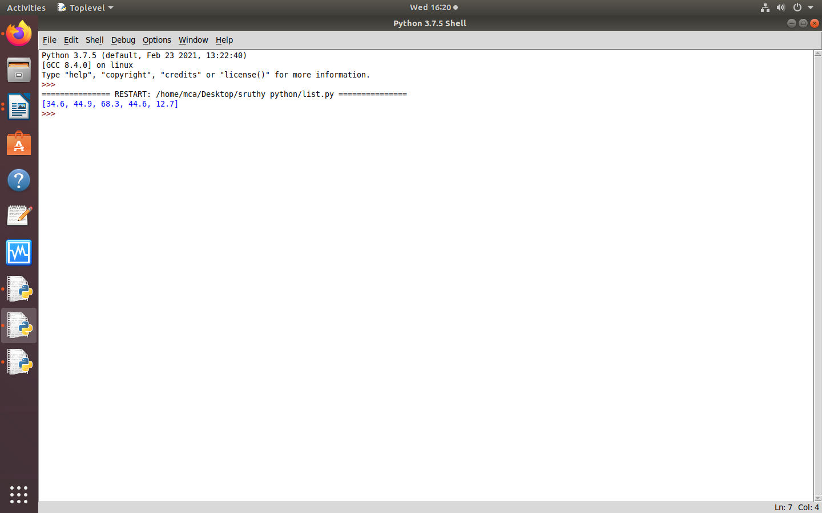
programcode(b):
print("enter the limit:")
n=int(input())
squares=[i*i for i in range(n)]
print("square of n numbers \n",squares)

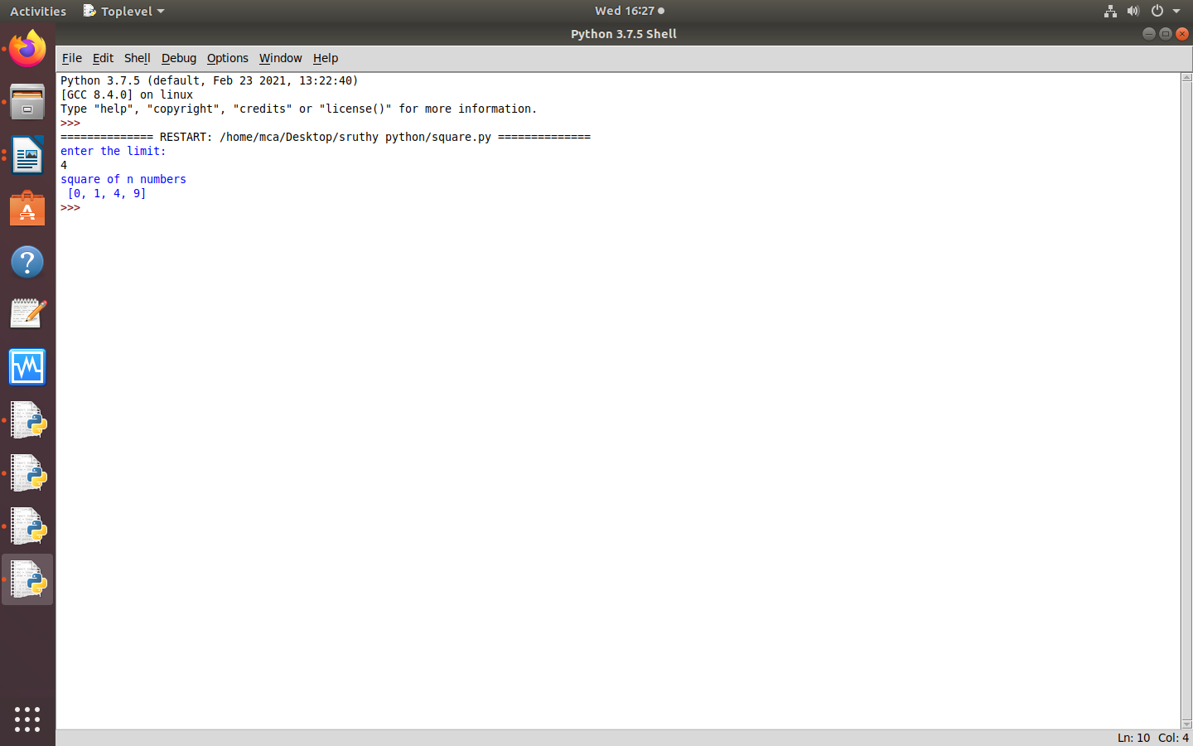
output:

