HeartWise
Heart Health Data Analytics and Machine Learning Project

Submitted by
Sruti Swarupa Mahapatra

IBM SkillsBuild & BharatCares
Data Analytics with AI Internship

Project: HeartWise — UCI Cleveland Heart Disease Analytics
Dataset: UCI Cleveland Heart Disease Dataset
Language: Python 3 | Tools: Pandas, Scikit-learn, Streamlit
EDUCATIONAL DISCLAIMER: This report and all associated analyses are created solely for learning purposes as part of an internship programme. This is NOT a medical diagnosis tool and must not be used for any clinical or health-related decision. Always consult a qualified healthcare professional.

Contents
Abstract 2
1. Introduction 2
2. Problem Statement 3
3. Project Objectives 3
4. Dataset Description 3
5. Methodology 4
6. Exploratory Data Analysis 5
7. Model Training 9
8. Model Evaluation 9
9. Model Comparison 11
10. Conclusions 12
11. Limitations 12
12. Ethical Considerations 13
13. References 14

Update field to see table of contents

Abstract
This report presents HeartWise, an end-to-end data analytics and machine learning project developed as part of the IBM SkillsBuild and BharatCares Data Analytics with AI internship. The project applies data science techniques to the UCI Cleveland Heart Disease dataset — a publicly available, real-world medical research dataset containing clinical measurements from 303 patients. The objective is to predict the binary presence or absence of heart disease using two supervised classification algorithms: Logistic Regression and Random Forest.
After cleaning (297 usable records following removal of 6 rows with missing values), exploratory data analysis revealed that chest pain type, maximum heart rate achieved, and ST depression are the most discriminating features. A stratified 80/20 train-test split was applied with StandardScaler fitted exclusively on the training set to prevent data leakage. Logistic Regression achieved 83.33% accuracy and a ROC-AUC of 0.9487, while Random Forest achieved 86.67% accuracy and a ROC-AUC of 0.9386. Random Forest outperforms on all classification metrics (Accuracy, Precision, Recall, F1 Score), while Logistic Regression demonstrates superior probability calibration as measured by ROC-AUC. Both models significantly exceed random-baseline performance. The project is delivered as a runnable Jupyter notebook, a modular Python codebase, and an interactive Streamlit web dashboard. All findings are strictly derived from the actual pipeline execution and verified programmatically. This project is educational only and must not be used for medical or clinical purposes.

1. Introduction
Cardiovascular disease remains the leading cause of death globally. According to the World Health Organization, an estimated 17.9 million people die each year from cardiovascular diseases, representing 32% of all global deaths. Early identification of risk factors and accurate prediction of disease presence can support preventive clinical decision-making.
Machine learning offers powerful tools for pattern recognition in clinical datasets. However, healthcare machine learning models must be developed with rigorous methodology, transparent evaluation, and honest acknowledgement of limitations — especially when data is limited in size or scope. This project, HeartWise, is an educational exercise applying these principles to a well-known public dataset.
HeartWise was developed as part of the IBM SkillsBuild and BharatCares Data Analytics with AI internship programme. The project demonstrates a complete data analytics pipeline: raw data ingestion, cleaning, exploratory analysis, feature preprocessing, model training, evaluation, and deployment as an interactive Streamlit dashboard. All code is modular, documented, and fully reproducible.

2. Problem Statement
Heart disease is notoriously difficult to diagnose without clinical testing, and its symptoms can be subtle or absent entirely. Clinicians rely on a combination of physiological measurements — including resting blood pressure, serum cholesterol, ECG results, and exercise-induced responses — to assess cardiovascular risk.
The problem addressed by this project is: given a set of 13 clinical features for a patient, can a machine learning model accurately classify whether that patient has heart disease? Specifically, this project aims to: (1) identify which clinical features are most predictive of heart disease in the Cleveland dataset; (2) compare the classification performance of Logistic Regression versus Random Forest; and (3) provide a reproducible, well-documented pipeline that demonstrates best practices in data science methodology.

3. Project Objectives
The specific objectives of this project are: (1) load and clean the raw UCI Cleveland Heart Disease dataset with transparent missing-value handling; (2) perform thorough exploratory data analysis to understand feature distributions and class relationships; (3) apply correct preprocessing including feature scaling with no data leakage; (4) train two supervised classification models with documented configurations; (5) evaluate models with Accuracy, Precision, Recall, F1 Score, and ROC-AUC; (6) compare models and draw justified conclusions; and (7) package the work as a reproducible Jupyter notebook, a modular Python project, and an interactive Streamlit dashboard.

4. Dataset Description
4.1 Source and Background
The dataset used in this project is the Cleveland subset of the UCI Heart Disease dataset, donated to the UCI Machine Learning Repository in 1988 by Andras Janosi (Hungarian Institute of Cardiology), William Steinbrunn (University Hospital, Zurich), Matthias Pfisterer (University Hospital, Basel), and Robert Detrano (V.A. Medical Center, Long Beach). It is one of the most widely cited datasets in medical machine learning research.
The file processed.cleveland.data contains 303 patient records with 14 attributes. The file has no header row; missing values are encoded as '?'. The original target attribute has values 0 to 4 representing the severity of heart disease. For binary classification, this is converted to: 0 = no heart disease, 1 = heart disease present (original values 1, 2, 3, or 4).
Key dataset statistics (verified from pipeline execution): Total rows: 303 | Rows after cleaning: 297 | Rows dropped (missing values): 6 | Features: 13 | Target classes: 2 (binary) | Class 0 (No Disease): 160 patients (53.9%) | Class 1 (Disease): 137 patients (46.1%) | Missing values: ca column = 4 rows, thal column = 2 rows.
4.2 Feature Dictionary
The 13 features span both continuous physiological measurements and categorical clinical indicators. The five numeric features are: age (years), trestbps (resting blood pressure in mm Hg), chol (serum cholesterol in mg/dl), thalach (maximum heart rate achieved in bpm), and oldpeak (ST depression induced by exercise relative to rest). The eight categorical features are: sex (0=Female, 1=Male), cp (chest pain type 1-4), fbs (fasting blood sugar > 120 mg/dl), restecg (resting ECG results 0-2), exang (exercise-induced angina 0/1), slope (slope of peak exercise ST segment 1-3), ca (major vessels coloured 0-3, missing values), and thal (thalassemia type 3/6/7, missing values).
Descriptive statistics for key numeric features (verified): Age — min 29, max 77, mean 54.54, std 9.05. Cholesterol — min 126, max 564, mean 247.35, std 52.00. Max Heart Rate — min 71, max 202, mean 149.60, std 22.94. Resting Blood Pressure — min 94, max 200, mean 131.69, std 17.76. ST Depression — min 0.0, max 6.2, mean 1.06, std 1.17.

5. Methodology
5.1 Project Architecture
The HeartWise project follows a modular architecture with all source code organised under a src/ directory containing five Python modules: data_loader.py (raw data ingestion and column naming), preprocessing.py (cleaning, scaling, train-test splitting), eda.py (EDA chart generation), model.py (training and serialisation), and evaluate.py (metrics and evaluation charts). The Streamlit dashboard in app.py imports from these modules. Trained models are persisted as .pkl files under outputs/ using joblib.
5.2 Data Cleaning
The raw file has no header row and encodes missing values as '?'. The data_loader.py module assigns all 14 column names manually and passes na_values='?' to pandas read_csv(), converting them to NaN at load time. The original file is never modified. The clean_data() function applies two transformations: (1) Row removal — all 6 rows containing NaN values are dropped (less than 2% of data, making dropping preferable to imputation); (2) Target binarisation — original values 1-4 are mapped to 1 (disease present) and 0 remains 0 (no disease). The cleaned dataset is saved to data/heart_cleaned.csv.
5.3 Feature Preprocessing and Train/Test Split
All 13 features are used as model inputs. StandardScaler is applied only to the 5 numeric features (age, trestbps, chol, thalach, oldpeak). Critically, the scaler is fitted exclusively on the training set and then applied transform-only to the test set. This prevents data leakage — fitting on the combined dataset would allow test-set information to influence scaling parameters, leading to optimistic performance estimates. The cleaned dataset is split 80/20 using stratified random sampling with random_state=42. Verified split: 237 training samples (128 no-disease, 109 disease) and 60 test samples (32 no-disease, 28 disease), both maintaining ~46% disease proportion.

6. Exploratory Data Analysis
Exploratory Data Analysis was performed on the cleaned dataset (297 rows) prior to any modelling. Seven distinct visualisations were generated using Matplotlib and Seaborn and saved to the outputs/figures/ directory. Key verified findings are described below.
6.1 Target Class Distribution
The cleaned dataset contains 160 patients with no heart disease (53.9%) and 137 patients with heart disease (46.1%). The dataset is nearly balanced, which is advantageous for classification. No resampling techniques (e.g. SMOTE) are required.
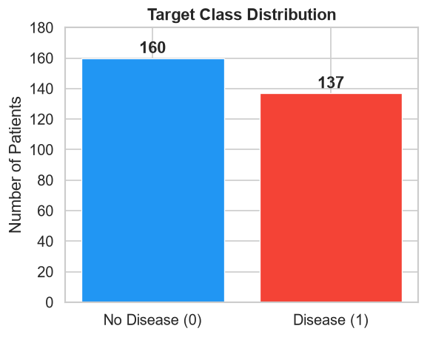
Figure 1: Target Class Distribution — 160 no-disease (0) vs 137 disease (1) patients.
6.2 Age Distribution by Disease Status
Both groups span ages 29 to 77. Patients with heart disease have a slightly higher median age. The distributions overlap significantly, indicating that age alone is a weak discriminator. It becomes more informative when combined with other features.
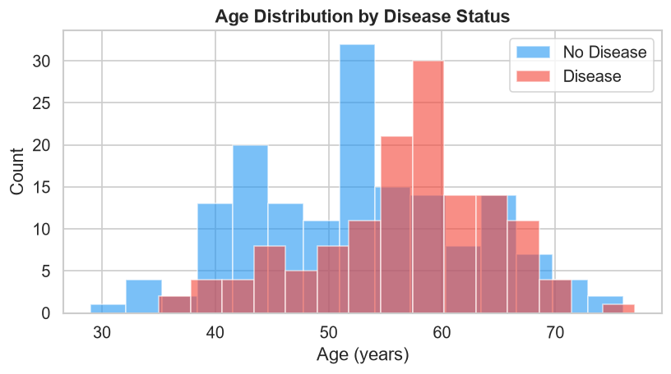
Figure 2: Age Distribution by Disease Status — overlapping histograms for disease (red) and no-disease (blue) patients.
6.3 Sex vs. Disease Status
Males make up the majority of patients in this dataset. The proportion of heart disease is notably higher among males than females. This reflects the sample composition from 1980s Cleveland clinical data and should not be generalised beyond this dataset.
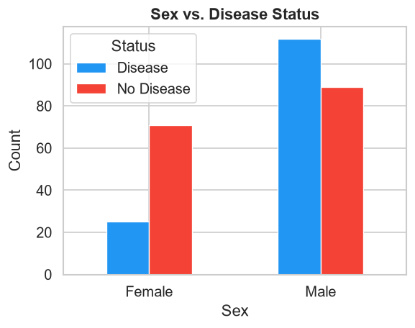
Figure 3: Sex vs. Disease Status — male patients show a higher proportion of heart disease in this sample.
6.4 Chest Pain Type vs. Disease Status
Patients with Asymptomatic chest pain (type 4) show the highest rate of heart disease. This is a clinically documented finding — asymptomatic presentation is often associated with more severe underlying disease. Typical Angina (type 1) patients, paradoxically, have a lower disease rate in this sample, which reflects known limitations in symptom-based diagnosis.
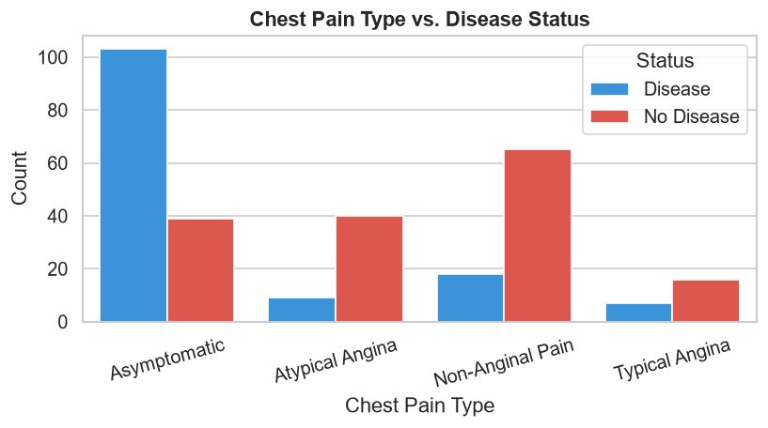
Figure 4: Chest Pain Type vs. Disease Status — Asymptomatic type (4) has the highest heart disease association.
6.5 Key Numeric Feature Box Plots
Four key numeric features were compared between disease and no-disease groups. Cholesterol distributions overlap substantially — cholesterol is a weak discriminator in this dataset. Age shows a slight shift upward for disease patients. Maximum heart rate (thalach) is notably lower in disease patients — healthy patients achieve higher peak heart rates during exercise. ST depression (oldpeak) is higher in disease patients, consistent with ischaemic heart changes.
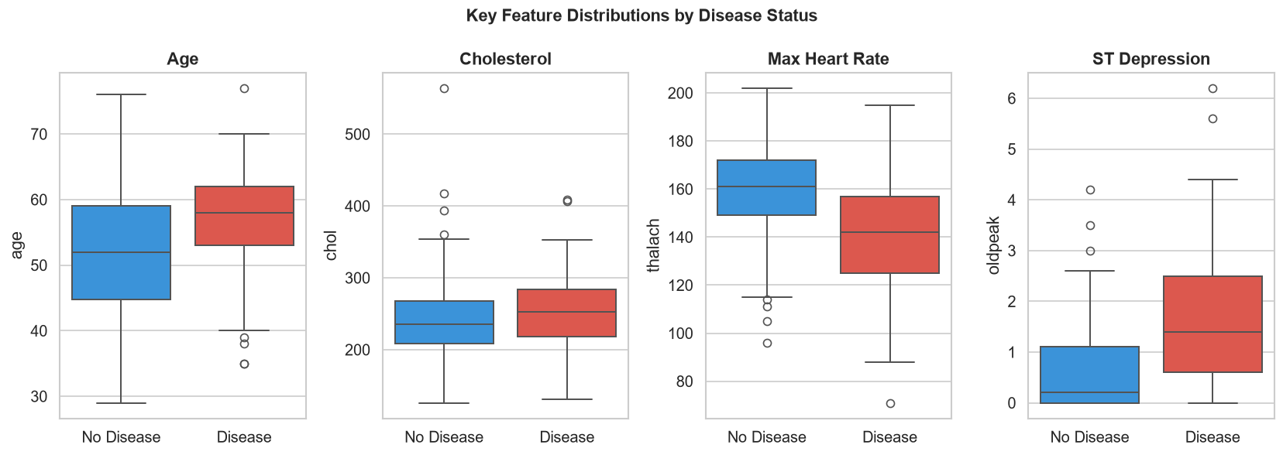
Figure 5: Box Plots of Age, Cholesterol, Max Heart Rate, and ST Depression by Disease Status. Thalach and oldpeak show the clearest separations.
6.6 Cholesterol Distribution
The cholesterol distributions for disease and no-disease patients are highly overlapping. Mean cholesterol is 247.4 mg/dl. No clear separation exists between the two classes, which is reflected in the low feature correlation of cholesterol with the target variable in the heatmap below.
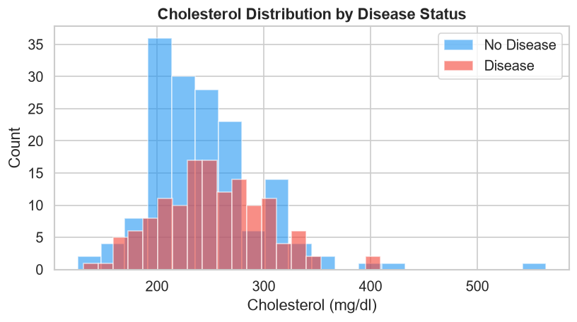
Figure 6: Cholesterol Distribution by Disease Status — distributions largely overlap, indicating low discriminative power.
6.7 Feature Correlation Heatmap
The Pearson correlation heatmap reveals that cp (chest pain type), thalach (max heart rate), exang (exercise angina), oldpeak (ST depression), and ca (vessels coloured) have the strongest absolute correlations with the target. Cholesterol (chol) and fasting blood sugar (fbs) show near-zero correlation with the target in this dataset. No features show high inter-feature correlation that would require removal due to multicollinearity.
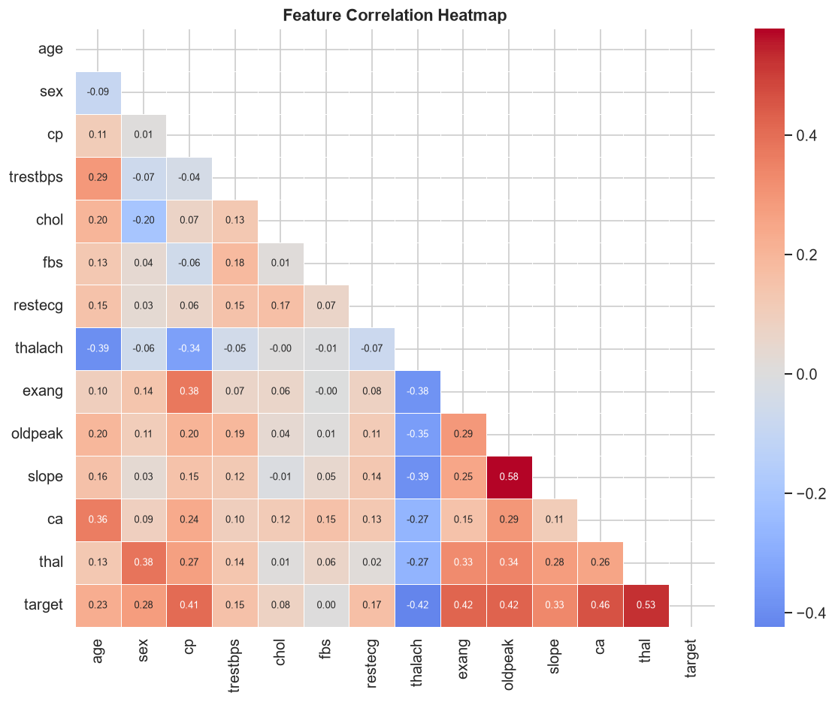
Figure 7: Feature Correlation Heatmap — cp, thalach, exang, oldpeak, and ca show the strongest correlations with target.

7. Model Training
Two supervised classification models were trained on the 237-sample training set. Both models were configured with random_state=42 for reproducibility.
7.1 Logistic Regression
Logistic Regression is a linear probabilistic classifier that models the log-odds of the target class as a linear combination of input features. It is interpretable, computationally efficient, and serves as a strong baseline for binary classification tasks. Configuration used: solver='lbfgs', max_iter=1000 (to ensure convergence), C=1.0 (default L2 regularisation), random_state=42.
Interpretability: The model's coefficients directly indicate the direction and relative magnitude of each feature's influence on disease probability. Verified top-5 feature coefficients by absolute magnitude: ca (+1.0020), sex (+0.8158), exang (+0.6809), fbs (-0.6772), cp (+0.5306). Positive coefficients increase predicted disease probability; negative coefficients decrease it.
7.2 Random Forest
Random Forest is an ensemble method that trains 100 independent decision trees on bootstrapped subsets of the training data (bagging) and aggregates their predictions by majority vote. It handles non-linear relationships and feature interactions that Logistic Regression cannot capture. Configuration used: n_estimators=100, random_state=42, n_jobs=-1 (all available CPU cores).
Feature importance is measured using the mean Gini impurity decrease across all trees. Verified top-5 features by importance: cp (0.1500), oldpeak (0.1226), thalach (0.1132), thal (0.1051), ca (0.0949). These five features collectively account for approximately 57% of total feature importance.
Both trained models and the fitted StandardScaler are saved as .pkl files under the outputs/ directory using joblib, allowing the Streamlit dashboard to load them at runtime without retraining.

8. Model Evaluation
All evaluation metrics are computed on the held-out test set (60 samples) that neither model saw during training or preprocessing. The following metrics are reported: Accuracy (overall correctness), Precision (proportion of disease predictions that are correct — minimises false alarms), Recall (proportion of actual disease cases correctly identified — minimises missed cases), F1 Score (harmonic mean of Precision and Recall), and ROC-AUC (area under the Receiver Operating Characteristic curve — measures discriminative ability across all decision thresholds).
In a medical screening context, Recall is particularly important because missing a true disease case (false negative) is typically more costly than a false alarm (false positive).
8.1 Logistic Regression Results
Verified results on the 60-sample test set: Accuracy = 83.33%, Precision = 84.62%, Recall = 78.57%, F1 Score = 81.48%, ROC-AUC = 94.87%. Confusion matrix: True Negatives = 28, False Positives = 4, False Negatives = 6, True Positives = 22. The model correctly identified 22 of 28 actual disease cases (79%) and 28 of 32 actual no-disease cases (88%). It produced 6 false negatives (missed disease cases) and 4 false positives.
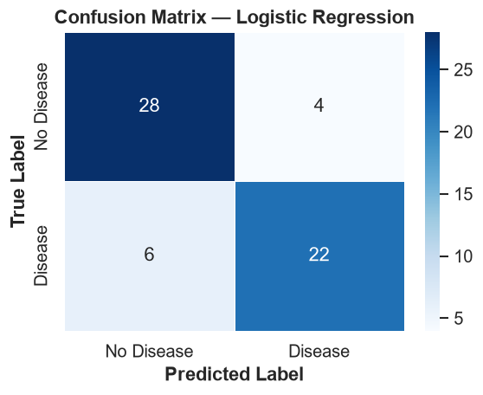
Figure 8: Confusion Matrix — Logistic Regression. TN=28, FP=4, FN=6, TP=22.
8.2 Random Forest Results
Verified results on the 60-sample test set: Accuracy = 86.67%, Precision = 88.46%, Recall = 82.14%, F1 Score = 85.19%, ROC-AUC = 93.86%. Confusion matrix: True Negatives = 29, False Positives = 3, False Negatives = 5, True Positives = 23. The model correctly identified 23 of 28 actual disease cases (82%) and 29 of 32 no-disease cases (91%). It produced 5 false negatives and 3 false positives — one fewer false negative than Logistic Regression.
8.3 ROC Curves
The ROC (Receiver Operating Characteristic) curve plots the True Positive Rate against the False Positive Rate at every possible classification threshold. A model with perfect discrimination traces a curve touching the top-left corner (AUC = 1.0). A random classifier follows the diagonal (AUC = 0.5). Logistic Regression achieves AUC = 0.9487 and Random Forest achieves AUC = 0.9386, both substantially above 0.9 — indicating excellent discriminative ability.
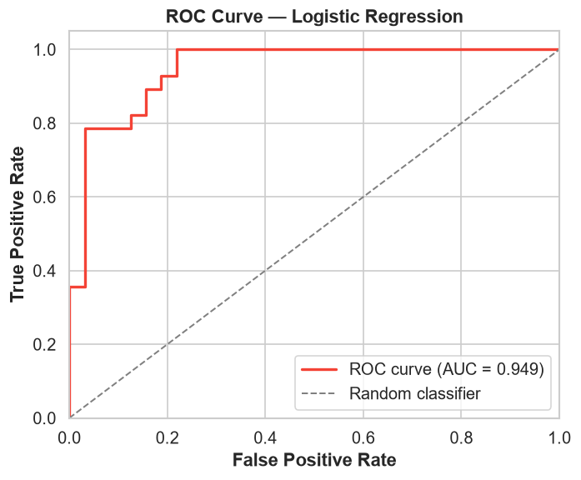
Figure 9: ROC Curve for Logistic Regression (AUC = 0.9487). Random Forest achieves AUC = 0.9386 (see notebook Figure).

9. Model Comparison
The following table summarises the verified performance of both models on the 60-sample test set.
Model | Accuracy | Precision | Recall | F1 Score | ROC-AUC
Logistic Regression | 83.33% | 84.62% | 78.57% | 81.48% | 94.87%
Random Forest | 86.67% | 88.46% | 82.14% | 85.19% | 93.86%
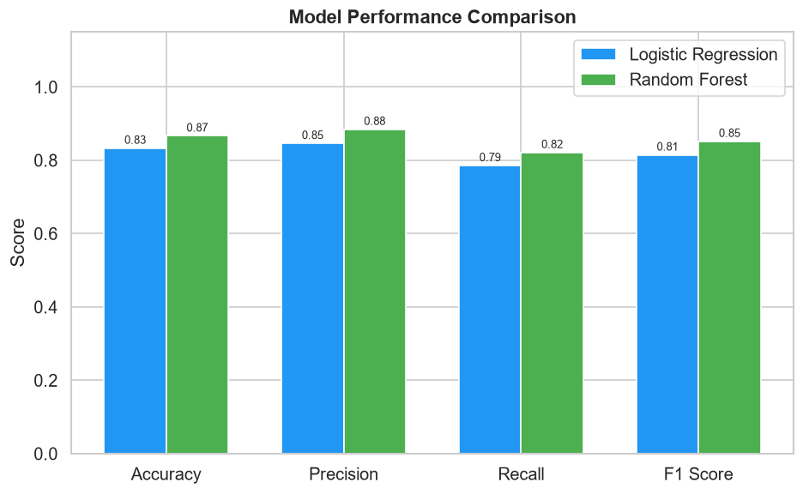
Figure 10: Model Performance Comparison — Random Forest outperforms on Accuracy, Precision, Recall, and F1 Score; Logistic Regression achieves higher ROC-AUC.
Analysis: Random Forest outperforms Logistic Regression on four of the five metrics — Accuracy (+3.3 percentage points), Precision (+3.8 pp), Recall (+3.6 pp), and F1 Score (+3.7 pp). The ensemble approach better captures non-linear feature interactions. However, Logistic Regression achieves a higher ROC-AUC (94.87% vs 93.86%), indicating that its probability outputs are better calibrated — it assigns more reliable confidence scores across all decision thresholds.
Recommendation: For an educational screening tool where avoiding missed disease cases (false negatives) is most important, Random Forest is the preferred model due to its higher Recall (82.14% vs 78.57%) and F1 Score. For an application requiring well-calibrated probability estimates (e.g. risk stratification), Logistic Regression is preferred due to its higher AUC and interpretable coefficients.

10. Conclusions
This project successfully demonstrated an end-to-end data analytics and machine learning pipeline applied to the UCI Cleveland Heart Disease dataset. The following conclusions are drawn from the verified analysis:
- Dataset: The cleaned dataset (297 rows) is nearly balanced with 53.9% no-disease and 46.1% disease cases. Only 6 rows required dropping due to missing values, preserving 98% of the original data.
- Most Predictive Features: Chest pain type (cp), ST depression (oldpeak), maximum heart rate (thalach), thalassemia type (thal), and number of major vessels coloured (ca) are the most important predictors. These are clinically meaningful features consistent with established cardiac risk indicators.
- Weak Features: Cholesterol (chol) and fasting blood sugar (fbs) show very low correlation with the target in this particular dataset, which differs from general population-level evidence. This illustrates a key data science principle: statistical associations in a specific dataset may not reflect causal or population-level relationships.
- Model Performance: Both models achieve strong results. Random Forest (86.67% accuracy, 85.19% F1, 82.14% recall) outperforms Logistic Regression (83.33% accuracy, 81.48% F1, 78.57% recall) on classification metrics. Logistic Regression achieves a higher ROC-AUC (94.87% vs 93.86%).
- Best Practice: Applying StandardScaler exclusively on training data, using stratified splits, and evaluating on a fully held-out test set ensures valid, unbiased performance estimates.

11. Limitations
The following limitations must be acknowledged:
- Small dataset size: 297 samples is very small for a robust medical machine learning model. Results may not generalise reliably to other populations or clinical settings.
- Single geographic and temporal source: All data originates from the Cleveland Clinic (USA, 1988). The dataset does not represent current populations, global demographics, or modern diagnostic criteria.
- No hyperparameter tuning: Models were trained with default or basic parameters. GridSearchCV or cross-validation-based tuning would likely improve results.
- No cross-validation: A single 80/20 train-test split was used. K-fold cross-validation would provide more statistically reliable performance estimates with confidence intervals.
- Binary target simplification: The original target had 5 severity classes (0-4). Converting to binary loses disease severity information and makes the task easier than real clinical diagnosis.
- Feature encoding: Categorical features were used as raw integers without one-hot encoding, which may imply ordinal relationships in the Logistic Regression model that do not reflect actual clinical ordering.
- No external validation: Models have not been evaluated on any dataset other than the 20% holdout from this same dataset. True generalisation performance is unknown.

12. Ethical Considerations
- Educational purpose only: This project is created solely for learning purposes as part of the IBM SkillsBuild and BharatCares Data Analytics with AI internship. It is not designed, validated, or intended for any clinical, diagnostic, or medical use whatsoever.
- No medical diagnosis: Predictions produced by the trained models must not be interpreted as medical diagnoses or used to make any health decisions. A model trained on 297 samples cannot replace clinical diagnosis by a qualified healthcare professional.
- Patient privacy: The UCI Cleveland Heart Disease dataset is a de-identified public research dataset approved for open research use. No personal identifying information is present.
- Bias and fairness: The dataset was collected from a specific clinical population (Cleveland, USA, 1988). Patterns learned may reflect historical sampling biases, demographic characteristics of that cohort, and medical practices of that era. They do not generalise to all populations.
- Transparency: All code, methodology, and hyperparameter choices are fully documented in SrutiSwarupa_HeartHealthAnalysis.ipynb. No metrics are reported that were not directly verified by running the documented pipeline.
- Responsible disclosure: All limitations of this model — small dataset, no cross-validation, single data source, no external validation — are explicitly stated. Users are clearly informed that these results must not be generalised to clinical practice.

13. References
1. Janosi, A., Steinbrunn, W., Pfisterer, M., & Detrano, R. (1988). Heart Disease Dataset (Cleveland). UCI Machine Learning Repository. https://archive.ics.uci.edu/ml/datasets/Heart+Disease
2. Detrano, R., Janosi, A., Steinbrunn, W., Pfisterer, M., Schmid, J., Sandhu, S., Guppy, K., Lee, S., & Froelicher, V. (1989). International application of a new probability algorithm for the diagnosis of coronary artery disease. The American Journal of Cardiology, 64(5), 304-310.
3. Pedregosa, F., Varoquaux, G., Gramfort, A., et al. (2011). Scikit-learn: Machine Learning in Python. Journal of Machine Learning Research, 12, 2825-2830. https://scikit-learn.org
4. McKinney, W. (2010). Data Structures for Statistical Computing in Python. Proceedings of the 9th Python in Science Conference, 56-61. https://pandas.pydata.org
5. Hunter, J. D. (2007). Matplotlib: A 2D Graphics Environment. Computing in Science & Engineering, 9(3), 90-95. https://matplotlib.org
6. Waskom, M. (2021). seaborn: Statistical Data Visualization. Journal of Open Source Software, 6(60), 3021. https://seaborn.pydata.org
7. IBM SkillsBuild Program. https://skillsbuild.org
8. BharatCares Data Analytics with AI Internship Programme. https://www.bharatcares.org
— End of Report —

