Creating Good Graphics

# Identifying the problem

Let’s start out by looking at some examples of less-than-effective charts.

## Example 1: Pie Chart Poll Results

See if you can spot the problem with this one, published in the March 16, 2021 Scottsbluff, NE Star Herald (wtfViz 2021).

|  |
| --- |
| Scottsbluff Star Herald Reader poll. |

Discuss:

* What is wrong with this chart?
* Do you think it might be misleading? If so, how?
* Do you think the mistakes were intentional?

## Example 2: High Support

While I didn’t intend this section to have a theme, here’s another chart on a similar topic from CBS News (wtfViz 2022).

|  |
| --- |
| High support. |

Discuss:

* What is wrong with this chart?
* What would you change to more accurately represent the data?
* Do you think the mistakes were intentional?

## Example 3: Gas Prices

Pie charts aren’t the only chart type that commonly are presented wrong. Here’s a bar chart that generated a lot of conversation online, from Express Web Desk (2018).

|  |
| --- |
| Gas and Diesel price changes in India (2004 - 2018). |

Discuss:

* What is wrong with this?
* What design choices contribute to the problems?
* Do you think this was intentionally designed to be misleading? Why or why not?

## Example 4: Information Overload

Not all charts are intentionally designed to be misleading. Sometimes, the desire to show all of the data goes awry. Here is an attempt to show 6 variables using three location variables, color, column length, and column width (Pies 2013). The original source doesn’t specify what variables are plotted, so analyze this based on its’ form, rather than the data it shows.

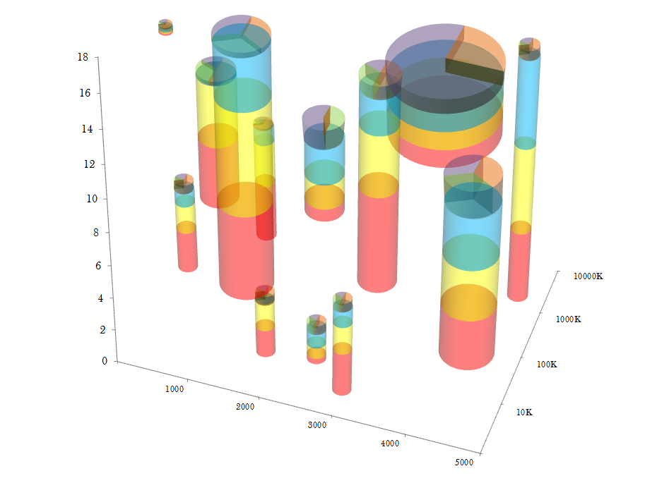

Discuss:

* What problems do you have reading this chart?
* Can you compare the quantities of all 6 variables shown? Why or why not?

(Yes, the blog this chart is taken from is satirical. This is *not* a recommended graphical form.)

These are some of my favorite examples, but of course, there are also bad charts in the scientific literature (Broman 2018). The goal of this module is to ensure that as you work on research, you will create effective graphics that are accessible and well-designed.

# Designing Good Charts

## Why Graphics Matter

Graphics are a form of **external cognition** that allow us to think about the *data* rather than the *chart*.

That is, graphics are a tool to make it easier for us to think about what the data means.

Good graphics take advantage of how the brain works, leveraging

* preattentive processing
* perceptual grouping
* awareness of visual limitations

Good graphics also depend on the data: the chart type should be chosen based on the types of variables you want to display, the amount of data you have, and the results you want to highlight.

### Example: Hertzsprung Russell Diagram

|  |
| --- |
| The Hertzsprung Russell diagram. Discovered independently by Ejnar Hertzsprung (1873–1967) and Henry Norris Russell (1877–1957). The diagram plots the color index of the star against the brightness (absolute magnitude) of the star. As a result, it is possible to discern that these two variables are related and change together over a star’s life cycle: a hypothesis that only came to be because of this chart. |

John Tukey, a famous statistician often considered the father of statistical graphics, wrote in Exploratory Data Analysis (1977):

The greatest value of a picture is when it forces us to notice what we never expected to see.

This chart is an excellent example of the value that good graphics create in research: they can help us understand our data in a new way, leading to innovations and new research directions.

Discuss:

* What variables are mapped to the following chart dimensions?
  + X location
  + Y location
  + color
* What other information is present on the chart that is not specifically a data value?
* What does this chart do well?
* What design features “work”?
* What don’t you like?

# References

Broman, Karl. 2018. “The Top Ten Worst Scientific Graphs.” Blog. *Karl Broman*. https://www.biostat.wisc.edu/~kbroman/topten_worstgraphs/.

Express Web Desk. 2018. “Twitter Abuzz over BJP’s Graph on Fuel Prices, Congress ‘Fixes’ It.” *The Indian Express*.

Pies, Eager. 2013. “Better Than Minard.” Blog. *Eager Pies*.

wtfViz. 2021. “Do You Think Nebraska Should Legalize Marijuana?” *Tumblr*. https://viz.wtf/image/646651837987061760.

———. 2022. “High Support.” Tumblr. *Viz.wtf*. https://viz.wtf/post/143173587191/high-support.