Internal Document

Susan VanderPlas

2015-05-20

This is a dynamic document created on 2015-05-07.

### Value1

Some text to describe this value's meaning

The average value of Value1 is 59.25 (SD: 26.39)

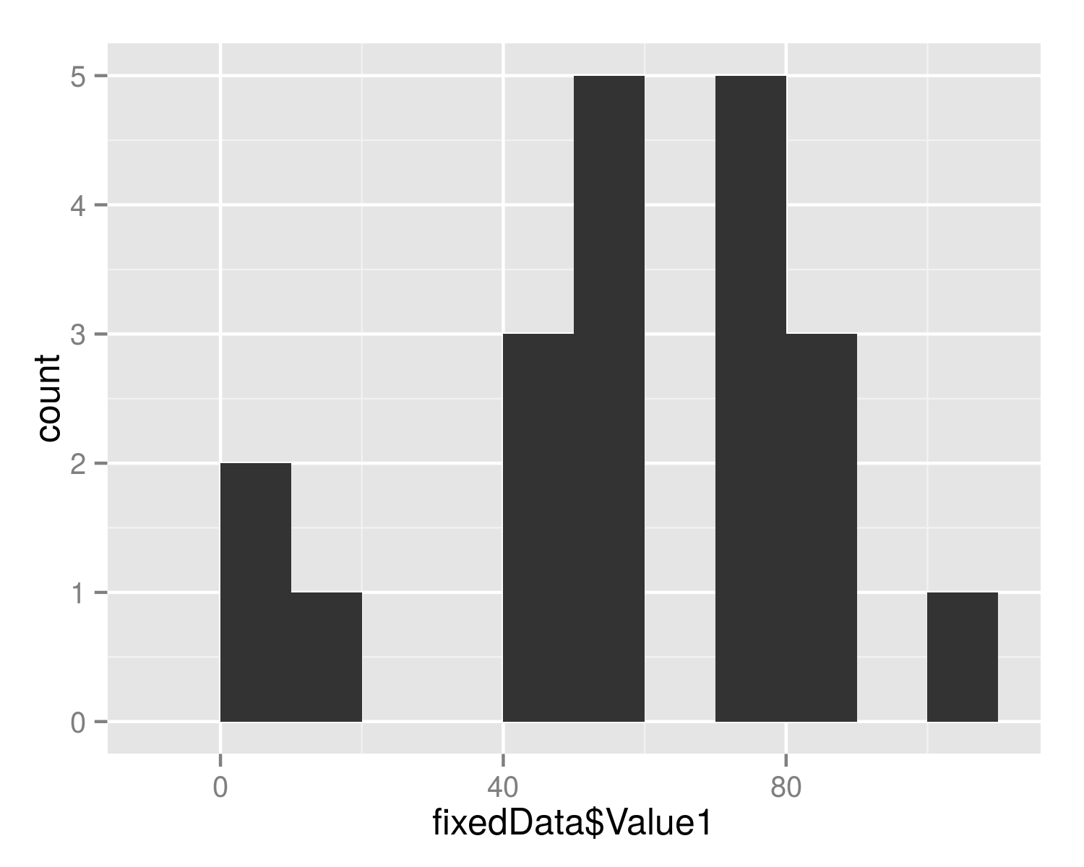

Histogram of Value1 values

### Other Values

Some text to describe the meaning of these numbers or measurement techniques, etc...

|  |  |
| --- | --- |
| Value2 | Value3 |
| 4 | 9 |

Additional Comments: none