**1. What are escape characters, and how do you use them?**

Escape character allows us to add special characters which are not allowed or may cause an error. Escape character can be denoted by \(backslash)

Please find the following image to see how we can use special character

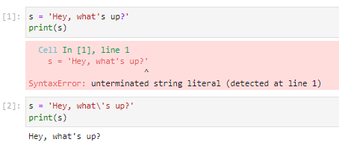

**2. What do the escape characters n and t stand for?**

n stands for new line and t stands for tab

**3. What is the way to include backslash characters in a string?**

If we want to use backslash character in the string then we can use 2 backslashes.

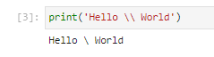

**4. The string "Howl's Moving Castle" is a correct value. Why isn't the single quote character in the word Howl's not escaped a problem?**

String contains the single quotation mark but it is wrapped by double quotation mark that’s why it is not giving an error.

**5. How do you write a string of newlines if you don't want to use the n character?**

If the string contains new lines and we don’t want to use the n character then we can wrap the string in triple quote

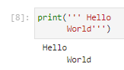

**6. What are the values of the given expressions?**

**'Hello, world!'[1] –** ‘e’

**'Hello, world!'[0:5] –** ‘Hello’

**'Hello, world!'[:5] -** ‘Hello’

**'Hello, world!'[3:] -** ‘lo, world!’

**7. What are the values of the following expressions?**

**'Hello'.upper() -** ‘HELLO’

**'Hello'.upper().isupper() -** True

**'Hello'.upper().lower() –** ‘hello’

**8. What are the values of the following expressions?**

**'Remember, remember, the fifth of July.'.split() -**

['Remember,', 'remember,', 'the', 'fifth', 'of', 'July.']

**'-'.join('There can only one.'.split())**

'There-can-only-one.'

**9. What are the methods for right-justifying, left-justifying, and centering a string?**

For right justify – string.rjust()

For left justify – string.ljust()

For centering – string.center()

**10. What is the best way to remove whitespace characters from the start or end?**

# strip() removes whitespace characters from the start or end of the string