**Exercise 1: Pipeline**

Prerequisite: Repo and a Branch (Main). This Repo will be used for IaaC code.

**Task 1 Create Pipeline**

1. Navigate to your project in Azure DevOps.
2. Navigate to Pipelines, then Pipelines.

1. Select New pipeline to create a new build pipeline.

1. Select Azure Repos Git as the source.

1. Select a Repository

1. Select starter pipeline
2. Default yml file created with sample script

You now have a working YAML pipeline (azure-pipelines.yml) in your repository that's ready for you to customize!. When you're ready to make changes to your pipeline, select it in the **Pipelines** page, and then **Edit** the azure-pipelines.yml file.

**Task 2: Use Bicep to add ADF integration with ADF**

1. In the same repo created, in Task 1 , Select a Branch and add a file with extension bicep

1. Enter file name with extension <<filename>>.bicep

1. Repeat step 1 and 2 and create bicep parameter file with extension <<filename>>.bicpeparam
2. Repeat step 1 and 1 and create YAML file to deploy ADF changes

Once files are created , navigate to github and grab or copy the content from below files.

Review the code. Change values for Resource group, service connection name, subscriptionID, file names of bicep and bicep params

**Task 3: Run the pipeline**

1. Navigate to Pipelines and then select Pipelines from the left-hand menu to go to the pipelines landing page.

**

You can view the status of the pipeline run in the landing page.

Once successful run, Navigate to Azure portal/Resource Group. Click on Data Factory and Launch ADF studio .

Choose **Recent** to view recently run pipelines (the default view) or choose **All** to view all pipelines.

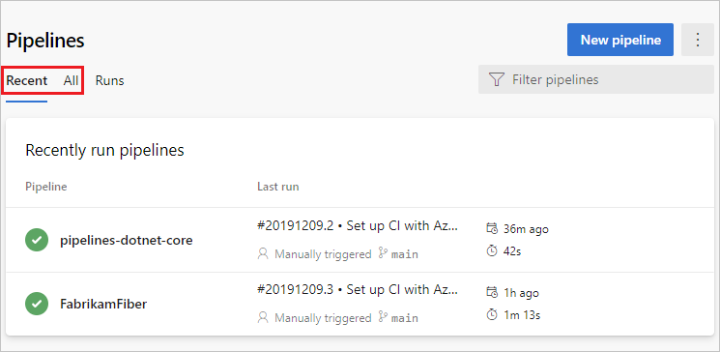

Select a pipeline to manage that pipeline and [view the runs](https://learn.microsoft.com/en-us/azure/devops/pipelines/create-first-pipeline?view=azure-devops&tabs=java%2Ctfs-2018-2%2Cbrowser#view-pipeline-details). Select the build number for the last run to view the results of that build, select the branch name to view the branch for that run, or select the context menu to run the pipeline and perform other management actions.

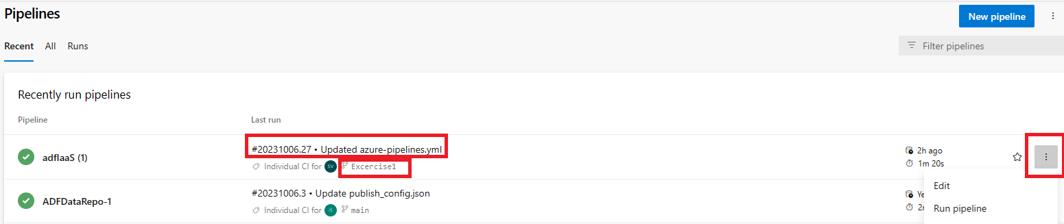

Select a pipeline and view all the runs for that pipeline. Pipeline runs will be retained based on retention policies set under Project settings/Pipelienes/Settings

Further, a run can be selected to view the status of your run, both while it is running and when it is complete.

The jobs pane displays an overview of the status of your stages and jobs. This pane may have multiple tabs depending on whether your pipeline has stages and jobs, or just jobs. In this example, the pipeline has two stages named **Build Bicep** and **Development Deploy**. You can drill down into the pipeline steps by choosing the job from either the **Stages** or **Jobs** pane. Steps for each job can be seen from Jobs pane

**Cancel and re-run a pipeline**

If the pipeline is running, you can cancel it by choosing **Cancel**. If the run has completed, you can re-run the pipeline by choosing **Run new**.

