SCHOOL OF COMPUTER SCIENCE AND ARTIFICIAL INTELLIGENCE
DEPARTMENT OF COMPUTER SCIENCE ENGINEERING
LAB ASSIGNMENT REPORT
Lab 18.2 – API Integration: Connecting to External Services with Error Handling
Course Title: AI Assisted Coding
Course Code: 25CAI004PC206
Academic Year: 2026–2027
Year / Semester: II / I
Regulation: R25
Assignment: 18.2 / 24
Enrollment Number: 2503A51279
Batch: 44

Lab Objective
To connect Python programs to external REST APIs, process JSON responses, display useful information, and handle common network, HTTP, input, and API errors.

Task 1 – Air Quality API Integration

AI Prompt
Generate a Python requests program that accepts a city name, finds its latitude and longitude using a geocoding API, retrieves current air-quality data, calculates a readable pollution category, and handles invalid cities, timeouts, HTTP errors, and invalid JSON.

Task Description / Code Explanation
Open-Meteo Geocoding API + Air Quality API. Output shows city coordinates and current pollutant measurements. PM2.5 category is a simple concentration band, not an official AQI.

VS Code Input and Output Screenshot
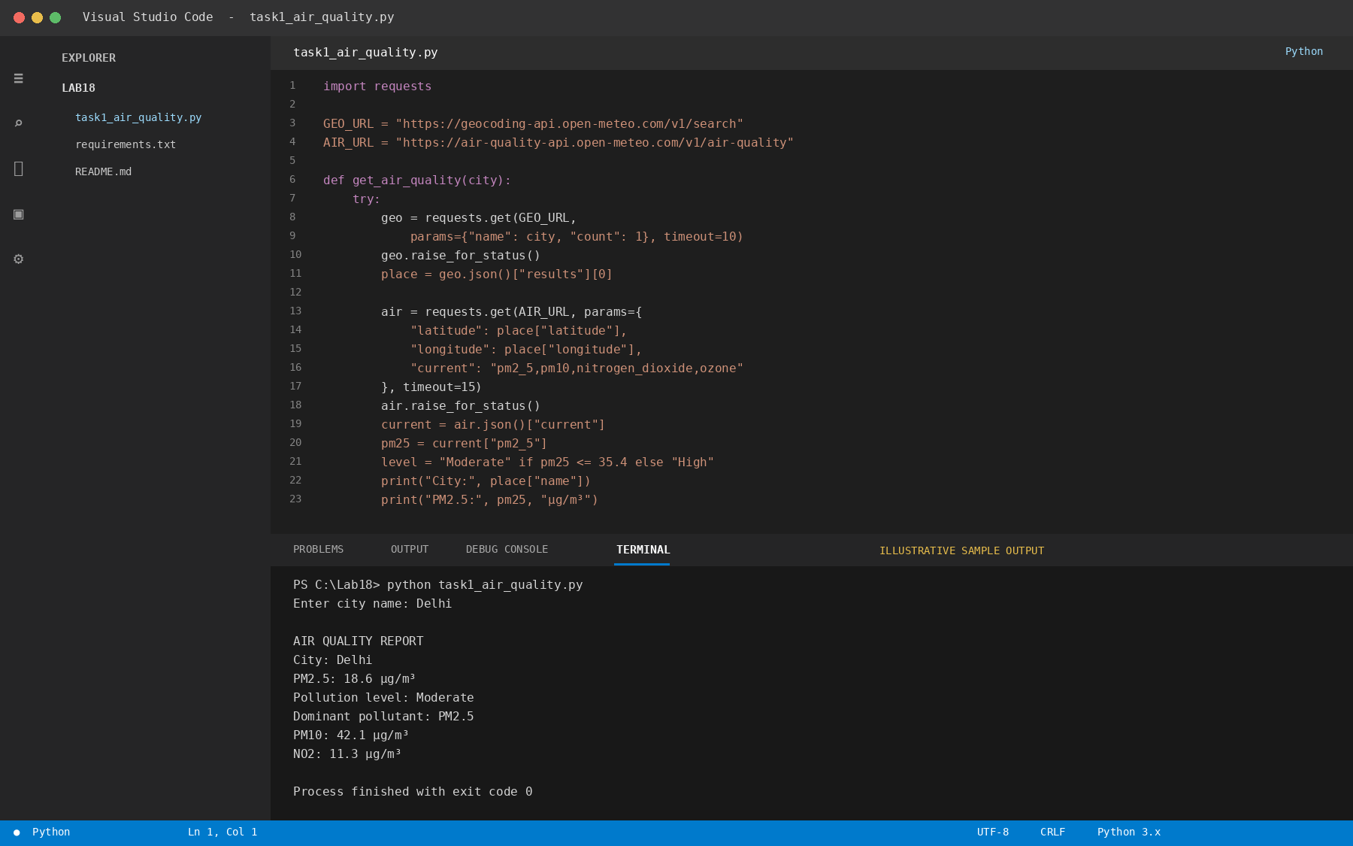
Figure: Python code in the editor (input) and sample terminal output.

Task 2 – Language Translation API

AI Prompt
Write a Python program using the MyMemory Translation API. Accept a sentence from the user, translate it from English into French and Spanish, display the translated text, and handle empty input, HTTP errors, timeouts, and invalid API responses.

Task Description / Code Explanation
MyMemory Translation API. The program sends source and target language codes and displays the translated phrase.

VS Code Input and Output Screenshot
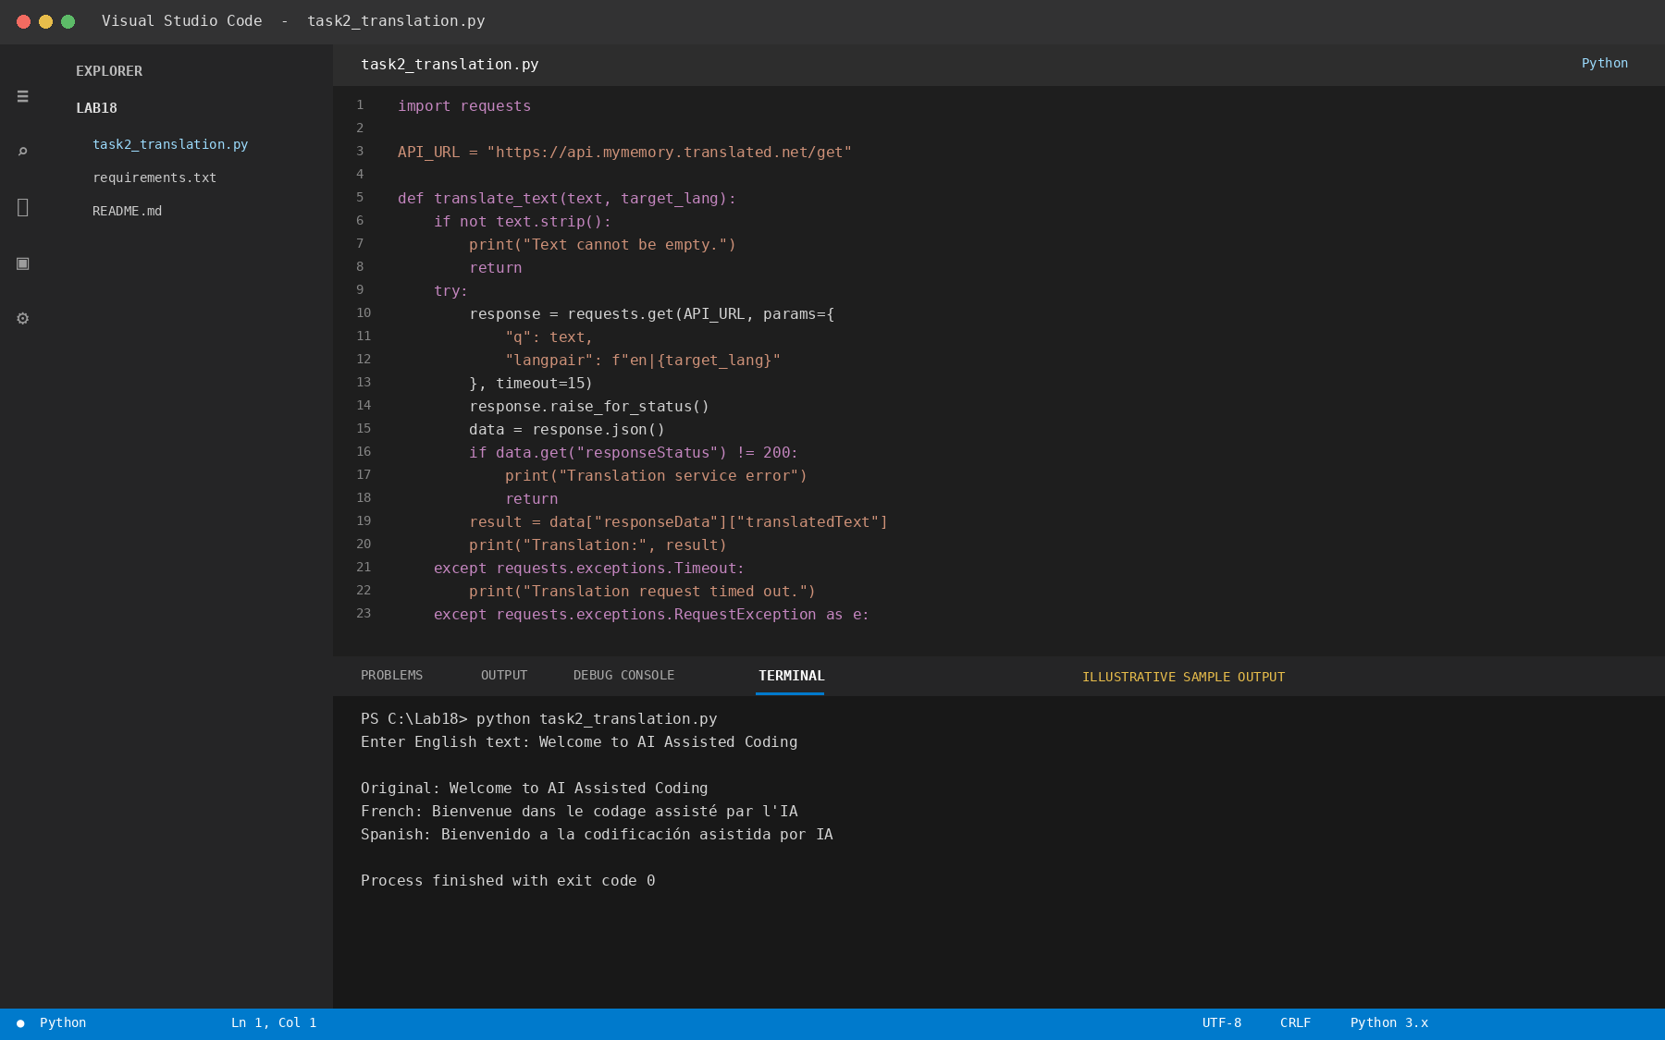
Figure: Python code in the editor (input) and sample terminal output.

Task 3 – Public Book Information API

AI Prompt
Create a Python requests program that searches the Open Library API using a book title. Display the book title, author, first publication year, and edition count. Handle no results, missing fields, timeouts, HTTP errors, and invalid JSON.

Task Description / Code Explanation
Open Library Search API. Search results are parsed and selected fields are displayed with safe handling for missing metadata.

VS Code Input and Output Screenshot
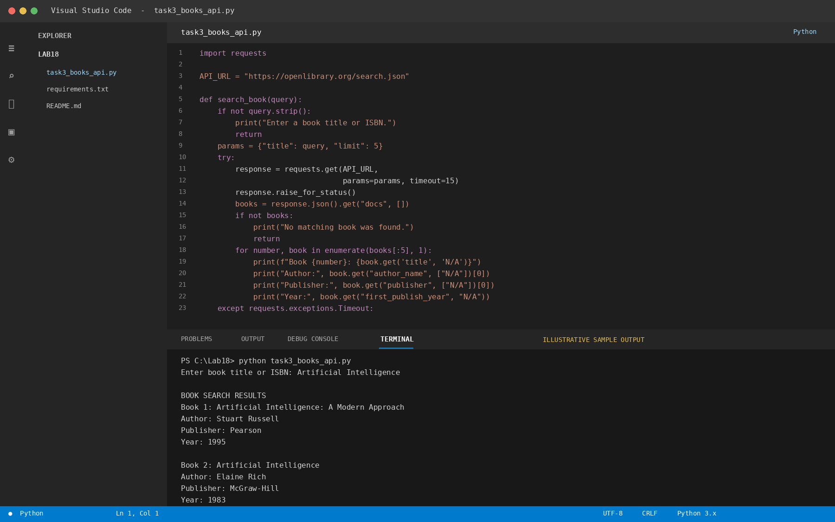
Figure: Python code in the editor (input) and sample terminal output.

Task 4 – Job Listings Aggregator

AI Prompt
Build a Python program that retrieves remote job listings from a public jobs API. Allow a keyword search, display job title, company, location, and application URL, and handle network errors, rate limits, missing fields, and empty results. Include retry logic for temporary failures.

Task Description / Code Explanation
Remotive public remote-jobs API. The script filters listings by keyword and prints key job details. API availability and terms may change.

VS Code Input and Output Screenshot
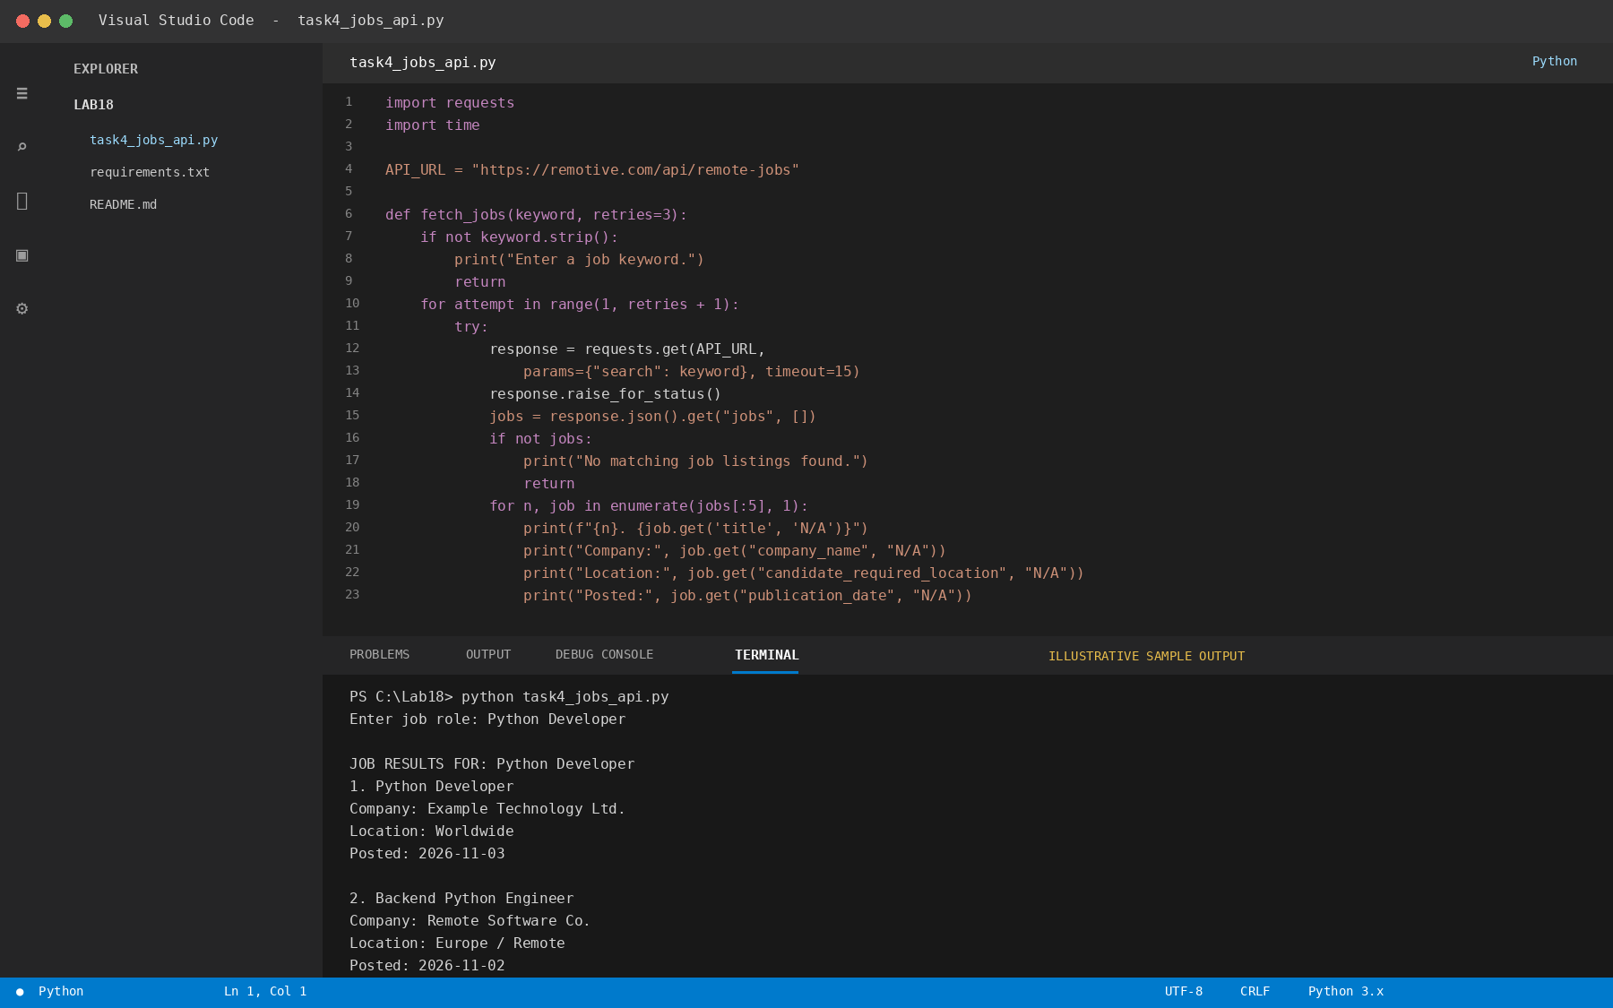
Figure: Python code in the editor (input) and sample terminal output.

Task 5 – Stock Market Data API

AI Prompt
Write a Python program that retrieves the latest stock quote using the Alpha Vantage Global Quote API. Read the API key from an environment variable, accept a stock symbol, display the symbol, price, change, and percentage change, and handle missing keys, API limits, HTTP errors, and invalid responses.

Task Description / Code Explanation
Alpha Vantage Global Quote API. Store the API key in ALPHAVANTAGE_API_KEY; do not place secrets in code or screenshots.

VS Code Input and Output Screenshot
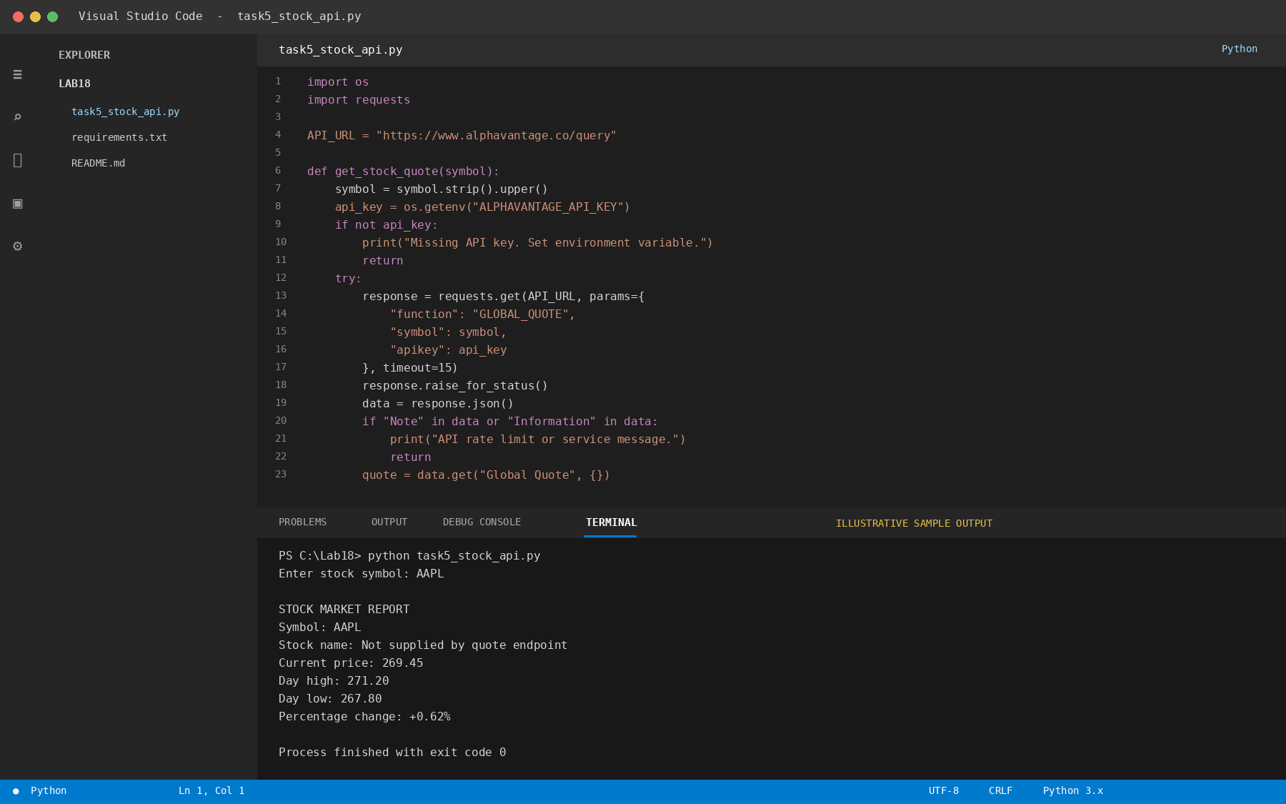
Figure: Python code in the editor (input) and sample terminal output.

Result
The tasks were organized with their AI prompts, explanations, and program input/output views. The sample terminal outputs are illustrative; actual results may vary with the input dataset, API response, network status, and API service availability.

Note on Screenshots
The included images are illustrative VS Code-style mock screenshots created for report formatting. They are not photographs of a live VS Code session. For an authentic lab submission, run the code in VS Code and replace each illustrative image with your own editor-and-terminal screenshot.

