>>>>>>>> BMIDE Standalone Installation <<<<<<<

Step1: Copy below files & put in a directory in your system’s D drive and unzip it
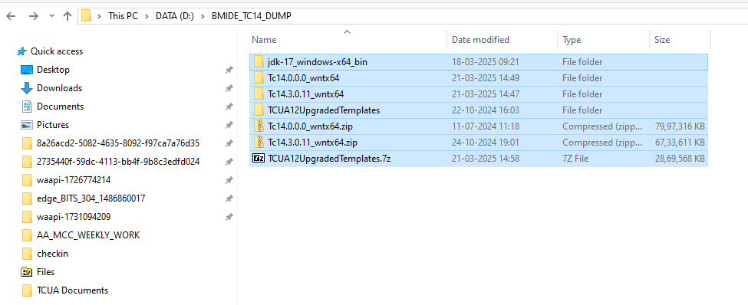
STEP2: Go to Tc14.3.0.11_wintx64 – wintx64 & make a copy of existing tem.bat as tem_copy.bat – add below lines on tem.bat file and save it.
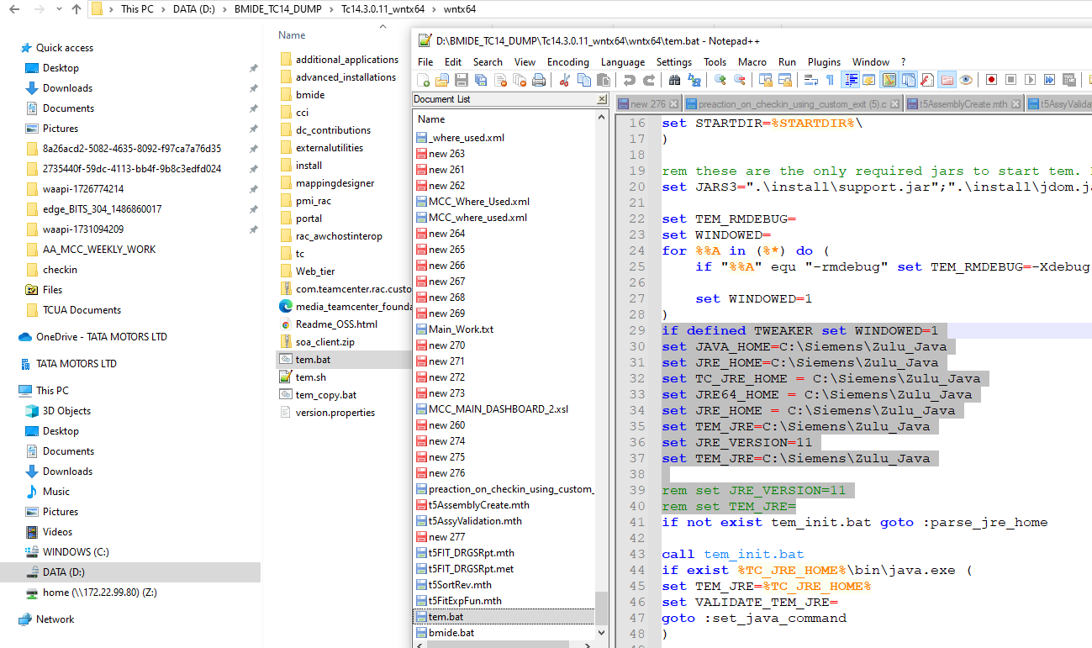
STEP3: Double click on tem.bat – select language as English – Next – Install
STEP4: Select major release directory from original media location source i.e. - Tc14.0.0.0_wintx64 according to below snap & click on next.

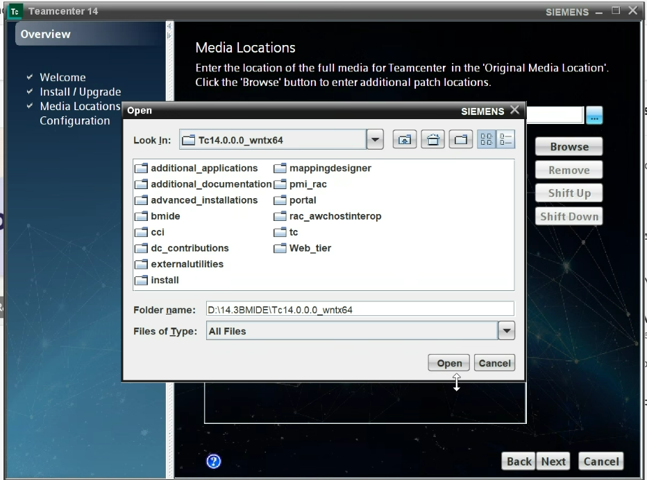

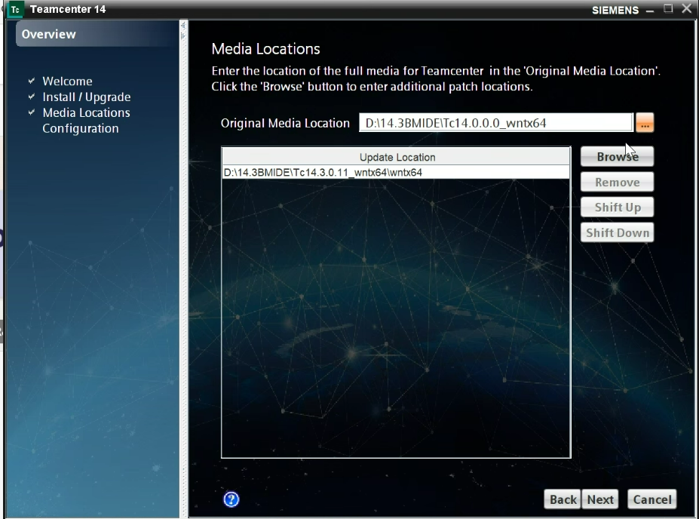

STEP5: On configuration window provide ID & Description as BMIDE & Click on Next
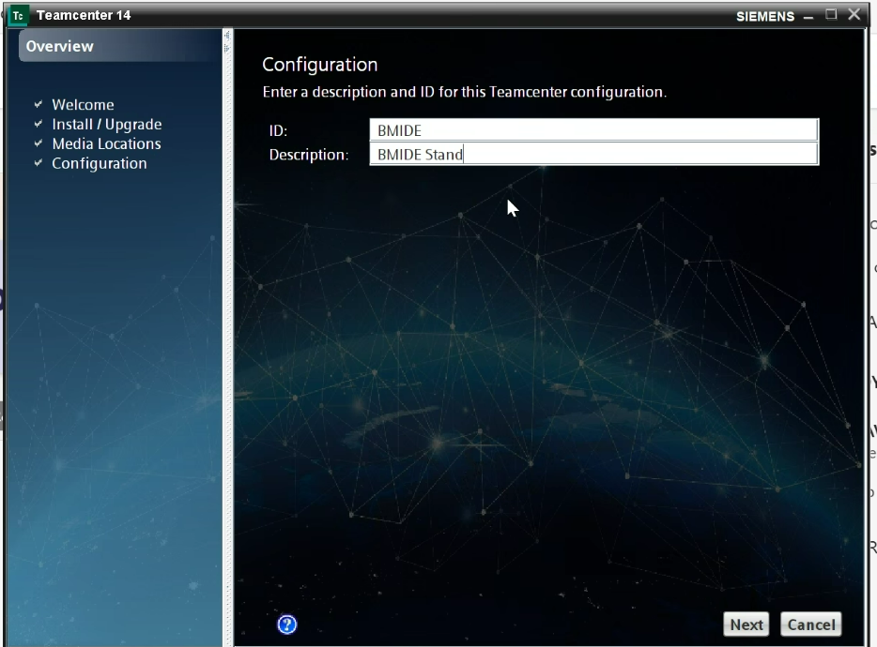

STEP6: On Solutions window check-box select Business Modeler IDE & click on Next
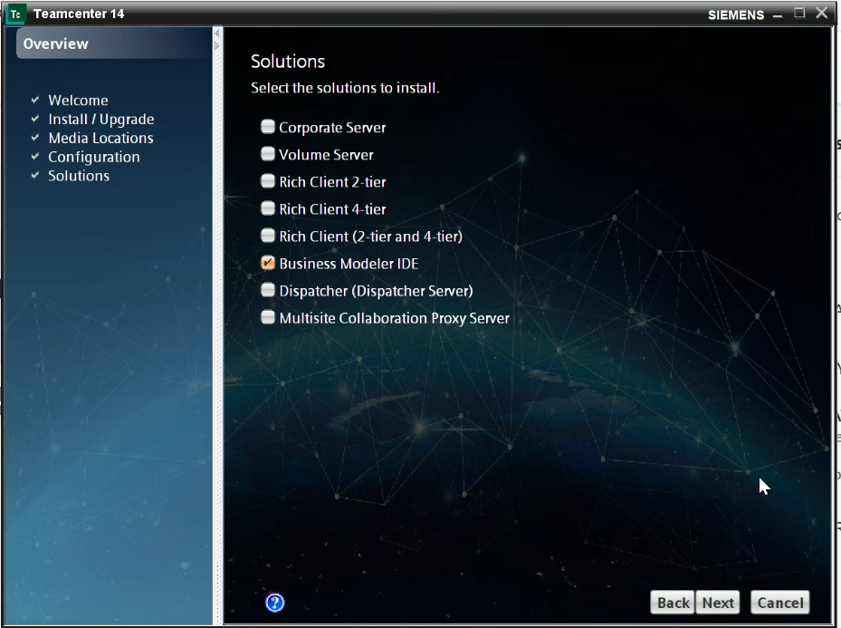
STEP7: On features window under Base Install select Business Modeler IDE Standalone & on Installation Directory provide path as D:\BMIDE & click on Next
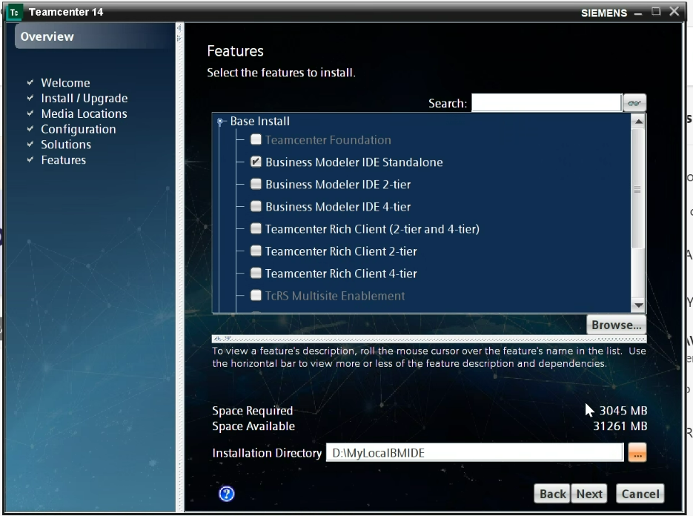

STEP8: On Java Development Kit window select Zulu_Java directory as C:\Siemens\Zulu_Java and make sure you Zulu Java Version should be 17 as it’s compatible only with Zulu-17 otherwise you will get error while launch bmide.bat.
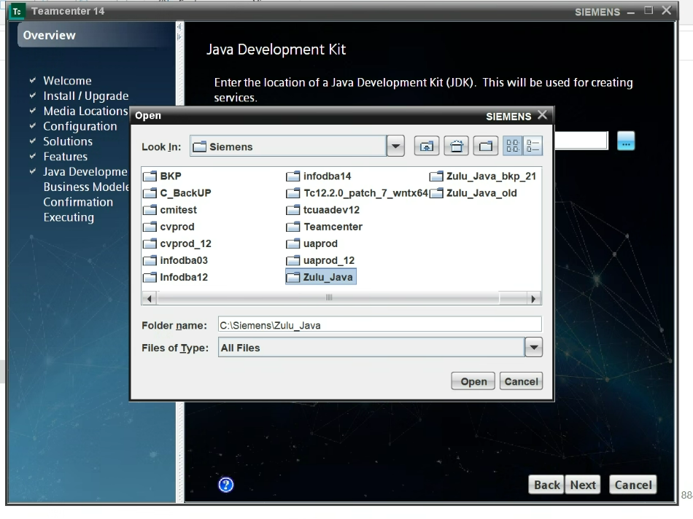
STEP9: On the Business Modeler IDE Client window click on Add button then Select Templates window will open & on Search field type: Systems & select below & click on OK
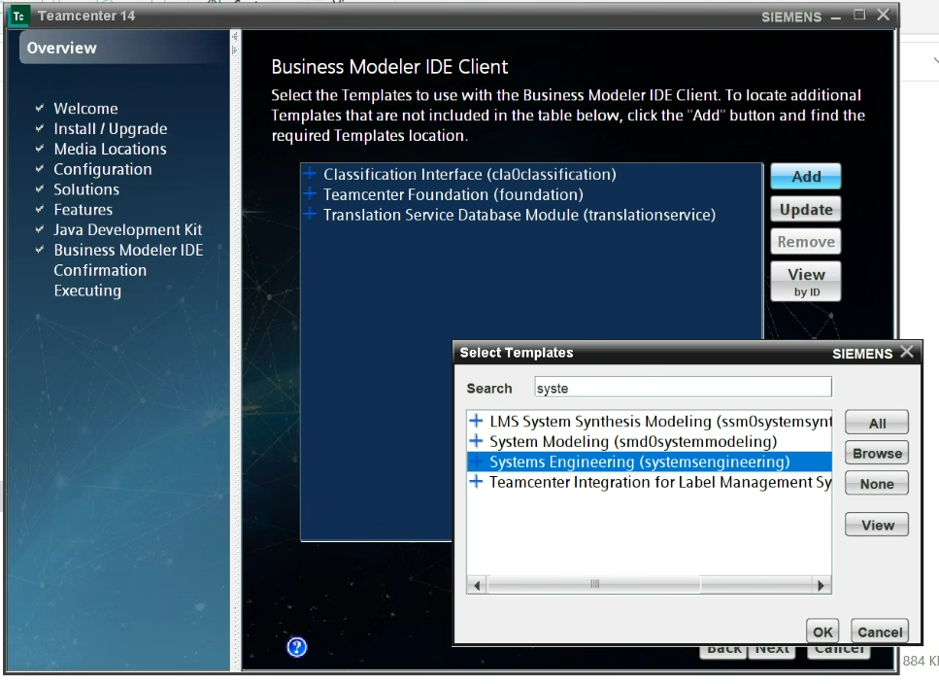
Again click on Add button on same window then Select Templates window will open & on Search field type: Change Management & select below & click on OK
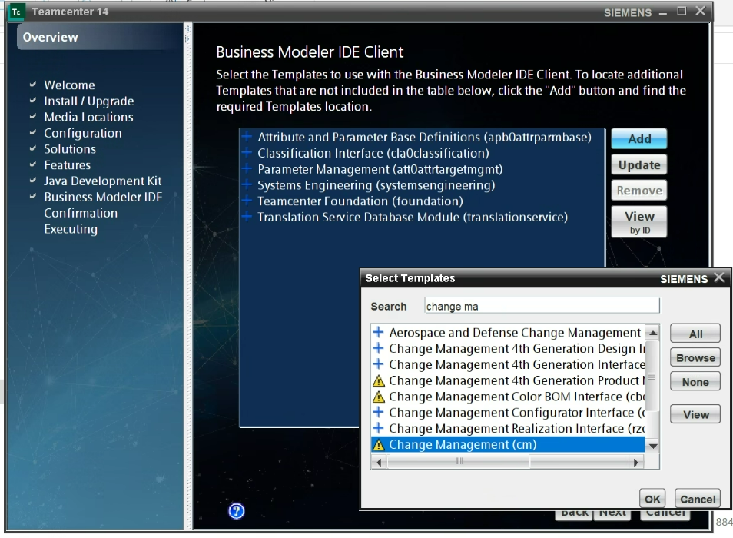
Again click on Add button on same window then Select Templates window will open & then click on Browse and select feature_cmirii.xml file from location – (D:\BMIDE_TC14_DUMP\TCUA12UpgradedTemplates\CMIR2\CMIRII_Server_TC12.0_V430\CMIRII_Server_Template_TC12.0_V430\tem_contributions) & click on open on Search field type: Change Management & select below & click on OK then on search field type CMIRII & select CMI RII (cmirii) as below then click on Ok & then click on Next
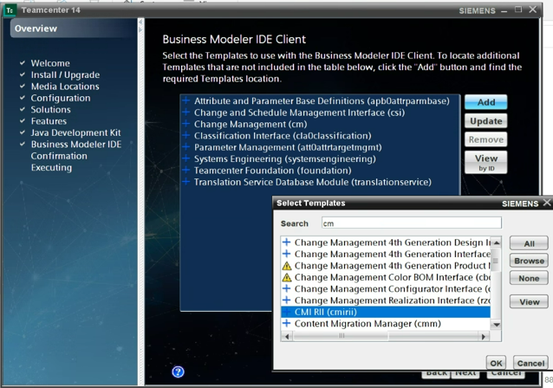

STEP10: Finally Click on Start button and View Details. After successful installation an Installation Successful pop will appear.
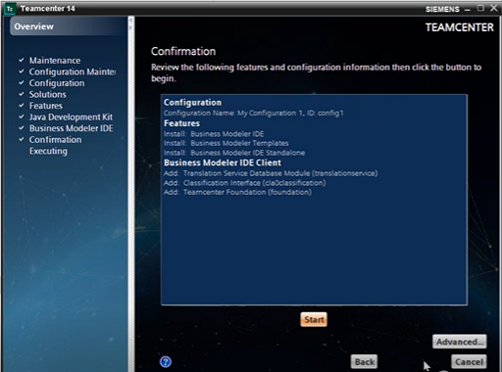
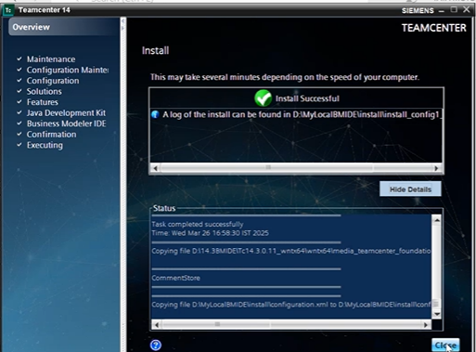

STEP11: Go to below path - D:\BMIDE\bmide\client & edit bmide.bat file and add below lines and save it then double click on bmide.bat file & then workspace window will open click on Launch. Default workspace will be as (D:\BMIDE\bmide\workspace\14000.0.0). After launch change perspective from Standard (by default) to Advance from (Window – Perspective – Open Perspective – Advanced) now close BMIDE.
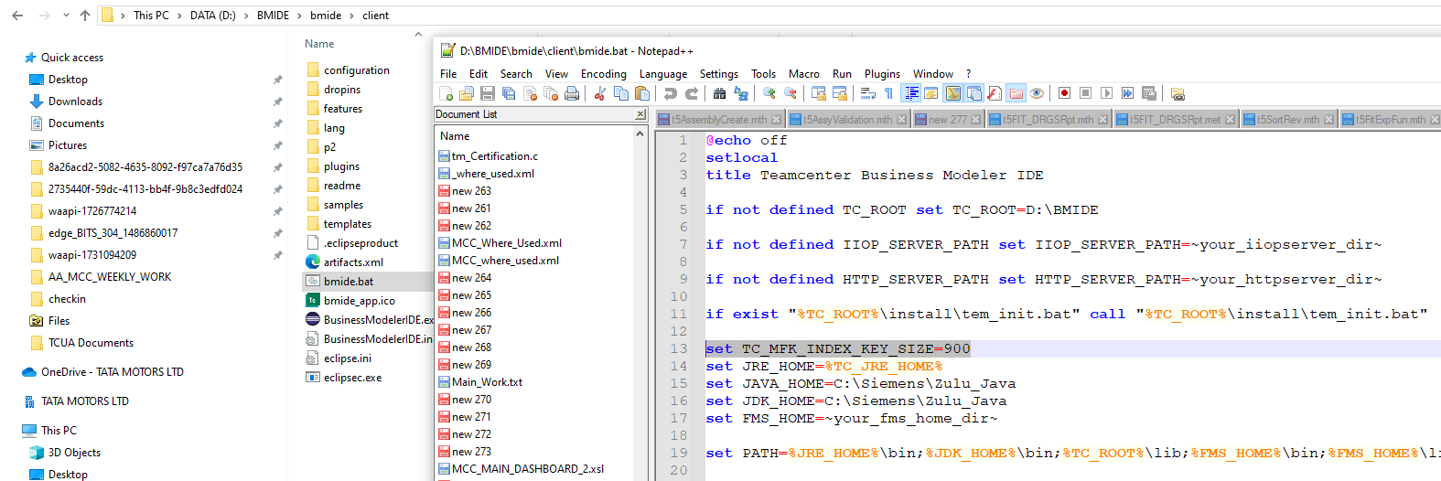
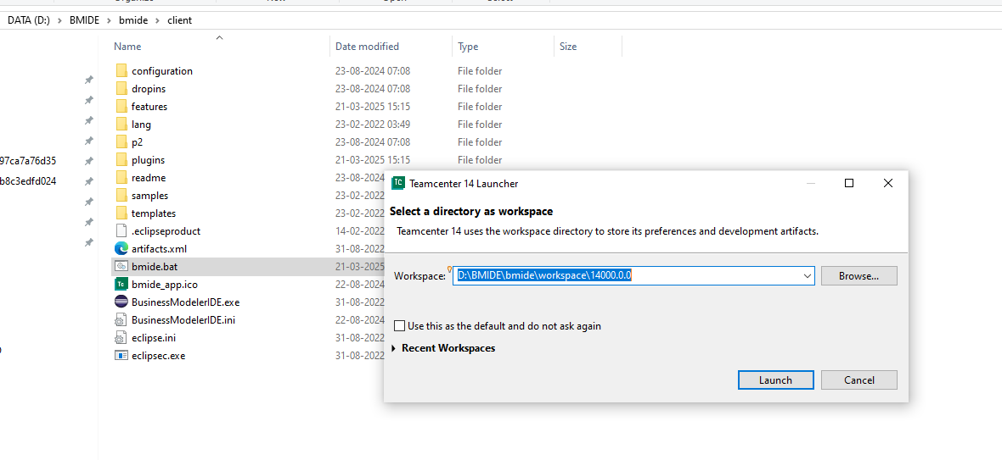
STEP12: Download latest TML project (TRL001.zip) from Digital Vault & copy zip to below location (D:\BMIDE\bmide\workspace\14000.0.0) & then unzip it on same place. Again launch bmide client from bmide.bat - Launch – File – Import… select below option under Business Modeler IDE then select project file from location (D:\BMIDE\bmide\workspace\14000.0.0\TRL001) & click on Finish. Finally you project file will be loaded.
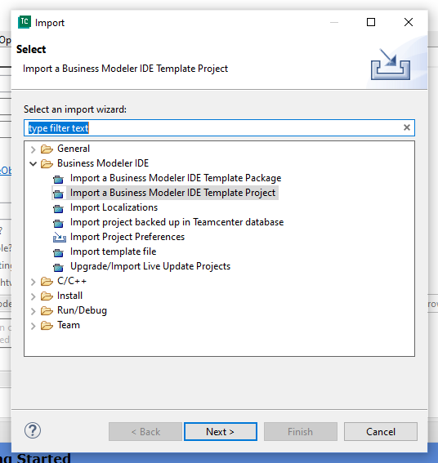

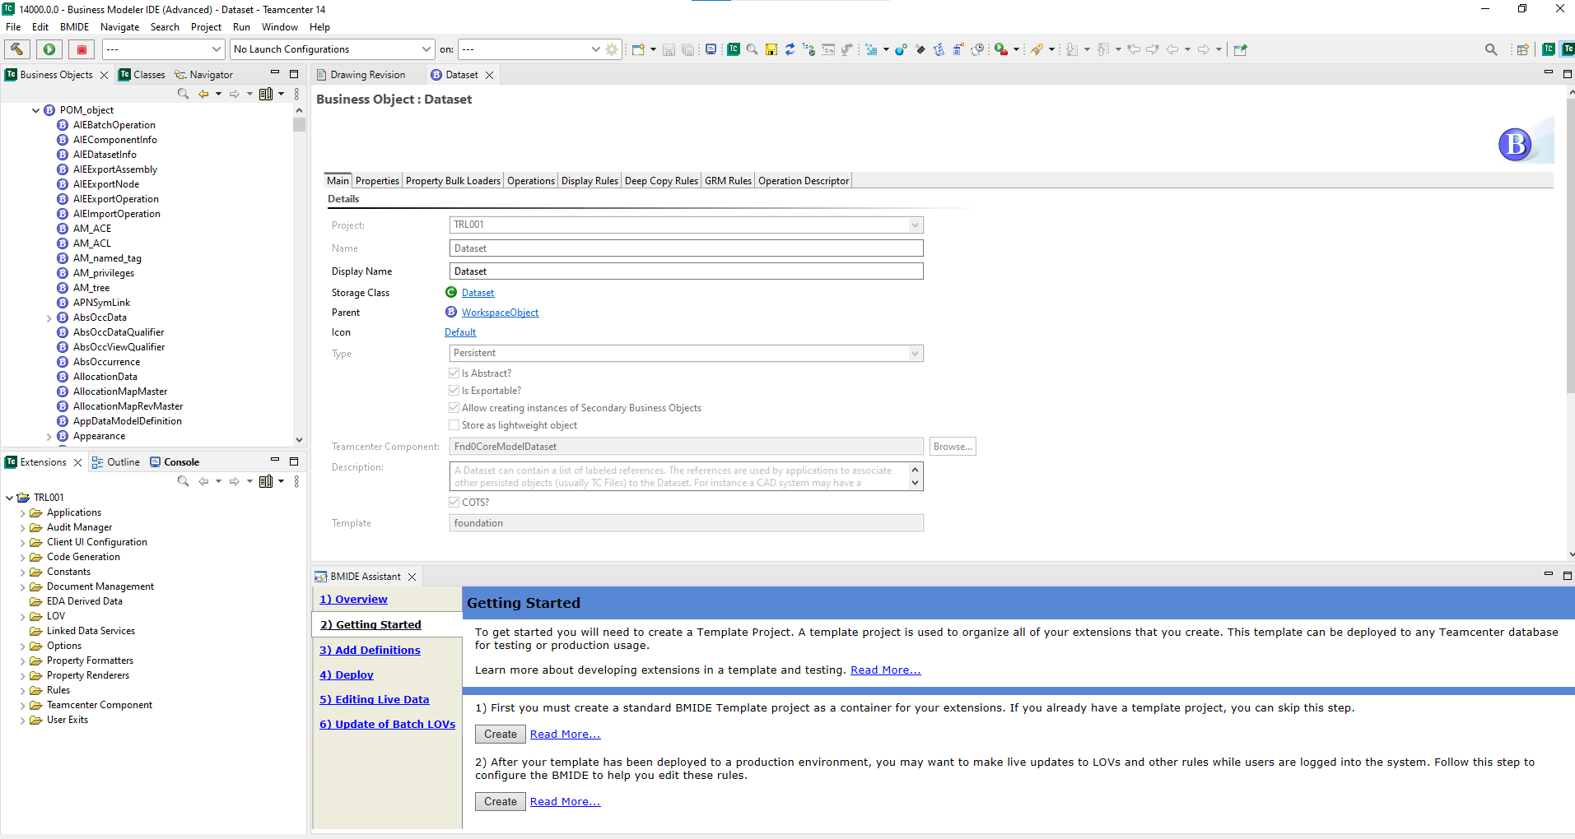
>>>>>>>>>>>> Thank You <<<<<<<<<<<<<

