1) Configure IPv4 forwarding on the Docker host machine.
Edit etc/sysctl.conf and set net.ipv4.ip_forward=1
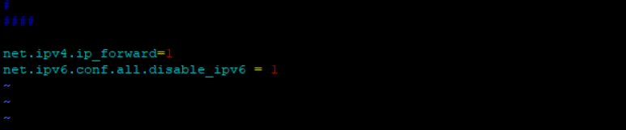
Restart docker

2) Go to Microservice Framework kit inside \additional_applications\docker_registry directory.
Depending on machine OS, run getDockerRegistry.sh or getDocker Registry.bat
It will create a tar file.
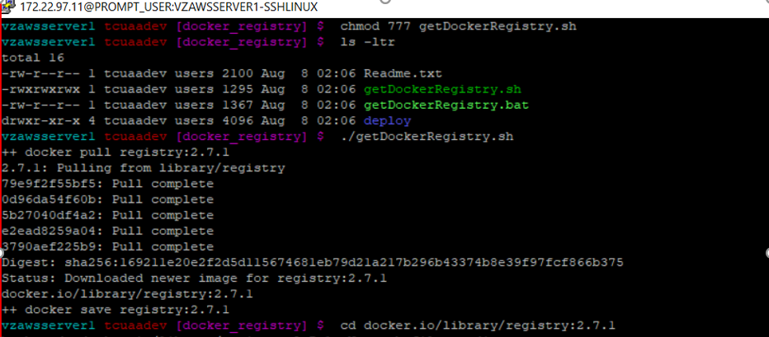
3) Move this .tar file to machine that will run docker registry service.
Load the image
docker image load –i tar_file_name
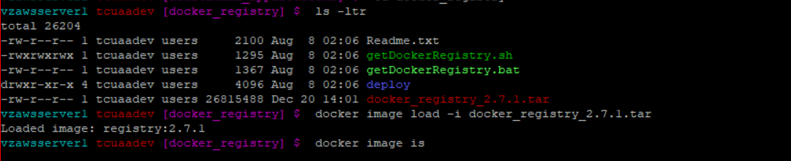
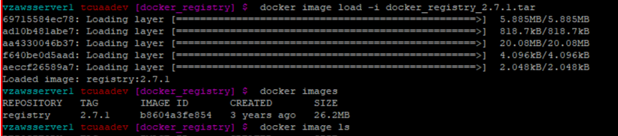

4) Create the following directories
/scratch/docker_registry/data
/scratch/docker_registry/certs
/scratch/docker_registry/auth
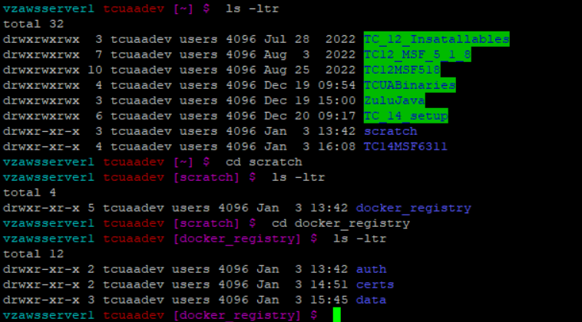
If different path is used, update the YML or YAML configuration files in Microservice Framework kit.
Kit\additional_applications\docker_registry\deploy\swarm

5) To generate certificates in /scratch/docker_registry/certs folder, use following command.
openssl req \
-newkey rsa:2048 -nodes -keyout domain.key \
-x509 -days 365 -out domain.crt
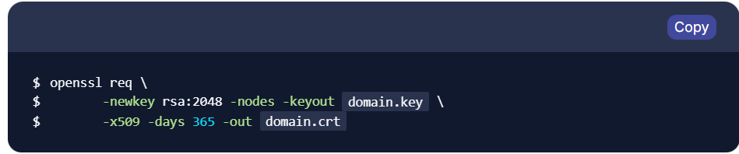

https://www.digitalocean.com/community/tutorials/openssl-essentials-working-with-ssl-certificates-private-keys-and-csrs
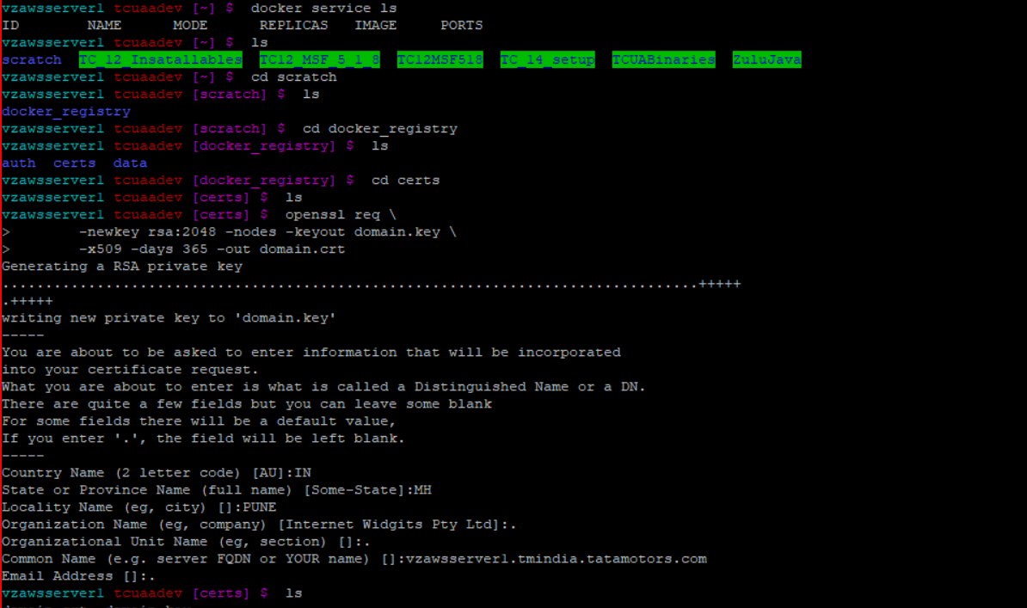
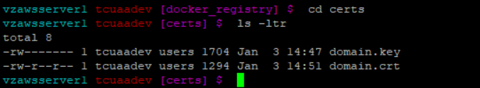
6) Deploy the registry to a new stack. This new stack is unrelated to Teamcenter, Active Workspace and Microservice Framework.
docker stack deploy –c path_to_MSF_kit/docker_registry.yml tcregistry
docker stack deploy -c /home/tcuaadev/TC_14_setup/TcMicroserviceFramework_6.3.11_lnx64/additional_applications/docker_registry/deploy/swarm/docker_registry.yml tcregistry
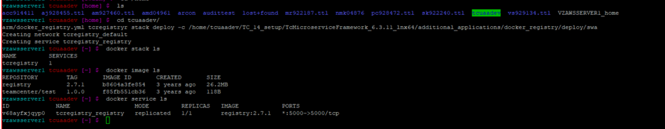

7) Go to
etc/docker/daemon.json
"insecure-registries" : ["http://vzawsserver1.tmindia.tatamotors.com:5000"]
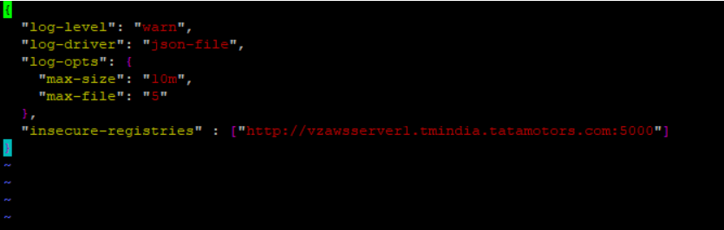

8) Validate functionality of Docker Registry
curl --cacert /home/tcuaadev/scratch/docker_registry/certs/domain.crt https://vzawsserver1.tmindia.tatamotors.com:5000/v2/_catalog
Valid response shows an empty repository.
{“repositories”:[“”]}
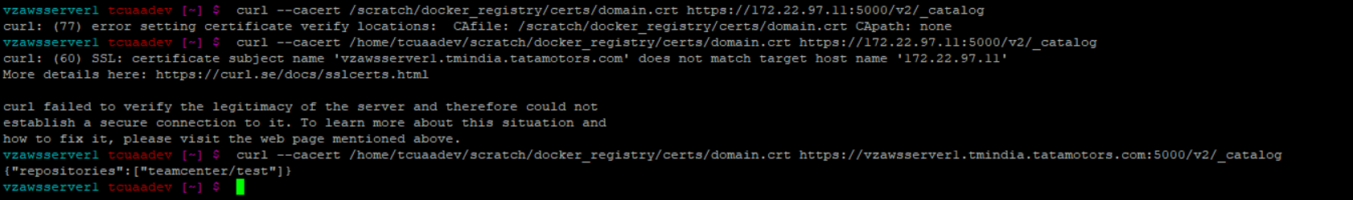

8) Install Microservice using TEM
tem.sh file run as Administrator from TC14.3.0.11 patch
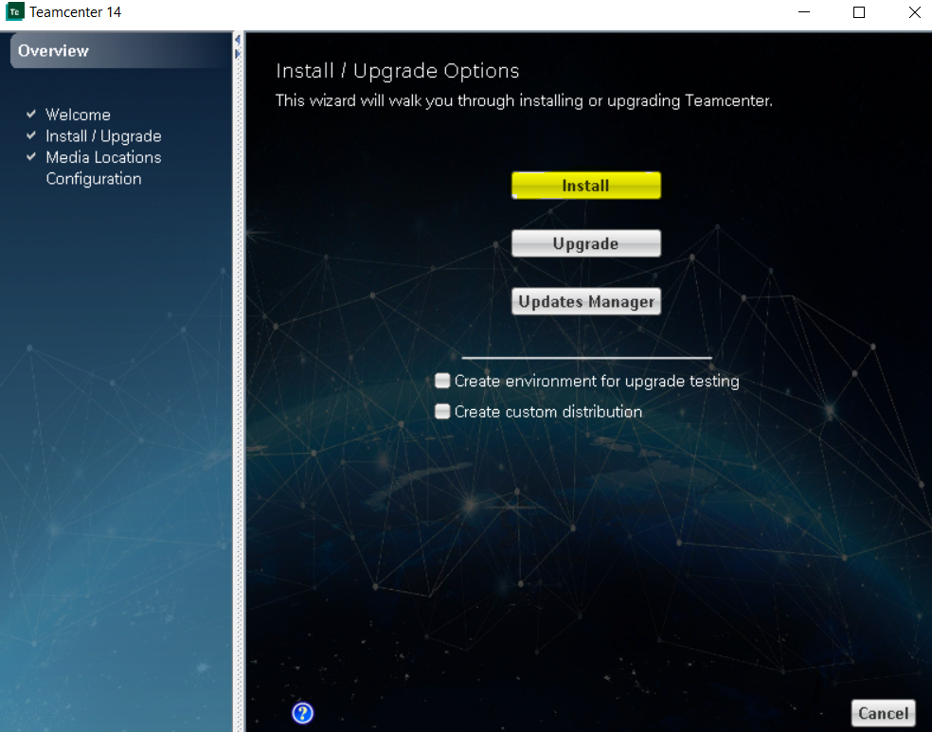

Browse below highlighted TC14.0.0.0, AWC 6.3.11 and MSF 6.3.11 path from set up directory

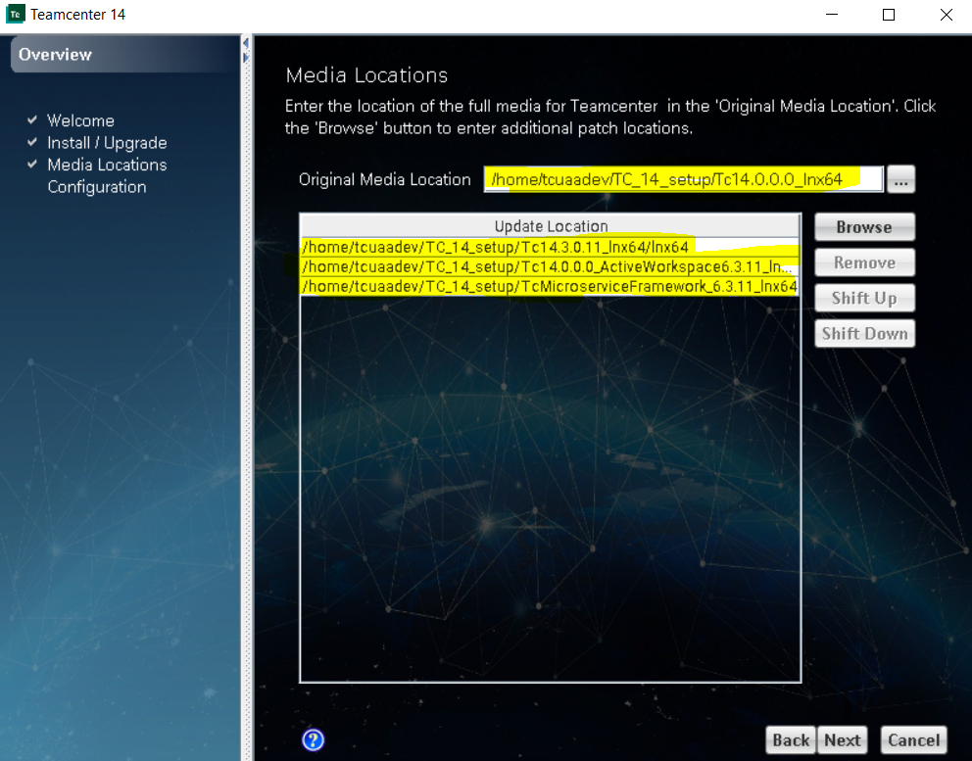

Give required name
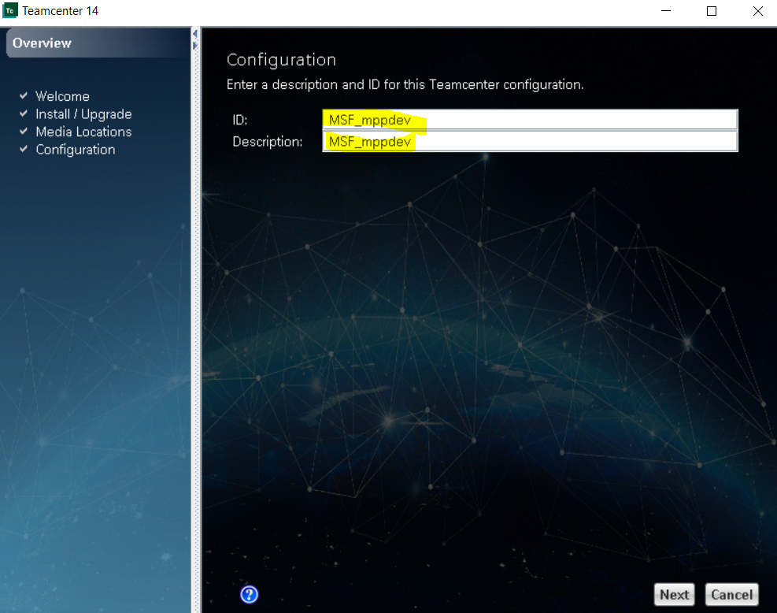

Click Next

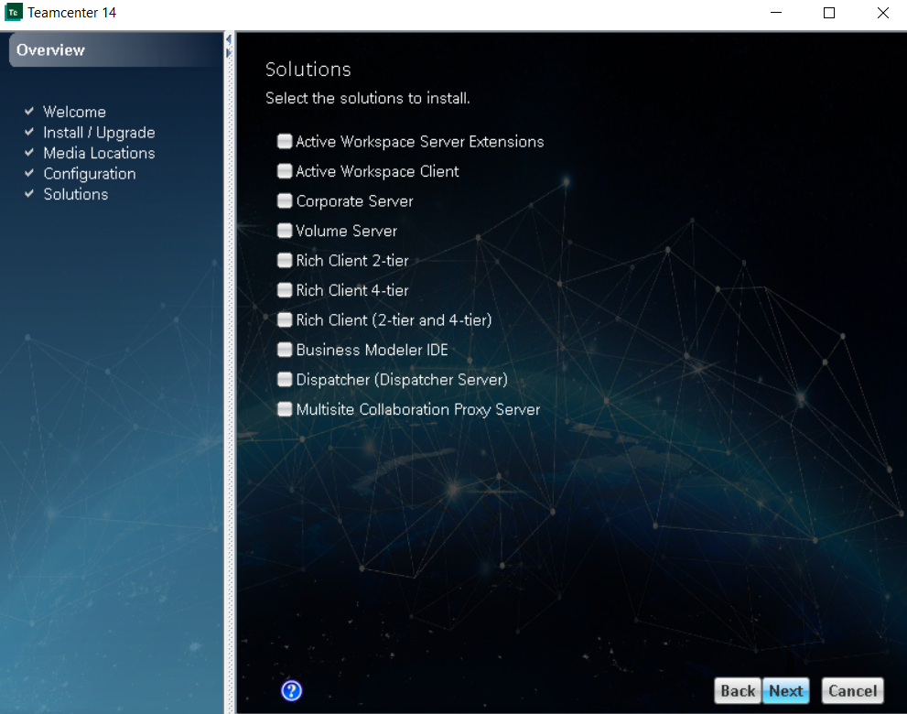

Select below highlighted feature

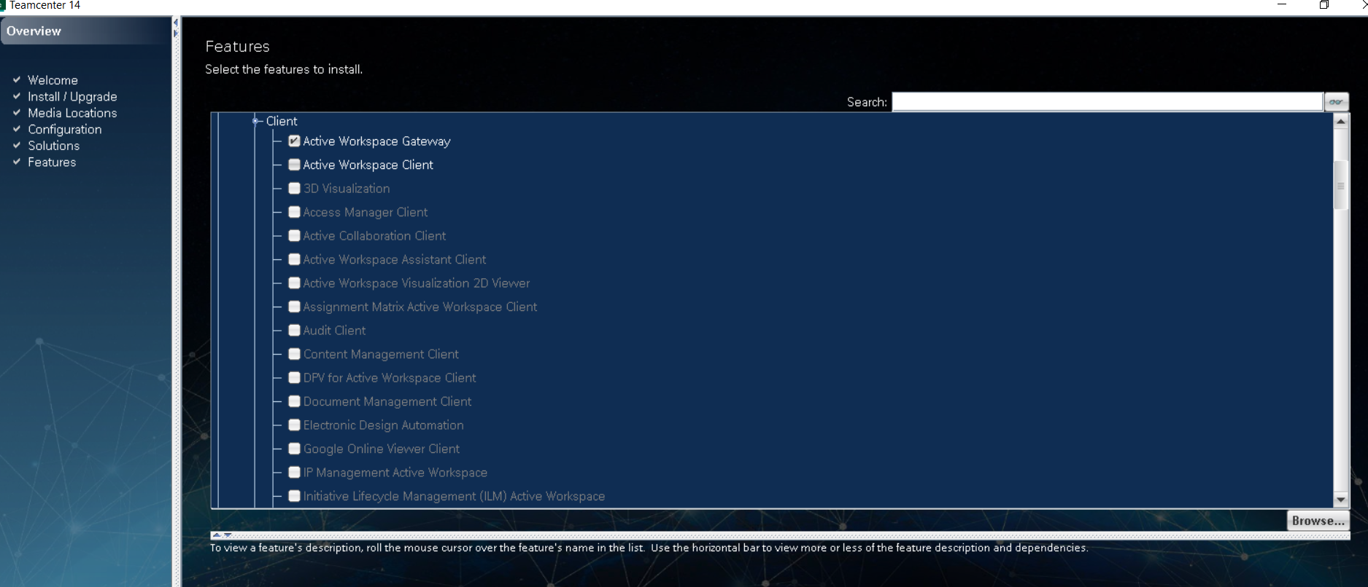

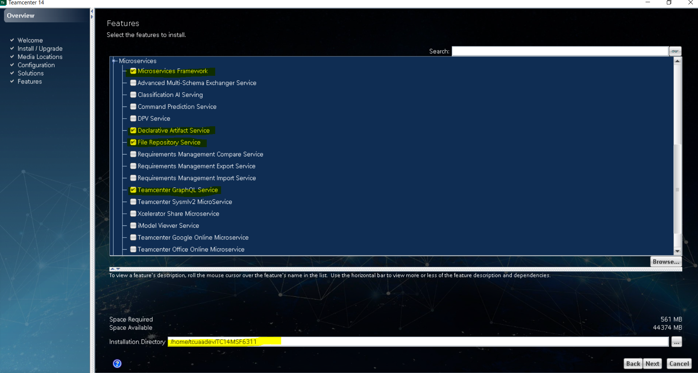

Put below highlighted FQDN and Keystore Password
Keystore Password-infodba
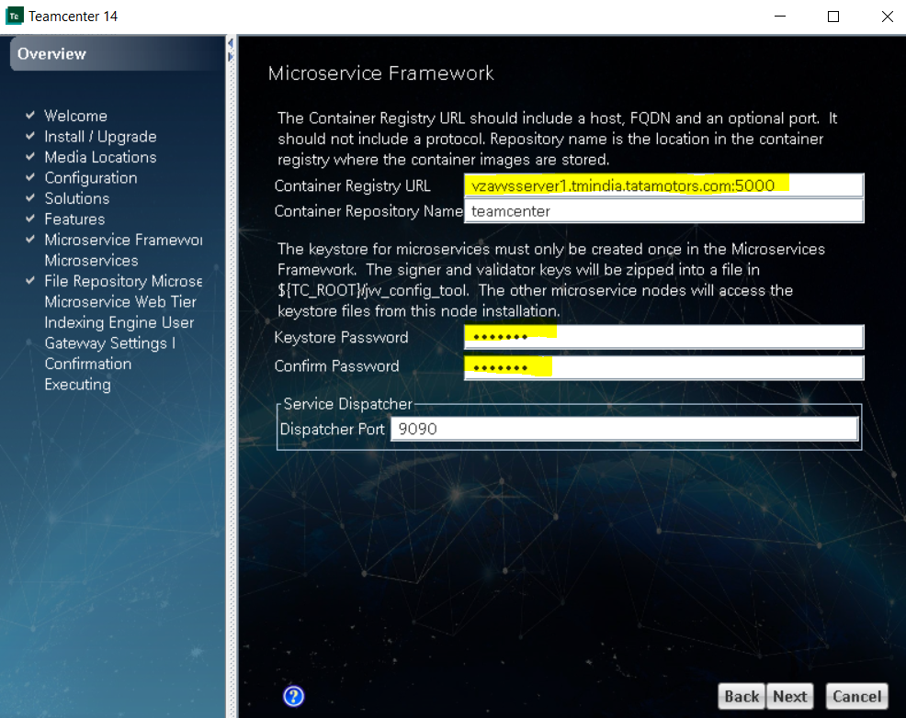

Run below mentioned command on docker server

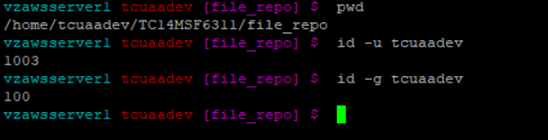

Put User ID and Group ID

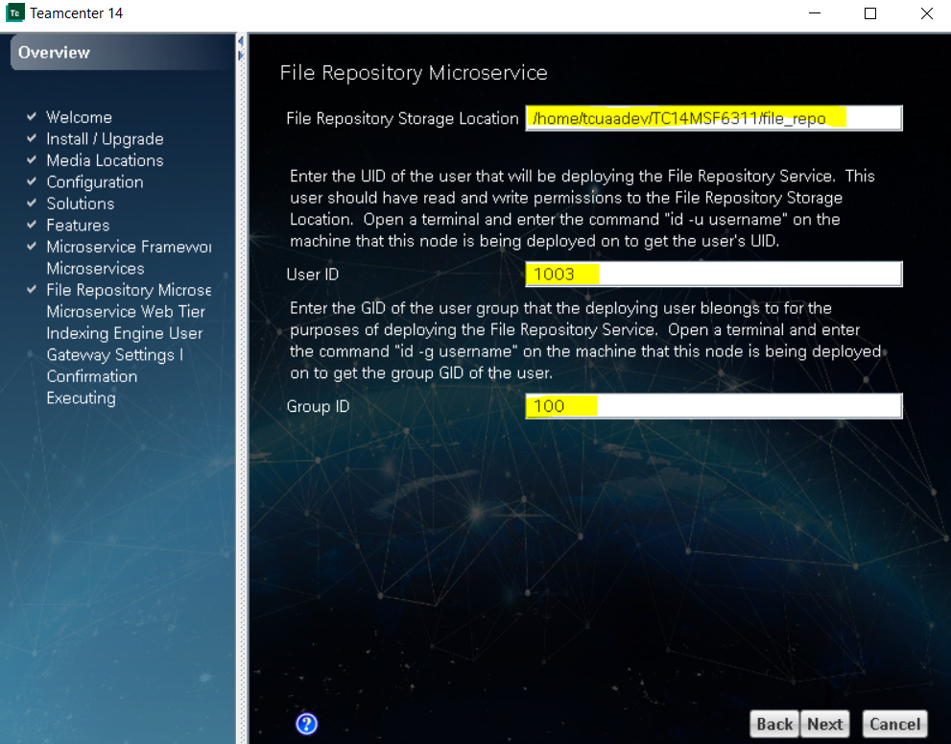

Put web tier URL as mentioned below

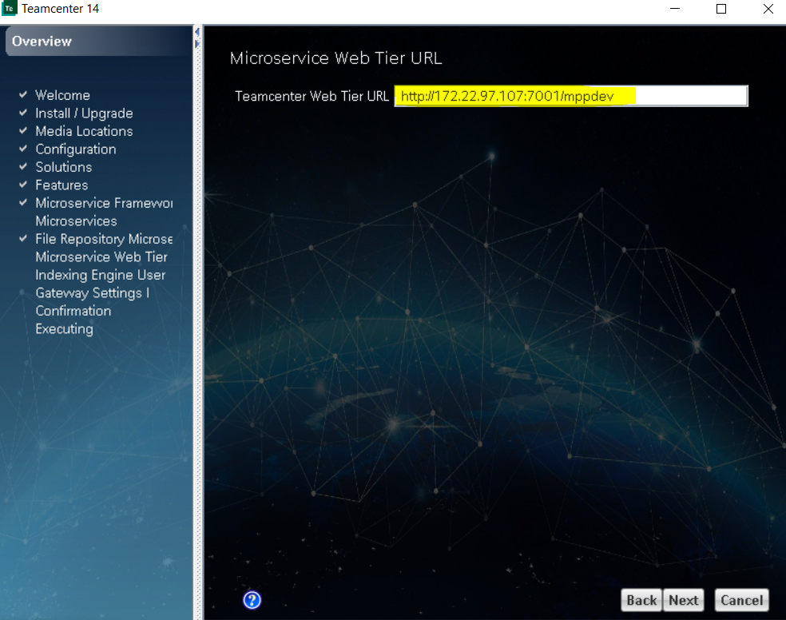

User-solr_admin
Password-solr_admin

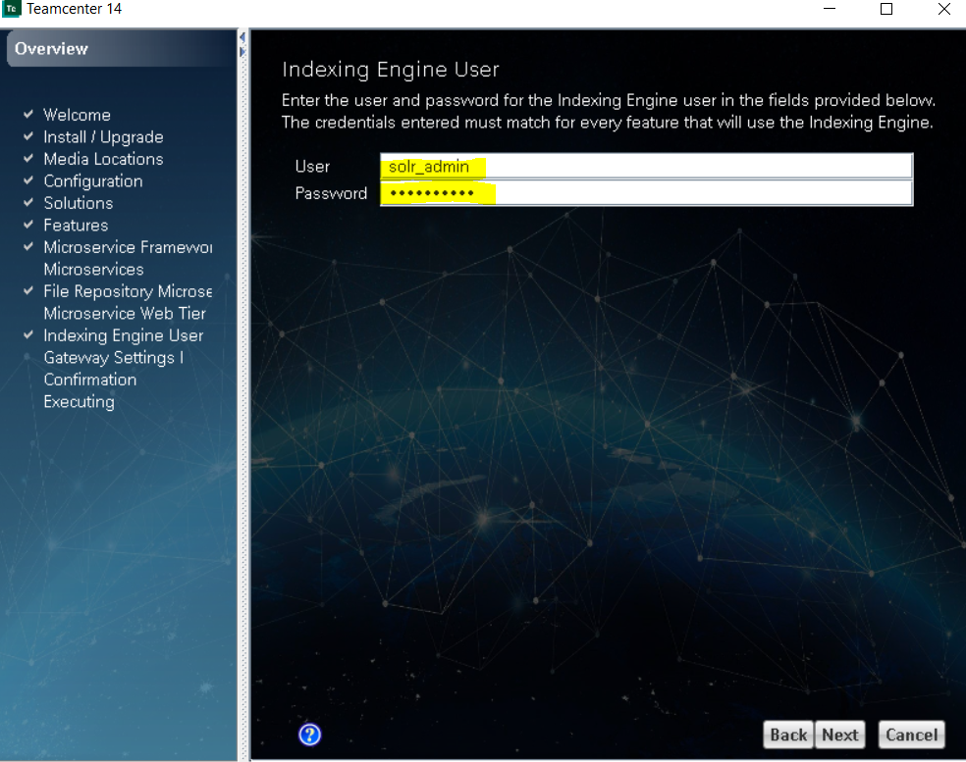

Put below highlighted Web Tier and FSC URL

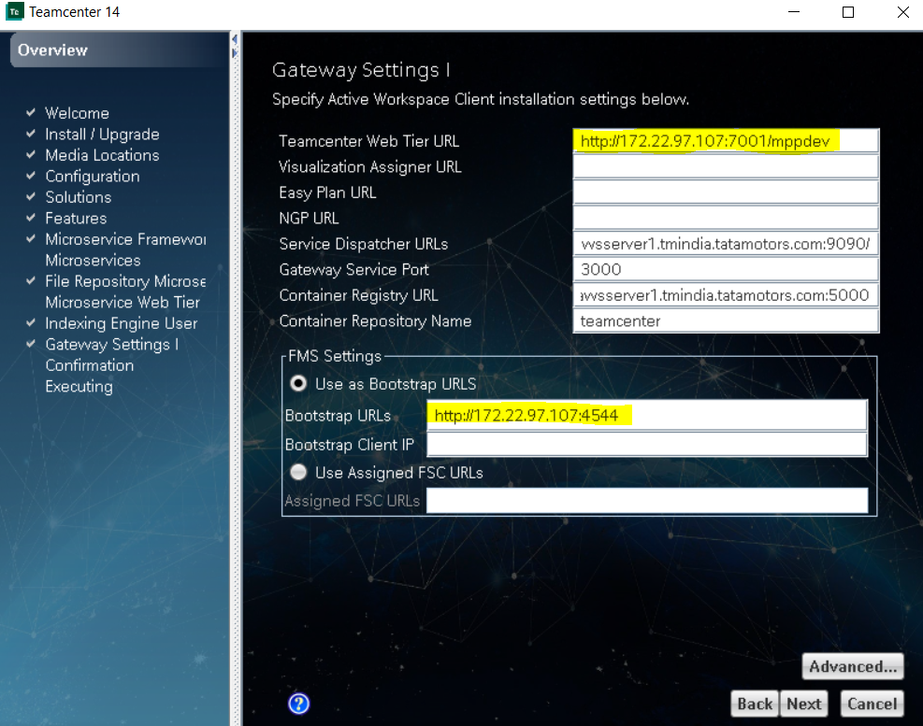
In Service Dispatcher URL, put IP instead of FQDN. This will be required when docker container and AWC client are installed on separate server and servers not able to publish files to gateway due to hostname not getting resolved.
If not done, you may face “Connection Refused” error in “Publish to Gateway” page. Then you need to edit FQDN with IP in Service_Dispatcher_URL in gateway.yml and redeploy the service.

Click Next
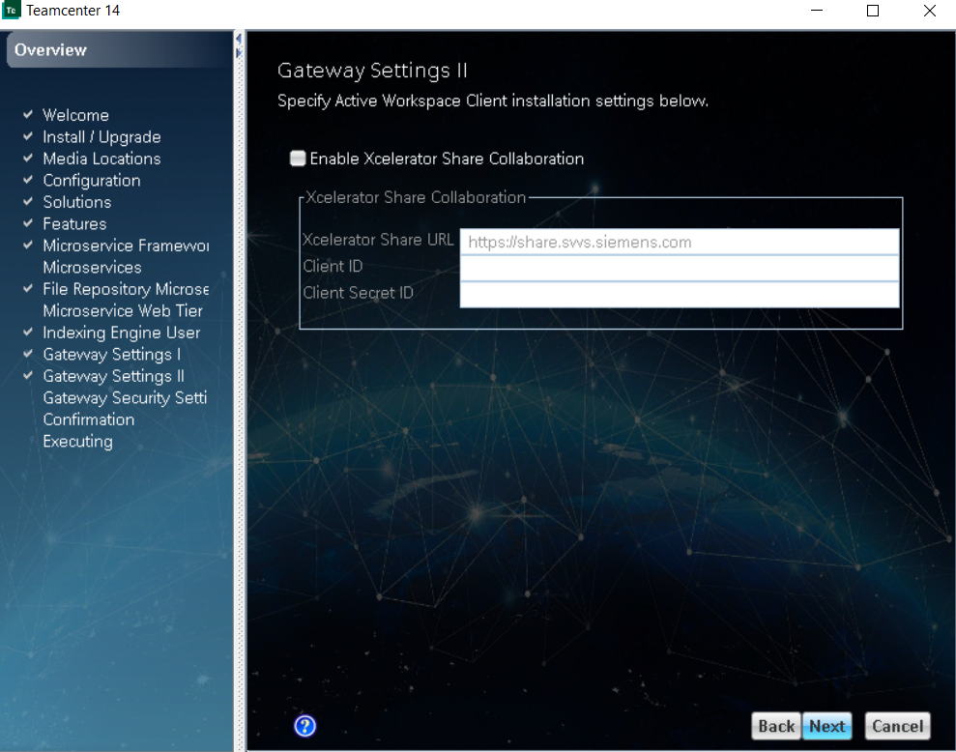

Click Next

