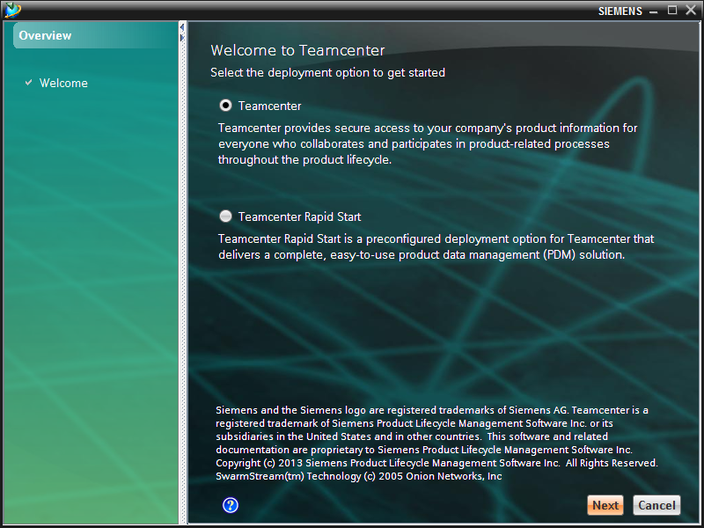

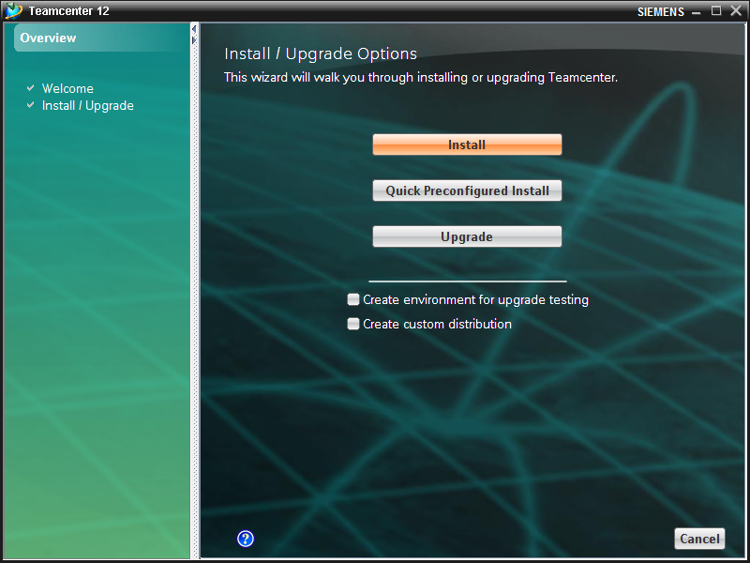

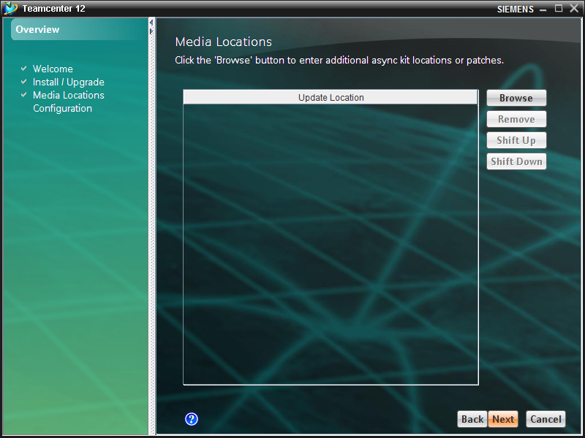

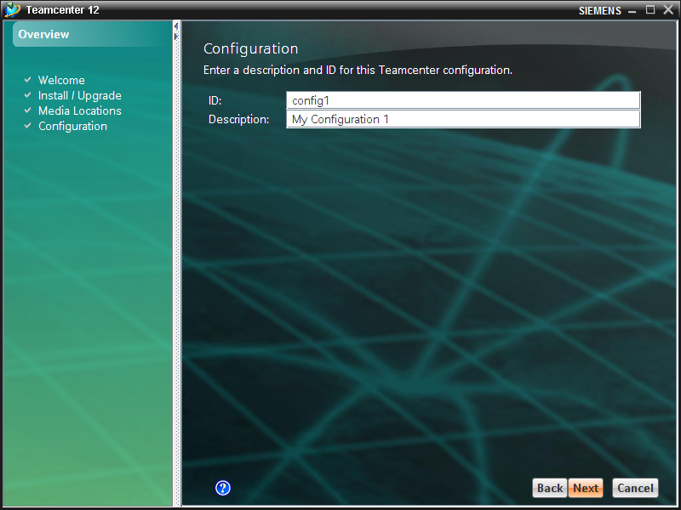
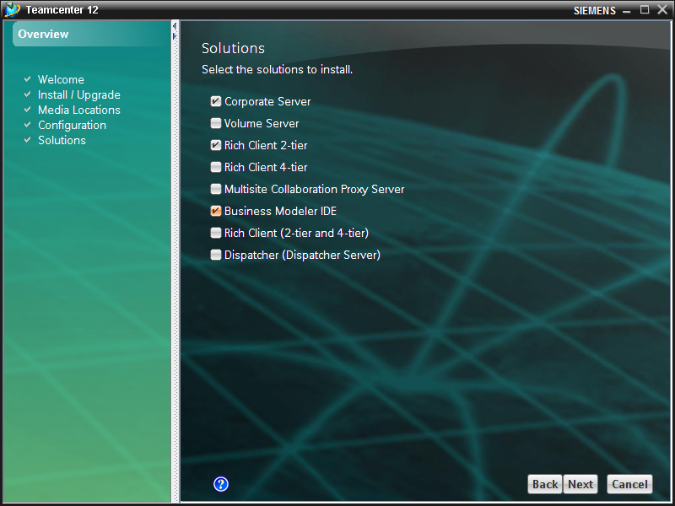

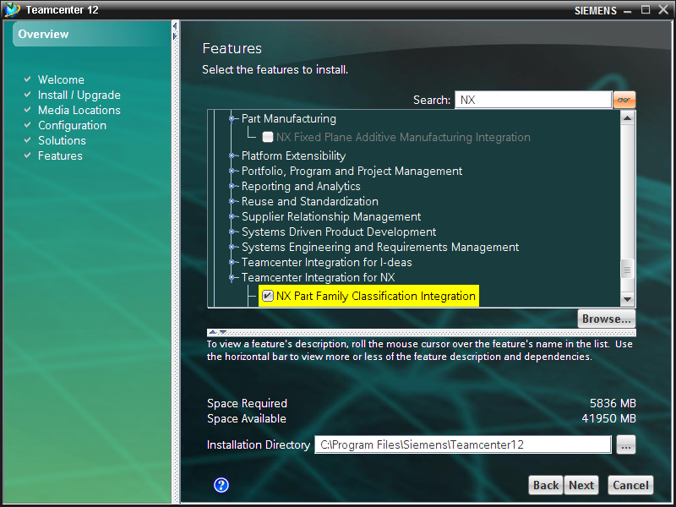

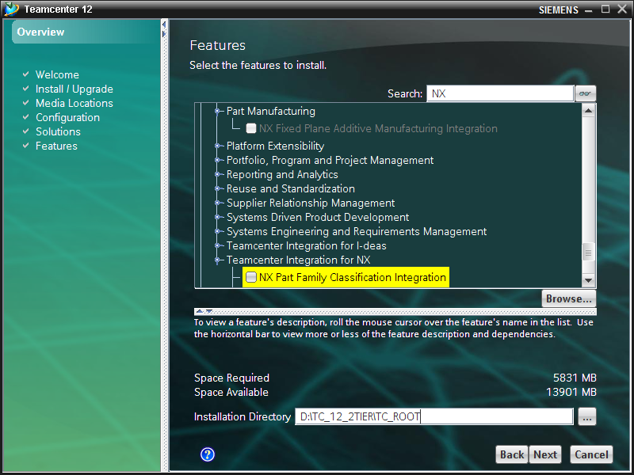

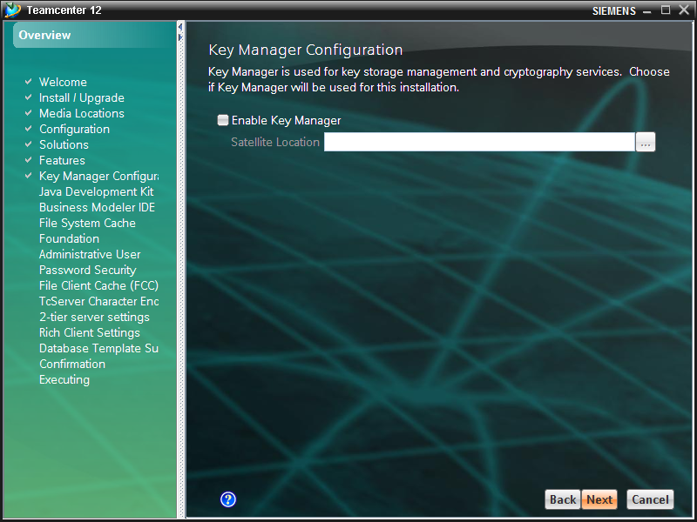

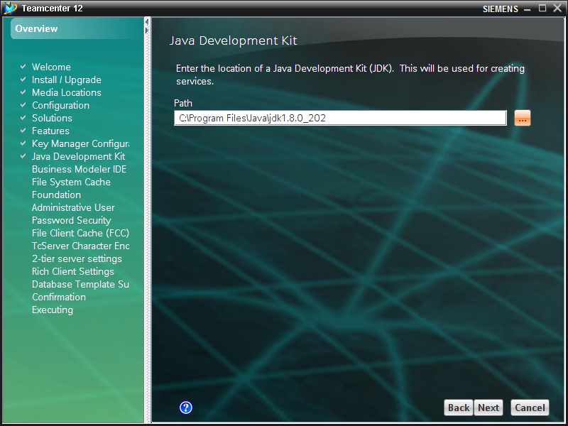

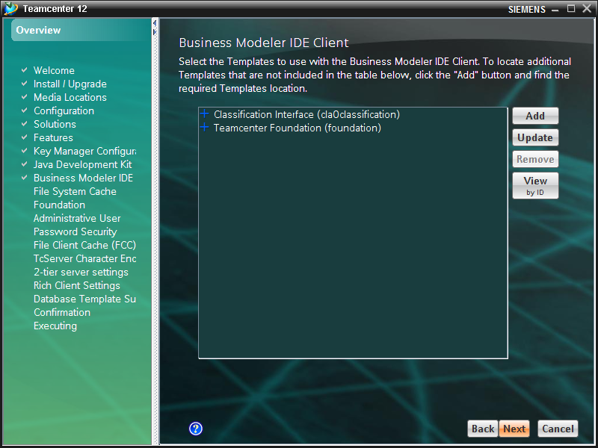

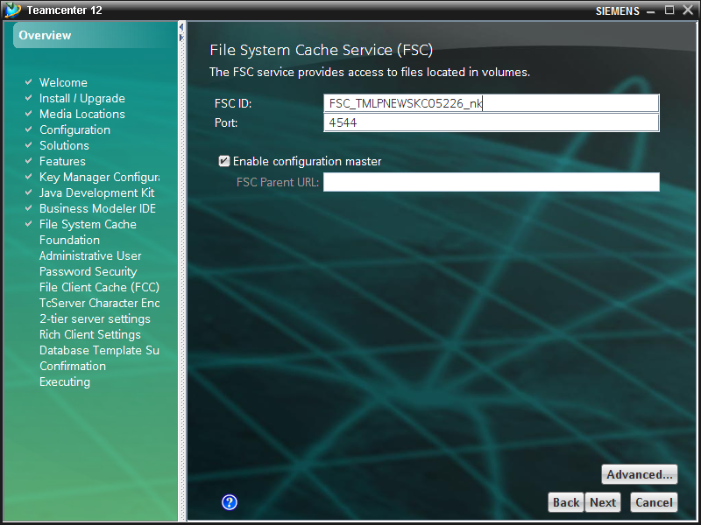

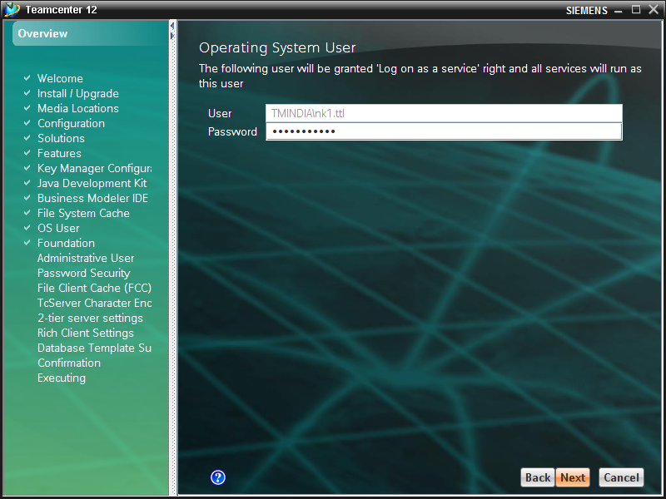

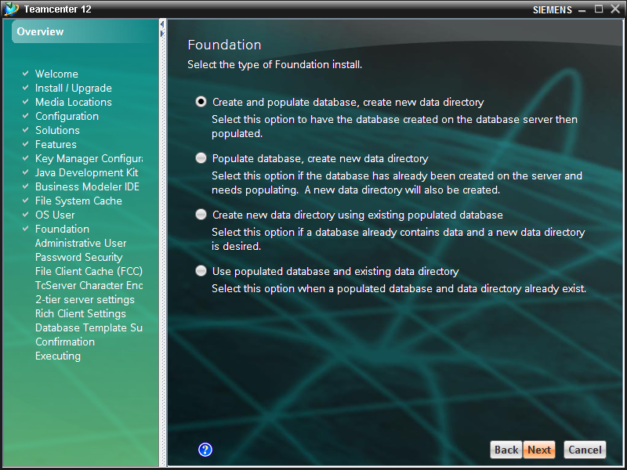

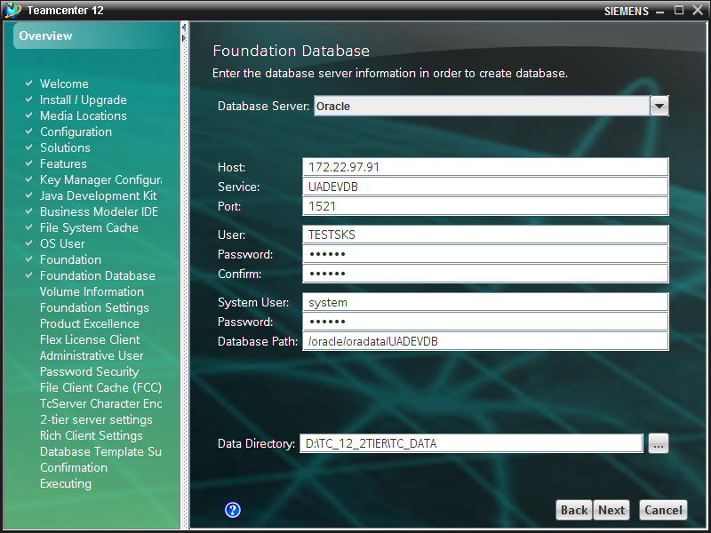
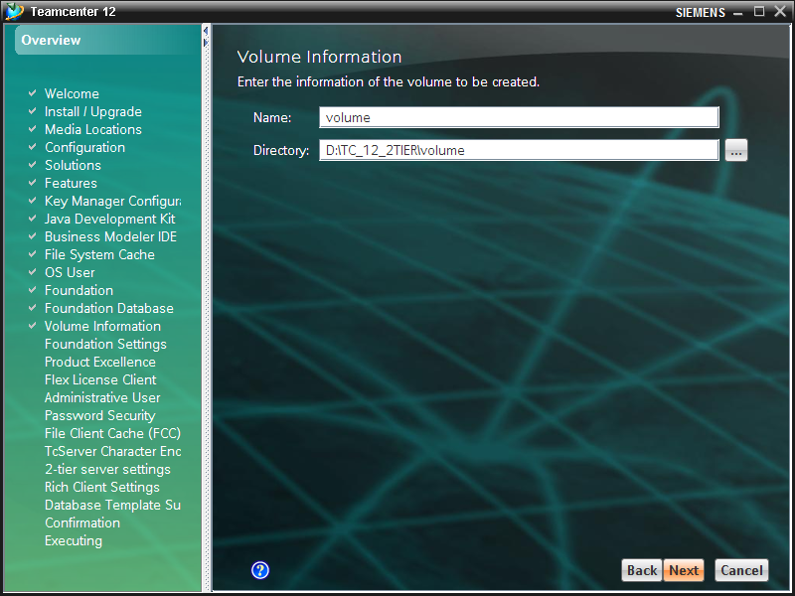

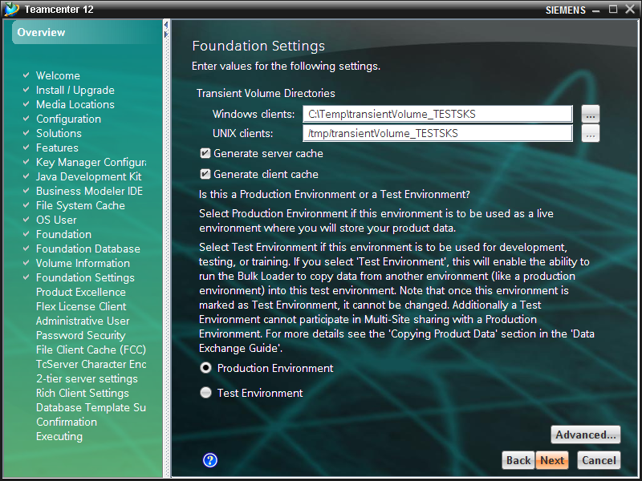

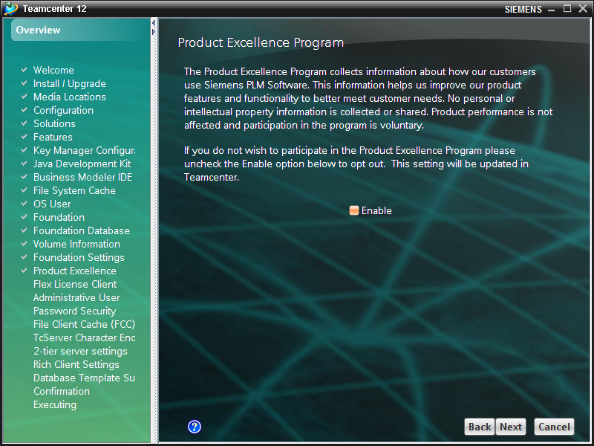

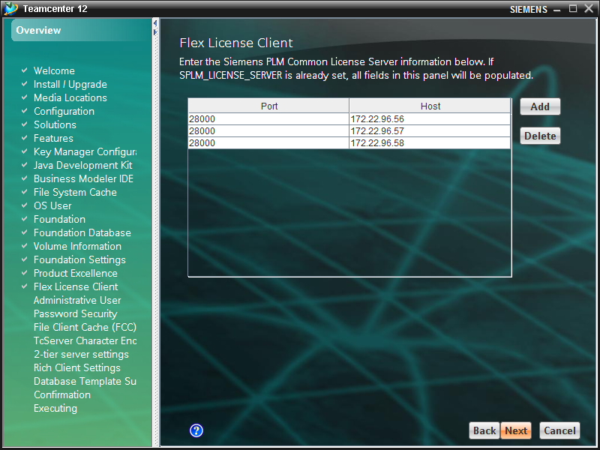

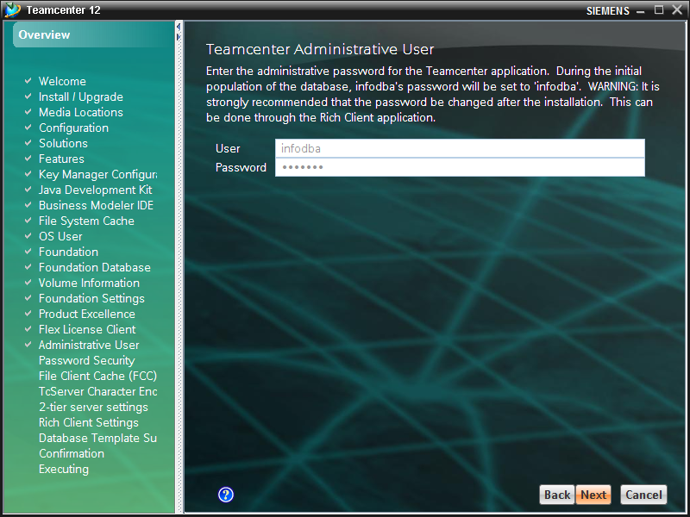

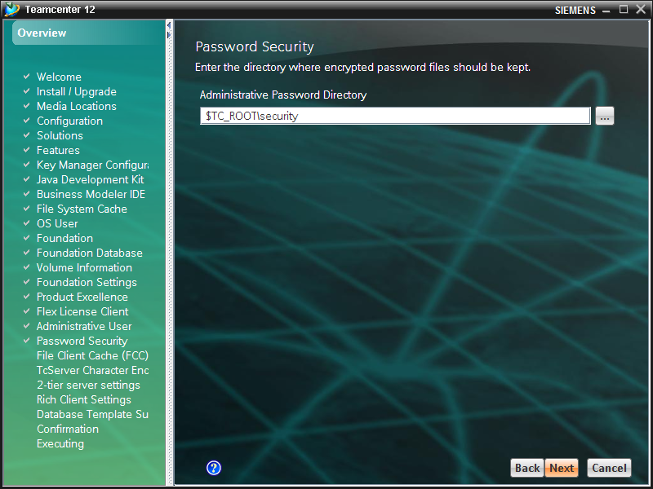

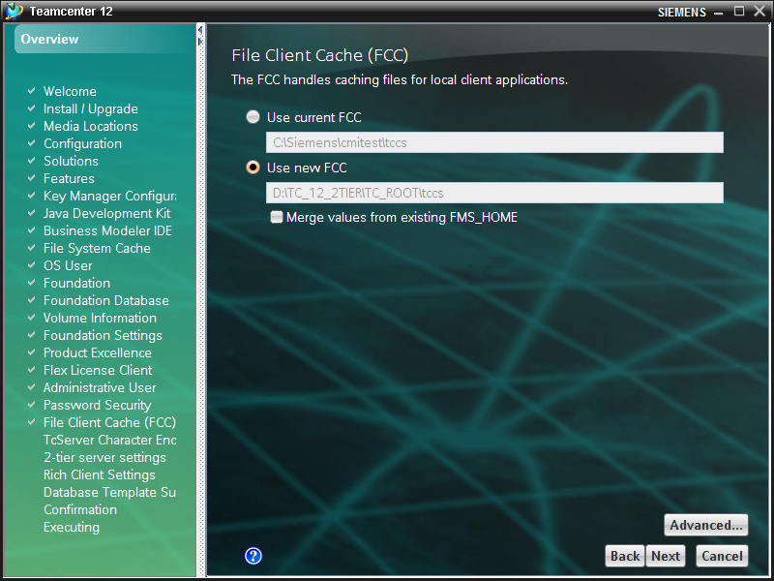

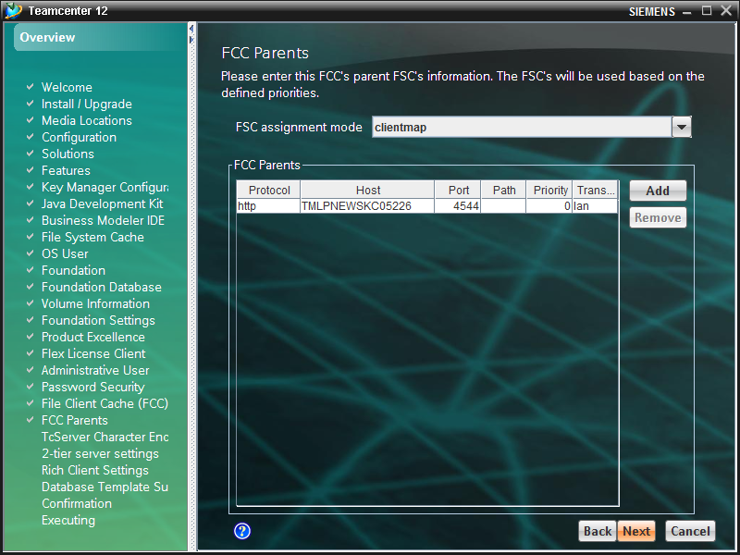
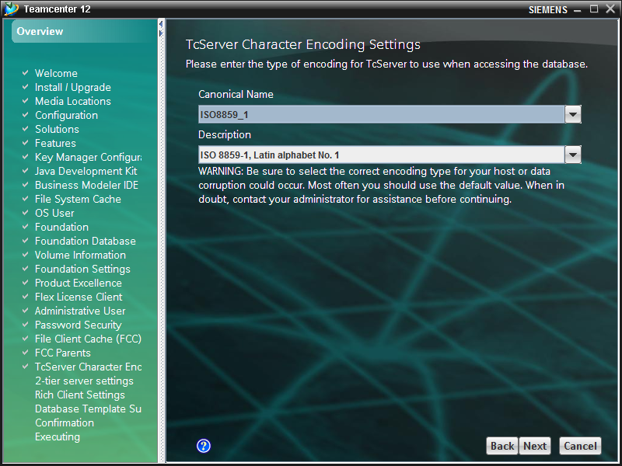

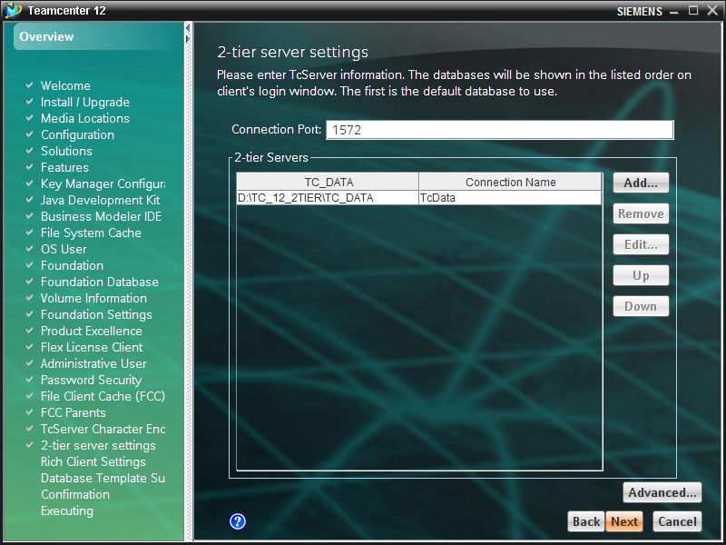
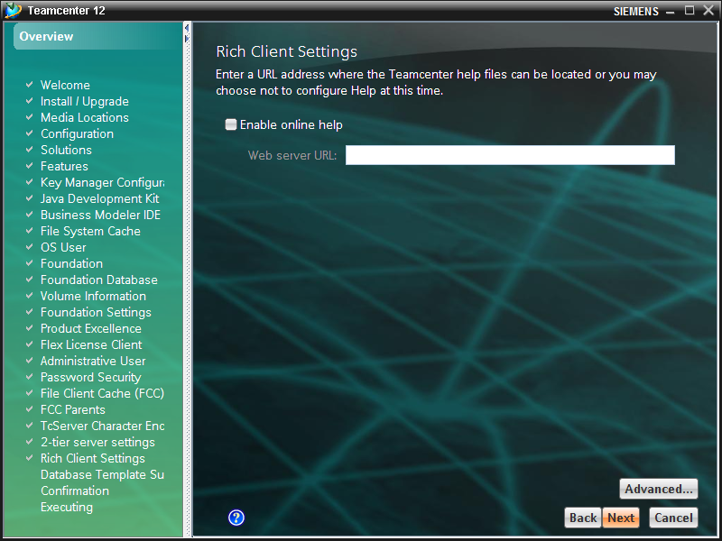

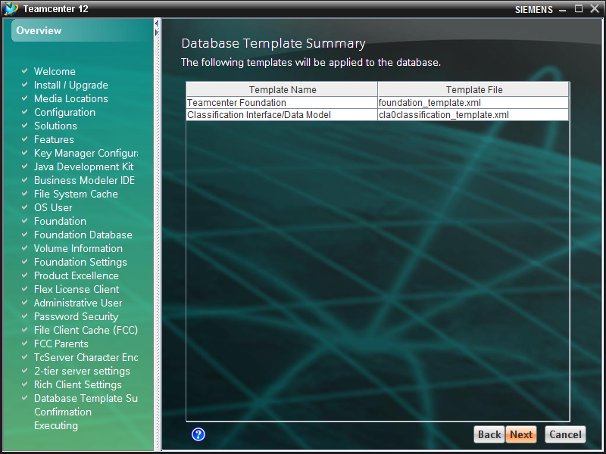

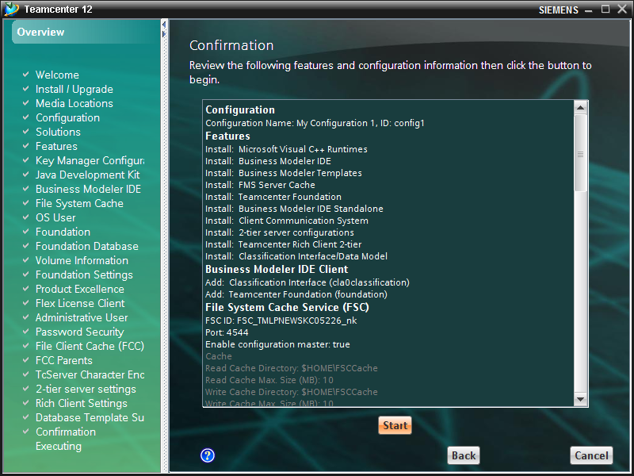

Configuration
Configuration Name: My Configuration 1, ID: config1
Features
Install: Microsoft Visual C++ Runtimes
Install: Business Modeler IDE
Install: Business Modeler Templates
Install: FMS Server Cache
Install: Teamcenter Foundation
Install: Business Modeler IDE Standalone
Install: Client Communication System
Install: 2-tier server configurations
Install: Teamcenter Rich Client 2-tier
Install: Classification Interface/Data Model
Business Modeler IDE Client
Add: Classification Interface (cla0classification)
Add: Teamcenter Foundation (foundation)
File System Cache Service (FSC)
FSC ID: FSC_TMLPNEWSKC05226_nk
Port: 4544
Enable configuration master: true
Cache
Read Cache Directory: $HOME\FSCCache
Read Cache Max. Size (MB): 10
Write Cache Directory: $HOME\FSCCache
Write Cache Max. Size (MB): 10
Proxy
Enable HTTP Proxy: false
Enable HTTPS Proxy: false
FCC Defaults
Windows Cache Directory: $HOME\FCCCache
UNIX Cache Directory: /tmp/$USER/FCCCache
Max. Read Cache Size (MB): 1000
Max. Write Cache Size (MB): 1000
Max. Partial File Read Cache Size (MB): 3000
Volumes
Local volumes only
Ext. Sites
Log On
Run as user: TMINDIA\nk1.ttl
OS User
User: TMINDIA\nk1.ttl
Foundation
Create and populate database, create new data directory
Foundation Database
Oracle
Host: 172.22.97.91
Service: UADEVDB
Port: 1521
User: TESTSKS
System User: system
Database Path: /oracle/oradata/UADEVDB
TC_DATA: D:\TC_12_2TIER\TC_DATA
Volume Information
FSC Host Name: TMLPNEWSKC05226
FSC Port: 4544
FSC Deployment Model: Simple Model
FSC ID: FSC_TMLPNEWSKC05226_nk
Name: volume
Directory: D:\TC_12_2TIER\volume
Foundation Settings
Windows clients: C:\Temp\transientVolume_TESTSKS
UNIX clients: /tmp/transientVolume_TESTSKS
Flex License Client
Environment Setting: 28000@172.22.96.56,28000@172.22.96.57,28000@172.22.96.58
Administrative User
User: infodba
File Client Cache (FCC)
FMS_HOME: Use new FCC D:\TC_12_2TIER\TC_ROOT\tccs
Client Communication System Switch
Use Configurations and Environments :false
Client Tag Filter :
FCC Parents
http://TMLPNEWSKC05226:4544/, 0, lan
TcServer Character Encoding Settings
TcServer Character Encoding Settings:ISO8859_1
2-tier server settings
Activation Mode:NORMAL
Connection Port:1572
Configuration Directory:D:\TC_12_2TIER\TC_ROOT\iiopservers
2-tier Servers:D:\TC_12_2TIER\TC_DATA,TcData,
General
Runtime Temp Folder:
Security Services
Login URL:
Application ID:Teamcenter

