This project is a way to diagnose and treat autistic children and children with other learning and cognitive difficulties like Down’s syndrome. A virtual environment is created in unity and the human interactions are tracked using a leap motion sensor.

The main motive of the project is to remove the barrier of a social stigma that exists around learning and psychological disabilities. This project can act as the mode of telemedicine to interact with doctors remotely.

The game like activity contains multiple levels of fill in the blank like exercises which the kid is expected to complete.

***Recorded metrics:***

Recognition time:

Once the level is shown to the kid, there are a few blanks, the child is supposed to observe the pattern on the screen and compare with the other alphabets to choose the correct alphabet that fits in the blank. The time taken by the child to recognize the correct alphabet for the blank and grab that alphabet is recorded and saved as the recognition time.

Coordination time:

Hand dexterity is one of the major issues with children diagnosed with autism spectrum disorder. The children have a difficulty with fine movements such as holding delicate objects etc. The children after grabbing the correct alphabet for the blank have to hold it properly and place it in the correct blank. The time taken by the child to move the alphabet from its place to the correct blank is recorded as the coordination time.

Number of wrong attempts:

As the name suggests, this field tracks the number of times the child has tried to place the wrong alphabet in the blank. Each time a wrong letter is placed in a blank, the letter snaps back to its original position. The child has to then try a different letter to fill the blank.

Facial emotions:

While the child interacts with the application, it automatically takes photos of the child’s face during specific checkpoints to identify the emotions of the child and in turn identify the difficulties that are faced by them.

All these 4 metrics are displayed as a final report to the physician as a website.

**Dynamic Difficulty:**

This is one of the main features of the application that has been developed to keep the child from getting demotivated or distracted. Autism has a huge spectrum and no 2 kids might have the same levels of autism. Having too many simple and similar levels might be too easy for one while it might be necessary for another kid. To handle this issue we have implemented the idea of dynamic difficulty which evaluates the performance real time and advanced the kid to further levels when performed well or loops back to a previous level, if the kid is found struggling in a particular level.

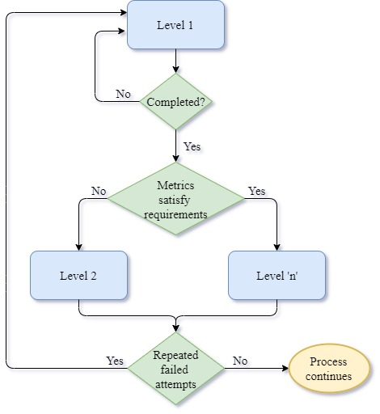

**Technologies used:**

* Unity (Development environment)
* Leap Motion SDK (interaction manager and sensor)
* Azure cognitive service (FaceAPI)
* ReactJS + Python (Website)

**Working Screen shots:**

