Print Service
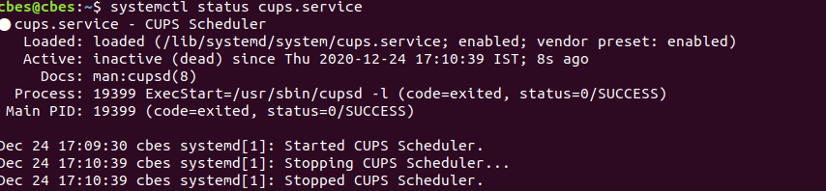
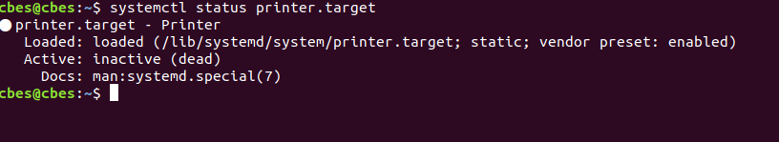
Blutooth Service
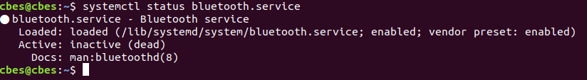
FTP

TFTP

All Running Processes
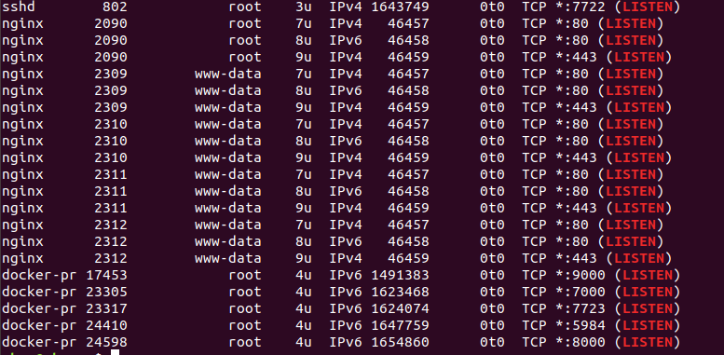

Root acces disabled

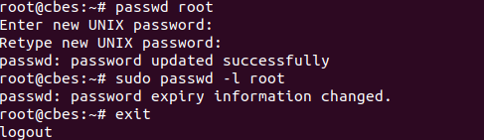

USB disabled


User Password Chang as per policy

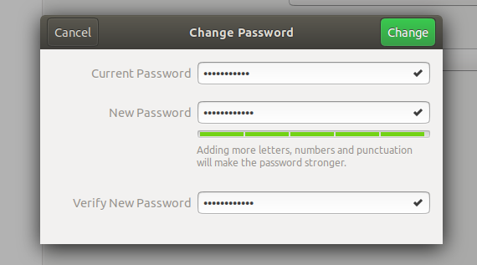

- bios paswword set as per password policy

Antivirus

Antivirus installed with licence
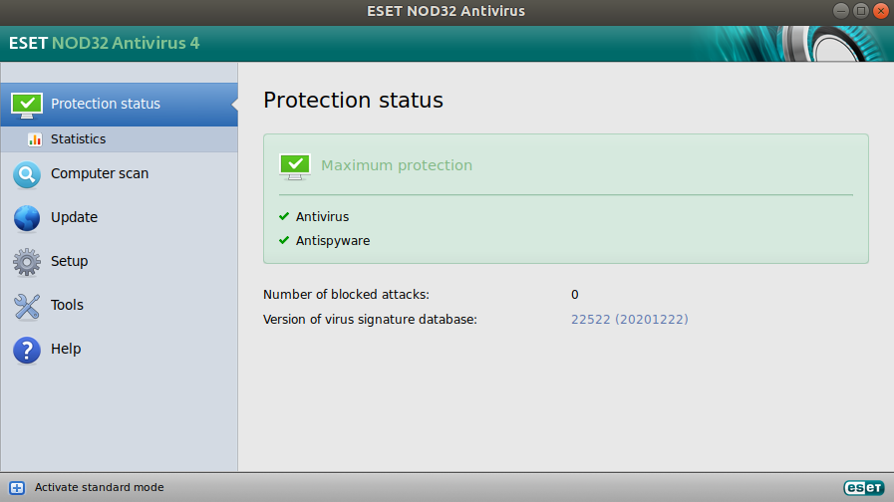

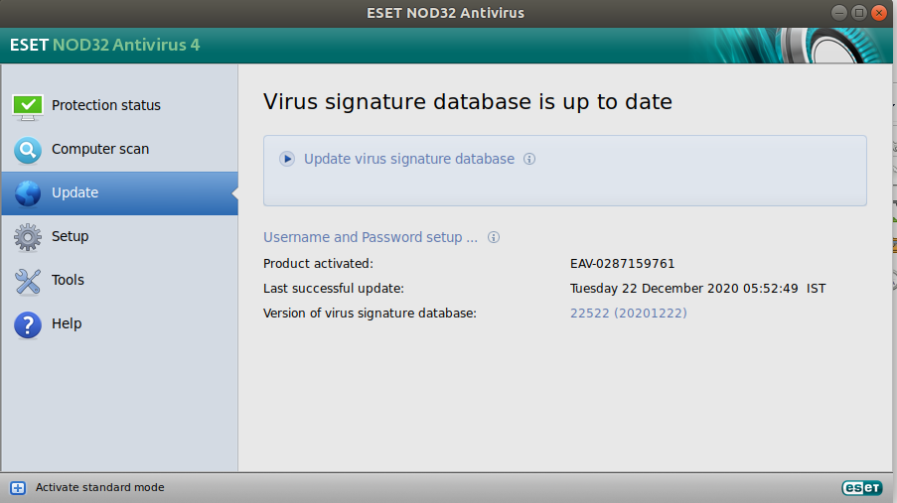

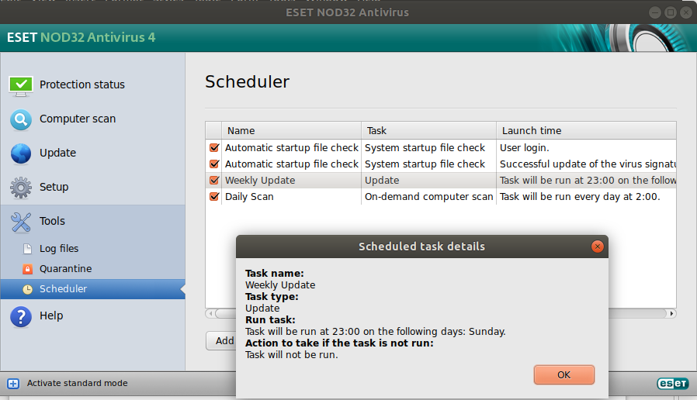
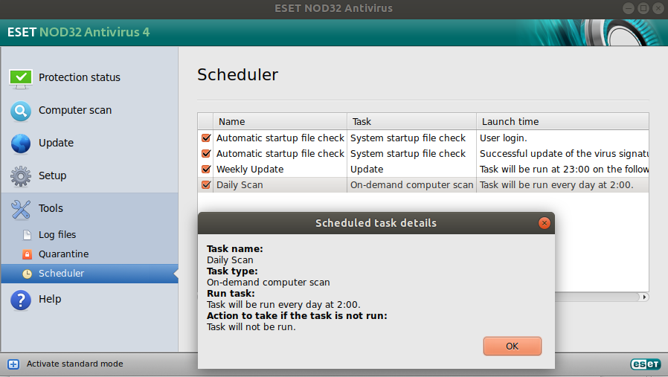
Daily scan of system

Weekly Update of Antivirus

