**CHETAN – React.js Expert**

### **Technical knowledge Summary**:

|  |  |
| --- | --- |
| Languages: | HTML, CSS, JavaScript, React.js, Node.js, Next.js |
| OS: | Windows, Linux Ubuntu, Mac |
| DBMS: | MySQL,MongoDB,Firebase, Redis |
| Others: | Git, Jira, DigitalOcean, AWS |

**Professional Work Experience:**

**(Total relevant experience – 4 Year plus in Web Development.)**

**Full-Stack Developer**

Innolytic Solutions Pvt Ltd | June 2017 - present

Collaborate with designers and other developers to launch a car rental service called borrowen built with node.Js, MongoDB and Express .

- Develop complete back-end of Inoib application and workflow in node.Js and MongoDB.

- Provide technical advice and assists in solving programming problems.

- Manage AWS, operations and security of clients application.

- Responsible for automatic code deployment and seamless integration. - Develop Complete E commerce back-end in node.Js with payment integration.

**Currently Working (Innolytic Solutions Pvt Ltd)**

**Projects :-**

1.   [https://www.msmex.in](https://www.msmex.in/) (**React.js, Redux, Node.js ,API, MySql**)

**-** A business advisory platform for Startups, Micro, Small & Medium Enterprises in India. Get professional advice and mentoring from the leading industry experts.

2.  [https://www.webisworld.com](https://www.webisworld.com/) (**React.js, Next.js, SSR, Node.js API, MySql**)

**-** webisworl is developer blog website it was created by me, I was made Custom CMS system for without using any third-party system like Ghost, Medium, Created from Scratch withServer-Side Rendering.

3.<https://github.com/chetanmajithiya/apple-store-react-hooks> (**React.js, Material UI, React Hooks Demo**)

- Demo of using React Hooks (it is latest in React.js for managing state management in Functional Components)

 4. [**https://www.dufther.com/**](https://www.dufther.com/)**( React.js , Node.js , MySql )**

**-**Dufther is an advanced Job Hiring Portal created for the Industrial Jobs across various sectors in India.

You can easily register as a Candidate to search and apply for Jobs, while as an Employer, you can manage Recruitment with simplified Job Posts and even add your own Recruitment Staff to manage Hiring.

**5.** [**https://borrowen.com/home**](https://borrowen.com/home) **(Node.js , Express.js , Mongo DB )**

**-**All types of vehicle renting platform for personal and business work .you can hire any type of vehicle including helicopter !

You can also say it is a one stop rental platform for all your need type .

**6.** [Admin (lotteryindowheels.in)](http://admin.lotteryindowheels.in/)

For this website , I have developed an Admin panel on React.js and have implemented bulk upload and export option in csv and excel format as well .  
Please see the screenshot below of Admin panel dashboard

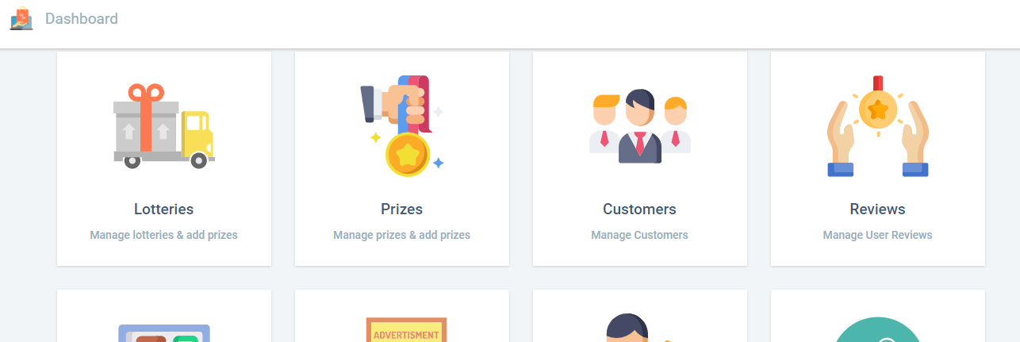

7. **Project Name: - LR Drive Smart OBD Connector.**

It is a device to monitor your car health as well as web mobile Application using this user keeps tracking driving behavior. also get Crash emergency service in case of accident.

Technologies Used: - Angular6, Angular Material, Node.js, Mongo DB

Developed an API for mobile application & web portal . Using node.js as well as JWT Authentication.

8. **Project Name :- Landmark Realtors.**

Technologies Used :- Angular7, Angular Material, Node.js, Mongo DB.Worked on UI part in angular 7, Developed Server side API,JWT Authentication using node.js.

9. **Project Name :- Learning Management System with Secured Media Content.**

It is online learning platform using this user can access the study materials after login.Technologies Used :- Angular7, Angular Material ,Node.js, Mongo DB.

Developed web Portal UI, Developing a Rest API for webPortal, Uploading Media Content using node .