**MAD3144S22Labtest2**

**Name: Sarwan singh**

**Student Id: C0853452**

**ScreenShots**

**1: After Inserting Sunroof Selection**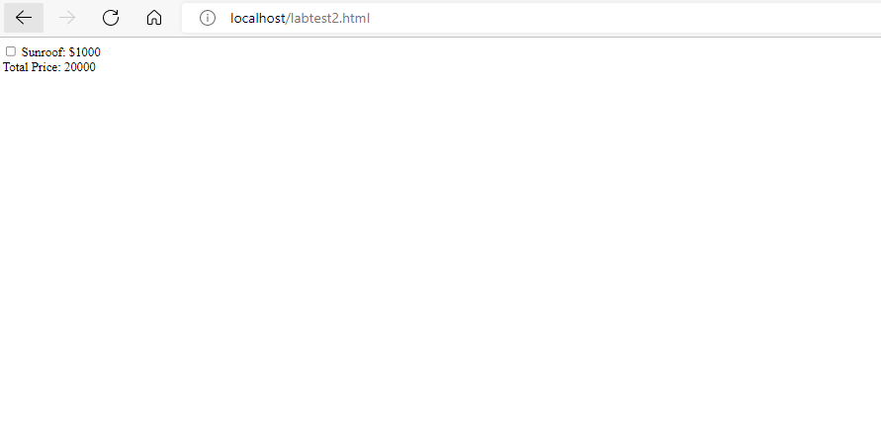

**2:After selecting Built-in GPS checkbox**

4: After Inserting And Selecting Sunroof and Built-in Gps

