AZƏRBAYCAN RESPUBLİKASI TƏHSİL NAZİRLİYİ BAKI ________________ UNİVERSİTETİ

**__________________**__ fakültəsi

**___________________** kafedrası

B A K A L A V R T Ə C R Ü B Ə H E S A B A T I

Tələbə No:

Ad:

Soyad:

İxtisas:

**Table of Contents**

Abstract 3

Company Background 3

My Role in the Company 4

Functional Description of the Project 5

Key Skills Developed 7

Professional IT Skills 7

Communicational Skills 7

Conclusion 8

Reference 8

# **Abstract**

My internship journey started on (month) 2020 in the logistics company called S-Global Logistic Ltd. For me it was a unique chance to undergo an internship in the large freight forwarding company on Azerbaijan market especially in desired IT department.

It was definitely one of the best decisions I have ever taken as it allowed me to learn new information in the IT sphere, however, from the other side with it challenges helped me to become a stronger leader and develop my communicational skills.

Below essay will contain all the information based on my personal experience.

# **Company Background**

S-Global Logistic Ltd effectively organizes the transportation, storage, and forwarding of cargo, as well as transports all types of cargo to any location in the world, in conjunction with customs clearance of export and import cargo. The general management of businesses enables to maximize employee engagement. The organization guarantees the liability of one contractor for achieving a high-quality outcome of the overall work due to an integrated approach. Clarity and automation of all business processes make it possible to improve the convenience, speed, and quality of services delivered, as well as lower service rates while reducing consumer risk. Additionally, S-Global Logistic Ltd are the partners with Pentagon Freight Service, a professional in in Shipping & Port agent business activities.

S-Global Logistic Ltd has a large number of awards and certificates, which confirm the high professionalism of the company and the full compliance of our services with international requirements.

As mentioned above my internship was in the IT department and my supervisor and mentor was ____________________ (name, surname, mail address).

# **My Role in the Company**

One of the main objectives in the company was to develop a program dedicated to the logistics operations 1C: TMS Logistics. It is online management system the purpose of the which is to provide timely exchange of information, SaaS document flow between customers, freight forwarders and transport and forwarding companies in a single information space, using the Internet portal. The main focus was the automation of transport logistics. It will be used as an order management system and will solve the task of automation of delivery of material items or service from the source of production to the consumer of the product or service, and form the optimal routes.

The overall benefit was to make the working process smooth, clear for the employees and easy for customers to see better results by speeding up the delivery process.

This activity allowed me to work in the IT department, but to overlook the job of the IT assistant who are developing technical blocks and other staff members too. I was the person engaged in the process from the start of the survey, developing the whole project based on it, overlooking its progress and familiarizing the whole team with the novelties confirmed by the company management. By this reason I had a possibility to know mostly all the departments of the company, see the whole chain of the process and better understand not only IT sphere but logistics operation as well.

# **Functional Description of the Project**

Automatizing certain aspects of performance in order to free up attentional resources is fundamental to skilled performance in a number of areas because it allows performers to allocate their limited capacities to where they are most needed (Gatbonton and Segalowitz, 1988).

The potential of the transport industry is huge, but the automation of transport logistics is extremely low, however individual automation solutions will help bypass competitors and increase profits. TMS, or transport management system, is a form of CRM designed specifically for the transportation industry. TMS helps you to keep track of the shipping process 24 hours a day, seven days a week. The device automates the dispatcher's work and regulates cargo movement, usually through the use of the GIS service. TMS allows you to keep track of:

* whether the freight is transported properly
* whether the driver deviates from the route
* whether the driver follows the transportation plan.

TMS-solution automates the process of calculations required for goods transportation, such as the optimal cargo loss, residue control, measurement of fuel consumption rate, optimal number of stops along the route, and etc. Based on main efficiency metrics, TMS business logic analyzes incoming data.

As the program has many options, it was crucial to understand which one are extremely requested by staff members. It was done through a survey research and based on the results all the important for quality work services were automized.

Below you can find the screenshot of the program showing data of the number of shipments, orders, detailed planned routes, and what the most important cost saving.

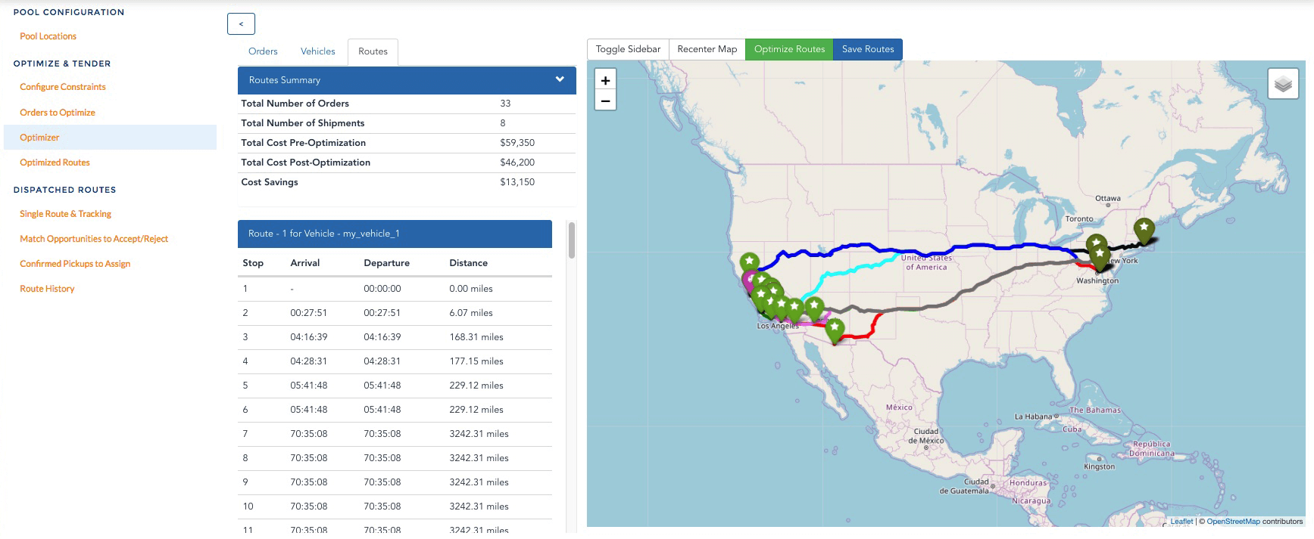

# 

# **Key Skills Developed**

In my opinion I developed many skills, but I would like to highlight professional IT skills and communicational.

## **Professional IT Skills**

When I first joined the company, I was sure in my knowledge and professional IT skills, however I could not even imagine how much new I can absorb not only from studying or reading book but how practically do things. Despite the fact that I was overlooking the project I managed not only to teach people but to learn from them too. Sometimes it was something totally new, sometimes something I already knew but I was explained the easier and faster way.

## **Communicational Skills**

Being a part of the team is like being a part of the movement. Managing employees, working with people with different characters is complicated, however the more you know the employee the easier to find a way. It is important to be open, optimistic and success oriented so the team can feel the spirit of being a part of something big. Despite the fact of being IT manager I think I succeeded to be a strong leader but, in a way, to stay approachable, honest, motivational, communicative, and respectful.

# **Conclusion**

I believe, internship in S-Global Logistic Ltd gave more something more important that knowledge and a benefit in my CV, it teach me how the real work is done and what is it to be a part of the team.

Knowledge and skills that I gained during my internship journey will be useful for my future study and career path.

# 

# **Reference**

Gatbonton, E. and Segalowitz, N. (1988). Creative Automatization: Principles for Promoting Fluency within a Communicative Framework. TESOL Quarterly, 22(3), p.473.