**Introduction:**

In this project, the objective was to implement a 4-bit computer in Verilog HDL. As a starter, a set of instructions had been issued to different student IDs. My student ID is: **1606099.** Since the last digit of my ID is **‘9’,** the instruction set that I had to implement is as follows:

|  |  |  |  |
| --- | --- | --- | --- |
| 1 | ADD A,B | 9 | IN B |
| 2 | SUB A,B | 10 | OUT A |
| 3 | XCHG B,A | 11 | JMP ADDRESS |
| 4 | MOV A,[ADDRESS] | 12 | PUSH A |
| 5 | MOV [ADDRESS],B | 13 | POP A |
| 6 | JNZ ADDRESS | 14 | CALL ADDRESS |
| 7 | XOR A,[ADDRESS] | 15 | RET |
| 8 | PUSHF | 16 | HLT |

**Defining the instruction set:**

**ADD A,B:** Add value stored in B to value stored in A and store the result in A.

**SUB A,B:** Subtract and store the result in A.

**XCHG B,A:** Swap/exchange the value stored in B and value stored in A.

**MOV A,[ADDRESS]:** Store the value stored in data memory at the address given by the instruction to A.

**MOV [ADDRESS],B:** Store the value in B to the address given by instruction in the data memory.

**JNZ ADDRESS:** If zero flag not activated, jump to the instruction given by address stored in the program memory.

**XOR A,[ADDRESS]:** XOR the value stored in A and value stored in data memory at the address given by the instruction, and store the result in A.

**PUSHF:** Push the flags to the stack.

**IN B:** Store the input port data to B.

**OUT A:** Send the value in A to the output port.

**JMP ADDRESS:** Jump to the instruction given by address stored in the program memory.

**PUSH A:** Push the value in A to the stack.

**POP A:** Store the latest value stored in the stack to A.

**CALL ADDRESS:** Go to the instruction given by address stored in the program memory.

**RET:** Return to the instruction from where it was called.

**HLT:** Halt the program execution.

|  |  |  |  |
| --- | --- | --- | --- |
| No. | Instruction | Assembly Key | Machine Code(Decimal) |
| 1 | ADD A,B | ADD_A_B | 0 |
| 2 | SUB A,B | SUB_A_B | 1 |
| 3 | XCHG B,A | XCHG_B_A | 2 |
| 4 | MOV A,[ADDRESS] | MOV_A_ADD | 3 |
| 5 | MOV [ADDRESS],B | MOV_ADD_B | 4 |
| 6 | JNZ ADDRESS | JNZ_ADD | 5 |
| 7 | XOR A,[ADDRESS] | XOR_A_ADD | 6 |
| 8 | PUSHF | PUSHF | 7 |
| 9 | IN B | IN_B | 8 |
| 10 | OUT A | OUT_A | 9 |
| 11 | JMP ADDRESS | JMP_ADD | 10 |
| 12 | PUSH A | PUSH_A | 11 |
| 13 | POP A | POP_A | 12 |
| 14 | CALL ADDRESS | CALL_ADD | 13 |
| 15 | RET | RET | 14 |
| 16 | HLT | HLT | 15 |

**Example Assembly Code:**

**Code:**

MOV A,[0000]

XCHG B,A

MOV A,[0001]

ADD A,B

SUB A,B

OUT A

HLT

**Expected result:**

The data memory has decimal 3 stored in address 0000 and decimal 5 stored in address 0001.

So, the result should be 5+3 = 8 then, 8-3 = 5. So, after the execution, 5 should be seen at the output port.

**Design Code:**

module four_bit_comp(clock,reset,data_in,prog_inst,prog_data,prog_count,data_out);

input clock;

input reset;

input [3:0] data_in; //data input port

input [3:0] prog_inst; //program intrsuction input port

input [3:0] prog_data; //program data input port

input [3:0] prog_count; //program counter

output reg [3:0] data_out; //output port

reg [3:0] A,B,C; //arithmetic registers

reg [3:0] IP,SP; //instruction pointer and stack pointer

reg [3:0] data_mem[15:0]; //data memory

reg [3:0] prog_inst_mem[15:0]; //program intsruction memory, stores inst code

reg [3:0] prog_data_mem[15:0]; //program data memory, stores data corresponding to inst

reg [3:0] stack[15:0]; //stack memory

reg HF,ZF,CF = 1'd0; //halt flag,zero flag,carry flag

integer count = 0;

always @(negedge clock) //this block loads the program and data

begin //before executing them

data_mem[prog_count] = data_in;

prog_inst_mem[prog_count] = prog_inst;

prog_data_mem[prog_count] = prog_data;

end

always @(posedge clock) //this block executes the program

begin

if (reset == 1) //resets everything

begin

HF = 0;ZF = 0;CF = 0;

A = 0;B = 0;C = 0;

IP = 0;SP = 15;

data_out = 4'bzzzz;

end

else if (reset == 0 && HF == 0)

begin

if (prog_inst_mem[IP] == 0)

begin //ADD A, B

{CF, A} = A + B;

if (A == 0) begin

ZF = 1;

end

end

else if (prog_inst_mem[IP] == 1)

begin //SUB A, B

{CF, A} = A - B;

if (A == 0) begin

ZF = 1;

end

end

else if (prog_inst_mem[IP] == 2)

begin //XCHG B, A

C = A;

A = B;

B = C;

if (B == 0) begin

ZF = 1;

end

end

else if (prog_inst_mem[IP] == 3)

begin //MOV A,[ADDRESS]

A = data_mem[prog_data_mem[IP]];

if (A == 0) begin

ZF = 1;

end

end

else if (prog_inst_mem[IP] == 4)

begin //MOV [ADDRESS],B

data_mem[prog_data_mem[IP]] = B;

if (B == 0) begin

ZF = 1;

end

end

else if (prog_inst_mem[IP] == 5)

begin //JNZ ADDRESS

if (ZF == 0) IP = prog_data_mem[IP];

end

else if (prog_inst_mem[IP] == 6)

begin //XOR A,[ADDRESS]

A = A ^ data_mem[prog_data_mem[IP]];

if (A == 0) begin

ZF = 1;

end

end

else if (prog_inst_mem[IP] == 7)

begin //PUSHF

stack[SP] = {1'b0,ZF,CF,HF};

SP = SP - 1;

end

else if (prog_inst_mem[IP] == 8)

begin

B = data_in; //IN B

if (B == 0) begin

ZF = 1;

end

end

else if (prog_inst_mem[IP] == 9)

begin //OUT A

data_out = A;

if (A == 0) begin

ZF = 1;

end

end

else if (prog_inst_mem[IP] == 10)

begin //JMP ADDRESS

IP = prog_data_mem[IP];

end

else if (prog_inst_mem[IP] == 11)

begin // PUSH A

stack[SP] = A;

SP = SP - 1;

if (A == 0) begin

ZF = 1;

end

end

else if (prog_inst_mem[IP] == 12)

begin //POP A

SP = SP + 1;

A = stack[SP];

stack[SP] = 4'd0;

if (A == 0) begin

ZF = 1;

end

end

else if (prog_inst_mem[IP] == 13)

begin //CALL ADDRESS

stack[SP] = IP;

SP = SP - 1;

IP = prog_data_mem[IP];

end

else if (prog_inst_mem[IP] == 14)

begin

SP = SP + 1; //RET

IP = stack[SP];

end

else if (prog_inst_mem[IP] == 15)

begin //HLT

HF = 1;

end

IP = IP + 1; //updating instruction pointer

end

end

endmodule

**Testbench Code:**

module testbench;

reg clock = 0;

reg reset = 1;

reg [3:0] data_in,prog_inst,prog_data,prog_count;

wire [3:0] data_out;

reg [3:0] prog_inst_mem[15:0];

reg [3:0] prog_data_mem[15:0];

reg [3:0] data_mem[15:0];

four_bit_comp test(clock,reset,data_in,prog_inst,prog_data,prog_count,data_out);

integer count;

parameter NONE = 4'b0000;

parameter ADD_A_B = 4'd0; //defining assembly keys

parameter SUB_A_B = 4'd1; //with machine code

parameter XCHG_B_A = 4'd2;

parameter MOV_A_ADD = 4'd3;

parameter MOV_ADD_B = 4'd4;

parameter JNZ_ADD = 4'd5;

parameter XOR_A_ADD = 4'd6;

parameter PUSHF = 4'd7;

parameter IN_B = 4'd8;

parameter OUT_A = 4'd9;

parameter JMP_ADD = 4'd10;

parameter PUSH_A = 4'd11;

parameter POP_A = 4'd12;

parameter CALL_ADD = 4'd13;

parameter RET = 4'd14;

parameter HLT = 4'd15;

initial begin

data_mem[0] = 4'd3; //data for storing in data memory

data_mem[1] = 4'd5;

data_mem[2] = 4'd0;

data_mem[3] = 4'd0;

data_mem[4] = 4'd0;

data_mem[5] = 4'd0;

data_mem[6] = 4'd0;

data_mem[7] = 4'd0;

data_mem[8] = 4'd0;

data_mem[9] = 4'd0;

data_mem[10] = 4'd0;

data_mem[11] = 4'd0;

data_mem[12] = 4'd0;

data_mem[13] = 4'd0;

data_mem[14] = 4'd0;

data_mem[15] = 4'd0;

prog_inst_mem[0] = MOV_A_ADD; prog_data_mem[0] = 4'd0; //assebly code

prog_inst_mem[1] = XCHG_B_A; prog_data_mem[1] = NONE;

prog_inst_mem[2] = MOV_A_ADD; prog_data_mem[2] = 4'd1;

prog_inst_mem[3] = ADD_A_B; prog_data_mem[3] = NONE;

prog_inst_mem[4] = SUB_A_B; prog_data_mem[4] = NONE;

prog_inst_mem[5] = OUT_A; prog_data_mem[5] = NONE;

prog_inst_mem[6] = HLT; prog_data_mem[6] = NONE;

prog_inst_mem[7] = NONE; prog_data_mem[7] = NONE;

prog_inst_mem[8] = NONE; prog_data_mem[8] = NONE;

prog_inst_mem[9] = NONE; prog_data_mem[9] = NONE;

prog_inst_mem[10] = NONE; prog_data_mem[10] = NONE;

prog_inst_mem[11] = NONE; prog_data_mem[11] = NONE;

prog_inst_mem[12] = NONE; prog_data_mem[12] = NONE;

prog_inst_mem[13] = NONE; prog_data_mem[13] = NONE;

prog_inst_mem[14] = NONE; prog_data_mem[14] = NONE;

prog_inst_mem[15] = NONE; prog_data_mem[15] = NONE;

end

initial begin

$dumpfile("dump.vcd");

$dumpvars;

for (count = 0;count < 16; count = count+1) begin

# 1 clock = 0;

data_in = data_mem[count];

prog_inst = prog_inst_mem[count];

prog_data = prog_data_mem[count];

prog_count = count;

# 1 clock = 1;

end

# 1 reset = 0;

# 32 $finish;

end

always #1 clock = !clock;

endmodule

**Waveform:**

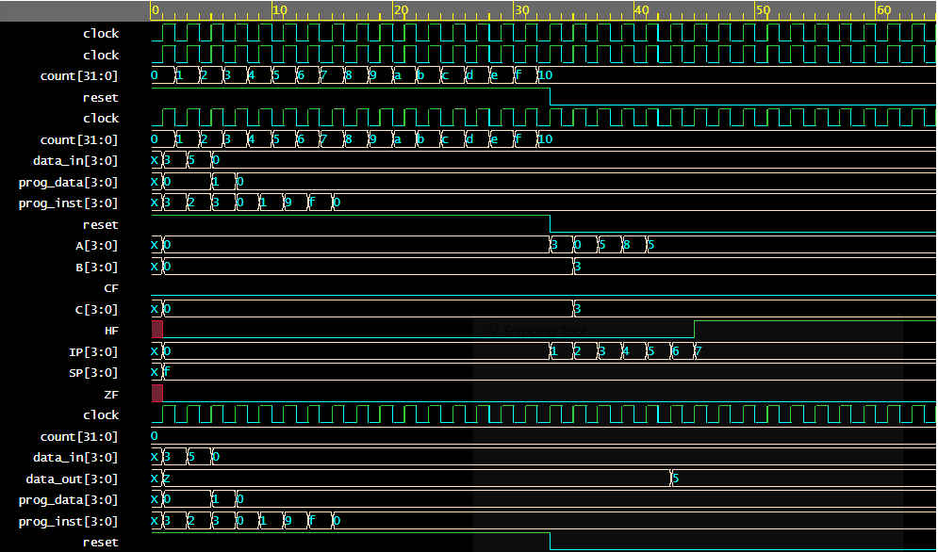

It can be observed from the waveform that, at the end of the program, output port “data_out[3:0]” gave 5 as output which matches with the expected output.