**Task 1:**

Determine the transfer function of the respiratory system shown in Fig. 3

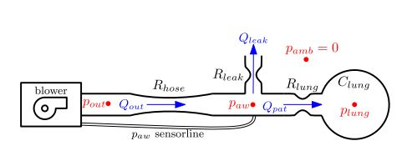

Equivalent Electrical Circuit -

+

–

Clung

Rlung

V0

Qpat(I0)

(Ileck)

Plung

Rleak

Qleak

1

Paw

Rhose

Iin

Qout

Pout

(vi)

Pamb = 0

P ⇒ Voltage

Q ⇒ Current

C⇒ Capacitance

R ⇒ resistance

Qout =

Qleak =

Qpat = Qout – Qleak = ...............(i)

$\frac{dP_{lung}}{dt}={\dot{P}}_{lung}=\frac{Q_{pat}}{C_{lung}}=\frac{P_{aw}-P_{lung}}{C_{lung}R_{lung}}$.........(ii)

Applying KCL at node 1

$$\frac{P_{out}-P_{aw}}{R_{hose}}=\frac{P_{aw}}{R_{leak}}+\frac{P_{aw}-P_{lung}}{R_{lung}}$$

⇒ $\frac{P_{out}}{R_{hose}}-\frac{P_{aw}}{R_{hose}}=\frac{P_{aw}}{R_{leak}}+\frac{P_{aw}}{R_{lung}}-\frac{P_{lung}}{R_{lung}}$

⇒ $\frac{P_{aw}}{R_{hose}}+\frac{P_{aw}}{R_{leak}}+\frac{P_{aw}}{R_{lung}}=\frac{P_{out}}{R_{hose}}+\frac{P_{lung}}{R_{lung}}$

⇒ Paw = .............(iii)

⇒ Paw = Plung + Pout .......(iv)

Substituting the value of Paw in eqn (i) & (ii)

Qpat = – Plung

= Plung + Paw

Qpat = Plung + Pout .........(v)

Plung = –

= Plung + Pout

Plung = Plung + Pout ........(vi)

Here, input ⇒ Pout , output ⇒ $\left[\begin{matrix}P_{aw} \\ Q_{pat}\end{matrix}\right]$, state ⇒ Plung

From eqn (iv) to (vi) we find:

P­lung= Ah Plung + Bh Pout .........(vii)

$\left[\begin{matrix}P_{aw} \\ Q_{pat}\end{matrix}\right]$ = Ch Plung + Dh Pout ..........(viii)

Where,

Ah =

Bh =

Ch =

Dh =

We know that,

Y(s) = $\left[C_{n} {\left(sI-A_{h}\right)}_{B_{h}}^{-1}+D_{h}\right]u(s)$

where Y(s) is the output matrix and u(s) is the input matrix

so, $\frac{Y(s)}{u(s)}=H\left(s\right)=C_{h}{\left(SI-A_{h}\right)}^{-1}B_{h}+D_{h}$

Using the values of parameters given in table 1 of the reference paper, H(s) was calculated using the code given below.

|  |  |
| --- | --- |
| Rlung | 5/1000 |
| Clung | 20 |
| Rleak | 60/1000 |
| Rhose | 4.5/1000 |
| ωn | 2π30 |

Code:

clc;

clearvars;

Rlung = 5/1000;

Clung = 20;

Rleak = 60/1000;

Rhose = 4.5/1000;

Ah = -((1/Rhose)+(1/Rleak))/(Rlung*Clung*((1/Rlung)+(1/Rhose)+(1/Rleak)))

Bh = (1/Rhose)/(Rlung*Clung*((1/Rlung)+(1/Rhose)+(1/Rleak)))

Ch = [(1/Rlung)/((1/Rlung)+(1/Rhose)+(1/Rleak));...

-((1/Rhose)+(1/Rleak))/(Rlung*((1/Rlung)+(1/Rhose)+(1/Rleak)))]

Dh = [(1/Rhose)/((1/Rlung)+(1/Rhose)+(1/Rleak));...

(1/Rhose)/(Rlung*((1/Rlung)+(1/Rhose)+(1/Rleak)))]

s = tf('s');

Hs = Ch*inv((s*eye(1) - Ah))*Bh + Dh

So, the calculated H(s) is:

H(s) = $\left[\begin{matrix}\frac{0.5063s +5.063}{s + 5.443} \\ \frac{101.3s+1.137e-13}{s+5.443}\end{matrix}\right]$

**Task 2:**

Determine the overall transfer function of the closed loop control system shown in Fig. 4.

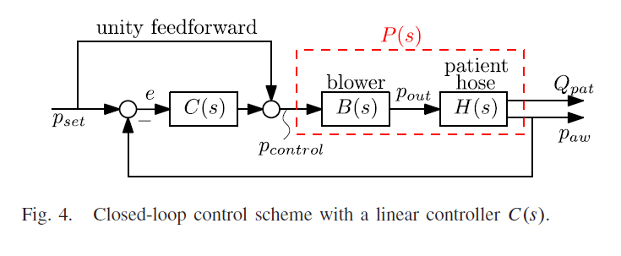

Changing the diagram to:

Pset

C(s)

B (s)

+

+

+

–

H2 (s)

H1 (s)

Qpat

Paw

Let

C(s) =

Pset(s)

C(s)

P2 (s)

P1 (s)

Qpat (s)

Paw (s)

+

+

+

–

So,

Now,

$P_{aw}\left(s\right)=P_{1}\left(s\right)\left[P_{set}\left(s\right)+C(s)(P_{set}\left(s\right)-P_{aw}(s))\right]$

= $P_{1}\left(s\right)P_{set}(s)+P_{1}\left(s\right)C\left(s\right)P_{set}(s)-P_{1}\left(s\right)C\left(s\right)P_{aw}(s)$

⇒ $P_{aw}(s)+P_{1}\left(s\right)C\left(s\right)P_{aw}(s)=P_{set}(s)(P_{1}(s)+P_{1}(s){C(s)}_{})$

⇒ $\frac{P_{aw}(s)}{P_{set}(s)}=\frac{P_{1}\left(s\right)+C\left(s\right)P_{1}(s)}{1+C\left(s\right)P_{1}(s)}=T_{1}(s)$…………….. (1)

Again,

Qpat (s)= $P_{2}\left(s\right)\left[P_{set}\left(s\right)+C(s)(P_{set}\left(s\right)-P_{aw}(s)\right]$

= $P_{2}\left(s\right)P_{set}\left(s\right)+P_{2}\left(s\right)C\left(s\right)P_{set}\left(s\right)-P_{2}\left(s\right)C\left(s\right)P_{aw}(s)$

= $P_{2}\left(s\right)P_{set}\left(s\right)+P_{2}\left(s\right)C\left(s\right)P_{set} \left(s\right)-P_{2}\left(s\right)C\left(s\right)P_{set}\left(s\right)T_{1}(s)$

= $P_{set}\left(s\right)\left[P_{2}\left(s\right)+P_{2}\left(s\right)C\left(s\right)-P_{2}\left(s\right)C\left(s\right)T_{1}(s)\right]$

⇒ $\frac{Q_{pat}(s)}{P_{set}(s)}=P_{2}\left(s\right)\left[1+C\left(s\right)(1-T_{1}(s))\right]$

$=P_{2}\left(s\right)\left[1+C\left(s\right)×\frac{1+C\left(s\right)P_{1}\left(s\right)-P_{1}\left(s\right)-C\left(s\right)P_{1}(s)}{1+C\left(s\right)P_{1}(s)}\right]$

${=P}_{2}\left(s\right)\left[1+\frac{C\left(s\right)-C\left(s\right)P_{1}(s)}{1+C\left(s\right)P_{1}(s)}\right]$

$= P_{2}\left(s\right)×\frac{1+C\left(s\right)P_{1}\left(s\right)+C\left(s\right)-C\left(s\right)P_{1}(s)}{1+C\left(s\right)P_{1}(s)}$

$\frac{Q_{pat}(s)}{P_{set}(s)}=\frac{P_{2}\left(s\right)+C\left(s\right)P_{2}(s)}{1+C\left(s\right)P_{1}(s)}=T_{2}(s)$…………………… (2)

By running the following code:

clc;

clearvars;

ki = 1;

wn = 2*3.1416*30;

zeta = 1;

s = tf('s');

Hs = [(0.5063*s + 5.063)/(s + 5.443);...

(101.3*s + 1.137e-13)/(s + 5.443)];

Bs = (wn^2)/(s^2+(2*zeta*wn*s)+wn^2);

Ps = Hs.*Bs;

Cs = ki/s;

Closed_Paw = (Ps(1)+(Cs*Ps(1)))/(1+(Cs*Ps(1)));

CLosed_Qpat = (Ps(2)+(Cs*Ps(2)))/(1+(Cs*Ps(1)));

We found T1(s) to be:

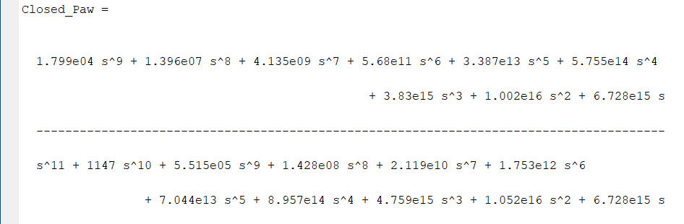

And T2(s) to be:

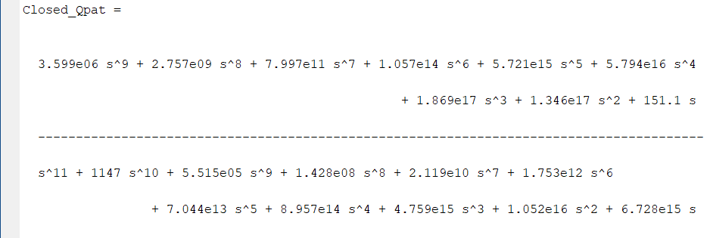

**Task 3:**

Sketch the root locus of the control system shown in Fig. 4 for 0<ki< of the integral controller C(s).

Comparing equations 1 and 2 with,

$$T\left(s\right)=\frac{KG(s)}{1+KG(s)H(s)}≡\frac{P_{1}\left(s\right)+C\left(s\right)P_{1}(s)}{1+\frac{Ki}{s}P_{1}(s)}=T_{1}(s)$$

And, $$T\left(s\right)=\frac{KG(s)}{1+KG(s)H(s)}≡\frac{P_{2}\left(s\right)+C\left(s\right)P_{2}(s)}{1+\frac{Ki}{s}P_{1}(s)}=T_{2}(s)$$

We Find that, for both closed loop transfer functions,

$KG\left(s\right)H\left(s\right)≡Ki\frac{P_{1}(s)}{s}$

So, the root locus will be drawn for $\frac{P(s)}{s}$ for $k_{i}>0$

Code for plotting root locus:

clc;

clearvars;

s = tf('s');

Ps = [(1.799e04*s+1.799e05)/(s^3+382.4*s^2+3.758e04*s+1.934e05);...

(3.599e06*s+4.04e-09)/(s^3+382.4*s^2+3.758e04*s+1.934e05)];

figure(1)

rlocus(Ps(1)/s);

axis([-200 5 -205 205]);

Root Locus:

