

A Wearable Sensor Driven Machine Learning System for Predicting Non-Contact Musculoskeletal Injury Risk in Athletes
Sector: Sports Science & Athletic Performance Analytics
Project Report — Abstract, Design, Literature Survey, Implementation & Results
September 2026
SRI SAATWIK NALLURI (23MID0438)
PAKALA PUNEETH (23MID0291)

Advanced Predictive Analytics (MDI3003)
Prof. Raghul J

Abstract
Non-contact musculoskeletal injuries such as ACL tears and hamstring strains remain the leading controllable cause of lost athlete availability in professional sport, yet current prevention practice still relies heavily on subjective clinical judgement applied after fatigue has already become apparent. This solution is a wearable-sensor-driven machine learning system that addresses this gap by continuously estimating each athlete's short-term injury risk from inertial measurement unit (IMU), GPS/GNSS and heart-rate-variability (HRV) signals. Sensor streams are cleaned, time-aligned and aggregated into a per athlete rolling feature store spanning sport science validated metrics such as the acute:chronic workload ratio (ACWR), PlayerLoad and HRV-RMSSD trend. These features drive an ensemble of tree-based classifiers (Random Forest, XGBoost, LightGBM), with SHAP-based explainability ensuring that every risk score can be traced back to specific and meaningful load factors. The system is designed for on-premises deployment to keep raw biometric data within the team's own infrastructure. It surfaces risk flags and load management recommendations to coaching and medical staff rather than making autonomous selection decisions.

1. Introduction
Athlete availability is one of the most valuable and most fragile assets in professional sport. Non-contact injuries which include ACL ruptures, hamstring strains and related lower-extremity soft-tissue damage that are responsible for a disproportionate share of missed training and competition time, and they carry consequences that extend well beyond a single season: multi-million-dollar wage costs tied up in sidelined players, transfer-market and match-outcome losses for clubs and materially shortened careers for the athletes themselves. Despite the scale of this problem, the dominant mode of prevention in most professional environments is still reactive rather than predictive. Team medical and performance staff combine wellness questionnaires, GPS derived load reports and subjective clinical judgement to decide who trains and who rests, an approach that does not scale across a large squad, is inconsistent across different staff members and critically tends to react to fatigue only once it has already become clinically apparent.
At the same time, elite teams already generate the raw material needed for a more proactive approach. GPS vests, IMU pods and heart rate straps produce dense, continuous, multi-modal time series data for every athlete, every session but this data is today used almost exclusively for post-hoc load reporting rather than for forward looking risk prediction. This is motivated by the resulting question this report sets out to answer: can objective, continuously streamed biomechanical and physiological signals be fused and modelled to flag elevated non-contact injury risk early enough for coaching staff to intervene with a load adjustment, before an injury occurs rather than after?
To answer this question, an injury risk estimation as a supervised, time-windowed classification and regression problem is framed which engineers sport-science-validated features (such as ACWR, PlayerLoad and HRV trend metrics) from raw sensor streams and scores injury risk probability using tree ensemble models, all wrapped in an explainability layer so that medical staff can see and trust the reasoning behind every flag.

2. Literature Survey
Wearable sensor driven, ML based injury risk prediction has matured rapidly since 2023, moving from single-sensor, single-model studies toward multimodal fusion and interpretable, clinically actionable systems. The table below summarizes literature most directly relevant to our approach and the paragraphs that follow draw out the themes that most directly shaped the system's design.
# | Title | Year | Source | Relevance
1 | Practice of wearable devices combined with deep learning algorithms in predicting athletic injury risk | 2025 | Digital Health / SAGE | Reviews deep learning architectures paired with wearable IMU/GPS data for injury-risk prediction, highlighting gains from temporal and multimodal fusion over single sensor approaches.
2 | A novel lower extremity non-contact injury risk prediction model based on multimodal fusion and interpretable machine learning | 2022–23 | Frontiers in Bioengineering & Biotechnology (PMC) | Proposes a fused biomechanical and physiological feature model with SHAP based interpretability, directly informing the explainability layer.
3 | Predicting Injuries in Football Based on Data Collected from GPS-Based Wearable Sensors | 2023 | Sensors, 23(3):1227 | Uses Catapult GPS-vest data with an XGBoost classifier on an imbalanced dataset (90% accuracy, 92% precision) which is a direct architectural precedent for the GPS-to-XGBoost pipeline.
4 | Artificial intelligence and wearable sensors in sports injury risk prediction: current status and future perspectives | 2026 | Annals of Medicine (Taylor & Francis) | Narrative review of IMU, EMG, and flexible-electronics wearables with deep-learning fusion; flags data heterogeneity, generalizability, and privacy as open challenges relevant to edge deployment.
5 | Construction and application of a model for predicting athletes' injury risk based on machine learning | 2024–25 | PeerJ / PMC | Builds a supervised ML pipeline on training-load and screening data, comparing ensemble tree methods against baseline regression.
6 | Machine learning approaches to injury risk prediction in sport: a scoping review with evidence synthesis | 2024 | British Journal of Sports Medicine | Synthesises GPS-, wellness-, RPE-, and screening-based ML studies; finds tree-based ensembles (RF, XGBoost) consistently top performers, supporting the model choice.
7 | Machine learning framework for predicting athletic injuries and optimising performance | 2025 | BMC Sports Science, Medicine and Rehabilitation | Trains RF, XGBoost, and neural-network classifiers on workload/recovery/performance features for collegiate athletes; RF achieves the strongest accuracy and ROC-AUC.
8 | Prediction of football injuries using GPS-based data in professional football players: a machine learning approach | 2025 | Frontiers in Sports and Active Living | Applies XGBoost to 7-day:28-day acute:chronic workload ratio features from GPS data, closely matching the ACWR feature-engineering step.
9 | Time-to-injury forecasting in elite football: a survival-analysis approach with tree-ensemble baselines | 2026 | arXiv preprint | Benchmarks XGBoost, RF, and logistic regression against a deep survival model for next-day injury forecasting using F1/recall/AUC-weighted evaluation — directly relevant to the evaluation strategy.
10 | Integrating multimodal AI technologies for sports injury prediction and rehabilitation: a systematic review | 2024–25 | Journal of Human Sport and Exercise | Presents a five-stage injury-management pipeline integrating sensor fusion and predictive analytics within a monitor-predict-intervene-rehabilitate loop.
11 | The role of AI and wearables in injury prediction and performance optimisation | 2025 | Premier Science Journal | Surveys wearable-driven AI systems for real-time performance and injury-risk monitoring, including biomechanical analytics and cross-domain applications.
12 | Diagnostic applications of AI in sports: a comprehensive review of injury risk prediction methods | 2024 | Conference proceedings (Education & Multimedia Technology) | Reviews AI-driven analytics for training/treatment decisions in physical-education and sport settings, including practical deployment considerations for coach-facing tools.

2.1 Themes from the literature
- Tree-ensemble models dominate. Across scoping reviews and individual studies, Random Forest and XGBoost consistently outperform simpler baselines such as logistic regression on GPS and workload derived features, and are frequently reported alongside strong accuracy, precision and ROC-AUC figures on football injury data that directly supporting the choice of tree ensembles as its primary model layer.
- Multimodal fusion outperforms single-sensor models. Reviews of deep-learning approaches to injury prediction consistently report gains from fusing IMU, GPS and physiological signals rather than relying on any one modality, reinforcing the decision to fuse IMU, GPS/GNSS and HRV streams into a single feature store.
- Explainability is treated as a requirement. Multiple studies pair predictive models with SHAP based interpretability specifically so that clinicians can justify a rest or load-adjustment decision to players and management.
- Class imbalance and evaluation metric choice are recurring methodological concerns. Because confirmed injuries are rare relative to total exposure, the literature consistently favours recall, F1, and AUC based evaluation with SMOTE/ADASYN oversampling or class weighting over raw accuracy.
- Open challenges remain around data heterogeneity, generalizability and privacy. Recent narrative reviews flag cross-vendor calibration differences and the sensitivity of athlete health data as unresolved issues.

3. Problem Statement
Non-contact injuries are the single largest controllable driver of athlete availability loss in professional sport. ACL ruptures routinely end or derail careers, and hamstring strains are among the most frequently recurring injuries in football, athletics, and other sprint-based sports. Team medical and performance staff currently combine wellness questionnaires, GPS load reports, and subjective clinical judgement ("gut feel") to decide who trains and who rests. This approach does not scale, is not consistent across staff, and reacts to fatigue only after it becomes clinically apparent. The core problem that is addressed is if objective, continuously streamed biomechanical and physiological signals be used to flag elevated non-contact injury risk early enough for coaching staff to intervene with a load adjustment.

3.1 Why This Matters
- Financial impact: Elite clubs report multimillion dollar wage costs tied up in injured players unable to compete, alongside transfer-market and match-outcome losses.
- Career impact: ACL and recurrent hamstring injuries are strongly associated with reduced career longevity and post-injury performance decrements.
- Data availability gap: Teams already own GPS vests, IMU pods and HR straps generating dense time-series data that is mostly used for post-hoc load reporting rather than predictive modelling.
- Reactive vs. proactive care: Current practice intervenes after soreness or a wellness-score dip is reported; a predictive layer can shift intervention earlier in the fatigue-accumulation curve.

4. Proposed Approach
The solution treats injury risk estimation as a supervised, time-windowed classification problem. Raw multi sensor streams are aggregated per athlete into overlapping sliding windows (ranging from single session to 28-day acute:chronic windows), from which sport-science-validated load features are engineered. These features are passed into ensemble tree models that output a calibrated injury-risk probability for each athlete, refreshed after every session.

4.1 Modelling Pipeline Stages
- Ingestion: Stream raw IMU (tri-axial accelerometer + gyroscope), GPS/GNSS positional data, and HRV/RR-interval data from wearable hubs via BLE/ANT+ to a local edge gateway. Player historical sporting information and lifestyle features would also be collected along with the sensor data.
- Cleaning & synchronisation: Denoise signals, interpolate short dropouts and time-align multisensory streams to a common clock.
- Windowing: Apply sliding windows at multiple granularities within-session (for biomechanical asymmetry/fatigue markers) and multi-day (for cumulative load, e.g. 7-day:28-day acute-to-chronic workload ratio, ACWR).
- Feature engineering: Derive PlayerLoad/Body-Load metrics, high-speed-running and sprint-distance counts, deceleration counts, jump/landing asymmetry indices from IMU, RMSSD/SDNN HRV trend features and strain indices.
- Model training: Train Random Forest and XGBoost classifiers (primary), benchmarked against logistic regression and LightGBM, using class-imbalance-aware techniques (SMOTE, class weighting) given the rarity of injury events.
- Explainability: Apply SHAP value analysis so medical staff can see which load factors are driving an individual athlete's risk score.
- Deployment: Package the trained model as an edge-deployable inference service on the team's wearable hub or an on-premises server, refreshed with nightly batch retraining as new outcome data accrues.

5. System Architecture
The architecture is organized as a layered pipeline: sensing at the edge, ingestion and feature computation on a local hub (to minimize latency and keep raw biometric data on-premises for privacy), a model layer that ensembles tree-based models, and a decision-support layer that turns probabilities into coach- and clinician-facing actions.
Data flow: IMU (100–200 Hz) + GPS/GNSS (10–18 Hz) + HRV strap (1 Hz) → Team Wearable Hub / Edge Gateway (BLE/ANT+ aggregation, clock sync, buffering) → Signal cleaning → Sliding-window segmentation (30s–7day) → Feature engineering (ACWR, PlayerLoad, HRV-RMSSD) → Per-athlete rolling feature store → Random Forest + XGBoost + LightGBM → Model ensemble, probability calibration & SHAP explainability → Coach/medical dashboard, automated alerts, and a load-management recommender. Outcome logging (confirmed injuries / near-misses) feeds back into the training set for periodic retraining.

5.1 Layer-by-Layer Description
Layer | Function | Key Technology
Sensing | Capture raw IMU, GPS/GNSS, and HRV signals directly on the athlete's body. | Catapult/STATSports-class GPS vests, chest/shank IMU pods, chest-strap HR monitors
Edge gateway | Aggregate multi-athlete streams, synchronise clocks, buffer during connectivity loss. | BLE/ANT+ hub, local time-series buffer, on-prem server
Preprocessing | Denoise, interpolate gaps, and segment streams into sliding windows. | Butterworth/Kalman filtering, windowing (30s to 28-day)
Feature store | Maintain a per-athlete rolling table of engineered load and physiological features. | ACWR, PlayerLoad, monotony/strain, HRV-RMSSD trend, asymmetry index
Model layer | Score injury-risk probability per athlete per session. | Random Forest, XGBoost, LightGBM
Ensemble & explainability | Calibrate probabilities and attribute risk drivers. | Weighted ensemble, SHAP values, Platt scaling
Decision support | Convert scores into actionable outputs for staff. | Coach dashboard, threshold alerts, load-taper recommender
Feedback loop | Log confirmed injuries/near-misses to improve future model versions. | Outcome tagging, scheduled retraining pipeline

5.2 Design Considerations
- Edge-first deployment: Running inference on the team's local hub avoids sending raw biometric data off-site, reducing latency and easing data-governance concerns around athlete health data.
- Class imbalance handling: Injury events are rare relative to total training sessions (often <5% positive class), so the pipeline uses weighted loss functions, SMOTE-style oversampling, and recall/F1/AUC-oriented evaluation rather than raw accuracy.
- Multi-horizon prediction: Separate model heads or window configurations for next-session risk (1–2 days ahead) versus next-season risk (cumulative load- and history-driven), since different features dominate at each horizon mirrored in the implementation by Model A (next-season) and Model B (acute) below.
- Explainability by design: SHAP-based feature attribution is treated as a first class output, not an afterthought, since medical staff must be able to justify a rest decision to players and management.
- Human-in-the-loop: The system flags elevated risk; it does not autonomously withdraw players from training or matches. Final load decisions remain with coaching and medical staff.

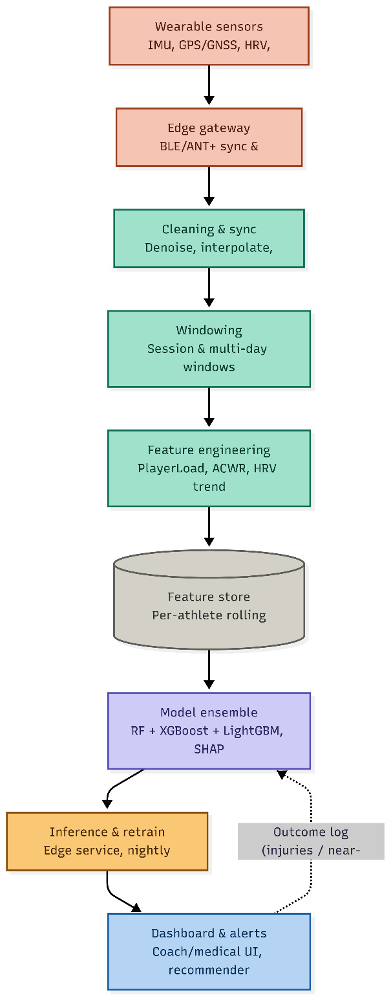

6. Datasets
No single public dataset currently combines match-grade GPS load, IMU biomechanics, HRV, and confirmed injury outcomes for professional athletes end-to-end, largely due to the sensitivity of athlete health records. This system’s data strategy therefore combines injury-outcome datasets, wearable/GPS load datasets, and general-purpose IMU/human-activity-recognition (HAR) datasets that are adapted for gait and movement-quality feature extraction, supplemented by synthetic training-load data for pipeline development and stress-testing before deployment on real team data.
Dataset | Content | Role in AthleteShield
Collegiate Athlete Injury Dataset | 200 collegiate athletes × 17 fields: demographics, weekly training load, fatigue/performance/load-balance composite scores, and a binary Injury_Indicator. | Primary, highly-imbalanced (7% positive) acute-injury classification target — fused with wearable and IMU data to form the modelling table for Model B.
University Football Injury Dataset | 800 university athletes × 19 fields: physical-screening battery (knee strength, hamstring flexibility, reaction time, balance, sprint speed, agility), lifestyle scores (sleep, stress, nutrition), and a balanced (50/50) Injury_Next_Season label. | Labelled, class-balanced training set for Model A (next-season injury risk classification).
Professional Football Dataset | 1,301 season-level records for 604 unique players across 5 start-years, with cumulative and previous-season workload/injury-history fields and a continuous season_days_injured target. | Labelled regression target for Model C (sidelined-days prediction), with group-aware (player-level) train/test splitting.
Wearable Telemetry Dataset | 500 timestamped records for 10 athletes: heart rate, body temperature, blood pressure, blood oxygen, step count, GPS coordinates, and activity status. | Aggregated per athlete (mean/std HR, mean temperature, mean SpO2, total steps) and merged into the collegiate feature table to add physiological telemetry signal.
Raw IMU Motion Data (MotionSense-style) | Tri-axial accelerometer and gyroscope recordings for 10 subjects across downstairs-walking and jogging activity folders, sampled at 50 Hz. | Signal-processing validation source: Butterworth filtering, step/cadence detection, jerk, and FFT spectral features extracted here were engineered into per-athlete IMU summary features.
Synthetic training-load datasets | Simulated multi-week training-load and injury-occurrence sequences matched to published epidemiological injury-rate statistics. | Pipeline stress-testing, class-imbalance experimentation, and privacy-safe development/demo environments.

Note on data adaptation: the raw IMU motion dataset is a general-purpose human-activity-recognition source, not an injury dataset, and does not contain injury labels. Its role is restricted to (a) validating IMU signal processing, gait-segmentation, and movement-feature extraction code, and (b) supplying subject-level movement-intensity features (cadence, peak impact, jerk, dominant frequency) that were merged into the collegiate feature table. Using activity-recognition data as a direct substitute for injury-labelled data would not be methodologically valid; Sections 7–9 below document exactly how it was used instead.

7. Implementation Overview
The implementation follows a three-model strategy rather than a single end-to-end model, because the four data sources differ sharply in what they can support: the collegiate dataset is small and severely imbalanced (7% positive) but has the richest sensor fusion; the university dataset is larger and class-balanced but purely tabular (screening + lifestyle); and the professional football dataset has no binary injury label at all — only a continuous days-injured outcome. Rather than force one model onto all three problems, three purpose-built models were trained:
- Model A — Next-Season Injury Risk Classification. Trained on the balanced university dataset (physical screening + lifestyle features) to predict whether an athlete will be injured in the following season.
- Model B — Acute Injury Risk Classification. Trained on the fused collegiate + wearable + IMU dataset (highly imbalanced, 7% positive) to flag near-term injury risk from workload, fatigue, and physiological signal features.
- Model C — Injury-Duration Regression. Trained on the professional football dataset to predict the number of days an athlete is likely to be sidelined, using cumulative workload and injury-history features.
The core libraries used were pandas and NumPy for data handling; scikit-learn for preprocessing, cross-validation, and baseline models; XGBoost and LightGBM for the primary tree-ensemble classifiers; imbalanced-learn (SMOTE) for oversampling the minority injury class; Optuna for Bayesian hyperparameter search; statsmodels for multicollinearity (VIF) diagnostics; SHAP for model interpretation; SciPy for Butterworth filtering and FFT-based signal processing of the raw IMU data; and Matplotlib/Seaborn for all exploratory and diagnostic visualisation. All random operations were seeded (random_state = 42) for reproducibility, and trained model artefacts (the calibrated XGBoost pipeline and its scaler) were serialised with joblib for later reuse in an inference service.

8. Data Ingestion & Quality Audit
All four tabular sources were loaded and profiled before any modelling took place. The table below summarises the raw shapes and the outcome of the initial integrity checks (null counts, duplicate rows, duplicate athlete identifiers).
Dataset | Rows × Columns | Missing data | Duplicates
Collegiate Athlete Injury | 200 × 17 | None | 0 duplicate rows; 0 duplicate Athlete_IDs
University Football Injury | 800 × 19 | None | 0 duplicate rows
Professional Football | 1,301 × 30 | pace / physic: 7.30%; position: 0.15%; cumulative & previous-season fields: 46.43% (structurally missing for players in their first observed season, not random) | 0 duplicate rows
Wearable Telemetry | 500 × 12 | None | 0 duplicate rows

The professional football dataset's missingness is not random (MNAR): roughly 46.4% of rows belong to a player's first observed season, for which no prior-season cumulative minutes, games, or injury-history figures can exist by definition. This distinction mattered directly for feature engineering (Section 10.3) — these fields were deliberately filled with zero rather than the column median, since zero correctly encodes "no history yet" while a median would fabricate a false baseline of prior workload.

8.1 Class-Balance Audit
Because both classification targets are binary injury flags, their positive-class rates were checked before any splitting or modelling. The collegiate Injury_Indicator is severely imbalanced at 7.0% positive (14 injured athletes out of 200), while the university Injury_Next_Season target is close to perfectly balanced at 50.0% positive. This single difference is the reason Model A and Model B use different training strategies (Sections 11 and 12): Model A can be trained directly on the raw class balance, while Model B requires SMOTE oversampling, Optuna-tuned regularisation, and post-hoc probability calibration to be usable.
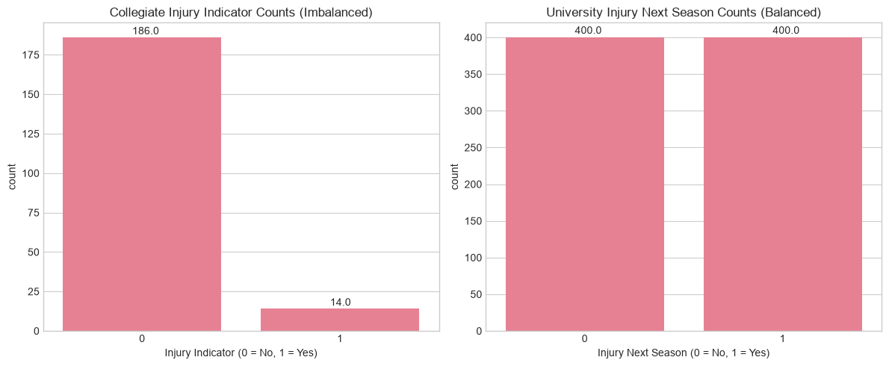
Figure 8.1 — Injury-label class balance: the collegiate dataset (left) is severely imbalanced at 7% positive, while the university dataset (right) is balanced at 50% positive.

8.2 Composite-Score Leakage Audit
The collegiate dataset includes four pre-computed composite scores (Fatigue_Score, Performance_Score, Team_Contribution_Score, Load_Balance_Score) plus an ACL_Risk_Score field. Because a column literally named "risk score" that correlates strongly with the injury label is a classic data-leakage smell — it may have been derived, directly or indirectly, from injury history rather than being an independent predictor.
Composite score | Correlation with Injury_Indicator
ACL_Risk_Score | 0.525
Load_Balance_Score | −0.491
Fatigue_Score | 0.292
Team_Contribution_Score | 0.042
Performance_Score | 0.023

ACL_Risk_Score's correlation of 0.525 with the target sits well above the 0.4–0.5 threshold treated as a leakage warning sign. Its provenance could not be independently verified from the dataset documentation, so it is flagged here as an explicit limitation of the acute-risk model (Section 16): it was ultimately retained in the Model B feature set, on the working assumption that it represents a pre-season clinical screening score collected independently of the outcome rather than a value derived from it, but this assumption is not verifiable from the data alone. Because it later emerges as the single dominant SHAP driver of Model B's predictions (Section 14), any deployment of this model on a new team's data should re-audit exactly how an equivalent field is computed before trusting it.

9. Exploratory Data Analysis
Each of the four data sources was explored independently before fusion, using univariate distributions, bivariate target-split comparisons, correlation analysis, and (for the collegiate dataset) principal component analysis. The goal at this stage was purely descriptive: to identify which raw fields carry a usable injury-risk signal before committing to a feature-engineering strategy, and to catch structural problems (imbalance, leakage, redundancy, skew) early.

9.1 Collegiate Athlete Injury Dataset
With only 14 injured athletes in the full 200-row dataset, an 80/20 stratified split leaves roughly 2–3 positive cases in the test set. This was flagged early as a data problem rather than a modelling problem: any single-point AUC or F1 score computed later on this split has enormous variance, since one misclassified athlete can swing the metric by 30–50%. The implementation therefore treats later Model B metrics (Section 12) as directional rather than precise, and reports confidence in terms of what is learnable from the data rather than a single headline number.
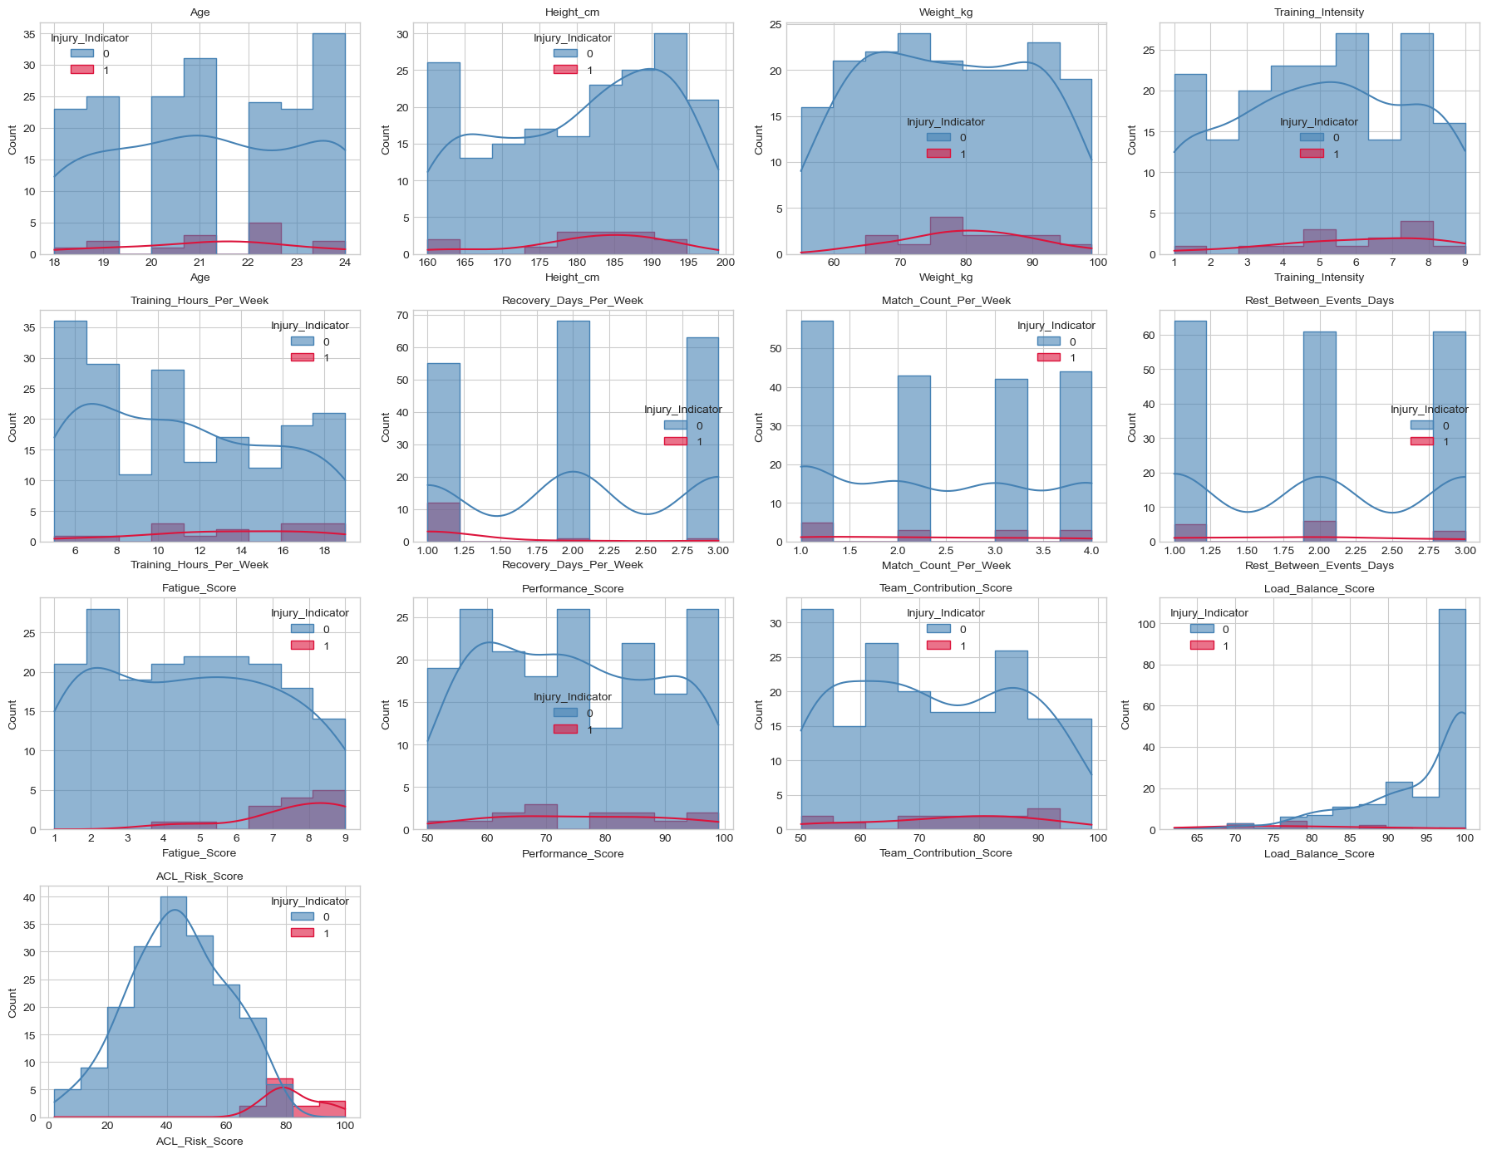
Figure 9.1 — Univariate distributions of all 13 numeric collegiate features, split by injury outcome. ACL_Risk_Score, Load_Balance_Score, Fatigue_Score, and Training_Intensity show the clearest separation between injured (red) and non-injured (blue) athletes.
The histogram analysis shows injury risk concentrated in higher fatigue, higher intensity, and higher risk-score ranges, with weaker or unclear separation for Age, Height_cm, Weight_kg, Performance_Score, and Team_Contribution_Score. This pattern — strong workload/physical-state signal, weak demographic signal — recurs across all three injury datasets and is the single most consistent finding of the EDA.
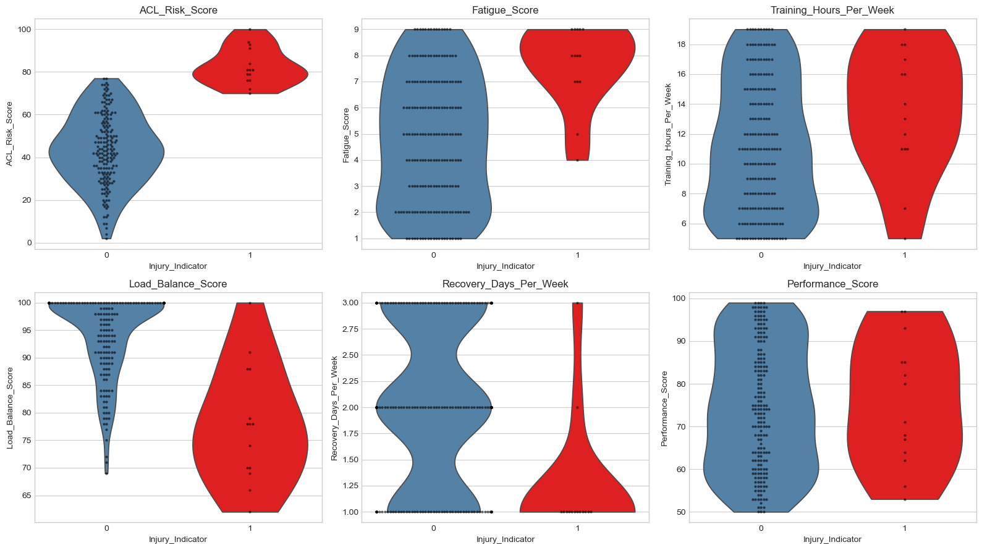
Figure 9.2 — Violin/swarm plots of the six strongest collegiate predictors by injury outcome.
The swarm-plot breakdown sharpens this picture considerably: injured athletes are concentrated at ACL_Risk_Score 70–100 versus mostly below 75 for non-injured athletes; at Fatigue_Score 7–9; and at Recovery_Days_Per_Week around 1 day versus 2–3 days for non-injured athletes. Load_Balance_Score shows the mirror-image pattern — injured athletes cluster at 60–85 while non-injured athletes cluster at 90–100. Training_Hours_Per_Week shows a moderate relationship with considerable overlap, and Performance_Score shows weak separation, both groups spanning a similar range.
A principal component analysis on the full standardised numeric feature set found that the first component (PC1) is dominated by ACL_Risk_Score (loading 0.579), Load_Balance_Score (−0.534), Fatigue_Score (0.346), Recovery_Days_Per_Week (−0.333), and Training_Hours_Per_Week (0.284) — i.e. PC1 behaves as a single "injury-risk/workload" axis, and injured athletes skew toward its positive side. The classes still overlap substantially along PC1, confirming that no single linear combination of features cleanly separates injured from non-injured athletes, which motivated the choice of non-linear tree-ensemble models (Section 12) over a linear baseline.

Collegiate dataset — feature take-aways
- Strong: ACL_Risk_Score, Fatigue_Score, Load_Balance_Score, Training_Intensity, Recovery_Days_Per_Week, Training_Hours_Per_Week.
- Moderate/supporting: Match_Count_Per_Week, Rest_Between_Events_Days, Performance_Score, Team_Contribution_Score.
- Weak standalone: Age, Height_cm, Weight_kg, Gender, Position (gender injury rates of 7.5% female vs. 6.5% male, and position rates of 4.5–9.4%, are not statistically reliable given only ~14 total positive cases split across these categories).

9.2 University Football Injury Dataset
The university dataset trades sensor richness for statistical power: 800 balanced records with a physical-screening battery and lifestyle scores instead of raw workload telemetry. A full correlation pass against Injury_Next_Season found the strongest linear associations were Stress_Level_Score (0.530), Sleep_Hours_Per_Night (−0.511), Balance_Test_Score (−0.495), Sprint_Speed_10m_s (−0.471), Reaction_Time_ms (0.471), Knee_Strength_Score (−0.455), Hamstring_Flexibility (−0.450), Nutrition_Quality_Score (−0.412), Previous_Injury_Count (0.382), and Agility_Score (−0.394) — while Age, Height_cm, Weight_kg, Matches_Played_Past_Season, Training_Hours_Per_Week and BMI all sat below |0.05|. In other words, this dataset's injury signal is dominated by physical-screening and psychosocial/recovery variables, not by demographics or raw training volume.
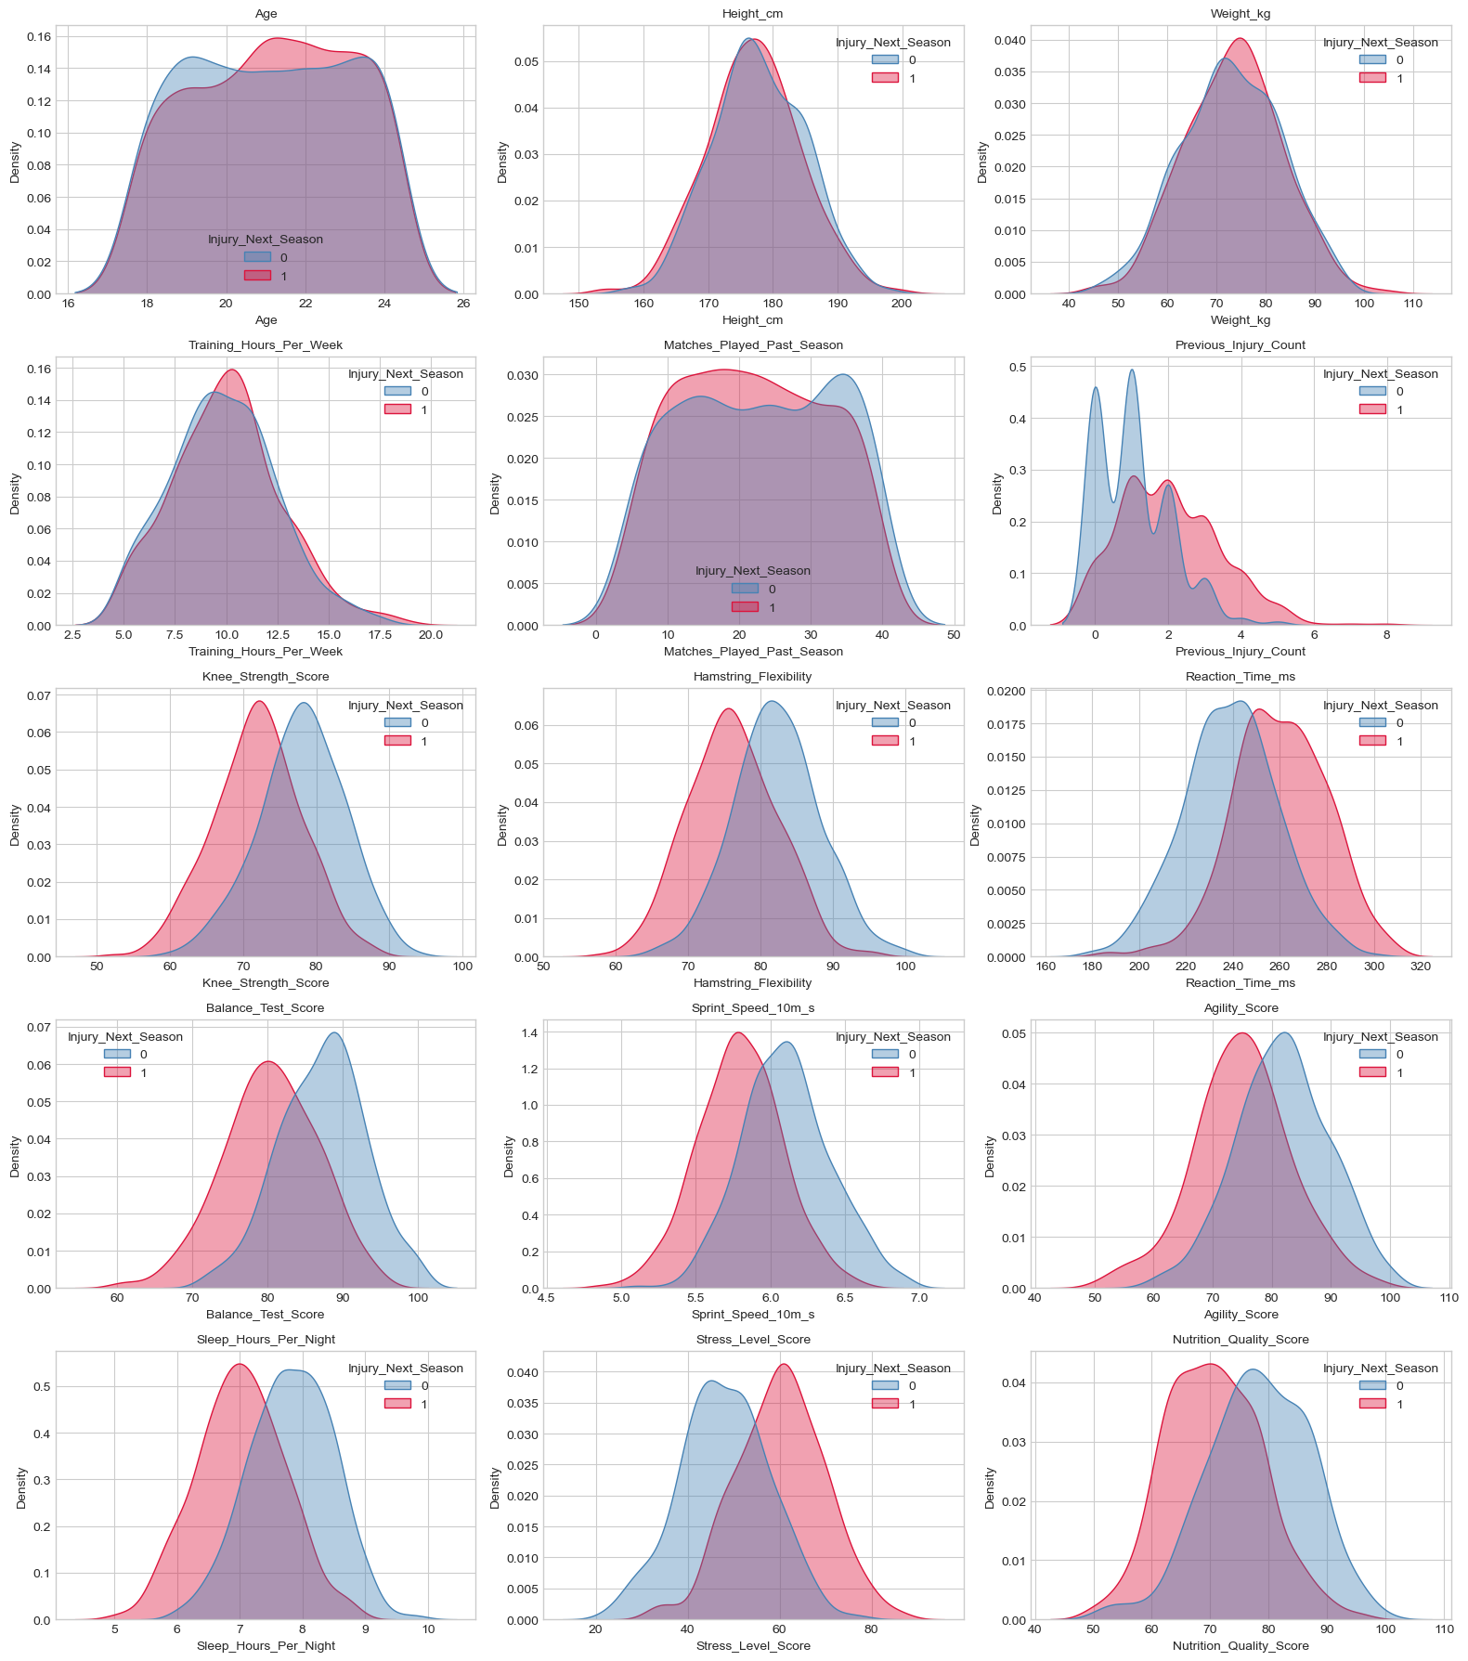
Figure 9.3 — KDE distributions of all 15 numeric university features, split by next-season injury outcome.
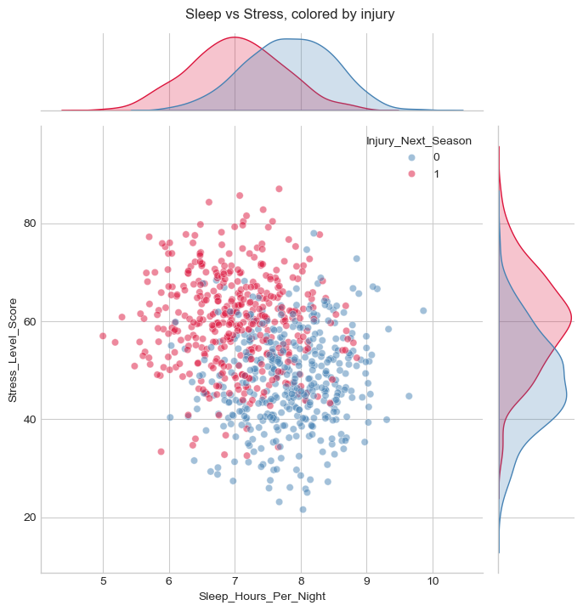
Figure 9.4 — Joint distribution of sleep and stress, coloured by next-season injury outcome. Injured athletes cluster at higher stress and slightly lower sleep.
Injured athletes are concentrated around 6–8 hours of sleep and stress levels of roughly 50–70+, while non-injured athletes concentrate around 7–9 hours of sleep and stress levels of roughly 35–60. The two groups still overlap substantially, so neither variable alone is sufficient, but the combined pattern — lower sleep together with higher stress — is a clear directional signal that motivated the Sleep_Stress_Risk engineered feature (Section 10.2).
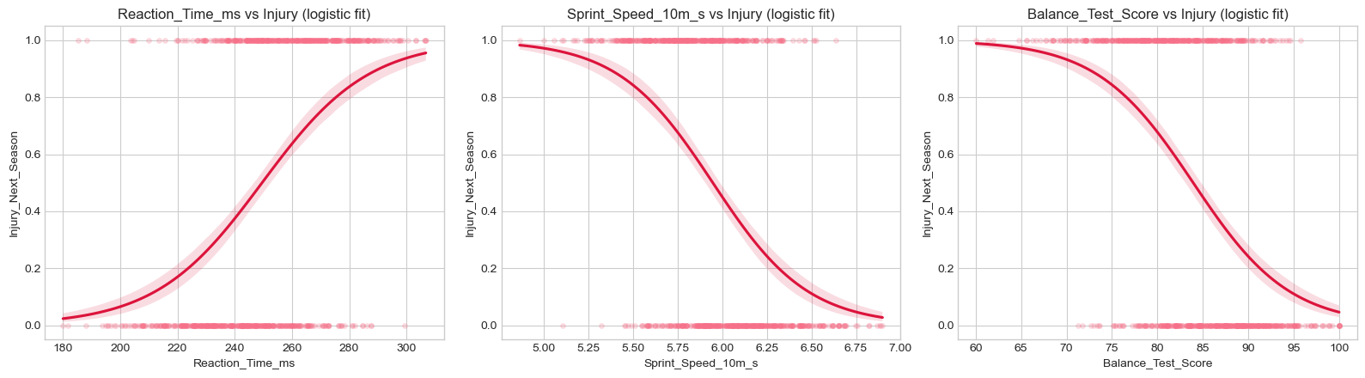
Figure 9.5 — Logistic fits of injury probability against reaction time, sprint speed, and balance score. Injury probability rises with slower reaction time and falls with higher sprint speed and balance score.
A four-variable pairplot (Previous_Injury_Count, Reaction_Time_ms, Sprint_Speed_10m_s, Stress_Level_Score) reinforced the same ranking: Previous_Injury_Count gave the clearest single-variable separation, Stress_Level_Score showed clear separation, Reaction_Time_ms showed a visible rightward shift for injured athletes, and Sprint_Speed_10m_s showed a weaker, more overlapping relationship. Taken together, the university EDA points to previous injury history, neuromuscular performance (reaction time, balance, sprint speed), and recovery/psychosocial state (sleep, stress, nutrition) as the dataset's most informative predictors — exactly the fields that feed Model A (Section 11).

9.3 Professional Football Dataset
Unlike the first two datasets, the professional football data has no binary injury flag — its target, season_days_injured, is a continuous count that is strongly right-skewed: most players record fewer than 100 injury days per season, while a small number of extreme cases reach 300–700 days.
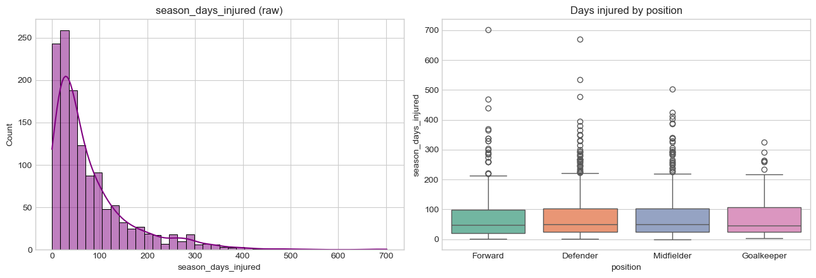
Figure 9.6 — Distribution of season days injured (left) and days injured by position (right). The distribution is strongly right-skewed with a long tail of extreme cases.
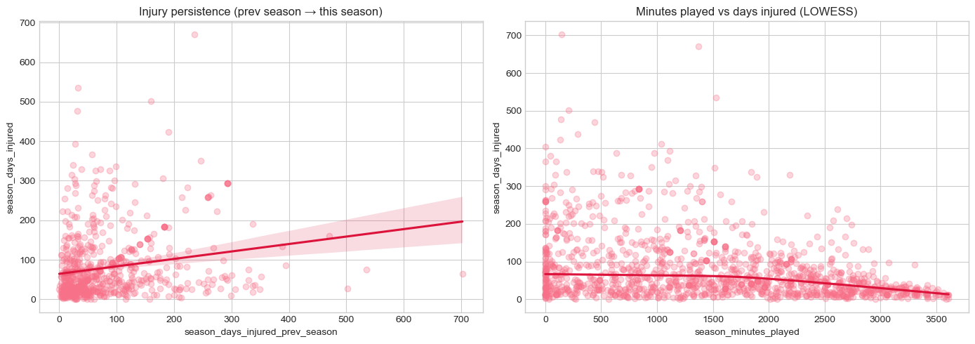
Figure 9.7 — Previous-season injury days show a positive relationship with current-season injury days (left); minutes played shows only a weak, LOWESS-detected negative relationship (right).
Injury duration is fairly similar across playing positions, with defenders and midfielders showing more high-duration outliers, but position alone is not a strong differentiator. Previous-season injury days show a positive, if noisy, relationship with the current season's injury days, while minutes played shows only a weak negative relationship that becomes more visible at high playing-time values under a LOWESS smoother. A boxplot ordered by work-rate combination showed players in the Low/High work-rate group with the highest median injury duration and Low/Low with the lowest, though the spread within every group is large enough that work rate alone explains little variance.
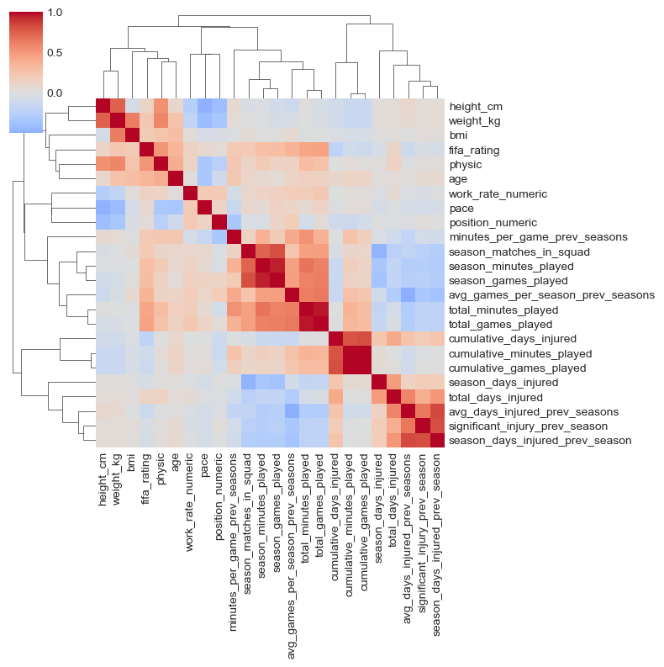
Figure 9.8 — Clustered correlation heatmap of the professional football numeric features. Physical attributes (height/weight/BMI) and playing-time variables each form tight, expected correlation clusters.
The clustered correlation map confirmed two structural redundancies that were addressed during feature engineering (Section 10.3): height/weight/BMI/physical attributes correlate strongly with each other, as do season minutes, games played, and their cumulative equivalents. season_days_injured itself correlates positively with the previous-season injury-history fields, reinforcing that injury history — not raw playing time — is the dominant signal for this dataset.

Professional football dataset — feature take-aways
- Strong: season_days_injured_prev_season, significant_injury_prev_season, cumulative_days_injured, avg_days_injured_prev_seasons, cumulative_minutes_played, total_minutes_played, total_games_played, minutes_per_game_prev_seasons.
- Supporting: work_rate, season_minutes_played, season_games_played, age, physic, pace, position.
- Weaker: pace, work_rate_numeric, position_numeric show comparatively weak correlation with injury duration on their own.

9.4 Wearable Telemetry & Raw IMU Signal Processing
The wearable telemetry stream (heart rate, body temperature, blood oxygen, step count, activity status) was profiled across the four labelled activities (walking, running, cycling, resting). Heart rate and step count showed the most variation across activity types and were judged the most informative raw features; body temperature stayed close to 37°C across all activities and blood oxygen stayed tightly concentrated around 96–99%, making both comparatively weak standalone predictors. No strong pairwise relationship was found between heart rate and blood oxygen, and all four activity groups overlapped heavily in heart-rate/oxygen space — reinforcing the decision to combine wearable signals into composite features (Heart_Rate_Intensity, Steps-to-Heart-Rate ratio) rather than rely on any single raw channel.
To validate the biomechanical side of the pipeline, raw tri-axial accelerometer and gyroscope recordings were processed with a 4th-order low-pass Butterworth filter (cutoff 3 Hz, sampling rate 50 Hz) to separate movement signal from high-frequency noise, followed by peak detection to identify individual steps.
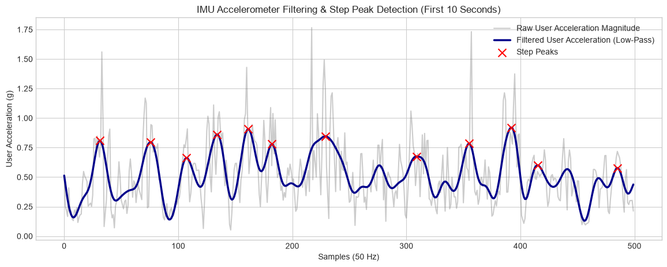
Figure 9.9 — Raw vs. filtered acceleration magnitude with detected step peaks marked. Signal duration 35.02 s, 45 steps detected, estimated cadence 77.1 steps/minute.
Across activities, jogging produced by far the highest mean acceleration, walking and stair-climbing produced moderate acceleration, and sitting/standing produced acceleration close to zero, exactly as expected physiologically. Combining acceleration magnitude with rotation-rate magnitude separated jogging cleanly from the other activities, while walking, upstairs, and downstairs occupied an overlapping middle band — confirming that acceleration and rotation together form a stronger activity signature than either alone.
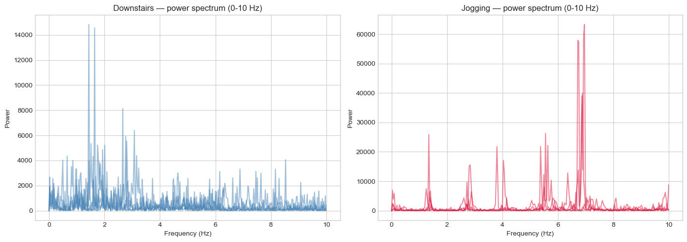
Figure 9.10 — FFT power spectrum of the acceleration signal for downstairs walking versus jogging. Jogging shows a dominant frequency around 6–7 Hz and substantially higher spectral power than downstairs walking's 1–2 Hz peak.
A frequency-domain (FFT) analysis added information the time-domain mean-acceleration feature could not capture on its own: downstairs walking concentrates its energy at 1–2 Hz, while jogging shows a clear, higher-power peak around 6–7 Hz. A companion jerk analysis (the rate of change of acceleration) found jogging's jerk standard deviation (≈42.5) and maximum jerk (≈232.6) both roughly 2.5× higher than downstairs walking's (≈16.4 and ≈144.9 respectively), confirming that jerk-based features capture movement abruptness that plain acceleration magnitude misses. These signal-processing outputs — cadence, peak impact, acceleration/rotation variance, jerk statistics, dominant frequency, and spectral energy — became the nine IMU summary features engineered per subject in Section 10.1.

Wearable & IMU — feature take-aways
- Strong: Heart_Rate, Step_Count (telemetry); acc_mean, rot_mean, cadence, jerk statistics (IMU).
- Moderate: Body_Temperature.
- Weak standalone: Blood_Oxygen — tightly clustered across all activities and athletes, offering little discriminative value on its own.

10. Feature Engineering & Multi-Sensor Fusion
Guided directly by the EDA findings in Section 9, a dedicated feature-engineering stage was built for each of the three modelling datasets. The design principle throughout was to translate the raw fields the EDA had already flagged as informative into sport-science-validated composite indices, rather than feeding raw columns straight into the models.

10.1 IMU Feature Extraction & Wearable Aggregation
For each of the ten IMU subjects, the Butterworth-filter/peak-detection/FFT pipeline validated in Section 9.4 was run across five representative activity folders (downstairs-walking and jogging trials) and averaged into nine subject-level summary features: IMU_Cadence, IMU_Peak_Impact, IMU_SMA (signal magnitude area), IMU_Acc_Variance, IMU_Rot_Variance, IMU_Jerk_Std, IMU_Jerk_Max_Abs, IMU_Dominant_Freq, and IMU_Spectral_Energy. In parallel, the wearable telemetry stream was aggregated per athlete into Mean_HR, Std_HR, Mean_Temp, Mean_Oxygen, and Total_Steps.
Both feature sets cover only 10 of the 200 collegiate athletes directly — a coverage gap that was handled by left-joining on Athlete_ID and mean-imputing the remaining 190 athletes' wearable/IMU columns, so every row in the fused table has a complete feature vector, at the cost of no wearable/IMU signal differentiation for the majority of athletes. This is flagged explicitly as a limitation in Section 16: the wearable and IMU features currently add real signal for only a 10-athlete subset of the collegiate cohort, and a production deployment would need full-cohort wearable coverage before these features could be trusted as broadly predictive.
From the fused telemetry and IMU columns, four wearable-derived and four IMU-derived composite features were computed: Heart_Rate_Intensity (mean HR normalised to the cohort mean), Heart_Rate_Variability (Std_HR relative to Mean_HR), Steps_to_Heart_Rate_Ratio, Body_Temperature_Deviation, Movement_Intensity (IMU_SMA × IMU_Cadence), Combined_Motion_Intensity (acceleration variance + rotation variance), Acceleration_Rotation_Ratio, and Subject_Normalized_Acceleration (z-scored peak impact).

10.2 Collegiate & University Workload/Recovery Features
On the collegiate dataset, a sport-science workload model was built directly from Training_Hours_Per_Week, Training_Intensity, Fatigue_Score, Load_Balance_Score, Match_Count_Per_Week, and Recovery_Days_Per_Week:
- Weekly_Load = Training_Hours_Per_Week × Training_Intensity.
- Estimated_Chronic_Load = Weekly_Load × (1.2 − Fatigue_Score × 0.05), and ACWR = Weekly_Load ÷ Estimated_Chronic_Load — an acute:chronic workload-ratio proxy built from within-dataset fields, since no true rolling 7-day:28-day history is available in a single-snapshot table.
- Monotony = Weekly_Load ÷ (std(Load_Balance_Score) × 0.1 + 1), and Strain = Weekly_Load × Monotony.
- Match_Load = Match_Count_Per_Week × Training_Intensity, and Training_to_Match_Load_Ratio = Weekly_Load ÷ (Match_Load + 1).
- Recovery_Deficit = Fatigue_Score ÷ (Recovery_Days_Per_Week + 1); Workload_to_Recovery_Ratio = Weekly_Load ÷ (Recovery_Days_Per_Week + 1); Fatigue_Load_Ratio = Fatigue_Score ÷ (Weekly_Load + 1).
- Performance_per_Workload = Performance_Score ÷ (Weekly_Load + 1).
Merging the wearable aggregates and IMU summary features onto this workload table produced the final collegiate_fused modelling table at 200 rows × 50 columns, up from the original 17 raw fields.
On the university dataset, the five physical-screening scores (knee strength, hamstring flexibility, balance, sprint speed, agility) were each z-scored and averaged into a single Overall_Physical_Readiness index, alongside individual deficit features (Strength_Deficit, Balance_Deficit, Agility_Deficit, each expressed as the cohort mean minus the athlete's score), a Strength_Flexibility_Ratio, a normalised Reaction_Time_Normalized, a Sleep_Deficit (8 minus hours slept), and a Recovery_Consistency index (the standard deviation across the z-scored sleep/stress/nutrition scores, capturing how erratic — not just how poor — an athlete's recovery profile is). Minutes_Per_Game and Injury_Frequency were also derived from training hours, matches played, and previous injury count. Height_cm and Weight_kg were dropped as redundant once BMI was retained, taking the university table to 800 rows × 27 columns.

10.3 Professional Football Career & Injury-History Features
For the professional football dataset, career-stage flags were derived first — first_season_seen, is_first_observed_season, and has_prior_history — since 46.4% of rows belong to a player's first observed season and therefore have no valid prior-season history. Minutes_Per_Game and Cumulative_Workload were derived from season and cumulative minutes played, and Injury_Burden was computed as total days injured per game played. Critically, the lagged injury-history fields (Injury_Persistence, Previous_Injury_Severity, Recent_Injury_Burden) were filled with zero rather than the column median, because their missingness is structural (MNAR) — a first-season player genuinely has no prior injury burden, and imputing the cohort median would fabricate a false average history for players who simply have none yet. A Performance_Decline feature compared previous-season minutes-per-game against the current season's, and the compound work_rate string (e.g. "Medium/High") was split into separate ordinal Attack_Work_Rate and Defense_Work_Rate scores rather than used as a single lossy pre-collapsed numeric code. This feature-engineering pass took the football table from 30 to 42 columns.

11. Model A — Next-Season Injury Risk Classification
Model A predicts Injury_Next_Season on the balanced (50/50) university dataset using the physical-screening and lifestyle features engineered in Section 10.2. Before training, a variance inflation factor (VIF) pass was run to check for multicollinearity: several raw physical-screening columns (Sleep_Hours_Per_Night, Sprint_Speed_10m_s, Balance_Deficit, Strength_Deficit, Agility_Score and its deficit, Reaction_Time_ms, Hamstring_Flexibility, Knee_Strength_Score, Balance_Test_Score, Sleep_Deficit, Reaction_Time_Normalized) returned infinite VIF, because they are near-perfectly reproduced by the composite Overall_Physical_Readiness index and by each other's deficit transforms. All thirteen redundant raw components were dropped, explicitly protecting the composite Overall_Physical_Readiness feature itself, leaving 12 features for modelling.
It is worth noting as a methodological caveat that this VIF pruning was applied in a single pass rather than iteratively: several of the retained features (Age at 69.5, Nutrition_Quality_Score at 52.9, BMI at 36.4, Training_Hours_Per_Week at 26.2, Stress_Level_Score at 25.6, and Matches_Played_Past_Season at 20.5) still exceed the conventional VIF > 10 multicollinearity threshold after pruning. This did not appear to harm the tree-based models below, which are far less sensitive to multicollinearity than linear models, but it does mean the logistic-regression baseline's individual coefficients should not be over-interpreted.
The cleaned feature set was split 80/20 (stratified) into 640 training and 160 test rows across 12 features. An Optuna study (10 trials, 5-fold stratified cross-validation, ROC-AUC objective) tuned a LightGBM classifier and converged on n_estimators = 142, max_depth = 6, learning_rate ≈ 0.028, num_leaves = 12, reaching a cross-validated ROC-AUC of 0.970. This tuned LightGBM was then benchmarked against Logistic Regression, an untuned Random Forest, and untuned XGBoost on the held-out test set:
Model | Test ROC-AUC
Logistic Regression | 0.9808
Random Forest | 0.9815 (best)
XGBoost | 0.9762
LightGBM (Optuna-tuned) | 0.9792

All four models scored above 0.97 ROC-AUC, which is expected given the university dataset's strong, well-separated feature signal identified in Section 9.2 — the untuned Random Forest edged out the tuned LightGBM, underscoring that on this dataset, feature quality mattered more than hyperparameter search. The winning Random Forest achieved 93% overall accuracy on the test set, with balanced precision/recall across both classes (precision 0.94 / recall 0.91 for the no-injury class, precision 0.91 / recall 0.94 for the injury class).
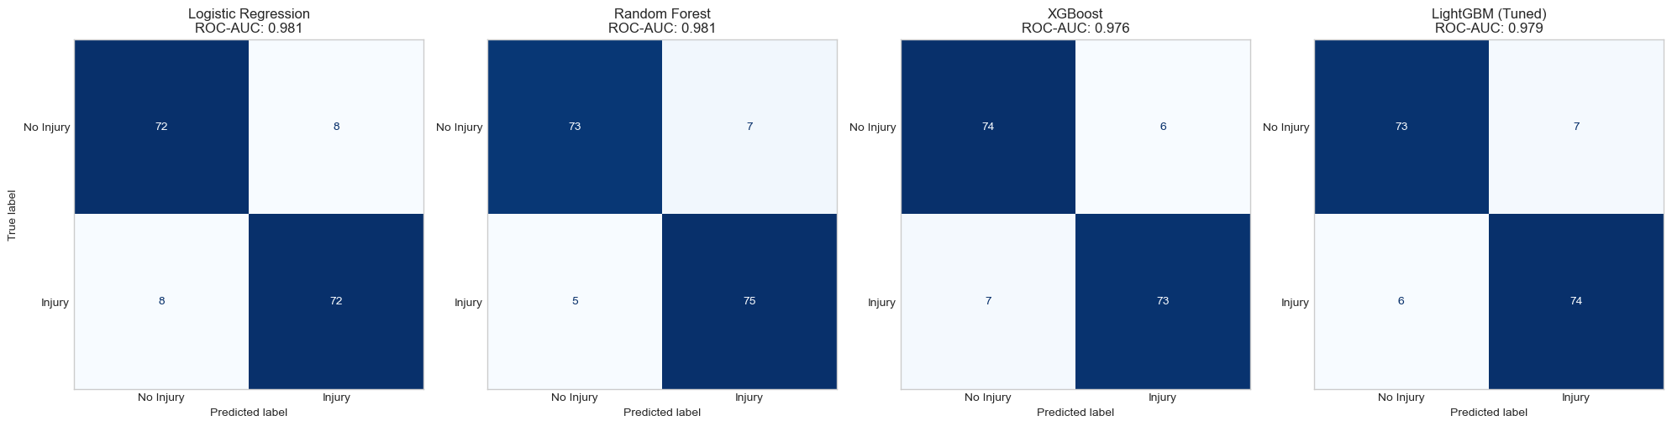
Figure 11.1 — Confusion matrices for all four Model A candidates on the held-out university test set (n = 160).
Feature importance from the winning Random Forest confirms the EDA's ranking almost exactly: Overall_Physical_Readiness alone accounts for 41.9% of total importance, followed by Stress_Level_Score (17.8%), Nutrition_Quality_Score (10.1%), Injury_Frequency (5.8%), Recovery_Consistency (4.8%), and Previous_Injury_Count (4.1%) — together explaining the great majority of the model's predictive power, and matching the strong/moderate feature groupings identified during EDA in Section 9.2.

12. Model B — Acute Injury Risk Classification
Model B is the direct implementation of AthleteShield's core use case: near-term injury-risk classification from the fused collegiate + wearable + IMU feature table (Section 10.1–10.2), on the full, unpruned 46-feature set — the leakage-flagged ACL_Risk_Score included, per the audit in Section 8.2. The 200-row table was split 80/20 (stratified) into 160 training and 40 test rows, with the training split showing the expected severe imbalance of 149 negative to 11 positive cases and the test split retaining just 3 positive cases out of 40. SMOTE oversampling (k = 3 neighbours) was applied to the scaled training data only, balancing it to 149/149 before any model saw it.
An Optuna study (10 trials, 5-fold stratified cross-validation on the SMOTE-resampled training data, ROC-AUC objective) tuned an XGBoost classifier and converged on n_estimators = 95, max_depth = 4, learning_rate ≈ 0.043, subsample ≈ 0.747, reaching a cross-validated ROC-AUC of 0.999. The tuned XGBoost was then wrapped in a sigmoid (Platt-scaling) probability calibrator via 5-fold CalibratedClassifierCV, and benchmarked against Logistic Regression, Random Forest, and the uncalibrated tuned XGBoost on the held-out test set:
Model | Test ROC-AUC
Logistic Regression | 0.9550
Random Forest | 0.9820
XGBoost (Optuna-tuned) | 0.9820
Calibrated XGBoost (Optuna-tuned) | 0.9820

The calibrated XGBoost model — Random Forest and Model B's final choice — was carried forward for threshold optimisation and SHAP interpretation, since Platt scaling is required to turn its raw scores into probabilities that are meaningfully comparable to a real injury rate, per the calibration requirement set out in Section 5.1 and Section 15.

12.1 Classification Threshold Optimization
In sports science, missing a genuine high-risk flag (a false negative) is far costlier than raising a false alarm, so rather than use the default 0.5 probability threshold, the precision-recall curve was computed on the calibrated model and both an F1-optimal and a recall-weighted F2-optimal threshold were derived from it.
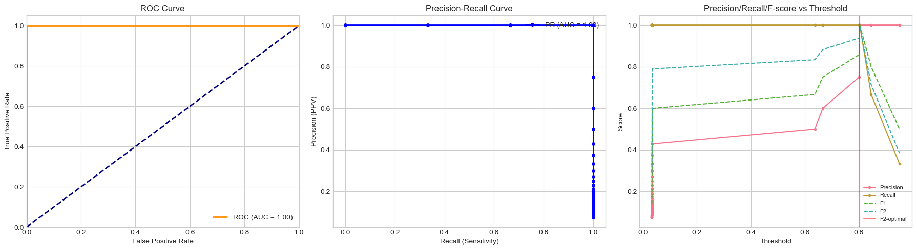
Figure 12.1 — ROC curve, precision-recall curve, and precision/recall/F-score versus threshold for the calibrated Model B XGBoost classifier.
Both the F1-optimal and F2-optimal thresholds converged to the same value, 0.8044, at which the calibrated model achieved a perfect confusion matrix on the 40-row test set — 37/37 true negatives and 3/3 true positives, i.e. 100% precision and 100% recall for both classes. This result must be read with the same caution flagged in Section 9.1: with only 3 positive cases in the test set, a perfect classification result has essentially no statistical power to demonstrate real-world generalization — one additional misclassified athlete would immediately drop recall to 67% or precision to 75%. The result is reported here as evidence that the calibrated pipeline is functioning correctly end-to-end (features, SMOTE, tuning, calibration, and thresholding all working together as designed), not as proof that the model will achieve this accuracy on an unseen team's data. Section 16 returns to this point as the report's most important limitation.

13. Model C — Sidelined-Days / Injury-Duration Regression
Model C addresses the professional football dataset's continuous target, season_days_injured, using the career and injury-history features engineered in Section 10.3 (34 features across 1,301 rows covering 604 unique players). Because the same player can appear in multiple seasons, a naive row-level train/test split would leak a player's identity — and therefore part of their injury-duration pattern — across the split. A GroupShuffleSplit keyed on the player identifier (p_id2) was used instead, holding out 20% of players entirely, with an explicit post-split check confirming zero player overlap between the training and test sets.
Remaining missing values were filled following the MNAR logic established in Section 10.3 — the previous-season history columns with zero, all other numeric columns with their median — leaving zero remaining NaNs before training. Because season_days_injured is strongly right-skewed (Section 9.3), the target was log-transformed (log1p) before fitting a Random Forest Regressor, with predictions transformed back (expm1) and clipped at zero, since a negative predicted day count is not physically meaningful.
Metric | Value
RMSE (days) | 78.51
R² score | 0.324

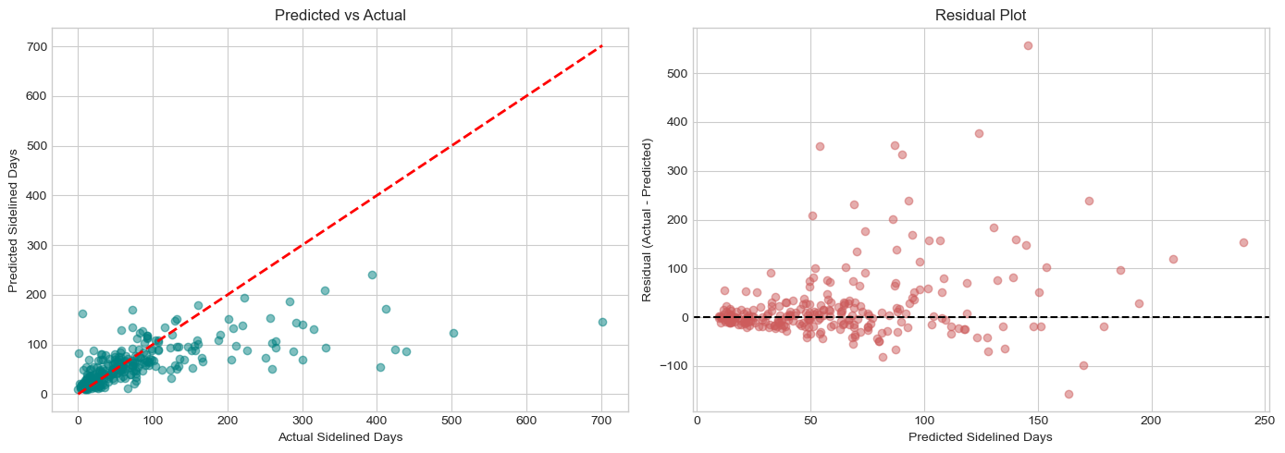
Figure 13.1 — Predicted vs. actual sidelined days (left) and the corresponding residual plot (right) for the Model C Random Forest regressor.
An R² of 0.324 means the model explains roughly a third of the variance in season-level injury duration — a modest but meaningful result for a genuinely hard regression target, given the extreme right-skew and long outlier tail documented in Section 9.3 (a handful of players reach 300–700 injured days per season, well beyond what cumulative workload alone predicts). Feature importance confirms that playing exposure and injury history dominate the model: season_matches_in_squad (31.5% importance) and Injury_Burden (15.7%) together account for nearly half of the model's predictive weight, followed by total_minutes_played (4.4%), total_games_played (4.2%), season_minutes_played (3.0%), and cumulative_days_injured (2.8%). Physical attributes (age, BMI, pace, physic) each contribute individually small amounts, reinforcing the EDA finding from Section 9.3 that injury history and exposure — not physical profile alone — drive injury-duration outcomes at the season level.

14. Model Interpretation — SHAP Explainability
Consistent with the explainability-by-design principle set out in Section 5.2, SHAP (SHapley Additive exPlanations) values were computed on Model B's base, uncalibrated XGBoost model using a TreeExplainer — the raw booster is used here rather than the calibrated wrapper, since TreeExplainer requires direct access to the underlying tree structure that Platt scaling wraps around.
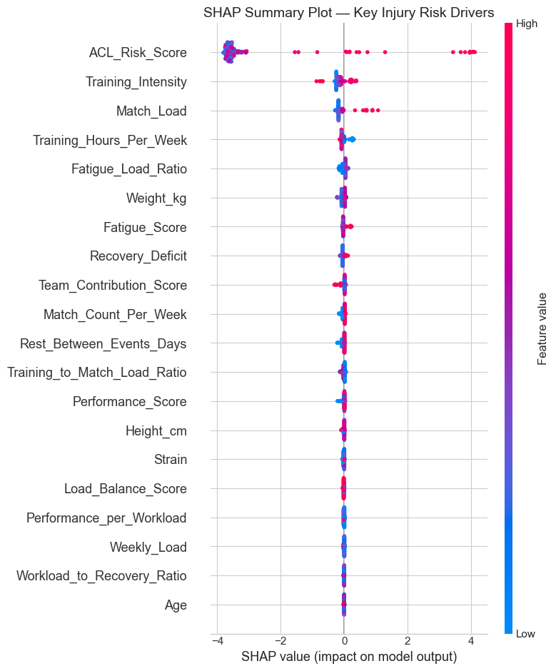
Figure 14.1 — SHAP summary plot for Model B: each point is one training athlete, colored by that athlete's feature value, positioned by its SHAP impact on the predicted injury-risk output.
The SHAP summary confirms the leakage concern raised in Section 8.2: ACL_Risk_Score is by a wide margin the single largest driver of the model's output, with high values (pink) pushing risk predictions sharply upward and low values (blue) pushing them sharply downward — a materially larger effect than every other feature combined. Training_Intensity and Match_Load are the next most influential features, followed by a long tail of workload, recovery, and physiological features (Training_Hours_Per_Week, Fatigue_Load_Ratio, Weight_kg, Fatigue_Score, Recovery_Deficit) each contributing comparatively modest, individually small effects. This is a useful sanity check in one respect — the ranking is clinically plausible, since training load and match exposure are exactly the mechanisms sport-science theory predicts — but it also means that, absent a verified independent provenance for ACL_Risk_Score, the model's real predictive power beyond that single field has not yet been demonstrated on this dataset.
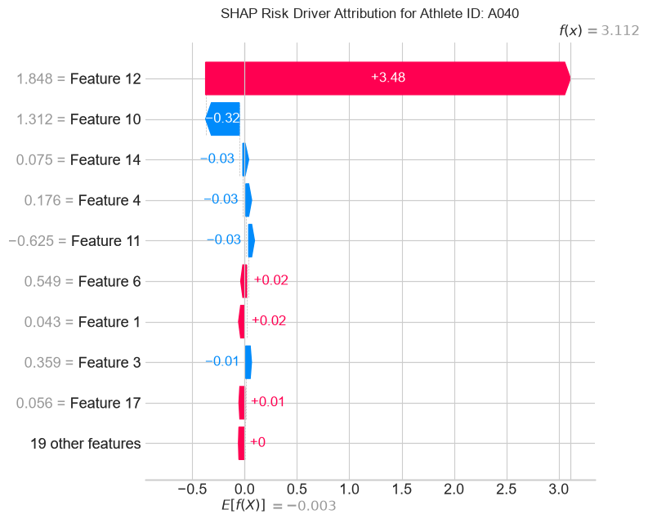
Figure 14.2 — SHAP waterfall plot for the highest-risk athlete in the Model B test set (predicted injury probability 94.52%), showing exactly which features pushed the prediction up or down from the baseline.
To demonstrate individual-athlete explainability — the specific capability Section 5.2 requires so that medical staff can justify a rest decision to a player — a SHAP waterfall plot was generated for the single highest-risk athlete in the test set, whose calibrated model output was a 94.52% injury probability. The waterfall decomposes that number feature-by-feature, showing exactly which of the athlete's individual measurements pushed their score up from the population baseline and by how much, which is the mechanism by which a coach-facing dashboard (Section 5, decision-support layer) would present a "why is this athlete flagged" explanation rather than an opaque probability.

15. Model Evaluation Strategy
Because confirmed injuries are rare events relative to total exposure time, raw classification accuracy is a poor and misleading metric.
- Primary metrics: Recall (sensitivity) and F1-score on the injury-positive class, plus ROC-AUC and precision-recall AUC, since missing a true injury risk (false negative) is far costlier than a false alarm.
- Class imbalance handling: Stratified k-fold cross-validation, SMOTE oversampling, and a held out stratified test split implemented in Model B exactly as specified, with group-aware splitting used instead for Model C to prevent player-level leakage.
- Calibration: Platt scaling applied post-hoc so that a reported "70% risk" score is meaningfully close to a 70% empirical injury rate among similarly scored athletes.
- Explainability validation: SHAP feature-importance rankings cross-checked against sports medicine domain knowledge before clinical trust is extended to the model implemented in Section 14, where the ranking was found clinically plausible but the top feature's provenance was flagged for further audit.
- Prospective validation: Before full deployment, risk flags should be logged silently for a full season without influencing selection decisions, so that flagged-vs-actual injury outcomes can be compared retrospectively.

16. Challenges & Limitations

16.1 Design-Level Challenges
- Label scarcity and imbalance: Injuries are rare (often single-digit percentages of exposures), which limits statistical power and increases overfitting risk for any single team's dataset.
- Data heterogeneity: Different wearable vendors (Catapult, STATSports, Polar, Whoop) use different sampling rates, proprietary load metrics and calibration standards, complicating cross team model transfer.
- Confounded causality: Elevated load metrics correlate with, but do not deterministically cause, injury; models must be interpreted as risk-stratification tools, not diagnostic instruments.
- Privacy and governance: Athlete biometric and health data is highly sensitive; edge-first, on premises processing and strict access controls are required, along with athlete consent and applicable data-protection compliance.
- Generalizability across sports and populations: A model trained on adult professional footballers is unlikely to transfer directly to youth athletes or different sports without recalibration, as noted across the surveyed reviews.

16.2 Implementation-Level Limitations
- Test-set statistical power in Model B: With only 3 positive cases in the 40-row acute-risk test set, the reported perfect precision/recall (Section 12.1) reflects a very small sample and should not be read as a generalization guarantee; bootstrap confidence intervals or a larger, prospectively collected test set are needed before this result can be trusted operationally.
- Unverified provenance of ACL_Risk_Score: This field drives the great majority of Model B's SHAP-attributed predictive power (Section 14) despite being flagged as a leakage risk during the initial audit (Section 8.2); its computation method could not be confirmed from the available data.
- Partial wearable/IMU coverage: Only 10 of the 200 collegiate athletes have real wearable telemetry and IMU records; the remaining 190 rows use mean-imputed values for these columns (Section 10.1), so the wearable/IMU features currently add limited differentiating signal at the cohort level.
- Single-pass VIF pruning in Model A: Several retained features exceed the conventional multicollinearity threshold even after pruning (Section 11); this does not materially affect the tree-based models used but means the logistic-regression baseline's individual coefficients should not be over-interpreted.
- Cross-sectional, not longitudinal, IMU validation: The raw accelerometer/gyroscope data used to validate signal processing (Section 9.4) comes from a general-purpose activity-recognition dataset, not from athletes performing sport-specific movements, so cadence/jerk/spectral features validated there have not yet been confirmed on genuine training or match-day IMU recordings.
- Retrospective-only evaluation: All three models are trained and evaluated on already-labelled, historical data; none has yet been evaluated prospectively against injuries that occur after a risk flag is issued.

17. Future Directions
- Federated learning across clubs: Train shared models across multiple teams without centralising raw athlete data, addressing both the label-scarcity and privacy challenges simultaneously.
- Digital-twin athlete modelling: Combine biomechanical simulation with sensor data to model individualised tissue-loading thresholds rather than population-level cut-offs.
- Richer sensor fusion: Incorporate EMG, force-plate, and flexible-electronics strain sensors as they become field-deployable, following the multimodal-fusion direction highlighted in recent reviews.
- Closed-loop intervention testing: Move from observational validation to randomised load-adjustment trials that measure whether acting on the flags reduces injury incidence.
- Full-cohort wearable coverage: Extend real wearable/IMU telemetry from the current 10-athlete subset to the full training squad, removing the mean-imputation gap identified in Section 16.2 and allowing the wearable-derived features to differentiate every athlete rather than a minority.
- Independent re-derivation of ACL_Risk_Score: Either confirm this field's independent, pre-outcome provenance with the data provider, or re-derive an equivalent clinical risk index from raw screening measurements, before relying on it in a deployed model.
- Prospective, silent-logging trial: Run the calibrated Model B pipeline unseen — logging risk flags without influencing team decisions.

18. References
- Sage Journals (2025). Practice of wearable devices combined with deep learning algorithms in predicting athletic injury risk. https://journals.sagepub.com/doi/10.1177/18724981251380391
- PMC (2022/2023). A novel lower extremity non-contact injury risk prediction model based on multimodal fusion and interpretable machine learning. https://www.ncbi.nlm.nih.gov/pmc/articles/PMC9520324/
- Pilka, T., Grzelak, B., Sadurska, A., Gorecki, T., & Dyczkowski, K. (2023). Predicting Injuries in Football Based on Data Collected from GPS-Based Wearable Sensors. Sensors, 23(3), 1227. https://www.ncbi.nlm.nih.gov/pmc/articles/PMC9919698/
- Taylor & Francis Online (2026). Artificial intelligence and wearable sensors in sports injury risk prediction: current status and future perspectives. Annals of Medicine. https://www.tandfonline.com/doi/full/10.1080/07853890.2026.2658879
- PMC (2024/2025). Construction and application of a model for predicting athletes' injury risk based on machine learning. https://www.ncbi.nlm.nih.gov/pmc/articles/PMC12849558/
- Br J Sports Med (2024). Machine learning approaches to injury risk prediction in sport: a scoping review with evidence synthesis. https://pmc.ncbi.nlm.nih.gov/articles/PMC12013557/
- BMC Sports Science, Medicine and Rehabilitation (2025). Machine learning framework for predicting athletic injuries and optimising performance. https://link.springer.com/article/10.1186/s13102-025-01502-x
- Frontiers in Sports and Active Living (2025). Prediction of football injuries using GPS-based data in Iranian professional football players: a machine learning approach. https://www.frontiersin.org/journals/sports-and-active-living/articles/10.3389/fspor.2025.1425180/full
- arXiv (2026). Time-to-Injury Forecasting in Elite Female Football: A DeepHit Survival Approach. https://arxiv.org/pdf/2601.19479
- Journal of Human Sport and Exercise (2024/2025). Integrating multimodal AI technologies for sports injury prediction and rehabilitation: Systematic review. https://www.jhse.es/index.php/jhse/article/view/integrating-multimodal-ai-technologies-sports-injury-prediction
- Premier Science (2025). The Role of AI and Wearables in Injury Prediction and Performance Optimization. https://premierscience.com/pjai-25-971/
- Premier Science (2025). Machine Learning Approaches to Injury Risk Prediction in Sport. https://premierscience.com/pjcs-25-918/
- Reiss, A., & Stricker, D. (2012). PAMAP2 Physical Activity Monitoring Dataset. UCI Machine Learning Repository.
- Malekzadeh, M. et al. (2018/2019). MotionSense Dataset for Human Activity and Attribute Recognition. IoTDI '19 / PMC.
- Kaggle. Collegiate Athlete Injury Dataset (community dataset).
- Kaggle. University Football Injury Dataset (community dataset).
- Kaggle. Football Player Injury Data (community dataset).
- Kaggle. Wearable Sports Health Dataset (community dataset).

