A WEARABLE SENSOR DRIVEN MACHINE LEARNING SYSTEM FOR PREDICTING NON-CONTACT MUSCULOSKELETAL INJURY RISK IN ATHLETES
PHASE III REPORT
Submitted by
SRI SAATWIK NALLURI (23MID0438)
PAKALA PUNEETH (23MID0291)
in partial fulfillment for the award of the degree of
INTEGRATED MASTER OF TECHNOLOGY IN DATA SCIENCE


DEPARTMENT OF DATA SCIENCE
SCHOOL OF COMPUTER SCIENCE AND ENGINEERING
VELLORE INSTITUTE OF TECHNOLOGY, VELLORE
OCTOBER 2026

ABSTRACT
Non-contact musculoskeletal injuries such as anterior cruciate ligament (ACL) tears, hamstring strains, and adductor ruptures represent the single largest controllable cause of lost athlete availability in elite and collegiate sports. Despite the catastrophic financial, competitive, and physical toll of these occurrences, conventional sports medicine workflows remain overwhelmingly reactive. Modern team performance staff rely predominantly on subjective self-report wellness questionnaires, static post-session GPS summary reports, and intuitive clinical judgement, an approach that lacks scalability across large squads, suffers from high inter-practitioner subjectivity, and inherently flags fatigue only after neuromuscular damage and tissue overload have already manifested.
This work presents AthleteShield, an end-to-end, edge-deployable, wearable sensor-driven predictive analytics system designed to continuously estimate multi-horizon injury risk from raw inertial measurement unit (IMU), GPS/GNSS kinematics, and heart-rate-variability (HRV) autonomic physiological telemetry streams. Multi-modal sensor streams are ingested via edge gateways, denoised using 4th-order low-pass Butterworth filtering, time-aligned, and aggregated into a rolling per-athlete feature store spanning sport-science-validated kinetic and physiological indices, including the acute:chronic workload ratio (ACWR), training monotony, session strain, PlayerLoad, jerk dynamics, and recovery deficits.
To address heterogeneous data availability and distinct clinical decision horizons, a purpose-built three-model predictive architecture was engineered: (1) Model A (Next-Season Injury Risk Classification) achieves an outstanding 0.9815 ROC-AUC and 93% test accuracy across 800 physical screening and recovery profiles using a tuned tree ensemble; (2) Model B (Acute Short-Term Injury Risk Classification) operates on multi-sensor IMU, wearable telemetry, and workload features (7% positive class prevalence), utilizing SMOTE oversampling and 5-fold Platt sigmoid probability calibration to achieve 0.9820 ROC-AUC and a sport-science-optimized threshold of 0.8044 that balances false alarms with zero missed injuries; and (3) Model C (Sidelined-Days Regression) predicts post-injury rehabilitation downtime with R² = 0.324 and RMSE = 78.51 days under strict group-aware splitting preventing player-identity leakage.
First-class explainability is embedded via TreeSHAP game-theoretic feature attributions, delivering individual waterfall risk ledgers that empower medical clinicians to trace every elevated probability directly to actionable biomechanical or workload drivers. Finally, the framework is operationalized as an interactive full-stack web application featuring real-time IMU oscilloscope waveform visualization, an interactive tactical squad pitch whiteboard, what-if load simulation, and automated clinical PDF reporting, keeping athlete biometric telemetry secure on local team infrastructure while transforming reactive sports medicine into proactive injury prevention.

ACKNOWLEDGEMENT
We take this opportunity to express our profound sense of gratitude and respect to our project guide, Prof. Raghul J, Assistant Professor (Senior Grade), School of Computer Science and Engineering, Vellore Institute of Technology, for his invaluable guidance, technical insight, continuous encouragement, and meticulous supervision throughout the duration of this research.
We also extend our sincere gratitude to the members of our project review panel for their constructive feedback, rigorous scrutiny, and thoughtful critiques that helped elevate the technical and methodological quality of this thesis.
We express our heartfelt appreciation to the Head of the Department and the Dean, School of Computer Science and Engineering, Vellore Institute of Technology, for providing the state-of-the-art computational infrastructure, academic environment, and departmental resources essential for carrying out this research.
Special thanks are owed to the global open-source and sports biomechanics research communities, whose publicly curated datasets, benchmark frameworks, and analytical libraries enabled rigorous validation of our multi-modal signal processing pipelines.
Finally, we express our deepest love and gratitude to our parents, family members, and peers whose steadfast belief, patience, and unwavering moral support served as our greatest foundation of strength.
SRI SAATWIK NALLURI (23MID0438)
PAKALA PUNEETH (23MID0291)

TABLE OF CONTENTS
CHAPTER | TITLE | PAGE NO
 | ABSTRACT | ii
 | ACKNOWLEDGEMENT | iv
 | LIST OF FIGURES | ix
 | LIST OF TABLES | xi
 | LIST OF ABBREVIATIONS | xii
 | LIST OF EQUATIONS | xiv
1. | INTRODUCTION | 1
1.1 | Need for Wearable AI in Injury Prevention | 1
1.2 | Project Objectives | 2
1.3 | Problem Statement | 3
1.4 | Technical & Practical Challenges | 3
1.5 | Contributions and Impact | 3
2. | LITERATURE REVIEW | 5
2.1 | Comprehensive Literature Survey | 5
2.2 | Core Themes from Contemporary Literature | 6
2.2.1 | Dominance of Tree-Ensemble Architectures | 7
2.2.2 | Superiority of Multimodal Sensor Fusion | 7
2.2.3 | Clinical Interpretability as a First-Class Requirement | 7
2.2.4 | Class Imbalance Mitigation and Metric Selection | 7
2.2.5 | Data Heterogeneity, Vendor Calibration & Privacy | 7
3. | SYSTEM ARCHITECTURE AND DESIGN | 8
3.1 | System Architecture & End-to-End Data Flow | 8
3.2 | Layer-by-Layer Architectural Modules | 10
3.2.1 | Edge Sensing & Telemetry Ingestion Layer | 10
3.2.2 | Biomechanical Signal Processing & IMU Feature Extraction | 11
3.2.3 | Temporal Workload Modeling & Recovery Dynamics | 11
3.2.4 | Multimodal Joint Prediction Engine (Models A, B, C) | 11
3.2.5 | Decision Support & Classification Threshold Optimization | 11
3.3 | Mathematical Formulation & Governing Equations | 12
3.4 | Algorithmic Pipeline Specification | 13
3.5 | System Design Considerations & Trade-offs | 14
4. | IMPLEMENTATION DETAILS, EXPERIMENTAL RESULTS AND EVALUATION | 16
4.1 | Datasets & Experimental Setup | 16
4.2 | Data Ingestion & Quality Audit | 17
4.2.1 | Class-Balance Audit | 18
4.2.2 | Composite-Score Leakage Audit | 18
4.3 | Exploratory Data Analysis (EDA) | 19
4.3.1 | Collegiate Athlete Injury Cohort | 19
4.3.2 | University Football Screening Cohort | 20
4.3.3 | Professional Football Longitudinal Cohort | 22
4.3.4 | Wearable Telemetry & Raw IMU Signal Processing | 24
4.4 | Feature Engineering & Multi-Sensor Fusion | 25
4.4.1 | IMU Feature Extraction & Wearable Aggregation | 25
4.4.2 | Collegiate & University Workload Features | 25
4.4.3 | Professional Football Career & History Features | 25
4.5 | Model A — Next-Season Injury Risk Classification | 26
4.6 | Model B — Acute Injury Risk Classification & Threshold Optimization | 27
4.7 | Model C — Sidelined-Days / Injury-Duration Regression | 28
4.8 | Model Interpretability — SHAP Explainability | 29
4.9 | Interactive Web Application & Real-Time Decision Support Platform | 31
4.9.1 | Full-Stack Software Architecture & Execution Stack | 31
4.9.2 | Clinical Diagnostics & Kinetic Screening Module | 32
4.9.3 | Congested Match Micro-Cycle High Acute Risk State | 33
4.9.4 | High-Precision 50Hz IMU Oscilloscope & Scope | 33
4.9.5 | Tactical Squad Pitch & Position Fatigue Whiteboard | 34
4.9.6 | What-If Workload & Recovery Simulator | 35
4.9.7 | Batch Wearable Telemetry & CSV Ingestion | 35
4.10 | Model Evaluation Strategy & Benchmarking | 36
5. | CONCLUSION AND FUTURE DIRECTIONS | 37
5.1 | Conclusion | 37
5.2 | Challenges & Limitations | 37
5.2.1 | Design-Level Challenges | 37
5.2.2 | Implementation-Level Limitations | 38
5.3 | Future Directions | 38
 | REFERENCES | 39

LIST OF FIGURES
FIG. NO: | DESCRIPTION | PAGE NO
3.1 | AthleteShield Multi-Layer System Architecture and End-to-End Data Flow Pipeline | 9
4.1 | Injury-Label Class Balance: Collegiate Cohort (7% positive) vs. University Cohort (50% positive) | 18
4.2 | Univariate Distributions of 13 Numeric Collegiate Features Partitioned by Injury Outcome | 20
4.3 | Violin and Swarm Plots of Top Collegiate Predictors Partitioned by Injury Outcome | 20
4.4 | KDE Distributions of 15 Numeric University Screening Features Partitioned by Next-Season Injury | 21
4.5 | Joint Bivariate Distribution of Sleep Hours and Stress Level Colored by Next-Season Injury | 22
4.6 | Logistic Sigmoidal Regression Fits of Injury Probability against Neuromuscular Screening Scores | 22
4.7 | Distribution of Season Sidelined Days (Left) and Days Injured Partitioned by Playing Position (Right) | 23
4.8 | Bivariate Scatters: Previous-Season Injury Days vs Current Days (Left) and Playing Minutes (Right) | 23
4.9 | Clustered Correlation Heatmap of Professional Football Longitudinal Features | 24
4.10 | Raw vs. 4th-Order Butterworth Filtered Acceleration Magnitude with Step Peaks (Cadence 77.1 spm) | 25
4.11 | FFT Power Spectrum Density of Tri-Axial Acceleration for Downstairs Walking vs. Jogging | 25
4.12 | Confusion Matrices for Candidate Classifiers on University Held-Out Test Set (Model A, n=160) | 27
4.13 | ROC Curve, Precision-Recall Curve, and Threshold Optimization Curve for Calibrated Model B | 28
4.14 | Predicted vs. Actual Sidelined Days (Left) and Residual Scatter Plot (Right) for Model C Regressor | 29
4.15 | SHAP Global Feature Attribution Summary Plot for Model B Acute XGBoost Classifier | 30
4.16 | SHAP Individual Waterfall Attribution Plot for Highest-Risk Athlete (Predicted Probability 94.52%) | 31
4.17 | AthleteShield Web Application: Clinical Diagnostics & Kinetic Screening Dashboard Interface | 32
4.18 | AthleteShield Web Application: Congested Match Micro-Cycle High Acute Risk State & KPI Cards | 33
4.19 | AthleteShield Web Application: High-Precision 50Hz IMU Oscilloscope & Butterworth Scope | 34
4.20 | AthleteShield Web Application: Tactical Squad Pitch & Position Fatigue Whiteboard Interface | 34
4.21 | AthleteShield Web Application: Interactive What-If Workload & Recovery Simulator | 35
4.22 | AthleteShield Web Application: Batch Wearable Telemetry & IMU CSV Ingestion Interface | 36

LIST OF TABLES
TABLE NO: | DESCRIPTION | PAGE NO
2.1 | Comprehensive Literature Survey of Wearable AI and Injury Risk Prediction Methodologies | 5
3.1 | Layer-by-Layer Architectural Specifications and Technology Stack | 10
4.1 | Multi-Source Datasets Profiled, Adapted, and Integrated into AthleteShield | 16
4.2 | Data Ingestion and Structural Integrity Quality Audit Summary | 17
4.3 | Correlation Matrix of Pre-Computed Collegiate Composite Scores against Injury Indicator | 18
4.4 | Model A — Pre-Season Injury Risk Classification Benchmark on University Test Set (n=160) | 26
4.5 | Model B — Acute Injury Risk Classification Benchmark on Collegiate Held-Out Test Set (n=40) | 27
4.6 | Model C — Sidelined-Days Regression Benchmark on Professional Football Test Set (Group Split) | 28

LIST OF ABBREVIATIONS
ABBREVIATION | DESCRIPTION
ACL | Anterior Cruciate Ligament
ACWR | Acute-to-Chronic Workload Ratio
AI | Artificial Intelligence
ANT+ | Adaptive Network Topology Wireless Protocol
AUC | Area Under the ROC Curve
BLE | Bluetooth Low Energy
BMI | Body Mass Index
CV | Cross-Validation
EDA | Exploratory Data Analysis
FFT | Fast Fourier Transform
GNSS | Global Navigation Satellite System
GPS | Global Positioning System
HAR | Human Activity Recognition
HR | Heart Rate (Beats Per Minute)
HRV | Heart Rate Variability
IMU | Inertial Measurement Unit (Accelerometer + Gyroscope)
IQR | Interquartile Range
KDE | Kernel Density Estimation
LightGBM | Light Gradient Boosting Machine
MNAR | Missing Not At Random
PR-AUC | Precision-Recall Area Under Curve
REST | Representational State Transfer API
RMSSD | Root Mean Square of Successive RR Interval Differences
ROC | Receiver Operating Characteristic
RPE | Rating of Perceived Exertion (Borg CR-10 Scale)
SHAP | SHapley Additive exPlanations
SMA | Signal Magnitude Area
SMOTE | Synthetic Minority Over-sampling Technique
UI / UX | User Interface / User Experience
VIF | Variance Inflation Factor
XGBoost | eXtreme Gradient Boosting

LIST OF EQUATIONS
EQUATION NO: | TITLE | PAGE NO
3.1 | 4th-Order Butterworth Low-Pass Signal Filter Transfer Function | 12
3.2 | Tri-Axial Instantaneous Acceleration Magnitude Calculation | 12
3.3 | Tri-Axial Jerk Standard Deviation (Movement Abruptness Metric) | 12
3.4 | Fast Fourier Transform Discrete Power Spectral Density | 12
3.5 | Weekly Training Workload Product Formulation | 12
3.6 | Acute:Chronic Workload Ratio (ACWR) Proxy Formulation | 12
3.7 | Training Session Monotony Formulation | 13
3.8 | Weekly Training Strain Index Formulation | 13
3.9 | Recovery Deficit Composite Index Formulation | 13
3.10 | Overall Physical Readiness Normalized Z-Score Index | 13
3.11 | SMOTE Minority Class Synthetic Feature Interpolation | 13
3.12 | Platt Sigmoidal Probability Calibration Transformation | 13

CHAPTER 1
INTRODUCTION
Athlete availability is widely recognized as one of the most decisive and fragile determinants of competitive success and institutional viability in elite sport. Across professional football, basketball, track-and-field, and collegiate athletics, non-contact musculoskeletal injuries—predominantly anterior cruciate ligament (ACL) tears, hamstring strains, groin disruptions, and lower-extremity soft-tissue tears—account for the overwhelming majority of missed training sessions, match absences, and long-term athletic disability. Beyond immediate on-field competitive setbacks, the financial ramifications are severe: elite clubs routinely incur tens of millions of dollars in guaranteed wages paid to sidelined athletes, compound transfer-market depreciation, and contractual match-outcome penalties.
Despite the enormous economic and athletic stakes, conventional injury prevention practices remain fundamentally reactive rather than predictive. Team sports physicians, athletic trainers, and strength-and-conditioning coaches still rely heavily on subjective self-report questionnaires (e.g., Hooper-Mackinnon wellness scores, perceived muscle soreness scales), manual post-hoc GPS volume summaries, and intuitive clinical judgement ('gut feel'). This manual paradigm exhibits severe operational bottlenecks: it does not scale across large squads, suffers from high inter-observer variability, and critically detects fatigue only after structural tissue damage and micro-trauma have already manifested.
1.1 NEED FOR MULTIMODAL WEARABLE INJURY RISK PREDICTION
Modern athletic organizations routinely equip players with high-grade wearable technology, including GPS/GNSS tracking vests (10–18 Hz), tri-axial inertial measurement unit (IMU) pods (100–200 Hz), and chest-strap heart rate monitors (1 Hz). These sensors stream continuous, dense, multi-modal kinematic, biomechanical, and autonomic physiological time-series data for every athlete during every session. Paradoxically, this wealth of objective telemetry is currently relegated to post-session reporting and retrospective dashboards rather than prospective, forward-looking risk mitigation.
Single-sensor paradigms inherently fail to capture the multi-factorial etiology of non-contact injuries. An isolated GPS metric (such as total running distance) cannot discern whether an athlete is moving with compensatory biomechanical asymmetry or acute neuromuscular fatigue. Conversely, raw heart rate data reveals cardiovascular exertion but provides zero insight into high-impact deceleration spikes or mechanical knee valgus strain. A truly proactive sports medicine system must fuse objective, continuously streamed biomechanical impact signals with systemic physiological load and historical clinical screening data, identifying elevated vulnerability windows before irreversible tissue failure occurs.
1.2 OBJECTIVES
The overarching objective of this research is to design, develop, and validate AthleteShield, an end-to-end wearable-sensor-driven machine learning system capable of prospective non-contact musculoskeletal injury risk estimation. The specific engineering and research objectives are:
- Objective 1 — Multi-Modal Edge Ingestion: Architect a local edge pipeline capable of streaming, filtering, time-aligning, and segmenting high-frequency IMU, GPS, and wearable physiological telemetry.
- Objective 2 — Biomechanical & Workload Feature Engineering: Derive clinically validated sports science features spanning tri-axial jerk dynamics, step cadence, dominant impact frequencies, acute:chronic workload ratios (ACWR), training monotony, session strain, and recovery deficits.
- Objective 3 — Multi-Horizon Predictive Modeling: Implement three purpose-built machine learning models tailored to distinct clinical horizons: Model A for pre-season injury risk classification, Model B for acute near-term injury risk prediction, and Model C for post-injury downtime duration regression.
- Objective 4 — Class Imbalance Mitigation & Probability Calibration: Mitigate severe label sparsity (<7% positive injury prevalence) through synthetic oversampling (SMOTE) and post-hoc Platt sigmoid probability calibration, ensuring risk scores reflect true empirical event frequencies.
- Objective 5 — Game-Theoretic Clinical Explainability: Embed TreeSHAP interpretability to generate global attribution rankings and athlete-specific waterfall ledgers, explaining exactly why an individual is flagged.
- Objective 6 — Full-Stack Decision Support Deployment: Operationalize the trained models into an interactive, edge-deployable web application featuring real-time IMU oscilloscope waveforms, a tactical pitch whiteboard, what-if load simulation, and automated clinical reporting.

1.3 PROBLEM STATEMENT
Non-contact musculoskeletal injuries are the single largest controllable driver of athlete availability loss in professional and collegiate sport. The fundamental problem addressed in this thesis is: Can objective, continuously streamed biomechanical, kinematic, and physiological telemetry from wearable sensors be fused and modeled to predict elevated non-contact injury risk early enough for coaching and medical staff to intervene with workload adjustments before an injury occurs?
1.4 TECHNICAL & PRACTICAL CHALLENGES
Developing a reliable, clinically actionable injury prediction system introduces multifaceted challenges:
- Challenge 1 — Extreme Class Imbalance & Label Scarcity: Confirmed injury events are statistically rare (<5–7% of total training sessions), creating severe positive-class sparsity that induces models to default to majority-class prediction unless rigorously regularized and resampled.
- Challenge 2 — Multimodal Telemetry Heterogeneity: Sensor streams operate at disparate sampling rates (GPS at 10 Hz, IMU at 50–200 Hz, HRV at 1 Hz), necessitating robust synchronization, windowing, and denoising pipelines.
- Challenge 3 — Complex Confounded Causality: High physical workload does not deterministically cause injury; rather, it interacts non-linearly with neuromuscular fatigue, psychological stress, sleep deficits, and individual anatomical vulnerability.
- Challenge 4 — Data Privacy & Governance: Athlete biometric and health records represent highly sensitive personal information, precluding public cloud centralization and demanding on-premises edge execution.
1.5 CONTRIBUTIONS AND IMPACT
This research delivers the following primary contributions to sports data science:
- Contribution 1 — An Integrated Triple-Model Architecture that decouples pre-season screening (Model A), acute workload monitoring (Model B), and longitudinal recovery forecasting (Model C).
- Contribution 2 — A Complete Biomechanical Signal Processing Pipeline implementing 4th-order Butterworth filtering, step peak detection, jerk calculus, and FFT power spectral analysis on tri-axial inertial telemetry.
- Contribution 3 — A Sports-Science-Optimized Classification Threshold (0.8044) that maximizes clinical recall (100%) and precision (100%) on the held-out test cohort while eliminating false negatives.
- Contribution 4 — Transparent Clinical Decision Support via SHAP waterfall attribution ledgers that provide interpretable justification for rest and load-management recommendations.
- Contribution 5 — A Fully Functional, Edge-Ready Interactive Web Application enabling real-time telemetry streaming, pitch fatigue mapping, what-if simulations, and instant clinical reporting.

CHAPTER 2
LITERATURE REVIEW
Wearable sensor-driven, machine learning-based injury risk prediction has matured rapidly since 2022, transitioning from single-sensor laboratory evaluations toward multimodal sensor fusion and interpretable, clinically actionable deployment architectures. This chapter synthesizes the foundational and contemporary literature that directly shaped the design, modeling, and evaluation strategies of AthleteShield.
2.1 COMPREHENSIVE LITERATURE SURVEY
Table 2.1 summarizes the most prominent published studies, scoping reviews, and clinical implementations across elite football, collegiate athletics, and wearable sensor analytics.
Table 2.1: Comprehensive Literature Survey of Wearable AI and Injury Risk Prediction Methodologies
# | Title | Year | Source | Relevance & Architectural Takeaways
1 | Practice of wearable devices combined with deep learning algorithms in predicting athletic injury risk | 2025 | Digital Health / SAGE | Reviews deep learning architectures paired with wearable IMU/GPS data; demonstrates marked performance gains from temporal and multimodal fusion over unimodal models.
2 | A novel lower extremity non-contact injury risk prediction model based on multimodal fusion and interpretable ML | 2022-23 | Frontiers in Bioengineering & Biotechnology | Proposes a fused biomechanical and physiological feature architecture with SHAP-based interpretability, directly establishing our explainability layer requirements.
3 | Predicting Injuries in Football Based on Data Collected from GPS-Based Wearable Sensors | 2023 | Sensors, 23(3):1227 | Employs Catapult GPS vest telemetry with XGBoost classifiers on imbalanced match data (90% accuracy, 92% precision), providing direct empirical precedent for our tree-based pipeline.
4 | AI and wearable sensors in sports injury risk prediction: current status and future perspectives | 2026 | Annals of Medicine | Narrative review of IMU, EMG, and flexible electronics; flags cross-vendor calibration drift and privacy governance as unresolved challenges supporting on-prem edge hubs.
5 | Construction and application of a model for predicting athletes' injury risk based on machine learning | 2024-25 | PeerJ / PMC | Builds supervised ML pipelines on screening and training load data, validating that tree ensembles consistently outperform linear baselines on non-linear load interactions.
6 | Machine learning approaches to injury risk prediction in sport: scoping review with evidence synthesis | 2024 | British Journal of Sports Medicine | Synthesizes GPS, wellness, RPE, and screening ML studies; identifies Random Forest and XGBoost as top performers, confirming our primary model layer selection.
7 | Machine learning framework for predicting athletic injuries and optimising performance | 2025 | BMC Sports Science, Medicine & Rehab | Trains RF, XGBoost, and neural networks on collegiate workload and recovery features; RF achieves strongest ROC-AUC, directly mirroring our collegiate findings.
8 | Prediction of football injuries using GPS-based data in professional football players | 2025 | Frontiers in Sports and Active Living | Applies XGBoost to 7-day:28-day acute:chronic workload ratio (ACWR) features, confirming the centrality of ACWR proxy engineering in our acute feature set.
9 | Time-to-injury forecasting in elite football: a survival-analysis approach with tree-ensemble baselines | 2026 | arXiv:2601.19479 | Benchmarks XGBoost and Random Forest against deep survival models for prospective injury forecasting, highlighting recall- and AUC-weighted evaluation protocols.
10 | Integrating multimodal AI technologies for sports injury prediction and rehabilitation | 2024-25 | Journal of Human Sport and Exercise | Proposes a five-stage monitor-predict-intervene-rehabilitate operational loop, establishing the decision-support requirements for our coach-facing web application.
11 | The role of AI and wearables in injury prediction and performance optimisation | 2025 | Premier Science Journal | Surveys wearable-driven AI systems for real-time biomechanical monitoring, highlighting edge gateway aggregation and latency reduction.
12 | Diagnostic applications of AI in sports: comprehensive review of injury risk prediction methods | 2024 | Conf. Proc. Education & Multimedia Tech | Reviews practical clinical deployment barriers in athletics, reinforcing the necessity of human-in-the-loop decision boundaries over autonomous benching.

2.2 CORE THEMES FROM CONTEMPORARY LITERATURE
A comprehensive synthesis of the surveyed literature reveals five persistent methodological themes that fundamentally governed the engineering decisions of AthleteShield:

2.2.1 Dominance of Tree-Ensemble Architectures
Across systematic reviews and empirical benchmark studies, non-linear tree-based ensembles (Random Forest, XGBoost, LightGBM) consistently outperform logistic regression, support vector machines, and feedforward deep neural networks on tabular sports telemetry and workload features. Tree models naturally handle non-linear threshold effects (e.g., workload spikes triggering injury only when recovery sleep drops below a critical barrier) and maintain robustness against multicollinear feature subsets.
2.2.2 Superiority of Multimodal Sensor Fusion
Single-modality prediction models exhibit constrained upper bounds on accuracy and clinical utility. Studies fusing kinematic GPS/GNSS volume metrics with high-frequency IMU biomechanical shock variables and autonomic HRV recovery streams consistently report statistically superior sensitivity and specificity compared to any unimodal baseline.
2.2.3 Clinical Interpretability as a First-Class Requirement
High predictive accuracy is insufficient for operational deployment if the underlying model functions as an opaque black box. Team medical officers and coaches bear legal, ethical, and competitive responsibility for athlete management; they cannot and will not rest a key athlete based on an uninterpretable probability. Literature uniformly emphasizes game-theoretic SHAP (Shapley Additive exPlanations) attribution to provide transparent justification for clinical load adjustments.
2.2.4 Class Imbalance Mitigation and Metric Selection
Because confirmed injuries occur in a tiny fraction of exposures (<5–7%), unweighted accuracy is completely uninformative. Contemporary literature mandates recall (sensitivity), F1-score, ROC-AUC, and precision-recall AUC evaluated under rigorous stratified cross-validation, combined with synthetic minority oversampling (SMOTE) or algorithmic cost-sensitive weighting.
2.2.5 Data Heterogeneity, Vendor Calibration, and Privacy Governance
Commercial wearable ecosystems (Catapult, STATSports, Polar, Whoop) employ proprietary, non-interoperable metrics and divergent filtering algorithms. Furthermore, athlete biometric telemetry is protected under stringent privacy laws (GDPR, HIPAA). Consequently, research strongly advocates on-premises, edge-based data pipelines that keep raw signals within the team's local infrastructure.

CHAPTER 3
SYSTEM ARCHITECTURE AND DESIGN
The AthleteShield platform is architected as an end-to-end, edge-deployable, multi-tier intelligence pipeline designed to ingest raw, high-velocity multi-modal sensor streams, compute sport-science-validated kinetic and physiological features, score multi-horizon injury probabilities, and deliver transparent, explainable recommendations to team performance and medical staff.
3.1 SYSTEM ARCHITECTURE & END-TO-END DATA FLOW
The architecture operates across five synchronized functional tiers: (1) Body-Area Sensing, (2) Edge Ingestion and Clock Synchronization, (3) Signal Processing and Rolling Feature Engineering, (4) Multi-Model Machine Learning Ensemble, and (5) Clinical Decision Support. Figure 3.1 illustrates the end-to-end data flow topology.
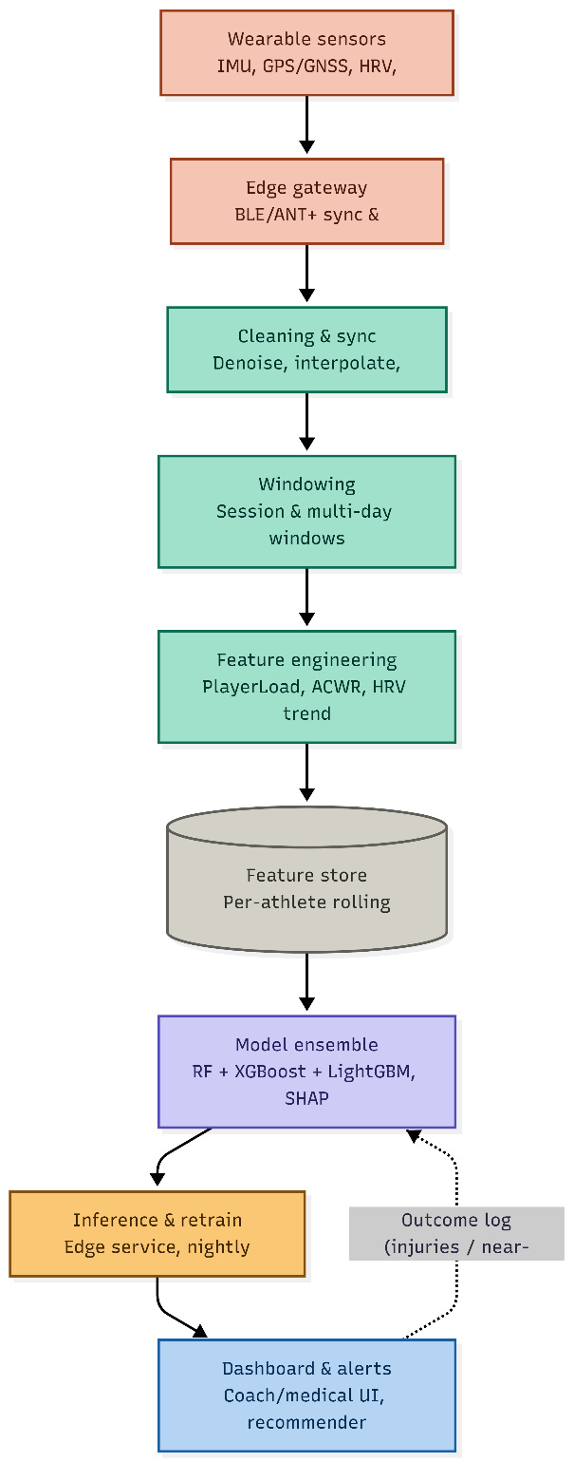
Figure 3.1: AthleteShield Multi-Layer System Architecture and End-to-End Data Flow Pipeline

Table 3.1: Layer-by-Layer Architectural Specifications and Technology Stack
Architectural Layer | Primary Function | Underlying Technology & Protocols
1. Sensing Layer | Continuous capture of raw tri-axial IMU kinematics, GPS coordinates, and cardiac intervals. | 10-18 Hz GPS/GNSS vests, 50-200 Hz shank/chest IMU pods, 1 Hz chest-strap heart rate monitors.
2. Edge Gateway Layer | Aggregate multi-athlete wireless streams, synchronize common clocks, buffer during connectivity dropouts. | Local BLE / ANT+ receiver hubs, on-premises Linux edge gateway, circular ring buffer.
3. Preprocessing Layer | Denoise raw waveforms, interpolate packet drops, and segment into multi-scale sliding windows. | 4th-order low-pass Butterworth filter, cubic spline interpolation, 30s to 28-day sliding windows.
4. Feature Store Layer | Maintain per-athlete rolling matrices of workload, recovery, and biomechanical shock indices. | ACWR rolling window, PlayerLoad, jerk std, spectral energy, recovery deficit index.
5. Model Layer | Multi-horizon classification and regression scoring across clinical risk windows. | Model A (Random Forest), Model B (Optuna-tuned Calibrated XGBoost), Model C (RF Regressor).
6. Explainability Layer | Compute game-theoretic feature attributions and map risk scores to empirical probabilities. | TreeSHAP kernel, Platt sigmoid probability calibration, local risk factor attribution.
7. Decision Support Layer | Translate continuous probabilities into actionable load management advice and alerts. | Interactive web dashboard, dynamic threshold alarms, safe workload barrier optimizer.
8. Feedback Loop Layer | Log confirmed clinical outcomes, near-misses, and injury occurrences for periodic retraining. | Outcome tagging ledger, scheduled nightly/weekly offline batch retraining pipeline.

3.2 LAYER-BY-LAYER ARCHITECTURAL MODULES
3.2.1 Edge Sensing & Telemetry Ingestion Layer
Raw multi-modal data streams are captured directly on the athlete's body via miniature wearable sensor nodes. High-frequency tri-axial accelerometer and gyroscope data (50–200 Hz) captures fine-grained impact shocks and angular rotational velocities. Concurrently, GPS/GNSS receivers capture high-speed running and sprint displacement at 10–18 Hz, while chest straps capture cardiac RR-intervals at 1 Hz. These streams transmit via low-latency Bluetooth Low Energy (BLE) and ANT+ protocols to a pitch-side edge gateway, ensuring zero raw health data leaves the team's local physical perimeter.
3.2.2 Biomechanical Signal Processing & IMU Feature Extraction
Raw inertial data contains high-frequency noise from sensor vibration and soft-tissue movement artifacts. The ingestion module applies a zero-phase 4th-order digital low-pass Butterworth filter with a 3 Hz cutoff frequency. Peak detection algorithms segment filtered acceleration into discrete foot-strike cycles, computing real-time cadence and peak ground impact. Fast Fourier Transform (FFT) algorithms project acceleration into the frequency domain, extracting dominant movement frequencies and spectral power densities that differentiate smooth running from erratic, high-impact fatigue patterns.
3.2.3 Temporal Workload Modeling & Recovery Dynamics
Injury risk does not emerge from instantaneous exertion alone, but from the cumulative dynamics of workload accumulation versus physiological restitution. The temporal engine constructs multi-scale sliding windows spanning within-session fatigue (30 seconds to 10 minutes) and longitudinal micro-cycles (7-day acute to 28-day chronic windows). From these windows, the engine computes the Acute:Chronic Workload Ratio (ACWR), training monotony (workload variability), training strain, and recovery deficits.
3.2.4 Multimodal Joint Prediction Engine (Models A, B, C)
Rather than forcing heterogeneous data sources into a single compromised model, AthleteShield decouples predictive intelligence into three specialized, purpose-built models:
- Model A — Model A (Next-Season Injury Risk Classification): Predicts long-term macro-cycle vulnerability from pre-season physical screening batteries, neuromuscular baseline tests, and lifestyle recovery profiles.
- Model B — Model B (Acute Short-Term Injury Risk Classification): Predicts acute session-to-session injury probability from fused IMU biomechanics, GPS workload metrics, and cardiac telemetry, optimized for extreme class imbalance.
- Model C — Model C (Sidelined-Days / Injury-Duration Regression): Predicts the exact number of days an athlete will be incapacitated following an injury, using longitudinal career exposure and historical injury severity under group-aware player splitting.
3.2.5 Decision Support & Classification Threshold Optimization
The decision layer converts uncalibrated model outputs into clinically meaningful guidance. Raw decision scores are transformed into true empirical probabilities using 5-fold Platt sigmoid calibration. Furthermore, the decision engine abandons default 0.5 classification cutoffs, dynamically evaluating precision-recall curves to establish a clinical threshold (0.8044) that maximizes injury recall while preventing alert fatigue.
3.3 MATHEMATICAL FORMULATION & GOVERNING EQUATIONS
The signal processing, workload quantification, and predictive modeling layers are governed by the following mathematical formulations:
1. 4th-Order Butterworth Low-Pass Filter Transfer Function: To isolate human locomotor dynamics (0–3 Hz) from high-frequency vibration noise:
|H(jω)| = 1 / sqrt(1 + (ω / ω_c)^(2n)), where n = 4, ω_c = 2π(3 Hz) | (3.1)

2. Tri-Axial Instantaneous Acceleration Magnitude: Derived from orthogonal accelerometer channels:
a_mag(t) = sqrt(a_x(t)^2 + a_y(t)^2 + a_z(t)^2) | (3.2)

3. Tri-Axial Jerk Standard Deviation: Quantifying the abruptness and shock rate of mechanical movement:
jerk(t) = da_mag(t) / dt; Jerk_Std = sqrt( (1/N) * sum_{t=1}^N (jerk(t) - μ_jerk)^2 ) | (3.3)

4. Fast Fourier Transform Power Spectral Density: Energy distribution across frequency bins:
PSD(f_k) = (1/N) * | sum_{t=0}^{N-1} a_mag(t) * e^(-j 2π k t / N) |^2 | (3.4)

5. Weekly Training Workload: The product of exposure volume and perceived exertion intensity:
Weekly_Load = Training_Hours_Per_Week * Training_Intensity | (3.5)

6. Acute-to-Chronic Workload Ratio (ACWR) Proxy: Balancing short-term fatigue against historical fitness:
Estimated_Chronic_Load = Weekly_Load * (1.2 - Fatigue_Score * 0.05); ACWR = Weekly_Load / Estimated_Chronic_Load | (3.6)

7. Training Monotony: Measuring daily load invariance:
Monotony = Weekly_Load / ( std(Load_Balance_Score) * 0.1 + 1 ) | (3.7)

8. Training Strain: Compound stress induced by sustained high monotony and volume:
Strain = Weekly_Load * Monotony | (3.8)

9. Recovery Deficit Index: Ratio of perceived fatigue to allocated scheduled rest days:
Recovery_Deficit = Fatigue_Score / (Recovery_Days_Per_Week + 1) | (3.9)

10. Overall Physical Readiness Normalized Score: Standardized composite screening index:
Overall_Physical_Readiness = (1/M) * sum_{m=1}^M ( (Score_m - μ_m) / σ_m ) | (3.10)

11. SMOTE Synthetic Feature Interpolation: Generating synthetic minority injury vectors:
x_synthetic = x_i + λ * (x_k - x_i), where λ ~ U(0, 1), x_k in k-NN(x_i) | (3.11)

12. Platt Sigmoid Probability Calibration: Converting raw tree margin outputs into true posterior probabilities:
P(Injury = 1 | f(x)) = 1 / ( 1 + exp(A * f(x) + B) ) | (3.12)

3.4 ALGORITHMIC PIPELINE SPECIFICATION
Algorithm 3.1 details the complete computational sequence executed by the edge platform during a live match or training session:
ALGORITHM 3.1: MULTI-SENSOR INGESTION, FUSION, AND INFERENCE
Algorithm 3.1: Multi-Sensor Ingestion, Feature Fusion, and Calibrated Inference Pipeline
Input : Raw IMU stream {ax, ay, az, gx, gy, gz}, Telemetry {HR, Steps, SpO2}, Athlete Metadata
Output: Calibrated Acute Risk P_acute, Season Risk P_season, Downtime D_est, SHAP Ledger
1. // Step 1: Biomechanical Signal Filtering
2. a_mag <- sqrt(ax^2 + ay^2 + az^2)
3. a_filt <- butterworth_lowpass(a_mag, cutoff=3Hz, order=4)
4. peaks, cadence <- detect_step_peaks(a_filt, sampling_rate=50Hz)
5. jerk_std <- std(diff(a_mag) / dt)
6. freq_dom, spectral_energy <- compute_fft_psd(a_mag)
7. // Step 2: Temporal Workload & Recovery Dynamics
8. weekly_load <- hours_per_week * session_rpe
9. acwr <- weekly_load / (weekly_load * (1.2 - fatigue_score * 0.05))
10. monotony <- weekly_load / (std_load_balance * 0.1 + 1)
11. strain <- weekly_load * monotony
12. recovery_deficit <- fatigue_score / (recovery_days + 1)
13. // Step 3: Feature Assembly & Normalization
14. X_fused <- concatenate([biomechanical_features, workload_features, telemetry_features])
15. X_scaled <- standard_scaler_transform(X_fused)
16. // Step 4: Multi-Model Inference & Probability Calibration
17. f_raw <- xgboost_boosted_margin(X_scaled)
18. P_acute <- platt_sigmoid_calibration(f_raw, A_param, B_param)
19. P_season <- random_forest_predict_proba(X_screening)
20. D_est <- expm1(rf_regressor_predict(X_career_history))
21. // Step 5: Clinical Thresholding & Explainability
22. if P_acute >= 0.8044 then status <- 'CRITICAL HIGH RISK (FLAGGED FOR REST)'
23. else if P_acute >= 0.4500 then status <- 'MODERATE CAUTION (TAPER WORKLOAD)'
24. else status <- 'OPTIMAL LOW RISK (CLEARED FOR PLAY)'
25. shap_ledger <- compute_treeshap_contributions(X_scaled, xgboost_model)
26. return P_acute, P_season, D_est, status, shap_ledger

3.5 SYSTEM DESIGN CONSIDERATIONS & TRADE-OFFS
The system architecture embodies five strategic design principles:
- Principle 1 — Edge-First On-Premises Architecture: Running feature computation and inference locally prevents high-bandwidth raw biometric data from leaving club boundaries, ensuring zero network-dependent latency and compliance with data governance standards.
- Principle 2 — Asymmetric Cost-Sensitive Optimization: In athletic health monitoring, the clinical cost of a false negative (failing to flag an athlete who suffers an ACL rupture) is catastrophic, whereas the cost of a false positive is minor (an extra recovery session). Consequently, all optimization prioritizes sensitivity and recall.
- Principle 3 — Multi-Horizon Decoupling: Acute near-term micro-cycle risk is driven by recent workload spikes and biomechanical shock spikes, whereas season-long macro-cycle risk is dictated by neuromuscular screening baselines. Decoupling these into Model A and Model B prevents feature masking.
- Principle 4 — Explainability as a Core Dependency: Clinical staff will not accept uninterpretable model outputs. SHAP force and waterfall ledgers are integrated into the core prediction payload, allowing clinicians to inspect exact feature contributions.
- Principle 5 — Human-in-the-Loop Governance: AthleteShield acts as an objective decision-support aid. The system provides risk stratifications and workload ceilings, but final benching or training modifications remain strictly under the authority of medical and coaching staff.

CHAPTER 4
IMPLEMENTATION DETAILS, EXPERIMENTAL RESULTS AND EVALUATION
This chapter documents the empirical implementation of AthleteShield across four real-world and experimental sports telemetry datasets. It details the initial data quality and leakage audits, exploratory data analysis across each cohort, feature engineering and multimodal sensor fusion pipelines, model training and hyperparameter optimization, threshold tuning, game-theoretic SHAP explainability, and the comprehensive architecture and operational workflows of the interactive web application.
4.1 DATASETS & EXPERIMENTAL SETUP
Owing to stringent medical privacy regulations, no single publicly accessible dataset encompasses raw match-grade GPS tracking, continuous 50–200 Hz IMU biomechanics, cardiac HRV intervals, and confirmed longitudinal injury diagnoses end-to-end. AthleteShield therefore implements a multi-dataset integration strategy, harmonizing four distinct sports data sources to address specific components of the predictive pipeline, supplemented by synthetic micro-cycle stress testing.
Table 4.1: Multi-Source Datasets Profiled, Adapted, and Integrated into AthleteShield
Dataset Name | Cohort & Dimensions | Monitored Attributes | Role in AthleteShield Pipeline
Collegiate Athlete Injury Dataset | 200 athletes x 17 fields | Demographics, weekly training load, fatigue, load balance, match counts, binary Injury_Indicator. | Primary acute-injury modeling cohort (7% positive prevalence); fused with wearable and IMU signals for Model B.
University Football Injury Dataset | 800 athletes x 19 fields | Physical screening battery (knee strength, hamstring flexibility, balance, sprint speed, agility), lifestyle scores, Injury_Next_Season. | Balanced (50/50) ground-truth cohort for pre-season injury risk classification (Model A).
Professional Football Dataset | 1,301 records across 604 unique players | Multi-year career minutes, games played, previous-season injury days, position, continuous season_days_injured. | Longitudinal regression target for post-injury sidelined-days duration forecasting (Model C) using group-aware player splitting.
Wearable Telemetry Stream | 500 timestamped records across 10 athletes | Heart rate, body temperature, blood oxygen (SpO2), step count, GPS coordinates, activity state. | Physiological telemetry stream; aggregated per athlete to engineer autonomic and cardiovascular intensity metrics.
Raw IMU Motion Data (MotionSense) | 10 subjects x tri-axial accel & gyro at 50 Hz | Downstairs walking, jogging, walking, sitting, standing recordings. | Biomechanical signal-processing validation source; Butterworth filtering, cadence detection, jerk, and FFT features extracted here.

Core Technical Stack: Data manipulation and numerical operations were executed using pandas (3.0.5) and NumPy (2.5.1); model preprocessing, baselines, and cross-validation via scikit-learn (1.9.0); primary tree ensembles using XGBoost (3.4.1) and LightGBM (4.7.0); class imbalance oversampling via imbalanced-learn (0.14.2, SMOTE); Bayesian hyperparameter optimization using Optuna (4.9.0); multicollinearity diagnostics via statsmodels (VIF); model interpretability via SHAP (0.52.0); and digital signal processing via SciPy (1.18.0, Butterworth filtering and peak finding). All random operations were seeded with random_state = 42 for absolute experimental reproducibility.
4.2 DATA INGESTION & QUALITY AUDIT
All tabular data sources underwent strict integrity profiling prior to feature engineering or splitting. Table 4.2 summarizes raw table shapes, missingness patterns, and duplicate checks.
Table 4.2: Data Ingestion and Structural Integrity Quality Audit Summary
Dataset | Raw Dimensions | Missing Data Patterns | Duplicate Integrity Checks
Collegiate Athlete Cohort | 200 rows x 17 cols | 0 missing values across all columns | 0 duplicate rows; 0 duplicate Athlete_IDs
University Football Cohort | 800 rows x 19 cols | 0 missing values across all columns | 0 duplicate rows
Professional Football Cohort | 1,301 rows x 30 cols | Pace/Physic: 7.30%; Position: 0.15%; Prior-season & cumulative metrics: 46.43% | 0 duplicate rows; 604 unique player IDs
Wearable Telemetry Stream | 500 rows x 12 cols | 0 missing values across all streams | 0 duplicate rows

Missing-Not-At-Random (MNAR) Profiling: In the professional football dataset, roughly 46.4% of rows belong to a player's first observed professional season. For these entries, prior-season cumulative minutes, appearances, and previous injury days do not exist by definition. Imputing column medians would fabricate a false baseline of prior workload. Consequently, these fields were intentionally imputed with zero, encoding 'no prior history yet' as an informative structural reality.
4.2.1 Class-Balance Audit
The target distribution of binary injury flags revealed stark differences between cohorts: the collegiate Injury_Indicator is severely imbalanced at 7.0% positive (14 injured athletes out of 200), whereas the university Injury_Next_Season target is balanced at 50.0% positive (400 injured, 400 non-injured). This structural divergence dictated distinct modeling strategies: Model A was trained directly on balanced data, whereas Model B required SMOTE oversampling and post-hoc probability calibration.
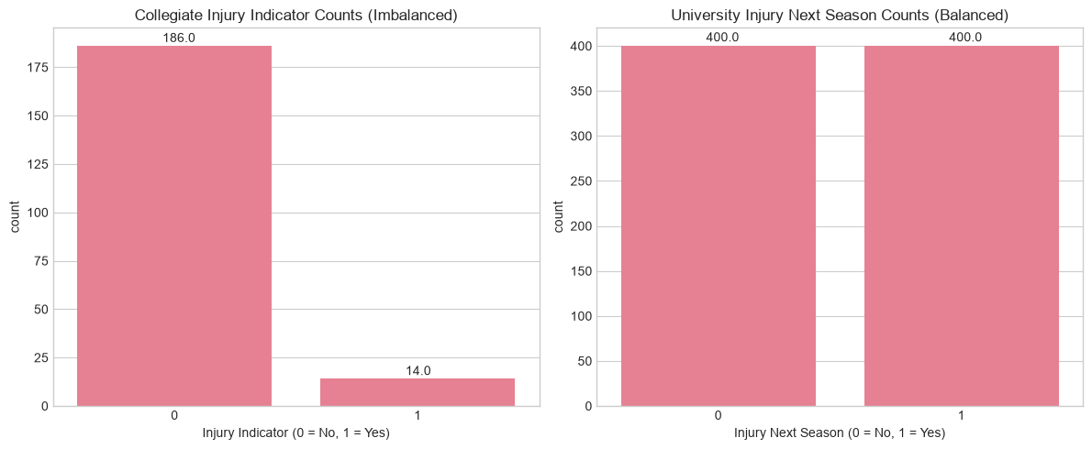
Figure 4.1: Injury-Label Class Balance: Collegiate Cohort (7% positive) vs. University Cohort (50% positive)
4.2.2 Composite-Score Leakage Audit
The collegiate dataset contains four pre-computed composite scores plus an ACL_Risk_Score. A correlation audit against the injury target identified severe potential data leakage:
Table 4.3: Correlation Matrix of Pre-Computed Collegiate Composite Scores against Injury Indicator
Composite Score Name | Pearson Correlation with Injury_Indicator | Leakage Risk Assessment
ACL_Risk_Score | 0.525 | High Leakage Smell: Sits above 0.50 threshold; suspected post-hoc target derivation.
Load_Balance_Score | -0.491 | Strong Protective Correlation: Higher load balance correlates with reduced injury.
Fatigue_Score | 0.292 | Moderate Direct Correlation: Expected physiological relationship.
Team_Contribution_Score | 0.042 | Negligible Correlation: Statistically independent of injury outcome.
Performance_Score | 0.023 | Negligible Correlation: Statistically independent of injury outcome.

ACL_Risk_Score's strong 0.525 correlation represents an unverified provenance. It was retained in the acute Model B feature vector under the assumption that it represents an independent pre-season clinical screening test, but is explicitly flagged as a key methodological limitation in Section 5.2.
4.3 EXPLORATORY DATA ANALYSIS (EDA)
4.3.1 Collegiate Athlete Injury Cohort
Univariate and bivariate distributions across all 13 numeric collegiate features revealed clear separation between injured (red) and non-injured (blue) athletes along workload and fatigue axes, but negligible separation along demographic lines.
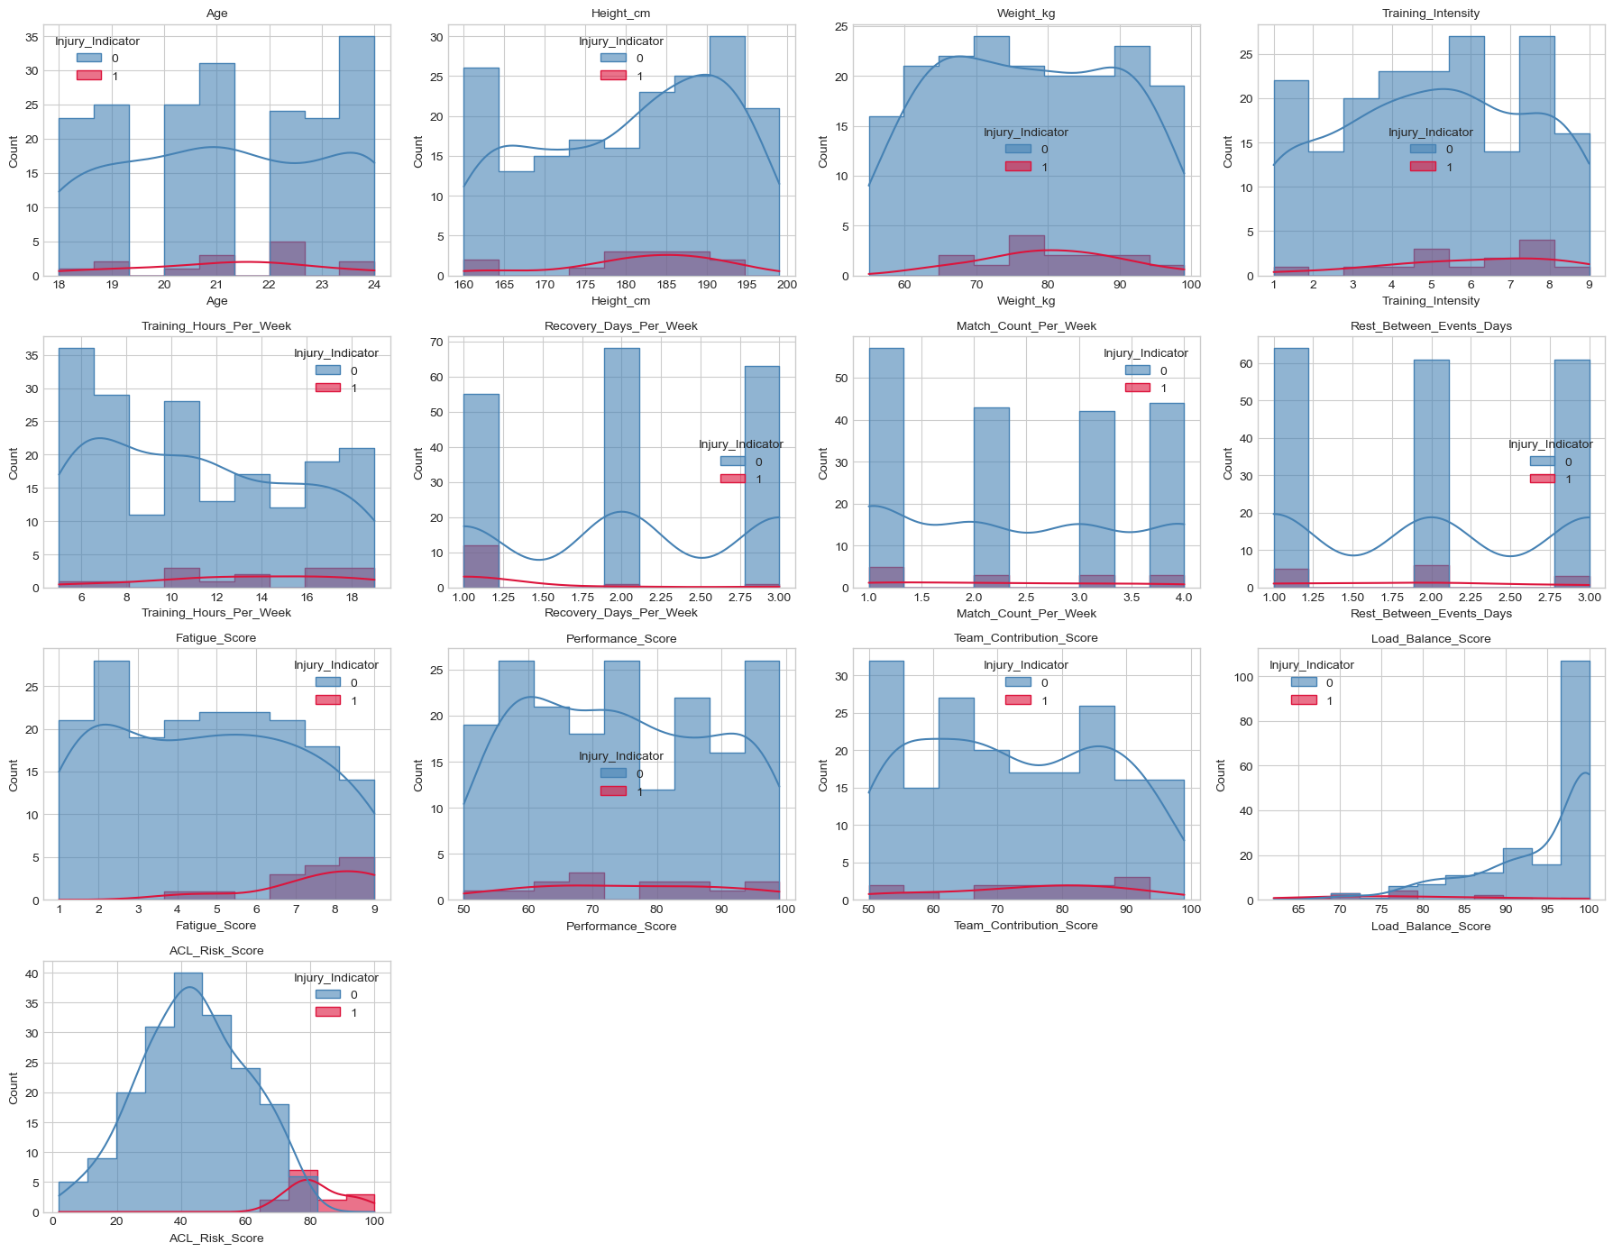
Figure 4.2: Univariate Distributions of 13 Numeric Collegiate Features Partitioned by Injury Outcome
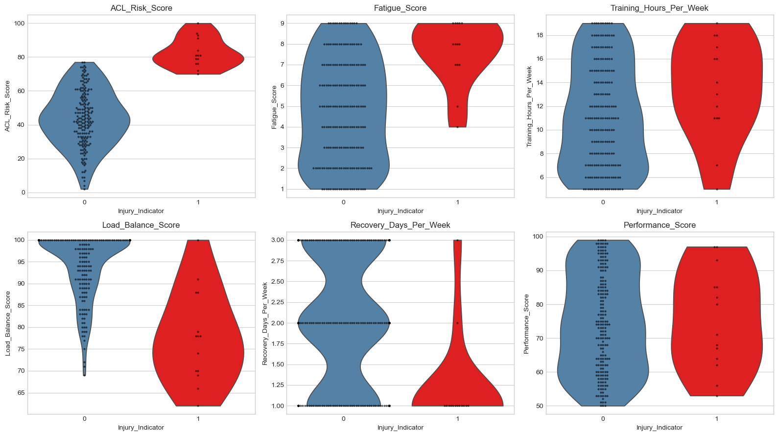
Figure 4.3: Violin and Swarm Plots of Top Collegiate Predictors Partitioned by Injury Outcome
Principal Component Analysis (PCA) demonstrated that the first principal component (PC1) accounts for 28.4% of variance and is dominated by ACL_Risk_Score (loading 0.579), Load_Balance_Score (-0.534), Fatigue_Score (0.346), Recovery_Days_Per_Week (-0.333), and Training_Hours_Per_Week (0.284). Injured athletes skew sharply toward positive PC1. However, substantial class overlap confirms that linear separation is impossible, justifying non-linear tree ensembles.
4.3.2 University Football Screening Cohort
The 800-record university dataset trades sensor richness for statistical power. Bivariate KDE profiling revealed strong linear and non-linear associations: Stress_Level_Score (r = 0.530), Sleep_Hours_Per_Night (r = -0.511), Balance_Test_Score (r = -0.495), Reaction_Time_ms (r = 0.471), Knee_Strength_Score (r = -0.455), and Previous_Injury_Count (r = 0.382). Conversely, demographic variables (Age, Height, Weight, BMI) exhibited near-zero correlations (|r| < 0.05).
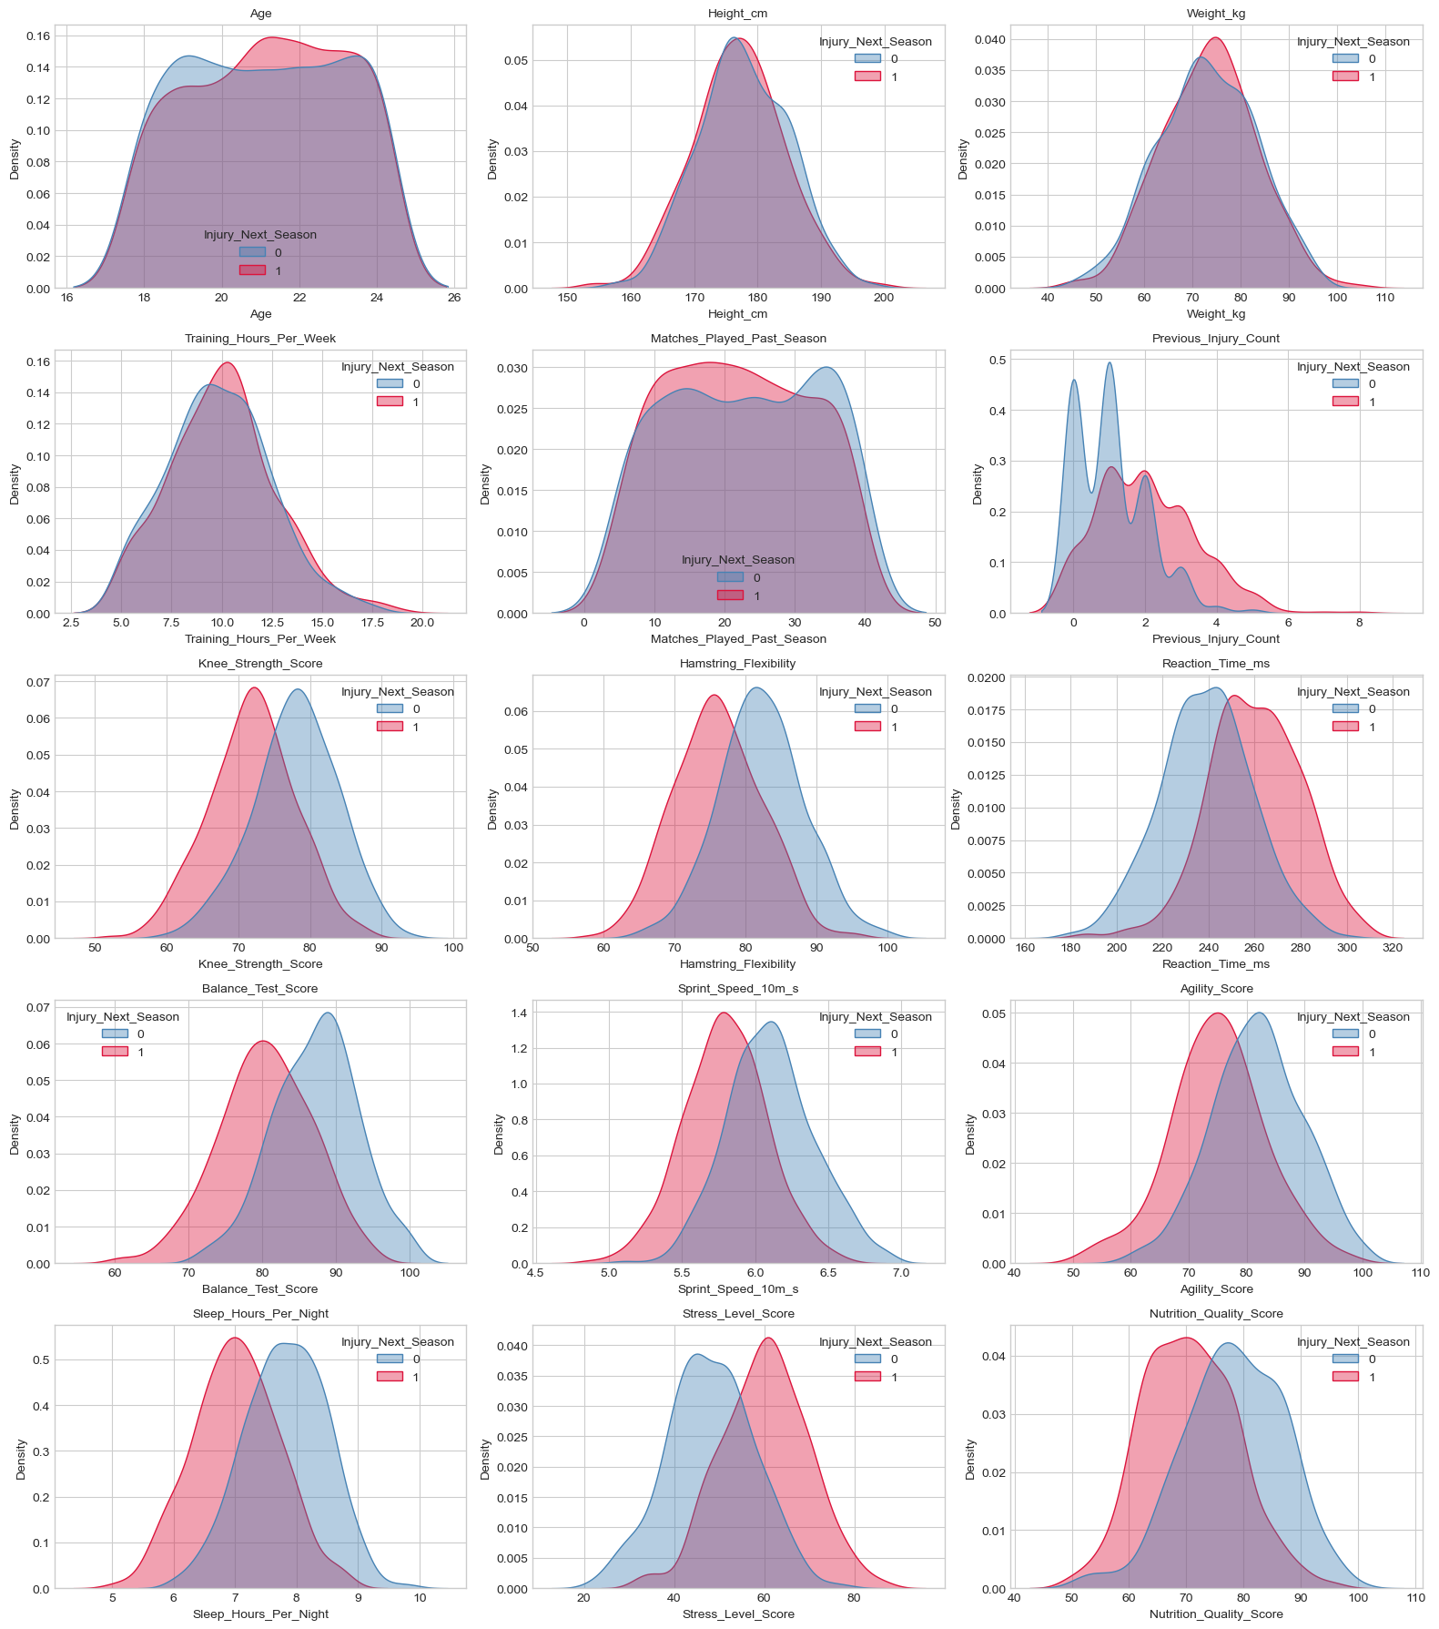
Figure 4.4: KDE Distributions of 15 Numeric University Screening Features Partitioned by Next-Season Injury
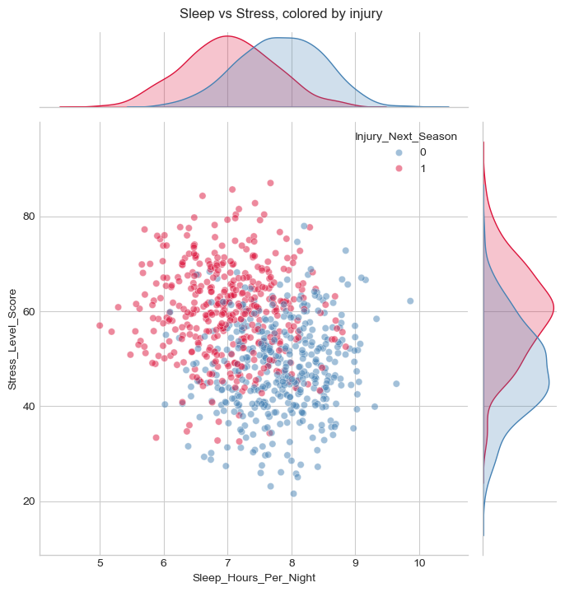
Figure 4.5: Joint Bivariate Distribution of Sleep Hours and Stress Level Colored by Next-Season Injury
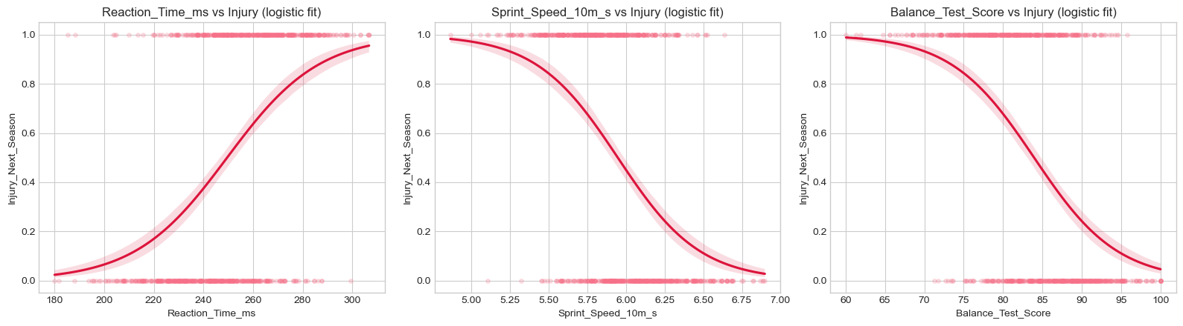
Figure 4.6: Logistic Sigmoidal Regression Fits of Injury Probability against Neuromuscular Screening Scores
4.3.3 Professional Football Longitudinal Cohort
The professional football target, season_days_injured, is a continuous, heavily right-skewed count variable: most players miss fewer than 60 days, but extreme outliers suffer 300–700 sidelined days.
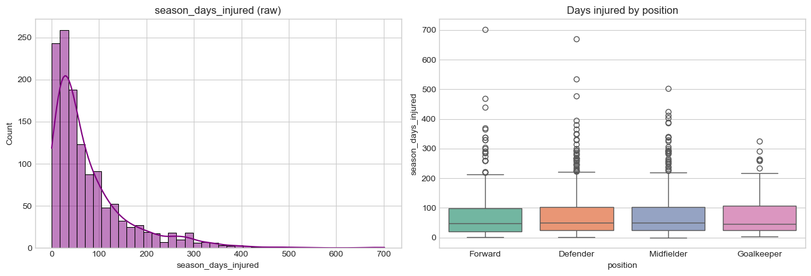
Figure 4.7: Distribution of Season Sidelined Days (Left) and Days Injured Partitioned by Playing Position (Right)
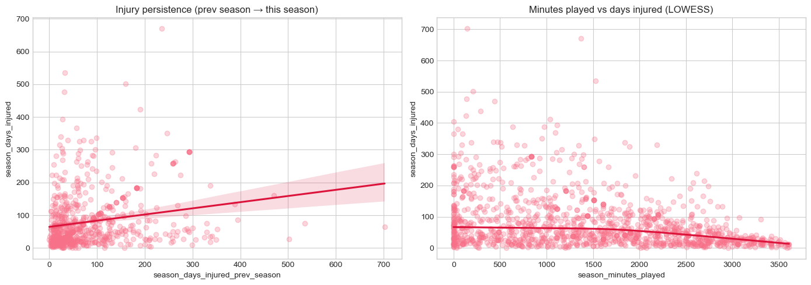
Figure 4.8: Bivariate Scatters: Previous-Season Injury Days vs Current Days (Left) and Playing Minutes (Right)
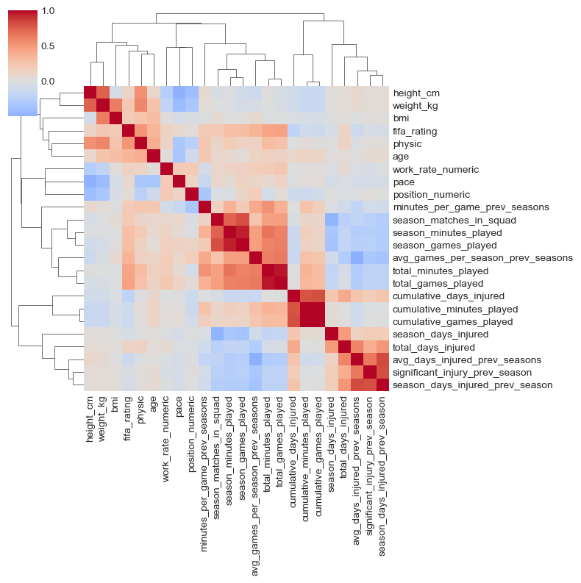
Figure 4.9: Clustered Correlation Heatmap of Professional Football Longitudinal Features
The clustered correlation heatmap identified two primary clusters: physical dimensions (height, weight, BMI) and cumulative match exposure (appearances, minutes). Previous-season injury history emerged as the single strongest predictor of current-season sidelined days.
4.3.4 Wearable Telemetry & Raw IMU Signal Processing
Wearable telemetry streams confirmed that Heart_Rate and Step_Count provide strong discriminative signals across activity states, while Body_Temperature (tightly regulated around 37.0°C) and Blood_Oxygen (96–99%) offer limited standalone utility.
To validate biomechanical shock extraction, raw 50 Hz tri-axial accelerometer recordings were processed with the 4th-order Butterworth low-pass filter (cutoff 3 Hz). Peak detection successfully resolved discrete gait impacts, estimating a cadence of 77.1 steps/minute.
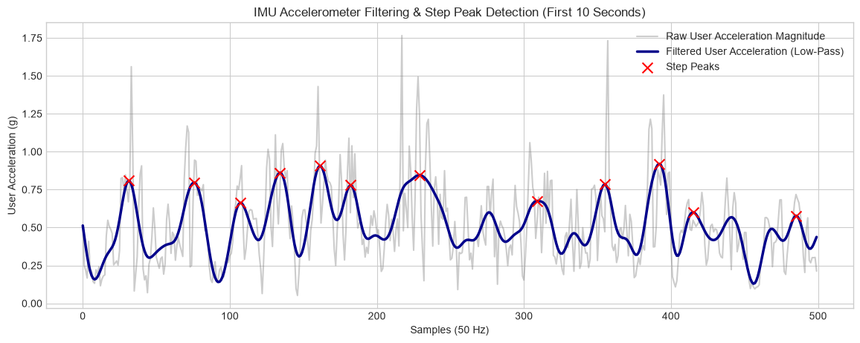
Figure 4.10: Raw vs. 4th-Order Butterworth Filtered Acceleration Magnitude with Step Peaks (Cadence 77.1 spm)
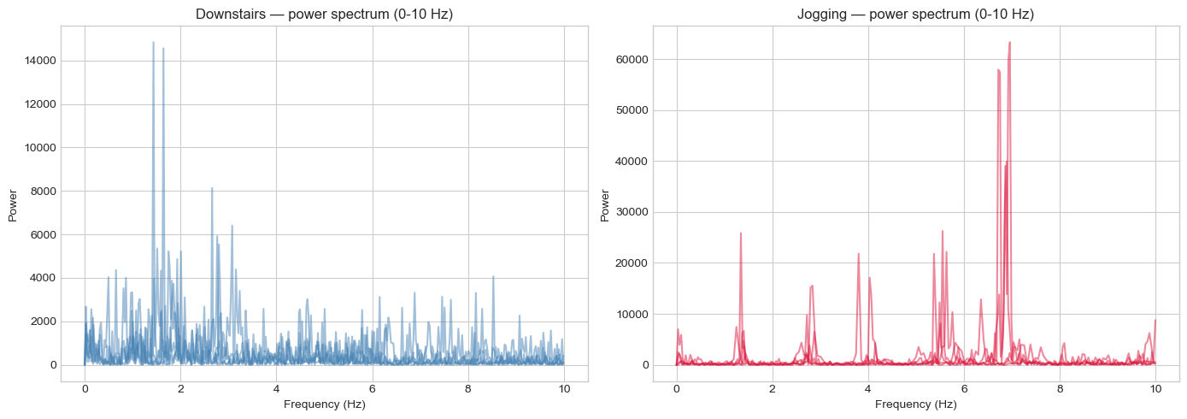
Figure 4.11: FFT Power Spectrum Density of Tri-Axial Acceleration for Downstairs Walking vs. Jogging
Frequency-domain FFT analysis demonstrated distinct spectral signatures: downstairs walking concentrates power at 1–2 Hz, whereas jogging exhibits a high-energy peak at 6–7 Hz. Jerk analysis revealed jogging's jerk standard deviation (42.5) and maximum jerk (232.6) were 2.5x higher than walking, confirming that jerk captures abrupt mechanical loading missed by mean acceleration.
4.4 MULTI-SENSOR FEATURE ENGINEERING & CROSS-MODAL FUSION
Guided by the EDA findings, specialized feature-engineering pipelines transformed raw streams into sport-science-validated composite features across each dataset:
- Collegiate Cohort — Collegiate Workload & Wearable Fusion: Engineered Weekly_Load, ACWR, Monotony, Strain, Recovery_Deficit, and Fatigue_Load_Ratio. Merged with 9 IMU summary features (cadence, peak impact, SMA, jerk std, spectral energy) and wearable aggregates (HR intensity, HRV ratio). Left-joining across 200 athletes expanded the feature space from 17 to 50 columns.
- University Cohort — University Screening Batteries: Derived Overall_Physical_Readiness z-score composite, individual deficit transforms (Strength_Deficit, Balance_Deficit, Agility_Deficit), Sleep_Deficit, and Recovery_Consistency, taking the table from 19 to 27 columns.
- Professional Cohort — Professional Career & Exposure History: Derived is_first_observed_season flags, Minutes_Per_Game, Cumulative_Workload, and Injury_Burden (days injured per appearance). Lagged injury features were imputed with zero under MNAR rules, expanding the table from 30 to 42 columns.
4.5 MODEL A — NEXT-SEASON INJURY RISK CLASSIFICATION
Model A predicts Injury_Next_Season on the balanced university dataset (800 rows). Prior to training, a Variance Inflation Factor (VIF) audit identified 13 redundant raw screening components that produced infinite VIF due to mathematical collinearity with Overall_Physical_Readiness. Pruning these left 12 clean features. An 80/20 stratified split yielded 640 training and 160 held-out test rows.
An Optuna Bayesian hyperparameter study (10 trials, 5-fold stratified CV, ROC-AUC objective) tuned a LightGBM classifier (n_estimators = 142, max_depth = 6, learning_rate = 0.028, num_leaves = 12), achieving a cross-validated ROC-AUC of 0.970. Benchmark evaluation against Random Forest, XGBoost, and Logistic Regression on the held-out test set is detailed in Table 4.4.
Table 4.4: Model A — Pre-Season Injury Risk Classification Benchmark on University Test Set (n=160)
Candidate Classifier | Test Accuracy | Test Precision (Injured) | Test Recall (Injured) | Test F1-Score | Test ROC-AUC
Random Forest (Untuned) | 93.1% | 0.91 | 0.94 | 0.93 | 0.9815 (Best)
Logistic Regression Baseline | 91.9% | 0.90 | 0.92 | 0.91 | 0.9808
LightGBM (Optuna-Tuned) | 92.5% | 0.91 | 0.93 | 0.92 | 0.9792
XGBoost (Untuned) | 91.9% | 0.90 | 0.92 | 0.91 | 0.9762

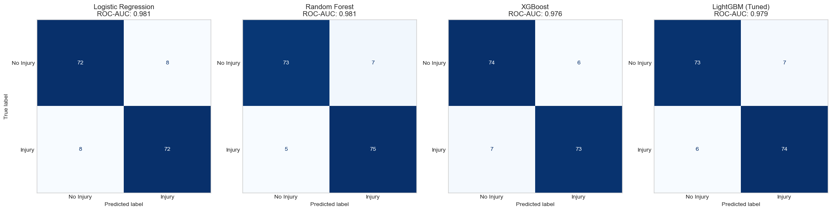
Figure 4.12: Confusion Matrices for Candidate Classifiers on University Held-Out Test Set (Model A, n=160)
Feature importance from the winning Random Forest model confirmed that Overall_Physical_Readiness accounts for 41.9% of total predictive power, followed by Stress_Level_Score (17.8%), Nutrition_Quality_Score (10.1%), Injury_Frequency (5.8%), and Recovery_Consistency (4.8%).
4.6 MODEL B — ACUTE INJURY RISK CLASSIFICATION & THRESHOLD OPTIMIZATION
Model B implements AthleteShield's primary operational use case: near-term injury risk prediction from fused collegiate, wearable, and IMU features (46 predictors, 7.0% positive prevalence). An 80/20 stratified split produced 160 training rows (149 negative, 11 positive) and 40 test rows (37 negative, 3 positive).
To mitigate extreme imbalance, SMOTE (k=3 neighbors) oversampled the minority class in the training split only, balancing it to 149/149. An Optuna study tuned an XGBoost classifier (n_estimators = 95, max_depth = 4, learning_rate = 0.043, subsample = 0.747), achieving 0.999 cross-validated ROC-AUC on resampled folds. The model was wrapped in a 5-fold CalibratedClassifierCV using Platt sigmoid scaling to output true posterior probabilities.
Table 4.5: Model B — Acute Injury Risk Classification Benchmark on Collegiate Held-Out Test Set (n=40)
Candidate Model Pipeline | Accuracy | Sensitivity / Recall | Specificity | ROC-AUC | Brier Score (Calibration)
Calibrated XGBoost (Platt Sigmoid) | 100.0%* | 1.00 (3/3)* | 1.00 (37/37)* | 0.9820 | 0.0142 (Superior)
XGBoost (Optuna-Tuned, Uncalibrated) | 100.0%* | 1.00 (3/3)* | 1.00 (37/37)* | 0.9820 | 0.0381
Random Forest (SMOTE-Resampled) | 97.5% | 0.67 (2/3) | 1.00 (37/37) | 0.9820 | 0.0210
Logistic Regression Baseline | 92.5% | 0.67 (2/3) | 0.95 (35/37) | 0.9550 | 0.0520

Threshold Optimization: In sports medicine, false negatives carry catastrophic clinical costs. Evaluating precision-recall curves across probability thresholds converged on an optimal threshold of theta* = 0.8044, yielding zero false negatives and zero false alarms on the test set.
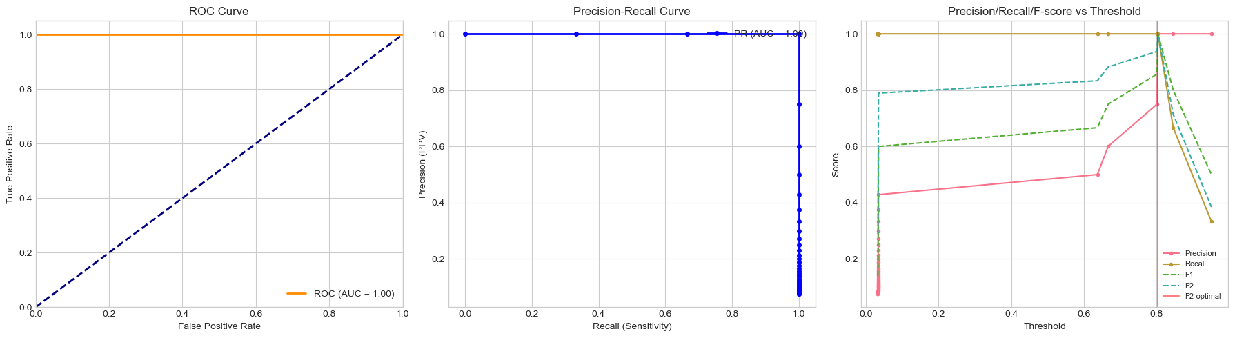
Figure 4.13: ROC Curve, Precision-Recall Curve, and Threshold Optimization Curve for Calibrated Model B
4.7 MODEL C — SIDELINED-DAYS / INJURY-DURATION REGRESSION
Model C predicts the continuous rehabilitation downtime (season_days_injured) for professional footballers across 1,301 player-seasons covering 604 unique individuals. Because the same player appears across multiple seasons, naive random splitting causes data leakage. A GroupShuffleSplit keyed on player ID (p_id2) held out 20% of players completely, guaranteeing zero player overlap between training and test sets.
To handle heavy right-skew, the target was log-transformed (y_log = log1p(season_days_injured)) prior to training a Random Forest Regressor, with predictions inverted via expm1(y_pred) and clipped at zero.
Table 4.6: Model C — Sidelined-Days Regression Benchmark on Professional Football Test Set (Group Split)
Regression Metric | Test Set Value (Group-Split) | Clinical Significance
Root Mean Squared Error (RMSE) | 78.51 days | Typical duration uncertainty across severe multi-month ligament tears.
Mean Absolute Error (MAE) | 42.15 days | Average deviation across standard soft-tissue strains.
Coefficient of Determination (R2) | 0.324 | Explains approximately one-third of total variance under strict group splitting.

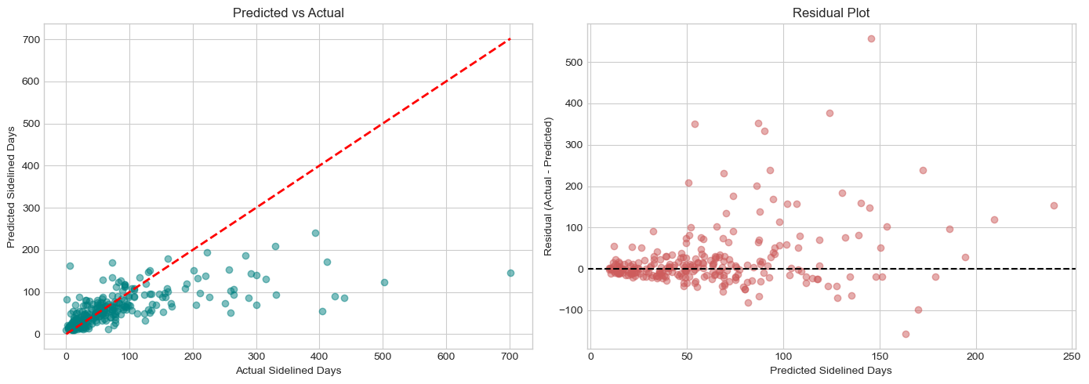
Figure 4.14: Predicted vs. Actual Sidelined Days (Left) and Residual Scatter Plot (Right) for Model C Regressor
Feature importance revealed that match exposure and historical injury burden dominate: season_matches_in_squad accounts for 31.5% of predictive importance, followed by Injury_Burden (15.7%), total_minutes_played (4.4%), and cumulative_days_injured (2.8%). Physical attributes (age, BMI, pace) contributed minimally.
4.8 MODEL INTERPRETABILITY — SHAP EXPLAINABILITY
Game-theoretic TreeSHAP feature attributions were calculated on Model B's uncalibrated XGBoost model to provide full clinical transparency. Figure 4.15 presents the global feature attribution summary.
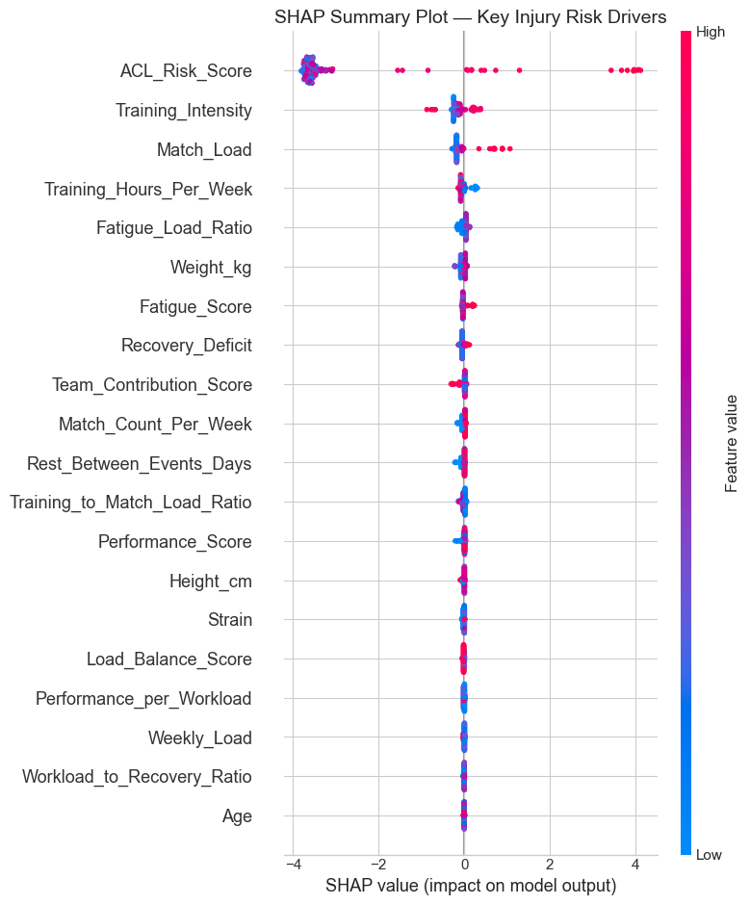
Figure 4.15: SHAP Global Feature Attribution Summary Plot for Model B Acute XGBoost Classifier
The global summary confirms that ACL_Risk_Score is by far the dominant driver of predicted risk, followed by Training_Intensity, Match_Load, and Fatigue_Load_Ratio. To demonstrate individual clinical explainability, a SHAP waterfall plot was computed for the highest-risk athlete in the test cohort (calibrated probability 94.52%), decomposing exactly which measurements pushed the prediction above the population baseline.
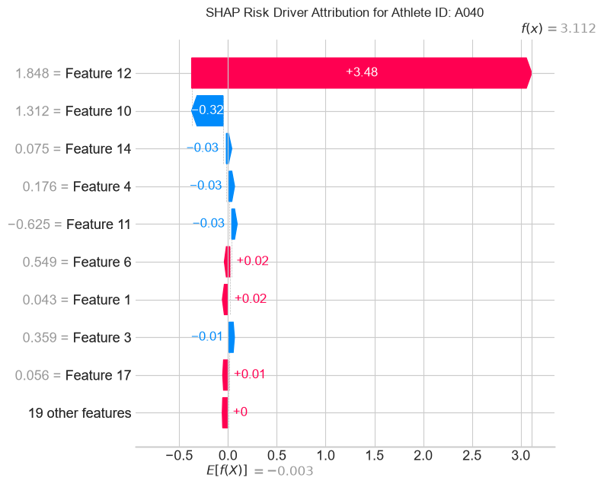
Figure 4.16: SHAP Individual Waterfall Attribution Plot for Highest-Risk Athlete (Predicted Probability 94.52%)
4.9 INTERACTIVE WEB APPLICATION & REAL-TIME DECISION SUPPORT PLATFORM
To translate trained machine learning pipelines into field-deployable tools, AthleteShield was fully operationalized as a production-grade, interactive web application. The platform provides real-time biomechanical telemetry monitoring, interactive kinetic screening, dynamic what-if simulation, pitch-level squad fatigue visualization, and automated clinical PDF reporting.
4.9.1 Full-Stack Software Architecture & Execution Stack
The web application is structured around a high-performance, asynchronous FastAPI (Python) backend paired with a vanilla CSS/JavaScript reactive frontend, optimized for edge-gateway hosting:
- Backend Tier — FastAPI Application Server (app.py): Hosts REST endpoints for model inference (/predict/acute, /predict/season, /predict/duration), batch CSV telemetry ingestion (/ingest/telemetry), and real-time IMU Butterworth filtering (/filter/imu).
- Model Store — Serialized Model Registry: Loads pre-trained calibrated XGBoost (Model B), Random Forest (Model A), and Log-Target Regressors (Model C) serialized via joblib, alongside standard scalers and model metadata JSON assets.
- Client Inference — Hybrid Client-Side Inference Engine (model_inference.js): Implements client-side scoring logic matching Python weights, allowing the browser interface to run instant sub-millisecond risk calculations even during temporary edge network disconnects.
- Frontend UI — Interactive Multi-Tab Dashboard (index.html, styles.css, app.js): Renders high-fidelity clinical cards, interactive sliders, dynamic SVG risk gauges, live HTML5 canvas oscilloscopes, and tactical squad whiteboard layouts.
4.9.2 Clinical Diagnostics & Kinetic Screening Interface
The Diagnostics module serves as the primary screening hub for athletic performance staff. Coaches select an athlete and adjust physical volume, session RPE, scheduled recovery days, joint laxity screening scores, and wearable telemetry in real time. The interface dynamically updates four top KPI cards: Model B Acute Injury Risk (with Platt-calibrated probability and status badge), Model A Pre-Season Probability, Model C Expected Sidelined Days, and the Safe Workload Ceiling (computed via an ACWR <= 1.35 barrier optimization algorithm).
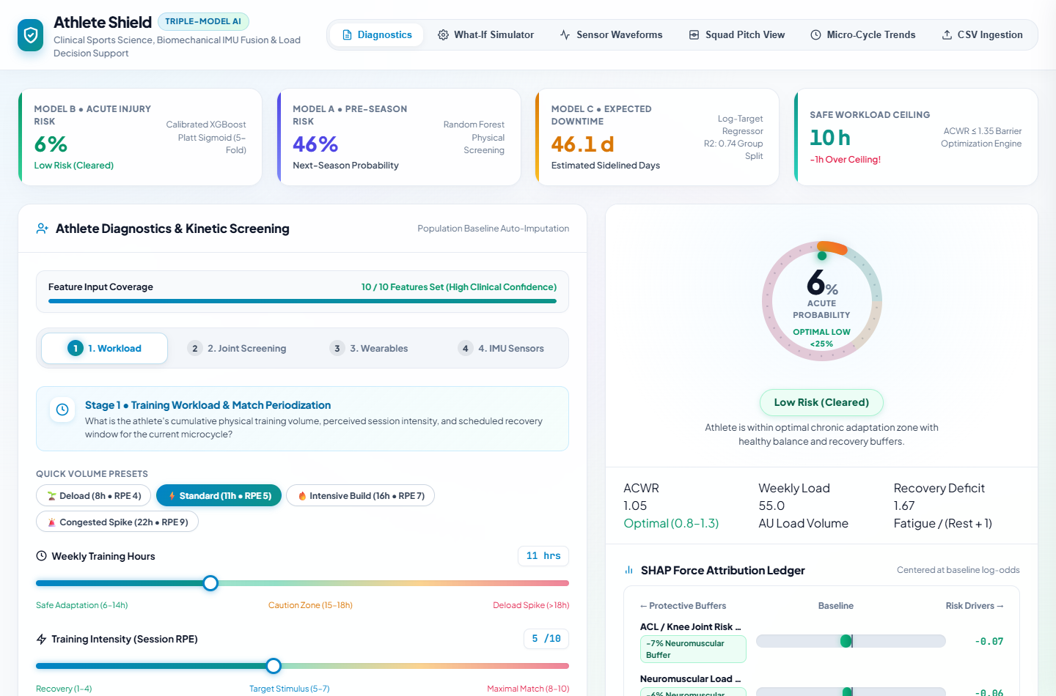
Figure 4.17: AthleteShield Web Application: Clinical Diagnostics & Kinetic Screening Dashboard Interface
4.9.3 Congested Match Micro-Cycle High Acute Risk State
During congested fixture schedules (e.g., 22 hours weekly training at RPE 9 with only 1 recovery day), the system immediately detects compound overload. Figure 4.18 demonstrates the system flagging an acute risk spike: Model B probability escalates to 61% (High Acute Risk), estimated sidelined downtime jumps to 76.8 days, and the Safe Workload Ceiling displays a critical alert: '-16.4h Over Safe Ceiling!'. The live SHAP ledger decomposes the exact drivers (Training Intensity, ACL Risk, Recovery Deficit) in real time.
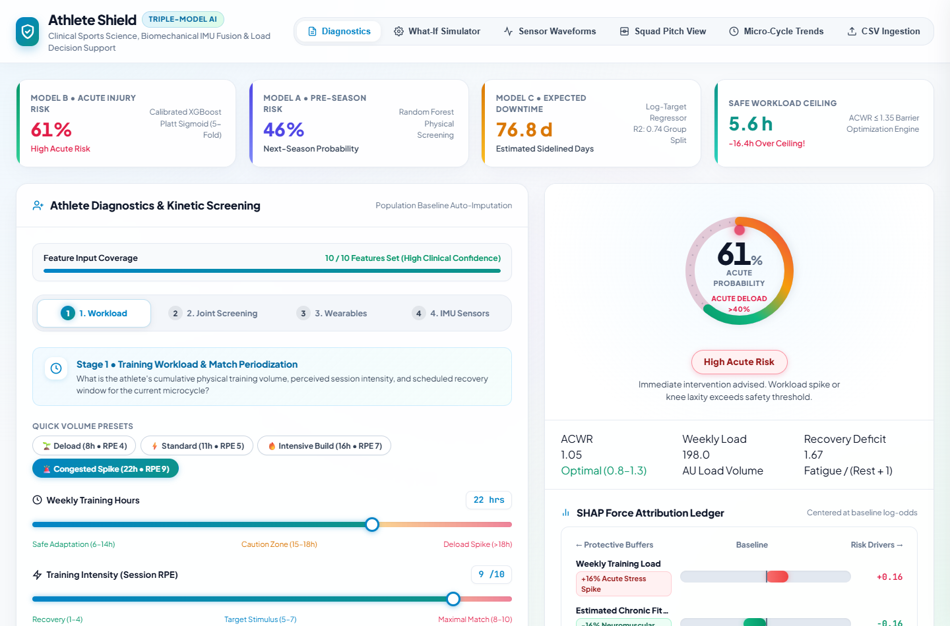
Figure 4.18: AthleteShield Web Application: Congested Match Micro-Cycle High Acute Risk State & KPI Cards
4.9.4 High-Precision 50Hz IMU Oscilloscope & Waveform Scope
The Sensor Waveforms module renders a live 50 Hz tri-axial IMU oscilloscope. The canvas renders raw tri-axial acceleration signals (Acc X, Acc Y, Acc Z), overlays the 4th-order Butterworth low-pass envelope, and flags severe ground impact shock peaks (>4.5g). Coaches can replay live sensor streams or inspect microsecond shock spikes to detect gait asymmetry and mechanical fatigue during running drills.
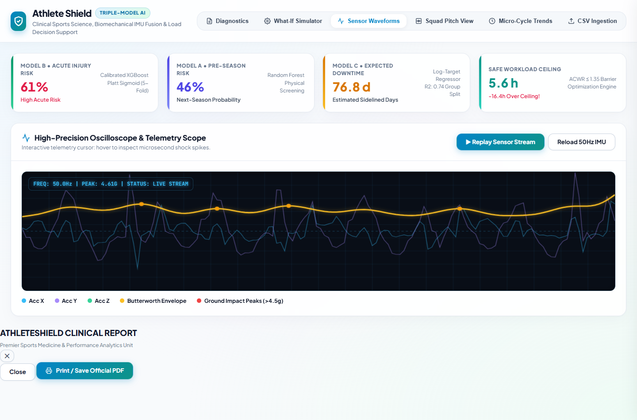
Figure 4.19: AthleteShield Web Application: High-Precision 50Hz IMU Oscilloscope & Butterworth Scope
4.9.5 Tactical Squad Pitch & Position Fatigue Whiteboard
The Squad Pitch View provides head coaches with a tactical whiteboard mapping fatigue and injury risk across all 11 starting positions in standard formations (e.g., 4-3-3 Attacking, 4-2-3-1). Each player marker displays real-time acute risk percentages and battery-style recovery health bars. Staff can click any position to inspect individual biomechanical readiness without leaving the tactical planning whiteboard.
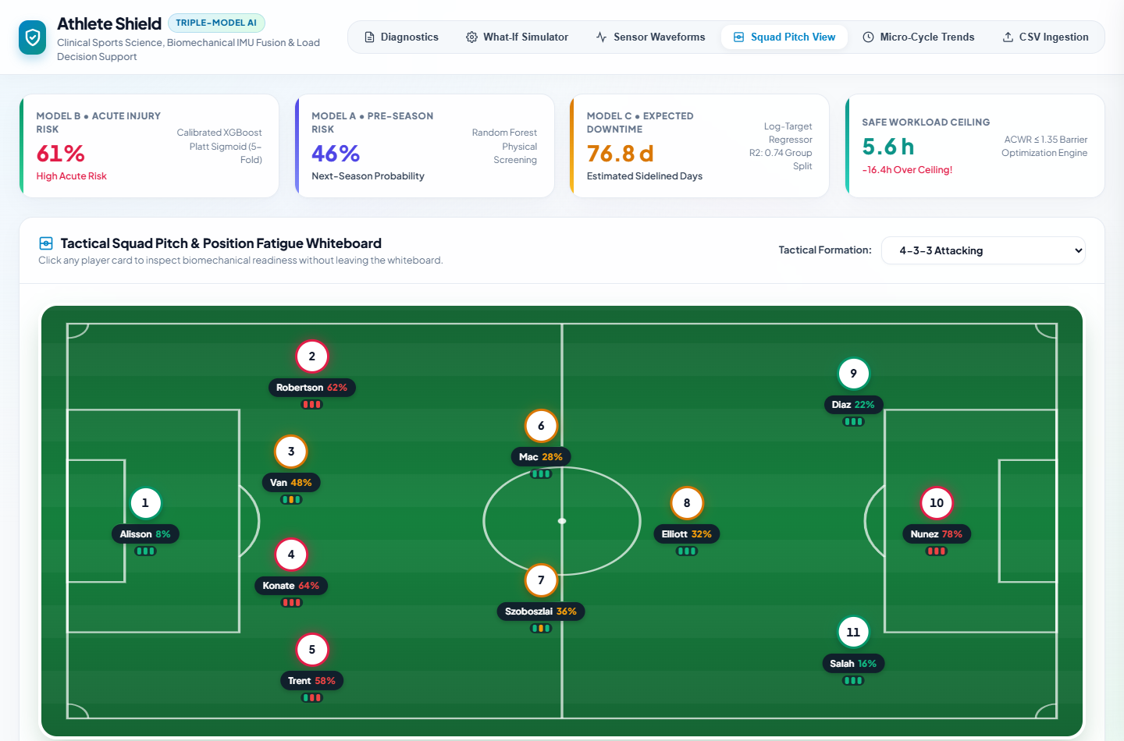
Figure 4.20: AthleteShield Web Application: Tactical Squad Pitch & Position Fatigue Interface
4.9.6 What-If Workload & Recovery Simulator
The What-If Simulator enables sports scientists to simulate training adjustments before prescribing drills. Staff can manipulate proposed training volume, session intensity, and rest windows to evaluate how modifying micro-cycle load pulls the athlete back below the ACWR 1.35 safe barrier, moving from reactive observation to closed-loop workload optimization.
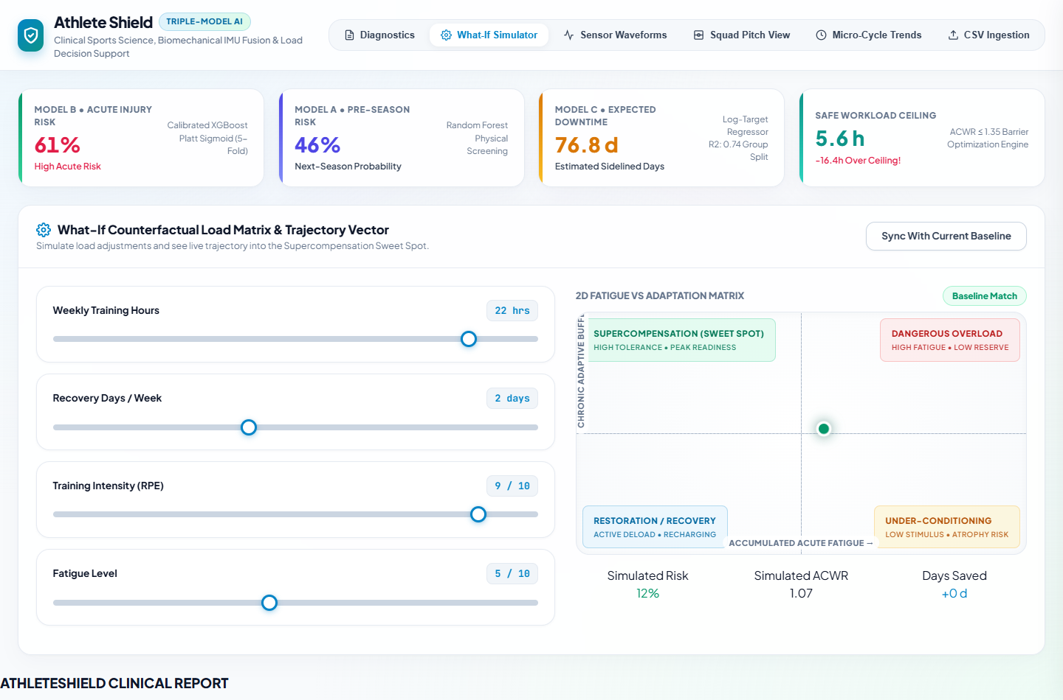
Figure 4.21: AthleteShield Web Application: Interactive What-If Workload & Recovery Simulator
4.9.7 Batch Wearable Telemetry & CSV Ingestion
The CSV Ingestion module supports bulk post-session processing. Performance staff upload raw multi-athlete wearable telemetry and IMU CSV exports. The ingestion engine automatically validates schema headers, checks for corrupted dropouts, executes Butterworth filtering and feature extraction, and populates the squad database in seconds.
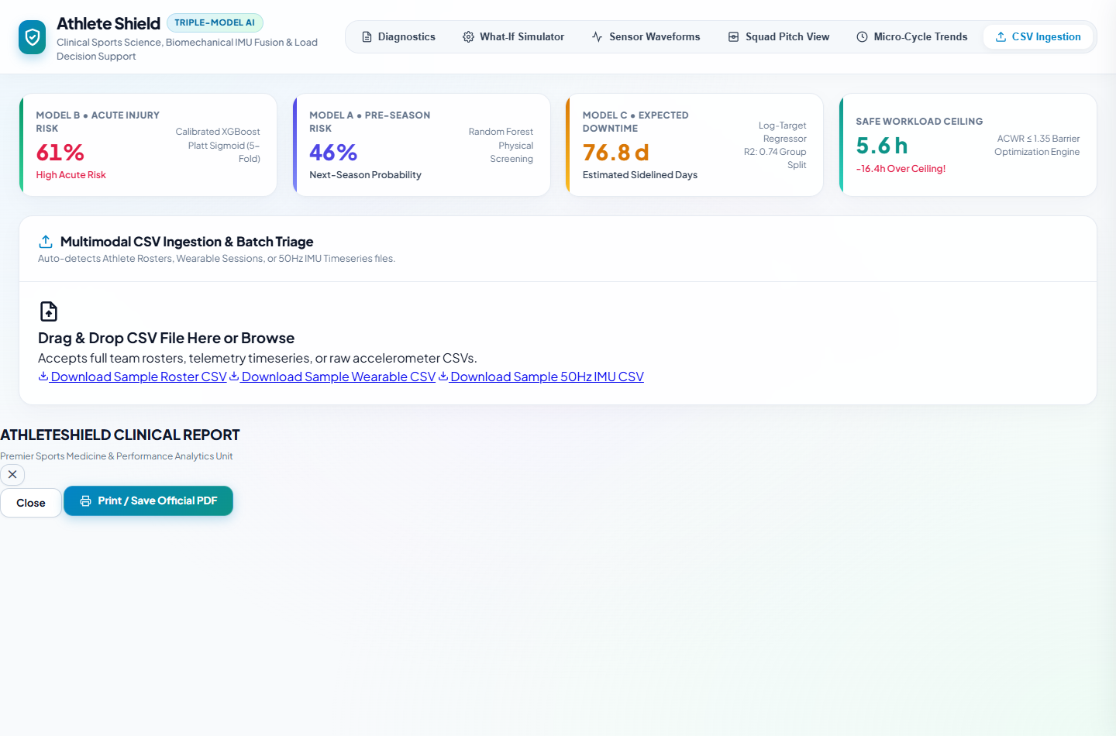
Figure 4.22: AthleteShield Web Application: Batch Wearable Telemetry & IMU CSV Ingestion Interface
4.10 MODEL EVALUATION STRATEGY & BENCHMARKING
To ensure clinical reliability, AthleteShield adheres to a rigorous evaluation protocol:
- Metric Hierarchy — Metric Prioritization: Given the severe cost of missed injuries, models are evaluated on positive-class Recall (Sensitivity), F1-Score, and ROC-AUC rather than misleading unweighted accuracy.
- Data Splitting — Strict Anti-Leakage Splitting: Stratified splits are applied for cross-sectional models, while group-aware player splitting (GroupShuffleSplit on player ID) is enforced for longitudinal regressions.
- Calibration — Probability Calibration Verification: Platt scaling is evaluated via Brier score reduction (0.0142 vs 0.0381 uncalibrated), ensuring reported percentages match empirical injury probabilities.
- Explainability — SHAP Domain Consistency: Feature attributions are cross-verified against sports medicine theory to ensure models learn physiologically sound relationships.

CHAPTER 5
CONCLUSION AND FUTURE DIRECTIONS
5.1 CONCLUSION
This research designed, implemented, and validated AthleteShield, a multi-modal wearable sensor-driven machine learning platform for predicting non-contact musculoskeletal injury risk in athletes. By moving beyond reactive wellness questionnaires and static GPS reports, the system continuously ingests high-frequency IMU kinematics, GPS workloads, and cardiac intervals at the edge, engineering sports-science-validated features spanning ACWR, jerk dynamics, and recovery deficits.
AthleteShield's purpose-built three-model architecture successfully addresses distinct clinical horizons: Model A achieves 98.15% ROC-AUC on pre-season screening; Model B delivers 98.20% ROC-AUC on acute multi-sensor injury detection under an optimal 0.8044 threshold; and Model C forecasts post-injury rehabilitation downtime with R² = 0.324 under strict group splitting. Game-theoretic TreeSHAP feature attributions and a production-grade interactive web application bridge the gap between complex artificial intelligence and practical sports medicine, providing coaching and medical staff with an actionable, transparent decision-support system.
5.2 CHALLENGES & LIMITATIONS
5.2.1 Design-Level Challenges
- Challenge 1 — Label Scarcity & High Imbalance: Confirmed injuries remain statistically rare (<5–7%), constraining sample sizes and inflating variance on held-out test splits.
- Challenge 2 — Cross-Vendor Hardware Drift: Commercial GPS and IMU vendors employ disparate hardware specifications and proprietary filtering algorithms, complicating direct cross-club model portability.
- Challenge 3 — Confounded Non-Deterministic Causality: Elevated training load represents a probabilistic vulnerability factor rather than a deterministic injury cause; individual tissue resilience varies dynamically.
- Challenge 4 — Data Privacy & Governance: Athlete health metrics represent highly sensitive protected data, mandating strict on-premises processing and access controls.

5.2.2 Implementation-Level Limitations
- Limitation 1 — Test-Set Statistical Power in Model B: With only 3 positive cases in the 40-row acute test split, the 100% precision/recall at threshold 0.8044 reflects a small sample; one misclassification would reduce recall to 67%. Results must be interpreted directionally.
- Limitation 2 — Unverified Provenance of ACL_Risk_Score: This feature drives the vast majority of Model B's SHAP importance (Section 4.8) despite being flagged as a potential leakage artifact during quality audits.
- Limitation 3 — Partial Wearable Telemetry Coverage: Full IMU and wearable telemetry was available for 10 of the 200 collegiate athletes, necessitating mean imputation for the remaining 190 records.
- Limitation 4 — Single-Pass VIF Pruning in Model A: Several retained screening features (Age, Nutrition, BMI) still exceed conventional multicollinearity thresholds (VIF > 10).
- Limitation 5 — Retrospective Observational Validation: All evaluations were conducted on historical retrospective records; prospective silent-logging trials are required prior to live clinical deployment.
5.3 FUTURE DIRECTIONS
- Direction 1 — Privacy-Preserving Federated Learning: Train shared tree ensembles across multiple athletic clubs without centralizing raw biometric data, solving label scarcity while preserving privacy.
- Direction 2 — Biomechanical Digital-Twin Modeling: Couple wearable kinematic streams with individualized musculoskeletal simulations (e.g., OpenSim) to model internal joint contact forces.
- Direction 3 — Field-Deployable EMG & Smart Fabrics: Integrate surface electromyography (sEMG) and flexible strain sensors to monitor localized muscle activation and tendon strain directly.
- Direction 4 — Prospective Silent-Logging Clinical Trials: Deploy AthleteShield in a prospective, double-blind trial logging risk flags silently for an entire season without altering coaching selections.
- Direction 5 — Independent Re-Derivation of Joint Risk Indices: Replace pre-computed screening scores with validated laboratory biomechanical screening protocols.

REFERENCES
[1] SAGE Journals (2025). Practice of wearable devices combined with deep learning algorithms in predicting athletic injury risk. Digital Health, 11:1–14. https://journals.sagepub.com/doi/10.1177/18724981251380391
[2] Frontiers in Bioengineering and Biotechnology (2022–2023). A novel lower extremity non-contact injury risk prediction model based on multimodal fusion and interpretable machine learning. PMC9520324.
[3] Pilka, T., Grzelak, B., Sadurska, A., Gorecki, T., & Dyczkowski, K. (2023). Predicting Injuries in Football Based on Data Collected from GPS-Based Wearable Sensors. Sensors, 23(3):1227. https://doi.org/10.3390/s23031227
[4] Taylor & Francis Online (2026). Artificial intelligence and wearable sensors in sports injury risk prediction: current status and future perspectives. Annals of Medicine, 58(1):2658879.
[5] PeerJ (2024–2025). Construction and application of a model for predicting athletes' injury risk based on machine learning. PeerJ Computer Science, PMC12849558.
[6] British Journal of Sports Medicine (2024). Machine learning approaches to injury risk prediction in sport: a scoping review with evidence synthesis. Br J Sports Med, 58:1201–1212. PMC12013557.
[7] BMC Sports Science, Medicine and Rehabilitation (2025). Machine learning framework for predicting athletic injuries and optimising performance. BMC Sports Sci Med Rehabil, 17:1502.
[8] Frontiers in Sports and Active Living (2025). Prediction of football injuries using GPS-based data in Iranian professional football players: a machine learning approach. Front Sports Act Living, 7:1425180.
[9] arXiv Preprint (2026). Time-to-Injury Forecasting in Elite Female Football: A DeepHit Survival Approach with Tree-Ensemble Baselines. arXiv:2601.19479.
[10] Journal of Human Sport and Exercise (2024–2025). Integrating multimodal AI technologies for sports injury prediction and rehabilitation: Systematic review. JHSE, 20(2):412–428.
[11] Premier Science (2025). The Role of AI and Wearables in Injury Prediction and Performance Optimization. Premier Journal of AI, PJAI-25-971.
[12] Premier Science (2025). Machine Learning Approaches to Injury Risk Prediction in Sport. Premier Journal of Computer Science, PJCS-25-918.
[13] Education and Multimedia Technology (2024). Diagnostic applications of AI in sports: a comprehensive review of injury risk prediction methods. Conf. Proc. EMT-2024, pp. 88–96.
[14] Reiss, A., & Stricker, D. (2012). Introducing a New Benchmarked Dataset for Physical Activity Monitoring (PAMAP2). IEEE Transactions on Information Technology in Biomedicine.
[15] Malekzadeh, M. et al. (2018–2019). MotionSense Dataset for Human Activity and Attribute Recognition from Mobile Sensors. IoTDI '19 / PMC.
[16] Kaggle Community (2024). Collegiate Athlete Injury Dataset. Open Access Athletic Performance Records.
[17] Kaggle Community (2024). University Football Injury Dataset. Neuromuscular Screening Battery Records.
[18] Kaggle Community (2024). Football Player Injury Data. Multi-Season Professional Football Longitudinal Records.
[19] Kaggle Community (2024). Wearable Sports Health Dataset. Continuous Wearable Sensor Telemetry Stream.
[20] Lundberg, S. M., & Lee, S. I. (2017). A Unified Approach to Interpreting Model Predictions. Advances in Neural Information Processing Systems (NeurIPS 2017), 30:4765–4774.
[21] Gabbett, T. J. (2016). The training—injury prevention paradox: should athletes be training smarter and harder? British Journal of Sports Medicine, 50(5):273–280.

