# WORKING OF THE SYSTEM

# CIRCUIT DIAGRAM

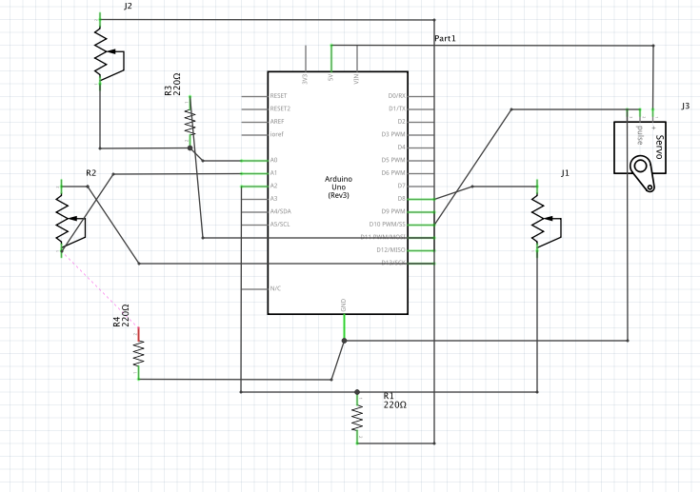

Figure 1: Circuit diagram of the system

# METHODOLOGY

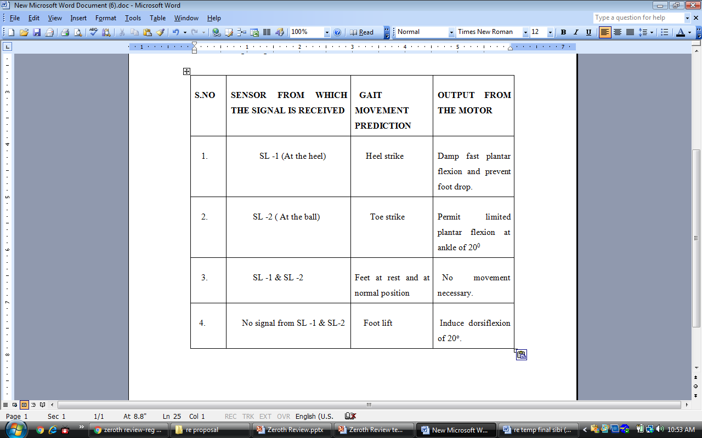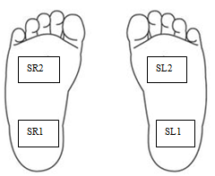

Figure 2: Methodology

# 5.3 ALGORITHM/ FLOWCHART

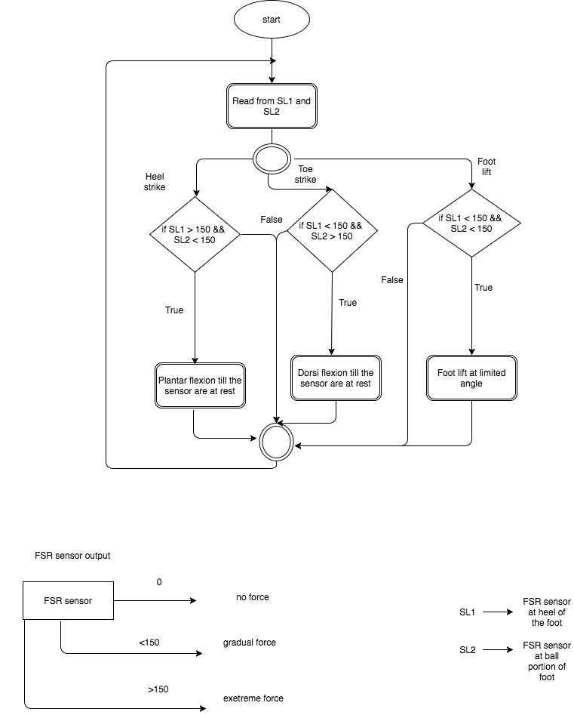

Figure 3: Algorithm Design

# SYSTEM DESIGN

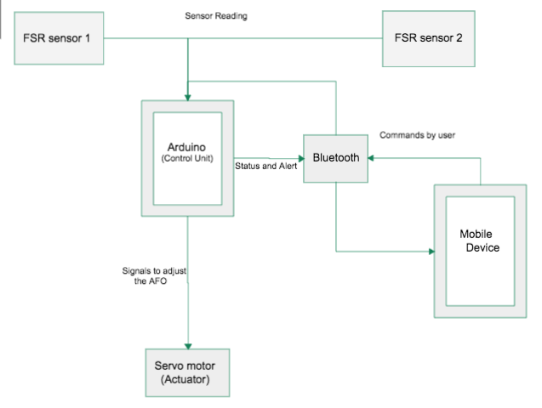

Figure 4: AFO System Design