**Project Report: Java-Based Quiz Application (QuizApp)**

**1. Introduction**

The **QuizApp** is a **Java-based quiz application** built using **JFrame** for the graphical user interface and **MySQL** as the backend database. The project is hosted on two separate **VirtualBox Virtual Machines (VMs)** for **application logic** and **database management**. The application enables users to take quizzes, track scores, and manage quiz questions through an admin panel.

**2. System Requirements**

* **VirtualBox** (For VM creation and networking)
* **Debian Linux (or any Linux distribution)** for VMs
* **Java Development Kit (JDK 11 or later)**
* **MySQL Server (MariaDB)**
* **Visual Studio Code or IntelliJ IDEA**
* **MySQL Workbench (Optional for database management)**

**3. Installation of VirtualBox and Creation of VMs**

**Step 1: Install VirtualBox**

1. Download VirtualBox from [VirtualBox Official Site](https://www.virtualbox.org/)
2. Install it on system following the on-screen instructions.

**Step 2: Create Virtual Machines**

1. Open **VirtualBox** and click **New**.
2. Name the VM as **Debian-1 (Application Server)** and select:
   * **Type:** Linux
   * **Version:** Debian (64-bit)
   * **Memory Size:** 2GB or more
   * **Storage:** Create a 20GB Virtual Hard Disk (VDI)
3. Repeat the same for **Debian-2 (Database Server)**.

**4. Network Configuration to Connect VMs**

**Step 1: Configure Internal Network**

1. Select **VM1 (QuizApp-Application Server)** → Go to **Settings** → **Network**.
2. Set **Adapter 1** to **Internal Network**.
3. Repeat the process for **VM2 (QuizApp-Database Server)**.

**Step 2: Assign Static IPs**

Modify network configurations in both VMs:

sudo nano /etc/network/interfaces

For **VM1**:

auto eth0

iface eth0 inet static

address 192.168.1.101

netmask 255.255.255.0

gateway 192.168.1.1

For **VM2**:

auto eth0

iface eth0 inet static

address 192.168.1.102

netmask 255.255.255.0

gateway 192.168.1.1

Restart networking:

sudo systemctl restart networking

**5. Deployment of QuizApp on VMs**

**Step 1: Install Dependencies on VM1 (Application Server)**

sudo apt update

sudo apt install default-jdk -y

Download and configure **MySQL Connector for Java**:

wget https://repo1.maven.org/maven2/mysql/mysql-connector-java/8.0.28/mysql-connector-java-8.0.28.jar

**Step 2: Install MySQL on VM2 (Database Server)**

sudo apt update

sudo apt install mysql-server -y

Configure MySQL for remote access:

sudo nano /etc/mysql/mysql.conf.d/mysqld.cnf

Change:

bind-address = 0.0.0.0

Restart MySQL:

sudo systemctl restart mysql

Grant privileges:

GRANT ALL PRIVILEGES ON quiz_app.* TO 'root'@'169.254.108.37' IDENTIFIED BY 'password';

FLUSH PRIVILEGES;

**6. QuizApp Folder Structure**

The application follows **MVC (Model-View-Controller) architecture**.

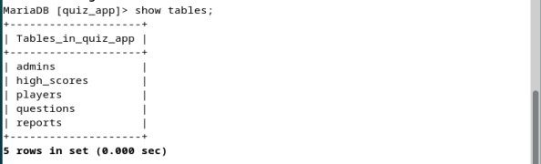

**7. Running the Application**

**Step 1: Start MySQL on VM2**

mysql -u root -p

**Step 2: Compile and Run the Application on VM1**

javac -cp .:mysql-connector-java-8.0.28.jar src/App.java

java -cp .:mysql-connector-java-8.0.28.jar App

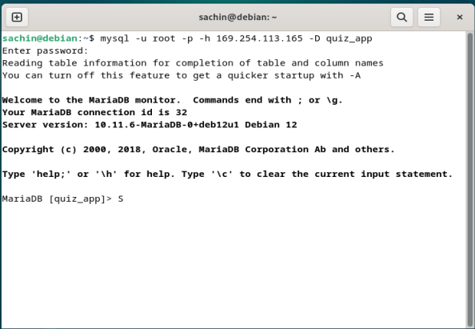

**8. Key Features & Functionality**

* **User Login & Registration** (PlayerDAO, PlayerController)
* **Quiz Management** (QuestionDAO, QuizController)
* **Admin Dashboard** (AdminController, Add/Delete Questions)
* **Score Reports & Leaderboard** (ReportDAO, HighScoreDAO)
* **Secure Password Hashing** (PasswordUtils.java)

**9. Challenges Faced & Solutions**

**Issue: MySQL Connection Refused**

* Fixed by updating bind-address = 0.0.0.0.
* Opened **port 3306** in the firewall.

sudo ufw allow 3306/tcp

sudo ufw reload

**Issue: Network Issues Between VMs**

* Ensured both VMs were on the same **Internal Network**.
* Assigned **static IP addresses** to both VMs.

**10. Conclusion**

The **QuizApp** successfully demonstrates a **distributed system setup**, integrating a **Java application with a remote database** hosted on separate VirtualBox VMs.

**11. References**

1. Java JDBC Documentation (<https://docs.oracle.com/javase/tutorial/jdbc/basics/index.html>)
2. VirtualBox Networking Guide (<https://www.virtualbox.org/manual/ch06.html>)
3. MySQL Administration Guide (<https://dev.mysql.com/doc/refman/8.4/en/tutorial.html>)

**Appendix**

1. **Video Presentation Link :**

<https://drive.google.com/file/d/1zVjpoStiEZXm7My8wdX0YmkPxeaGuu8x/view?usp=sharing>

1. **PPT Link:**

<https://docs.google.com/presentation/d/1CCbHlrMiOCFHyNH0o5fRjLY6gZT1ACGF/edit?usp=drive_link&ouid=110909031381492795570&rtpof=true&sd=true>

1. **System Architecture Diagram:**

<https://drive.google.com/file/d/1pfjKadke4axnqI3tp-6ZwTUfVyrNsg0w/view?usp=drive_link>

1. **GitHub Repository Link:**

<https://github.com/sachinsingh2156/Java-based-quiz-app-Using-virtualization.git>