Sleep Monitoring System
Priyanka Kumari¹, Sachin Singh², Aayushma Thapa², Manish Yadav⁴ and Prof. Santhosh S⁵
Faculty of Engineering and Technology, Jain (Deemed – to – be University), Bengaluru, Karnataka, 562112, India
¹20btrco072@jainuniversity.ac.in, ²20btrcs170@jainuniversity.ac.in, ³20btrse072@jainuniversity.ac.in, ⁴20btrse037@jainuniversity.ac.in, ⁵s.santhosh@jainuniversity.ac.in
Abstract. In the realm of personal health and medical diagnostics, sleep monitoring systems have emerged as pivotal tools. This review provides a comprehensive examination of contemporary sleep monitoring technologies, delineating their evolution, functionalities, and applications. It commences with a brief overview of the importance of sleep monitoring in healthcare and personal wellness, followed by a detailed analysis of various types of sleep monitoring systems, including wearable devices, non-wearable technologies, and mobile applications. The report delves into the comparative effectiveness and accuracy of these systems, highlighting technological advancements and user experiences. A critical evaluation of the strengths, limitations, and user feedback of current systems reveals significant insights into their practicality and reliability. Additionally, the review explores the burgeoning developments in this field, particularly the integration of artificial intelligence and machine learning, which promises enhanced precision and user engagement. This report not only serves as a valuable resource for understanding current trends and challenges in sleep monitoring but also provides a vision for future research directions. It aims to assist healthcare professionals, researchers, and technology developers in comprehending the potential and limitations of existing systems, thereby fostering innovation in the development of more sophisticated and user-friendly sleep monitoring solutions.
Keywords: First Keyword, Second Keyword, Third Keyword.
- Introduction
In recent years, the importance of sleep in maintaining overall health and well-being has gained substantial recognition, prompting a surge in the development and utilization of sleep monitoring systems. Sleep, a vital physiological process, plays a critical role in cognitive function, emotional regulation, and physical health. Disruptions in sleep patterns have been linked to a wide array of health issues, ranging from chronic diseases to impaired cognitive functions. Consequently, the accurate monitoring of sleep patterns has become a critical component in both clinical settings and personal health management.
The advent of sleep monitoring systems signifies a remarkable evolution in healthcare technology, offering individuals and healthcare professionals unprecedented insights into sleep patterns and quality. These systems, varying from sophisticated wearable devices to non-invasive home-based setups, leverage an array of sensors and algorithms to track various sleep parameters such as duration, stages, and quality of sleep. With the escalating prevalence of sleep disorders and growing public interest in health and wellness, these systems have become more than mere gadgets; they are now essential tools in preventive healthcare and personalized medicine.
This review report aims to provide an in-depth analysis of the current landscape of sleep monitoring systems. It encompasses a detailed examination of the technologies employed, their effectiveness, user experiences, and their applications in both clinical and personal contexts. By scrutinizing the latest advancements and identifying existing gaps in technology and application, the report seeks to offer a comprehensive perspective on the state of sleep monitoring technologies. It also aims to shed light on the future potential of these systems, considering the ongoing technological innovations and the increasing awareness of the importance of sleep health.
In navigating through the realms of technology, health, and personal wellness, this review stands as a testament to the intricate relationship between technological advancement and healthcare, and its profound impact on improving the quality of life.

- Related Work
There are four categories, in which we can classify modern sleep monitoring technologies, currently under study.
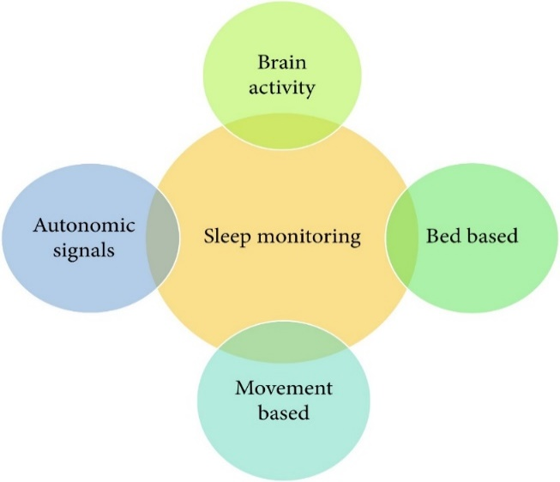
Fig. 1. Categories of Modern Sleep Monitoring Technologies.
Modern sleep monitoring tools practice diverse sensing technologies. These sensors can also be used for sleep staging. We do not cover sleep stages in the proposed system. PSG (polysomnography) is a type of sleep observing technology, which measures physiological factors such as breathing, temperature, muscle fluctuation, and oxygen saturation (SPO2). With the help of this technology, researchers can classify sleep-onset and wake-up time. A device has been attached to the wrist of the patient during his sleep to analyze the physical parameters or changes. It is investigated that there is a solid relationship between wrist movement and the sleep status of the user. In another method, there is the use of audio-video recording together with a Passive Infrared (PIR) sensor to detect the patient’s sleep status.
The current study shows an ambient sleep observation method using sensors that are installed in homes. This study comprises of PIR sensors for motion detection, interaction sensors, which are connected to windows and doors, environment temperature monitors to measure the temperature of a room, and some other devices, which can detect heat and energy.
  - Existing Work
Several devices are also available which are currently used for sleep evaluation at home as shown in Table. Many of these are accessible in the market for purchase. The following table shows the comparison between various sleep monitoring devices where REM (rapid eye movement) and NREM (nonrapid eye movement) are sleep stages.
Table 1. Various Sleep Monitoring System Accuracy.
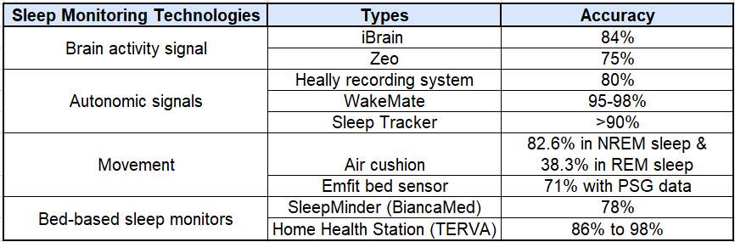
The iBrain encompasses the headband, which registers solo front lead EEG signals. Zeo is another device that comprises the headband of plastic and cloth material placed on the forehead, which measures electroencephalogram (EEG), electromyography muscle electromyogram (EMG), and electrooculogram (EOG) signals, where these signals are transferred to mobile phone through Wi-Fi or bluetooth. The Heally system encloses embedded sensors within a shirt, which are used to calculate the respiratory and cardiac movement of the patient. The SleepTracker is another device fixed to a watch. This wristwatch captures human activity during sleep. WakeMate consists of a band, which is worn on the wrist of the patient. This band sends actigraphy information to a mobile phone. This information consists of total sleep duration, how many times the patient is awake during sleep and “sleep quality” information based on physical activity. Air cushion consists of an air-filled beanbag, which can calculate several ambient and physical parameters. Emfit Bed Sensor consists of Emfit foil electrodes, which locates under a mattress to calculate parameters like respiration, heart rate, and body movement.
Nowadays, mobile devices are commonly used in everyday routine, which also provides several apps to monitor the sleep of patients. A system called ubiquitous architecture uses heart rate signals, sound signals, and accelerometer data for sleep monitoring. This idea works combining with the monitoring system through a smartwatch or smartphone. It also suggests an innovative and intelligent algorithm for the signal organization.
Even though, the abovementioned methods and tools have their benefits for analyzing patient’s sleep. There are many drawbacks as well. Most of them are not grounded on the IoT and machine learning. The IoT model consists of many sensing devices, data transfer protocols, and cloud computing tools, which is trending and emerging nowadays. Data processing is performed on devices like mobile devices, which requires a lot of energy that is why such models can only be feasible for a little time.

- Limitation of Existing Systems
The existing systems are more focused on providing assistance to the user in monitoring the sleep and guiding the user to get relaxed while sleeping using various attachments. The inventions do not focus on monitors the real time health related parameters of the user while they take nap and do not provide the user with favorable ambient conditions and no means to determine their real time location at the time of nap.
In order to overcome the aforementioned drawbacks, here the proposed device will allow the user to take a nap from busy schedules and prevent the user from getting stressed and monitors the real time health related parameters of the user while they take nap along with locating the user while they are having the nap. It will also recommend the time to take nap based on the busy schedule of a person. It will monitor the sleeping activity and duration of a person and help them to provide information about their sleep activity and will also advise them how they can improve it

Sample Heading (Third Level). Only two levels of headings should be numbered. Lower level headings remain unnumbered; they are formatted as run-in headings.

Sample Heading (Forth Level). The contribution should contain no more than four levels of headings. The following Table 1 gives a summary of all heading levels.
Table 2. Table captions should be placed above the tables.
Heading level | Example | Font size and style
Title (centered) | Lecture Notes | 14 point, bold
1st-level heading | 1 Introduction | 12 point, bold
2nd-level heading | 2.1 Printing Area | 10 point, bold
3rd-level heading | Run-in Heading in Bold. Text follows | 10 point, bold
4th-level heading | Lowest Level Heading. Text follows | 10 point, italic
Displayed equations are centered and set on a separate line.
x + y = z (1)
Please try to avoid rasterized images for line-art diagrams and schemas. Whenever possible, use vector graphics instead (see Fig. 1).

Fig. 2. A figure caption is always placed below the illustration. Short captions are centered, while long ones are justified. The macro button chooses the correct format automatically.
For citations of references, we prefer the use of square brackets and consecutive numbers. Citations using labels or the author/year convention are also acceptable. The following bibliography provides a sample reference list with entries for journal articles [1], an LNCS chapter [2], a book [3], proceedings without editors [4], as well as a URL [5].

References
- Author, F.: Article title. Journal 2(5), 99–110 (2016).
- Author, F., Author, S.: Title of a proceedings paper. In: Editor, F., Editor, S. (eds.) CONFERENCE 2016, LNCS, vol. 9999, pp. 1–13. Springer, Heidelberg (2016).
- Author, F., Author, S., Author, T.: Book title. 2nd edn. Publisher, Location (1999).
- Author, F.: Contribution title. In: 9th International Proceedings on Proceedings, pp. 1–2. Publisher, Location (2010).
- LNCS Homepage, http://www.springer.com/lncs, last accessed 2016/11/21.

