Smart Sleep Monitoring System Using Machine Learning
Sachin Singh¹, Manish Yadav ², Priyanka Kumari ³, Aayushma Thapa⁴, Samyak Maharjan⁵, Preeti Kurmi⁶, and Prof. Santhosh S⁷
¹ Department of Computer Engineering (Software Engineering), Jain (Deemed-to-be University), Kanakapura Road, Jakkasandra, 562112, INDIA
sachinsingh2156@gmail.com, ymanish0428@gmail.com, poddarpriyanka06@gmail.com, aayushmathapa392@gmail.com, samyakmaharjan3@gmail.com, preetikurmi12345@gmail.com, s.santhosh@jainuniversity.ac.in
Abstract. Sleep is a crucial component of overall human health, and many people struggle to get enough high-quality sleep. To help individuals improve their sleep quality, we propose a sleep monitoring system that uses a smartwatch and machine learning algorithms. This system gathers data on different elements related to sleep such as duration, quality, and physiological factors, which are analyzed using Naive Bayes machine learning algorithms to provide personalized insights and recommendations for improving sleep. These recommendations could include adjustments to sleep schedules, changes to sleep hygiene practices, or dietary changes that can improve sleep. By providing personalized recommendations tailored to each individual's unique sleep patterns and physiological factors, this system has the potential to be a powerful tool for improving sleep quality and overall health. With the increasing popularity of wearable technology and the growing demand for personalized health solutions, a sleep monitoring system that uses a smartwatch and machine learning algorithms could be a valuable tool for improving sleep quality and overall well-being.
Keywords: User, Systems, Data, Sleep, Sensor, Algorithm, physical movement, stress, nap.
- Introduction
In the contemporary era, the quest for quality sleep is increasingly challenged by factors such as technological distractions and lifestyle-induced stress, impacting overall health and contributing to diseases like obesity, diabetes, and cardiovascular issues. Addressing this, our research introduces a smartwatch-based sleep monitoring system, leveraging machine learning to analyze sleep duration, quality, and physiological signals. This non-intrusive, user-friendly system offers personalized insights and recommendations aimed at enhancing sleep quality, from adjusting sleep schedules to dietary modifications.

Central to our proposition is the machine learning algorithm's ability to detect complex patterns within sleep data, facilitating bespoke advice that grows more accurate as more data is gathered. This approach not only tailors to individual needs, considering the diverse factors affecting sleep but also promises ease of adoption given its simplicity and non-intrusiveness.
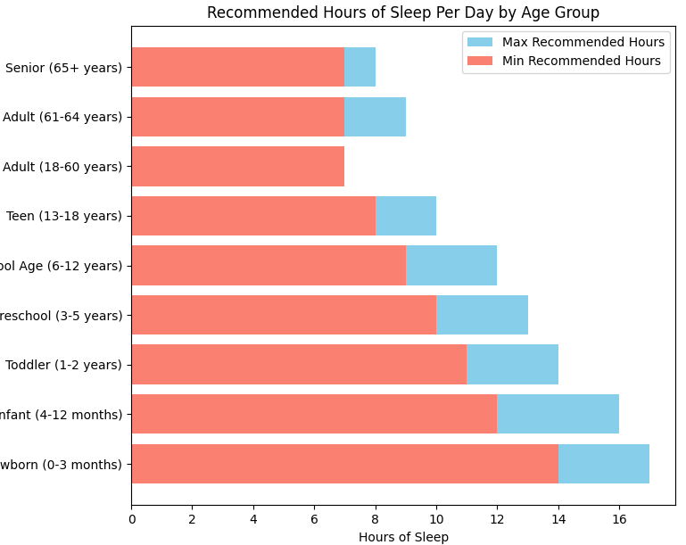
Fig. 1. Amount of sleep needed according to CDC.
Our system aligns with CDC-recommended sleep durations across various age groups, as illustrated in an accompanying graph.[1] By offering data-driven, personalized sleep improvement strategies, we present a novel solution to the pervasive issue of poor sleep quality, promising a pathway to better health and well-being.
An effective tool for people wishing to enhance their sleep quality and general well-being is a sleep monitoring system that makes use of a smartwatch and machine learning algorithms. The suggested sleep monitoring system can help people attain better sleep quality and enhance their general health and well-being in light of the rising prevalence of sleep-related problems and the growing need for personalized health solutions.
- Problem Definition
In addressing the significant health issue of inadequate sleep, which affects a considerable portion of the population and can lead to serious physical and mental health problems such as obesity, diabetes, hypertension, depression, and anxiety, it is crucial to acknowledge the varying impact on different socioeconomic groups. As illustrated in Figure 2, insomnia prevalently affects people from diverse socioeconomic backgrounds in distinct ways.[2] For instance, individuals with basic schooling or those unemployed show higher instances of insomnia compared to other groups. Such disparities highlight the need for a tailored approach to sleep improvement.
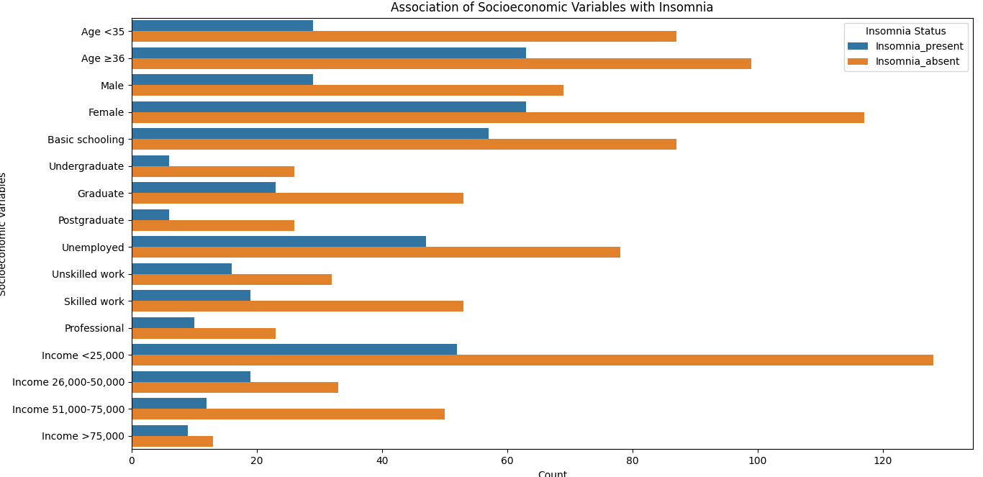
Fig. 2. People of different socioeconomic group suffering from insomnia
The proposed solution is a sleep monitoring system that leverages a smartwatch to collect data on a user's sleep patterns and machine learning algorithms to analyze this data, providing personalized insights and recommendations. The system aims to track various sleep metrics, including REM sleep, sleep duration, and quality, to generate a comprehensive sleep score. With an analysis of the sleep score, the system will furnish users with an understanding of their sleep patterns, such as their tendencies to wake up, the frequency of nocturnal awakenings, and the quantity of deep and REM sleep obtained.
Taking into account the diverse socioeconomic impacts demonstrated in the aforementioned graph, the system will deliver customized advice for sleep enhancement based on the user's unique data. This may include modifications to their sleep schedule or lifestyle adjustments aimed at augmenting sleep quality. By integrating personalized sleep tracking with the nuanced understanding of how insomnia affects different socioeconomic groups, this system offers a targeted strategy to combat the widespread issue of inadequate sleep.
- Literature Survey
Sleeping disorder refers to when the user is unable to sleep their normal hours which builds up stress and subsequently has a drastic effect on user’s health. Some of the drastic effects of sleeping disorders are depression and in severe cases the sleeping disorder sometimes leads to unconditional heart which makes it quite vital and important for the user to have subsequent hours of sleep. In the busy and hectic world, it’s quite normal to get stressed but the nap in between work enables better mind freshness and subsequently provides enhanced work focus. Several inventions have been developed which allow the user to get themselves relaxed at the workplace.
In the paper “Sleep monitoring systems: Current status and future challenges” The authors draw attention to the shortcomings of current monitoring techniques like actigraphy and polysomnography in terms of accuracy and usefulness in daily life.[3] The lack of uniformity among various sleep monitoring technologies makes it challenging to compare the findings of different studies. When it comes to privacy and data security, there are ethical issues with the gathering and use of sleep data. In or-der to address the difficulties associated with sleep monitoring, the paper suggests some potential solutions, such as the creation of new monitoring technologies, the standardization of measurement procedures, increased cooperation between experts in various fields, and more study to determine the connection between sleep and health.
The article "A Real-Time Sleep Monitoring System with a Smartphone" describes a real-time sleep monitoring system that uses a smartphone's sensors and machine learning algorithms to track sleep patterns and stages. The system aims to address the shortcomings of existing sleep monitoring technology by providing a more workable and accessible solution. The study describes the challenges involved in developing a reliable and accurate sleep monitoring system, as well as the approach taken to overcome these challenges. The suggested approach was employed by a small test group of subjects, and the findings showed that it functioned brilliantly in identifying sleep stages and metrics linked to sleep quality. [4]
This research does a literature analysis on the use of the Internet of Things (IoT) for monitoring sleep quality in "Internet of Things for Sleep Quality Monitoring System: A Survey". The goal of the study is to outline the present trends, issues, and potential directions for further academic endeavors in this area. The study discusses a wide array of subjects including sensor technology, data analytics, privacy and security concerns, and IoT-based sleep quality monitoring. The project intends to identify potential areas for IoT-based sleep monitoring research in the future and to provide insights into the challenges and potential of such systems. The authors proposed combining many sensors with data analytics techniques to improve the precision. [5]
The objective of the study, described in the publication "Development of a sleep monitoring system with wearable vital sensor for home use," is the development of a wearable sleep monitoring system. The study's main concern is the absence of affordable, dependable sleep monitoring equipment that can be used at home to improve sleep and spot sleeping disorders. To assess sleep quality and identify sleeping disorders, the proposed system analyses the data. It achieves this by measuring vital signals including heart rate, breathing rate, and bodily movement with a wearable sensor. The study also examines and offers remedies for the difficulties in developing a wearable sleep monitoring system. [6]
An air-mattress with a balancing tube method is used in the study "Nonconstrained Sleep Monitoring System and Algorithms Using Air-Mattress with Balancing Tube Method" to provide a non-invasive method of monitoring sleep patterns. The system collects and processes data on different factors, such as heart rate, rate of respiration, movements, and sleep stages, using non-invasive sensors and sophisticated algorithms. The system is a dependable and efficient instrument for sleep monitoring since it offers insightful information on the quality of sleep and potential problems. In comparison to polysomnography (PSG), which is regarded as the standard for sleep monitoring, the study undertaken to assess the accuracy of the system demonstrates high accuracy in recognizing sleep stages.[7]
The study "Development and Preliminary Validation of Heart Rate and Breathing Rate Detection Using a Passive, Ballistocardiograph-Based Sleep Monitoring System" describes the development of a passive, ballistocardiograph-based sleep monitoring system that can track the rate of heartbeat and breathing during sleep. A pressure sensitive pad positioned beneath the mattress is used by the system to find ballistocardiograph (BCG) signals, which are produced by the body's movements while you sleep. Advanced algorithms are used to process the BCG signals in order to detect heart rate and breathing rate, which provides important data on the user's sleep patterns. The system is a reliable and efficient tool for sleep monitoring because the study used to confirm its accuracy reveals that it has a high accuracy in detecting heart rate and breathing rate when compared to polysomnography (PSG).[8]
A long-term sleep monitoring system that can measure parameters using an un-constrained technique is presented in the publication "Long-term Sleep Monitoring System and Long-term Sleep Parameters using Unconstrained Method" by Jeyhun Shin, Young Joon Chee, and Kiangsu Park. It demonstrates a long-term sleep monitoring system that measures several aspects of sleep using an unrestricted technique. The system utilizes a bed-based sensor system that can detect body movements, respiratory signals, and heart rate to calculate sleep stages, sleep efficiency, and other sleep parameters. The study shows that the system can accurately measure sleep parameters over long periods of time, making it a valuable tool for monitoring sleep disorders and evaluating the effectiveness of treatments. Overall, the system provides valuable insights into sleep patterns and potential sleep disorders while maintaining user comfort and ease of use.[9]
A study comparing the accuracy of sleep-tracking technology with polysomnography in teenagers is presented in the article "Validation of Sleep-Tracking Technology Compared with Polysomnography in Adolescents" by Massimiliano de Zambotti, Fiona C. Baker, and Ian M. Colrain. In this study, the accuracy of the widely used Fitbit Charge HR sleep tracker was compared to that of teenage polysomnography. The 25 individuals in the study discovered that, when compared to polysomnography, Fitbit significantly overestimated the total time slept, sleep start latency, and waking after sleep onset. The study emphasizes the value of exercising caution when utilizing sleep-tracking technology for clinical or research reasons and contends that additional study is required to increase the devices' accuracy. In conclusion, the article offers insightful information about the limitations of tracking technologies and [10]
Zilu Liang and Bernd Plunderer’s paper "Sleep tracking in the real world: a qualitative study into barriers for improving sleep" gives a qualitative study on the challenge-es associated with using sleep-tracking technology to improve sleep. The article offers a qualitative investigation of the challenges to using sleep-tracking technologies to improve sleep. The study involved 12 participants who used a sleep-tracking device, and the results showed that accuracy and reliability of the device were significant concerns for the participants. Additionally, participants reported that the sleep data provided by the devices did not necessarily lead to changes in behavior or better sleep quality. The paper highlights the importance of considering user experience and motivation when designing sleep-tracking technology and the need for further research to improve the usability and effectiveness of such devices. [11]
The paper "Pajama’s, Polysomnography and Professional Athletes: The Role of Sleep Tracking Technology in Sport" by Driller et al. discusses the use of sleep tracking technology in professional athletes. The paper presents a case study of a professional rugby team that used sleep tracking devices to monitor their sleep and optimize their recovery. The study found that sleep tracking technology can provide valuable information for athletes and coaches to identify and address sleep-related issues, which can improve performance and reduce the risk of injury. The paper also highlights the challenges of using sleep tracking technology in a sports context, such as the need for reliable and accurate data and the importance of privacy and data protection. Overall, the paper provides insights into the potential benefits and challenges of using sleep tracking technology in professional sports. [12]
The study "How Does Sleep Tracking Influence Your Life?" by Koosharem et al. explores how people's behavior and perceptions of sleep are affected by sleep monitoring technologies. Twenty people participated in the study, each of whom utilized a sleep tracking device and answered questionnaires and interviews. The findings demonstrated that the use of sleep tracking equipment improved participants' awareness of and comprehension of their sleep patterns, resulting in modifications to sleep behavior and routines. However, the study also revealed concerns around data privacy, accuracy of the devices, and the potential for sleep tracking technology to create stress and anxiety around sleep. Overall, the paper highlights the potential benefits and drawbacks of sleep tracking technology, emphasizing the need for further re-search and design improvements to maximize the positive impact of such devices. [13]
A non-invasive system that monitors sleep using body movement signals to track sleep patterns is proposed in the paper "The Design and Realization of Sleep-monitoring System Based on Body-movement Signals" by Wei et al. The technology collects and analyses data on body movement while you sleep using an accelerometer and a microcontroller. To analyze movement data and categorize sleep stages, the authors suggest a sleep stage classification algorithm based on the Fast Fourier Trans-form (FFT) and linear discriminant analysis (LDA) methods. Five healthy individuals were used to test the system, and the findings indicated that it could classify sleep stages with some accuracy. The suggested system offers a low-cost and non-invasive replacement for conventional sleep monitoring methods, which may be helpful for applications involving home-based sleep monitoring. [14]
A high-performance and resource-efficient sleep monitoring system built on the In-ernet of Things (IoT) is presented in the paper "High-Performance and Resource Efficient IoT-based Sleep Monitoring System". The device collects body movement information and snoring sounds using an accelerometer and a microphone, respectively, and sends the information to a cloud server for analysis. The suggested method is built to ensure precise sleep tracking while minimizing power usage and data transmission. The experimental results show the system's efficiency in accurately identifying sleep stages and sleep-related events, pointing to its potential for use in real-world sleep monitoring and management. [15]
The article "An unobtrusive sleep monitoring system for the human sleep behavior understanding" describes an unobtrusive sleep monitoring system based on a bed sensor for recording sleep-related body movements and a smartphone application for gathering self-reported sleep data. The proposed system seeks to identify sleep problems and to give an accurate and comprehensive picture of sleep behavior, including sleep onset, duration, efficiency, and quality. Pilot research using 10 healthy people to test the system revealed that it can give useful data for sleep monitoring and management and has the potential to be utilized for the diagnosis and treatment of sleep disorders. [16]
A literature review is published in "A survey on sleep assessment methods" by Vanessa Ibanez, Joseph Silva, and Omar Cauli with the goal of summarizing and contrasting the most recent sleep evaluation techniques. They discovered that, in terms of accuracy, sleep detection techniques can be categorized as follows after analyzing all of the current sleep evaluation techniques: Questionnaire Contactless devices, contact devices, contact devices, and polysomnography. According to a survey of the literature, current subjective approaches have a sensitivity range of 73% to 97.7% and a specificity range of 50% to 96%. A sensibility of greater than 90% is presented by objective techniques like actigraphy. One drawback of such technology is that their specificity is low in comparison to their sensitivity. [17]
Different treatments for sleeping difficulties are suggested in "Assistive technology to enable sleep function in patients with acquired brain injury: Issues and opportunities" by Anmol Biajar, Tatyana Mollayeva, Sandra Sokoloff, and Angela Colantonio. They suggested treatments such as nasotracheal suction mechanical ventilation, adaptive servo-ventilation, light therapy, positional therapy, CBT, and continuous positive airway pressure (CPAP) therapy. These are some basic treatments for people with brain injuries who have sleeping problems. [18]
The authors of "Non-invasive analysis of sleep patterns via multimodal sensor in-put" are Vangelis Metis, Dimitris Kotsiopoulos, Vassilis Athetoses, and Fillia Mak. They use Microsoft Kinect and a bed pressure mat sensor to examine people's sleep habits. They gathered information from seven different people by imitating their sleeping patterns. Each person spent some time lying on their bed and carried out the activities they would usually do before going to sleep. Two distinct sensors were used to record the various actions taken during that time. then placed a bed pressure mat underneath the covers for the first one, and then affixed a Microsoft Kinect sensor to the ceiling for the second. The captured information was then manually annotated in accordance with. [19]
By using polysomnography (PSG) as the gold standard, Xuan Kai Lee et al.'s paper "Validation of a Consumer Sleep Wearable Device with Actigraphy and Polysomnography in Adolescents Across Sleep Opportunity Manipulations" sought to validate a sleep wearable device for monitoring sleep stages and parameters in adolescents. The study discovered that while the consumer device was less accurate for detecting sleep stages, it was accurate for assessing total time spent sleeping, sleep start latency, and wake after sleep onset. The device is a helpful tool for tracking adolescent sleep, but the authors warn against using only its readings for clinical diagnoses. [20]
A system, method, and item for stress reduction and sleep promotion are disclosed in U.S. Pat. No. 11013883B2, which was created by Todd Youngblood and Tara Youngblood of Mooresville, North Carolina (US). A system for reducing stress and promoting sleep includes at least one remote control and a piece of equipment for regulating surface temperature. In some implementations, the system for promoting sleep and reducing stress consists of at least one body sensor, at least one remote server, and/or a pulsed electromagnetic frequency device. [21]
- Methodology
When a person is sleeping, their hand is connected to a wearable smartwatch called a Sleep Monitoring Device. Our body temperature and blood pressure drop as we sleep as physiological demands are reduced. The majority of our physiological functions, such as heart rate, breathing, and brain wave activity, are very predictable during non-REM sleep but fairly changeable when we are awake or during REM sleep. Periodically throughout the night, REM sleep occurs, which is characterized by rapid eye movement, increased bodily activity while dreaming, a faster heartbeat, and shallower breathing. Non-REM sleep is a relaxed state of sleep characterized by low levels of autonomic physiological activity, delta wave brain activity, and dreaming. It always happens during a typical sleep cycle. So, with the help of sleep monitoring device, we are going to measure different aspects of REM sleep.
- Proposed System
For overcoming all the limitations of existing system, we are going to propose a personalized sleep analysis algorithm that will not only monitor the sleep activities, but it will also provide feedback, measures and diet suggestion for effective sleep.
- Smartwatch: This component is responsible for data collection about the user's sleep, such as sleep duration, sleep quality, and REM sleep. The sensor will be embedded in the smartwatch and will collect data throughout the night.
- Sleep Monitoring Algorithm: This component will collect and process the data collected by the smartwatch sensor, generate a sleep score, and initiate the machine learning algorithms for sleep analysis.
- Machine Learning Algorithms: This component will analyze the sleep score generated by the sleep monitoring algorithm and provide insights and recommendations for sleep improvement using Naive Bayes Algorithm.
- Sleep Analysis and Insights: This component will analyze the data collected by the smartwatch sensor and provide insights into the user's sleep patterns, such as when they are most likely to wake up, how often they wake up during the night, and how much deep and REM sleep they are getting.
- Personalized Sleep Improvements and Diet: This component will provide personalized recommendations for improving the user's sleep, as well as recommendations for their diet based on their sleep data. This component will take into account the user's sleep patterns, sleep score, and diet preferences to provide tailored recommendations.
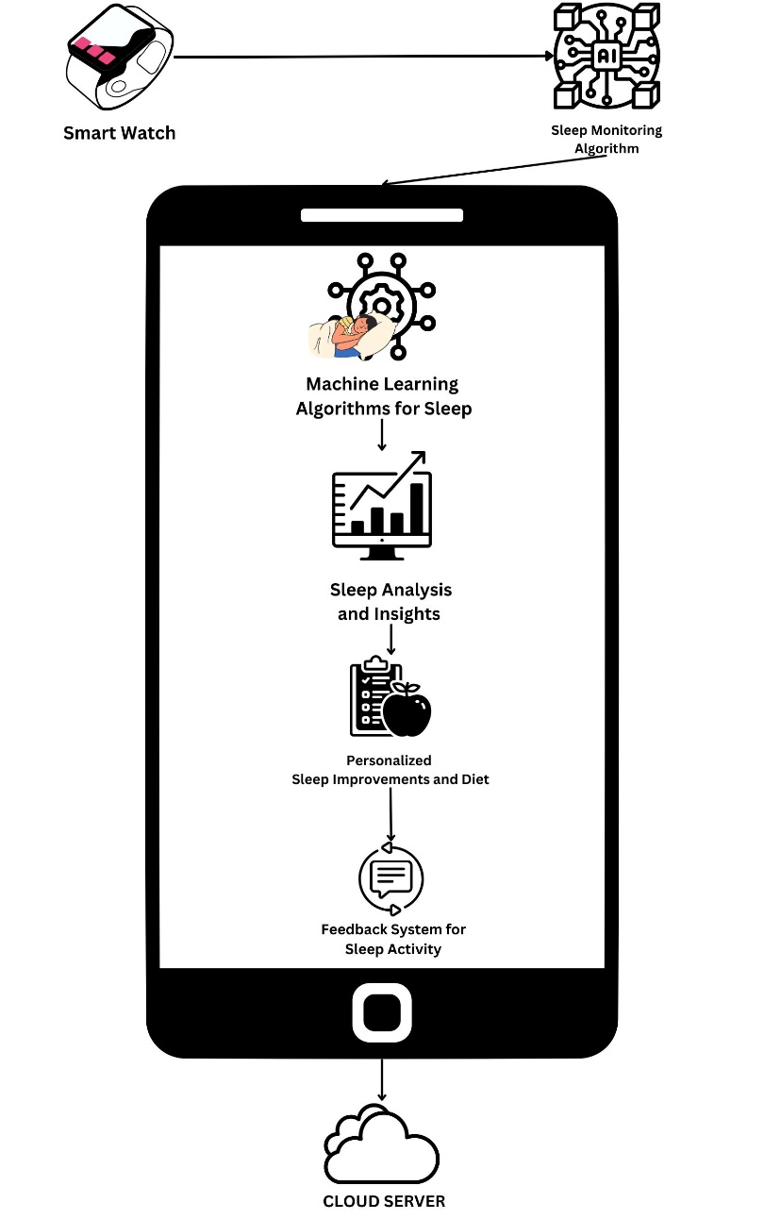
Fig. 3. Proposed System Architecture
- Feedback System for Sleep Activity: This component will provide feedback on the user's sleep activity, such as whether they are meeting their sleep goals, and suggestions for how they can improve their sleep habits. This component will also provide feedback on their diet, such as whether they are eating a balanced diet that supports good sleep.
- Sleep Data Storage: This component will store the user's sleep data in a secure and reliable database for future analysis and reference.
- Implementation
Sleep monitoring devices use market available smartwatches that contain different sensors such as optical heart rate sensor, accelerometer sensor, gyroscope, ambient light sensor, and microcontroller. Also, we use a mobile application for storing and processing the sensor data, which is then used to create a sleep plan and analyze the data using machine learning. The hardware component and the mobile application make up the entirety of the system.
  - Hardware Used
Sleep monitoring devices use market available smartwatches that contain different sensors such as optical heart rate sensor, accelerometer sensor, gyroscope, ambient light sensor, and microcontroller. Also, we use a mobile application for storing and processing the sensor data, which is then used to create a sleep plan and analyze the data using machine learning. The hardware component and the mobile application make up the entirety of the system.
In hardware, we deployed a smart watch preinstalled with an ambient light sensor, microcontroller, accelerometer sensor, gyroscope, and optical heart rate sensor.
- Optical heart rate sensor: It measures the changes in a blood vessel's volume brought on by the heart pumping blood. Optical heart-rate monitors may measure heart rate precisely by analyzing the arterial pulse of underlying skin vascular beds and are either built into a wrist-worn gadget, an arm band, or a chest patch.
- Accelerometer sensor: An instrument that measures the acceleration of an object in its immediate rest frame. Accelerometers are capable of measuring vibration. This sensor is used to evaluate a patient's level of sleep-related movement.
- Gyroscope: A gyroscope is a tool for determining or maintaining orientation and angular velocity. They also offer motion detecting capabilities in commonplace items like smartphones and game controllers. The gyroscope can detect minute changes in orientation brought on by breathing and heart rate during sleep, as well as more obvious movements like turning over or changing postures. The wearer's motions may be tracked by the gyroscope, which can also identify if they are in deep sleep, light sleep, or REM (rapid eye movement) sleep. Additionally, it has the ability to identify sleep disruptions including awakenings and snoring.
- Ambient Light Sensor: Ita type of sensor that measures the amount of light in an environment and adjusts the device's display brightness accordingly. The ambient light sensor monitors the amount of light hitting a tiny photodiode or phototransistor-tor in order to function. Ambient light sensors can also be used in sleep monitoring by detecting changes in the lighting conditions in a room. By measuring the amount of light in the environment, a sleep tracker or smartwatch can determine when the wearer has gone to bed and when they wake up. For example, if the sensor detects changes in the light levels during the night, such as from a passing car or streetlight, it may indicate that the wearer had a restless night and was disturbed by external factors.
- Microcontroller: Smartwatches may use different microcontrollers depending on their specific requirements and design considerations. Ultimately, the choice of microcontroller will depend on factors such as performance requirements, power consumption, and cost. The microcontroller typically receives data from various sensors, and then uses algorithms to analyze this data and determine when the wearer is asleep and what stage of sleep, they are in. The microcontroller can also store this data and communicate it to the user or to a smartphone app.

  - Mobile Application
A tiny Android app that displays a patient's current sleep quality status has also been created. This app makes it easier to see the patient's sleep quality. It will be simple to determine the patient's general sleep condition thanks to calculated findings that the app may retrieve and display in a pie chart. Figure displays a screenshot of the application.

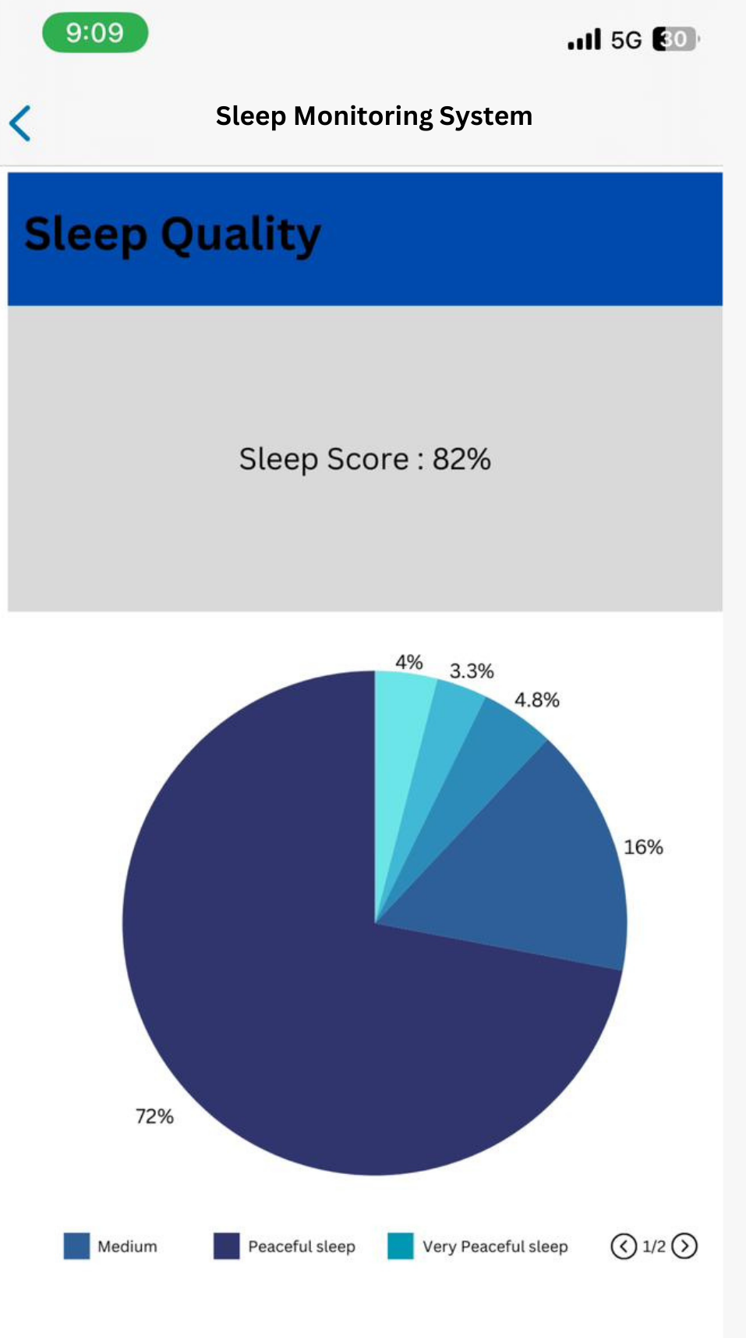
Fig. 4. Mobile Application Screen Shot
Figure displays the patient's sleep data as a pie graph, which illustrates how the patient's sleep data is divided into five categories. According to the graph, the patient had restful sleep. In this graph, the sound sleep is depicted by blue.
- Result
Assessing the efficacy of algorithms in sleep pattern analysis is pivotal to our sleep monitoring system. This section presents a comparative analysis of several machine learning algorithms, including Logistic Regression, SVM, KNN, Random Forest, Naive Bayes, and Decision Tree. The focus is on evaluating their accuracy in predicting sleep quality, leading to an informed selection of the most reliable algorithm for our application. The results indicate a clear frontrunner, as illustrated in the following graph.
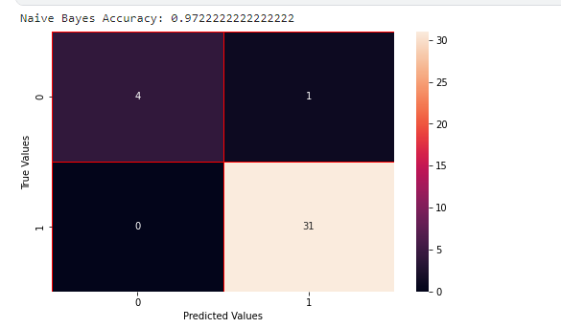
Fig. 5. Accuracy of Naïve Bayes Algorithm
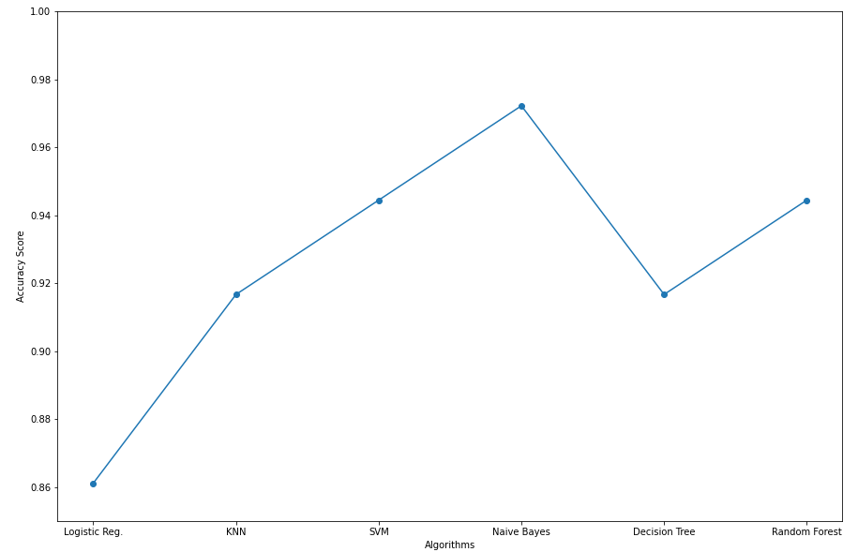
Fig. 6. Comparison for accuracy of all algorithms.
In an extensive comparison of available sleep monitoring algorithms, the Naive Bayes algorithm emerged as the most accurate. This probabilistic classifier, which assumes independence between predictor variables, has proven to be highly effective in predicting sleep patterns, outperforming other sophisticated algorithms. The accuracy of Naive Bayes in our tests underscores its potential as a reliable tool in sleep quality assessment, aligning with the system's goal to deliver precise and personalized sleep health insights.
- Conclusion

In conclusion, a sleep monitoring system that uses a smartwatch and machine learning algorithms can provide users with valuable insights into their sleep patterns and recommendations for improving their sleep quality. By collecting data on sleep duration, sleep quality, and other sleep-related metrics, the system can provide personalized insights into sleep patterns, such as when the user is most likely to wake up and how often they wake up during the night. Machine learning algorithms can then analyze this data and provide tailored recommendations for improving sleep, such as adjusting sleep schedules or changing sleeping positions. Additionally, by including a feedback system that provides suggestions on sleep activity and diet, the system can provide users with a comprehensive set of recommendations for improving their overall health and well-being. A sleep monitoring system that uses a smartwatch and machine learning algorithms has the potential to be a powerful tool for individuals looking to improve their sleep quality and overall health. With the right design and implementation, such a system can provide users with valuable insights and personalized recommendations, ultimately leading to better sleep and a better quality of life.

References
- “How Much Sleep Do I Need? | CDC.” Accessed: Feb. 08, 2024. [Online]. Available: https://www.cdc.gov/sleep/about_sleep/how_much_sleep.html
- . Bhaskar, D. Hemavathy, and S. Prasad, “Prevalence of chronic insomnia in adult patients and its correlation with medical comorbidities,” J Family Med Prim Care, vol. 5, no. 4, p. 780, 2016, doi: 10.4103/2249-4863.201153
- Q. Pan, D. Brulin, and E. Campo, “Current Status and Future Challenges of Sleep Monitoring Systems: Systematic Review,” JMIR Biomed Eng, vol. 5, no. 1, p. e20921, Aug. 2020, doi: 10.2196/20921.
- T. Y. Han, S. D. Min, and Y. Nam, “A Real-Time Sleep Monitoring System with a Smartphone,” in Proceedings - 2015 9th International Conference on Innovative Mobile and Internet Services in Ubiquitous Computing, IMIS 2015, Institute of Electrical and Electronics Engineers Inc., Sep. 2015, pp. 458–461. doi: 10.1109/IMIS.2015.69.
- Universitas Bina Nusantara, Institute of Electrical and Electronics Engineers, and Institute of Electrical and Electronics Engineers. Indonesia Section, Proceedings, the Eleventh 2016 International Conference on Knowledge, Information and Creativity Support Systems (The KICSS 2016) : 10-11 November 2016, Royal Ambarrukmo Yogyakarta Hotel, Yogyakarta, Indonesia.
- K. Ouchi, T. Suzuki, K.-I. Kameyama, and M. Takahashi, “Development of a Sleep Monitoring System with Wearable Vital Sensor for Home Use. DEVELOPMENT OF A SLEEP MONITORING SYSTEM WITH WEARABLE VITAL SENSOR FOR HOME USE,” 2009. [Online]. Available: https://www.researchgate.net/publication/221335140
- J. H. Shin, Y. J. Chee, D. U. Jeong, and K. S. Park, “Nonconstrained sleep monitoring system and algorithms using air-mattress with balancing tube method,” in IEEE Transactions on Information Technology in Biomedicine, Jan. 2010, pp. 147–156. doi: 10.1109/TITB.2009.2034011.
- D. C. Mack, J. T. Patrie, P. M. Suratt, R. A. Felder, and M. Alwan, “Development and preliminary validation of heart rate and breathing rate detection using a passive, ballistocardiography-based sleep monitoring system,” IEEE Transactions on Information Technology in Biomedicine, vol. 13, no. 1, pp. 111–120, 2009, doi: 10.1109/TITB.2008.2007194.
- J. Shin, Y. Chee, and K. Park, “Long-term Sleep Monitoring System and Long-term Sleep Parameters using Unconstrained Method,” IEEE, 2018.
- M. De Zambotti, F. C. Baker, and I. M. Colrain, “Validation of sleep-tracking technology compared with polysomnography in adolescents,” Sleep, vol. 38, no. 9, pp. 1461–1468, Sep. 2015, doi: 10.5665/sleep.4990.
- Z. Liang and B. Ploderer, “Sleep tracking in the real world: A qualitative study into barriers for improving sleep,” in Proceedings of the 28th Australian Computer-Human Interaction Conference, OzCHI 2016, Association for Computing Machinery, Inc, Nov. 2016, pp. 537–541. doi: 10.1145/3010915.3010988.
- M. W. Driller et al., “Pyjamas, Polysomnography and Professional Athletes: The Role of Sleep Tracking Technology in Sport,” Sports, vol. 11, no. 1. MDPI, Jan. 01, 2023. doi: 10.3390/sports11010014.
- E. Kuosmanen, “How Does Sleep Tracking Influence Your Life? Experiences from a Longitudinal Field Study with a Wearable Ring.” [Online]. Available: https://www.withings.com/mx/en/sleep
- G. Chen, Institute of Electrical and Electronics Engineers. Beijing Section. Reliability Society Chapter, and Institute of Electrical and Electronics Engineers, 2019 2nd International Conference on Safety Produce Informatization (IICSPI) : proceedings : Chongqing, China, November 28-30, 2019.
- 2020 IEEE 91st Vehicular Technology Conference (VTC Spring) : proceedings : Antwerp, Belgium, 25-28 May 2020.
- IEEE Poland Section and Institute of Electrical and Electronics Engineers, 7th IEEE International Conference on Cognitive Infocommunications : CogInfoCom 2016 : proceedings : October 16-18, 2016, Wrocław. Poland.
- V. Ibáñez, J. Silva, and O. Cauli, “A survey on sleep assessment methods,” PeerJ, vol. 2018, no. 5, 2018, doi: 10.7717/peerj.4849.
- A. Biajar, T. Mollayeva, S. Sokoloff, and A. Colantonio, “Assistive technology to enable sleep function in patients with acquired brain injury: Issues and opportunities,” British Journal of Occupational Therapy, vol. 80, no. 4. SAGE Publications Inc., pp. 225–249, Apr. 01, 2017. doi: 10.1177/0308022616688017.
- V. Metsis, D. Kosmopoulos, V. Athitsos, and F. Makedon, “Non-invasive analysis of sleep patterns via multimodal sensor input,” in Personal and Ubiquitous Computing, Springer London, Jan. 2014, pp. 19–26. doi: 10.1007/s00779-012-0623-1.
- X. K. Lee et al., “Validation of a consumer sleep wearable device with actigraphy and polysomnography in adolescents across sleep opportunity manipulations,” Journal of Clinical Sleep Medicine, vol. 15, no. 9, pp. 1337–1346, Sep. 2019, doi: 10.5664/jcsm.7932.
- E. Tobaldini, L. Nobili, S. Strada, K. R. Casali, A. Braghiroli, and N. Montano, “Heart rate variability in normal and pathological sleep,” Front Physiol, vol. 4, pp. 1–11, Oct. 2013, doi: 10.3389/fphys.2013.00294.

