Sleep Monitoring System
Sachin Singh¹, Manish Yadav ², Priyanka Kumari ³, Aayushma Thapa⁴, Samyak Maharjan⁵, Preeti Kurmi⁶, and Prof. Santhosh S⁷
¹ Department of Computer Engineering (Software Engineering), Jain (Deemed-to-be University), Kanakapura Road, Jakkasandra, 562112, INDIA
sachinsingh2156@gmail.com, ymanish0428@gmail.com, poddarpriyanka06@gmail.com, aayushmathapa392@gmail.com, samyakmaharjan3@gmail.com, preetikurmi12345@gmail.com, s.santhosh@jainuniversity.ac.in
Abstract. Sleep is a crucial component of overall human health, and many people struggle to get enough high-quality sleep. To help individuals improve their sleep quality, we propose a sleep monitoring system that uses a smartwatch and machine learning algorithms. This system gathers data on different elements related to sleep such as duration, quality, and physiological factors, which are analyzed using machine learning algorithms to provide personalized insights and recommendations for improving sleep. These recommendations could include adjustments to sleep schedules, changes to sleep hygiene practices, or dietary changes that can improve sleep. By providing personalized recommendations tailored to each individual's unique sleep patterns and physiological factors, this system has the potential to be a powerful tool for improving sleep quality and overall health. With the increasing popularity of wearable technology and the growing demand for personalized health solutions, a sleep monitoring system that uses a smartwatch and machine learning algorithms could be a valuable tool for improving sleep quality and overall well-being.
Keywords: User, Systems, Data, Sleep, Sensor, Algorithm, physical movement, stress, nap.
- Introduction
Our daily routine cannot be completed without sleep, and having an adequate amount of good sleep is key to maintaining our general health and well-being. Obesity, diabetes, cardiovascular disease, and depression are just a few of the health problems that are linked to poor sleep quality. Unfortunately, many people struggle to get enough quality sleep, and in recent years, this problem has become more prevalent due to increased technology usage, work-related stress, and other factors.
To help individuals improve their sleep quality, we propose a sleep monitoring system that utilizes a smartwatch and machine learning algorithms. This system collects data on sleep duration, sleep quality, heart rate, and other physiological factors, which are then analyzed by machine learning algorithms to identify patterns and correlations between different factors and sleep quality.
The proposed sleep monitoring system is designed to be user-friendly and non-intrusive. Users simply wear the smartwatch while sleeping, and the system collects data on their sleep patterns throughout the night. The collected data is then analyzed by machine learning algorithms to provide personalized insights and recommendations for improving sleep quality.
The system can provide recommendations based on several factors. The recommendations may include adjustments to sleep schedules, changes to sleep hygiene practices, or dietary changes that can improve sleep. For example, the system might recommend adjusting the user's bedtime or wake-up time based on their sleep patterns. It could also suggest implementing a consistent bedtime routine, and other recommendations such as avoiding electronic devices before bed or practicing relaxation techniques. The system could additionally recommend changes in diet that can enhance sleep quality, including avoiding coffee and alcohol before bed or eating foods that are high in magnesium and tryptophan. The proposed sleep monitoring system has several potential benefits. First, it provides personalized recommendations tailored to each individual's unique sleep patterns and physiological factors. This is particularly important since sleep quality is affected by various factors, including age, gender, and medical history. By providing personalized recommendations, the system can be more effective in improving sleep quality compared to general sleep recommendations.
Second, The system is user-friendly and non-intrusive. Users can simply wear the smartwatch while sleeping, and the system does not require any active participation from the user. This ease of use can increase compliance and adoption rates.
Third, the system utilizes machine learning algorithms to analyze sleep data and provide personalized recommendations. This allows the system to identify complex patterns and correlations between different factors and sleep quality that may be difficult for humans to recognize. Additionally, the system can learn and improve over time as it collects more data, increasing its effectiveness in providing personalized recommendations.
An effective tool for people wishing to enhance their sleep quality and general well-being is a sleep monitoring system that makes use of a smartwatch and machine learning algorithms. The suggested sleep monitoring system can help people attain better sleep quality and enhance their general health and well-being in light of the rising prevalence of sleep-related problems and the growing need for personalized health solutions.
- Problem Definition
A serious health problem that a sizable portion of the population faces is inadequate sleep. Obesity, diabetes, hypertension, melancholy, and anxiety are just a few of the physical and mental health issues that can result from getting too little sleep. Many people find it difficult to comprehend their sleep patterns and implement significant changes to enhance their sleep. People can track their sleep and receive individualized recommendations for improvement with the use of a sleep monitoring system that uses a smartwatch and machine learning.
The answer is to create a sleep monitoring system that employs a smartwatch to gather information about a user's sleep patterns and machine learning algorithms to analyze the information and offer individualized insights and suggestions. The system will monitor a number of sleep metrics, including REM sleep, sleep length, and quality, and utilize this information to produce a sleep score. Once the sleep score has been analyzed, the system will give users information about their sleeping habits, including when they are most likely to wake up, how often they wake up during the night, and how much deep and REM sleep they are obtaining. The system would offer the user personalized suggestions for enhancing their sleep based on this data, such as altering their sleep routine, boosting.
- Literature Survey
Sleeping disorder refers to when the user is unable to sleep their normal hours which builds up stress and subsequently has a drastic effect on user’s health. Some of the drastic effects of sleeping disorders are depression and in severe cases the sleeping disorder sometimes leads to unconditional heart which makes it quite vital and important for the user to have subsequent hours of sleep. In the busy and hectic world, it’s quite normal to get stressed but the nap in between work enables better mind freshness and subsequently provides enhanced work focus. Several inventions have been developed which allow the user to get themselves relaxed at the workplace.
In the paper “Sleep monitoring systems: Current status and future challenges” The authors draw attention to the shortcomings of current monitoring techniques like actigraphy and polysomnography in terms of accuracy and usefulness in daily life. The lack of uniformity among various sleep monitoring technologies makes it challenging to compare the findings of different studies. When it comes to privacy and data security, there are ethical issues with the gathering and use of sleep data. In or-der to address the difficulties associated with sleep monitoring, the paper suggests some potential solutions, such as the creation of new monitoring technologies, the standardization of measurement procedures, increased cooperation between experts in various fields, and more study to determine the connection between sleep and health.
The article "A Real-Time Sleep Monitoring System with a Smartphone" describes a real-time sleep monitoring system that uses a smartphone's sensors and machine learning algorithms to track sleep patterns and stages. The system aims to address the shortcomings of existing sleep monitoring technology by providing a more workable and accessible solution. The study describes the challenges involved in developing a reliable and accurate sleep monitoring system, as well as the approach taken to overcome these challenges. The suggested approach was employed by a small test group of subjects, and the findings showed that it functioned brilliantly in identifying sleep stages and metrics linked to sleep quality. [2]
This research does a literature analysis on the use of the Internet of Things (IoT) for monitoring sleep quality in "Internet of Things for Sleep Quality Monitoring System: A Survey". The goal of the study is to outline the present trends, issues, and potential directions for further academic endeavors in this area. The study discusses a wide array of subjects including sensor technology, data analytics, privacy and security concerns, and IoT-based sleep quality monitoring. The project intends to identify potential areas for IoT-based sleep monitoring research in the future and to provide insights into the challenges and potential of such systems. The authors proposed combining many sensors with data analytics techniques to improve the precision. [3]
The objective of the study, described in the publication "Development of a sleep monitoring system with wearable vital sensor for home use," is the development of a wearable sleep monitoring system. The study's main concern is the absence of affordable, dependable sleep monitoring equipment that can be used at home to improve sleep and spot sleeping disorders. To assess sleep quality and identify sleeping disorders, the proposed system analyses the data. It achieves this by measuring vital signals including heart rate, breathing rate, and bodily movement with a wearable sensor. The study also examines and offers remedies for the difficulties in developing a wearable sleep monitoring system.[4]
An air-mattress with a balancing tube method is used in the study "Nonconstrained Sleep Monitoring System and Algorithms Using Air-Mattress with Balancing Tube Method" to provide a non-invasive method of monitoring sleep patterns. The system collects and processes data on different factors, such as heart rate, rate of respiration, movements, and sleep stages, using non-invasive sensors and sophisticated algorithms. The system is a dependable and efficient instrument for sleep monitoring since it offers insightful information on the quality of sleep and potential problems. In comparison to polysomnography (PSG), which is regarded as the standard for sleep monitoring, the study undertaken to assess the accuracy of the system demonstrates high accuracy in recognizing sleep stages.[5]
The study "Development and Preliminary Validation of Heart Rate and Breathing Rate Detection Using a Passive, Ballistocardiograph-Based Sleep Monitoring System" describes the development of a passive, ballistocardiograph-based sleep monitoring system that can track the rate of heartbeat and breathing during sleep. A pressure sensitive pad positioned beneath the mattress is used by the system to find ballistocardiograph (BCG) signals, which are produced by the body's movements while you sleep. Advanced algorithms are used to process the BCG signals in order to detect heart rate and breathing rate, which provides important data on the user's sleep patterns. The system is a reliable and efficient tool for sleep monitoring because the study used to confirm its accuracy reveals that it has a high accuracy in detecting heart rate and breathing rate when compared to polysomnography (PSG).[7]
A long-term sleep monitoring system that can measure parameters using an un-constrained technique is presented in the publication "Long-term Sleep Monitoring System and Long-term Sleep Parameters using Unconstrained Method" by Jeyhun Shin, Young Joon Chee, and Kiangsu Park. It demonstrates a long-term sleep monitoring system that measures several aspects of sleep using an unrestricted technique. The system utilizes a bed-based sensor system that can detect body movements, respiratory signals, and heart rate to calculate sleep stages, sleep efficiency, and other sleep parameters. The study shows that the system can accurately measure sleep parameters over long periods of time, making it a valuable tool for monitoring sleep disorders and evaluating the effectiveness of treatments. Overall, the system provides valuable insights into sleep patterns and potential sleep disorders while maintaining user comfort and ease of use.[8]
A study comparing the accuracy of sleep-tracking technology with polysomnography in teenagers is presented in the article "Validation of Sleep-Tracking Technology Compared with Polysomnography in Adolescents" by Massimiliano de Zambotti, Fiona C. Baker, and Ian M. Colrain. In this study, the accuracy of the widely used Fitbit Charge HR sleep tracker was compared to that of teenage polysomnography. The 25 individuals in the study discovered that, when compared to polysomnography, Fitbit significantly overestimated the total time slept, sleep start latency, and waking after sleep onset. The study emphasizes the value of exercising caution when utilizing sleep-tracking technology for clinical or research reasons and contends that additional study is required to increase the devices' accuracy. In conclusion, the article offers insightful information about the limitations of tracking technologies and [9]
Zilu Liang and Bernd Plunderer’s paper "Sleep tracking in the real world: a qualitative study into barriers for improving sleep" gives a qualitative study on the challenge-es associated with using sleep-tracking technology to improve sleep. The article offers a qualitative investigation of the challenges to using sleep-tracking technologies to improve sleep. The study involved 12 participants who used a sleep-tracking device, and the results showed that accuracy and reliability of the device were significant concerns for the participants. Additionally, participants reported that the sleep data provided by the devices did not necessarily lead to changes in behavior or better sleep quality. The paper highlights the importance of considering user experience and motivation when designing sleep-tracking technology and the need for further research to improve the usability and effectiveness of such devices. [10]
The paper "Pajama’s, Polysomnography and Professional Athletes: The Role of Sleep Tracking Technology in Sport" by Driller et al. discusses the use of sleep tracking technology in professional athletes. The paper presents a case study of a professional rugby team that used sleep tracking devices to monitor their sleep and optimize their recovery. The study found that sleep tracking technology can provide valuable information for athletes and coaches to identify and address sleep-related issues, which can improve performance and reduce the risk of injury. The paper also highlights the challenges of using sleep tracking technology in a sports context, such as the need for reliable and accurate data and the importance of privacy and data protection. Overall, the paper provides insights into the potential benefits and challenges of using sleep tracking technology in professional sports. [11]
The study "How Does Sleep Tracking Influence Your Life?" by Koosharem et al. explores how people's behavior and perceptions of sleep are affected by sleep monitoring technologies. Twenty people participated in the study, each of whom utilized a sleep tracking device and answered questionnaires and interviews. The findings demonstrated that the use of sleep tracking equipment improved participants' awareness of and comprehension of their sleep patterns, resulting in modifications to sleep behavior and routines. However, the study also revealed concerns around data privacy, accuracy of the devices, and the potential for sleep tracking technology to create stress and anxiety around sleep. Overall, the paper highlights the potential benefits and drawbacks of sleep tracking technology, emphasizing the need for further re-search and design improvements to maximize the positive impact of such devices. [12]
A non-invasive system that monitors sleep using body movement signals to track sleep patterns is proposed in the paper "The Design and Realization of Sleep-monitoring System Based on Body-movement Signals" by Wei et al. The technology collects and analyses data on body movement while you sleep using an accelerometer and a microcontroller. To analyze movement data and categorize sleep stages, the authors suggest a sleep stage classification algorithm based on the Fast Fourier Trans-form (FFT) and linear discriminant analysis (LDA) methods. Five healthy individuals were used to test the system, and the findings indicated that it could classify sleep stages with some accuracy. The suggested system offers a low-cost and non-invasive replacement for conventional sleep monitoring methods, which may be helpful for applications involving home-based sleep monitoring. [13]
A high-performance and resource-efficient sleep monitoring system built on the In-ernet of Things (IoT) is presented in the paper "High-Performance and Resource Efficient IoT-based Sleep Monitoring System". The device collects body movement information and snoring sounds using an accelerometer and a microphone, respectively, and sends the information to a cloud server for analysis. The suggested method is built to ensure precise sleep tracking while minimizing power usage and data transmission. The experimental results show the system's efficiency in accurately identifying sleep stages and sleep-related events, pointing to its potential for use in real-world sleep monitoring and management. [14]
The article "An unobtrusive sleep monitoring system for the human sleep behavior understanding" describes an unobtrusive sleep monitoring system based on a bed sensor for recording sleep-related body movements and a smartphone application for gathering self-reported sleep data. The proposed system seeks to identify sleep problems and to give an accurate and comprehensive picture of sleep behavior, including sleep onset, duration, efficiency, and quality. Pilot research using 10 healthy people to test the system revealed that it can give useful data for sleep monitoring and management and has the potential to be utilized for the diagnosis and treatment of sleep disorders. [15]
An inconspicuous sleep monitoring system based on a bed sensor for collecting sleep-related body movements and a smartphone application for gathering self-reported sleep data is described in the paper "An unobtrusive sleep monitoring system for the understanding of human sleep behavior." The suggested method aims to pinpoint sleep issues and provide a precise and thorough analysis of sleep behavior, including sleep onset, duration, effectiveness, and quality. The system can provide relevant data for sleep monitoring and management, and it has the potential to be used for the diagnosis and treatment of sleep problems, according to a pilot study utilizing 10 healthy persons to test the system. [16]
A literature review is published in "A survey on sleep assessment methods" by Vanessa Ibanez, Joseph Silva, and Omar Cauli with the goal of summarizing and contrasting the most recent sleep evaluation techniques. They discovered that, in terms of accuracy, sleep detection techniques can be categorized as follows after analyzing all of the current sleep evaluation techniques: Questionnaire Contactless devices, contact devices, contact devices, and polysomnography. According to a survey of the literature, current subjective approaches have a sensitivity range of 73% to 97.7% and a specificity range of 50% to 96%. A sensibility of greater than 90% is presented by objective techniques like actigraphy. One drawback of such technology is that their specificity is low in comparison to their sensitivity. [17]
Different treatments for sleeping difficulties are suggested in "Assistive technology to enable sleep function in patients with acquired brain injury: Issues and opportunities" by Anmol Biajar, Tatyana Mollayeva, Sandra Sokoloff, and Angela Colantonio. They suggested treatments such as nasotracheal suction mechanical ventilation, adaptive servo-ventilation, light therapy, positional therapy, CBT, and continuous positive airway pressure (CPAP) therapy. These are some basic treatments for people with brain injuries who have sleeping problems. [18]
The authors of "Non-invasive analysis of sleep patterns via multimodal sensor in-put" are Vangelis Metis, Dimitris Kotsiopoulos, Vassilis Athetoses, and Fillia Mak. They use Microsoft Kinect and a bed pressure mat sensor to examine people's sleep habits. They gathered information from seven different people by imitating their sleeping patterns. Each person spent some time lying on their bed and carried out the activities they would usually do before going to sleep. Two distinct sensors were used to record the various actions taken during that time. then placed a bed pressure mat underneath the covers for the first one, and then affixed a Microsoft Kinect sensor to the ceiling for the second. The captured information was then manually annotated in accordance with. [19]
By using polysomnography (PSG) as the gold standard, Xuan Kai Lee et al.'s paper "Validation of a Consumer Sleep Wearable Device with Actigraphy and Polysomnography in Adolescents Across Sleep Opportunity Manipulations" sought to validate a sleep wearable device for monitoring sleep stages and parameters in adolescents. The study discovered that while the consumer device was less accurate for detecting sleep stages, it was accurate for assessing total time spent sleeping, sleep start latency, and wake after sleep onset. The device is a helpful tool for tracking adolescent sleep, but the authors warn against using only its readings for clinical diagnoses. [20]
The paper "Validation of a Consumer Sleep Wearable Device with Actigraphy and Polysomnography in Adolescents Across Sleep Opportunity Manipulations" by Xuan Kai Lee et al. sought to validate a consumer sleep wearable device for monitoring sleep stages and parameters in adolescents using polysomnography (PSG) as the gold standard. The research found that while the consumer device had lower sensitivity for identifying different stages of sleep, it was precise for measuring total sleep time, sleep start latency, and wakefulness following sleep onset. Although the gadget is useful for monitoring adolescent sleep, the scientists advise against using its findings alone to make clinical diagnosis. [21]
A system, method, and item for stress reduction and sleep promotion are disclosed in U.S. Pat. No. 11013883B2, which was created by Todd Youngblood and Tara Youngblood of Mooresville, North Carolina (US). A system for reducing stress and promoting sleep includes at least one remote control and a piece of equipment for regulating surface temperature. In some implementations, the system for promoting sleep and reducing stress consists of at least one body sensor, at least one remote server, and/or a pulsed electromagnetic frequency device. [22]
A bed with a mattress and a foot warming system is described in U.S. Patent No. 20210289947A1 by inventors Ronald Stuarant BENSON of Toronto, California, and Ryan Cameron DENOMME of Kitchener, California. A support structure that is positioned beneath and covered by the mattress cover may also be included in the mattress. A heating unit, an envelope, a power source, and an electrical connector that connects the heating unit to the power source are all possible components of the foot warming system. Between the top and bottom of the enclosure, the heating unit may be positioned inside. At the foot of the bed, between the support framework and the mattress cover, the heating unit, and the envelope. [23]
- Methodology
When a person is sleeping, their hand is connected to a wearable smartwatch called a Sleep Monitoring Device. Our body temperature and blood pressure drop as we sleep as physiological demands are reduced. The majority of our physiological functions, such as heart rate, breathing, and brain wave activity, are very predictable during non-REM sleep but fairly changeable when we are awake or during REM sleep. Periodically throughout the night, REM sleep occurs, which is characterized by rapid eye movement, increased bodily activity while dreaming, a faster heartbeat, and shallower breathing. Non-REM sleep is a relaxed state of sleep characterized by low levels of autonomic physiological activity, delta wave brain activity, and dreaming. It always happens during a typical sleep cycle. So, with the help of sleep monitoring device, we are going to measure different aspects of REM sleep.
- Proposed System
For overcoming all the limitations of existing system, we are going to propose a personalized sleep analysis algorithm that will not only monitor the sleep activities, but it will also provide feedback, measures and diet suggestion for effective sleep.
- Smartwatch: This component is responsible for data collection about the user's sleep, such as sleep duration, sleep quality, and REM sleep. The sensor will be embedded in the smartwatch and will collect data throughout the night.
- Sleep Monitoring Algorithm: This component will collect and process the data collected by the smartwatch sensor, generate a sleep score, and initiate the machine learning algorithms for sleep analysis.
- Machine Learning Algorithms: This component will analyze the sleep score generated by the sleep monitoring algorithm and provide insights and recommendations for sleep improvement.
- Sleep Analysis and Insights: This component will analyze the data collected by the smartwatch sensor and provide insights into the user's sleep patterns, such as when they are most likely to wake up, how often they wake up during the night, and how much deep and REM sleep they are getting.
- Personalized Sleep Improvements and Diet: This component will provide personalized recommendations for improving the user's sleep, as well as recommendations for their diet based on their sleep data. This component will take into account the user's sleep patterns, sleep score, and diet preferences to provide tailored recommendations.
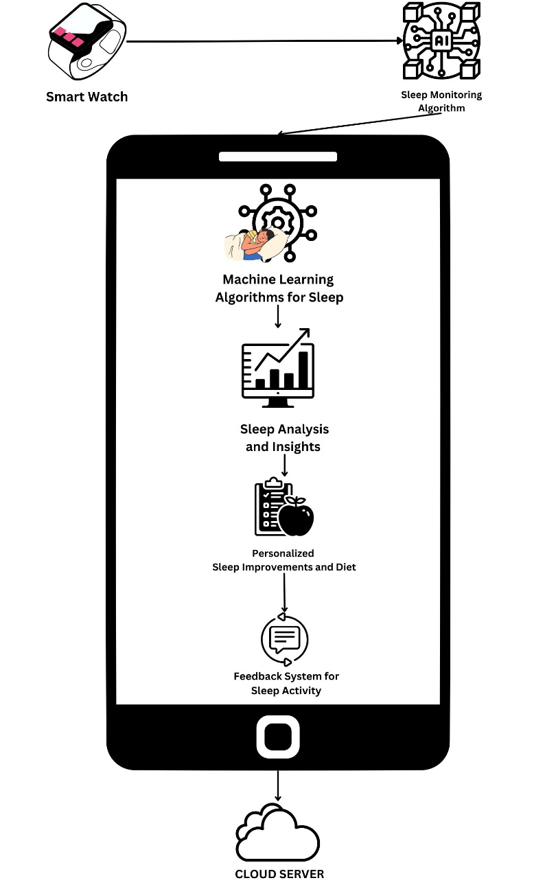
Fig. 1. Proposed System Architecture
- Feedback System for Sleep Activity: This component will provide feedback on the user's sleep activity, such as whether they are meeting their sleep goals, and suggestions for how they can improve their sleep habits. This component will also provide feedback on their diet, such as whether they are eating a balanced diet that supports good sleep.
- Sleep Data Storage: This component will store the user's sleep data in a secure and reliable database for future analysis and reference.
- Implementation
Sleep monitoring devices use market available smartwatches that contain different sensors such as optical heart rate sensor, accelerometer sensor, gyroscope, ambient light sensor, and microcontroller. Also, we use a mobile application for storing and processing the sensor data, which is then used to create a sleep plan and analyze the data using machine learning. The hardware component and the mobile application make up the entirety of the system.
  - Hardware Used
Sleep monitoring devices use market available smartwatches that contain different sensors such as optical heart rate sensor, accelerometer sensor, gyroscope, ambient light sensor, and microcontroller. Also, we use a mobile application for storing and processing the sensor data, which is then used to create a sleep plan and analyze the data using machine learning. The hardware component and the mobile application make up the entirety of the system.
In hardware, we deployed a smart watch preinstalled with an ambient light sensor, microcontroller, accelerometer sensor, gyroscope, and optical heart rate sensor.
- Optical heart rate sensor: It measures the changes in a blood vessel's volume brought on by the heart pumping blood. Optical heart-rate monitors may measure heart rate precisely by analyzing the arterial pulse of underlying skin vascular beds and are either built into a wrist-worn gadget, an arm band, or a chest patch.
- Accelerometer sensor: An instrument that measures the acceleration of an object in its immediate rest frame. Accelerometers are capable of measuring vibration. This sensor is used to evaluate a patient's level of sleep-related movement.
- Gyroscope: A gyroscope is a tool for determining or maintaining orientation and angular velocity. They also offer motion detecting capabilities in commonplace items like smartphones and game controllers. The gyroscope can detect minute changes in orientation brought on by breathing and heart rate during sleep, as well as more obvious movements like turning over or changing postures. The wearer's motions may be tracked by the gyroscope, which can also identify if they are in deep sleep, light sleep, or REM (rapid eye movement) sleep. Additionally, it has the ability to identify sleep disruptions including awakenings and snoring.
- Ambient Light Sensor: Ita type of sensor that measures the amount of light in an environment and adjusts the device's display brightness accordingly. The ambient light sensor monitors the amount of light hitting a tiny photodiode or phototransistor-tor in order to function. Ambient light sensors can also be used in sleep monitoring by detecting changes in the lighting conditions in a room. By measuring the amount of light in the environment, a sleep tracker or smartwatch can determine when the wearer has gone to bed and when they wake up. For example, if the sensor detects changes in the light levels during the night, such as from a passing car or streetlight, it may indicate that the wearer had a restless night and was disturbed by external factors.
- Microcontroller: Smartwatches may use different microcontrollers depending on their specific requirements and design considerations. Ultimately, the choice of microcontroller will depend on factors such as performance requirements, power consumption, and cost. The microcontroller typically receives data from various sensors, and then uses algorithms to analyze this data and determine when the wearer is asleep and what stage of sleep, they are in. The microcontroller can also store this data and communicate it to the user or to a smartphone app.

  - Mobile Application
A tiny Android app that displays a patient's current sleep quality status has also been created. This app makes it easier to see the patient's sleep quality. It will be simple to determine the patient's general sleep condition thanks to calculated findings that the app may retrieve and display in a pie chart. Figure displays a screenshot of the application.

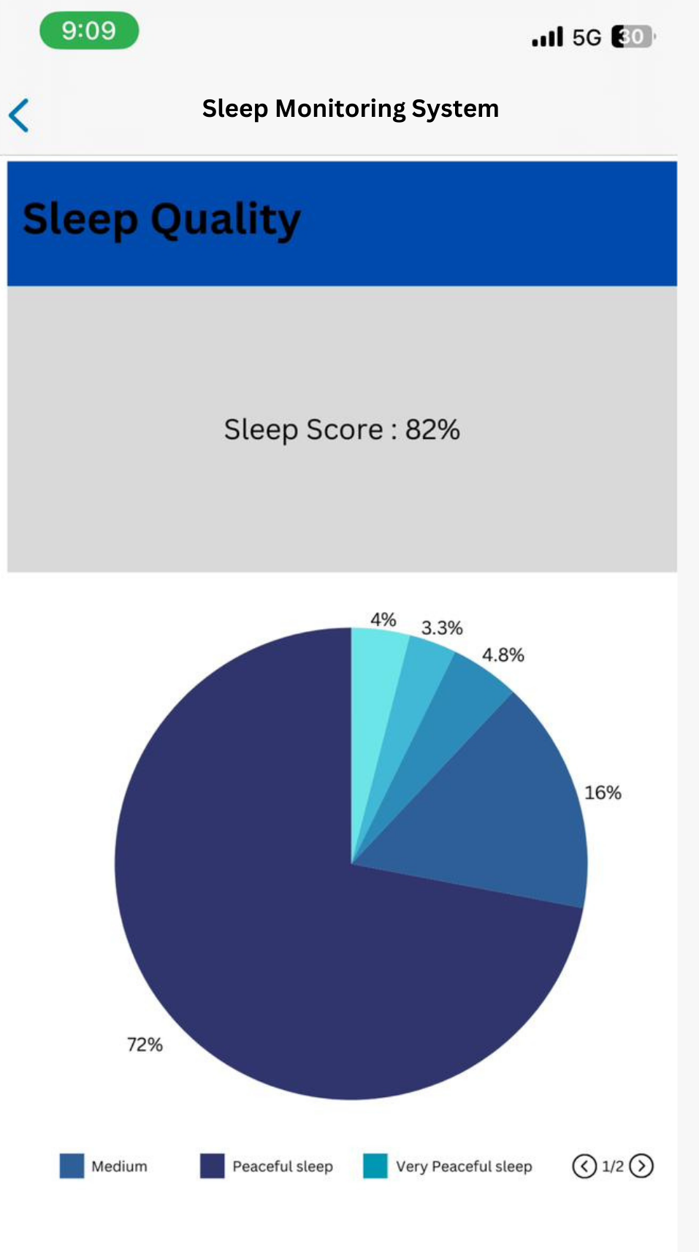
Fig. 2. Mobile Application Screen Shot
Figure displays the patient's sleep data as a pie graph, which illustrates how the patient's sleep data is divided into five categories. According to the graph, the patient had restful sleep. In this graph, the sound sleep is depicted by blue.
- Conclusion
In conclusion, a sleep monitoring system that uses a smartwatch and machine learning algorithms can provide users with valuable insights into their sleep patterns and recommendations for improving their sleep quality. By collecting data on sleep duration, sleep quality, and other sleep-related metrics, the system can provide personalized insights into sleep patterns, such as when the user is most likely to wake up and how often they wake up during the night. Machine learning algorithms can then analyze this data and provide tailored recommendations for improving sleep, such as adjusting sleep schedules or changing sleeping positions. Additionally, by including a feedback system that provides suggestions on sleep activity and diet, the system can provide users with a comprehensive set of recommendations for improving their overall health and well-being. A sleep monitoring system that uses a smartwatch and machine learning algorithms has the potential to be a powerful tool for individuals looking to improve their sleep quality and overall health. With the right design and implementation, such a system can provide users with valuable insights and personalized recommendations, ultimately leading to better sleep and a better quality of life.

References
- Ibáñez V, Silva J, Cauli O. A survey on sleep assessment methods. PeerJ. 2018 May 25;6:e4849. doi: 10.7717/peerj.4849. PMID: 29844990; PMCID: PMC5971842.
- Biajar, Anmol, Tatyana Mollayeva, Sandra Sokoloff, and Angela Colantonio. “Assistive Technology to Enable Sleep Function in Patients with Acquired Brain Injury: Issues and Opportunities.” British Journal of Occupational Therapy 80, no. 4 (April 2017): 225–49. https://doi.org/10.1177/0308022616688017.
- Metsis, V., Kosmopoulos, D., Athitsos, V. et al. Non-invasive analysis of sleep patterns via multimodal sensor input. Pers Ubiquit Comput 18, 19–26 (2014). https://doi.org/10.1007/s00779-012-0623-1
- Lee XK, Chee NIYN, Ong JL, Teo TB, van Rijn E, Lo JC, Chee MWL. Validation of a Consumer Sleep Wearable Device With Actigraphy and Polysomnography in Adolescents Across Sleep Opportunity Manipulations. J Clin Sleep Med. 2019 Sep 15;15(9):1337-1346. doi: 10.5664/jcsm.7932. PMID: 31538605; PMCID: PMC6760396.
- Ronald Stuart BENSON, Ryan Cameron DENOMME. Sleep monitoring system (2018) U.S. Pat. No.10874350B2
- Todd Youngblood, Tara Youngblood Stress reduction and sleep promotion system (2021) U.S. Pat No.11013883B2
- Kody Lee Karschnik, Omid Sayadi, Wade Daniel Palashewski, Ramazan Demirli, Eric Rose, Saurabh Chhaparwal Bed with foot warming system (2020) U.S. Pat No. 20210289947A1.
- PAN, Qiang & Brulin, Damien & Campo, Eric. (2020). Sleep monitoring systems: Current status and future challenges (Preprint). JMIR Biomedical Engineering. 5. 10.2196/20921.
- T. -Y. Han, S. -D. Min and Y. Nam, "A Real-Time Sleep Monitoring System with a Smartphone," 2015 9th International Conference on Innovative Mobile and Internet Services in Ubiquitous Computing, Santa Catarina, Brazil, 2015, pp. 458-461, doi: 10.1109/IMIS.2015.69.
- N. Surantha, G. P. Kusuma and S. M. Isa, "Internet of things for sleep quality monitoring system: A survey," 2016 11th International Conference on Knowledge, Information and Creativity Support Systems (KICSS), Yogyakarta, Indonesia, 2016, pp. 1-6, doi: 10.1109/KICSS.2016.7951426.
- Suzuki, Takuji & Ouchi, Kazushige & Kameyama, Ken-Ichi & Takahashi, Masaya. (2009). Development of a Sleep Monitoring System with Wearable Vital Sensor for Home Use.. 326-331.
- Nonconstrained Sleep Monitoring System and Algorithms Using Air-Mattress With Balancing Tube Method. (2010, January 1). IEEE Journals & Magazine | IEEE Xplore. https://ieeexplore.ieee.org/stamp/stamp.jsp?tp=&arnumber=5290162&tag=1
- Development and Preliminary Validation of Heart Rate and Breathing Rate Detection Using a Passive, Ballistocardiography-Based Sleep Monitoring System David C. Mack, James T. Patrie, Paul M. Suratt, Robin A. Felder, and Majd Alwan, Senior Member, IEEE https://ieeexplore.ieee.org/stamp/stamp.jsp?tp=&arnumber=4663856
- Promises and Challenges in the Use of Consumer-Grade Devices for Sleep Monitoring Sirinthip Roomkham , David Lovell , Joseph Cheung , and Dimitri Perrin. https://ieeexplore.ieee.org/stamp/stamp.jsp?tp=&arnumber=8309286
- Long-term Sleep Monitoring System and Long-term Sleep Parameters using Unconstrained Method Jaehyuk Shin, Youngjoon Chee, and Kwangsuk Park, Member, IEEE https://citeseerx.ist.psu.edu/document?repid=rep1&type=pdf&doi=7bb91d3bbf05f30ba1dcaa7d4ebf9ffb0c7042f9
- de Zambotti M, Baker FC, Colrain IM. Validation of Sleep-Tracking Technology Compared with Polysomnography in Adolescents. Sleep. 2015 Sep 1;38(9):1461-8. doi: 10.5665/sleep.4990. PMID: 26158896; PMCID: PMC4531414.
- Zilu Liang and Bernd Ploderer. 2016. Sleep tracking in the real world: a qualitative study into barriers for improving sleep. In Proceedings of the 28th Australian Conference on Computer-Human Interaction (OzCHI '16). Association for Computing Machinery, New York, NY, USA, 537–541. https://doi.org/10.1145/3010915.3010988
- Driller, M. W., Dunican, I. C., Omond, S. E. T., Boukhris, O., Stevenson, S., Lambing, K., & Bender, A. (2023). Pyjamas, Polysomnography and Professional Athletes: The Role of Sleep Tracking Technology in Sport. Sports, 11(1), 14. https://doi.org/10.3390/sports11010014
- Kuosmanen, E., Visuri, A., Kheirinejad, S., Van Berkel, N., Koskimäki, H., Ferreira, D., & Hosio, S. (2022). How Does Sleep Tracking Influence Your Life? Proceedings of the ACM on Human-computer Interaction, 6(MHCI), 1–19. https://doi.org/10.1145/3546720
- Y. Wei et al., "The Design and Realization of Sleep-monitoring System Based on Body-movement Signals," 2019 2nd International Conference on Safety Produce Informatization (IICSPI), Chongqing, China, 2019, pp. 533-536, doi: 10.1109/IICSPI48186.2019.9096055.
- N. Surantha, O. K. Utomo and S. M. Isa, "High-Performance and Resource-Efficient IoT-based Sleep Monitoring System," 2020 IEEE 91st Vehicular Technology Conference (VTC2020-Spring), Antwerp, Belgium, 2020, pp. 1-5, doi: 10.1109/VTC2020-Spring48590.2020.9129521.
- P. Barsocchi, M. Bianchini, A. Crivello, D. La Rosa, F. Palumbo and F. Scarselli, "An unobtrusive sleep monitoring system for the human sleep behaviour understanding," 2016 7th IEEE International Conference on Cognitive Infocommunications (CogInfoCom), Wroclaw, Poland, 2016, pp. 000091-000096, doi: 10.1109/CogInfoCom.2016.7804531.
- S. T. -B. Hamida and B. Ahmed, "A remote deep sleep monitoring system based on a single channel for in-home insomnia diagnosis," 2015 7th International Conference on New Technologies, Mobility and Security (NTMS), Paris, France, 2015, pp. 1-2, doi: 10.1109/NTMS.2015.7266469.

