Game Design Document

Fill up the Following document

1. Write the title of your project.

Yellost’s Orb Quest

1. What is the goal of the game?

To collect the orbs

1. Write a brief story of your game?

Yellost is collecting seven orbs to make a cake. On his way, he meets

many monsters who want to eat him. Help Yellost get the orbs safely, without getting eaten.

1. Which are the playing characters of this game?

* Playing characters are the ones which respond to the user based on the input from the user
* Cars, monkeys, dinos, wizards etc, are the playing characters in the game.

|  |  |  |
| --- | --- | --- |
| Number | Character Name | What can this character do? |
| 1 | Yellost | Move Left |
| 2 |  | Move Right |
| 3 |  | Jump |
| 4 |  | Run Left |
| 5 |  | Run Right |
| 6 |  | Use Sword |
| 7 |  |  |
| 8 |  |  |

1. Which are the Non Playing Characters of this game?

* Non Playing characters are the ones which don't have an action or a behaviour when the user interacts with the game.
* Hurdles, stones, bananas, coins, etc are non playing characters in the game.

|  |  |  |
| --- | --- | --- |
| Number | Character Name | What can this character do? |
| 1 | Bieth | Bite, Fire |
| 2 | Cavamello | Bite, Mini Tornados |
| 3 | Griterk | Bite, Mini Tsunamis,  Punch |
| 4 | Venoake | Bite, Spit Venom, Fire, Burrow To Hide And Appear Below Yellost |
| 5 | Epolf | Bite, Scratch, Roll To Attack, Burrow To Hide And Appear Below Yellost, Fire |
| 6 | Scapus | Tentacle Drill, Tentacle Hit, Bouncing Energy Ball, Mini Tsunamis, Mini Lightning, Mini Tornados, Fire |
| 7 | Stroture | Bouncing Energy Ball, Fire, Nuclear Bomb, Mini Tornado, Mini Lightning, Punch, Fork Rain, Gun, Knife |
| 8 | Sword | Allows Yellost To Bounce Back Yellow Attacks Back to the Enemy |
| 9 | Orb | To Win The Level |

Draw your imagination of this game. What does this game look like?

* Draw the game either on your computer or on paper,
* Add images of scenes of the game to show each of the playing and non-playing characters at least once.

Yellost:

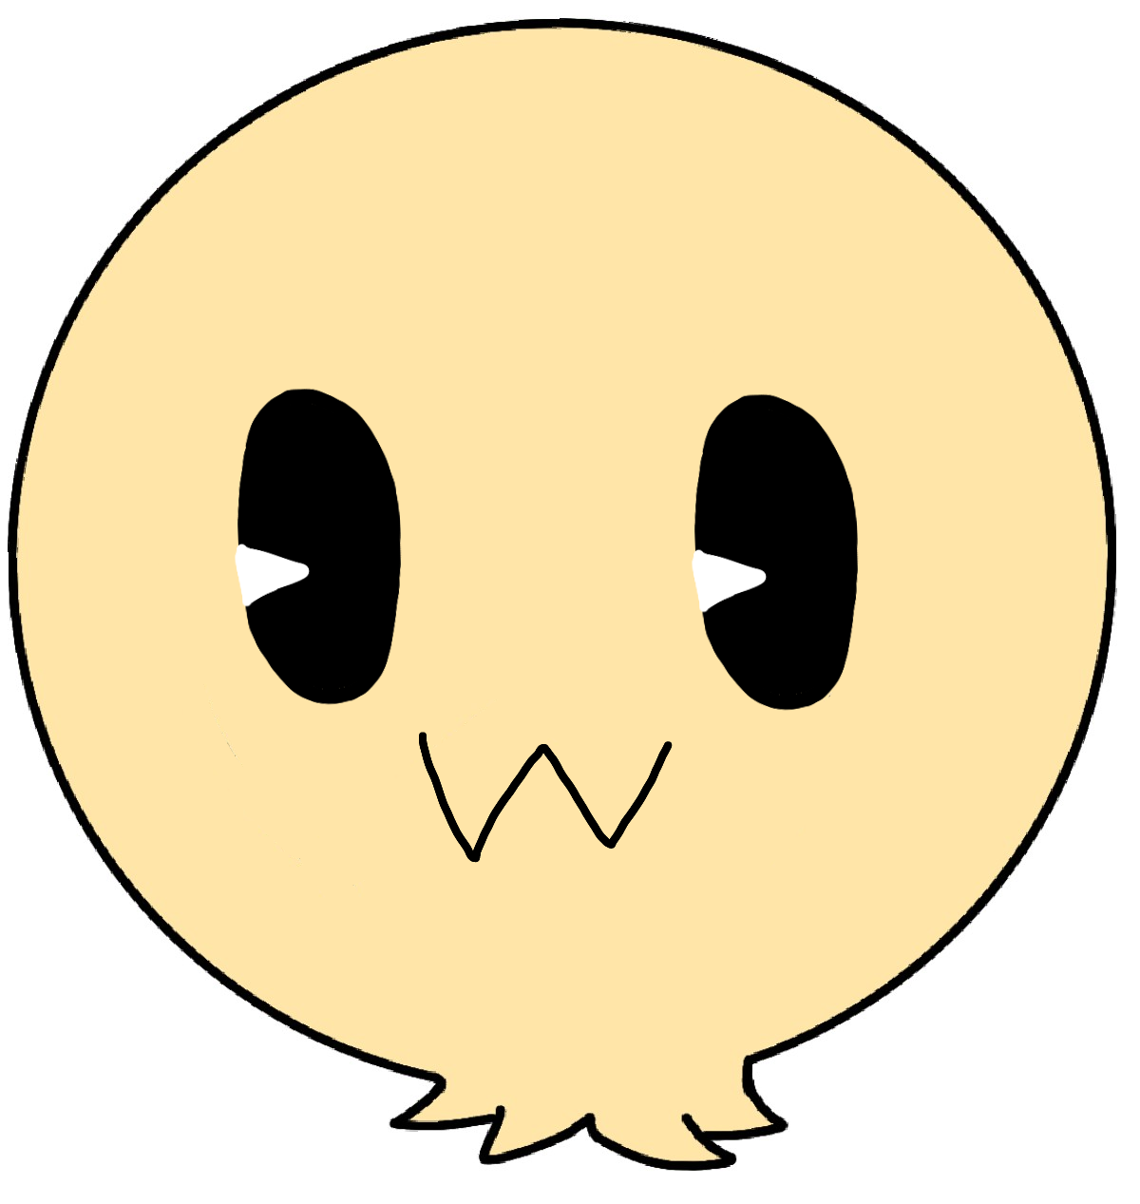

Bieth:

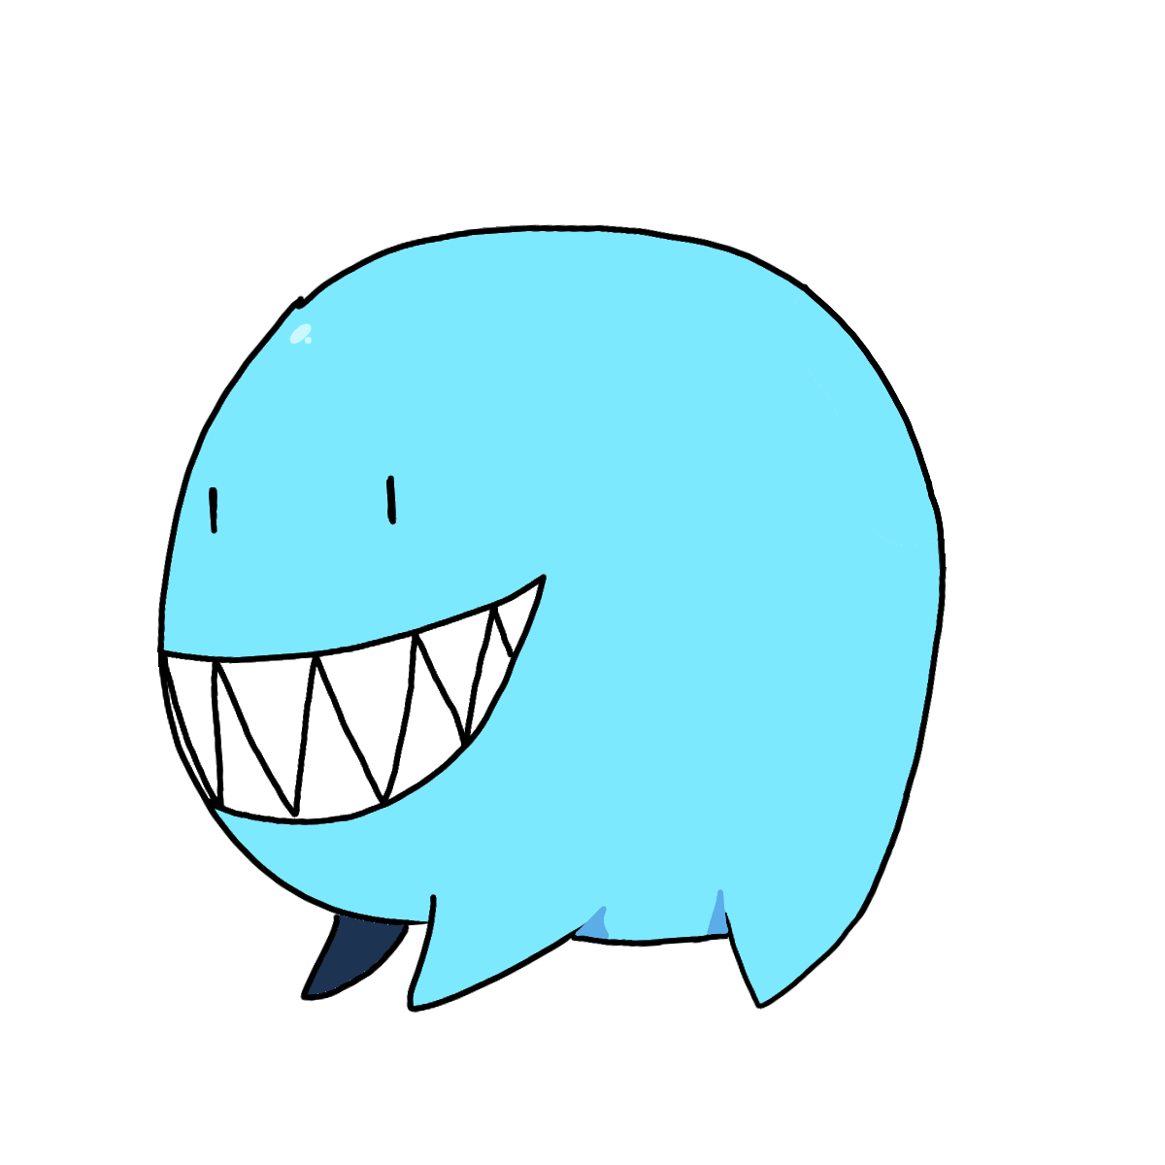

Cavamello:

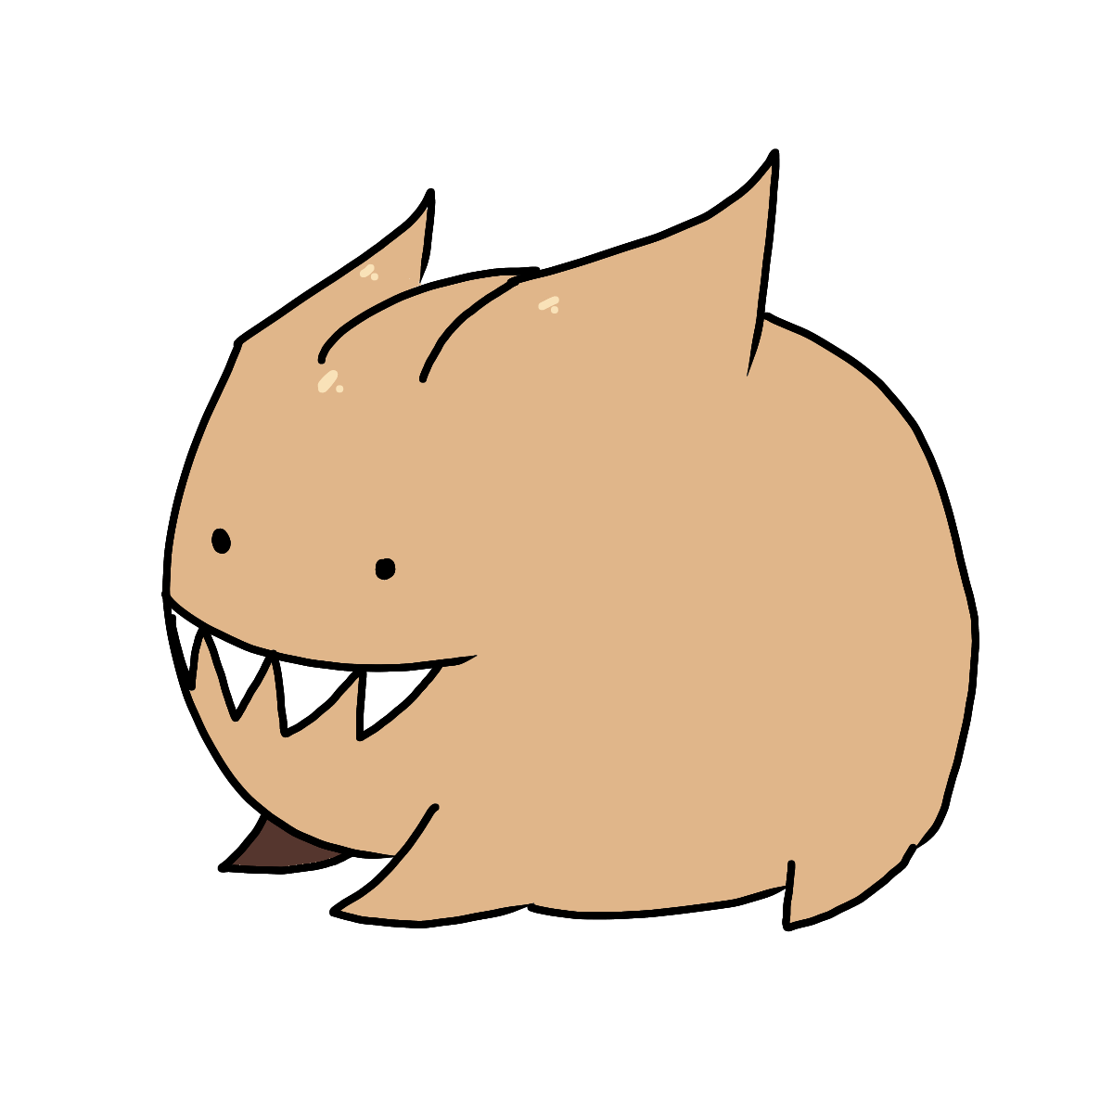

Giterk:

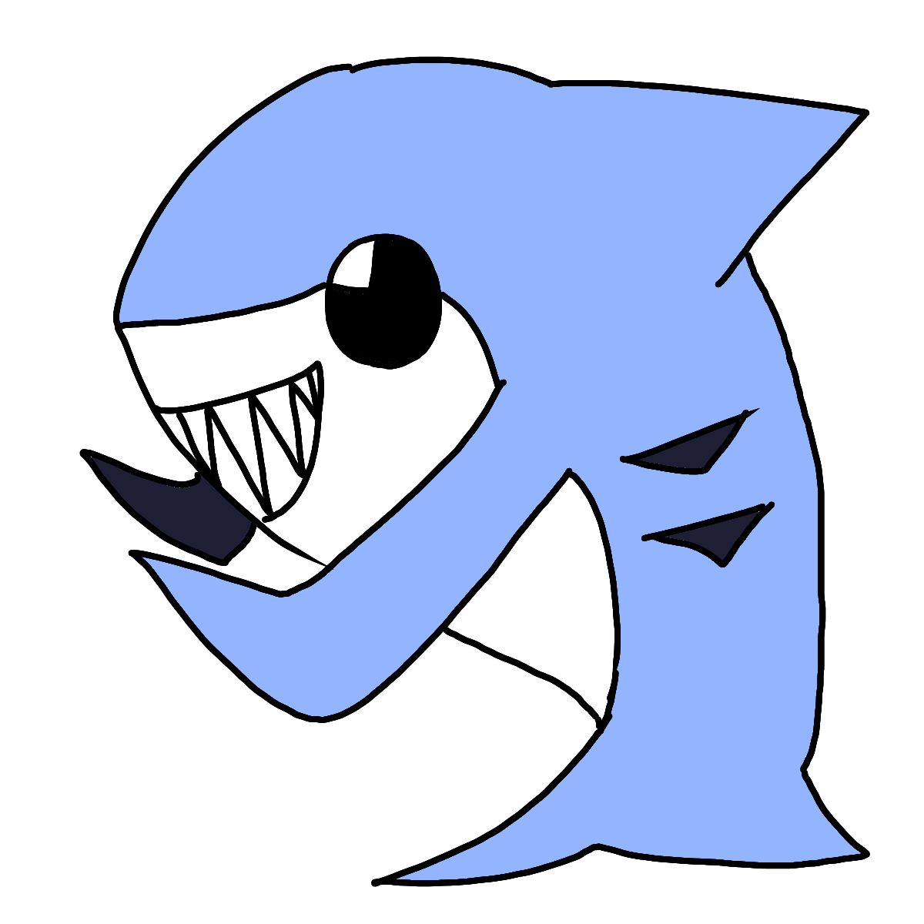

Venoake:

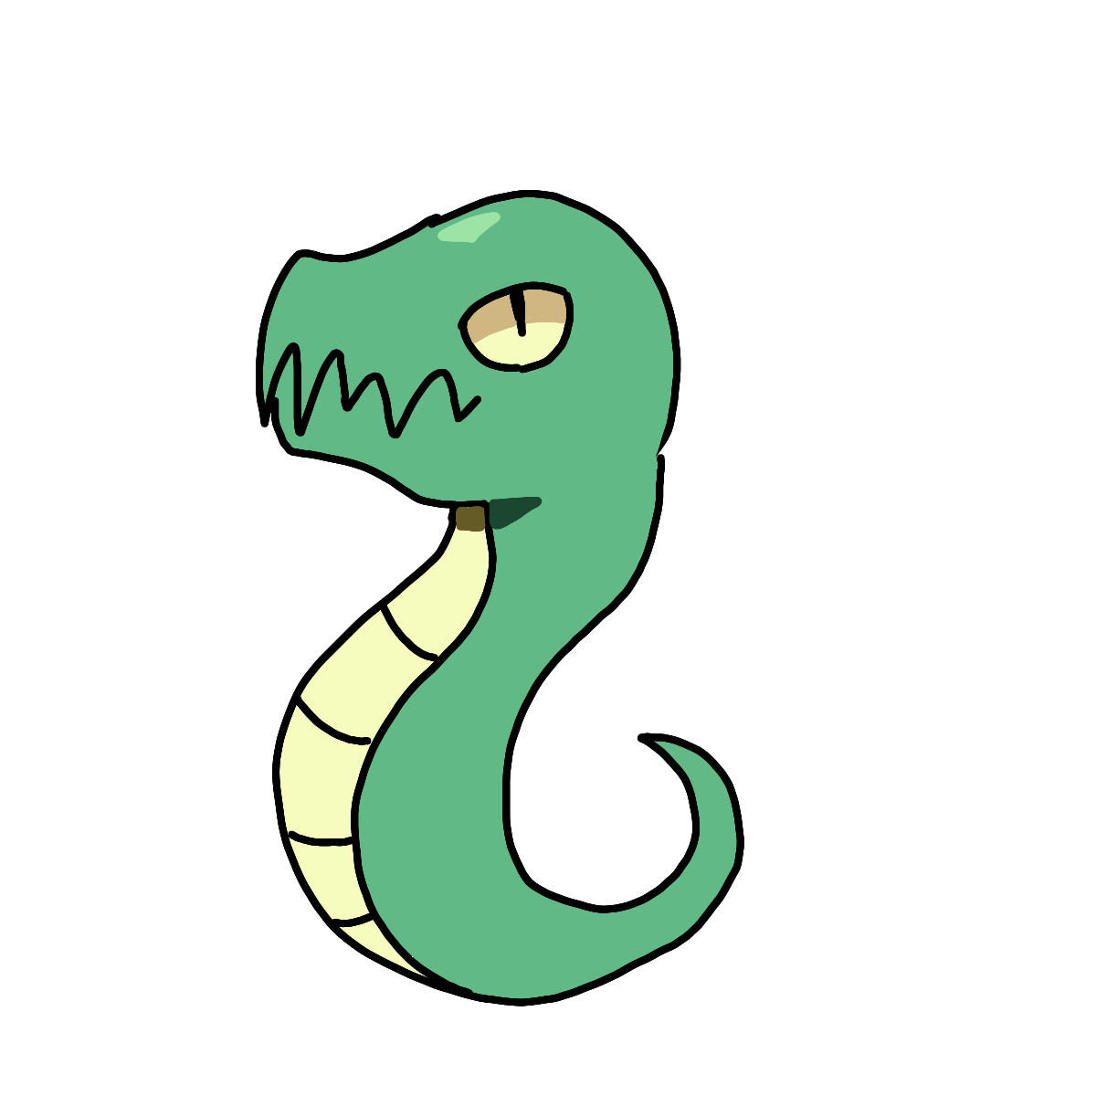

Epolf:

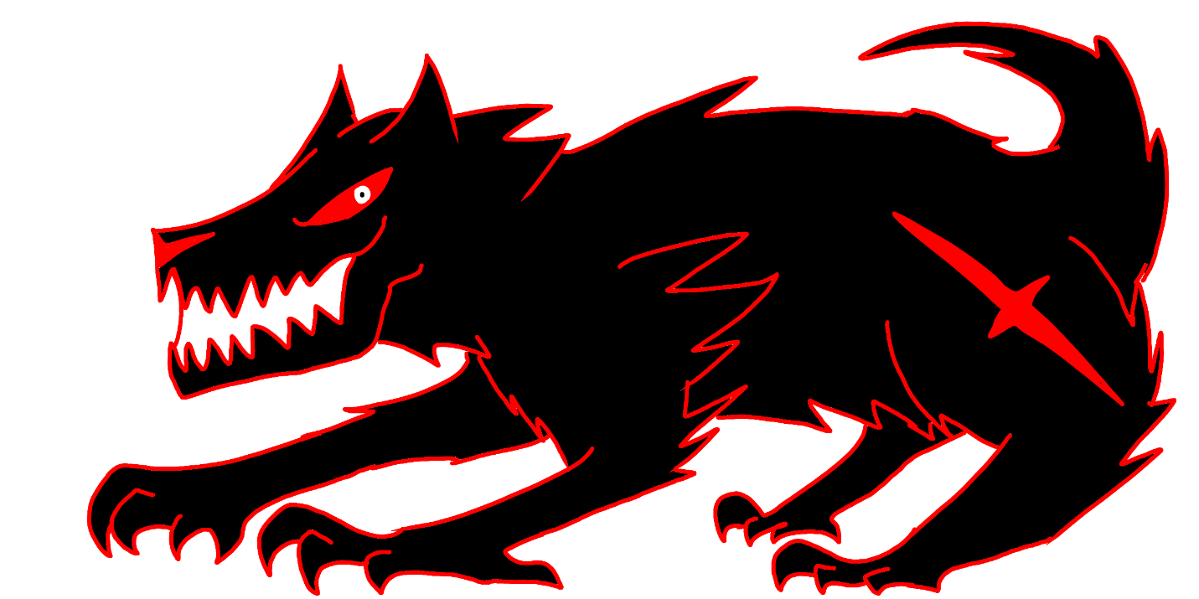

Scapus:

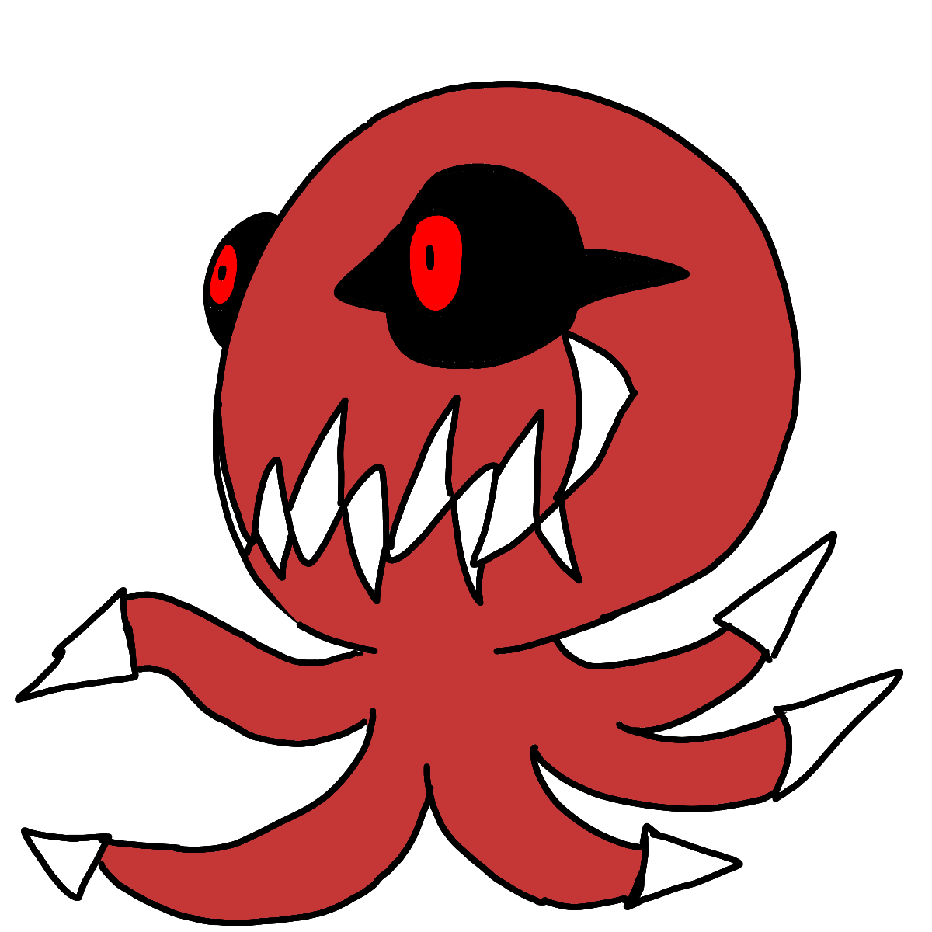

Stroture:

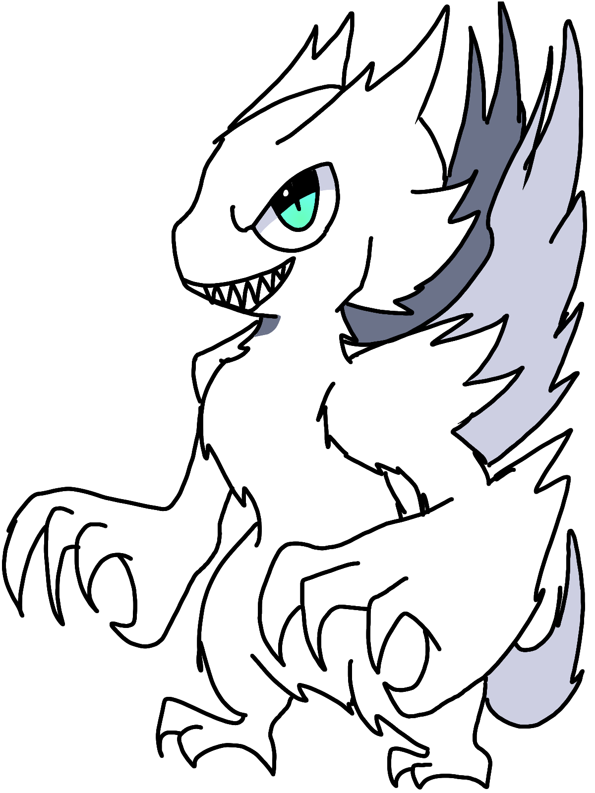

Orb:

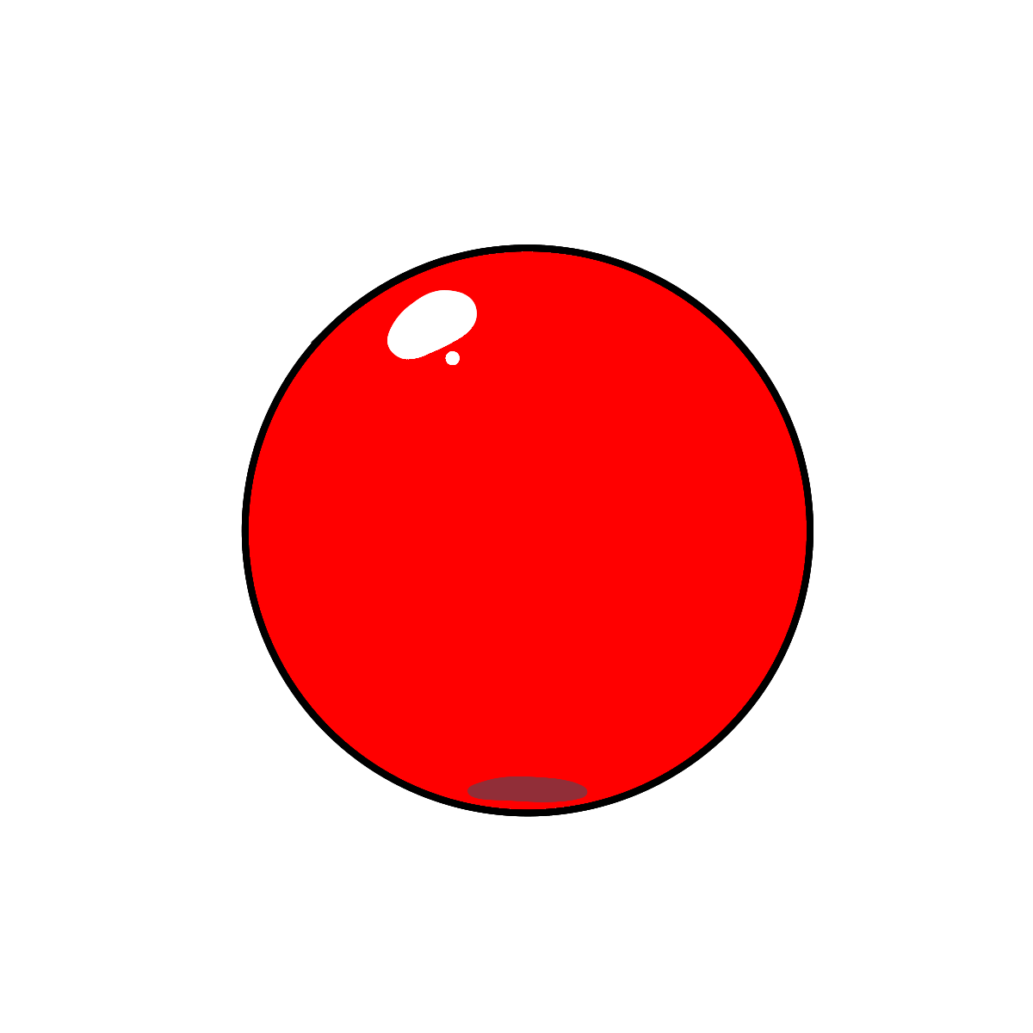

Sword:

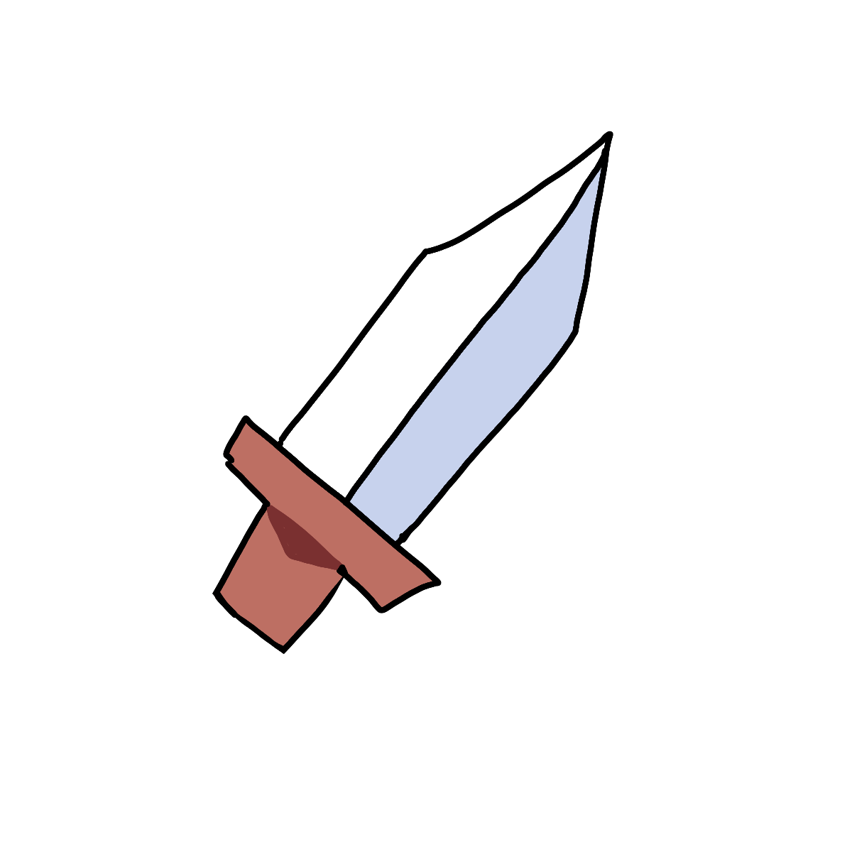

How do you plan to make your game engaging?

* I don’t know. It’s just fun.