**Change Request And Cross Evaluation Change Documentation**

**Document**

**CHANGES BASED ON CROSS REVIEW**

A lot of the change suggestions weren’t valid for our current version due to the extensive number of changes that were made in the code. However, these are the few changes we made based on the cross-review

We added an Exit button for the admin class so that they aren’t stuck in it.

We changed the login algorithm to make it more efficient

We created a common user class to store the common method of creating an account.

We added a lot of comments so the reader is able to follow the code structure and work.

The consistency in naming conventions and variables names was increased.

The input requirements are now specified to the user for better clarity.

**Change Requests**

1. **Modified Class Diagram**

Based on valuable feedback from our TA Kai we changed our class diagram structure from the over-complex one to a more simple version which follows a similar structure as the one below-:

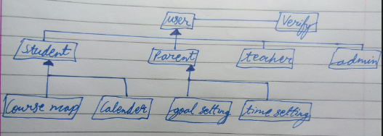

Apart from that, a few changes in the functional and non-functional requirements were made such that they could be practically integrated with the code and were user-friendly and efficient as well.

**2. Changes From Functional Requirements -**

3.1.2 was not implemented due to the difficulty of integrating a deliverable message to a user’s email address, and additionally, it was much more effective for the user to create their own password with certain criteria so they are able to remember it easier. 3.1.7 was not implemented, however instead the opt for a simple welcome message to greet students was incorporated within the system. 3.1.8 was partially implemented with all relevant menu options other than the Q/A menu option. This was decided based on the importance of such a feature and if there will be sufficient gain from such a process without the use of a simple AI, or preset questions and answers, which defeats the purpose of the ‘interactive’ section. 3.1.9, 3.1.10 relate to the aesthetic of the interface, which was completed via the implementation of tkinter, and hence due to the difficulty of the requirement, we were unable to incorporate the ‘railway’ theme and intricate scenery after user actions.

3.1.11, 3.1.12 was not disregarded, however the need for videos we felt was exaggerated and hence, felt it would be more appropriate and effective for users to learn via notes they can read to sum up information meaningfully and intricately. The omission of the resume study option was primarily due to time constraints. 3.1.14 was omitted due to the lack of need for such a requirement as all notes were already provided, and any additional notes could be handwritten by the user alternatively. This notes page would not be able to be accessed during a quiz, hence its insignificance. 3.1.19, 3.1.20 were disregarded similarly to 3.1.8. 3.1.22 was alternatively approached with the ability for parents to set times and topic goals, however they are unable to track exact time spent by a student. 3.1.25, 3.1.26 were similarly omitted to 3.1.2.

**3. Changes From Non Functional Requirements -**

4.2.2 was not introduced, but instead provided the user an option to try again or quit and study the topic again. This potentially could have been implemented in a way such that if the score was lower than 5 for example, a further reading prompt would appear after completion of the test. 4.3.4. Admins are only required to provide a valid username and password to view user information. The additional security question was omitted due to our ability to comply to all legal requirements and the admins' inability to physically manipulate sensitive information. 4.4.6 images were rather neglected throughout, other than the opening welcome screen to entice users. Potentially more images should have been easily added to increase the aesthetics of the interface.