Title page:

Comparative Analysis of Six Correlation Metrics on Identifying DNA Co-Methylation Patterns

Mayla Wardª, Neo Eloff^{b}, and Shuying Sun^{b*}
ªDepartment of Mathematics, Western Washington University, 516 High St, Bellingham, WA, USA, 98225. Email: maylacward@gmail.com
^{b}Department of Mathematics, Texas State University, 601 University Dr., San Marcos, TX, USA,78666. Email: neoeloff@gmail.com
^{b}Department of Mathematics, Texas State University, 601 University Dr., San Marcos, TX, USA,78666. Email: s_s355@txstate.edu
*Corresponding author: Shuying Sun. Email: s_s355@txstate.edu or ssun5211@yahoo.com
ORCID ID of Shuying Sun: 0000-0003-3974-6996

Funding: The two student authors (Mayla Ward and Neo Eloff) were funded in the summer of 2022 with the NSF-REU grant #2150205. This project was supported by a Texas State University internal grant of the corresponding author (Shuying Sun).

Acknowledgments: This project was made possible with the use of Texas State University’s facilities and resources. We were particularly grateful for the help and support from colleagues at the High-Performance Computing Cluster and the Writing Center. We appreciate the editor and reviewer’s thoughtful comments and suggestions, which have helped us improve this paper greatly.

Comparative Analysis of Six Correlation Metrics on Identifying DNA Co-Methylation Patterns

Abstract
DNA methylation is an important epigenetic event and is significantly associated with cancer. Different genomic sites tend to be co-methylated. It is unclear which correlation metrics should be used to study co-methylation and how different metrics perform in identifying highly co-methylated (HCM) sites. It is also unclear the impact of different features of the data, e.g., outlier, low variance, and data transformation (from B to M=logit(B)). We therefore conducted comprehensive analyses of six metrics, Pearson, Spearman, Kendall, Hoeffding, Distance, and Maximal Information Coefficient (MIC). Key findings are summarized below. First, the runtime of the six metrics drastically differed and increased with sample size, especially for MIC. Spearman and Pearson were much faster (with no missing data). Second, the numbers of HCM sites identified by the six metrics were very different. Pearson and Distance both identified more HCM sites and had strong similarities. However, these metrics were susceptible to outliers and data transformation. They identified more HCM sites when using B values, but these sites tended to have outliers and lower variance. Third, Kendall and Hoeffding's scores were significantly lower than other metrics’ correlation coefficients, making it difficult to identify HCM sites without a proper cutoff. Fourth, MIC required a large sample size to perform properly. Although it may detect unique correlation patterns, it is difficult to interpret these patterns biologically. Finally, considering all factors together (runtime, outlier, low variance, and data transformation), Spearman is relatively better for co-methylation analysis with no missing data.
Keywords: DNA Methylation, Pearson Correlation, Spearman Correlation

1. Introduction
DNA methylation is an epigenetic event that occurs when a methyl group (-CH₃) is covalently bonded to a cytosine base in a CG or CpG site (a pair of phosphate-bonded cytosine and guanine bases) [1]. Co-methylation refers to the similarity of methylation signals between CG sites that are either nearby on the same chromosome (within-sample co-methylation) or across different chromosomes and samples (between-sample co-methylation) [2, 3][5][6]. Going forward, we will use co-methylation to refer to between-sample co-methylation, which is the focus of this research.
For Illumina methylation array data, the methylation level at a CG site is often expressed using a Beta or B value. This value has a clear biological interpretation as the percent of methylation at a site. Many studies also use a logit transformation to convert these raw Beta or B values into M values: M=log₂(B/(1-B)). This transformation expands the range of B values concentrated near 0 and 1 and therefore produces a more homoscedastic measure of methylation[7]. As a result, M values are frequently used in studies on differential methylation [4, 5][9]. However, no research shows whether the logit transformation has any impact on co-methylation analysis.
Previous studies have employed correlation between the methylation levels (B values) from different CG sites to study co-methylation using Pearson’s correlation and Spearman’s correlations [3, 6, 7]. Pearson correlation is known to be strongly affected by outliers [8, 9], and Spearman correlation is rank-based method that does not use real value in the data [10]. Besides these two, there are other correlation metrics [11-21], most of which have not been used on co-methylation analysis. We selected six correlation metrics to evaluate their performance on identifying co-methylation. In particular, we compared the use of Pearson’s Correlation [22], Spearman’s Correlation [10], Kendall’s Tau Correlation [16, 17], Hoeffding’s D Measure [15], the Distance Correlation [20], and the Maximal Information Coefficient (MIC) [19].
We selected the above six methods based on their complementary strengths, relevance to prior work on genetic and epigenetic data, and availability of efficient implementations. The selected metrics are good representative of linear (Pearson), rank-based (Spearman, Kendall), distance-based (Distance Correlation), and nonparametric or information-theoretic approaches (Hoeffding, MIC), allowing detection of linear, monotonic, functional, and more general associations. Notably, Distance Correlation and MIC are relatively recent methods and have not been widely tested on large epigenetic datasets. All methods are efficiently implemented in R, making them practical for methylation data analysis.
The six metrics’ key features and attributes were summarized in Table 1, and the brief introduction of these metrics was shown in the Supplemental File (Section S1). Because of these correlation metrics’ differences, and the key characteristic of DNA methylation data, we explored how each of the six targeted metrics performs on identifying co-methylation patterns using matched-normal samples of a breast cancer dataset. This study investigates the impact of outliers and low variance on the metrics, the impact of using B and M values, the ability of each metric to detect highly correlated or co-methylated (HCM) CG sites, and other key features.
Previous work has analyzed some or all of the metrics included in this paper and applied them to different genetic datasets, but not DNA methylation data. Santos et al. applied eight correlation methods to gene expression data [23]. Hou et al. also studied correlations in gene expression data using Pearson, Spearman and MIC [24]. Another simulation study, conducted by Temizhan et al., applied nine different correlation methods (including our six selected ones except MIC) to bivariate normal and lognormal datasets [25]. Other studies have been conducted to investigate both theoretical interactions and applied functionality of the six methods we study [26-28]. Although these methods were previously evaluated on gene expression data and simulation data, methylation data differ substantially in structure and behavior, motivating our research. Our study is the first one to compare these correlation methods on co-methylation analysis by considering the effects of outliers, low variance, and data transformation.

2 Methods
This section has two distinct parts. Section 2.1 is the introduction to the data, transformation, and generation of the correlation matrices. Section 2.2 is a summary of the different analysis methods used to compare the six correlation metrics with our data.

Data, transformation, and correlation matrix generation

Data
Our analysis was conducted using 53 breast cancer (BRCA) patients’ matched-normal tissues that are publicly available from The Cancer Genome Atlas (TCGA) website [29]. Initially, for the Illumina 450K methylation microarray data, there were 485,577 CG sites for each sample. 380,355 sites were then left after removing CG sites with missing data (i.e., NA values), sites on chromosome Y, and duplicate sites. Removing sites with NA values also improved the runtime for several correlation metrics, especially the rank-based methods. See the Discussion section for further explanation of the impact of missing data on correlation calculations.

Transformation to address heteroskedasticity and outliers
The Illumina 450K methylation microarray data we used had the B values as measurements of methylation signals that were obtained after preprocessing steps. No raw methylation intensity values were used in this study. B values range from 0 to 1 and have low variance near 0 and 1[7, 8]. M values (M=log₂(B/(1-B))) range from -$∞$ to $∞$ and are often preferred for statistical analyses to address the outlier sensitivity and heteroscedasticity of B values [4, 5][9][7]. The monotonic conversion from B to M values preserves rank in the data. Thus, it is necessary to distinguish between the use of B and M values only when calculating non-rank-based Pearson and Distance correlations. We also investigated the impact of this logit transformation on identifying HCM sites.

Correlation matrix generation
We will briefly summarize the computational methods and functions in R below. Our comparison of correlation metrics for co-methylation analysis focuses on three different sample sizes, six different correlation metrics, and two different transformations of data (B and M values). To avoid a heavy computational burden, we computed all our correlations using the first 10,000 (or 10K) sites free of NA values from the BRCA data, and these sites were used for all analyses in this study. The 10K CG sites cover all chromosomes in the whole genome, and the 10K dataset is very similar to the entire data regarding key features. For a comparison of these two datasets’ features (e.g., genomic contexts and variability distribution), see the Discussion section.
We calculated pairwise correlations of these 10K sites using the full 53 samples, as well as using the first 10 and 30 samples. For Pearson, Spearman, and Kendall, we used the cor function with the parameter use = “everything”. For Hoeffding, we used the hoeffd function from the package Hmisc [30][17]. For Distance, we used the dcor.matrix function from the package Pigengene [31], which implements the dcor function from the package energy [32][21, 22]. Finally, for MIC, we used the mine function provided in the minerva package [14][17][23], with parameters n.cores = 3 and use = “everything”. As discussed earlier, for the non-rank-based correlation methods (Pearson and Distance), we computed correlation values using both B values and M values. In total, we generated 24 different correlation matrices, 8 for each of the sample sizes (N = 10, 30, or 53).

Comparison methods

Comparison of metrics - six main questions
We conducted an in-depth analysis to assess the performance of different correlation methods. We focused on addressing the following six questions, and the analysis result will be presented in Sections 3.1 to 3.7.
- Are there significant runtime differences among the six correlation methods? [Section 3.1]
- What is the impact of sample size on co-methylation analysis? [Section 3.2]
- Do these six correlation metrics yield similar or different conclusions regarding co-methylation identification? [Section 3.3 and 3.4]
- How do outliers in methylation data affect co-methylation analysis? [Section 3.5]
- How does the variance of methylation data affect co-methylation analysis? [Section 3.6]
- Does the choice of B or M values affect co-methylation results? [Section 3.7]

Runtime
To determine the computational efficiency of each correlation metric, we used the system.time function in R 4.2.0 to record the user, system, and elapsed time of generating each 10,000 by 10,000 (or 10K×10K) correlation matrix. The execution runtime for these correlation methods also varied depending on the language and algorithm used to implement them. The specific functions used to generate our correlations are listed in Section 2.1, with more information on the effects of missing data, low variance, and parameter choices discussed in the Discussion.

Generating 8×8 matrices, bar plots, and bin plots
Following the generation of the correlation matrices, we created “8×8 matrices” as Sun et al did [3][6]. These 8×8 tables were essential in comparing the choice of sample size, correlation metric, and data transformation (questions 2, 3, and 6 listed above). To construct the tables, we split the [-1, 1] interval into 8 sub-intervals of length 0.25. For an example 8×8 table, see the Supplemental Table S1 (in Section S2).
Previous comparative research has compared two metrics using a scatter plot[19, 24]. However, this method of comparison was complicated by the volume of our data (49,995,000 coefficients to plot). A similar comparison was achieved using bin plots, which, like scatterplots, represented each pair as a point on a graph with the density of points in each region indicated by a color scale.
Finally, we used “8×8 bar plots” to analyze how HCM pairs were scored by different metrics. We produced a set of tables that compared the HCM pairs from a target metric with the correlations assigned to those pairs by each of the remaining metrics. We then used bar plots to depict the distribution of these scores from each metric. These bar plots allowed us to investigate the disparity between HCM pairs identified by different metrics.

High correlation or high co-methylation counts
A major focus of this study was to look at the performance of identifying HCM sites or pairs. We will use high correlation and high co-methylation interchangeably. One way to identify HCM sites was to look at a single CG site and count the number of other sites it was highly correlated with. For a given metric, we defined a pair as HCM if the magnitude of its correlation is ≥ 0.75 (not 0.8 as used before) for the sake of convenience and consistency because our 8×8 matrices used it.

Experimental subsetting
For our outlier and variance analysis (questions 4 and 5), we split the 10K data into different subsets based on the variance and outlier count of each CG site. This enabled us to study the impact of these factors. To analyze the outliers, we split the data into subsets containing sites with 0 outliers, 1 or 2 outliers, and then 3 or more outliers. We then took a sample of 1,000 sites from each subset so that the comparisons were of equal size. Similarly, for variance, we divided the sites based on the standard deviation (SD) of their Beta values. The three groups were sites with SD < 0.05, 0.05 ≤ SD ≤ 0.1, and SD > 0.1. The goal of the experimental subsetting was to separate the impact of either outliers or low variance and study how these factors affect the identification of HCM pairs.

3. Results
This section focuses on providing our best answers to the questions posed in Section 2.

3.1 Runtime comparison
The generation of 24 correlation matrices of size 10K × 10K was done using R 4.2.0 with runtime listed in Table 2. We used datasets with three sample sizes (10, 30, and 53 samples) and a computer with an Intel Core i5-8600K CPU @ 3.60GHz processor and 16 GB of RAM. User time, system time, and elapsed time were recorded and listed separately. It should be noted that elapsed time is typically the sum of user and system times but may be greater in cases where parallelization was used (e.g., for MIC). For each metric, we observed that runtime scaled with sample size. The increase due to sample size was minimal for Pearson and Spearman, which were the fastest of our metrics and ran in only a few seconds. With all other metrics, we observed a much larger time complexity. The run time of Kendall and Hoeffding ranges from 40-50 seconds to 700-1100 seconds. This runtime (< 20 minutes) made them the second fastest group. Lastly, Distance and MIC required larger runtimes that scaled dramatically as sample size increased, ranging from 850 seconds (14 minutes) to 24,000 seconds (6.07 hours). The increase in runtime for large sample sizes made these methods less practical for use on large datasets. For a more detailed discussion of runtime, see the Discussion section.

3.2 Sample size impact
The original BRCA dataset included 53 samples for each CG site. To analyze the effect that different sample sizes have on co-methylation detection, we computed each correlation type using all 53 samples as well as subsets of 10 and 30 samples. The distribution of correlation scores for each metric and sample size is shown in Figure 1. As the sample size increased from 10 to 53, the correlations in the [0.5, 0.75) and [0.75, 1] range decreased while the number of correlations in the [0, 0.5) range drastically increased. This indicated that a sample size of 10 may have falsely identified some high co-methylations. Another problem with small sample size arises using Distance correlation (see the pink and yellow bars for B.Distance and M.Distance, respectively). Using 10 samples, this metric (with both B and M values) did not identify any pair as completely uncorrelated (i.e., pink and yellow bars vanish in the range of [0, 0.25) ). With Hoeffding’s statistic (see the cyan bar in Figure 1), almost all pairs, for all three sample sizes, were contained in the [0, 0.25) interval. Figure 1 also shows that as the sample size increased, the number of pairs located in the lower quartile decreased for MIC (see the gray bars). This could be because MIC was unable to detect correlations using only 10 samples but could detect more HCM pairs using 53 samples.
To further analyze the change in the correlations assigned to CG pairs, we looked at 8×8 tables of the same correlation metrics using different numbers of samples, see the Supplemental Table S2, in which we compared Pearson coefficients computed from 10 samples, 30 samples, and 53 samples. This table shows a much stronger agreement (indicated by larger percentages in the diagonals) between the 30 and 53 sample correlations as opposed to the comparisons with the 10 sample correlations. This stronger diagonal could also be seen when comparing sample sizes for the other metrics and data types (See the Supplemental Table S3). In fact, for all 30 vs. 53 sample 8×8 tables, at least 80% of the correlations generated with 30 samples fell within the corresponding diagonal cell of the 53 sample 8×8 table or one cell to the right or left. This strong agreement was not present when comparing 10 and 30 (or 10 and 50) sample correlation scores. Given the strong agreement between the correlations calculated using 30 and 53 samples, we chose to proceed with our analysis using 30 samples so that our findings would be useful to geneticists studying smaller datasets.

3.3 Pair-wise comparison of different metrics
We performed a pairwise comparison of six metrics using correlation scores they assigned to each pair of CG sites. We first calculated Pearson’s correlation based on the absolute values of the scores produced by each method (Table 3). We then analyzed scatterplots (bin plots) for each pair of metrics. This comparison used only the upper triangle of each correlation matrix to avoid duplication. In total, we produced 56 binned scatterplots comparing six correlation methods (with both B and M values for Pearson and Distance). Figures 2 and 3 show plots that epitomize the general patterns seen among these 56 combinations. These plots are grouped by the correlations exhibited in Table 3. Figure 2 shows a sample of metrics with correlation scores greater than 0.75. Figure 3 shows a sample of metrics with correlation scores less than 0.75. Additional bin plots are in Supplemental Figures S1-S3 (in Section S3).
Figure 2A and B show the strong correlation between B.Pearson and M.Pearson (ρ=0.9651) and between M.Distance and B.Distance (ρ=0.9780). Comparisons of high correlation scores using B and M values for Pearson and Distance will be revisited in Section 3.7 and the Supplemental File (Section S4). Figure 2C (ρ=0.9285) shows positive correlation between M.Pearson and M.Distance, with a chevron shape because Distance correlation scores were strictly positive while Pearson correlation scores ranged from -1 to 1 (recall that ρ is calculated using the absolute value of each pair’s correlation score). Noticeably, Distance correlation scores often had greater (and rarely had lesser) magnitudes than their Pearson counterparts. Figure 2D demonstrates a similarity between Kendall coefficients and Hoeffding statistics (ρ=0.8356). The graph comparing Spearman and Hoeffding (see the Supplemental Figure S1B) has a similar pattern due to the high correlation between Kendall and Spearman (Figure 2E). All other metrics exhibited very noisy plots and poor correlations when compared with Hoeffding’s statistics (see Figure 3C and D, and Supplemental Figure S1A). Figure 2E plots Spearman and Kendall, who had the highest correlation (ρ=0.9902) among all the metrics. Despite their similarity, Kendall’s coefficient has a smaller range than Spearman’s, indicating that Kendall’s might require a different threshold for what is considered a “high” correlation. The shape of the graph in Figure 2E is also consistent with the theoretical bounds relating Kendall and Spearman correlation coefficients (see page 829 of Kruskal and William, 1958) [33]. Figure 2F compares M.Pearson with Spearman (ρ=0.7968). This plot shows that these two metrics did not agree well with each other. The pattern exhibited by Figure 2F is representative of the relationship between both M and B.Pearson when compared to Spearman or Kendall (see Supplemental Figure S2).
Figure 3 shows pairs of metrics that did not display a strong similarity (ρ<0.75 in Table 3). Figure 3A compares Kendall’s coefficient with B.Distance (ρ=0.7108). The curve forming a lower bound for the region in Figure 3A indicated that as Kendall coefficients increased in magnitude, Distance coefficients also increased. The amount of noise above this curve indicated that pairs with large B.Distance coefficients may attain any Kendall correlation. Conversely, high Kendall correlations unanimously correspond to high Distance correlations. Figure 3B, which compares MIC with M.Pearson (ρ = 0.4901), resembles the original plot shown in the MIC paper [19], for more detail, see the Discussion section. The streaking pattern in this plot (and others comparing MIC) resulted from the fact that MIC outputs only a finite number of possible scores for a sample size of 30. Figure 3C plots Hoeffding vs. M.Pearson (ρ = 0.6240). Plots comparing B.Pearson and M and B.Distance correlations to Hoeffding statistics all displayed this pattern. Finally, Figure 3D shows the comparison between Hoeffding and MIC. This plot was very similar to those produced when comparing Hoeffding and Distance, which had correlation scores of 0.6735 and 0.6318 for M.Distance and B.Distance, respectively (see Table 3 and Supplemental Figure S1A). It is likely that the high concentration of points near (0, 0.25) (the small red region) contributed to this higher correlation.
Overall, the bin plots help us to identify families of metrics that behave similarly or dissimilarly. The strongest similarities occurred when comparing (1) Pearson and Distance correlations (with both M and B data) and (2) Kendall, Spearman, and Hoeffding correlations. Meanwhile, MIC and Hoeffding had the weakest relationships with other metrics, typically displaying noisy relationships. Finally, we note that many of the comparisons between rank-based metrics (Spearman, Kendall, Hoeffding, and MIC) and non-ranked metrics (Pearson, Distance) had noisy bin plots. This indicated that the different properties of ranked and non-ranked metrics (such as how they are affected by outliers and low variance) may distinguish the performance of these two classes of correlation methods.

3.4 High correlations (positive or negative)
Pearson, Spearman, Kendall distinguished between positive and negative correlations and assigned scores in the range [-1, 1]. Hoeffding, Distance, and MIC measured strength but not direction of correlation, assigning scores in the range [0, 1] ([-0.5, 1] in the case of Hoeffding). It was evident from both previous research [3] and our analysis (see the Supplemental Table S2) that, among the three signed metrics, the number of positive correlations with coefficients in the range [0.75, 1] (~1,600,000) vastly outnumbered those negative correlations with scores in the range [-1, -0.75) (~200,000). We wanted to investigate how strong positive and negative correlations were identified by metrics that did not distinguish the direction of correlation.
The bar plots in Figure 4 A and B show how pairs identified as strongly positively correlated by Pearson (with M and B data, respectively) were scored by each of the other metrics. Only Distance assigned high scores to the majority of these pairs as Pearson did. Furthermore, since B.Pearson identified 500,000 more highly positively correlated pairs compared to M.Pearson, Figure 4B shows a greater discrepancy between M and B counts for Pearson and Distance alike. Figure 4C and Figure 4D show how pairs identified as strongly negatively correlated by Pearson (with M and B data, respectively) were scored by each of the other metrics. Note that the outputs of Distance, Hoeffding, and MIC are non-negative, and so were counted in the positive intervals on the right side of each plot. The plots demonstrate that most pairs with strong negative Pearson correlations also received strong correlations from Distance (but not other metrics), consistent with our findings shown in Figure 2C. Figures 4E and F show that the strongly negatively correlated pairs identified by Spearman and Kendall were also identified as highly correlated by other metrics. Spearman’s coefficient identified 119,957 strong negative correlations, about half as many as either M.Pearson or B.Pearson. Kendall’s coefficient identified even fewer negative correlations, assigning scores in the range [-1, -0.75) to only 1,434 pairs. Furthermore, these pairs were scored predominantly in the [0.5, 1] interval for MIC and the [0.25, 1] interval for Hoeffding. This is a sharp contrast to the distribution of strongly negative Pearson pairs shown in Figure 4C and Figure 4D, for which most Hoeffding and MIC scores were an interval lower ([0.25, 0.5] for MIC and [0, 0.25] for Hoeffding). Interestingly, despite identifying twice as many highly negatively correlated pairs, Pearson's coefficient disagreed with many of the high negative correlations assigned by Spearman (Figure 4E). Plots C, D, and E demonstrate that M.Pearson, B.Pearson, and Spearman each identified highly negatively correlated pairs that were not scored similarly by the other two metrics.
In summary, Figure 4 compares different correlation methods applied to those pairs that were strongly correlated using the three signed metrics (Pearson, Spearman, and Kendall). We observed that strong positive correlations due to M.Pearson and B.Pearson are not frequently agreed upon by any metrics other than M.Distance and B.Distance (Figure 4A-D). In contrast, the smaller number of highly negatively correlated pairs identified by Spearman and Kendall generated stronger correlations with MIC and Hoeffding in addition to many high correlations using Pearson and Distance (Figure 4E and Figure 4F).

3.5 Impact of outliers
Pearson’s correlation is susceptible to outliers, [11]which was a concern. To better understand the effect of outliers, we employed a subset selection process using the 10K data and based on the number of outliers outside of the 3IQR region. Subset 1: First 10K CG sites. Subset 2: Sites with 0 outliers outside of 3IQR. Subset 3: Sites with 1 or 2 outliers outside of 3IQR. Subset 4: Sites with at least 3 outliers outside of 3IQR. For detailed information of these subsets, see the Supplemental Table S4. We sampled 1,000 random CG sites from the first 10K sites and selected the first 1,000 CG sites from the other three subsets. Figure 5A shows a typical or random sample. We observed that the sample with no outliers (Figure 5B) had lower HCM counts than all other samples, including Distance (pink and yellow) and Pearson (black and red). Sites that contained 1 or 2 outliers (Figure 5C) showed an increase in HCM counts in both Distance and Pearson when compared to Figure 5A. Sites with at least 3 outliers (Figure 5D) displayed that over 70% of the sites in the sample had 900 – 1000 HCM counts for B.Pearson and B.Distance, which suggested that outliers significantly impact HCM counts of each CG site. Notably, across all four samples, Spearman (green), Kendall (blue), Hoeffding (cyan), and MIC (grey) performed very similarly, suggesting that outliers have little to no impact on these metrics. This is consistent with the properties of these rank-based metrics (i.e., not affected by outliers).
In summary, outliers had a significant impact on Pearson and Distance correlation coefficients (especially those correlations using B values) but no impact on rank-based correlation metrics. Those CG sites whose samples contain 3 or more outliers were frequently identified by Pearson and Distance correlation methods as highly correlated with many other CG sites.

3.6 Impact of variance
As with outliers, we were concerned that low variance among B values could impact how some metrics identified CG sites with high correlations using either M or B data. To conduct analysis, we partitioned four subsets. Subset 1: First 10K CG sites. Subset 2: Sites with standard deviation (SD) < 0.05. Subset 3: Sites with 0.05 ≤ SD ≤ 0.1. Subset 4: Sites with SD > 0.1. For detailed information of these subsets, see the Supplemental Table S5.
Figure 6 shows bar plots of the HCM counts for each subset. Figure 6A shows the distribution of HCM counts for 1000 random sites. We observed that sites with a standard deviation < 0.05 (Figure 6B) were most like the random sample (Figure 6A) with only a slight increase in HCM counts in B.Pearson (black) and B.Distance (purple) in the (200, 300] bin. The sample with 0.05 ≤ SD ≤ 0.1 (Figure 6C), had a notable reduction in HCM counts with Pearson (red and black) and Distance (yellow and pink). In the sample SD > 0.1 (Figure 6D), we observed a substantial increase in HCM counts in all metrics except Hoeffding (cyan) and Kendall (blue). This contrasts with Figure 6C, which declined, indicating that only a substantial increase in variance coincided with an increased HCM count. Although Spearman (green) is a rank-based metric, it behaved similarly to Pearson (black and red) and Distance (pink and yellow) in its identification of HCM pairs in the upper intervals of Figure 6D. Overall, for sites with high variance (SD > 0.1), there was a pattern of increased HCM counts in the data from most metrics.
Overall, we found that the impact of low variance was minimal. The low-variance sample (with SD<0.05) was most like a random sample, which makes sense given that it accounts for 60.37% of the entire data see the Supplemental Table S5. In contrast, the high-variance sample identified more HCM counts than the random sample. This was particularly true for Pearson, Distance, and Spearman. However, our analysis does not reveal any monotonic trend of increasing HCM counts with increased variance, and the increases witnessed in Figure 4D appear much smaller than the impacts of outliers in Figure 5D. Even though the above analysis shows the impact of low variance is minimal, if some researchers think that it is not biologically meaningful to have HCM CG sites with a low variance level, it is proper to filter out those CG sites to only identify sites and pairs with biological significance. For example, Sun et al. (2022) removed CG sites with maximum and minimum methylation differences < 0.05 [3][6].

3.7 Impact of transformations: B vs. M values
Here, we briefly discussed our study on the impact that the logit transformation converting B values to M values had on Pearson and Distance correlations. Our study consisted of pair-based and site-based analyses. For more details, see the Supplemental File (Section S4).

3.7.1 Pair-based analysis
It is evident that B values produce significantly more highly correlated pairs than M values. With Pearson correlation, an additional 525,963 pairs are highly correlated using B values (an additional 29% of the HCM count of M value correlations). With Distance correlation, this number rises to 537,331 (30% of the HCM count of M value correlations) (see the Supplemental Table S6 and Table S7 for the 8×8 matrices). In order to understand the differences between correlations with M values and B values we studied the presence of outliers in highly correlated pairs. We considered CG pairs that were highly correlated using only M values, only B values, or both, and then divided these groups based on whether the sites in each pair had one or more outliers (measured using a fence of 3IQR on the original B values). As Table 4 shows, pairs that were correlated using only M values tended to have at least one site with no outliers, while pairs that were highly correlated using only B values tended to have at least one site with outliers. Interestingly, pairs with both M and B correlations were likely to have either no sites with outliers or both sites with outliers. This suggests that correlations with B values are more susceptible to outliers in the original data, whereas the logit transformation reduced the influence of these points.

3.7.2 Site-based analysis
As discussed in Section 3.7.1, this section examined how the logit transformation from B to M values affected HCM counts for Pearson and Distance measures. Specifically, we assessed whether the observed differences were driven by a small subset of CG sites or reflected a broader tendency for CG sites to exhibit higher correlations under B values than under M values. To evaluate this, we constructed a scatterplot comparing each site’s HCM counts using B values versus M values (Figure 7). We classify a site as B-dominant if it has at least twice as many HCM counts under B values as under M values (yellow regions Figure 7), with a minimum absolute difference of 100 counts; M-dominant sites are defined analogously (pink regions Figure 7).
Further analysis shows that B-dominant sites constitute a small fraction of the 10K sites yet account for the majority of highly correlated B-only pairs (see the Supplemental file, Section S4.2). Similarly, a small number of M-dominant sites generate most highly correlated M-only pairs. This pattern is consistent with the Pareto Principle (the “80/20 rule”), whereby a minority of sites drives most of the observed differences between B and M correlations. Across all four subsets (four colored regions in Figure 7), fewer than 8% of sites contributed between 37.22% and 68.69% of pairs that were highly correlated exclusively under their dominant data type (see the supplemental Table S8). We further examined whether B-dominant and M-dominant CG sites exhibited distinct statistical characteristics by comparing their outlier counts and variance distributions to those of the full 10K dataset. We found that B-dominant sites showed higher outlier counts and lower standard deviation, whereas M-dominant sites exhibited fewer outliers but higher standard deviation relative to the overall dataset (see Supplemental Figure S4 and Figure S5).

4. Discussion
In this section, we briefly listed a few aspects or factors that are related to the six correlation metrics we studied and our comparison analysis. Due to space limitations, more detailed explanations and discussions of these seven aspects are provided in the Supplementary File (Section S5.1-5.7). First, missing data can affect the run time and performance of all metrics significantly in various ways (Section S5.1). Second, it is worth to pay attention to some specific features and characteristics of certain correlation metrics (e.g., Hoeffding’s D statistic range of $-1/60≤D≤1/30$, and MIC’s low variance threshed), see Section S5.2. Third, we provided some further discussion on the cutoff of different metrics (see Section S5.3 with the Supplemental Figure S6). Fourth, we conducted a permutation-based control analysis (see Section 5.4 with the Supplemental Table S9). Fifth, there are a few other studies that compare various correlation methods using different datasets and analysis methods [23-27]. We briefly highlighted the contributions of these studies and our research work in this area (see Section S5.5). Sixth, our conducted a comparative analysis to show the 10K data represent the entire data well (see Section 5.6 with the Supplemental Figure S7). Seventh, our research work has certain limitations as well as contribution and novelty (Section S5.7).

5. Conclusion
In this paper, we have conducted the first in-depth analyses to study the performance of six correlation metrics in identifying co-methylation patterns. In particular, we addressed several questions regarding runtime, the impact of sample size, similarity or difference between metrics, the impact of outliers, low variance, and logit transformation (or data types, B vs. M values). The key conclusions regarding these questions and aspects are summarized below. First, runtime drastically differed and increased with sample size. Spearman and Pearson were faster (with no missing data). Second, sample size affected runtime and HCM site identification. When the sample size increased from 10 to 30 and then 53, the number of HCM sites decreased. Sample sizes 30 and 53 produced similar results. Third, pairwise comparison showed strong similarities between Pearson and Distance as well as between Spearman and Kendall. Comparisons to MIC and Hoeffding showed less similarity. The numbers of HCM sites identified by the six metrics were very different, with Pearson and Distance identifying the highest number of HCM sites. Fourth, generally, the impact of low variance was negligible, but the sites with large variance tended to produce far more HCM counts. Fifth, outliers significantly affect Pearson and Distance but not on other metrics. Six, the transformation from B to M had a large impact on Pearson and Distance. More HCM sites were identified when using B values, and HCM sites identified only with B values tended to have more outliers and lower variance. Finally, it is a small number of sites that contribute to a large number of the HCM pairs that were only identified either with B or M values. The findings of this project will be useful for further studies related to methylation pattern analysis and the identification of methylation biomarkers. It can provide new understanding and significant insights on gene co-expression and interaction analyses.

Supplementary material is attached.

Statements and Declarations
Ethics approval and consent to participate: Not applicable because publicly available datasets were used.
Consent for publication: Not applicable.

Competing interests: The authors declare that they have no competing interests. The authors also declare that the research was conducted in the absence of any commercial, financial, or non-financial relationships that could be construed as a potential or actual conflict of interest.

Data and Code Availability:
The original or raw datasets supporting the conclusions of this article are publicly available in the TCGA repository https://portal.gdc.cancer.gov/. Therefore, no ethics committee approval was required for this study. The datasets (tables and figures) supporting the conclusions of this article are included within the article. All R code/script files that generated figures and tables were posted on online: https://github.com/ss355/Cor.Study.

Author Contributions:
All authors contributed to the study’s conception and design. Datasets were prepared by the corresponding author. Data analyses were conducted by the first two student authors, and the first draft of the manuscript was written by these two authors. They contributed equally to this project. The corresponding author led the project, provided original ideas and suggestions throughout the project, and extensively revised the paper. All authors commented on previous versions of the manuscript. All authors read and approved the final manuscript.

References

1. Jones, P.A. and J.D. Buckley, The role of DNA methylation in cancer. Adv Cancer Res, 1990. 54: p. 1-23.
2. Sun, L. and S. Sun, Within-sample co-methylation patterns in normal tissues. BioData Min, 2019. 12: p. 9.
3. Sun, S., et al., Thorough statistical analyses of breast cancer co-methylation patterns. BMC Genom Data, 2022. 23(1): p. 29.
4. Du, P., et al., Comparison of Beta-value and M-value methods for quantifying methylation levels by microarray analysis. BMC Bioinformatics, 2010. 11: p. 587.
5. Weinhold, L., et al., A statistical model for the analysis of beta values in DNA methylation studies. BMC Bioinformatics, 2016. 17(1): p. 480.
6. Akulenko, R. and V. Helms, DNA co-methylation analysis suggests novel functional associations between gene pairs in breast cancer samples. Hum Mol Genet, 2013. 22(15): p. 3016-22.
7. Mallona, I., et al., DNA co-methylation networks outline the structure and remodeling dynamics of colorectal cancer epigenome. BioRxiv, 2020.
8. Devlin, S.J., R. Gnanadesikan, and J.R. Kettenring, Robust Estimation and Outlier Detection with Correlation-Coefficients. Biometrika, 1975. 62(3): p. 531-545.
9. Kim, Y., T.H. Kim, and T. Ergün, The instability of the Pearson correlation coefficient in the presence of coincidental outliers. Finance Research Letters, 2015. 13: p. 243-257.
10. Spearman, C., The proof and measurement of association between two things. American Journal of Psychology, 1904. 15: p. 72-101.
11. Bergsma, W. and A. Dassios, A consistent test of independence based on a sign covariance related to Kendall's tau. Bernoulli, 2014. 20(2): p. 1006-1028.
12. Blum, J.R., J. Kiefer, and M. Rosenblatt, Distribution Free Tests of Independence Based on the Sample Distribution Function. Annals of Mathematical Statistics, 1961. 32(2): p. 485-498.
13. Chatterjee, S., A New Coefficient of Correlation. Journal of the American Statistical Association, 2021. 116(536): p. 2009-2022.
14. Filosi, M., et al., Maximal Information-Based Nonparametric Exploration for Variable Analysis.” R package (Minerva) version 1.5.10. 2021-06-19. https://cran.r-project.org/web/packages/minerva/ 2021.
15. Hoeffding, W., A Non-Parametric Test of Independence. Annals of Mathematical Statistics, 1948. 19(4): p. 546-557.
16. Kendall, M.G., A new measure of rank correlation. Biometrika, 1938. 30: p. 81-93.
17. Kendall, M.G., The treatment of ties in ranking problems. Biometrika, 1945. 33: p. 239-251.
18. Papadatos, N. and T. Xifara, A simple method for obtaining the maximal correlation coefficient and related characterizations. Journal of Multivariate Analysis, 2013. 118: p. 102-114.
19. Reshef, D.N., et al., Detecting novel associations in large data sets. Science, 2011. 334(6062): p. 1518-24.
20. Székely, G.J., M.L. Rizzo, and N.K. Bakirov, Measuring and testing dependence by correlation of distances. Annals of Statistics, 2007. 35(6): p. 2769-2794.
21. Tripathi, Y.M., et al., A nonlinear correlation measure with applications to gene expression data. PLoS One, 2022. 17(6): p. e0270270.
22. Stigler, S.M., Francis Galton's account of the invention of correlation. Statistical Science, 1989. 4(2): p. 73-79.
23. de Siqueira Santos, S., et al., A comparative study of statistical methods used to identify dependencies between gene expression signals. Brief Bioinform, 2014. 15(6): p. 906-18.
24. Hou, J., et al., Distance correlation application to gene co-expression network analysis. BMC Bioinformatics, 2022. 23(1): p. 81.
25. Temizhan, E., H. Mirtagioglu, and M. Mendes, Which correlation coefficient should be used for investigating relations between quantitative variables. American Scientific Research Journal for Engineering, Technology, and Sciences. , 2022. 85: p. 265-277.
26. Edelmann, D., T.F. Móri, and G.J. Székely, On relationships between the Pearson and the distance correlation coefficients. Statistics & Probability Letters, 2021. 169.
27. Shiekh, R.H.A. and E.F. El-Hashash, A comparison of the pearson, spearman rank and kendall tau correlation coefficients using quantitative variables. Asian Journal of Probability and Statistics, 2022: p. 36-48.
28. Shao, F. and H. Liu, The theoretical and experimental analysis of the maximal information coefficient approximate algorithm. Journal of Systems Science and Information, 2021. 9(1): p. 95-104.
29. TCGA GDC Data Portal (https://portal.gdc.cancer.gov/).
30. Harrell, F.E., R Package ‘hmisc: Harrell Miscellaneous’. Version 4.7–2. https://cran.r-project.org/web/packages/Hmisc/. 2022.
31. Zare, H., Pigengene: Computing and using eigengenes. R Package version 1.16.0. 2020. https://rdrr.io/bioc/Pigengene/. 2020.
32. Rizzo, M. and G. Szekely, E-Statistics: Multivariate Inference via the Energy of Data. R package (energy) version 1.7-11. 2022-12-22 https://cran.r-project.org/web/packages/energy/ 2022.
33. Kruskal, W.H., Ordinal Measures of Association. Journal of the American Statistical Association, 1958. 53(284): p. 814-861.

Tables and Figures

Table 1. Summary of attributes associated with each correlation metric. (*) indicates that the range of Hoeffding’s D Statistic may vary based on sample size and ties in data. (**) indicates that MIC is not strictly rank-based but is grid-based with a similar effect.
Correlation Metric | Range | Rank-Based? | Type of Dependency (large $n$) | Type of Dependency  (small $n$)
Pearson’s Correlation | [-1, 1] | No | Linear | Linear
Spearman’s Rank Correlation | [-1, 1] | Yes | Monotonic | Monotonic
Kendall’s Tau-B Coefficient | [-1, 1] | Yes | Monotonic | Monotonic
Hoeffding’s D Statistic | [-0.5, 1]* | Yes | Functional, non-functional, locally correlated | Functional
Distance Correlation | [0, 1] | No | Functional, non-functional, locally correlated | Functional
Maximal Information Coefficient (MIC) | [0, 1] | Yes** | Functional, non-functional, locally correlated | Monotonic

Table 2. Runtime for correlation matrix generation of data with 3 sample sizes. Runtime using 10, 30, and 53 samples was recorded in seconds. The Cor Type column refers to the metric. B.Pearson and M.Pearson indicate that Pearson correlations were calculated using B values and M values respectively. Colors were used for the elapsed time with green serving as the lowest runtime, blue as the median, and pink (or red) as the largest runtime.
 |  | Number of Samples |  |  |  |  | Number of Samples
Cor Type |  | N = 10 | N = 30 | N = 53 | Cor Type |  | N = 10 | N = 30 | N = 53
B.Pearson | User: | 2.1 | 2.95 | 4.03 | Hoeffding | User: | 47.75 | 240.53 | 693.41
B.Pearson | System: | 0.19 | 0.18 | 0.17 | Hoeffding | System: | 6.25 | 7.94 | 8.73
B.Pearson | Elapsed: | 2.28 | 3.14 | 4.2 | Hoeffding | Elapsed: | 54.1 | 253.02 | 706.66
M.Pearson | User: | 2.2 | 3.06 | 4.08 | B.Distance | User: | 4998.72 | 14496.81 | 17319.09
M.Pearson | System: | 0.09 | 0.1 | 0.16 | B.Distance | System: | 186.94 | 365.16 | 1975.54
M.Pearson | Elapsed: | 2.29 | 3.15 | 4.24 | B.Distance | Elapsed: | 5189.33 | 14868.98 | 19310.78
Spearman | User: | 1.73 | 2.6 | 3.72 | M.Distance | User: | 4972.19 | 15704.98 | 17121.22
Spearman | System: | 0.18 | 0.19 | 0.19 | M.Distance | System: | 189 | 341.14 | 2104.22
Spearman | Elapsed: | 1.93 | 2.79 | 3.9 | M.Distance | Elapsed: | 5164.78 | 16052 | 19240.27
Kendall | User: | 44.11 | 362.38 | 1104.69 | MIC | User: | 122.75 | 132.9 | 37.8
Kendall | System: | 0.09 | 0.24 | 0.29 | MIC | System: | 92.67 | 198.74 | 39.05
Kendall | Elapsed: | 44.28 | 362.29 | 1105.48 | MIC | Elapsed: | 850.78 | 5303.79 | 23668.49

Table 3. Pearson correlation of different pairs of correlation metrics. Pearson’s correlation between the absolute value of correlation scores by different metrics. Bold indicates ρ> 0.75.
Metrics | B.Pearson | M.Pearson | Spearman | Kendall | Hoeffding | B.Distance | M.Distance | MIC
B.Pearson | 1 | 0.9651 | 0.7336 | 0.7332 | 0.5846 | 0.9372 | 0.9078 | 0.4586
M.Pearson | 0.9651 | 1 | 0.7968 | 0.7925 | 0.6240 | 0.9131 | 0.9285 | 0.4901
Spearman | 0.7336 | 0.7968 | 1 | 0.9902 | 0.8029 | 0.7066 | 0.7532 | 0.6280
Kendall | 0.7332 | 0.7925 | 0.9902 | 1 | 0.8356 | 0.7108 | 0.7558 | 0.6318
Hoeffding | 0.5846 | 0.6240 | 0.8029 | 0.8356 | 1 | 0.6318 | 0.6735 | 0.7284
B.Distance | 0.9372 | 0.9131 | 0.7066 | 0.7108 | 0.6318 | 1 | 0.9780 | 0.5696
M.Distance | 0.9078 | 0.9285 | 0.7532 | 0.7558 | 0.6735 | 0.9780 | 1 | 0.6155
MIC | 0.4586 | 0.4901 | 0.6280 | 0.6318 | 0.7284 | 0.5696 | 0.6155 | 1

Table 4. Summary of M-Only, B-Only, and Both (M and B) pairs based on outlier counts. Each cell indicates the number of pairs with the corresponding correlation type and number of outliers. Bold cells indicate outlier counts common to more than 30% of pairs in each group.
 | Positive Pearson |  |  | Negative Pearson |  |  | Distance
Outlier numbers | M-Only | B-Only | Both | M-Only | B-Only | M and B | M-Only | B-Only | Both
Both 0 outliers | 47.75% | 9.28% | 25.31% | 56.44% | 26.51% | 49.34% | 49.7% | 8.25% | 31.28%
Both 0 outliers | 103664 | 66917 | 346525 | 30421 | 20137 | 75688 | 110910 | 62811 | 494245
One site with 0 outliers | 50.07% | 42.31% | 24.15% | 39.57% | 32.14% | 19.12% | 47.71% | 42.21% | 20.85%
One site with 0 outliers | 108710 | 305125 | 330666 | 21332 | 24410 | 29329 | 106465 | 321028 | 329411
Both sites have outliers | 2.16% | 48.39% | 50.52% | 3.97% | 41.33% | 31.53% | 2.57% | 49.25% | 47.86%
Both sites have outliers | 4704 | 348963 | 691613 | 2144 | 31386 | 48377 | 5747 | 376614 | 756205
Total | 217078 | 721005 | 1368804 | 53897 | 75933 | 153394 | 223122 | 760453 | 1579861

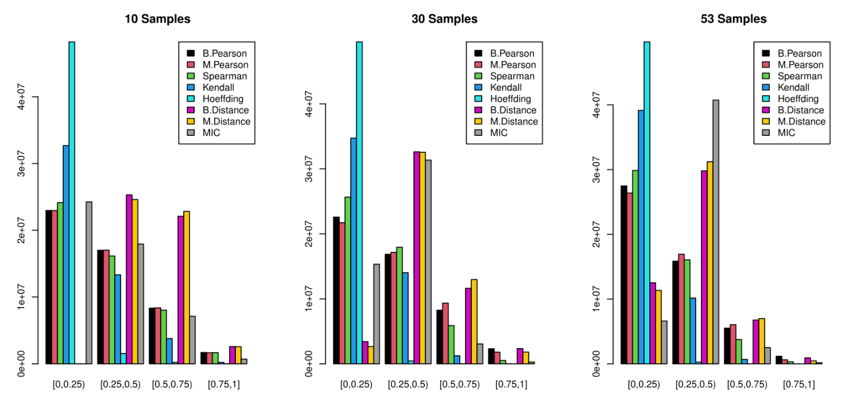Figure 1. Bar plots for the distribution of correlation coefficients by sample size. Left: 10 samples; Middle: 30 samples; Right: 53 samples. For metrics capable of producing negative correlation scores (Pearson,, Spearman,, and Kendall), the absolute value has been plotted to represent the magnitude or strength of correlations.

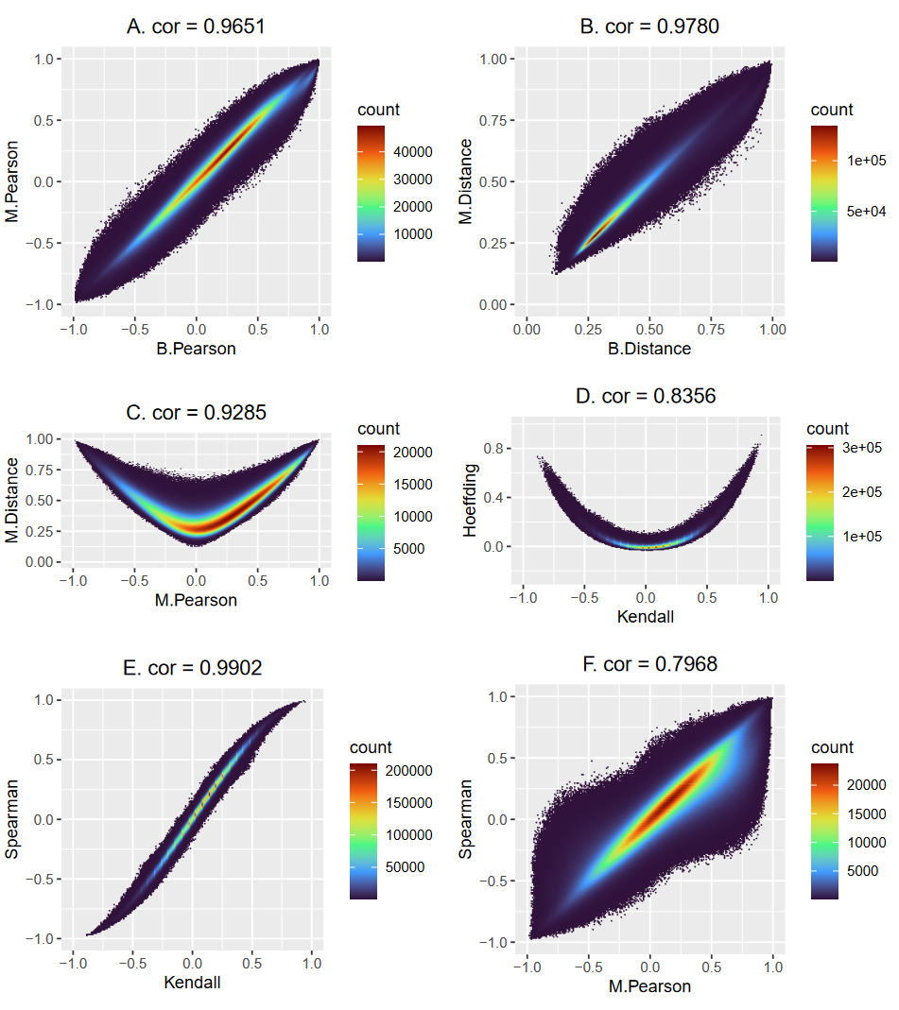
Figure 2. Scatterplots for metrics with strong correlations/similarity. (A) B.Pearson vs. M.Pearson, (B) B.Distance vs. M.Distance, (C) M.Pearson vs. M.Distance, (D) Kendall vs. Hoeffding, (E) Kendall vs. Spearman, (F) M.Pearson vs. Spearman. Bin sizes were chosen to produce similar resolutions despite different output ranges across metrics. Color scales varied based on the maximum density in each figure.

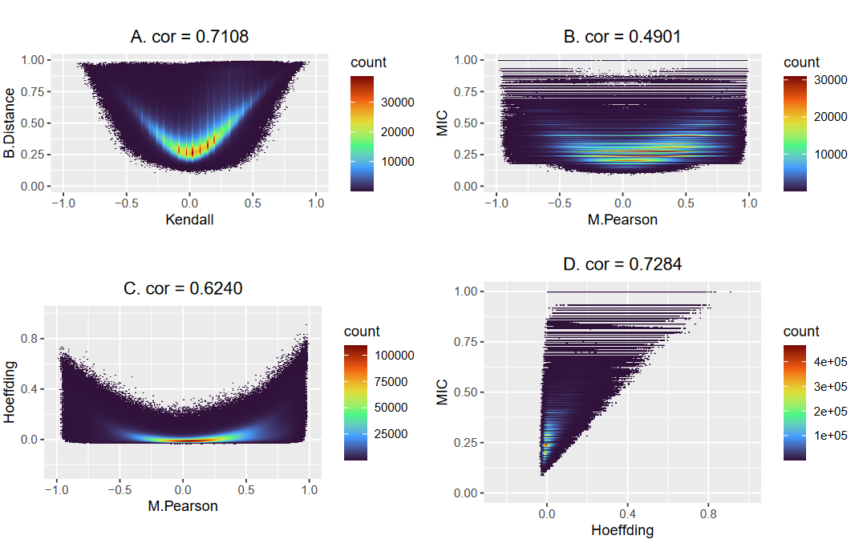
Figure 3. Scatterplots for metrics with weak correlations/similarity. (A) Kendall vs. B.Distance, (B) M.Pearson vs. MIC, (C) M.Pearson vs. Hoeffding, (D) Hoeffding vs. MIC.

.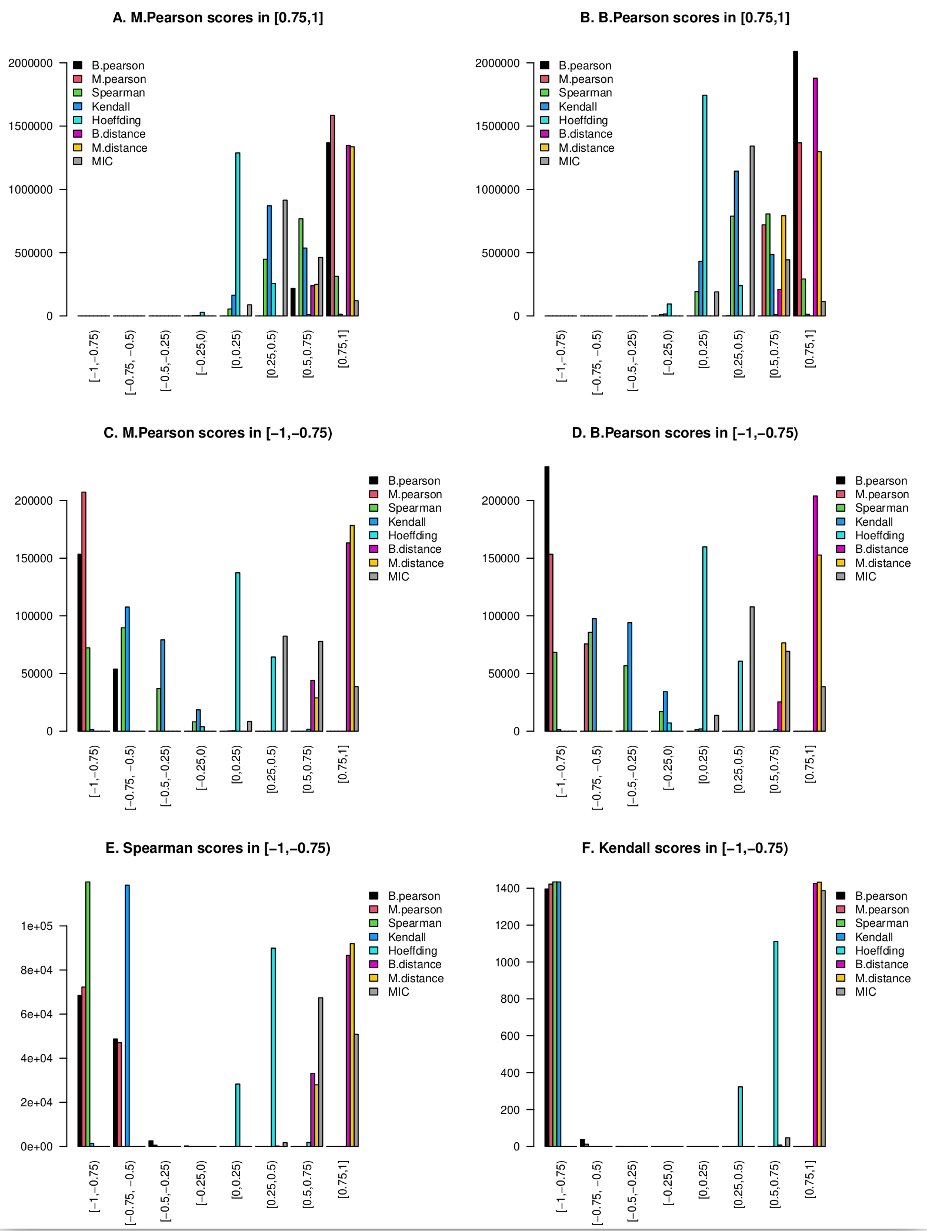
Figure 4. Bar plots for the distribution of HCM pairs across metrics. (A) HCM counts for strong positive M.Pearson coefficients, (B) HCM counts for strong positive B.Pearson coefficients, (C) HCM counts for strong negative M.Pearson coefficients, (D) HCM counts for strong negative B.Pearson coefficients, (E) HCM counts for strong negative Spearman coefficients, (F) HCM counts for strong negative Kendall coefficients.

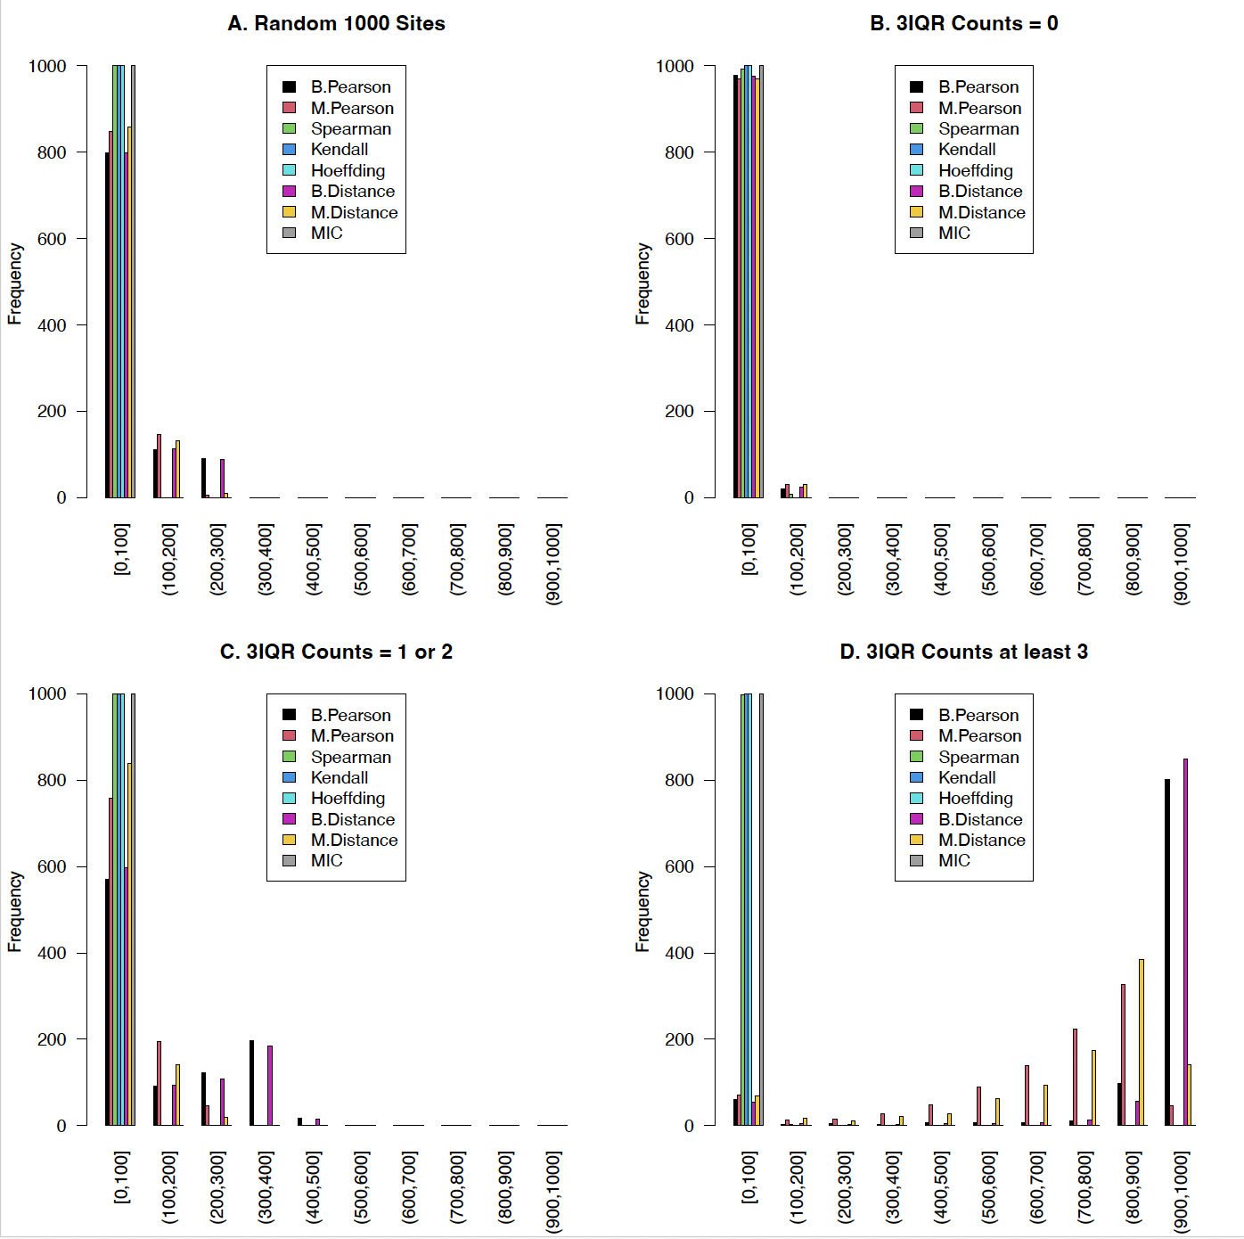
Figure 5. Bar plots of HCM counts for different subsets selected based on outliers. The horizontal axis displays different bins for the HCM counts. Each bar represents the number of HCM counts located within that bin, with a maximum count of 1000. A value of y = 1000 (e.g., the green, blue, and gray bars on the top left) indicates that all CG sites contained within that sample had a HCM count within the bin.

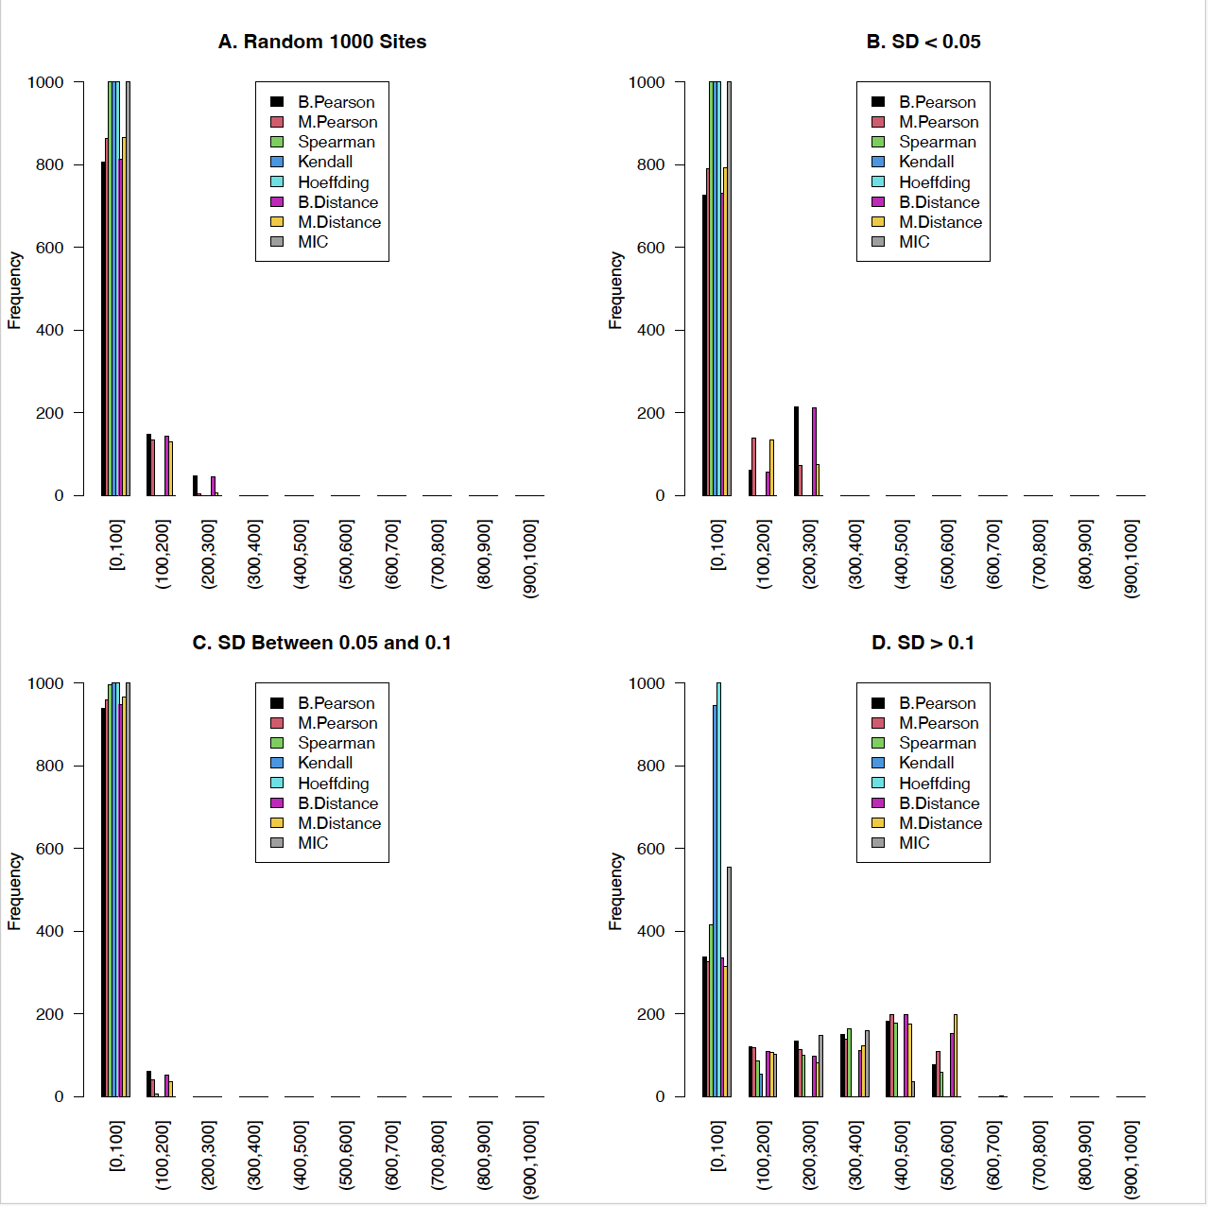
Figure 6. Bar plots of HCM counts for different subsets selected based on standard deviations. The horizontal axis displays different bins for the HCM counts of each CG site. Each bar represents the number of HCM counts located within that bin, with a maximum count of 1000. A value of y = 1000 (e.g., the green, blue, and gray bars on the top left) indicates that all CG sites contained within that sample had a HCM count within the bin.

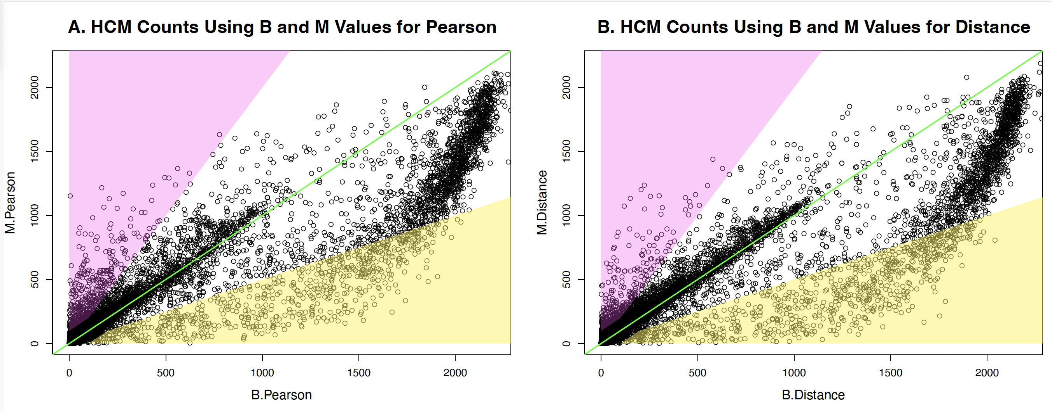
Figure 7. Scatterplots of HCM counts for Pearson and Distance correlations using B and M values. Each point represents a CG site, with the x-axis indicating HCM counts when B values were used, and the y-axis indicating HCM counts when M values were used. The green line has a slope of 1, indicating pairs that have similar counts using both M and B values. The yellow region indicates B-dominant sites while the pink region represents M-dominant sites.
1. Siegel, R.L., A.N. Giaquinto, and A. Jemal, Cancer statistics, 2024. CA Cancer J Clin, 2024. 74(1): p. 12-49.
2. Jones, P.A. and J.D. Buckley, The role of DNA methylation in cancer. Adv Cancer Res, 1990. 54: p. 1-23.
3. Yang, X., L. Yan, and N.E. Davidson, DNA methylation in breast cancer. Endocr Relat Cancer, 2001. 8(2): p. 115-27.
4. Egger, G., et al., Epigenetics in human disease and prospects for epigenetic therapy. Nature, 2004. 429(6990): p. 457-63.
5. Sun, L. and S. Sun, Within-sample co-methylation patterns in normal tissues. BioData Min, 2019. 12: p. 9.
6. Sun, S., et al., Thorough statistical analyses of breast cancer co-methylation patterns. BMC Genom Data, 2022. 23(1): p. 29.
7. Du, P., et al., Comparison of Beta-value and M-value methods for quantifying methylation levels by microarray analysis. BMC Bioinformatics, 2010. 11: p. 587.
8. Weinhold, L., et al., A statistical model for the analysis of beta values in DNA methylation studies. BMC Bioinformatics, 2016. 17(1): p. 480.
9. Spindola, L.M., et al., Detecting multiple differentially methylated CpG sites and regions related to dimensional psychopathology in youths. Clin Epigenetics, 2019. 11(1): p. 146.
10. de Siqueira Santos, S., et al., A comparative study of statistical methods used to identify dependencies between gene expression signals. Brief Bioinform, 2014. 15(6): p. 906-18.
11. Kim, Y., T.H. Kim, and T. Ergün, The instability of the Pearson correlation coefficient in the presence of coincidental outliers. Finance Research Letters, 2015. 13: p. 243-257.
12. Schober, P., C. Boer, and L.A. Schwarte, Correlation Coefficients: Appropriate Use and Interpretation. Anesth Analg, 2018. 126(5): p. 1763-1768.
13. Kendall, M.G., A new measure of rank correlation. Biometrika, 1938. 30: p. 81-93.
14. Kendall, M.G., The treatment of ties in ranking problems. Biometrika, 1945. 33: p. 239-251.
15. Hoeffding, W., A Non-Parametric Test of Independence. Annals of Mathematical Statistics, 1948. 19(4): p. 546-557.
16. Hollander, M., D. Wolfe, and E. Chicken, Nonparametric statistical methods. Third ed. 2014, Hoboken, NJ: John Wiley & Sons Inc.
17. Harrell, F.E., R Package ‘hmisc: Harrell Miscellaneous’. Version 4.7–2. https://cran.r-project.org/web/packages/Hmisc/. 2022.
18. Székely, G.J., M.L. Rizzo, and N.K. Bakirov, Measuring and testing dependence by correlation of distances. Annals of Statistics, 2007. 35(6): p. 2769-2794.
19. Reshef, D.N., et al., Detecting novel associations in large data sets. Science, 2011. 334(6062): p. 1518-24.
20. TCGA GDC Data Portal (https://portal.gdc.cancer.gov/).
21. Rizzo, M. and G. Szekely, E-Statistics: Multivariate Inference via the Energy of Data. R package (energy) version 1.7-11. 2022-12-22 https://cran.r-project.org/web/packages/energy/ 2022.
22. Zare, H., Pigengene: Computing and using eigengenes. R Package version 1.16.0. 2020. https://rdrr.io/bioc/Pigengene/. 2020.
23. Filosi, M., et al., Maximal Information-Based Nonparametric Exploration for Variable Analysis.” R package (Minerva) version 1.5.10. 2021-06-19. https://cran.r-project.org/web/packages/minerva/ 2021.
24. Kruskal, W.H., Ordinal Measures of Association. Journal of the American Statistical Association, 1958. 53(284): p. 814-861.
25. Huo, X.M. and G.J. Székely, Fast Computing for Distance Covariance. Technometrics, 2016. 58(4): p. 435-447.
26. Knight, W.R., A Computer Method for Calculating Kendalls Tau with Ungrouped Data. Journal of the American Statistical Association, 1966. 61(314p): p. 436-&.
27. Shao, F. and H. Liu, The theoretical and experimental analysis of the maximal information coefficient approximate algorithm. Journal of Systems Science and Information, 2021. 9(1): p. 95-104.
28. Edelmann, D., T.F. Móri, and G.J. Székely, On relationships between the Pearson and the distance correlation coefficients. Statistics & Probability Letters, 2021. 169.
29. Hou, J., et al., Distance correlation application to gene co-expression network analysis. BMC Bioinformatics, 2022. 23(1): p. 81.
30. Shiekh, R.H.A. and E.F. El-Hashash, A comparison of the pearson, spearman rank and kendall tau correlation coefficients using quantitative variables. Asian Journal of Probability and Statistics, 2022: p. 36-48.
31. Temizhan, E., H. Mirtagioglu, and M. Mendes, Which correlation coefficient should be used for investigating relations between quantitative variables. American Scientific Research Journal for Engineering, Technology, and Sciences. , 2022. 85: p. 265-277.

