ICESJMS-2013-347

Time-varying natural mortality in fisheries stock assessment models: Identifying a default approach

Kelli F. Johnson1*, Cole C. Monnahan2, Carey R. McGilliard1,3, Katyana A. Vert-pre1,4, Sean C. Anderson5, Curry J. Cunningham1, Felipe Hurtado-Ferro1, Roberto Licandeo6, Melissa Muradian2, Kotaro Ono1, Cody S. Szuwalski1, Juan L. Valero1,7, Athol R. Whitten1, and André E. Punt1

*1School of Aquatic and Fishery Sciences, University of Washington, Box 355020, Seattle, WA 98195-5020, USA  
2Quantitative Ecology & Resource Management, University of Washington, Box 352182, Seattle, WA 98195-2812, USA  
3Joint Institute for the Study of the Atmosphere and Ocean, University of Washington, Alaska Fisheries Science Center, National Marine Fisheries Service, National Oceanic and Atmospheric Administration, , Seattle, WA, USA  
4School of Forest Resources and Conservation, University of Florida,* *Box 110240, Gainesville, FL 32611, USA  
5Department of Biological Sciences, Simon Fraser University, Burnaby BC, V5A 1S6, Canada  
6Fisheries Centre, Aquatic Ecosystems Research Laboratory, University of British Columbia, Vancouver, BC V6T 1Z4, Canada  
7Center for the Advancement of Population Assessment Methodology, 8901 La Jolla Shores Drive, La Jolla, CA 92037, USA*

*\*Corresponding author: tel: +1 206 543 4270; fax: +1 206 685 7471; email: kfjohns@uw.edu*

**Supplementary Tables**

Table S1. Percentage of models that failed to converge (non-invertible covariance matrix or parameters on the bounds) for each scenario. Values of NA indicate models that were removed from the analysis due to a lack of convergence (i.e. less than 15 of 100 initial runs produced a covariance matrix).

|  |  |  |  |  |  |  |  |  |  |
| --- | --- | --- | --- | --- | --- | --- | --- | --- | --- |
| *F* | EM | Species | True trend in *M* | | | | | | |
| Constant | Down 50 | Down 75 | Down 90 | Up 50 | Up 75 | Up 90 |
| Constant F | Estimate *M* | cod | 5.66 |  |  |  |  |  |  |
| flatfish | 2.91 |  |  |  |  |  |  |
| sardine | 30.56 |  |  |  |  |  |  |
| Fixed Mhistorical | cod | 0.00 |  |  |  |  |  |  |
| flatfish | 0.00 |  |  |  |  |  |  |
| sardine | 9.91 |  |  |  |  |  |  |
| Increase F | Estimate *M* | cod | 0.00 | 0.00 | 0.99 | 0.00 | 0.99 | 0.00 | 0.00 |
| flatfish | 0.00 | 4.76 | 1.96 | 0.00 | 67.53 | 47.37 | 0.99 |
| sardine | 12.28 | 4.76 | 9.09 | 6.54 | NA | NA | 34.21 |
| Fixed Mlow | cod | 0.00 | 0.00 | 0.00 | 0.00 | 0.99 | 0.00 | 0.00 |
| flatfish | 0.99 | 0.00 | 0.00 | 0.00 | NA | 80.51 | 3.85 |
| sardine | 86.81 | 22.48 | 39.76 | 70.67 | NA | NA | NA |
| Fixed Mhistorical | cod | 0.00 | 0.00 | 0.00 | 0.00 | 0.00 | 0.00 | 0.00 |
| flatfish | 0.00 | 26.40 | 3.92 | 0.00 | 15.97 | 0.99 | 0.00 |
| sardine | 9.91 | 0.99 | 4.76 | 13.04 | NA | 79.84 | 11.50 |
| Fixed Mhigh | cod | 0.00 | 0.00 | 0.00 | 0.00 | 0.00 | 0.00 | 0.00 |
| flatfish | 0.99 | 3.85 | 1.98 | 0.99 | 0.00 | 3.85 | 1.96 |
| sardine | 0.99 | 0.99 | 0.00 | 0.00 | 23.66 | 13.79 | 3.85 |
| Contrast F | Estimate *M* | cod | 0.00 | 0.00 | 0.00 | 0.00 | 5.66 | 0.00 | 0.00 |
| flatfish | 0.99 | 6.54 | 0.00 | 0.00 | 84.66 | 59.68 | 4.76 |
| sardine | 23.08 | 6.54 | 9.91 | 26.47 | NA | NA | 45.05 |
| Fixed Mlow | cod | 0.00 | 0.00 | 0.00 | 0.00 | 13.04 | 0.00 | 0.00 |
| flatfish | 7.41 | 0.00 | 0.99 | 3.85 | NA | 85.51 | 27.01 |
| sardine | 90.95 | 38.27 | 70.50 | 90.46 | NA | NA | NA |
| Fixed Mhistorical | cod | 0.00 | 0.00 | 0.00 | 0.00 | 0.99 | 0.00 | 0.00 |
| flatfish | 0.99 | 18.49 | 0.00 | 0.00 | 50.98 | 3.85 | 0.00 |
| sardine | 25.37 | 5.66 | 14.53 | 15.97 | NA | NA | 24.81 |
| Fixed Mhigh | cod | 0.00 | 0.00 | 0.00 | 0.00 | 0.99 | 0.00 | 0.00 |
| flatfish | 4.81 | 5.66 | 0.00 | 0.00 | 0.00 | 11.21 | 11.21 |
| sardine | 3.85 | 1.96 | 1.96 | 2.91 | 34.64 | 16.67 | 3.85 |

Table S2. Results from an analysis of variance for terminal *SSB,* terminal *F*, and TAC, testing the null hypothesis that relative errors (REs) for each metric are similar between fishing mortality scenarios and life-history types when *M* is time-invariant in the operating model and fixed at *Mhistorical* in the estimation method.

|  |  |  |  |  |  |
| --- | --- | --- | --- | --- | --- |
| RE metric | category | dof | MSE | F | P(>F) |
| terminal *SSB* | species | 2 | 0.081 | 1.740 | 0.176 |
| *F* | 1 | 0.000 | 0.008 | 0.930 |
| species * *F* | 2 | 0.001 | 0.024 | 0.976 |
| residual | 594 | 0.046 |  |  |
| terminal *F* | species | 2 | 0.048 | 0.663 | 0.516 |
| *F* | 1 | 0.131 | 1.812 | 0.179 |
| species * *F* | 2 | 0.014 | 0.198 | 0.821 |
| residual | 594 | 0.072 |  |  |
| *TAC* | species | 2 | 0.140 | 2.053 | 0.129 |
| *F* | 1 | 0.030 | 0.447 | 0.504 |
| species * *F* | 2 | 0.071 | 1.044 | 0.353 |
| residual | 594 | 0.068 |  |  |

Table S3. Median absolute relative errors (MAREs) in parameter estimates for the flatfish-like life history. Values are reported for the self-test (i.e. time invariant *M* in the operating model and a correctly specified estimation method) for each of the three fishing patterns: constant, increase, and contrast.

|  |  |  |  |  |  |  |  |  |  |  |  |
| --- | --- | --- | --- | --- | --- | --- | --- | --- | --- | --- | --- |
| *F* | EM | *R0* | *Q* | *L*∞ | *K* | *Cvyoung* | *Cvold* | S1 | S2 | S3 | S4 |
| Constant F | Estimated *M* | 0.21 | 0.22 | 0.03 | 0.10 | 0.16 | 0.06 | 0.02 | 0.07 | 0.02 | 0.15 |
| Fixed *Mhistorical* | 0.06 | 0.06 | 0.03 | 0.10 | 0.18 | 0.07 | 0.01 | 0.07 | 0.02 | 0.16 |
| Increase F | Estimated *M* | 0.12 | 0.09 | 0.04 | 0.12 | 0.16 | 0.12 | 0.02 | 0.09 | 0.02 | 0.14 |
| Fixed *Mhistorical* | 0.08 | 0.06 | 0.04 | 0.11 | 0.16 | 0.11 | 0.02 | 0.09 | 0.02 | 0.14 |
| Contrast F | Estimated *M* | 0.14 | 0.09 | 0.06 | 0.17 | 0.17 | 0.11 | 0.02 | 0.07 | 0.02 | 0.16 |
| Fixed *Mhistorical* | 0.08 | 0.05 | 0.06 | 0.16 | 0.18 | 0.11 | 0.02 | 0.07 | 0.02 | 0.16 |

Table S4. Median absolute relative errors (MAREs) in parameter estimates for the sardine-like life history. Values are reported for the self-test (i.e. time invariant *M* in the operating model and a correctly specified estimation method) for each of the three fishing patterns: constant, increase, and contrast.

|  |  |  |  |  |  |  |  |  |  |  |  |
| --- | --- | --- | --- | --- | --- | --- | --- | --- | --- | --- | --- |
| *F* | EM | *R0* | *q* | *L*∞ | *K* | *Cvyoung* | *Cvold* | S1 | S2 | S3 | S4 |
| Constant F | Estimated *M* | 0.24 | 0.19 | 0.01 | 0.03 | 0.05 | 0.10 | 0.01 | 0.05 | 0.02 | 0.08 |
| Fixed *Mhistorical* | 0.11 | 0.08 | 0.01 | 0.04 | 0.05 | 0.11 | 0.01 | 0.05 | 0.02 | 0.08 |
| Increase F | Estimated *M* | 0.19 | 0.11 | 0.01 | 0.04 | 0.04 | 0.14 | 0.01 | 0.04 | 0.02 | 0.09 |
| Fixed *Mhistorical* | 0.13 | 0.06 | 0.01 | 0.04 | 0.05 | 0.14 | 0.01 | 0.04 | 0.02 | 0.08 |
| Contrast F | Estimated *M* | 0.21 | 0.08 | 0.01 | 0.05 | 0.04 | 0.14 | 0.01 | 0.03 | 0.02 | 0.08 |
| Fixed *Mhistorical* | 0.11 | 0.06 | 0.01 | 0.05 | 0.05 | 0.14 | 0.01 | 0.04 | 0.02 | 0.07 |

**Supplementary Figures**

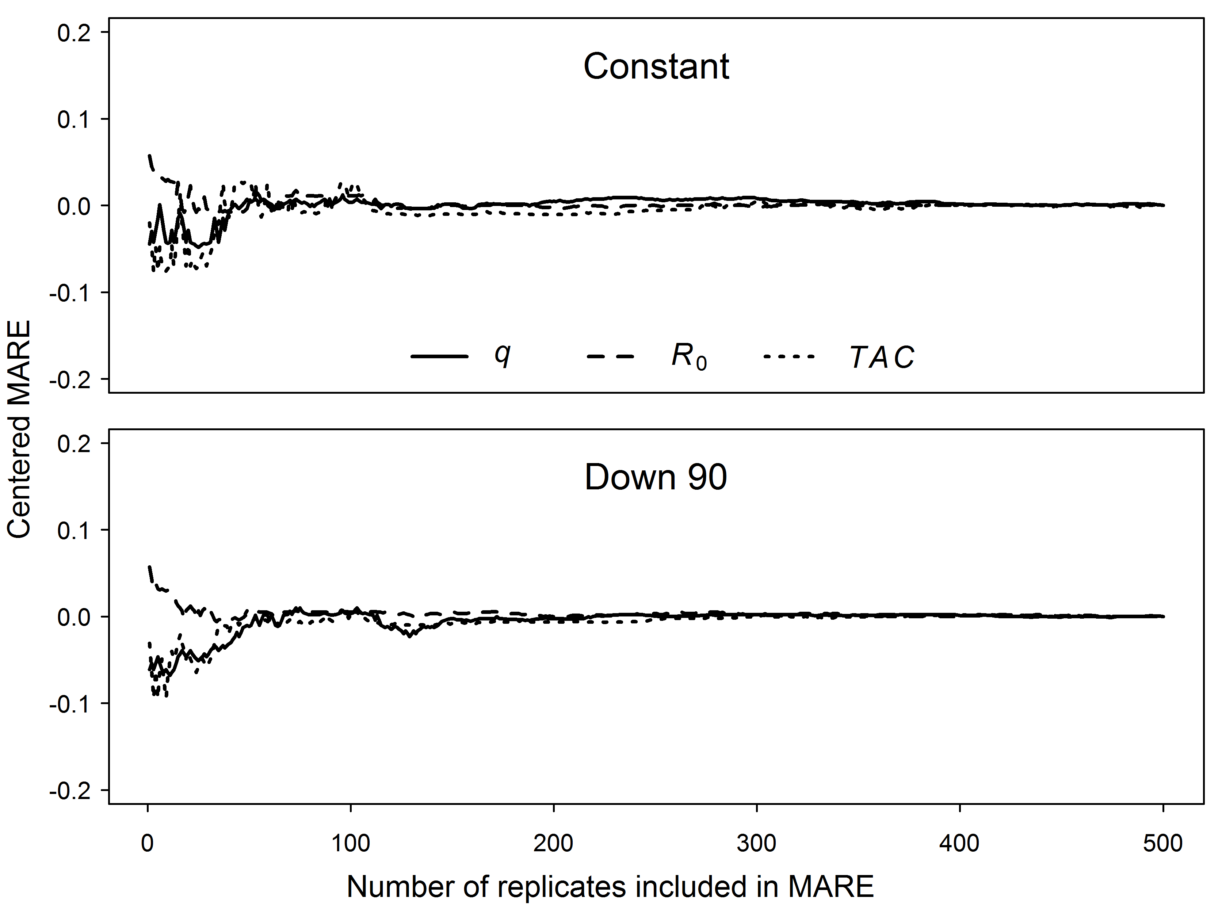Figure S1. Centered median absolute relative errors (MAREs) (MAREi – MARE500, where i = number of iterations used in calculation) of *q*, *R0*,and *TAC* versus the number of replicates included in the calculation for the centered MARE for cod fished at an increasing rate, where *M* either (1) decreased in year 90 or (2) remained constant in the operating model and was fixed at *Mlow* in the estimation method. Centering the MAREs facilitates comparison across metrics.

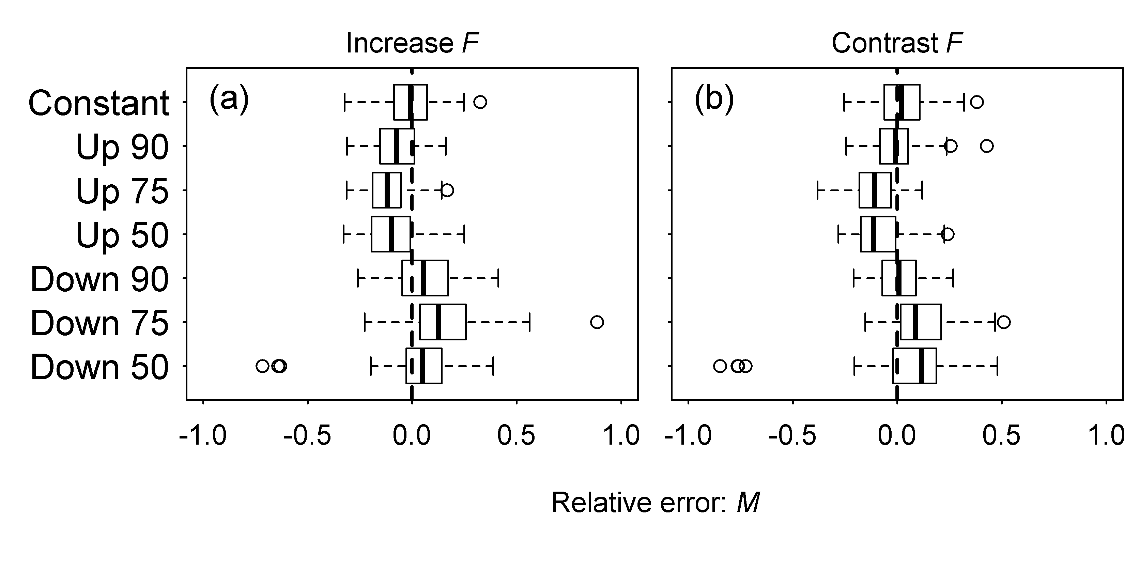Figure S2. Boxplots for the relative errors (REs) in *Mhistorical* for the flatfish-like life history.

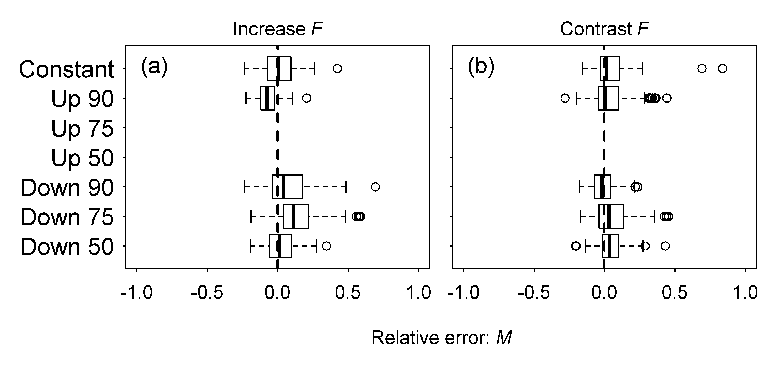Figure S3. Boxplots for the relative errors (REs) in *Mhistorical* for the sardine-like life history. Rows without boxplots indicates scenarios where the optimization algorithm failed to converge.

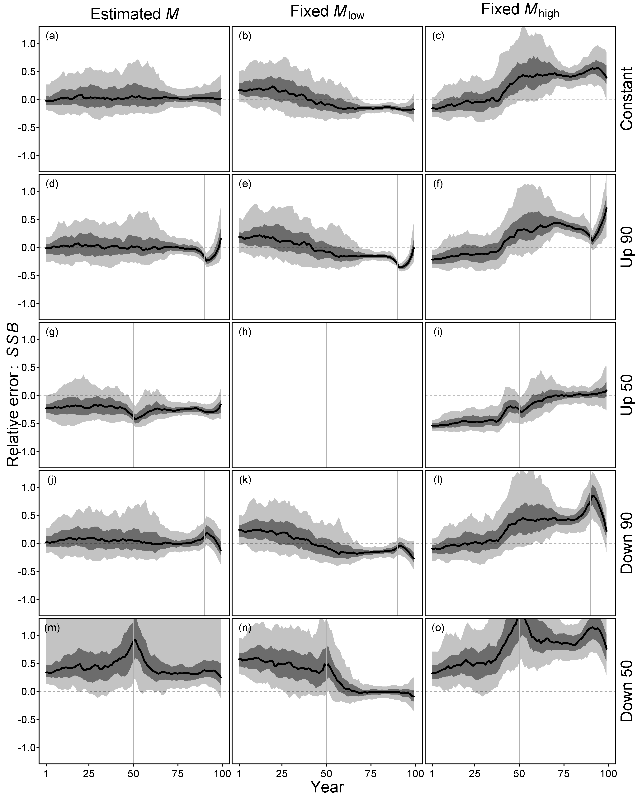

Figure S4. Time trajectories of relative error (RE) for *SSB* for the flatfish-like life-history type under a contrast fishing scenario when the true *M* changed in a block like fashion in years 50 or 90 or was constant across all years. *M* was either estimated, fixed at a high value, or fixed at a low value. Values of zero (dashed line) indicate no difference between the operating model value and the estimate from the estimation method. The solid vertical line indicates the year that *M* changed to *M\**. The shaded regions cover 50% and 90% of the relative errors, and the line denotes the median. Empty plots indicate scenarios where the optimization algorithm failed to converge.

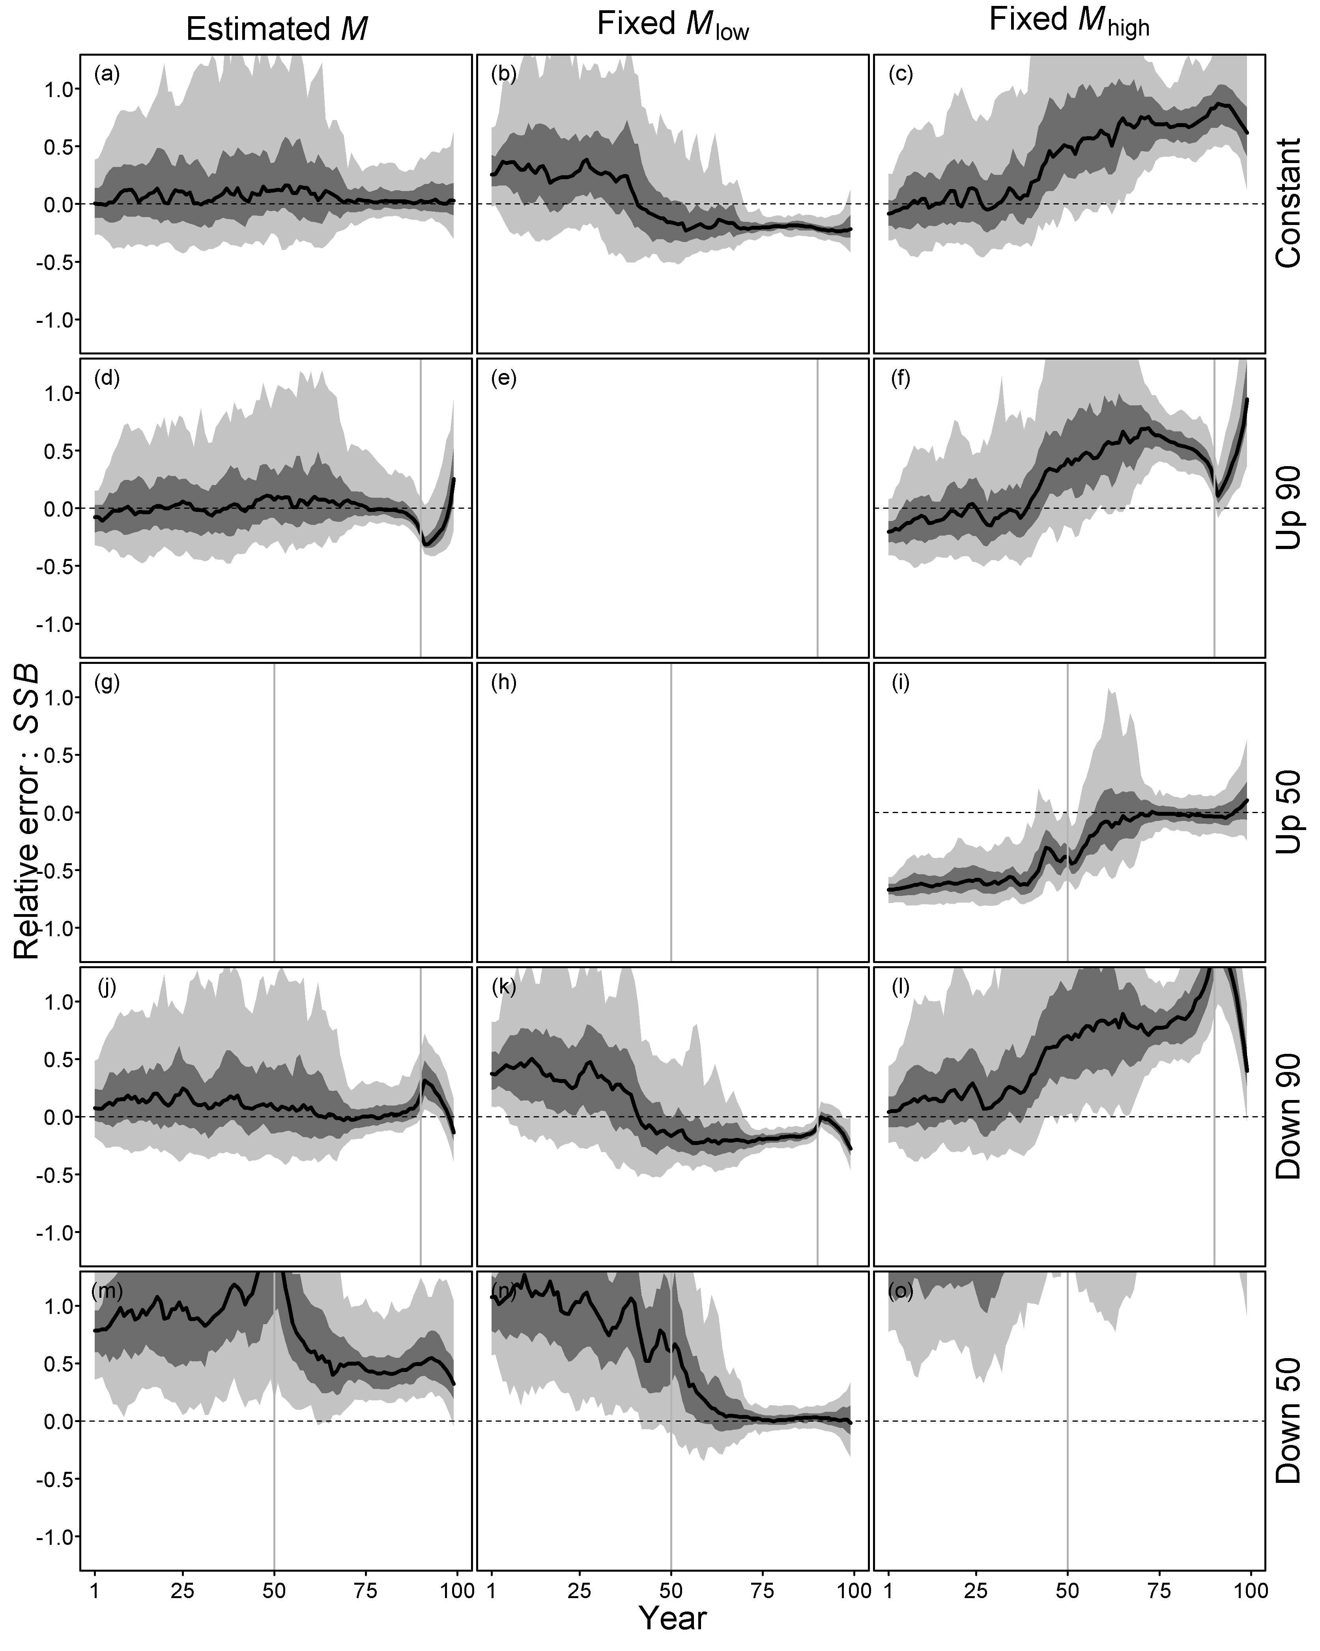

Figure S5. Time trajectories of relative error (RE) for *SSB* for the sardine-like life-history type under a contrast fishing scenario when the true *M* changed in a block like fashion in years 50 or 90 or was constant across all years. *M* was either estimated, fixed at a high value, or fixed at a low value. Values of zero (dashed line) indicate no difference between the operating model value and the estimate from the estimation method. The solid vertical line indicates the year that *M* changed to *M\**. The shaded regions cover 50% and 90% of the relative errors, and the line denotes the median. Empty plots indicate scenarios where the optimization algorithm failed to converge.

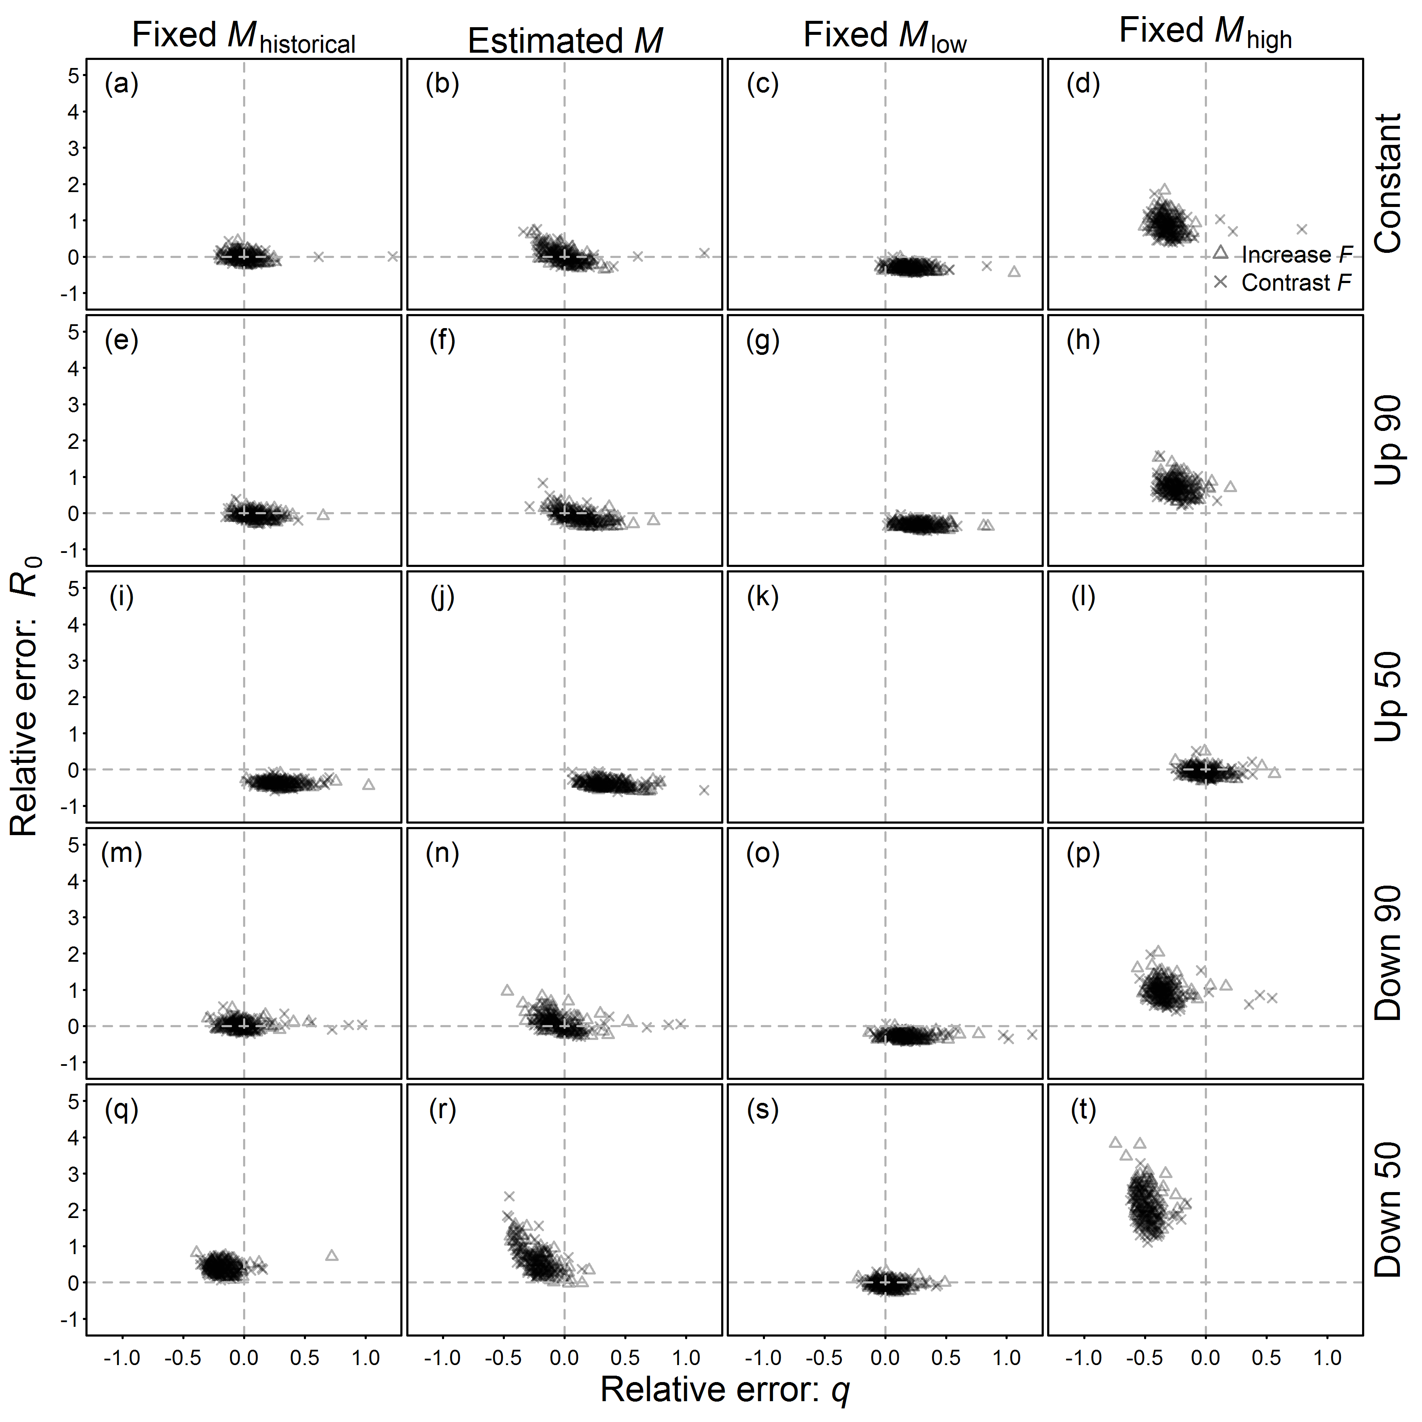Figure S6. Correlation between the relative errors (REs) for *R0* and *q* for the flatfish-like life history for two fishing patterns. Positive errors in parameter estimates occur above and to the right of the dashed line, whereas negative errors occur below and to the left of the dashed line. Empty plots indicate scenarios where the optimization algorithm failed to converge.