SOURCE : <https://preppindata.blogspot.com/2019/12/2019-week-44.html>

Last week's challenge, Chin & Beard Suds Co. looked at Store Performance for the end of year appraisals. This week we are looking at our staff members.

Chin & Beard Suds Co. wants to understand how much our team are selling each day but we don't capture team member level sales at the moment. We would like to reward our top three sellers in each store but who are they?

### Requirements

](https://1.bp.blogspot.com/-bXeJX9bMRoA/XfFO6ohf8mI/AAAAAAAAAwI/P2rRX0nBe10-Cvnlrkx6Gj7prxyXIdzVQCEwYBhgL/s1600/Screenshot%2B2019-12-11%2Bat%2B20.06.50.png)

*Team Member Days*

[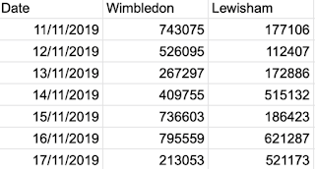](https://1.bp.blogspot.com/-H3Ty-Bbp9OU/XfFO6vT-mLI/AAAAAAAAAwA/SUzcMIUVdpozF0cK27mFwSfT8839gsOLACEwYBhgL/s1600/Screenshot%2B2019-12-11%2Bat%2B20.06.42.png)

*Store Sales*

* [Input Data](https://drive.google.com/open?id=1pH9rH25upJXbVkRgeqA5aEY8XN3A_aC4)
* Determine how many staff work in each store each day
* Join Store Sales and Team Member Days
* Estimate the Staff Sales per Day based on the Store Sales divided by the number of staff who worked that day
* Determine the team member's rank within their store
  + Number 1 is the highest estimated average Estimated Sales per Day
* Output the data

### Output

One File:

* 4 Columns:
  + Store
  + Team Member
  + Rank
  + Estimated Sales From Staff Member (avg per day)
* 13 Rows of Data (14 Rows including headers)

The outputs can be [found here](https://drive.google.com/open?id=1ZsfN827ljY6_zzPjXavdJ8ajJLCskCnt) for comparison.