**ShopBridge E-Commerce-App**

1.Created login page for Admin as Name and Password . Performed Data Validation on these.

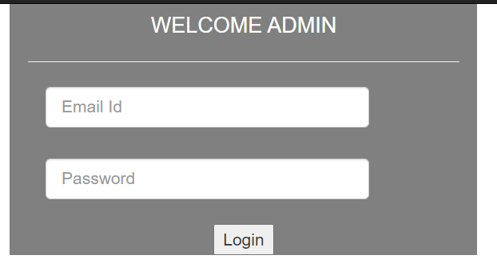

2. Created Products page contains CompanyName, ProductName, Description, Price and performed add, delete, modify, list and search.

3.Dropdownlist contains company name and product name by selecting any one of these display the details according to it after clicking on Search button.

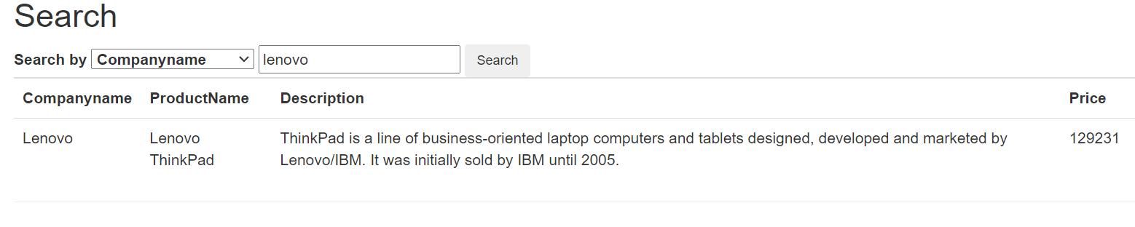

**ASP.NET Web API REST Service In ASP.NET MVC Using HttpClient**

* **Installed system.web.httpclient**

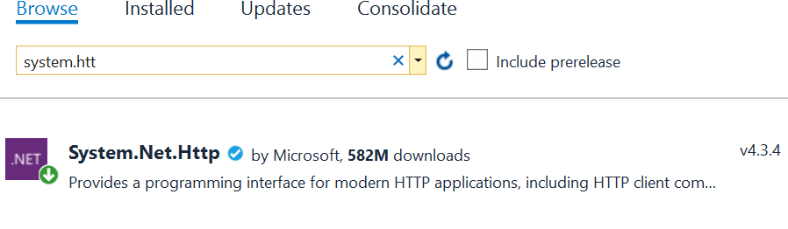

* Installed Microsoft.Aspnet.WebApi.Client

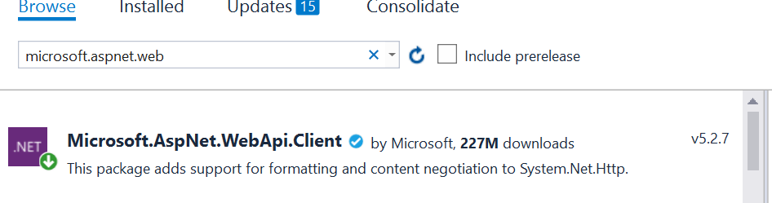

string Baseurl = "http://localhost:50986/";

public async Task<ActionResult> List()

{

List<ProductAdminLogin> productInfo = new List<ProductAdminLogin>();

using (var client = new HttpClient())

{

//Passing service base url

client.BaseAddress = new Uri(Baseurl);

client.DefaultRequestHeaders.Clear();

//Define request data format

client.DefaultRequestHeaders.Accept.Add(new MediaTypeWithQualityHeaderValue("application/json"));

//Sending request to find web api REST service resource GetAllEmployees using HttpClient

HttpResponseMessage Res = await client.GetAsync("api/ProductDeatil/GetAllEmployees");

//Checking the response is successful or not which is sent using HttpClient

if (Res.IsSuccessStatusCode)

{

//Storing the response details recieved from web api

var productResponse = Res.Content.ReadAsStringAsync().Result;

//Deserializing the response recieved from web api and storing into the Employee list

productInfo = JsonConvert.DeserializeObject<List<ProductAdminLogin>>(productResponse);

}

//returning the employee list to view

return View(productInfo);

}

­­­­­­Deployment of Code.

* Created a site in ISS Manager (site name as ‘shopbridge.local’).
* In the visual studio published the code in IIS using this site name.

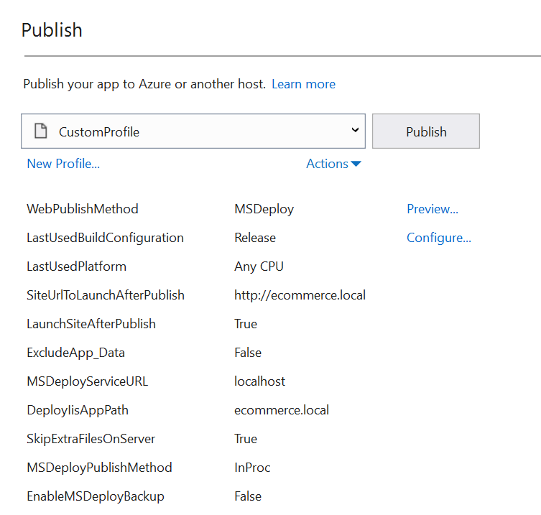

Test Cases:

* Using MS Test created another project.

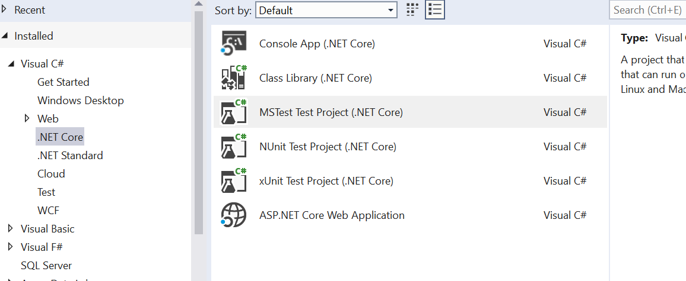

* Added reference

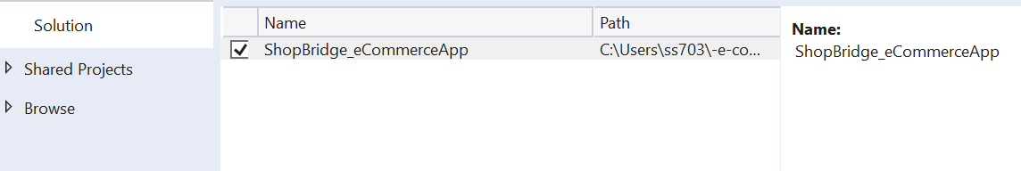

* Executed Test cases

