Influencer Campaign Performance Tracker
Power BI Dashboard & Marketing Analytics Report

Submitted By: P.Sharmila
Internship: AI & ML Internship
Task Number: Task 06
Domain: Data Analytics + Marketing Analytics + Business Intelligence
Tools Used:
- Python
- Pandas
- NumPy
- Power BI
- Microsoft Excel

ACKNOWLEDGEMENT

I sincerely express my gratitude to our AI & ML Internship Program for providing me with the opportunity to complete the project titled "Influencer Campaign Performance Tracker." This project helped me gain practical knowledge in Data Analytics, Python, and Power BI Dashboard development.
I extend my heartfelt thanks to my mentors and faculty members for their valuable guidance, continuous support, and encouragement throughout this project. Their suggestions and feedback greatly improved the quality of my work.
I also thank my institution for providing the necessary resources and learning environment to successfully complete this project. Finally, I express my gratitude to everyone who directly or indirectly supported me during the completion of this project.

TABLE OF CONTENTS

S.No | Contents | Page No.
1 | Cover Page | 1
2 | Acknowledgement | 2
3 | Table of Contents | 3
4 | Introduction | 4
5 | Problem Statement | 5
6 | Objectives | 6
7 | Dataset Description | 7
8 | Data Cleaning & Preprocessing | 8
9 | Feature Engineering | 9
10 | KPI Design | 10
11 | Dashboard Overview (Page 1) | 11
12 | Influencer Performance Analysis (Page 2) | 12
13 | Influencer Segmentation (Page 3) | 13
14 | Business Insights | 14
15 | Recommendations | 15
16 | Conclusion | 16
17 | Future Scope | 17
18 | References | 18

INTRODUCTION

Influencer marketing has become one of the most effective digital marketing strategies used by businesses to promote their products and services. Brands collaborate with influencers on various social media platforms such as Instagram, YouTube, Facebook, TikTok, and X (Twitter) to increase brand awareness, customer engagement, and product sales.
As marketing campaigns continue to grow, organizations generate a large volume of campaign data. This data includes information such as campaign spending, revenue, audience reach, engagement, conversions, and return on investment (ROI). Analyzing this data manually is time-consuming and may not provide meaningful insights for decision-making.
The Influencer Campaign Performance Tracker is developed to analyze influencer marketing campaigns using Python for data preprocessing and Power BI for interactive dashboard visualization. The dashboard helps marketing teams monitor campaign performance, compare influencers, evaluate platform effectiveness, analyze audience behavior, and measure campaign profitability.
The project also includes KPI analysis, campaign segmentation, ROI evaluation, and business recommendations that support data-driven marketing decisions. By using interactive dashboards, organizations can quickly identify high-performing campaigns and optimize future marketing investments.

PROBLEM STATEMENT

Influencer marketing has become one of the fastest-growing digital marketing strategies for promoting products and services. Companies invest significant amounts of money in influencer campaigns across different social media platforms to improve brand awareness, customer engagement, and sales.
However, many organizations face challenges in evaluating the effectiveness of these campaigns. They often struggle to identify which influencers generate the highest return on investment (ROI), which platforms perform best, and whether campaign spending produces the expected business outcomes. Without proper analysis, businesses may continue investing in low-performing campaigns, resulting in reduced profitability and inefficient marketing decisions.
This project addresses these challenges by developing an interactive Power BI dashboard that analyzes influencer campaign performance. The dashboard enables users to monitor important marketing KPIs, compare campaign performance, evaluate influencer effectiveness, analyze audience behavior, and support data-driven business decisions.

OBJECTIVES

The main objectives of this project are:
- To analyze influencer marketing campaign performance using Python and Power BI.
- To design and monitor important Key Performance Indicators (KPIs).
- To evaluate campaign effectiveness using Revenue, Reach, ROI, Engagement Rate, and Conversions.
- To identify high-performing influencers and social media platforms.
- To compare campaign spending with return on investment.
- To analyze audience behavior across different audience groups.
- To categorize influencers based on campaign performance.
- To provide business recommendations for improving future marketing campaigns.
- To develop an interactive dashboard that supports data-driven decision-making.

DATASET DESCRIPTION

The dataset used in this project is Final_Influencer_Campaign_Dataset.csv, which contains detailed information about influencer marketing campaigns. The dataset was prepared after data cleaning and feature engineering using Python.
The dataset consists of 1,048,575 records and contains campaign-related information such as influencer details, social media platforms, audience reach, engagement metrics, campaign spending, revenue generated, conversions, and ROI.
The following important columns are included in the dataset:
- Campaign_ID
- Influencer_Name
- Platform
- Followers
- Reach
- Likes
- Comments
- Shares
- Spend
- Revenue
- Conversions
- Audience_Group
- Engagement_Rate
- ROI
- Influencer_Size
- ROI_Category
- Engagement_Category
- Cost_Efficient
These attributes were used to create interactive visualizations and business insights in the Power BI dashboard.

DATA CLEANING & PREPROCESSING

Data cleaning is one of the most important steps in data analytics. Before building the dashboard, the dataset was cleaned and prepared using Python to ensure that the analysis was accurate and reliable.
The following preprocessing steps were performed:
- Loaded the dataset using the Pandas library.
- Checked the dataset structure and data types.
- Identified and handled missing values.
- Removed duplicate records to improve data quality.
- Verified numeric columns for calculations.
- Checked for inconsistent values.
- Prepared the cleaned dataset for dashboard development.
- Exported the final cleaned dataset for Power BI visualization.
These preprocessing steps ensured that the dataset was ready for KPI calculation, visualization, and business analysis.

FEATURE ENGINEERING

Feature engineering was performed to generate additional business metrics that improve campaign analysis. New columns were created using Python to provide better insights into influencer performance and campaign effectiveness.
The following features were created:
- Engagement_Rate – Measures the audience engagement for each campaign.
- ROI (Return on Investment) – Measures campaign profitability.
- Influencer_Size – Categorizes influencers as Micro, Macro, or Mega.
- ROI_Category – Classifies campaigns into High ROI and Low ROI.
- Engagement_Category – Groups campaigns into High Engagement and Low Engagement.
- Cost_Efficient – Identifies campaigns that delivered better performance with lower cost.
These engineered features helped create meaningful KPIs and interactive visualizations in Power BI.

KPI DESIGN

Key Performance Indicators (KPIs) are measurable values that help evaluate the success of influencer marketing campaigns. These KPIs were designed to provide meaningful insights into campaign performance and support better business decision-making.
The following KPIs were implemented in the Power BI dashboard:
KPI | Description
Total Campaigns | Total number of influencer campaigns.
Total Revenue | Total revenue generated from all campaigns.
Total Spend | Total amount spent on influencer campaigns.
Total Reach | Total number of people reached through campaigns.
Total Conversions | Total successful customer conversions.
Average ROI | Average Return on Investment across campaigns.
Average Engagement Rate | Average audience engagement rate.
Cost Per Engagement | Average campaign cost required for one engagement.
These KPIs provide a quick overview of campaign performance and help marketing teams identify areas for improvement.

DASHBOARD OVERVIEW

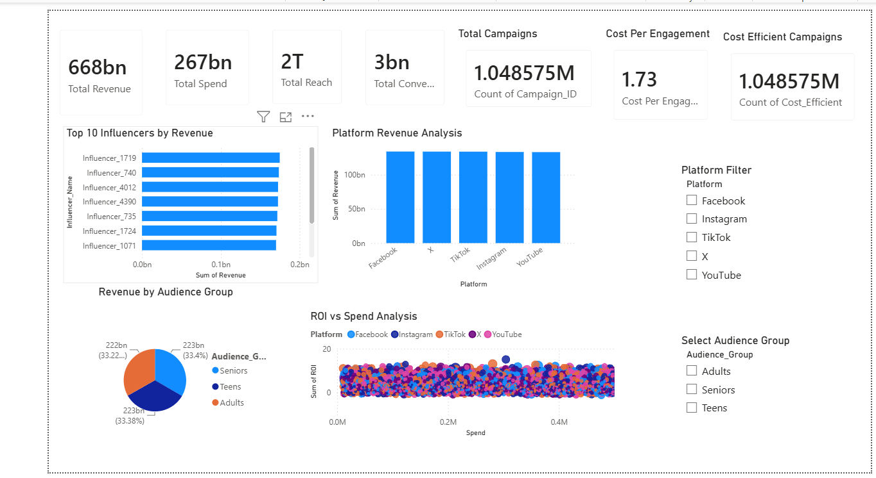
Dashboard Overview
The Dashboard Overview page provides a summary of the overall influencer campaign performance. It displays important KPIs such as Total Revenue, Total Spend, Total Reach, Total Campaigns, Total Conversions, and Cost Per Engagement.
The dashboard also includes visualizations for platform-wise revenue analysis, audience group analysis, campaign spending versus ROI, and the Top 10 influencers by revenue. Interactive slicers allow users to filter data based on platform and audience group, making the dashboard dynamic and user-friendly.
This page enables management to quickly monitor campaign performance and make informed marketing decisions.

INFLUENCER PERFORMANCE ANALYSIS

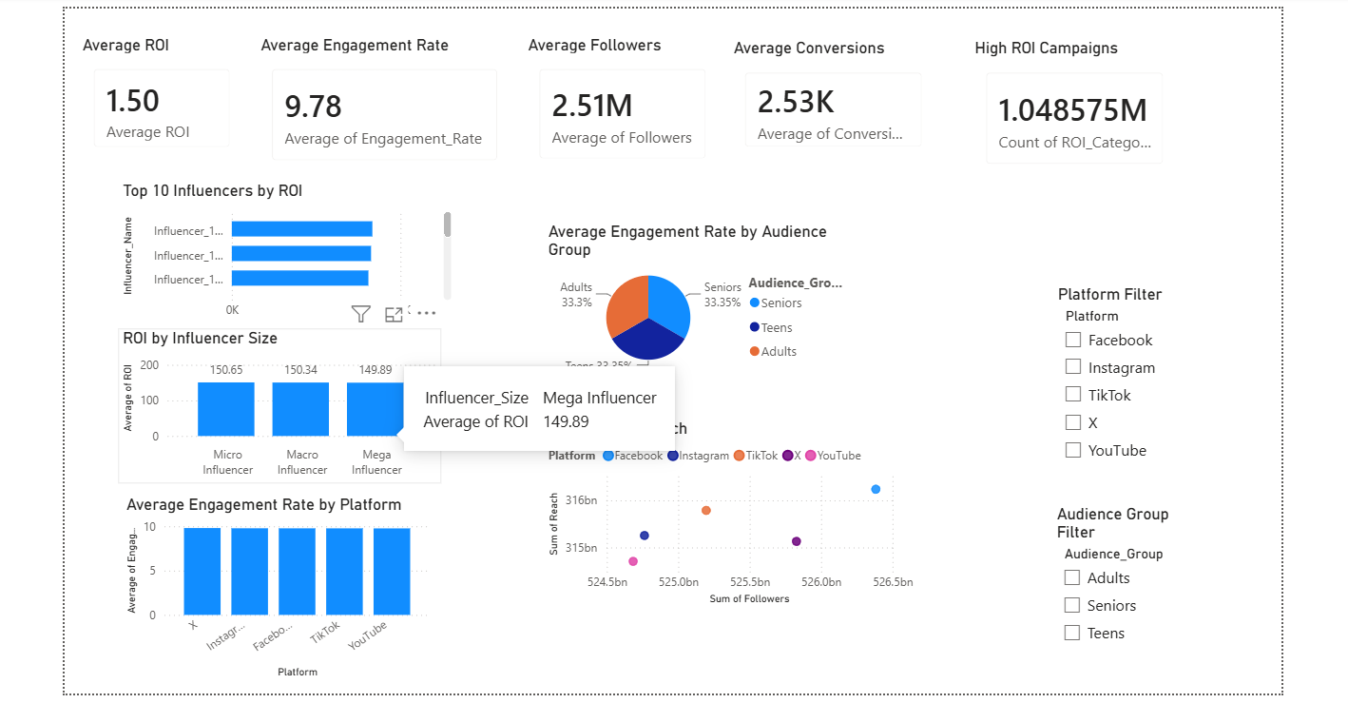
Influencer Performance Analysis
The Influencer Performance Analysis dashboard provides a detailed evaluation of influencer marketing campaigns. This page focuses on measuring influencer effectiveness using key performance metrics such as Average ROI, Average Engagement Rate, Average Followers, and Average Conversions.
The dashboard includes visualizations that compare influencer performance based on ROI, influencer size, audience groups, and social media platforms. A scatter plot is used to analyze the relationship between Followers and Reach, helping users understand how audience size influences campaign reach.
The dashboard also contains ROI Category Distribution and Engagement Category Distribution charts, which classify campaigns based on their performance. Interactive filters allow users to analyze campaign results for specific platforms and audience groups.
This page helps marketing teams identify top-performing influencers, evaluate campaign effectiveness, and improve future influencer marketing strategies.

Key Insights
• Average ROI helps evaluate overall campaign profitability.
• Average Engagement Rate measures audience interaction.
• Top-performing influencers generate better campaign results.
• Followers and Reach show a positive relationship.
• Platform-wise analysis helps identify the most effective social media platforms.
• Audience group analysis supports better marketing targeting.

INFLUENCER SEGMENTATION

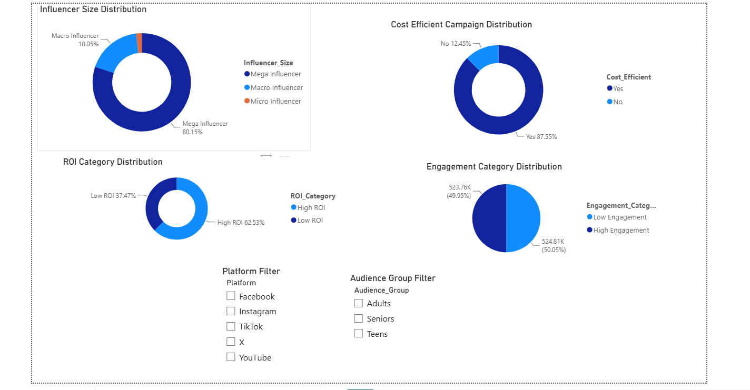

Influencer Segmentation
Influencer segmentation is an important part of campaign analysis because it helps marketing teams classify influencers based on their performance. In this project, influencers were grouped using multiple business metrics such as Influencer Size, ROI Category, Engagement Category, and Cost Efficiency.
The dashboard displays the distribution of Micro, Macro, and Mega Influencers, allowing users to understand the composition of influencer campaigns. It also categorizes campaigns into High ROI and Low ROI, helping identify profitable campaigns.
The Engagement Category Distribution visualization highlights campaigns with high and low audience engagement, while the Cost Efficient Campaign Distribution identifies campaigns that achieved better results with lower spending.
Interactive filters make it easier to analyze specific platforms and audience groups, helping marketing teams make better campaign planning decisions.

Key Insights
- Mega influencers contributed a major share of the campaigns.
- High ROI campaigns delivered better business value.
- High Engagement campaigns generated stronger audience interaction.
- Cost-efficient campaigns achieved better results with optimized spending.
- Segmentation helps brands select the right influencers for future campaigns.

BUSINESS INSIGHTS

Based on the dashboard analysis, the following business insights were identified:
- High ROI influencers consistently generated better campaign performance.
- Campaigns with higher engagement rates achieved improved audience interaction.
- Different social media platforms produced varying levels of revenue and engagement.
- Audience groups responded differently depending on the campaign type.
- Cost-efficient campaigns provided higher returns with optimized marketing budgets.
- Influencer segmentation helps businesses choose suitable creators for future campaigns.
- Interactive dashboards enable faster decision-making and continuous campaign monitoring.

RECOMMENDATIONS

Based on the analysis performed in this project, the following recommendations are suggested to improve influencer marketing campaigns:
- Collaborate more frequently with high ROI influencers to maximize campaign profitability.
- Increase investment in campaigns that demonstrate high engagement and strong audience response.
- Monitor campaign spending regularly to ensure cost-effective marketing.
- Select appropriate social media platforms based on campaign objectives and target audience.
- Focus on audience segments that consistently deliver higher conversions.
- Use interactive dashboards to monitor campaign performance in real time.
- Continuously evaluate influencer performance before launching future campaigns.
These recommendations can help organizations improve marketing effectiveness, reduce unnecessary spending, and achieve better business outcomes.

CONCLUSION

The Influencer Campaign Performance Tracker project successfully analyzed influencer marketing campaign data using Python and Power BI. The dashboard provides a comprehensive view of campaign performance through meaningful KPIs, interactive visualizations, and influencer segmentation.
The project demonstrates how business intelligence tools can transform raw campaign data into valuable insights. Marketing teams can use this dashboard to evaluate campaign effectiveness, identify top-performing influencers, optimize marketing budgets, and improve future campaign planning.
Overall, this project highlights the importance of data-driven decision-making in digital marketing and shows how analytics can contribute to improved business performance.

FUTURE SCOPE

This project can be enhanced further by implementing advanced analytical and predictive techniques. Some possible future improvements include:
- Integrating real-time social media data using APIs.
- Applying Machine Learning models to predict campaign success.
- Developing automated campaign recommendation systems.
- Performing sentiment analysis on influencer posts and audience comments.
- Creating cloud-based dashboards for remote monitoring.
- Expanding the dashboard with additional marketing KPIs and predictive analytics.
These improvements can make the dashboard more intelligent and valuable for business decision-making.

